

Bachelor of Computer Applications (BCA) Programme

Project Report

BCA Sem V

AY 2018-19

*<Topic Title: Accounts++>*

*by*

|  |  |
| --- | --- |
| Exam No. | Name of Student |
| *105* | Lohar Hamid A. |

|  |  |
| --- | --- |
| Project Guide by : | |
| Nidhi Desai |  |

*I N D E X*

|  |  |  |
| --- | --- | --- |
| **Sr. No** | **Description** | **Page No.** |
| 1 | Introduction |  |
|  | 1.1 Abstract |  |
|  | 1.2 Scope & Objective |  |
| 2 | Requirement Analysis |  |
|  | 2.1 Requirement Gathering |  |
|  | 2.2 Requirement Analysis |  |
|  | 2.3 Software Model |  |
|  | 2.4 Technology Details |  |
| 3 | Designing |  |
|  | 3.1 Data Flow Diagram |  |
|  | 3.2 Database Design |  |
|  | 3.3 User Interface |  |
| 4 | Coding |  |
| 5 | Testing |  |
|  | 5.1 Unit Testing |  |
|  | 5.2 Navigation Testing |  |
|  | 5.3 Functional Testing |  |
|  | 5.4 Environment Testing |  |
| 6 | Conclusion |  |
| 7 | Bibliography |  |

**1. Introduction**

Accounts++ is simple online accounting application. It is useful for companies to record their account. It allows different types of accounting entries eg. Sales,purchase,cash,Journal entries... etc. User can see final status of their origination using final accounting statements like Balance sheet and Profit & Loss account.

**1.1 Abstract**

Accounts++ is web application built with ASP.NET Framework. User can register their company and then he/she can record their companies accounts securely. It provide accounting in same way as it was being done traditionally. Accounts++ provides different types of transaction entries which fulfill all the requirements of financial accounting system.

1. Sale Entry
2. Purchase Entry
3. Sale Return Entry
4. Purchase Return Entry
5. Income Entry
6. Expanse Entry
7. Cash Transaction Entry
8. Journal Entry (All other types of entries)

It also provide following reports which are very useful for analysis.

1. Sale Book
2. Purchase Book
3. Sale Return Book
4. Purchase Return Book
5. Cash Book
6. Income/Expanse Report
7. Ledger Reports

It also provide final account reports.

1. Trial Balance
2. Trading and Profit & Loss Account
3. Balance Sheet

**1.2 Scope & Objective**

**Scope:**

Scope of this project is in accounting system of company. Every small/big company keeps accounts. This online application provide some simple accounting for small companies with ease of use and no complexity.

**Objective:**

1. Keep record of all Financial transactions.
2. Maintain Accounting Accuracy.
3. Provide Accounting Reports for better analysis.
4. Gives Idea of company's financial status by providing final accounts.

**2.Requirement Analysis**

**2.1 Requirement Gathering.**

**Terms Used:**

* Account: it is a record in the general ledger that is used to collect and store debit and credit amounts. Sometimes it is also Called Ledger.

Following Requirements are gathered for our Accounting Application “Accounts++” by analyzing accounting application available in market.

1. System Should allow Recording financial transactions for financial year.
2. User should be allowed to create/update/delete Accounts(Ledgers) as needed.
3. System must follow basic rules of financial accounting system. eg. there must be three types of accounts (Personal Accounts, Real Accounts and Profit & Loss Accounts) and System must follow rules for particular account.
4. System should be able to record transactions accurate.
5. System should be able to record all types of transactions which are financial transactions.
6. System should keep subsidiary books like Purchase Book, Sales book etc..
7. System should be able to generate proper invoice on particular transaction. This invoice should be generated when it is demanded.
8. System should keep track of Inventory purchased and sold.
9. System must provide Ledger report when needed.
10. System must provide Final account Reports. Which are Balance Sheet, Profit & Loss account.

**2.2 Requirement Analysis.**

After Analyzing requirements gathered above We can satisfy all of above requirements expect Requirement No. 8 “System should keep track of Inventory purchased and sold”. This requirement will need extra cost and time which are not allowed for this project.

For Requirement No 7. “System should be able to generate invoice”. It can only generate invoice in fixed format defined by system. We can provide flexibility in invoice format in future.

**2.3 Software Model.**

As we have all requirements ready with us and there is no much risk in system so we will follow waterfall model for project development.

Waterfall model consists of 5/6 simple stages which are follow. where 2st stage is completed which is requirement analysis.

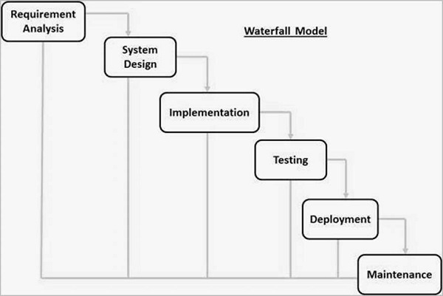

**2.4 Technology Details.**

|  |  |
| --- | --- |
| **Project Title** | Account++ (Online Accounting System) |
| **Project Objective** | Record and Maintain Company’s Accounts online. |
| **Name Of College** | SDJ International College |
| **Front-End Tool** | ASP.NET |
| **Back-End Tool** | Ms Access Database along with ADO.NET |
| **Operating System** | Any Operating System with latest Browser Support.  eg. Chrome, Firefox |
| **Internal Guide** | Nidhi Desai |
| **Submitted By** | Lohar Hamid A. |

**3. Designing**

**3.1 Data Flow Diagram.**

**3.1.1 Context Level DFD**

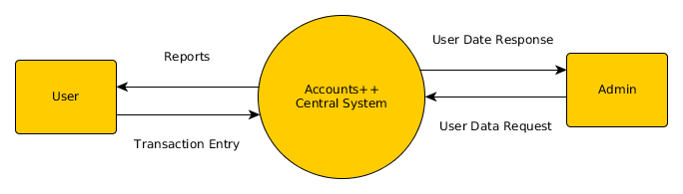**Context Level Data Flow Diagram for Accounts++**

**3.1.2 Level 1 DFD**

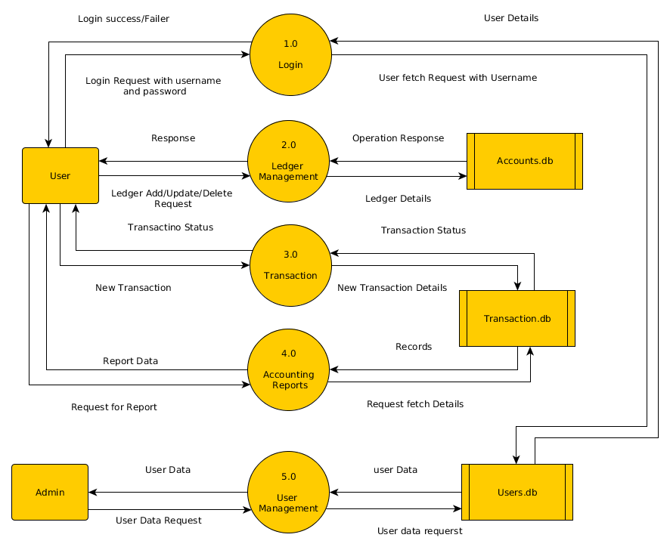

**Level 1 Data Flow Diagram for Accounts++**

**3.1.2 Level 2 DFD**

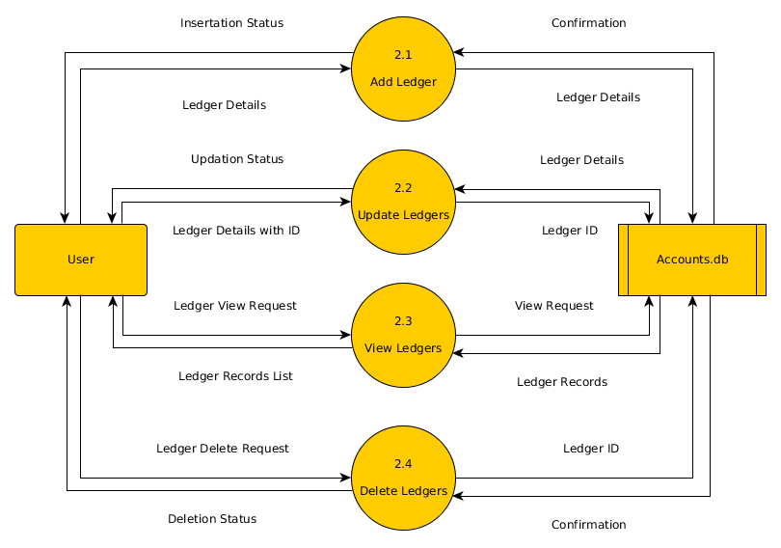**Level 2 Data Flow Diagram for Accounts++ (Ledgers)**

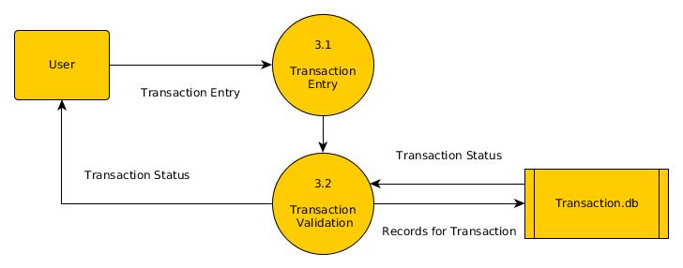

**Level 2 Data Flow Diagram for Accounts++ (Transactions)**

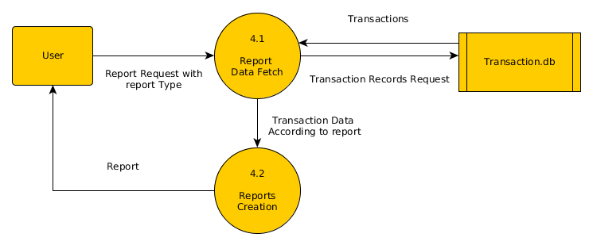

**Level 2 Data Flow Diagram for Accounts++ (Reports)**

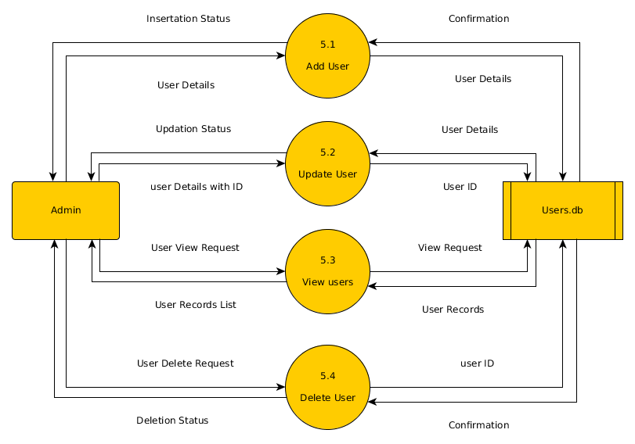**Level 2 Data Flow Diagram for Accounts++ (Admin Side)**

**3.2 Database Design**

**Users**

|  |  |  |  |
| --- | --- | --- | --- |
| **Column Name** | **Data Type** | **Description** | **Constraints** |
| Id | Number | Unique ID of Users | Primary Key |
| CompanyName | Text | Full Name of Company | - |
| Username | Text | Unique Username for all users | - |
| Email | Text | Email of User | - |
| PhoneNo | Text | Contact detail of user | - |
| Password | Text | Password for user Login | - |

**Accounts**

|  |  |  |  |
| --- | --- | --- | --- |
| **Column Name** | **Data Type** | **Description** | **Constraints** |
| Id | Number | Unique ID of Account/Ledger | Primary Key |
| Name | Text | Name of Account | - |
| Type | Text | Account type (personal/pnl/real) | - |
| Balance | Number | Current Balance of Account | - |
| user_id | Number | Reference to User’s Record | Foreign Key |

**Transactions**

|  |  |  |  |
| --- | --- | --- | --- |
| **Column Name** | **Data Type** | **Description** | **Constraints** |
| Id | Number | Unique ID of Transaction | Primary Key |
| t_num | Number | Id for Transactions belongs to one group | - |
| ac_credit | Number | Reference to Account for Credit | Foreign Key |
| ac_debit | Number | Reference to Account for Debit | Foreign Key |
| amt_credit | Number | Amount to be credited | - |
| amt_debit | Number | Amount to be debited | - |

**3.2 User Interface**

sdafasdf