HUMAN HEALTH RISK ASSESSMENT FROM THE CONTAMINANTS OF MAHANANDA RIVER WATER AND ITS ADJACENT GROUNDWATER
Author’s Name And affiliations: (9 font, First and Middle Name- abbreviation, Surname-Full, Use footnote for affiliations)

Title: (UPPER CASE 11 font, bold) 100 characters without space)
N. C. Ghosh,*, M. Moniruzzaman,, M. M. R. Mondol^{3,}
Abstract
This study aims to assess the physicochemical parameters of the surface water of the Mahananda River and the concentration of the nutrients of the Mahananda River water and the adjacent groundwater. Among physicochemical parameters, pH, Dissolved Oxygen (DO), and Total Dissolved Solids (TDS) were measured on 18 sampling sites of the river, while Sulfate (SO₄²⁻), Orthophosphate (PO₄³⁻), Arsenic (As), and Manganese (Mn) concentrations were measured on 17 equidistant sampling sites of the river and the adjacent groundwater. The mean pH value was 8.50 with a standard deviation (SD) of 0.30. DO and TDS were 9.56 mgL⁻¹ (SD 1.67) and 127.62 mgL⁻¹ (SD 24.76), respectively. The mean SO₄²⁻ concentration was found to be 5.38 mgL⁻¹ (SD 12.00) for groundwater and 2.29 mgL⁻¹ (SD 1.96) for surface water, while the mean PO₄³⁻ concentration was 1.17 mgL⁻¹ (SD 0.78) and 0.63 mgL⁻¹ (SD 0.15) for groundwater and surface water respectively. The contamination of As was found to be as high as 100 µgL⁻¹ in the groundwater while within 25 µgL⁻¹ in the surface water. Mn concentration was high at almost all the points, with a mean value of 1.64 mgL⁻¹ (SD 0.90) and 0.54 mgL⁻¹ (SD 0.23) for the groundwater and surface water, respectively. The carcinogenic risk from As and non-carcinogenic risk from both As and Mn was estimated for adults and children. The carcinogenic risks were found to be high for both surface water and groundwater, while non-carcinogenic risks were found high for surface water and very high for groundwater.
Abstract: Not more than 250 words, 8 font
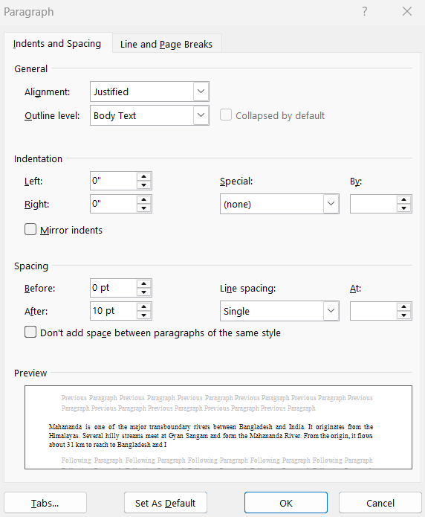
Keywords: Arsenic, Carcinogenic Risk, Groundwater, Mahananda River, Manganese.
Keywords: 6-8 key words (8 font, Italic)

Introduction
Section heading: 10 font, bold
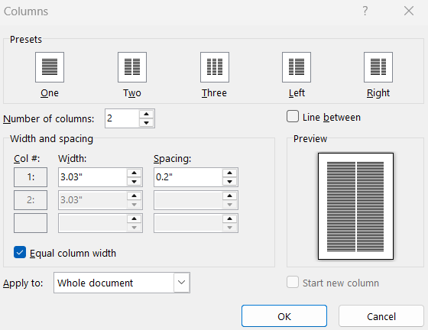
Mahananda is one of the major transboundary rivers between Bangladesh and India. It originates from the Himalayas. Several hilly streams meet at Gyan Sangam and form the Mahananda River. From the origin, it flows about 31 km to reach to Bangladesh and India border adjacent to the Banglabandha-Fulbari land port. About 1.5 km up from this point, the river experienced a major diversion by the Fulbari barrage, where the river meets the Teesta irrigation canal of India and flows further downstream with the same canal name up to Nitaiganj. The mainstream of the river with the remaining streamflow flows as the border river for about 20 km. It then flows through India for 225 km and finally falls on the Ganges near the Farakka barrage. Prior to the falls on the Ganges, a part of the river bifurcated and flowed about 71 km to reach the Bholahat upazila of Chapainawabganj district of Bangladesh. The following 16 km river flow from Bholahat upazila sadar to Baruipara of Gomostapur upazila is again a border river and finally enters Bangladesh at this point. Mahananda River travels about 76 km and falls to the Padma River at Sultanganj of the Godagari upazila of Rajshahi. The total catchment area of the river from its origin to Sultanganj is 20600 km², where 11530 km² is in India, and 9070 km² is in Bangladesh (Ghosh et al., 2022).
Body: Double Column (throughout the manuscript), 9 font, single space, Justified. Adjust Tables and Figures in double column format. In case of large Tables and Figures, use single column format and place them either top or bottom of the page.
The Mahananda River in Bangladesh, crosses Gomastapur, Shibganj, and Chapainawabganj Sadar upazilas. The river has two tributaries in Bangladesh, one on the left bank at Gomostapur, Punarbhaba River, and the other on the right bank at Chapainawabganj Sadar, Pagla River. According to the Bangladesh Water Development Board (BWDB) data, the river’s minimum water level declined from 1977 to 2017. BWDB data also suggest that the adjacent groundwater level follows the same trend, and the southern part has a lower groundwater level than the northern part (RRI, 2019). The river contributes to the irrigation of above 10000 hectares of cropland. People near the river use its water for bathing, washing, and household work. According to the Bangladesh Population and Housing Census 2011, about 8.3% of the district’s population uses tap water for drinking purposes, while 88.2% uses groundwater and 3.5% other water sources, including surface water (BBS, 2014). They also use this water for cooking.
As is found on Earth naturally. There are both organic and inorganic forms of As in the environment. The organic form is much less harmful than the inorganic form. Inorganic As is highly toxic and found at high levels in the groundwater of many countries, including Bangladesh. Ingestion of As-rich groundwater poses the greatest threat to human health. Inorganic As is a significant contaminant in drinking water and is a confirmed carcinogen (Farzan et al., 2013). Long-term exposure to a high level of inorganic As causes skin, lung, and bladder cancer, pigmentation changes, skin lesions, and hard patches on the palms and soles. In addition to skin cancer, long-term exposure to As may also cause cancers of the bladder and lungs (Tolins et al., 2014). The other effects of As on human health include developmental effects, diabetes, pulmonary disease, and cardiovascular disease (Ravenscroft et al., 2009).
Methodology
Study Area
Sub Section Heading: 9 font, Italic
The whole reach of the Mahananda River in the Chapainawabganj district of Bangladesh….
Sampling Points
Physicochemical parameters were analyzed at 18 points of the Mahananda River……. e river sampling points. The surface water sampling points for physicochemical parameters are shown in Fig. 1 and Table 1, while nutrients and elemental analysis points are shown in Fig. 2 and Table 2.
Foot Note: 8 Font
Corresponding author’s email only
Health Risk Assessment
the ingestion route ($I_{o}$) was calculated by Eq. (1) (USEPA, 1989):
$$I_{o}= \frac{C_{w}×IR×EF×ED}{BW×AT} Eq. (1)$$
where $C_{w}$ is the metal concentration at the exposure site dermal contact ($I_{d}$) was calculated by Eq. (2) (USEPA, 1989):
$$I_{d}= \frac{C_{w}×SSA×k_{p}×CF×ET×EF×ED}{BW×AT} Eq. (2)$$
where $SSA$ is the skin surface area (cm²); $k_{p}$ is the permeability coefficient specific for each metal (cm.h⁻¹); $CF$
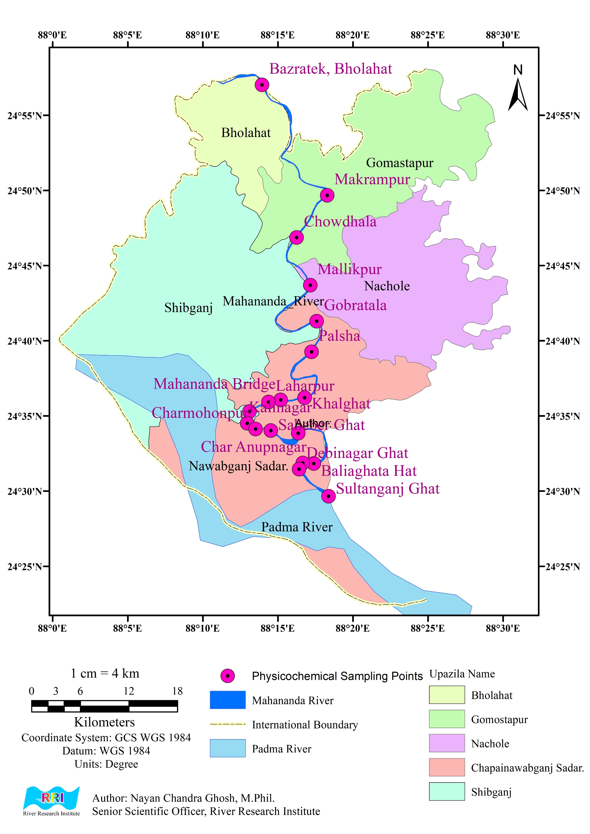
Fig. 1. Surface water sampling points for the analysis of physicochemical parameters.
Table 1. Coordinates of the surface water sampling points for the analysis of physicochemical parameters.
Name | Latitude | Longitude
Bazratek, Volahat | 24°57.025'N | 88°13.953'E
Makrampur | 24°49.673'N | 88°18.295'E
Chowdhala | 24°46.869'N | 88°16.257'E
Mallikpur | 24°43.700'N | 88°17.171'E
Gobratala | 24°41.304'N | 88°17.593'E
Palsha | 24°39.265'N | 88°17.247'E
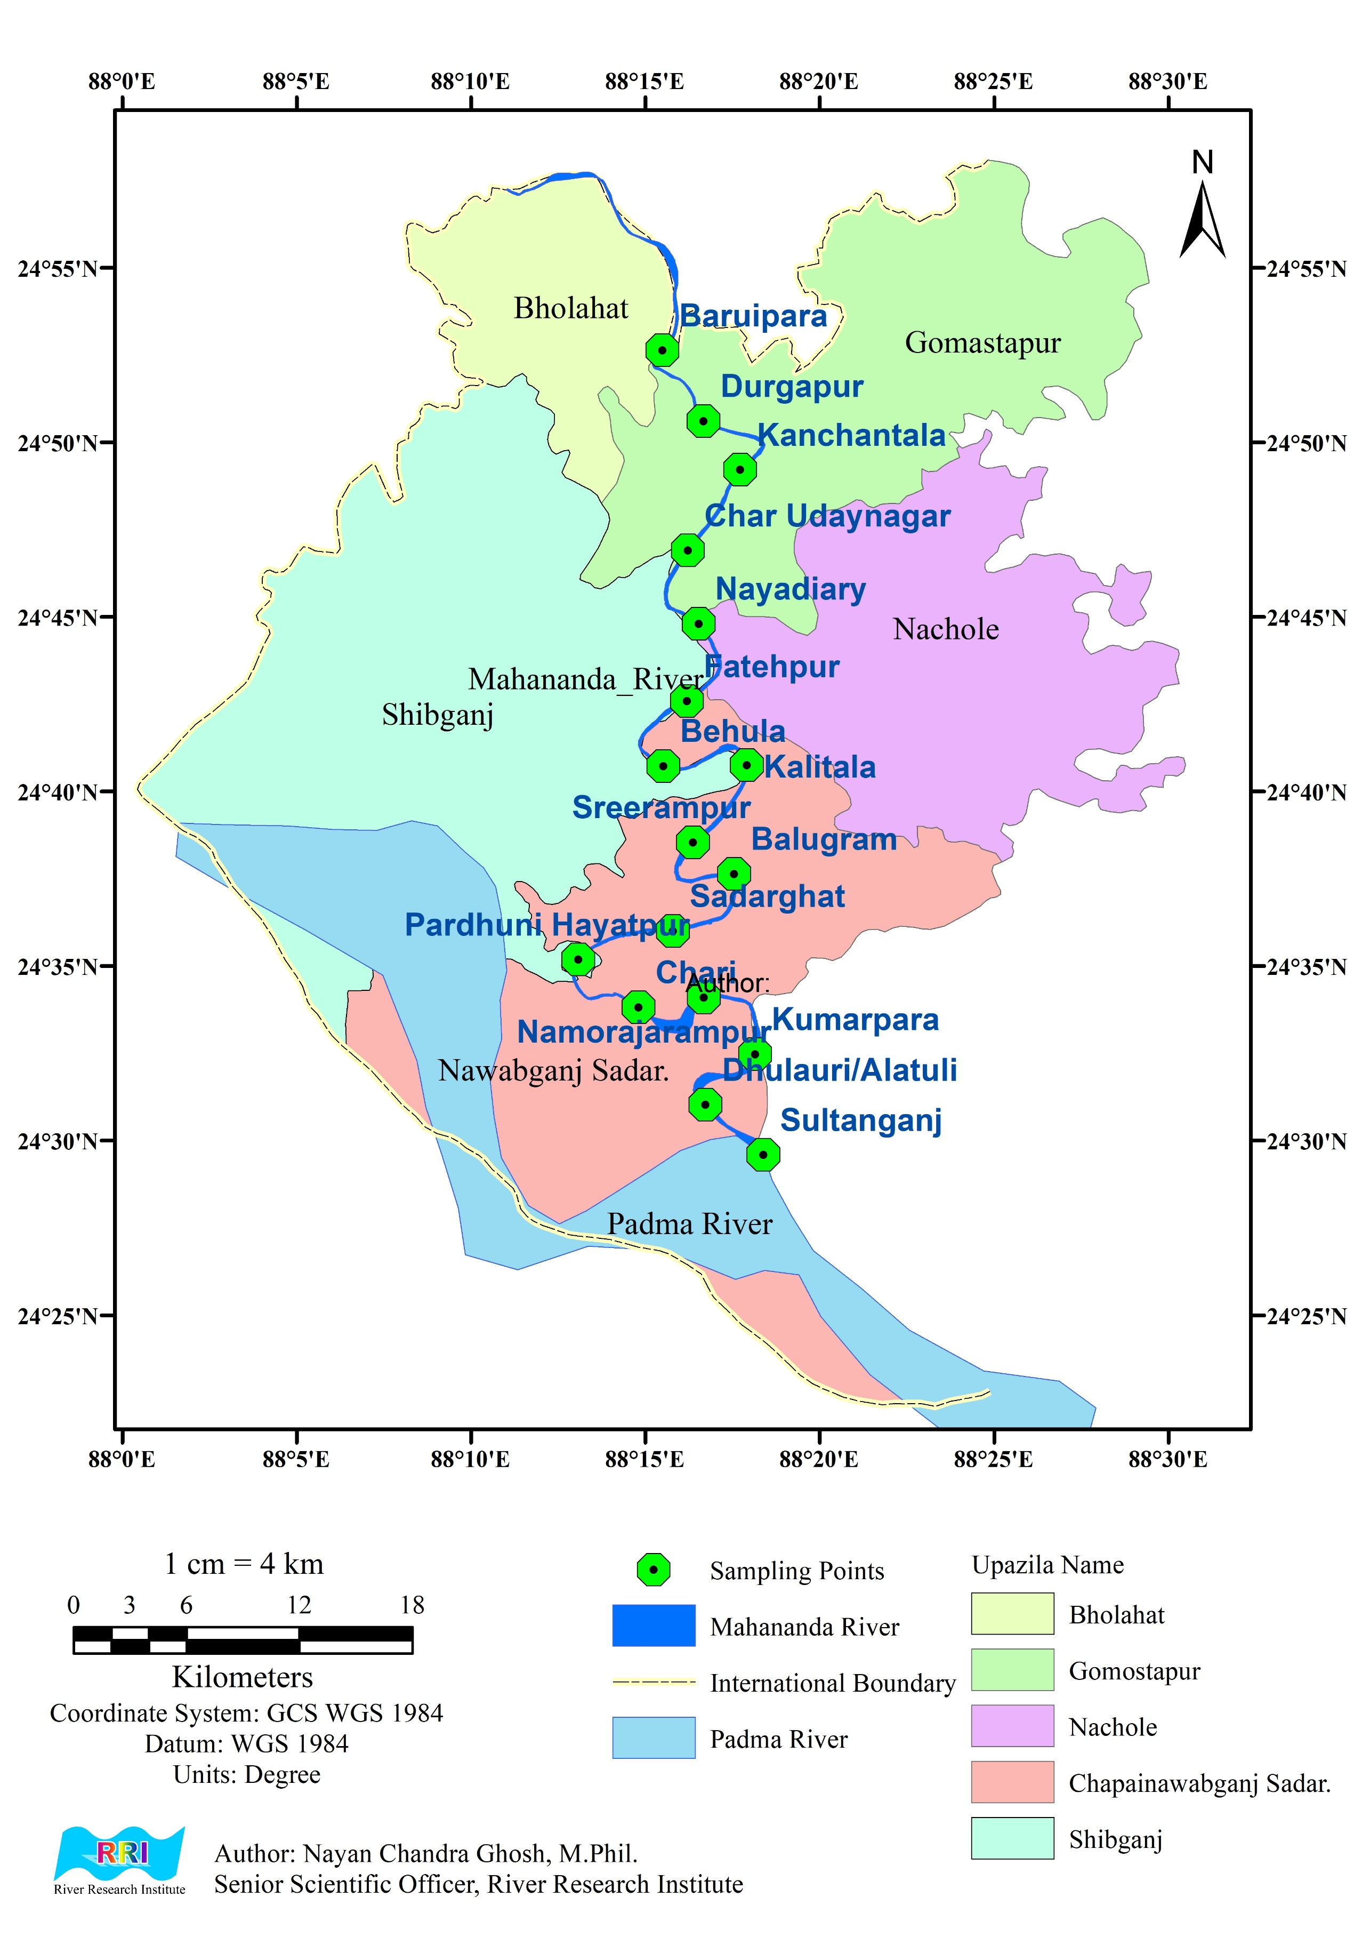
Fig. 2. Surface water sampling points for the analysis of nutrients and elements.
Table 2. Coordinates of the surface water sampling points for the analysis of nutrients and elements.
Name | Latitude | Longitude
Baruipara | 24°52.639'N | 88°15.490'E
Durgapur | 24°50.615'N | 88°16.673'E
Kanchantala | 24°49.218'N | 88°17.724'E
Char Udaynagar | 24°46.906'N | 88°16.219'E
Nayadiary | 24°44.809'N | 88°16.532'E
Fatehpur | 24°42.595'N | 88°16.192'E
Behula | 24°40.735'N | 88°15.515'E
Kalitala | 24°40.760'N | 88°17.911'E
Sreerampur | 24°38.547'N | 88°16.366'E
Balugram | 24°37.642'N | 88°17.547'E
Sadarghat | 24°36.008'N | 88°15.792'E
Pardhuni Hayatpur | 24°35.191'N | 88°13.076'E
Chari | 24°33.817'N | 88°14.809'E
Namorajarampur | 24°34.105'N | 88°16.680'E
Kumarpara | 24°32.479'N | 88°18.151'E
Dhulauri/Alatuli | 24°31.032'N | 88°16.721'E
Sultanganj | 24°29.598'N | 88°18.384'E

Table 3. Risk assessment parameters.
Parameters | Value (Adult) | Value (Child)
$$IR$$ | 2 | 1 | (Akter et al., 2021)
$$EF$$ | 365 | 365 | (USEPA, 1989)
$$ED$$ | 74.3 | 10 | (BBS, 2014; Akter et al., 2021)
$$BW$$ | 70 | 25 | (Akter et al., 2021)
$$AT$$ | 27120 | 3650 | (USEPA, 2011)
$$SSA$$ | 18000 | 13000 | (USEPA, 2011)
$$k_{p}$$ | 0.001 | 0.001 | (USEPA, 2004)
$$CF$$ | 0.001 | 0.001 | (Turdiyeva and Lee, 2023)
$$ET$$ | 0.58 | 1.00 | (USEPA, 2004
$SF$ oral | 1.5 | 1.5 | (USEPA IRIS, 2019; RAIS, 2022; OEHHA, 2018)
$SF$ dermal | 1.58 | 1.58 | (USEPA, 2004)
$RfD$ oral (As) | 0.0003 | 0.0003 | (USEPA IRIS, 2019; RAIS, 2022)
$RfD$ dermal (As) | 0.000285 | 0.000285 | (USEPA, 2004)
$RfD$ oral (Mn) | 0.024 | 0.024 | (USEPA, 2004; USEPA IRIS, 2019; RAIS, 2022)
$RfD$ dermal (Mn) | 0.00096 | 0.00096 | (USEPA, 2004)

Results and Discussions
Xxxxxxxxxxxxxxxxxxxxxxxxxxxxxxxxxxxxxxxxxxxxxxxxxxxxxxxxxxxxxxxxxxxxxxxxxxxxxxxxxxxxxxxxxxxxxxxx
Conclusions
Xxxxxxxxxxxxxxxxxxxxxxxxxxxxxxxxxxxxxxxxxxxxxxxxxxxxxxxxxxxxxxxxxxxxxxxxxxxxxxxxxxxxxxxxxxxxxxxx
Recommendations
Xxxxxxxxxxxxxxxxxxxxxxxxxxxxxxxxxxxxxxxxxxxxxxxxxxxxxxxxxxxxxxxxxxxxxxxxxxxxxxxxxxxxxxxxxxxxxxxx
Acknowledgment
Xxxxxxxxxxxxxxxxxxxxxxxxxxxxxxxxxxxxxxxxxxxxxxxxxxxxxxxxxxxxxxxxxxxxxxxxxxxxxxxxxxxxxxxxxxxxxxxx
Conflict of Interest
Xxxxxxxxxxxxxxxxxxxxxxxxxxxxxxxxxxxxxxxxxxxxxxxxxxxxxxxxxxxxxxxxxxxxxxxxxxxxxxxxxxxxxxxxxxxxxxxx
Author’s Contribution
xxxxxxxxxxxxxxxxxxxxxxxxxxxxxxxxxxxxxxxxxxxxxxxxxxxxxxxxxxxxxxxxxxxxxxxxxxxxxxxxxxxxxxxxxxxxxx
References
Akter, S., Brahma, P. P., Tasneem, A. and Uddin, M. K. (2021). Probabilistic Human Health Risk Assessment of Fe, As and Mn in the Groundwater of Dhamrai Upazila, Dhaka, Bangladesh. Journal of Scientific Research & Reports. 27(4): 1-11. https://doi.org/10.9734/jsrr/2021/v27i430374
Ali, M. M., Rahman, S., Islam, M. S., Rakib, M. R. J., Hossen, S., Rahman, M. Z., Kormoker, T., Idris, A. M. and Phoungthong, K. (2022). Distribution of heavy metals in water and sediment of an urban river in a developing country: A probabilistic risk assessment. Int. J. Sediment Res. 37(2): 173–187. https://doi.org/10.1016/j.ijsrc.2021.09.002
Anonna, T.A., Ahmed, Z., Alam, R., Karim, M.M., Xie, Z., Kumar, P., Zhang, F. and Simal-Gandara, J. (2022). Water Quality Assessment for Drinking and Irrigation Purposes in Mahananda River Basin of Bangladesh. Earth Syst. Environ. 6: 87–98. https://doi.org/10.1007/s41748-021-00274-x
ATSDR (2012). Toxicological profile for manganese. Atlanta, GA, US Department of Health and Human Services, Public Health Service, Agency for Toxic Substances and Disease Registry.
BBS (2014). Bangladesh Bureau of Statistics Community Report, Bangladesh population and housing census 2011, Zila: Chapainawabganj, pp-501.
Cook, D.G., Fahn, S. and Brait, K.A. (1974). Chronic manganese intoxication. Arch Neurol. 30(1): 59–64. https://doi.org/10.1001/archneur.1974.00490310061010
ECR (2023). Environmental Conservation Rule, 2023. Department of Environment, Ministry of Environment, Forest and Climate Change, Government of the People's Republic of Bangladesh.

TABLE ANATOMY
Table caption and Table body (9 font)
Table 4. Summary of the test scenarios in the fixed bed model

Test | Objectives | Scenarios | Flow Condition
T0-1 | Trial calibration of the model | September 2016 bathymetry with existing structures (Jetty) | Q=11489 m³/s(ebb) Q=6600m³/s(tide)
T0-2 | Calibration of the model | September 2016 bathymetry with existing structures (Jetty) | Q=11489m³/s(ebb) Q=6600m³/s(tide)
T1 | To test the performance of the proposed sheet pile and revetment along with Paira bridge and consequent hydraulic and morphological  changes. | September 2016 bathymetry with existing structure (Jetty) in position plus proposed sheet pile + revetment and Paira bridge | Q=13861m³/s(50- year design discharge) Q=6600m³/s(tide)
T2 | To test the performance of revised design of revetment along with Paira bridge and consequent hydraulic and morphological change. | September 2016 bathymetry with existing structures (Jetty) plus proposed revetment and Paira bridge | Q=13861m³/s(50- year design discharge) Q=6600m³/s(tide)
T3-a | To test the performance of final design of revetment and dredged channel along with Paira bridge and consequent hydraulic a nd morphological  changes around the bridge corridor | September 2016 bathymetry with existing structures (Jetty) plus revetment and Paira bridge. 900m long proposed dredged channel is introduced along the right side of Pier-18. | Q=12698m³/s (50- year design discharge as a reverse flow), WL=3.24mPWD.  Q=6600m³/s(tide), WL=0.79 mPWD

Note: Water Levels (WL) are based on the datum of the Public Works Department (PWD). The PWD datum is 0.46 m higher than the mean sea level (Tingsanchali and Karim, 2005)
Table footnote (8 font)

GRAPH
Please, don’t write any graph heading/ caption over here. It looks very ugly
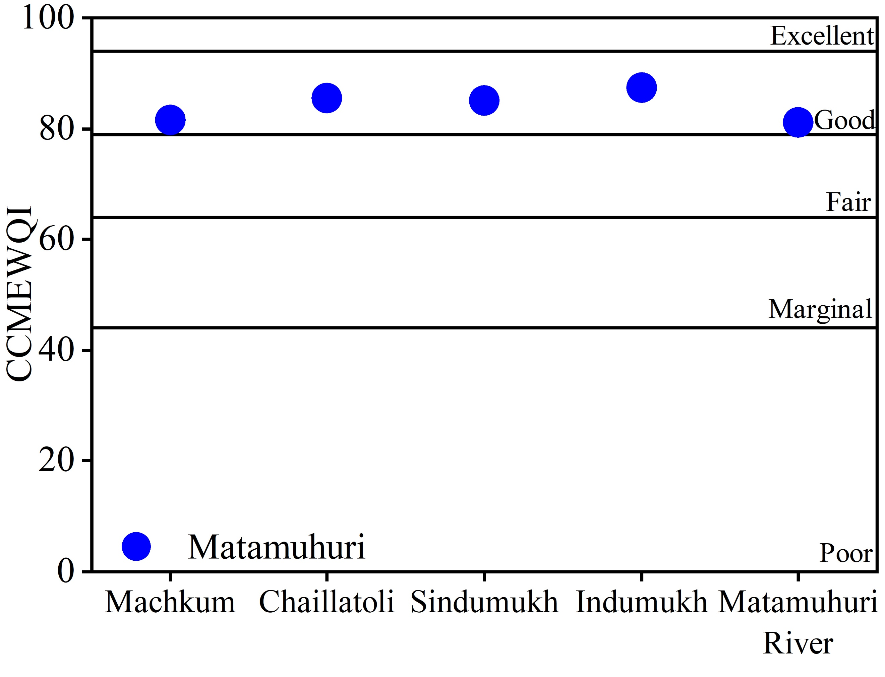
Figure Caption (9 font)
Fig. 5. CCMEWQI of Matamuhuri Rivers.

IMPORTANT NOTES:
Please avoid sentences that give no information other than directing the reader to the Figure or Table.

For instance,

Scale factors for the prototype and model have been obtained for different parameters are
Oh! No, Not

presented in the following Table 1

Oh! No, Not
Write in this way instead
On the basis of the above considerations the scale factors for the prototype and model have been obtained for different parameters (Table 1).

SIMILAR FIGURES

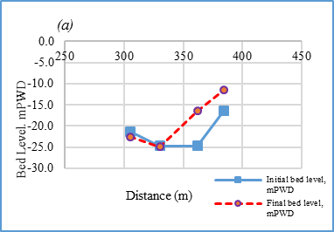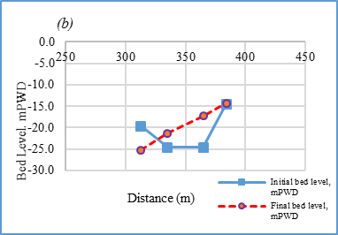
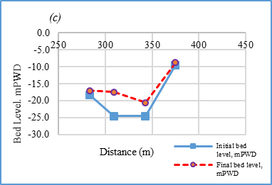
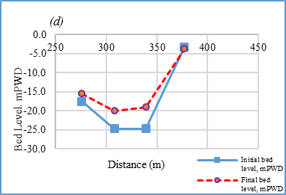

Fig. 2. The initial and final bed level of dredged channel (a) along cross-section 10 US (b) along cross-section 08US (c) along cross-section 06 US (d) along cross-section 04 US

Note: Similar figure should be clustered under a common caption like above, but every figure should be clearly specified

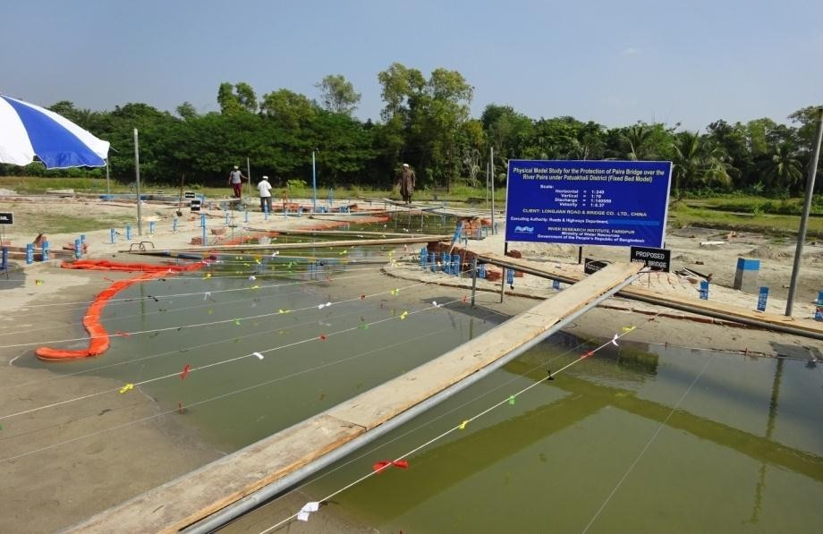

300 dpi is required
Bank erosion
tendency
Fig. 3. Bank erosion tendency at the upstream of the proposed revetment for test T1

Note: Dot per inch. Dpi (actually, pixel per inch. ppi) is important in case of printing.

UNITS, ABBREVIATIONS, SYMBOLS:
Only metric units (SI) should be used in a manuscript. After the first appearance of a term in full, a standard abbreviation may be used. Please take care that all terminology and notation used will be widely understood. Superscripts, not slashes (/), should be used to describe units, e.g. m³s⁻¹, kg m⁻³ s⁻¹, m s⁻¹.
m³/s
write
Oh! No,
m3s-1

EQUATIONS:
Mathematical expression/equation should be inserted using Microsoft Word. Equations should be numbered consecutively and referenced in the text [e.g. Eq. (1)],
for example,

Q = (0.403 + 053h_{w}/p)(2g)^{0.5}b [(h_{w} + u ²/2g)^{1.5} – (u ²/2g)^{1.5}] Eq. (1) (not bold)
w w

Equation numbering style (not bold)

A SECTION WITH SEVERAL POINTS
Each test of the model continues about 16-20 hours until a dynamic equilibrium scour is reached. Considering the above issues the model scale is selected ensuring the following model requirements.
- The model scale is undistorted.

- The model sale is selected to ensure sufficient water depth for measurement of velocity.

- The model fulfilled flow as well as sediment transport condition simultaneously.
- The geometric scale should be such that it allows the model to be fitted within the available laboratory space at RRI.

- The discharge requirement in the model should be within RRI pumping capacity.

Numbering style (don’t insert any bullet point like
or any other style)

RESULTS AND DISCUSSIONS
Results should be clear and abridged. Discussions should explore the consequences of the outcomes of the work, don’t repeat them again. Authors can write the Results and Discussions section collectively.

CONCLUSION
The main conclusion of the research should be clear as well as concise. Conclusion may be presented in a short conclusion section.

ACKNOWLEDGEMENTS
Please mention those individuals (if any) who provided help either financial or any other form during research. This section should be placed in a distinct segment towards the end of the article afore the references.

Conflict of Interest
Please mention whether there is any conflict of interest among the authors or other persons.

Author’s Contributions
Contribution of each authors in the manuscript must be specified clearly.

REFERENCING PARTICULARS
Citing in the text References should be cited in the text either in brackets, e.g. Earlier studies (Mehedi, 2014) showed… or using the name as part of a sentence, e.g. Mehedi (2014) states…
  - For two authors the format is: (Moniruzzaman and Nayan, 2016).
  - For three or more authors: (Uma et al., 2000).

  - Groups of references should be listed first alphabetically and then chronologically, e.g.
  - (Hasanuzzaman, 2005; 2010; Shaha and Das, 2004; Swapan, 1999).
Personal communications - emails, conversations, letters - should not be in the reference list, but may be mentioned in the text, e.g. (interview with Sheela Rani Chowdhury, River Research Institute, 12 November 2014).

In reference list
Surname
Let’s assume a name
Write
Abul Kalam Mohammad HasanuzzamanHasanuzzaman, A. K. M

Journal articles
Hasanuzzaman, A. K. M. and Mehedi H. M. (2016). Numerical modelling using MIKE 21C for the proposed bridge on Kalni river under Habiganj road division. Tech. J. River Res. Inst. 13 (1): 76-86. DOI Number
Moududi, M. A. A., Kanungoe, P., Hossain, M. A., Islam, M. J. and Mehedi, H.M. (2016). Post-evaluation of the Ganges left bank erosion protection projects from Pankanarayanpur to Indo-Bangladesh border. Tech. J. River Res. Inst. 13(1): 111-124. DOI Number

Kanungoe, P., Islam, M. J., Bawali, M. D., Podder, M. A. H., Afrin, S. and Tofiquzzaman, M., et. al. (2016). Hydrological analysis and hydraulic assessment of the existing Pagla-Jagannathpur-Aushkandi road and road structures using MIKE 21C model. Tech. J. River Res. Inst. 13(1): 65-75. DOI Number

*If authors are more than four nos, write et. al. at the end of the row for the rest of the author(s)

(In case of Book example): The title should be italic and name of publisher should be given with total page number. e.g.
Guy H.P. (1999). Laboratory Methods for Sediment Analysis. Adelaide Univ. Press Australia P.500.

E-books
Lowry, R. (2009). Concepts and Applications of Inferential Statistics [online]. Vassar College, Poughkeepsie NY. http://faculty.vassar.edu/lowry/intro.html. (Accessed 21 February 2026).

Theses

Mehedi, H. M. (2005). Determination of friction angle of soil by Double-Punch Test.
Unpublished B.Sc. Dissertation, Bangladesh Agricultural University, Mymensingh

Government publications
DOE (2006). Bangladesh Climate Change Impacts and Vulnerability-A Synthesis, Comprehensive Disaster Management Programme, Component 4b, Climate Change Cell, Department of Environment (DoE), Government of the People’s republic of Bangladesh
http://www.preventionweb.net/files/574_10370.pdf.pdf. (Accessed 22 March 2026)

Standards
ISO (2008). ISO 9001:2008: Quality management systems -- Requirements. International Organization for standardization (ISO), Geneva, Switzerland

Blogs
Ndaw, F. (2016). “3 ways countries can improve water supplies in small towns” [online] 14 July http://blogs.worldbank.org/water/psd/category/countries/bangladesh (Accessed 26 March 2026).

Web sites
RRI (2016). History of RRI. [online] http://www.rri.gov.bd/history-rri-0 (Accessed 22 March 2026).

N.B. Aside from scientific papers/journal articles or any other reliable sources, non-scientific publications/texts (blogs, websites, personal communications, newspapers, magazines and periodicals) are not encouraged as a reference.

Dhaka Laboratory, River Research Institute, Dhaka-1205, Bangladesh.
Department of Physics, Bangladesh University of Engineering and Technology, Dhaka-1000, Bangladesh. * Corresponding Author: (E-mail: nayan.ghs@gmail.com)
Geotechnical Research Directorate, River Research Institute, Faridpur-7800, Bangladesh.
Institute of Water and Flood Management, Bangladesh University of Engineering and Technology, Dhaka-1000, Bangladesh.
Department of Civil Engineering, Bangladesh University of Engineering and Technology, Dhaka-1000, Bangladesh.

