本模型配置来源于网页：<http://dev.px4.io/en/airframes/airframe_reference.html>

3

UAV Type 1: Tricopter Y+

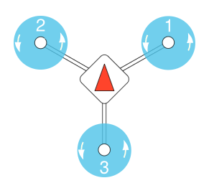

UAV Type 2: Tricopter Y-

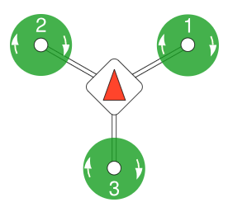

UAV Type 3: Quadrotor X

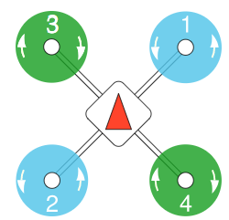

UAV Type 4: Quadrotor +

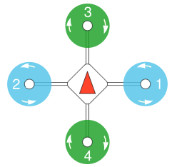

UAV Type 5: Hexarotor x

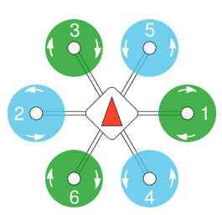

UAV Type 6: Hexarotor +

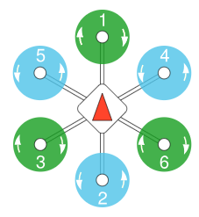

UAV Type 7: Hexarotor Coaxial

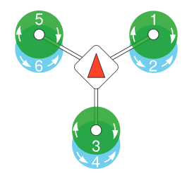

UAV Type 8: Octorotor x

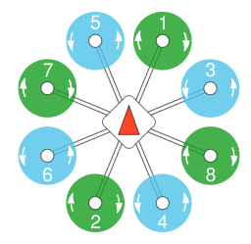

UAV Type 9: Octorotor +

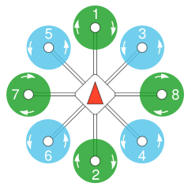

UAV Type 10: Octorotor Coaxial

