# COSC-310-Group-6

Assignment for COSC 310 Group 6 Assignment 2

This project implements a therapy conversation agent.

The overarching class is the Conversation class. When we start a new conversation with a patient, we create a new Conversation object. The conversation class has an instance of a Patient, and an array called conversationTopic that has a predefined list of topics to discuss in a specific order: Greetings, SmallTalk, Discussion, Advice, and Goodbye. In the Discussion topic, we discuss Subjects including Emotions, Symptoms, Events, Status, or Habits. These subjects are linked to Solutions in a graph called the Context Graph.

The Context Graph has two sets of nodes: Subjects and Solutions. These nodes are represented in the Context Graph by two one-dimensional arrays, subjects and solutions. The edges are represented by an adjacency list: the arrays subjects and solutions store a linked list of the edges.

Conventions for UML diagram:

* Arrows from subclasses to superclasses (extends)
* Filled in diamonds attached to a line indicate composition (Conversation has a Patient)
* Abstract members italicized
* Static members underlined
* Final members all caps

UML Diagram

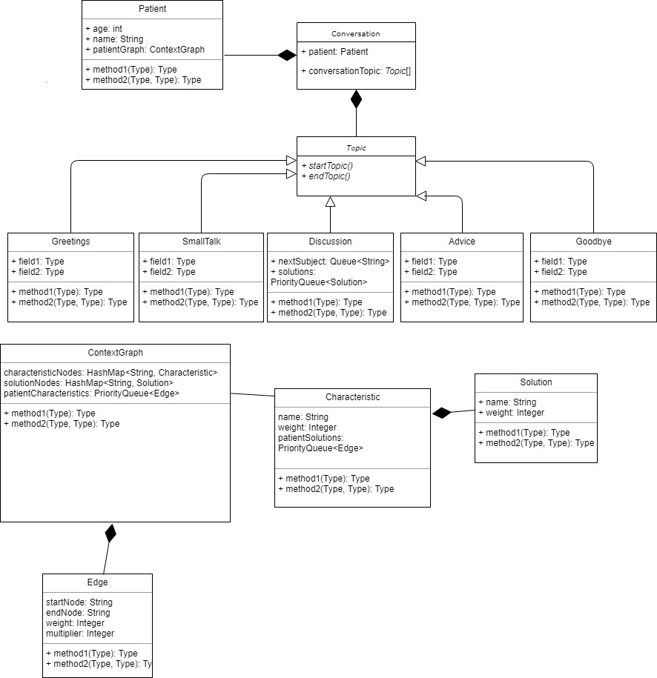

Methods:

# ConvoBot Methods:

# Topic methods:

WBS

S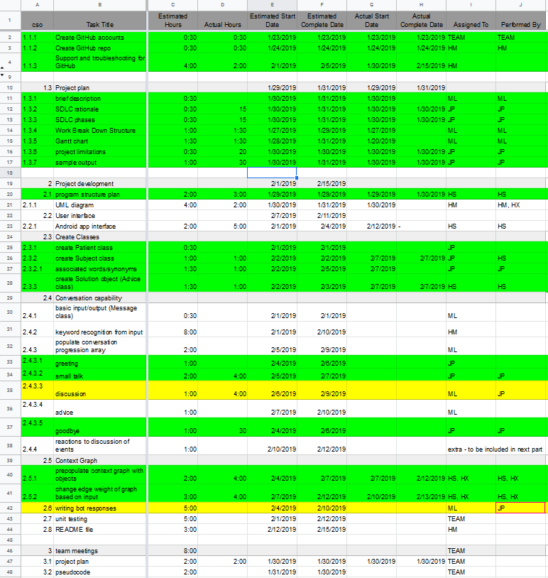

Link: https://docs.google.com/spreadsheets/d/1r-X-w9h50yBHoTPS1j0cAH8LC9jF8CfqRzDWSvb3xO8/edit?fbclid=IwAR27quDdMBQY_OKYMwjLY89LAU2Qy5bgI6UpQc5CviTx5OkD49b4w7z7oIM#gid=0