**CSC 5750 – Principles of Web Technology**

**Homework 1 – [your name]**

**25 points – Due January 28, 5pm**

**Late deadline is January 30, 11:59pm, but 20% off**

**a)** Save this document with your name and the homework number somewhere in the file name.

**b)** Paste your code and screenshots into the document.

**c)** Gather the following files into a ZIP file with your name and the homework number somewhere in the file name:

● This document

● All HTML files

● All CSS files

● Image files

● Any other optional files specific to your implementation

**d)** Submit the ZIP file to Canvas where you downloaded this document.

You've been hired by an arena to create a web site to handle their upcoming events. The events include:

● Athletic events

● Concerts

● Seminars and conferences

Choose or create an arena. Create the following three web pages:

● An **Arena page** that contains general information about the arena including its:

ü Arena name

ü Arena capacity

ü Arena concessions

ü Seating categories

ü Arena history including year built

ü Arena location shown on a map image

ü Arena image

Use div tags to format the page into four or more panels. Use Google or Leaflet to render the map. Use a marker to show the arena location.

● An **Events page** that shows in tabular format at least seven upcoming events to be held at the arena. Show one item per row and for each one, include its:

ü Event

ü Date

ü Ticket price range

ü Image related to event

Use DataTables to render the table.

● A **Tickets page** that provides the user a form that enables them to buy tickets for one of the events listed on the Events page. The form includes:

ü Arena seating chart image

ü Customer name

ü Customer e-mail address

ü Event

ü Event date

ü Seat category

ü Number of tickets (allow 1 to 21)

ü Payment type

Use self-validating HTML controls wherever appropriate. Align the labels in one vertical column, and the text boxes in another vertical column. Place the date and time controls in a field set. Define the form to use method **get** and action **http://www.tipjar.com/cgi-bin/test**.

When creating the pages, begin with the HTML templates (main and other) provided on Canvas. Place a header with page title(s) at the top of each page. Place a footer at the bottom of each page including:

● Arena name

● Arena address

● Arena telephone number

● E-mail address link

● Copyright text

Incorporate the following HTML elements on each page:

● HTML comments (header and body).

● A title in the <head> section.

● Tags around all textual content (<label>, <p>, or other tag) if no other tag used.

● At least one of the quick styling tags: <b>, <i>, and <u>.

● Links to the other two pages in a menu along the top or left side.

● Horizontal ruler(s).

Place all styling attributes in a separate CSS file and connect it to the three HTML pages. When creating the CSS page, begin with the CSS template provided on Canvas. Determine a four-color scheme for all pages. Include the following properties in the CSS file:

● Background properties

● Font properties

● Text properties

● Color properties

● Padding properties

● At least three .class styles.

● At least one :hover style.

**Note:** use only relative links, not absolute links, to other files on your web site. This means there should be no drive letters or absolute paths, only relative paths, in your file references. You can test this by zipping your web site files, unzipping them in another folder, and then running your web site. There should be no linking errors if you used only relative links. The best approach is to put all web site files in one folder.

**Arena page**

*[your Arena page HTML code here]\**

***<!DOCTYPE html>***

***<html lang="en" xmlns="http://www.w3.org/1999/xhtml">***

***<head>***

***<title>Arena page</title>***

***<!-- Required meta tags -->***

***<meta charset="utf-8">***

***<meta name="viewport" content="width=device-width, initial-scale=1">***

***<!-- Bootstrap CSS -->***

***<!-- Latest compiled and minified CSS -->***

***<link rel="stylesheet" href="https://stackpath.bootstrapcdn.com/bootstrap/3.4.1/css/bootstrap.min.css" integrity="sha384-HSMxcRTRxnN+Bdg0JdbxYKrThecOKuH5zCYotlSAcp1+c8xmyTe9GYg1l9a69psu" crossorigin="anonymous">***

***<!-- W3.CSS link -->***

***<link rel="stylesheet" href="https://www.w3schools.com/w3css/4/w3.css">***

***<link href="../Contents/Content.css" rel="stylesheet" />***

***</head>***

***<body>***

***<ul class="navbar-customized bg-danger">***

***<li><a href="#"><b>Little Ceasar Arena</b></a></li>***

***<li><a href="/Views/Arena.html">Arena Page</a></li>***

***<li><a href="/Views/Events.html">Events Page</a></li>***

***<li><a href="/Views/Tickets.html">Tickets Page</a></li>***

***</ul>***

***<div class="container">***

***<h1 class="text-warning"> Arena Page</h1>***

***<div>***

***<h3>Little Caesars Arena</h3>***

***<hr />***

***</div>***

***<div>***

***<b>Arena capacity:</b>***

***Ice hockey: 19,515***

***Basketball: 20,332***

***Concerts: 15,000–22,000***

***</div>***

***<div>***

***<b>Arena concessions:</b> Sales of game tickets, parking, concessions, souvenirs,***

***and any potential naming rights deals would not be subject to revenue sharing with the City of Detroit as they were with Joe Louis Arena.***

***</div>***

***<div>Seating categories: First-class, Middle-class, Regular</div>***

***<div>***

***<b>Arena history including year built:</b>***

***Little Caesars Arena is a multi-purpose arena in Midtown Detroit. Construction began on April 24, 2015, following a formal groundbreaking ceremony on September 25, 2014. Opened on September 5, 2017, the arena, which cost $862.9 million to construct, replaced Joe Louis Arena and The Palace of Auburn Hills as the homes of the Detroit Red Wings of the National Hockey League (NHL) and the Detroit Pistons of the National Basketball Association (NBA), respectively.***

***</div>***

***<div>Arena location shown on a map image:</div>***

***<img src="\Images\Arena\arena-little-caesars-01.jpg" />***

***<div>***

***Arena image***

***</div>***

***</div>***

***<div class="footer bg-info">***

***<div class="row">***

***<div class="col-md-4">***

***<h3>***

***Arena Name: Little Ceasar Arena***

***</h3>***

***</div>***

***<div class="col-md-4">***

***<div><b>Arena Address:</b> 2645 Woodward Ave, Detroit, MI 48201</div>***

***<div><b>Arena Telphone:</b> (313) 471-7000</div>***

***<div><b>Email Address:</b> info@littleceasararena.com</div>***

***</div>***

***<div class="col-md-4">***

***<p>© 2021 - Little Ceasar Arena</p>***

***</div>***

***</div>***

***</div>***

***<!-- Latest compiled and minified JavaScript -->***

***<script src="https://stackpath.bootstrapcdn.com/bootstrap/3.4.1/js/bootstrap.min.js" integrity="sha384-aJ21OjlMXNL5UyIl/XNwTMqvzeRMZH2w8c5cRVpzpU8Y5bApTppSuUkhZXN0VxHd" crossorigin="anonymous"></script>***

***</body>***

***</html>***

*[your Arena page screenshot here]\*\**

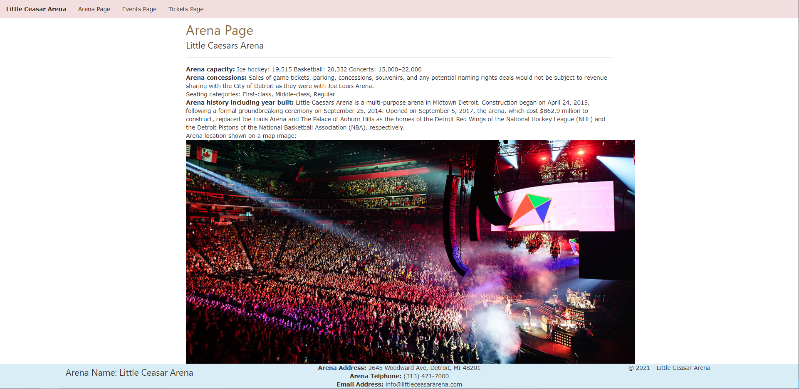

**Events page**

*[your Events page HTML code here]\**

***<!DOCTYPE html>***

***<html lang="en" xmlns="http://www.w3.org/1999/xhtml">***

***<head>***

***<title>Events page</title>***

***<!-- Required meta tags -->***

***<meta charset="utf-8">***

***<meta name="viewport" content="width=device-width, initial-scale=1">***

***<!-- Bootstrap CSS -->***

***<!-- Latest compiled and minified CSS -->***

***<link rel="stylesheet" href="https://stackpath.bootstrapcdn.com/bootstrap/3.4.1/css/bootstrap.min.css" integrity="sha384-HSMxcRTRxnN+Bdg0JdbxYKrThecOKuH5zCYotlSAcp1+c8xmyTe9GYg1l9a69psu" crossorigin="anonymous">***

***<!-- W3.CSS link -->***

***<link rel="stylesheet" href="https://www.w3schools.com/w3css/4/w3.css">***

***<link href="../Contents/Content.css" rel="stylesheet" />***

***</head>***

***<body>***

***<ul class="navbar-customized bg-danger">***

***<li><a href="#"><b>Little Ceasar Arena</b></a></li>***

***<li><a href="/Views/Arena.html">Arena Page</a></li>***

***<li><a href="/Views/Events.html">Events Page</a></li>***

***<li><a href="/Views/Tickets.html">Tickets Page</a></li>***

***</ul>***

***<div class="container">***

***<h1 class="text-warning"> Events Page</h1>***

***<hr />***

***<table class="table table-sm table-hover table-responsive table-responsive-lg">***

***<thead>***

***<tr>***

***<th scope="col">Event</th>***

***<th scope="col">Date</th>***

***<th scope="col">Ticket Price Range</th>***

***<th scope="col">Images related to event</th>***

***<!--<th scope="col">#</th>***

***<th scope="col">First</th>***

***<th scope="col">Last</th>***

***<th scope="col">Handle</th>-->***

***</tr>***

***</thead>***

***<tbody>***

***<tr>***

***<th scope="row">The Millennium Tour 2021</th>***

***<td>APR 09 / 2021</td>***

***<td>10 $ - 40 $</td>***

***<td>***

***<figure class="figure">***

***<img src="../Images/Events/events-millenium_tour_600x600_thumb-8fbb1c836f.jpg" class="figure-img img-fluid rounded img-thumbnail event-img-width" alt="...">***

***</figure>***

***</td>***

***</tr>***

***<tr>***

***<th scope="row">The Weekend</th>***

***<td>JUNE 28 / 2021</td>***

***<td>30 $ - 50 $</td>***

***<td>***

***<figure class="figure">***

***<img src="../Images/Events/events-weeknd_313_presents_600x600_thumb-b47621808a.jpg" class="figure-img img-fluid rounded img-thumbnail event-img-width" alt="...">***

***</figure>***

***</td>***

***</tr>***

***<tr>***

***<th scope="row">Justin Bieber</th>***

***<td>JUNE 28 / 2021</td>***

***<td>20 $ - 40 $</td>***

***<td>***

***<figure class="figure">***

***<img src="../Images/Events/events-Justin_Bieber_Detroit_2021_600x600-f765928793.jpg" class="figure-img img-fluid rounded img-thumbnail event-img-width" alt="...">***

***</figure>***

***</td>***

***</tr>***

***<tr>***

***<th scope="row">Rage Agaist the Machine</th>***

***<td>JUNE 26 - 27 / 2021</td>***

***<td>40 $ - 60 $</td>***

***<td>***

***<figure class="figure">***

***<img src="../Images/Events/events-rage_against_the_machine_313_presents_600x600_thumb-1-1289b510c4-1-79d1397c52.jpg" class="figure-img img-fluid rounded img-thumbnail event-img-width" alt="...">***

***</figure>***

***</td>***

***</tr>***

***<tr>***

***<th scope="row">My Chemical Romance</th>***

***<td>SEP 15 / 2021</td>***

***<td>30 $ - 40 $</td>***

***<td>***

***<figure class="figure">***

***<img src="../Images/Events/events-my_chemical_romance_313_presents_600x600_thumb-d028253a7b.jpg" class="figure-img img-fluid rounded img-thumbnail event-img-width" alt="...">***

***</figure>***

***</td>***

***</tr>***

***<tr>***

***<th scope="row">Alan Jackson</th>***

***<td>SEP 17 / 2021</td>***

***<td>70 $ - 80 $</td>***

***<td>***

***<figure class="figure">***

***<img src="../Images/Events/events-alan_jackson_2021_313_presents_600x600_v2-9488592118.jpg" class="figure-img img-fluid rounded img-thumbnail event-img-width" alt="...">***

***</figure>***

***</td>***

***</tr>***

***<tr>***

***<th scope="row">Harry Styles</th>***

***<td>SEP 20 / 2021</td>***

***<td>50 $ - 70 $</td>***

***<td>***

***<figure class="figure">***

***<img src="../Images/Events/events-HarryStyles_1080x1080_2021-8ffc82717d.jpg" class="figure-img img-fluid rounded img-thumbnail event-img-width" alt="...">***

***</figure>***

***</td>***

***</tr>***

***<tr>***

***<th scope="row">Tame Impala</th>***

***<td>OCT 05 / 2021</td>***

***<td>35 $ - 50 $</td>***

***<td>***

***<figure class="figure">***

***<img src="../Images/Events/events-tame_impala_313_presents_600x600_thumb-f5749392fc.jpg" class="figure-img img-fluid rounded img-thumbnail event-img-width" alt="...">***

***</figure>***

***</td>***

***</tr>***

***<tr>***

***<th scope="row">Dan + Shay</th>***

***<td>DEC 03 / 2021</td>***

***<td>50 $ - 75 $</td>***

***<td>***

***<figure class="figure">***

***<img src="../Images/Events/events-Dan_shay_2021_600x600_thumb-cd95d10d5c.jpg" class="figure-img img-fluid rounded img-thumbnail event-img-width" alt="...">***

***</figure>***

***</td>***

***</tr>***

***</tbody>***

***</table>***

***</div>***

***<div class="footer bg-info">***

***<div class="row">***

***<div class="col-md-4">***

***<h3>***

***Arena Name: Little Ceasar Arena***

***</h3>***

***</div>***

***<div class="col-md-4">***

***<div><b>Arena Address:</b> 2645 Woodward Ave, Detroit, MI 48201</div>***

***<div><b>Arena Telphone:</b> (313) 471-7000</div>***

***<div><b>Email Address:</b> info@littleceasararena.com</div>***

***</div>***

***<div class="col-md-4">***

***<p>© 2021 - Little Ceasar Arena</p>***

***</div>***

***</div>***

***</div>***

***<!-- Latest compiled and minified JavaScript -->***

***<script src="https://stackpath.bootstrapcdn.com/bootstrap/3.4.1/js/bootstrap.min.js" integrity="sha384-aJ21OjlMXNL5UyIl/XNwTMqvzeRMZH2w8c5cRVpzpU8Y5bApTppSuUkhZXN0VxHd" crossorigin="anonymous"></script>***

***</body>***

***</html>***

*[your Events page screenshot here]\*\**

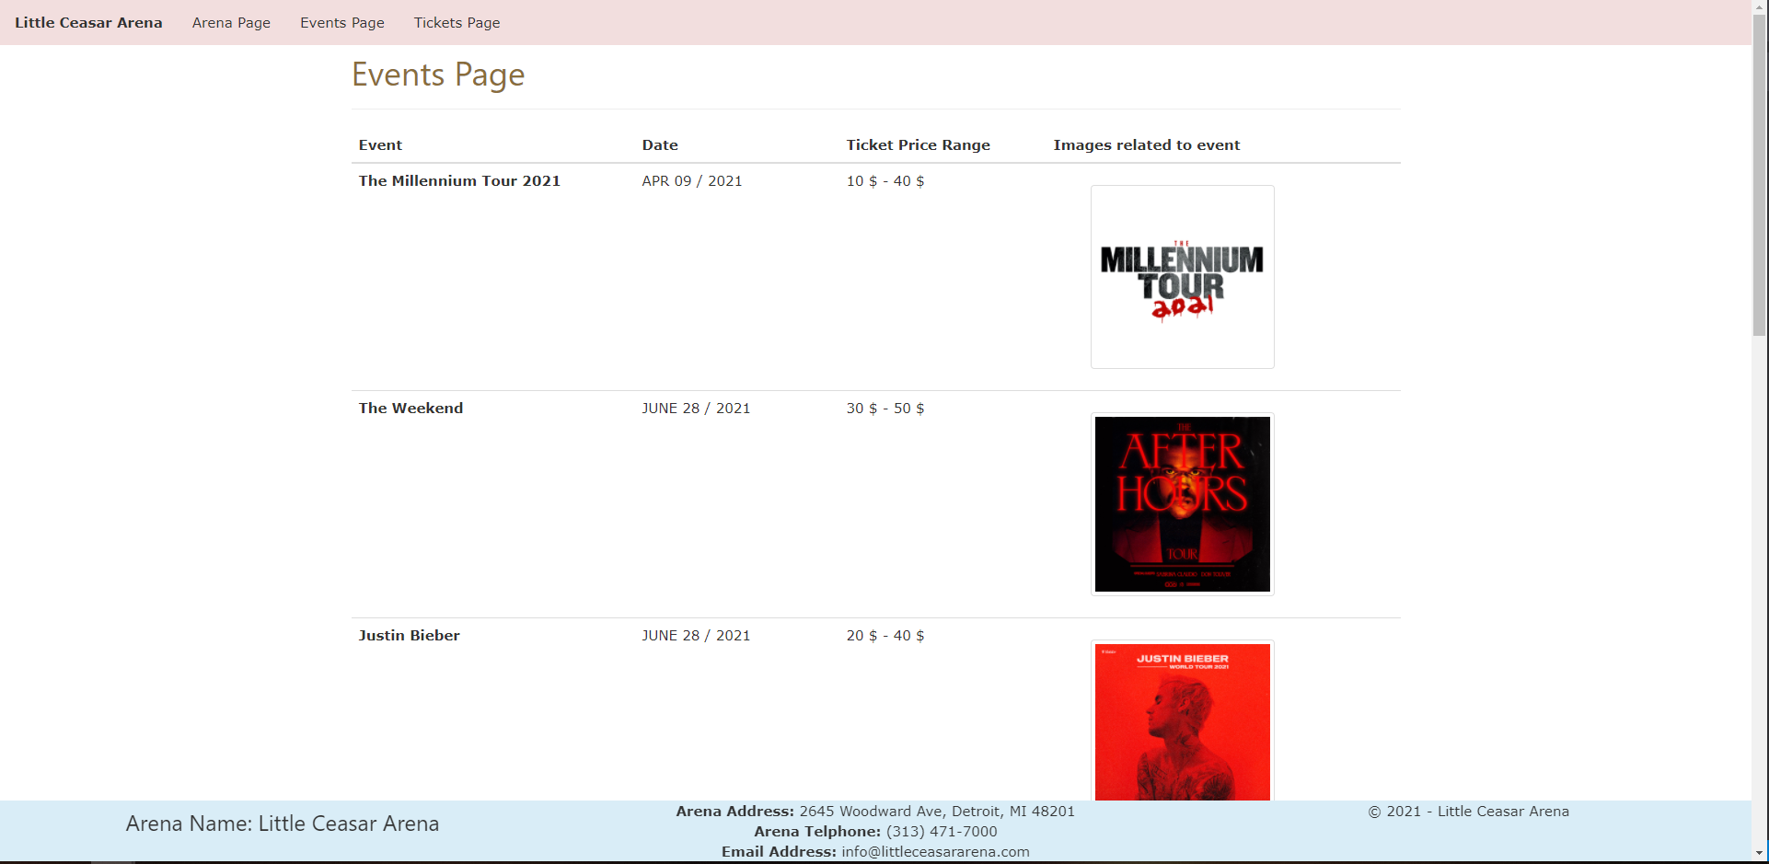

**Tickets page**

*[your Tickets page HTML code here]\**

*<!DOCTYPE html>*

*<html lang="en" xmlns="http://www.w3.org/1999/xhtml">*

*<head>*

*<title>Tickets page</title>*

*<!-- Required meta tags -->*

*<meta charset="utf-8">*

*<meta name="viewport" content="width=device-width, initial-scale=1">*

*<!-- Bootstrap CSS -->*

*<!-- Latest compiled and minified CSS -->*

*<link rel="stylesheet" href="https://stackpath.bootstrapcdn.com/bootstrap/3.4.1/css/bootstrap.min.css" integrity="sha384-HSMxcRTRxnN+Bdg0JdbxYKrThecOKuH5zCYotlSAcp1+c8xmyTe9GYg1l9a69psu" crossorigin="anonymous">*

*<!-- W3.CSS link -->*

*<link rel="stylesheet" href="https://www.w3schools.com/w3css/4/w3.css">*

*<link href="../Contents/Content.css" rel="stylesheet" />*

*</head>*

*<body>*

*<ul class="navbar-customized bg-danger">*

*<li><a href="#"><b>Little Ceasar Arena</b></a></li>*

*<li><a href="/Views/Arena.html">Arena Page</a></li>*

*<li><a href="/Views/Events.html">Events Page</a></li>*

*<li><a href="/Views/Tickets.html">Tickets Page</a></li>*

*</ul>*

*<div class="container">*

*<h1 class="text-warning"> Tickets Page</h1>*

*<form method="get" action="http://www.tipjar.com/cgi-bin/test">*

*<div class="form-horizontal">*

*<h4>Buy a Ticket</h4>*

*<hr>*

*<div class="form-group">*

*<label class="control-label col-md-2" for="ArenaSeatingChart">Arena Seating Chart</label>*

*<div class="col-md-10">*

*<img src="../Images/ArenaSeatingChart/seating-chart-01-little-seasar.JPG" class="arena-seating-chart" />*

*</div>*

*</div>*

*<div class="form-group">*

*<label class="control-label col-md-2" for="CustomerName">CustomerName</label>*

*<div class="col-md-10">*

*<input class="form-control text-box single-line" data-val="true" data-val-required="CustomerName is required!" id="CustomerName" name="CellPhone" type="tel" value="">*

*<span class="field-validation-valid text-danger" data-valmsg-for="CustomerName" data-valmsg-replace="true"></span>*

*</div>*

*</div>*

*<div class="form-group">*

*<label class="control-label col-md-2" for="CustomerEmail">CustomerEmail</label>*

*<div class="col-md-10">*

*<input class="form-control text-box single-line" data-val="true" data-val-required="Email Address is required!" id="CustomerEmail" name="EmailAddress" type="email" value="">*

*<span class="field-validation-valid text-danger" data-valmsg-for="CustomerEmail" data-valmsg-replace="true"></span>*

*</div>*

*</div>*

*<div class="form-group">*

*<label class="control-label col-md-2" for="Events">Events</label>*

*<div class="col-md-10">*

*<select id="Events" class="form-control">*

*<option value="1">The Millennium Tour 2021</option>*

*<option value="2">The Weekend</option>*

*<option value="3">Justin Bieber</option>*

*<option value="4" selected>Rage Agaist the Machine</option>*

*<option value="5">My Chemical Romance</option>*

*<option value="6">Alan Jackson</option>*

*<option value="7">Harry Styles</option>*

*</select>*

*</div>*

*</div>*

*<div class="form-group">*

*<label class="control-label col-md-2" for="EventDate">EventDate</label>*

*<div class="col-md-10">*

*<input class="form-control text-box single-line" data-val="true" data-val-required="EventDate is required!" id="EventDate" name="EventDate" type="date" value="">*

*<span class="field-validation-valid text-danger" data-valmsg-for="EventDate" data-valmsg-replace="true"></span>*

*</div>*

*</div>*

*<div class="form-group">*

*<label class="control-label col-md-2" for="SeatCategory">SeatCategory</label>*

*<div class="col-md-10">*

*<select id="SeatCategory" class="form-control col-md-9">*

*<option value="1">First Class</option>*

*<option value="2">Middle Class</option>*

*<option value="3">Regular</option>*

*</select>*

*</div>*

*</div>*

*<div class="form-group">*

*<label class="control-label col-md-2" for="NumberOfTickets">Number Of Tickets (allow 1 to 21)</label>*

*<div class="col-md-10">*

*<input class="form-control text-box single-line" data-val="true" data-val-required="NumberOfTickets is required!" id="NumberOfTickets" name="CellPhone" type="tel" value="">*

*<span class="field-validation-valid text-danger" data-valmsg-for="NumberOfTickets" data-valmsg-replace="true"></span>*

*</div>*

*</div>*

*<div class="form-group">*

*<label class="control-label col-md-2" for="PaymentType">PaymentType</label>*

*<div class="col-md-10">*

*<select id="PaymentType" class="form-control col-md-9">*

*<option value="1">Debit</option>*

*<option value="2">Credit</option>*

*</select>*

*</div>*

*</div>*

*<div class="form-group">*

*<div class="col-md-offset-2 col-md-10">*

*<input type="submit" value="Buy Ticket" class="btn btn-default btn-success">*

*</div>*

*</div>*

*</div>*

*</form>*

*</div>*

*<div class="footer bg-info">*

*<div class="row">*

*<div class="col-md-4">*

*<h3>*

*Arena Name: Little Ceasar Arena*

*</h3>*

*</div>*

*<div class="col-md-4">*

*<div><b>Arena Address:</b> 2645 Woodward Ave, Detroit, MI 48201</div>*

*<div><b>Arena Telphone:</b> (313) 471-7000</div>*

*<div><b>Email Address:</b> info@littleceasararena.com</div>*

*</div>*

*<div class="col-md-4">*

*<p>© 2021 - Little Ceasar Arena</p>*

*</div>*

*</div>*

*</div>*

*<!-- Latest compiled and minified JavaScript -->*

*<script src="https://stackpath.bootstrapcdn.com/bootstrap/3.4.1/js/bootstrap.min.js" integrity="sha384-aJ21OjlMXNL5UyIl/XNwTMqvzeRMZH2w8c5cRVpzpU8Y5bApTppSuUkhZXN0VxHd" crossorigin="anonymous"></script>*

*</body>*

*</html>*

*[your Tickets page screenshot here]\*\**

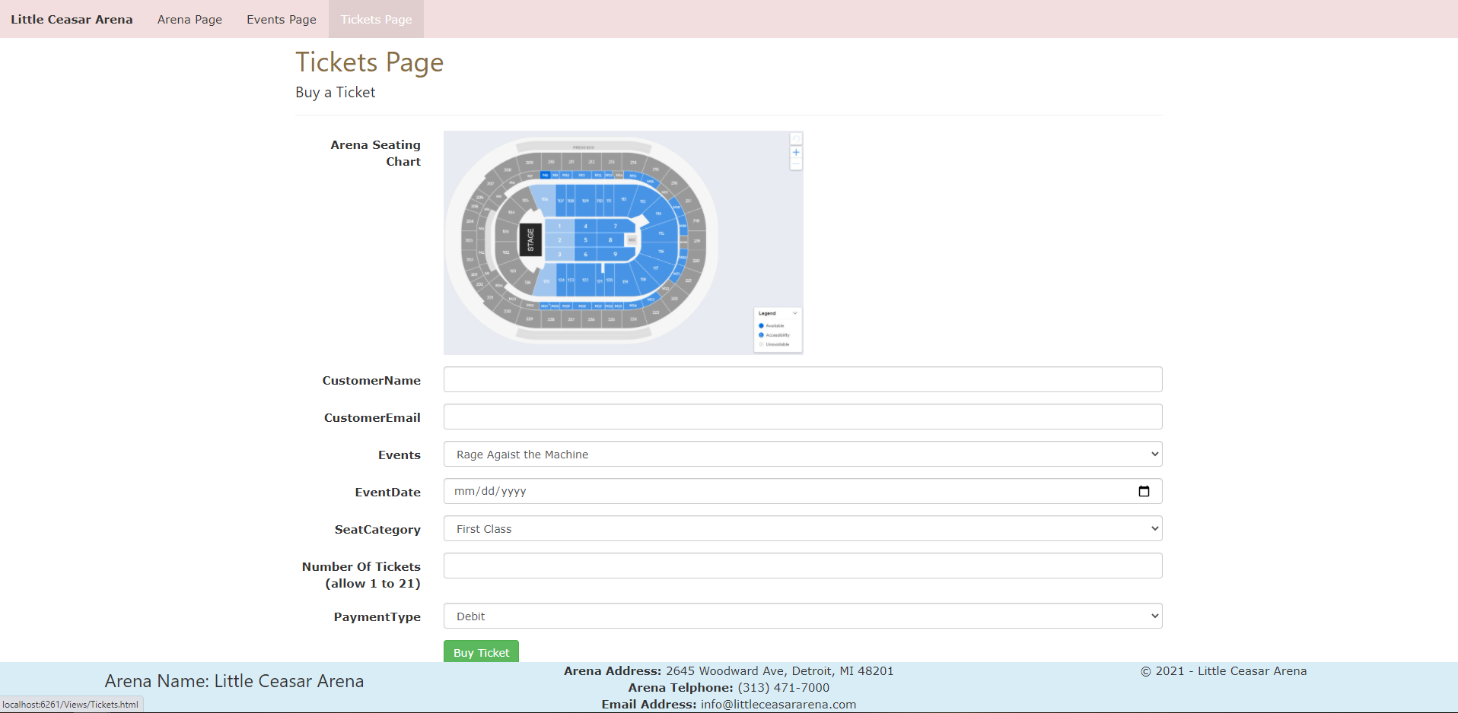

*[your www.tipjar.com/cgi-bin/test response screenshot here]\*\**

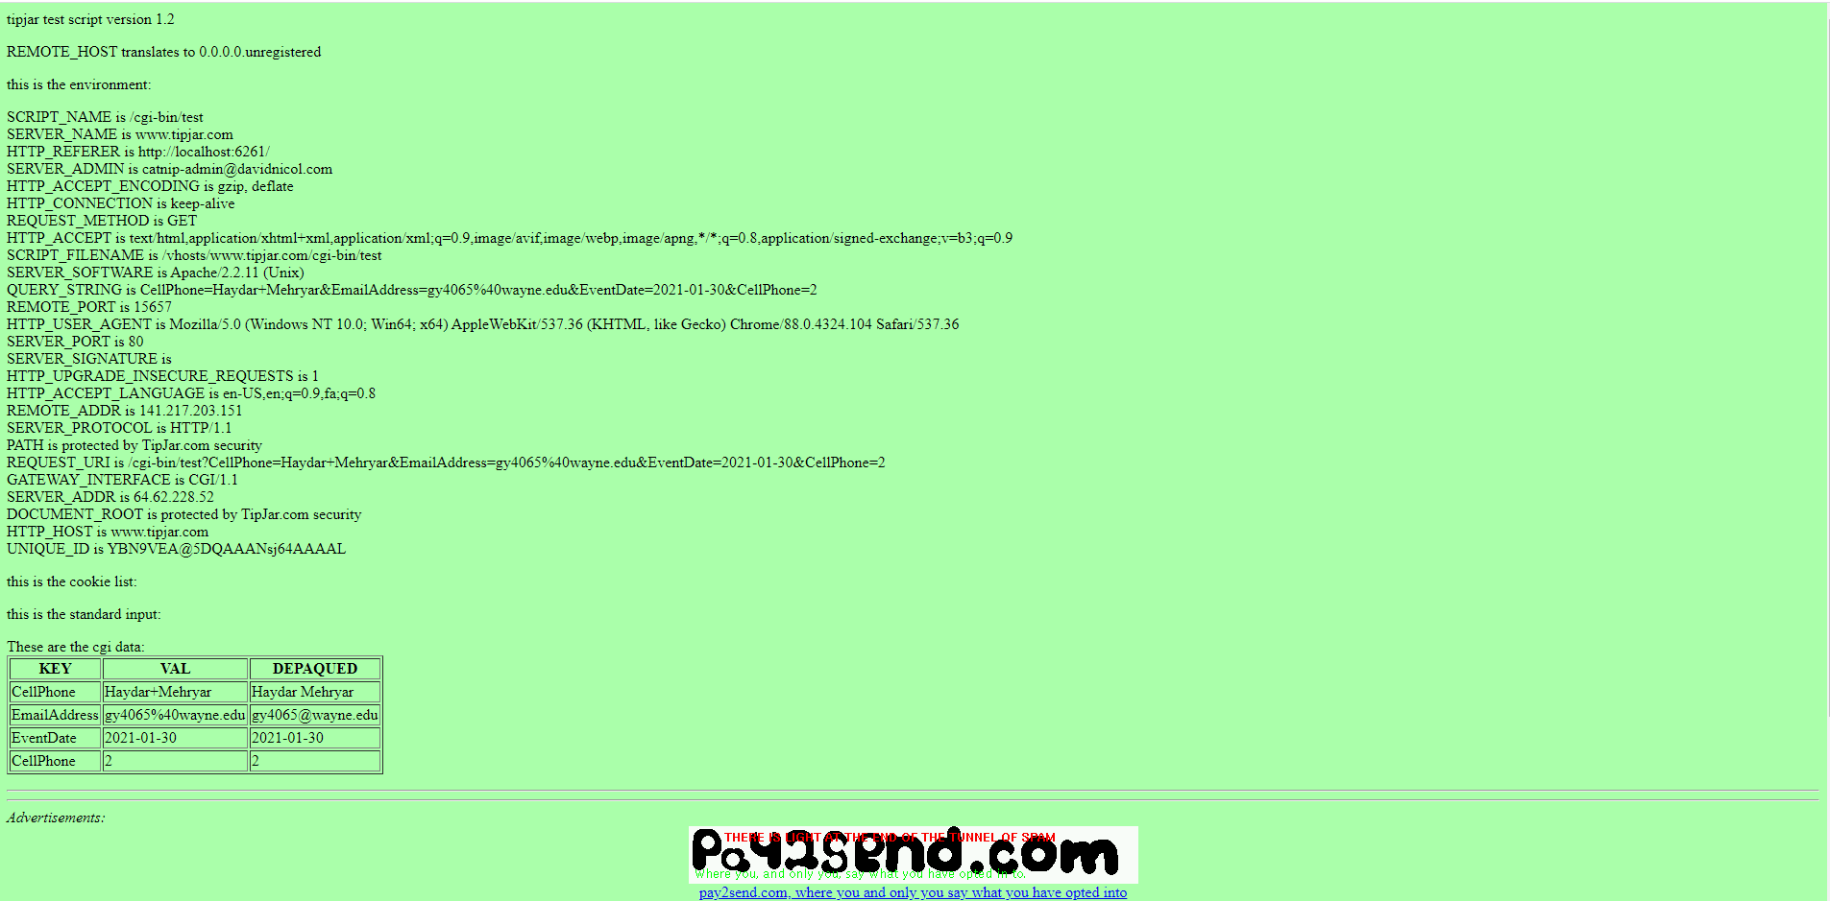

**CSS file**

*[your CSS code here]\**

**body {**

**}**

**.event-img-width {**

**width:200px;**

**}**

**img.arena-seating-chart {**

**width:50%;**

**}**

**ul.navbar-customized {**

**list-style-type: none;**

**margin: 0;**

**padding: 0;**

**overflow: hidden;**

**/*background-color: #333;*/**

**}**

**ul.navbar-customized li {**

**float: left;**

**}**

**ul.navbar-customized li a {**

**display: block;**

**/*color: white;*/**

**text-align: center;**

**padding: 14px 16px;**

**text-decoration: none;**

**}**

**/* Change the link color to #111 (black) on hover */**

**li a:hover {**

**background-color: #e0cece;**

**text-decoration:none;**

**color:white;**

**}**

**.footer {**

**position: fixed;**

**left: 0;**

**bottom: 0;**

**width: 100%;**

**/*background-color: red;**

**color: white;*/**

**text-align: center;**

**}**

**\* Copying-and-pasting web page code to a Word document**

**macOS**

1) From within the HTML editor window, press **command-A** and press **command-C**.

2) From within the Word document, press **command-V**.

**Windows**

1) From within the HTML editor window, press **CTRL-A** and press **CTRL-C**.

2) From within the Word document, press **CTRL-V**.

**\*\* Copying-and-pasting a web page to a Word document**

**macOS**

1) From the browser window, press **shift-command-4-space**.

2) From within the Word document, **command-V**.

**Windows**

1) From the browser window, press **ALT-PrintScreen**.

2) From within the Word document, press **CTRL-V**.