**CSC 5750 – Principles of Web Technology**

**Homework 2 – [your name]**

**25 points – Due February 11, 5pm**

**Late deadline is February 13, 11:59pm, but 20% off**

**a)** Save this document with your name and the homework number somewhere in the file name.

**b)** Paste your code and screenshots into the document.

**c)** Gather the following files into a ZIP file with your name and the homework number somewhere in the file name:

● This document

● All HTML files

● All CSS files

● Image files

● Any other optional files specific to your implementation

**d)** Submit the ZIP file to Canvas where you downloaded this document.

You've been hired again by the arena to enhance the web site you created for them in Homework 1. Start with the web site you created in Homework 1, or the Homework 1 key on Canvas, and make the following changes to it:

**Arena page**

● Update the header comment.

● Add text ", v2" to the end of the title (in the <head> section).

● Move the two-dimensional events array declaration from the Events page to this page. Place the declaration within a script tag within the head tag. Make the array global – don't place its declaration within any JavaScript function.

● Create JavaScript function **storeEvents** that stringifies and stores the events array in local storage. Write a message to the console that reports that the array was stored.

● Call JavaScript function **storeEvents** when the page loads using attribute **onload**.

These changes move the source of the events data to this page. By placing it in local storage, the events array can be made available to all other web pages.

**Events page**

● Add text ", v2" to the end of the title (in the <head> section).

● Create JavaScript function **loadEvents** that retrieves and parses the events array in local storage. Move the DataTables script that sets the data source for the table to the bottom of JavaScript function **loadEvents**. Write a message to the console that reports that the array was retrieved.

● Call JavaScript function **loadEvents** when the page loads using attribute **onload**.

These changes move the source of the events data to local storage. Placing the DataTables script just after local storage retrieval insures that they occur in the proper order.

**Tickets page**

● Add text ", v2" to the end of the title (in the <head> section).

● Add a two-dimensional seats array declaration to the page. Place the declaration within a script tag within the head tag. Make the array global – don't place its declaration within any JavaScript function. Define 4-8 seat types. Each row in the array contains a seat type and price:

var seats =

[

[

"Regular",

25

],

[

"Mezzanine",

50

], …

];

● If not done already, use a combo box to enable the user to select one of your seat types.

● Add the following read-only text boxes:

ü Seat cost

ü Subtotal

ü Tax

ü Total

Style these text boxes differently from the other text boxes:

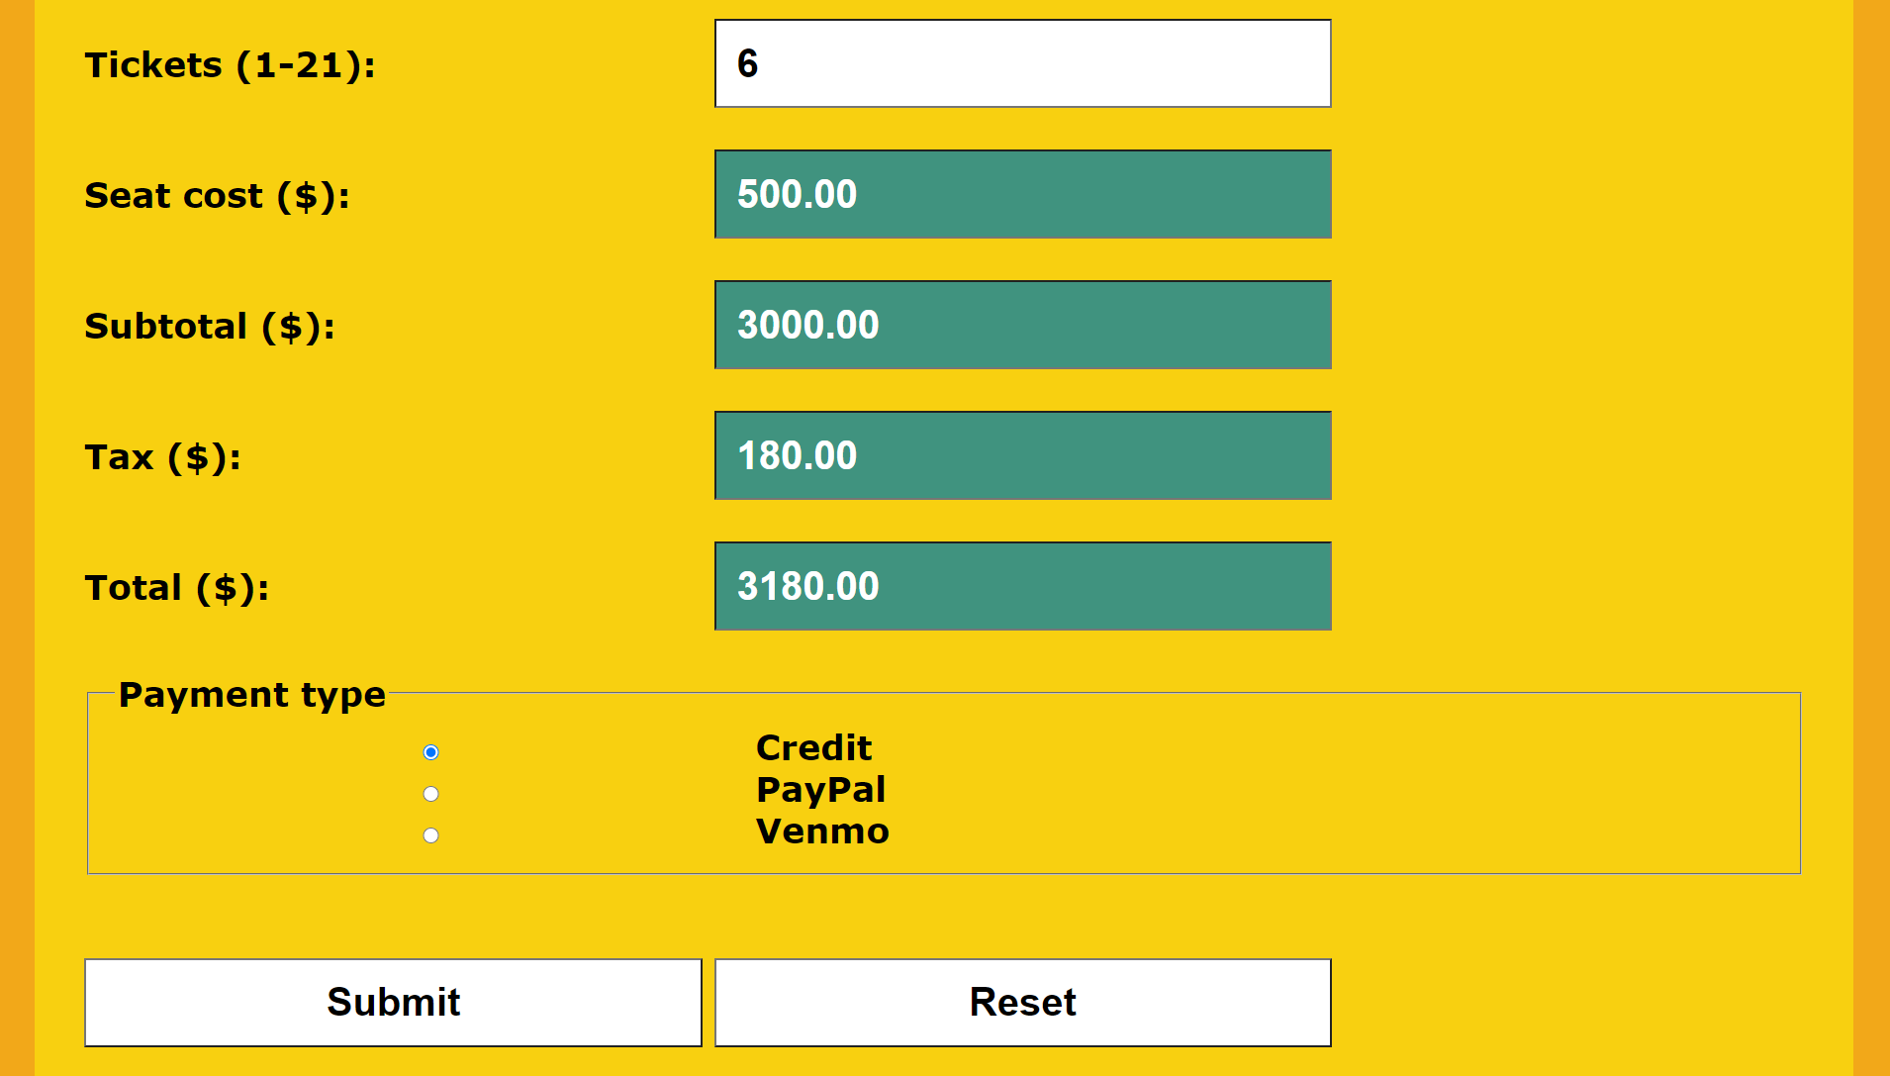

● Create JavaScript function **seatTypeSelected** that gets the seat cost based on the seat type selected in the seat type combo box. Use combo box property **selectedIndex** to find the seat cost in the seat types array corresponding to the selected seat type. Store the seat cost in a variable. Also store the following in different variables:

ü Subtotal (tickets x seat cost)

ü Tax (subtotal x 0.06)

ü Total (subtotal + tax)

Then store the seat cost, subtotal, tax, and total values in their respective text boxes. Show each value to two decimal places using property **toFixed**. Write a message to the console that reports the seat type (property **value**) and index (property **selectedIndex**) that was selected.

● Call JavaScript function **seatTypeSelected** when the page loads using attribute **onload**, and whenever the user changes the seat type or number of tickets. Attribute **onchange** triggers a call to a function when a change is made.

● Since they must be referenced in JavaScript, insure that the following controls have attribute **ID** defined:

ü Seat type combo box

ü Tickets text box

ü Seat cost text box

ü Subtotal text box

ü Tax text box

ü Total text box

● Insure that all user-entry and read-only fields send their data to the server when the form is submitted.

**Styles (CSS) page**

Edit the **Styles page** with the read-only text box style and any other needed additional styles.

**Data flow**

Here is a summary of the data flow in this web site:

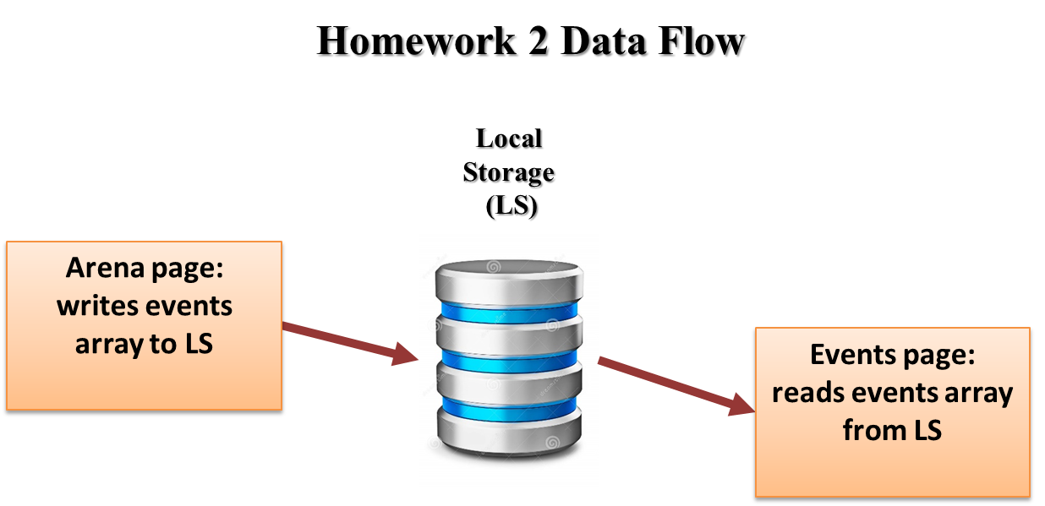

**Note:** use only relative links, not absolute links, to other files on your web site. This means there should be no drive letters or absolute paths, only relative paths, in your file references. You can test this by zipping your web site files, unzipping them in another folder, and then running your web site. There should be no linking errors if you used only relative links. The best approach is to put all web site files in one folder.

**Arena page**

*[your Arena page HTML code here]\**

**If possible, format your code like this:**

**Font “Courier New”**

**Font size “9”**

**Bold**

**<!DOCTYPE html>**

**<html lang="en" xmlns="http://www.w3.org/1999/xhtml">**

**<head>**

**<title>Arena page, v2</title>**

**<!-- Required meta tags -->**

**<meta charset="utf-8">**

**<meta name="viewport" content="width=device-width, initial-scale=1">**

**<!-- Bootstrap CSS -->**

**<!-- Latest compiled and minified CSS -->**

**<link rel="stylesheet" href="https://stackpath.bootstrapcdn.com/bootstrap/3.4.1/css/bootstrap.min.css" integrity="sha384-HSMxcRTRxnN+Bdg0JdbxYKrThecOKuH5zCYotlSAcp1+c8xmyTe9GYg1l9a69psu" crossorigin="anonymous">**

**<!-- W3.CSS link -->**

**<link rel="stylesheet" href="https://www.w3schools.com/w3css/4/w3.css">**

**<!-- DataTables CSS and script links -->**

**<link rel="stylesheet" type="text/css" href="https://cdn.datatables.net/1.10.23/css/jquery.dataTables.min.css">**

**<link href="../Contents/Content.css" rel="stylesheet" />**

**</head>**

**<body>**

**<ul class="navbar-customized bg-danger">**

**<li><a href="#"><b>Little Ceasar Arena</b></a></li>**

**<li><a href="/Views/Arena.html">Arena Page</a></li>**

**<li><a href="/Views/Events.html">Events Page</a></li>**

**<li><a href="/Views/Tickets.html">Tickets Page</a></li>**

**</ul>**

**<div class="container">**

**<h1 class="text-warning"> Arena Page</h1>**

**<div>**

**<h3>Little Caesars Arena</h3>**

**<hr />**

**</div>**

**<div>**

**<b>Arena capacity:</b>**

**Ice hockey: 19,515**

**Basketball: 20,332**

**Concerts: 15,000–22,000**

**</div>**

**<div>**

**<b>Arena concessions:</b> Sales of game tickets, parking, concessions, souvenirs,**

**and any potential naming rights deals would not be subject to revenue sharing with the City of Detroit as they were with Joe Louis Arena.**

**</div>**

**<div>Seating categories: First-class, Middle-class, Regular</div>**

**<div>**

**<b>Arena history including year built:</b>**

**Little Caesars Arena is a multi-purpose arena in Midtown Detroit. Construction began on April 24, 2015, following a formal groundbreaking ceremony on September 25, 2014. Opened on September 5, 2017, the arena, which cost $862.9 million to construct, replaced Joe Louis Arena and The Palace of Auburn Hills as the homes of the Detroit Red Wings of the National Hockey League (NHL) and the Detroit Pistons of the National Basketball Association (NBA), respectively.**

**</div>**

**<div>Arena location shown on a map image:</div>**

**<img src="../Images/Arena/CrislerArena.jpg" />**

**<!--<img src="\Images\Arena\arena-little-caesars-01.jpg" />-->**

**<div>**

**Arena image**

**</div>**

**</div>**

**<div class="footer bg-info">**

**<div class="row">**

**<div class="col-md-4">**

**<h3>**

**Arena Name: Little Ceasar Arena**

**</h3>**

**</div>**

**<div class="col-md-4">**

**<div><b>Arena Address:</b> 2645 Woodward Ave, Detroit, MI 48201</div>**

**<div><b>Arena Telphone:</b> (313) 471-7000</div>**

**<div><b>Email Address:</b> info@littleceasararena.com</div>**

**</div>**

**<div class="col-md-4">**

**<p>© 2021 - Little Ceasar Arena</p>**

**</div>**

**</div>**

**</div>**

**<script src="https://code.jquery.com/jquery-3.5.1.js"></script>**

**<script src="https://cdn.datatables.net/1.10.23/js/jquery.dataTables.min.js"></script>**

**<!-- Latest compiled and minified JavaScript -->**

**<script src="https://stackpath.bootstrapcdn.com/bootstrap/3.4.1/js/bootstrap.min.js" integrity="sha384-aJ21OjlMXNL5UyIl/XNwTMqvzeRMZH2w8c5cRVpzpU8Y5bApTppSuUkhZXN0VxHd" crossorigin="anonymous"></script>**

**<!-- DataTables script -->**

**<script type="text/javascript">**

**"use strict";**

**var data =**

**[**

**[**

**"Drone Racing",**

**"10 May 2021",**

**"$25-$45",**

**"<img src='../Images/Events/Image-DroneRacing.jfif' alt='Image Missing!' width='300' height='200'>"**

**],**

**[**

**"Elton John",**

**"20 May 2021",**

**"$125-$445",**

**"<img src='../Images/Events/Image-EltonJohn.jfif' alt='Image Missing!' width='300' height='200'>"**

**],**

**[**

**"Sweater Knitting",**

**"30 May 2021",**

**"$25-$45",**

**"<img src='../Images/Events/Image-Sweater.jfif' alt='Image Missing!' width='300' height='200'>"**

**],**

**[**

**"The Beatles",**

**"10 June 2021",**

**"$225-$645",**

**"<img src='../Images/Events/Image-TheBeatles.jfif' alt='Image Missing!' width='300' height='200'>"**

**],**

**[**

**"Book Reading",**

**"20 June 2021",**

**"$25-$45",**

**"<img src='../Images/Events/Image-Book.jfif' alt='Image Missing!' width='300' height='200'>"**

**],**

**[**

**"Monster Truck Racing",**

**"30 June 2021",**

**"$25-$45",**

**"<img src='../Images/Events/Image-MonsterTruck.jfif' alt='Image Missing!' width='300' height='200'>"**

**],**

**[**

**"Evel Knievel",**

**"10 July 2021",**

**"$50-$200",**

**"<img src='../Images/Events/Image-EvelKnievel.jfif' alt='Image Missing!' width='300' height='200'>"**

**],**

**[**

**"Wayne State Basketball",**

**"20 July 2021",**

**"$25-$45",**

**"<img src='../Images/Events/Image-Basketball.jfif' alt='Image Missing!' width='300' height='200'>"**

**]**

**];**

**$(document).ready(function () {**

**$('#tblMenu').DataTable(**

**{**

**"data": data,**

**"autoWidth": false**

**});**

**//================================================================**

**// clearFields**

**//================================================================**

**function clearFields() {**

**//hRawData.innerHTML = "Raw data";**

**//tRawData.value = "";**

**//tStringifyData.value = "";**

**//tParseData.value = "";**

**//tblMenu.innerHTML = "";**

**}**

**//================================================================**

**// convertToAndFromJSON**

**//================================================================**

**function convertToAndFromJSON(obj) {**

**// Clear fields**

**clearFields();**

**// Show raw object**

**hRawData.innerHTML = "Raw data (object type: " + typeof (obj) + ")";**

**tRawData.value = obj;**

**// Stringify and show object**

**var objStringify = JSON.stringify(obj);**

**tStringifyData.value = objStringify;**

**// Parse and show object**

**var objParse = JSON.parse(objStringify);**

**tParseData.value = objParse;**

**}**

**//================================================================**

**// sendDataViaLocalStorage**

**//================================================================**

**function storeEvents() {**

**// Clear storage fields**

**localStorage.removeItem("localArrayUnnamed");**

**localStorage.removeItem("localArrayNamed");**

**// Place objects (including arrays) in local storage**

**// Objects must be stringified when placed in localStorage**

**localStorage.setItem("localArrayUnnamed", JSON.stringify(data));**

**// Open other page**

**//window.open("JSONStringifyAndParse-DataPage.html", "_self");**

**}**

**storeEvents();**

**});**

**</script>**

**</body>**

**</html>**

*[your Arena page screenshot here]\*\**

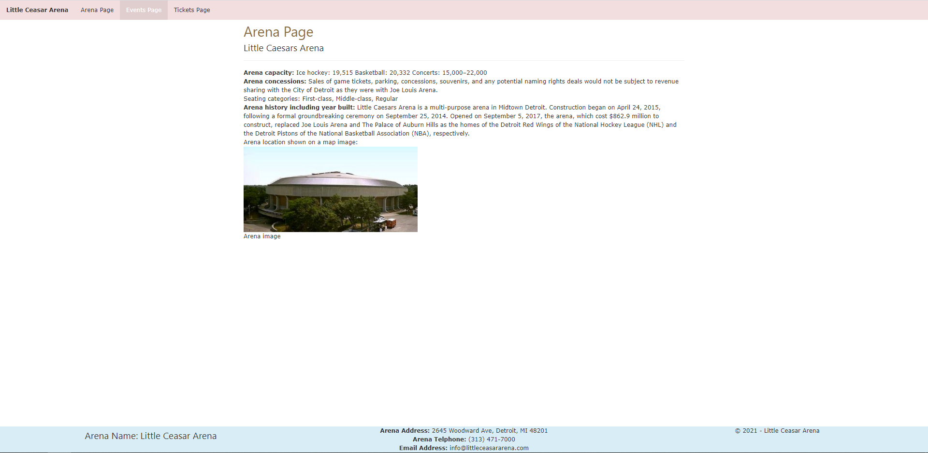

**Events page**

*[your Events page HTML code here]\**

**If possible, format your code like this:**

**Font “Courier New”**

**Font size “9”**

**Bold**

**<!DOCTYPE html>**

**<html lang="en" xmlns="http://www.w3.org/1999/xhtml">**

**<head>**

**<title>Events page, v2</title>**

**<!-- Required meta tags -->**

**<meta charset="utf-8">**

**<meta name="viewport" content="width=device-width, initial-scale=1">**

**<!-- Bootstrap CSS -->**

**<!-- Latest compiled and minified CSS -->**

**<link rel="stylesheet" href="https://stackpath.bootstrapcdn.com/bootstrap/3.4.1/css/bootstrap.min.css" integrity="sha384-HSMxcRTRxnN+Bdg0JdbxYKrThecOKuH5zCYotlSAcp1+c8xmyTe9GYg1l9a69psu" crossorigin="anonymous">**

**<!-- W3.CSS link -->**

**<link rel="stylesheet" href="https://www.w3schools.com/w3css/4/w3.css">**

**<!-- DataTables CSS and script links -->**

**<link rel="stylesheet" type="text/css" href="https://cdn.datatables.net/1.10.23/css/jquery.dataTables.min.css">**

**<link href="../Contents/Content.css" rel="stylesheet" />**

**</head>**

**<body>**

**<ul class="navbar-customized bg-danger">**

**<li><a href="#"><b>Little Ceasar Arena</b></a></li>**

**<li><a href="/Views/Arena.html">Arena Page</a></li>**

**<li><a href="/Views/Events.html">Events Page</a></li>**

**<li><a href="/Views/Tickets.html">Tickets Page</a></li>**

**</ul>**

**<div class="container">**

**<h1 class="text-warning"> Events Page</h1>**

**<hr />**

**<table class="table table-sm table-hover table-responsive table-responsive-lg" id="tblMenu">**

**<thead>**

**<tr>**

**<th scope="col">Event</th>**

**<th scope="col">Date</th>**

**<th scope="col">Ticket Price Range</th>**

**<th scope="col">Images related to event</th>**

**<!--<th scope="col">#</th>**

**<th scope="col">First</th>**

**<th scope="col">Last</th>**

**<th scope="col">Handle</th>-->**

**</tr>**

**</thead>**

**<tbody>**

**<tr>**

**<th scope="row">The Millennium Tour 2021</th>**

**<td>APR 09 / 2021</td>**

**<td>10 $ - 40 $</td>**

**<td>**

**<figure class="figure">**

**<img src="../Images/Events/events-millenium_tour_600x600_thumb-8fbb1c836f.jpg" class="figure-img img-fluid rounded img-thumbnail event-img-width" alt="...">**

**</figure>**

**</td>**

**</tr>**

**<tr>**

**<th scope="row">The Weekend</th>**

**<td>JUNE 28 / 2021</td>**

**<td>30 $ - 50 $</td>**

**<td>**

**<figure class="figure">**

**<img src="../Images/Events/events-weeknd_313_presents_600x600_thumb-b47621808a.jpg" class="figure-img img-fluid rounded img-thumbnail event-img-width" alt="...">**

**</figure>**

**</td>**

**</tr>**

**<tr>**

**<th scope="row">Justin Bieber</th>**

**<td>JUNE 28 / 2021</td>**

**<td>20 $ - 40 $</td>**

**<td>**

**<figure class="figure">**

**<img src="../Images/Events/events-Justin_Bieber_Detroit_2021_600x600-f765928793.jpg" class="figure-img img-fluid rounded img-thumbnail event-img-width" alt="...">**

**</figure>**

**</td>**

**</tr>**

**<tr>**

**<th scope="row">Rage Agaist the Machine</th>**

**<td>JUNE 26 - 27 / 2021</td>**

**<td>40 $ - 60 $</td>**

**<td>**

**<figure class="figure">**

**<img src="../Images/Events/events-rage_against_the_machine_313_presents_600x600_thumb-1-1289b510c4-1-79d1397c52.jpg" class="figure-img img-fluid rounded img-thumbnail event-img-width" alt="...">**

**</figure>**

**</td>**

**</tr>**

**<tr>**

**<th scope="row">My Chemical Romance</th>**

**<td>SEP 15 / 2021</td>**

**<td>30 $ - 40 $</td>**

**<td>**

**<figure class="figure">**

**<img src="../Images/Events/events-my_chemical_romance_313_presents_600x600_thumb-d028253a7b.jpg" class="figure-img img-fluid rounded img-thumbnail event-img-width" alt="...">**

**</figure>**

**</td>**

**</tr>**

**<tr>**

**<th scope="row">Alan Jackson</th>**

**<td>SEP 17 / 2021</td>**

**<td>70 $ - 80 $</td>**

**<td>**

**<figure class="figure">**

**<img src="../Images/Events/events-alan_jackson_2021_313_presents_600x600_v2-9488592118.jpg" class="figure-img img-fluid rounded img-thumbnail event-img-width" alt="...">**

**</figure>**

**</td>**

**</tr>**

**<tr>**

**<th scope="row">Harry Styles</th>**

**<td>SEP 20 / 2021</td>**

**<td>50 $ - 70 $</td>**

**<td>**

**<figure class="figure">**

**<img src="../Images/Events/events-HarryStyles_1080x1080_2021-8ffc82717d.jpg" class="figure-img img-fluid rounded img-thumbnail event-img-width" alt="...">**

**</figure>**

**</td>**

**</tr>**

**<tr>**

**<th scope="row">Tame Impala</th>**

**<td>OCT 05 / 2021</td>**

**<td>35 $ - 50 $</td>**

**<td>**

**<figure class="figure">**

**<img src="../Images/Events/events-tame_impala_313_presents_600x600_thumb-f5749392fc.jpg" class="figure-img img-fluid rounded img-thumbnail event-img-width" alt="...">**

**</figure>**

**</td>**

**</tr>**

**<tr>**

**<th scope="row">Dan + Shay</th>**

**<td>DEC 03 / 2021</td>**

**<td>50 $ - 75 $</td>**

**<td>**

**<figure class="figure">**

**<img src="../Images/Events/events-Dan_shay_2021_600x600_thumb-cd95d10d5c.jpg" class="figure-img img-fluid rounded img-thumbnail event-img-width" alt="...">**

**</figure>**

**</td>**

**</tr>**

**</tbody>**

**</table>**

**</div>**

**<div class="footer bg-info">**

**<div class="row">**

**<div class="col-md-4">**

**<h3>**

**Arena Name: Little Ceasar Arena**

**</h3>**

**</div>**

**<div class="col-md-4">**

**<div><b>Arena Address:</b> 2645 Woodward Ave, Detroit, MI 48201</div>**

**<div><b>Arena Telphone:</b> (313) 471-7000</div>**

**<div><b>Email Address:</b> info@littleceasararena.com</div>**

**</div>**

**<div class="col-md-4">**

**<p>© 2021 - Little Ceasar Arena</p>**

**</div>**

**</div>**

**</div>**

**<script src="https://code.jquery.com/jquery-3.5.1.js"></script>**

**<script src="https://cdn.datatables.net/1.10.23/js/jquery.dataTables.min.js"></script>**

**<!-- Latest compiled and minified JavaScript -->**

**<script src="https://stackpath.bootstrapcdn.com/bootstrap/3.4.1/js/bootstrap.min.js" integrity="sha384-aJ21OjlMXNL5UyIl/XNwTMqvzeRMZH2w8c5cRVpzpU8Y5bApTppSuUkhZXN0VxHd" crossorigin="anonymous"></script>**

**<script type="text/javascript">**

**"use strict";**

**$(document).ready(function () {**

**//================================================================**

**// Script-level variables**

**//================================================================**

**var data;**

**var arrUnnamed;**

**//================================================================**

**// getAndShowData**

**//================================================================**

**function loadEvents() {**

**// Get data**

**arrUnnamed = JSON.parse(localStorage.getItem("localArrayUnnamed"));**

**data=JSON.parse(localStorage.getItem("localArrayUnnamed"))**

**// Show data**

**$('#tblMenu').DataTable(**

**{**

**"data": data,**

**"autoWidth": false**

**});**

**}**

**loadEvents();**

**})**

**</script>**

**</body>**

**</html>**

*[your Events page screenshot here]\*\**

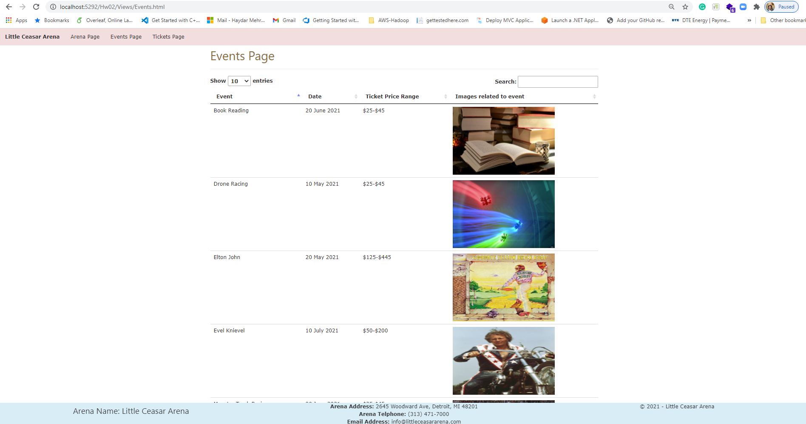

**Tickets page**

*[your Tickets page HTML code here]\**

**If possible, format your code like this:**

**Font “Courier New”**

**Font size “9”**

**Bold**

**<!DOCTYPE html>**

**<html lang="en" xmlns="http://www.w3.org/1999/xhtml">**

**<head>**

**<title>Tickets page, v2</title>**

**<!-- Required meta tags -->**

**<meta charset="utf-8">**

**<meta name="viewport" content="width=device-width, initial-scale=1">**

**<!-- Bootstrap CSS -->**

**<!-- Latest compiled and minified CSS -->**

**<link rel="stylesheet" href="https://stackpath.bootstrapcdn.com/bootstrap/3.4.1/css/bootstrap.min.css" integrity="sha384-HSMxcRTRxnN+Bdg0JdbxYKrThecOKuH5zCYotlSAcp1+c8xmyTe9GYg1l9a69psu" crossorigin="anonymous">**

**<!-- W3.CSS link -->**

**<link rel="stylesheet" href="https://www.w3schools.com/w3css/4/w3.css">**

**<!-- DataTables CSS and script links -->**

**<link rel="stylesheet" type="text/css" href="https://cdn.datatables.net/1.10.23/css/jquery.dataTables.min.css">**

**<link href="../Contents/Content.css" rel="stylesheet" />**

**</head>**

**<body>**

**<ul class="navbar-customized bg-danger">**

**<li><a href="#"><b>Little Ceasar Arena</b></a></li>**

**<li><a href="/Views/Arena.html">Arena Page</a></li>**

**<li><a href="/Views/Events.html">Events Page</a></li>**

**<li><a href="/Views/Tickets.html">Tickets Page</a></li>**

**</ul>**

**<div class="container">**

**<h1 class="text-warning"> Tickets Page, v2</h1>**

**<form method="get" action="http://www.tipjar.com/cgi-bin/test">**

**<div class="form-horizontal">**

**<h4>Buy a Ticket</h4>**

**<hr>**

**<div class="form-group">**

**<label class="control-label col-md-2" for="ArenaSeatingChart">Arena Seating Chart</label>**

**<div class="col-md-10">**

**<img src="../Images/ArenaSeatingChart/seating-chart-01-little-seasar.JPG" class="arena-seating-chart" />**

**</div>**

**</div>**

**<div class="form-group">**

**<label class="control-label col-md-2" for="CustomerName">CustomerName</label>**

**<div class="col-md-10">**

**<input class="form-control text-box single-line" data-val="true" data-val-required="CustomerName is required!" id="CustomerName" name="CellPhone" type="tel" value="">**

**<span class="field-validation-valid text-danger" data-valmsg-for="CustomerName" data-valmsg-replace="true"></span>**

**</div>**

**</div>**

**<div class="form-group">**

**<label class="control-label col-md-2" for="CustomerEmail">CustomerEmail</label>**

**<div class="col-md-10">**

**<input class="form-control text-box single-line" data-val="true" data-val-required="Email Address is required!" id="CustomerEmail" name="EmailAddress" type="email" value="">**

**<span class="field-validation-valid text-danger" data-valmsg-for="CustomerEmail" data-valmsg-replace="true"></span>**

**</div>**

**</div>**

**<div class="form-group">**

**<label class="control-label col-md-2" for="Events">Events</label>**

**<div class="col-md-10">**

**<select id="Events" class="form-control">**

**<option value="1">The Millennium Tour 2021</option>**

**<option value="2">The Weekend</option>**

**<option value="3">Justin Bieber</option>**

**<option value="4" selected>Rage Agaist the Machine</option>**

**<option value="5">My Chemical Romance</option>**

**<option value="6">Alan Jackson</option>**

**<option value="7">Harry Styles</option>**

**</select>**

**</div>**

**</div>**

**<div class="form-group">**

**<label class="control-label col-md-2" for="EventDate">EventDate</label>**

**<div class="col-md-10">**

**<input class="form-control text-box single-line" data-val="true" data-val-required="EventDate is required!" id="EventDate" name="EventDate" type="date" value="">**

**<span class="field-validation-valid text-danger" data-valmsg-for="EventDate" data-valmsg-replace="true"></span>**

**</div>**

**</div>**

**<div class="form-group">**

**<label class="control-label col-md-2" for="NumberOfTickets">Number Of Tickets (allow 1 to 21)</label>**

**<div class="col-md-10">**

**<input class="form-control text-box single-line" data-val="true" data-val-required="NumberOfTickets is required!" id="NumberOfTickets" name="CellPhone" type="tel" value="">**

**<span class="field-validation-valid text-danger" data-valmsg-for="NumberOfTickets" data-valmsg-replace="true"></span>**

**</div>**

**</div>**

**<div class="form-group">**

**<label class="control-label col-md-2" for="SeatType">SeatType</label>**

**<div class="col-md-10">**

**<select id="SeatType" class="form-control col-md-9">**

**<!--<option value="1">First Class</option>**

**<option value="2">Middle Class</option>**

**<option value="3">Regular</option>-->**

**</select>**

**</div>**

**</div>**

**<div class="form-group">**

**<label class="control-label col-md-2" for="SeatCost">Seat Cost ($)</label>**

**<div class="col-md-10">**

**<input class="form-control text-box single-line" data-val="true" data-val-required="SeatCost is required!" id="SeatCost" name="CellPhone" type="tel" value="" readonly>**

**<span class="field-validation-valid text-danger" data-valmsg-for="SeatCost" data-valmsg-replace="true"></span>**

**</div>**

**</div>**

**<div class="form-group">**

**<label class="control-label col-md-2" for="Subtotal">Subtotal</label>**

**<div class="col-md-10">**

**<input class="form-control text-box single-line" data-val="true" data-val-required="Subtotal is required!" id="Subtotal" name="CellPhone" type="tel" value="" readonly>**

**<span class="field-validation-valid text-danger" data-valmsg-for="Subtotal" data-valmsg-replace="true"></span>**

**</div>**

**</div>**

**<div class="form-group">**

**<label class="control-label col-md-2" for="Tax">Tax</label>**

**<div class="col-md-10">**

**<input class="form-control text-box single-line" data-val="true" data-val-required="Tax is required!" id="Tax" name="CellPhone" type="tel" value="" readonly>**

**<span class="field-validation-valid text-danger" data-valmsg-for="Tax" data-valmsg-replace="true"></span>**

**</div>**

**</div>**

**<div class="form-group">**

**<label class="control-label col-md-2" for="Total">Total</label>**

**<div class="col-md-10">**

**<input class="form-control text-box single-line" data-val="true" data-val-required="Total is required!" id="Total" name="CellPhone" type="tel" value="" readonly>**

**<span class="field-validation-valid text-danger" data-valmsg-for="Total" data-valmsg-replace="true"></span>**

**</div>**

**</div>**

**<div class="form-group">**

**<label class="control-label col-md-2" for="PaymentType">PaymentType</label>**

**<div class="col-md-10">**

**<select id="PaymentType" class="form-control col-md-9">**

**<option value="1">Credit</option>**

**<option value="2">Paypal</option>**

**<option value="2">Venmo</option>**

**</select>**

**</div>**

**</div>**

**<div class="form-group">**

**<div class="col-md-offset-2 col-md-10">**

**<input type="submit" value="Submit" class="btn btn-default btn-success">**

**<input type="reset" value="Reset" class="btn btn-default btn-primary">**

**</div>**

**</div>**

**</div>**

**</form>**

**</div>**

**<div class="footer bg-info">**

**<div class="row">**

**<div class="col-md-4">**

**<h3>**

**Arena Name: Little Ceasar Arena**

**</h3>**

**</div>**

**<div class="col-md-4">**

**<div><b>Arena Address:</b> 2645 Woodward Ave, Detroit, MI 48201</div>**

**<div><b>Arena Telphone:</b> (313) 471-7000</div>**

**<div><b>Email Address:</b> info@littleceasararena.com</div>**

**</div>**

**<div class="col-md-4">**

**<p>© 2021 - Little Ceasar Arena</p>**

**</div>**

**</div>**

**</div>**

**<script src="https://code.jquery.com/jquery-3.5.1.js"></script>**

**<script src="https://cdn.datatables.net/1.10.23/js/jquery.dataTables.min.js"></script>**

**<!-- Latest compiled and minified JavaScript -->**

**<script src="https://stackpath.bootstrapcdn.com/bootstrap/3.4.1/js/bootstrap.min.js" integrity="sha384-aJ21OjlMXNL5UyIl/XNwTMqvzeRMZH2w8c5cRVpzpU8Y5bApTppSuUkhZXN0VxHd" crossorigin="anonymous"></script>**

**<script type="text/javascript">**

**"use strict";**

**var seats = [**

**[**

**"Regular",**

**25**

**],**

**[**

**"Mezzanine",**

**50**

**],**

**[**

**"Middle Class",**

**70**

**],**

**[**

**"First Class",**

**100**

**],**

**];**

**$(document).ready(function () {**

**//================================================================**

**// Script-level variables**

**//================================================================**

**var subtotal=0;**

**var tax=0;**

**var total=0;**

**//================================================================**

**// Setting SeatType Dropdown**

**//================================================================**

**var options = "";**

**for (var i = 0; i < seats.length; i++) {**

**options += '<option value="' + seats[i][1] + '">' + seats[i][0] + '</option>';**

**}**

**$('#SeatType').append(options);**

**$("#SeatType").change(function () {**

**var str = "";**

**$("#SeatType option:selected").each(function () {**

**var numberOfTickets = $("#NumberOfTickets").val();**

**var seatCost = $(this).val();**

**$("#SeatCost").val(seatCost);**

**str += $(this).text() + " " + $(this).val() + " " + numberOfTickets;**

**subtotal = numberOfTickets * seatCost;**

**tax = subtotal * 0.06;**

**total = subtotal + tax;**

**console.log(subtotal);**

**console.log(tax);**

**console.log(total);**

**$("#Subtotal").val(subtotal);**

**$("#Tax").val(tax);**

**$("#Total").val(total);**

**});**

**});**

**})**

**</script>**

**</body>**

**</html>**

*[your Tickets page screenshot for one seat type and ticket count here]\*\**

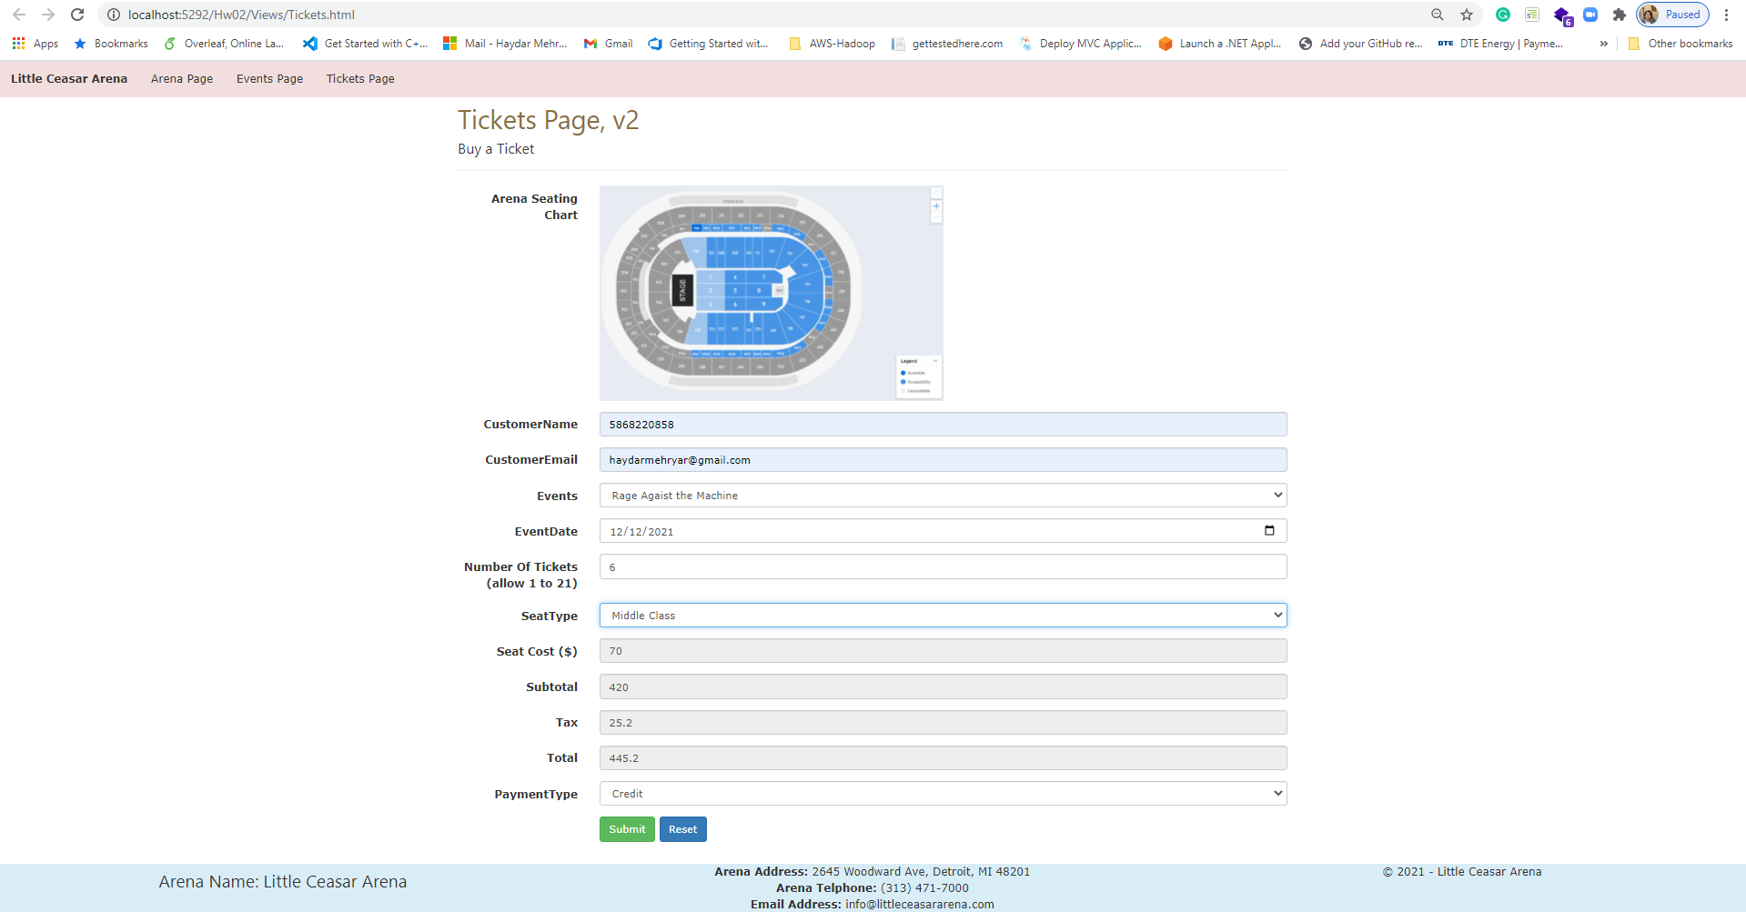

*[your www.tipjar.com/cgi-bin/test response screenshot here]\*\**

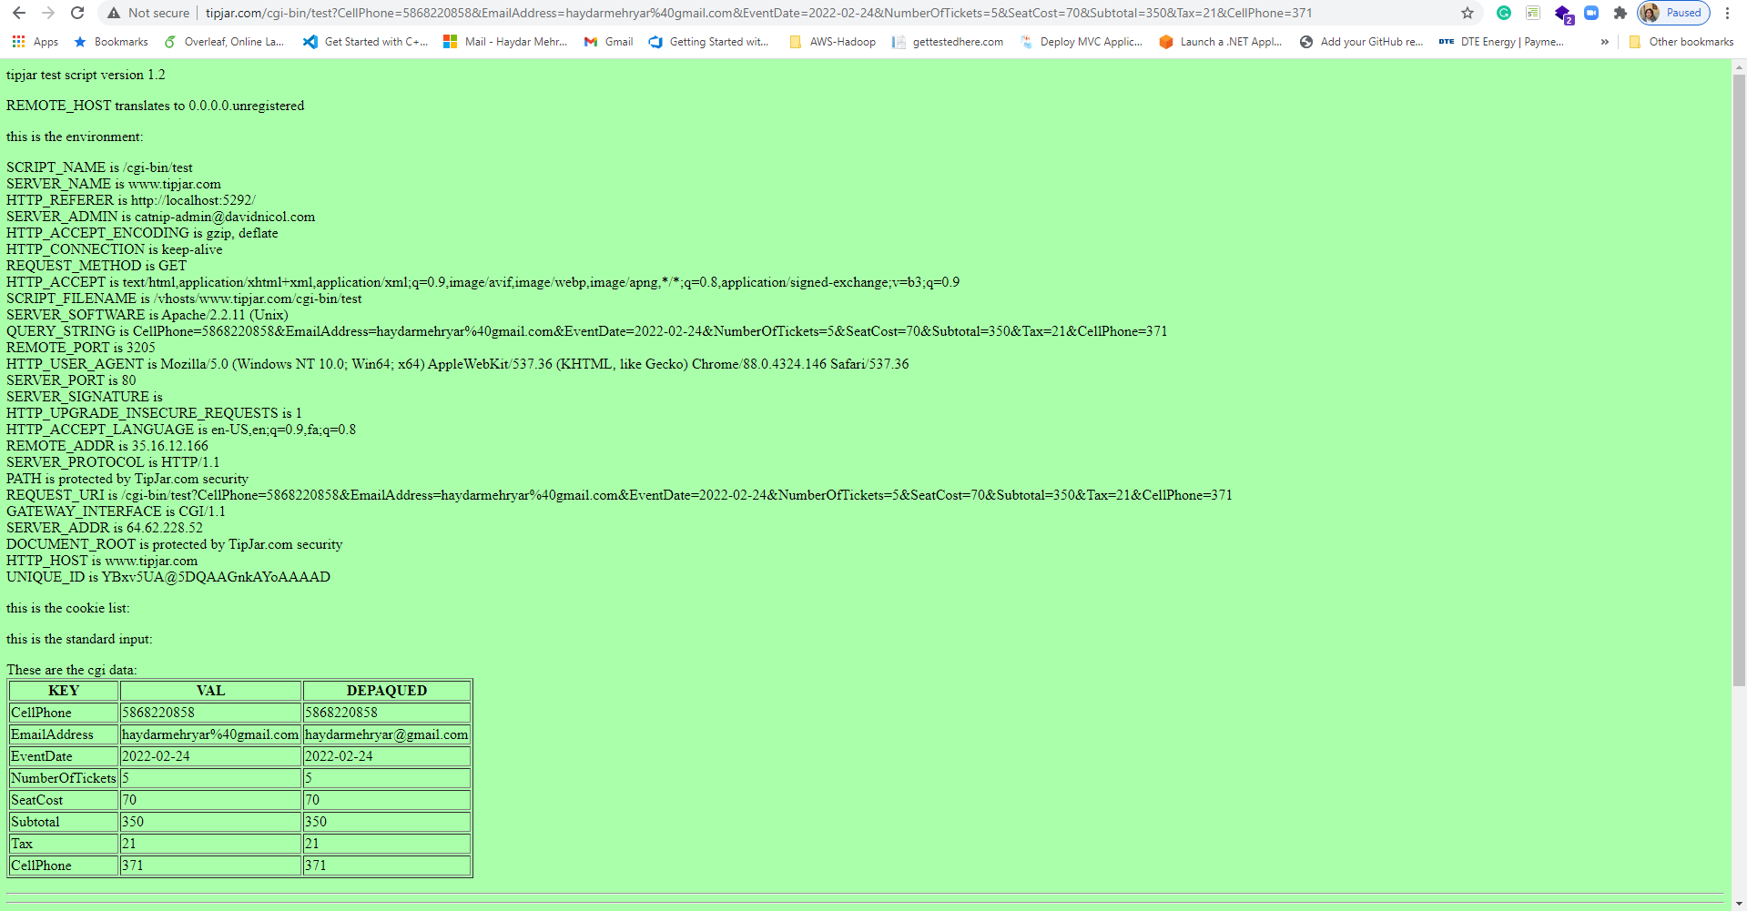

*[your Tickets page screenshot for another seat type and ticket count here]\*\**

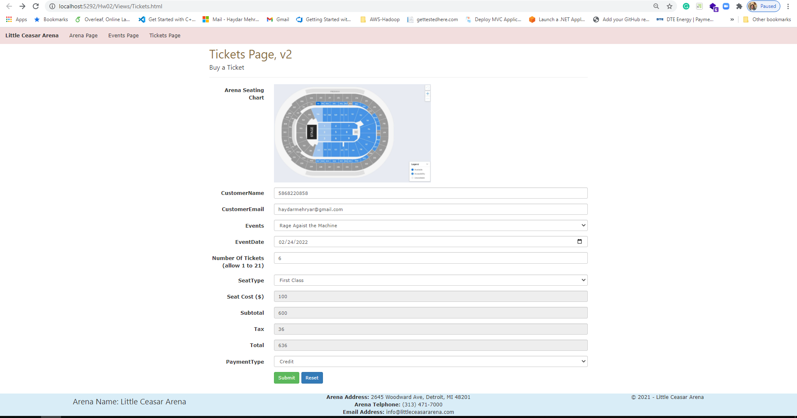

*[your www.tipjar.com/cgi-bin/test response screenshot here]\*\**

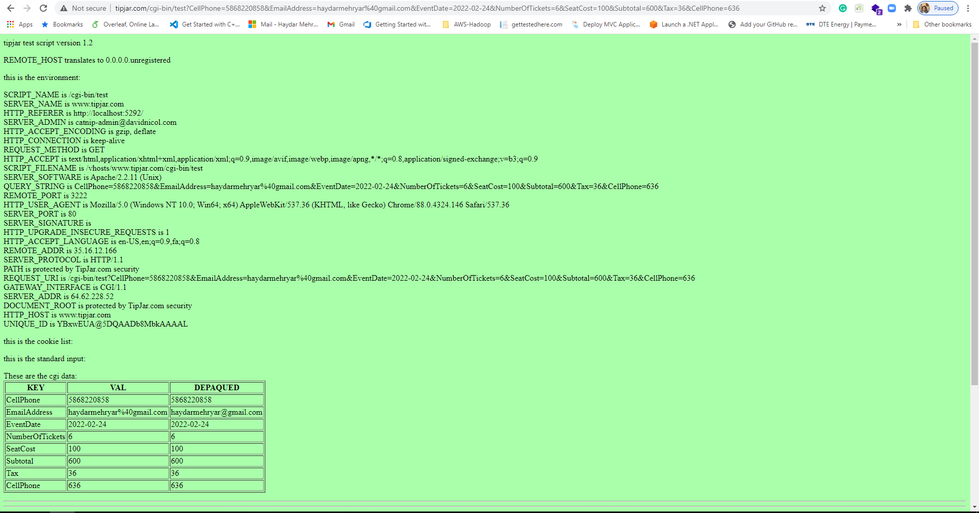

*[your Tickets page screenshot for another seat type and ticket count here]\*\**

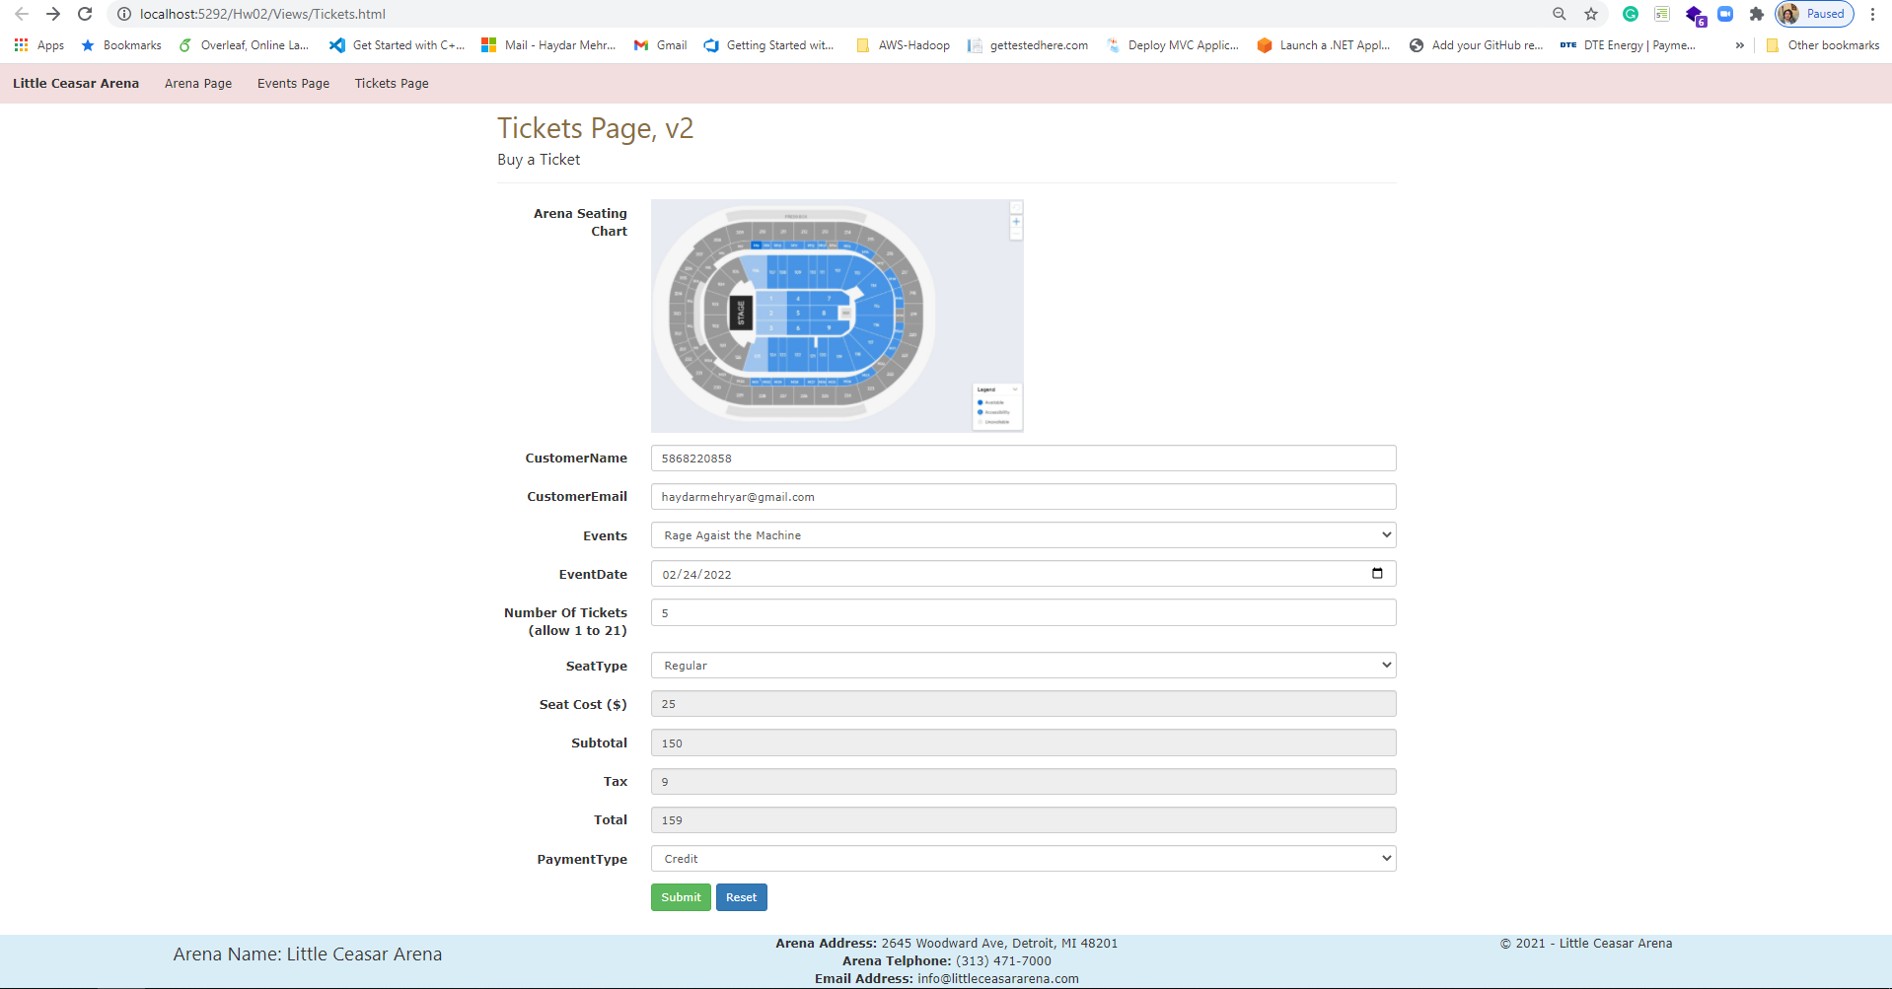

*[your www.tipjar.com/cgi-bin/test response screenshot here]\*\**

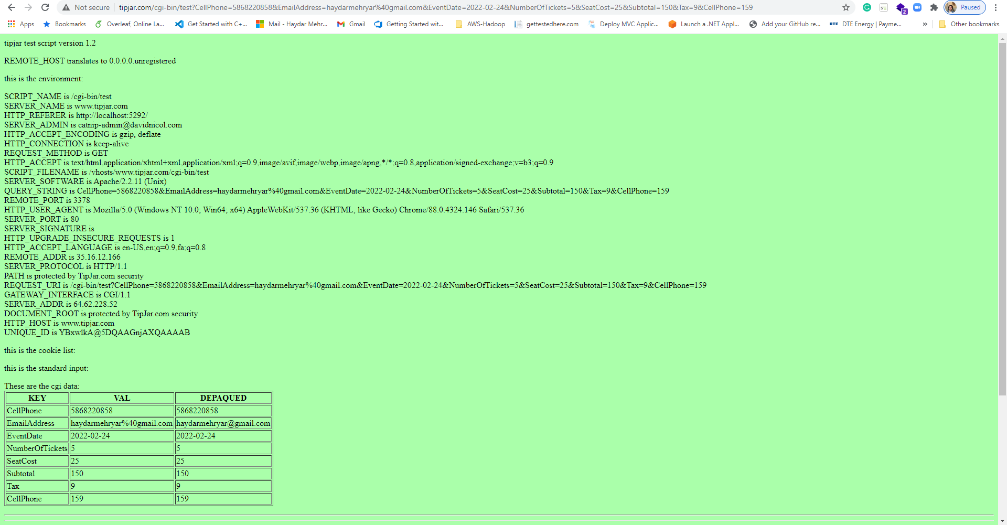

**CSS file**

*[your CSS code here]\**

**If possible, format your code like this:**

**Font “Courier New”**

**Font size “9”**

**Bold**

**body {**

**}**

**.event-img-width {**

**width:200px;**

**}**

**img.arena-seating-chart {**

**width:50%;**

**}**

**ul.navbar-customized {**

**list-style-type: none;**

**margin: 0;**

**padding: 0;**

**overflow: hidden;**

**/*background-color: #333;*/**

**}**

**ul.navbar-customized li {**

**float: left;**

**}**

**ul.navbar-customized li a {**

**display: block;**

**/*color: white;*/**

**text-align: center;**

**padding: 14px 16px;**

**text-decoration: none;**

**}**

**/* Change the link color to #111 (black) on hover */**

**li a:hover {**

**background-color: #e0cece;**

**text-decoration:none;**

**color:white;**

**}**

**.footer {**

**position: fixed;**

**left: 0;**

**bottom: 0;**

**width: 100%;**

**/*background-color: red;**

**color: white;*/**

**text-align: center;**

**}**

**\* Copying-and-pasting web page code to a Word document**

**macOS**

1) From within the HTML editor window, press **command-A** and press **command-C**.

2) From within the Word document, press **command-V**.

**Windows**

1) From within the HTML editor window, press **CTRL-A** and press **CTRL-C**.

2) From within the Word document, press **CTRL-V**.

**\*\* Copying-and-pasting a web page to a Word document**

**macOS**

1) From the browser window, press **shift-command-4-space**.

2) From within the Word document, **command-V**.

**Windows**

1) From the browser window, press **ALT-PrintScreen**.

2) From within the Word document, press **CTRL-V**.