**CSC 5750 – Principles of Web Technology**

**Homework 3, part 2 of 2 – [your name]**

**25 points – Due March 11, 5pm**

**Late deadline is March 13, 11:59pm, but 20% off**

**a)** Save this document with your name and the homework number somewhere in the file name.

**b)** Paste your code and screenshots into the document.

**c)** Gather the following files into a ZIP file with your name and the homework number somewhere in the file name:

● This document

● All HTML files

● All CSS files

● Image files

● Any other optional files specific to your implementation

**d)** Submit the ZIP file to Canvas where you downloaded this document.

You've been hired again by the arena to enhance the web site you created for them in Homeworks 1 and 2. Start with the web site you created in Homework 2, or the Homework 2 key on Canvas, and make the following changes to it. All files referenced here should exist in both a development and a production folder. The production folder was created in Homework 3, part 1 of 2.

**Arena page**

● Update the header comment.

● Add text ", v3" to the end of the title (in the <head> section).

● Create file **Events.json** and move the two-dimensional events array from this page to the file. Place the file in your production folder.

● Remove JavaScript function **storeEvents** and its call.

The events data will now come from your web server. Local storage will no longer be used.

**Events page**

● Add text ", v3" to the end of the title (in the <head> section).

● Modify JavaScript function **loadEvents** to retrieve and parse the events array from file **Events.json** on the server. You may use AJAX or jQuery to retrieve the file. Insure that the DataTables script that sets the data source for the table runs after the AJAX/jQuery request has completed. Again, write a message to the console that reports that the array was retrieved.

**Tickets page**

● Add text ", v3" to the end of the title (in the <head> section).

● Create file **Seats.json** and move the two-dimensional events array from this page to the file. Place the file in your production folder. Keep the seats declaration but without any data.

● Add JavaScript function **loadSeats** to retrieve and parse the seats array from file **Seats.json** on the server. You may use AJAX or jQuery to retrieve the file. If using jQuery, add a link to the jQuery library in the <head> section. Write a message to the console that reports that the array was retrieved. Call the function when the page loads.

● Add JavaScript function **loadEvents** to retrieve and parse the events array from file **Events.json** on the server. You may use AJAX or jQuery to retrieve the file. Write a message to the console that reports that the array was retrieved. This data will be used to build the events combo box.

● Add JavaScript function **setEvents** to loop through the events array, extract the event names, and use them to build options for the events combo box. Use DOM functions createElement, setAttribute, createTextNode, and appendChild to create and attach the options to the current combo box. Use the current HTML options as a guide and then remove them after writing the function. Write a message to the console that reports that the combo box was set.

● Since there are data dependencies among the functions, use the following call sequence to insure that the next function doesn't begin until the previous function has completed:

loadSeats → loadEvents → setEvents → seatTypeSelected

**Styles (CSS) page**

Make any style changes as needed.

**Data flow**

Here is a summary of the data flow in this web site:

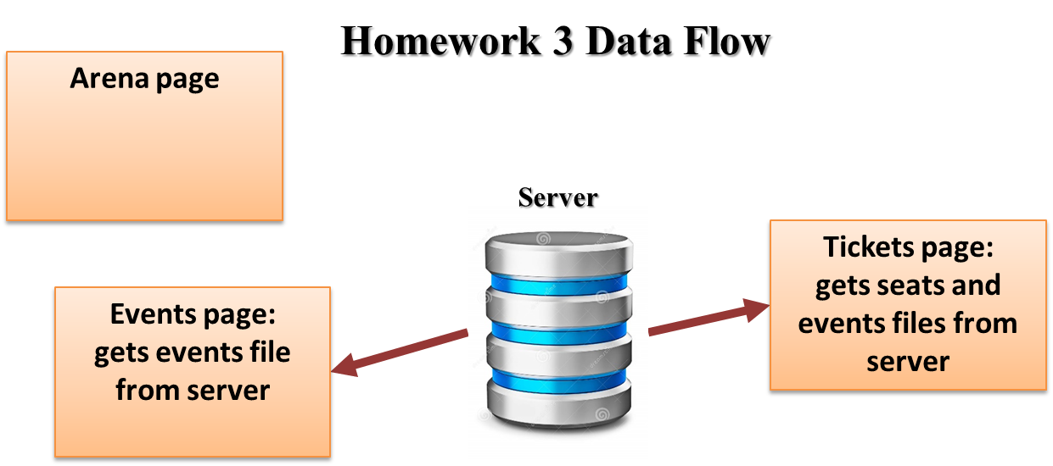

**Note:** use only relative links, not absolute links, to other files on your web site. This means there should be no drive letters or absolute paths, only relative paths, in your file references. You can test this by zipping your web site files, unzipping them in another folder, and then running your web site. There should be no linking errors if you used only relative links. The best approach is to put all web site files in one folder.

**Arena page**

*[your Arena page HTML code here]\**

<!DOCTYPE html>

<html lang="en" xmlns="http://www.w3.org/1999/xhtml">

<head>

<title>Arena page, v2</title>

<!-- Required meta tags -->

<meta charset="utf-8">

<meta name="viewport" content="width=device-width, initial-scale=1">

<!-- Bootstrap CSS -->

<!-- Latest compiled and minified CSS -->

<link rel="stylesheet" href="https://stackpath.bootstrapcdn.com/bootstrap/3.4.1/css/bootstrap.min.css" integrity="sha384-HSMxcRTRxnN+Bdg0JdbxYKrThecOKuH5zCYotlSAcp1+c8xmyTe9GYg1l9a69psu" crossorigin="anonymous">

<!-- W3.CSS link -->

<link rel="stylesheet" href="https://www.w3schools.com/w3css/4/w3.css">

<!-- DataTables CSS and script links -->

<link rel="stylesheet" type="text/css" href="https://cdn.datatables.net/1.10.23/css/jquery.dataTables.min.css">

<link href="../Contents/Content.css" rel="stylesheet" />

</head>

<body>

<ul class="navbar-customized bg-danger">

<li><a href="#"><b>Little Ceasar Arena</b></a></li>

<li><a href="/Views/Arena.html">Arena Page</a></li>

<li><a href="/Views/Events.html">Events Page</a></li>

<li><a href="/Views/Tickets.html">Tickets Page</a></li>

</ul>

<div class="container">

<h1 class="text-warning"> Arena Page</h1>

<div>

<h3>Little Caesars Arena</h3>

<hr />

</div>

<div>

<b>Arena capacity:</b>

Ice hockey: 19,515

Basketball: 20,332

Concerts: 15,000–22,000

</div>

<div>

<b>Arena concessions:</b> Sales of game tickets, parking, concessions, souvenirs,

and any potential naming rights deals would not be subject to revenue sharing with the City of Detroit as they were with Joe Louis Arena.

</div>

<div>Seating categories: First-class, Middle-class, Regular</div>

<div>

<b>Arena history including year built:</b>

Little Caesars Arena is a multi-purpose arena in Midtown Detroit. Construction began on April 24, 2015, following a formal groundbreaking ceremony on September 25, 2014. Opened on September 5, 2017, the arena, which cost $862.9 million to construct, replaced Joe Louis Arena and The Palace of Auburn Hills as the homes of the Detroit Red Wings of the National Hockey League (NHL) and the Detroit Pistons of the National Basketball Association (NBA), respectively.

</div>

<div class="col-md-7">

<iframe src="https://www.google.com/maps/embed?pb=!1m14!1m8!1m3!1d11796.266553292922!2d-83.0552673!3d42.3411026!3m2!1i1024!2i768!4f13.1!3m3!1m2!1s0x0%3A0xcb0fd860979f4678!2sLittle%20Caesars%20Arena!5e0!3m2!1sen!2sus!4v1612490585556!5m2!1sen!2sus"

width="600" height="450" frameborder="0" style="border:0;" allowfullscreen="" aria-hidden="false" tabindex="0"></iframe>

</div>

<div class="col-md-5">

<img src="../Images/Arena/CrislerArena.jpg" class="arena-img"/>

<!--<img src="\Images\Arena\arena-little-caesars-01.jpg" />-->

</div>

</div>

<div class="footer bg-info">

<div class="row">

<div class="col-md-4">

<h3>

Arena Name: Little Ceasar Arena

</h3>

</div>

<div class="col-md-4">

<div><b>Arena Address:</b> 2645 Woodward Ave, Detroit, MI 48201</div>

<div><b>Arena Telphone:</b> (313) 471-7000</div>

<div><b>Email Address:</b> info@littleceasararena.com</div>

</div>

<div class="col-md-4">

<p>© 2021 - Little Ceasar Arena</p>

</div>

</div>

</div>

<script src="https://code.jquery.com/jquery-3.5.1.js"></script>

<script src="https://cdn.datatables.net/1.10.23/js/jquery.dataTables.min.js"></script>

<!-- Latest compiled and minified JavaScript -->

<script src="https://stackpath.bootstrapcdn.com/bootstrap/3.4.1/js/bootstrap.min.js" integrity="sha384-aJ21OjlMXNL5UyIl/XNwTMqvzeRMZH2w8c5cRVpzpU8Y5bApTppSuUkhZXN0VxHd" crossorigin="anonymous"></script>

<!-- DataTables script -->

<script type="text/javascript">

"use strict";

$(document).ready(function () {

//================================================================

// clearFields

//================================================================

function clearFields() {

//hRawData.innerHTML = "Raw data";

//tRawData.value = "";

//tStringifyData.value = "";

//tParseData.value = "";

//tblMenu.innerHTML = "";

}

//================================================================

// convertToAndFromJSON

//================================================================

function convertToAndFromJSON(obj) {

// Clear fields

clearFields();

// Show raw object

hRawData.innerHTML = "Raw data (object type: " + typeof (obj) + ")";

tRawData.value = obj;

// Stringify and show object

var objStringify = JSON.stringify(obj);

tStringifyData.value = objStringify;

// Parse and show object

var objParse = JSON.parse(objStringify);

tParseData.value = objParse;

}

});

</script>

</body>

</html>

**If possible, format your code like this:**

**Font “Courier New”**

**Font size “9”**

**Bold**

*[your Arena page screenshot here]\*\**

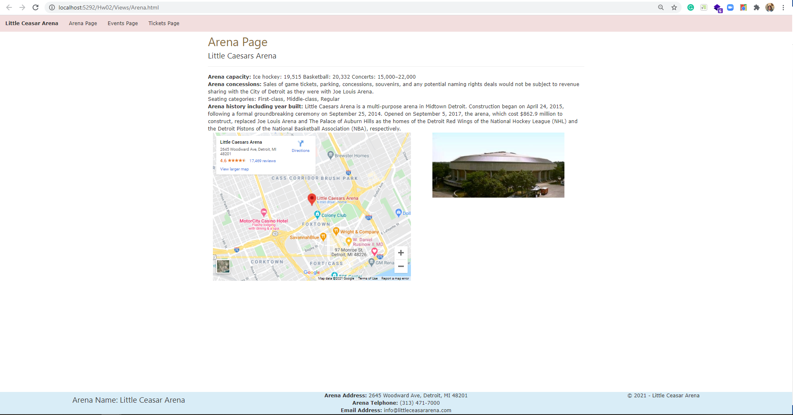

**Events page**

*[your Events page HTML code here]\**

<!DOCTYPE html>

<html lang="en" xmlns="http://www.w3.org/1999/xhtml">

<head>

<title>Events page, v3</title>

<!-- Required meta tags -->

<meta charset="utf-8">

<meta name="viewport" content="width=device-width, initial-scale=1">

<!-- Bootstrap CSS -->

<!-- Latest compiled and minified CSS -->

<link rel="stylesheet" href="https://stackpath.bootstrapcdn.com/bootstrap/3.4.1/css/bootstrap.min.css" integrity="sha384-HSMxcRTRxnN+Bdg0JdbxYKrThecOKuH5zCYotlSAcp1+c8xmyTe9GYg1l9a69psu" crossorigin="anonymous">

<!-- W3.CSS link -->

<link rel="stylesheet" href="https://www.w3schools.com/w3css/4/w3.css">

<!-- DataTables CSS and script links -->

<link rel="stylesheet" type="text/css" href="https://cdn.datatables.net/1.10.23/css/jquery.dataTables.min.css">

<link href="../Contents/Content.css" rel="stylesheet" />

</head>

<body>

<ul class="navbar-customized bg-danger">

<li><a href="#"><b>Little Ceasar Arena</b></a></li>

<li><a href="/Views/Arena.html">Arena Page</a></li>

<li><a href="/Views/Events.html">Events Page</a></li>

<li><a href="/Views/Tickets.html">Tickets Page</a></li>

</ul>

<div class="container">

<h1 class="text-warning"> Events Page</h1>

<hr />

<table class="table table-sm table-hover table-responsive table-responsive-lg" id="tblMenu">

<thead>

<tr>

<th scope="col">Event</th>

<th scope="col">Date</th>

<th scope="col">Ticket Price Range</th>

<th scope="col">Images related to event</th>

<!--<th scope="col">#</th>

<th scope="col">First</th>

<th scope="col">Last</th>

<th scope="col">Handle</th>-->

</tr>

</thead>

<tbody>

<tr>

<th scope="row">The Millennium Tour 2021</th>

<td>APR 09 / 2021</td>

<td>10 $ - 40 $</td>

<td>

<figure class="figure">

<img src="../Images/Events/events-millenium_tour_600x600_thumb-8fbb1c836f.jpg" class="figure-img img-fluid rounded img-thumbnail event-img-width" alt="...">

</figure>

</td>

</tr>

<tr>

<th scope="row">The Weekend</th>

<td>JUNE 28 / 2021</td>

<td>30 $ - 50 $</td>

<td>

<figure class="figure">

<img src="../Images/Events/events-weeknd_313_presents_600x600_thumb-b47621808a.jpg" class="figure-img img-fluid rounded img-thumbnail event-img-width" alt="...">

</figure>

</td>

</tr>

<tr>

<th scope="row">Justin Bieber</th>

<td>JUNE 28 / 2021</td>

<td>20 $ - 40 $</td>

<td>

<figure class="figure">

<img src="../Images/Events/events-Justin_Bieber_Detroit_2021_600x600-f765928793.jpg" class="figure-img img-fluid rounded img-thumbnail event-img-width" alt="...">

</figure>

</td>

</tr>

<tr>

<th scope="row">Rage Agaist the Machine</th>

<td>JUNE 26 - 27 / 2021</td>

<td>40 $ - 60 $</td>

<td>

<figure class="figure">

<img src="../Images/Events/events-rage_against_the_machine_313_presents_600x600_thumb-1-1289b510c4-1-79d1397c52.jpg" class="figure-img img-fluid rounded img-thumbnail event-img-width" alt="...">

</figure>

</td>

</tr>

<tr>

<th scope="row">My Chemical Romance</th>

<td>SEP 15 / 2021</td>

<td>30 $ - 40 $</td>

<td>

<figure class="figure">

<img src="../Images/Events/events-my_chemical_romance_313_presents_600x600_thumb-d028253a7b.jpg" class="figure-img img-fluid rounded img-thumbnail event-img-width" alt="...">

</figure>

</td>

</tr>

<tr>

<th scope="row">Alan Jackson</th>

<td>SEP 17 / 2021</td>

<td>70 $ - 80 $</td>

<td>

<figure class="figure">

<img src="../Images/Events/events-alan_jackson_2021_313_presents_600x600_v2-9488592118.jpg" class="figure-img img-fluid rounded img-thumbnail event-img-width" alt="...">

</figure>

</td>

</tr>

<tr>

<th scope="row">Harry Styles</th>

<td>SEP 20 / 2021</td>

<td>50 $ - 70 $</td>

<td>

<figure class="figure">

<img src="../Images/Events/events-HarryStyles_1080x1080_2021-8ffc82717d.jpg" class="figure-img img-fluid rounded img-thumbnail event-img-width" alt="...">

</figure>

</td>

</tr>

<tr>

<th scope="row">Tame Impala</th>

<td>OCT 05 / 2021</td>

<td>35 $ - 50 $</td>

<td>

<figure class="figure">

<img src="../Images/Events/events-tame_impala_313_presents_600x600_thumb-f5749392fc.jpg" class="figure-img img-fluid rounded img-thumbnail event-img-width" alt="...">

</figure>

</td>

</tr>

<tr>

<th scope="row">Dan + Shay</th>

<td>DEC 03 / 2021</td>

<td>50 $ - 75 $</td>

<td>

<figure class="figure">

<img src="../Images/Events/events-Dan_shay_2021_600x600_thumb-cd95d10d5c.jpg" class="figure-img img-fluid rounded img-thumbnail event-img-width" alt="...">

</figure>

</td>

</tr>

</tbody>

</table>

</div>

<div class="footer bg-info">

<div class="row">

<div class="col-md-4">

<h3>

Arena Name: Little Ceasar Arena

</h3>

</div>

<div class="col-md-4">

<div><b>Arena Address:</b> 2645 Woodward Ave, Detroit, MI 48201</div>

<div><b>Arena Telphone:</b> (313) 471-7000</div>

<div><b>Email Address:</b> info@littleceasararena.com</div>

</div>

<div class="col-md-4">

<p>© 2021 - Little Ceasar Arena</p>

</div>

</div>

</div>

<script src="https://code.jquery.com/jquery-3.5.1.js"></script>

<script src="https://cdn.datatables.net/1.10.23/js/jquery.dataTables.min.js"></script>

<!-- Latest compiled and minified JavaScript -->

<script src="https://stackpath.bootstrapcdn.com/bootstrap/3.4.1/js/bootstrap.min.js" integrity="sha384-aJ21OjlMXNL5UyIl/XNwTMqvzeRMZH2w8c5cRVpzpU8Y5bApTppSuUkhZXN0VxHd" crossorigin="anonymous"></script>

<script type="text/javascript">

"use strict";

$(document).ready(function () {

//================================================================

// Script-level variables

//================================================================

var data;

var arrUnnamed;

//================================================================

// getAndShowData

//================================================================

function loadEvents() {

// Get data

$.getJSON("../Scripts/Events.json", function (response) {

console.log(response);

populateTable(response);

})

}

// Populating the Inventory Table

function populateTable(json) {

var inventoryBody = document.querySelector("#tblMenu > tbody");

//Remove the Pre-Defined Data

while (inventoryBody.firstChild) {

inventoryBody.removeChild(inventoryBody.firstChild);

}

// Populating the Inventory Table through a for LOOP

json.forEach((row) => {

var tr = document.createElement("tr");

for (var i = 0; i < row.length; i++) {

var td = document.createElement("td");

//rowSize=(row.length-1);

if (i == 3) {

var img = document.createElement("IMG");

img.src = row[i];

img.width = '300';

img.height = '200';

td.append(img);

}

else {

td.textContent = row[i];

}

tr.appendChild(td);

}

row.forEach((cell) => {

});

inventoryBody.appendChild(tr);

});

}

loadEvents();

})

</script>

</body>

</html>

**If possible, format your code like this:**

**Font “Courier New”**

**Font size “9”**

**Bold**

*[your Events page screenshot here]\*\**

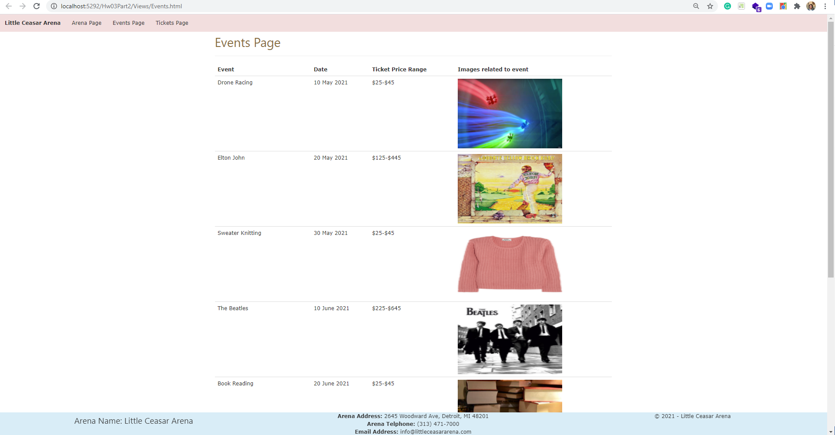

**Tickets page**

*[your Tickets page HTML code here]\**

**<!DOCTYPE html>**

**<html lang="en" xmlns="http://www.w3.org/1999/xhtml">**

**<head>**

**<title>Tickets page, v3</title>**

**<!-- Required meta tags -->**

**<meta charset="utf-8">**

**<meta name="viewport" content="width=device-width, initial-scale=1">**

**<!-- Bootstrap CSS -->**

**<!-- Latest compiled and minified CSS -->**

**<link rel="stylesheet" href="https://stackpath.bootstrapcdn.com/bootstrap/3.4.1/css/bootstrap.min.css" integrity="sha384-HSMxcRTRxnN+Bdg0JdbxYKrThecOKuH5zCYotlSAcp1+c8xmyTe9GYg1l9a69psu" crossorigin="anonymous">**

**<!-- W3.CSS link -->**

**<link rel="stylesheet" href="https://www.w3schools.com/w3css/4/w3.css">**

**<!-- DataTables CSS and script links -->**

**<link rel="stylesheet" type="text/css" href="https://cdn.datatables.net/1.10.23/css/jquery.dataTables.min.css">**

**<link href="../Contents/Content.css" rel="stylesheet" />**

**</head>**

**<body>**

**<ul class="navbar-customized bg-danger">**

**<li><a href="#"><b>Little Ceasar Arena</b></a></li>**

**<li><a href="/Views/Arena.html">Arena Page</a></li>**

**<li><a href="/Views/Events.html">Events Page</a></li>**

**<li><a href="/Views/Tickets.html">Tickets Page</a></li>**

**</ul>**

**<div class="container">**

**<h1 class="text-warning"> Tickets Page</h1>**

**<form method="get" action="http://www.tipjar.com/cgi-bin/test">**

**<div class="form-horizontal">**

**<h4>Buy a Ticket</h4>**

**<hr>**

**<div class="form-group">**

**<label class="control-label col-md-2" for="ArenaSeatingChart">Arena Seating Chart</label>**

**<div class="col-md-10">**

**<img src="../Images/ArenaSeatingChart/seating-chart-01-little-seasar.JPG" class="arena-seating-chart" />**

**</div>**

**</div>**

**<div class="form-group">**

**<label class="control-label col-md-2" for="CustomerName">CustomerName</label>**

**<div class="col-md-10">**

**<input class="form-control text-box single-line" data-val="true" data-val-required="CustomerName is required!" id="CustomerName" name="CellPhone" type="tel" value="">**

**<span class="field-validation-valid text-danger" data-valmsg-for="CustomerName" data-valmsg-replace="true"></span>**

**</div>**

**</div>**

**<div class="form-group">**

**<label class="control-label col-md-2" for="CustomerEmail">CustomerEmail</label>**

**<div class="col-md-10">**

**<input class="form-control text-box single-line" data-val="true" data-val-required="Email Address is required!" id="CustomerEmail" name="EmailAddress" type="email" value="">**

**<span class="field-validation-valid text-danger" data-valmsg-for="CustomerEmail" data-valmsg-replace="true"></span>**

**</div>**

**</div>**

**<div class="form-group">**

**<label class="control-label col-md-2" for="Events">Events</label>**

**<div class="col-md-10">**

**<select id="Events" class="form-control">**

**<!--<option value="1">The Millennium Tour 2021</option>**

**<option value="2">The Weekend</option>**

**<option value="3">Justin Bieber</option>**

**<option value="4" selected>Rage Agaist the Machine</option>**

**<option value="5">My Chemical Romance</option>**

**<option value="6">Alan Jackson</option>**

**<option value="7">Harry Styles</option>-->**

**</select>**

**</div>**

**</div>**

**<div class="form-group">**

**<label class="control-label col-md-2" for="EventDate">EventDate</label>**

**<div class="col-md-10">**

**<input class="form-control text-box single-line" data-val="true" data-val-required="EventDate is required!" id="EventDate" name="EventDate" type="date" value="">**

**<span class="field-validation-valid text-danger" data-valmsg-for="EventDate" data-valmsg-replace="true"></span>**

**</div>**

**</div>**

**<div class="form-group">**

**<label class="control-label col-md-2" for="NumberOfTickets">Number Of Tickets (allow 1 to 21)</label>**

**<div class="col-md-10">**

**<input class="form-control text-box single-line" data-val="true" data-val-required="NumberOfTickets is required!" id="NumberOfTickets" name="NumberOfTickets" type="tel" value="">**

**<span class="field-validation-valid text-danger" data-valmsg-for="NumberOfTickets" data-valmsg-replace="true"></span>**

**</div>**

**</div>**

**<div class="form-group">**

**<label class="control-label col-md-2" for="SeatType">SeatType</label>**

**<div class="col-md-10">**

**<select id="SeatType" class="form-control col-md-9">**

**<!--<option value="1">First Class</option>**

**<option value="2">Middle Class</option>**

**<option value="3">Regular</option>-->**

**</select>**

**</div>**

**</div>**

**<div class="form-group">**

**<label class="control-label col-md-2" for="SeatCost">Seat Cost ($)</label>**

**<div class="col-md-10">**

**<input class="form-control text-box single-line" data-val="true" data-val-required="SeatCost is required!" id="SeatCost" name="SeatCost" type="tel" value="" readonly>**

**<span class="field-validation-valid text-danger" data-valmsg-for="SeatCost" data-valmsg-replace="true"></span>**

**</div>**

**</div>**

**<div class="form-group">**

**<label class="control-label col-md-2" for="Subtotal">Subtotal</label>**

**<div class="col-md-10">**

**<input class="form-control text-box single-line" data-val="true" data-val-required="Subtotal is required!" id="Subtotal" name="Subtotal" type="tel" value="" readonly>**

**<span class="field-validation-valid text-danger" data-valmsg-for="Subtotal" data-valmsg-replace="true"></span>**

**</div>**

**</div>**

**<div class="form-group">**

**<label class="control-label col-md-2" for="Tax">Tax</label>**

**<div class="col-md-10">**

**<input class="form-control text-box single-line" data-val="true" data-val-required="Tax is required!" id="Tax" name="Tax" type="tel" value="" readonly>**

**<span class="field-validation-valid text-danger" data-valmsg-for="Tax" data-valmsg-replace="true"></span>**

**</div>**

**</div>**

**<div class="form-group">**

**<label class="control-label col-md-2" for="Total">Total</label>**

**<div class="col-md-10">**

**<input class="form-control text-box single-line" data-val="true" data-val-required="Total is required!" id="Total" name="Total" type="tel" value="" readonly>**

**<span class="field-validation-valid text-danger" data-valmsg-for="Total" data-valmsg-replace="true"></span>**

**</div>**

**</div>**

**<div class="form-group">**

**<label class="control-label col-md-2" for="PaymentType">PaymentType</label>**

**<div class="col-md-10">**

**<select id="PaymentType" class="form-control col-md-9">**

**<option value="1">Credit</option>**

**<option value="2">Paypal</option>**

**<option value="2">Venmo</option>**

**</select>**

**</div>**

**</div>**

**<div class="form-group">**

**<div class="col-md-offset-2 col-md-10">**

**<input type="submit" value="Submit" class="btn btn-default btn-success">**

**<input type="reset" value="Reset" class="btn btn-default btn-primary">**

**</div>**

**</div>**

**</div>**

**</form>**

**</div>**

**<div class="footer bg-info">**

**<div class="row">**

**<div class="col-md-4">**

**<h3>**

**Arena Name: Little Ceasar Arena**

**</h3>**

**</div>**

**<div class="col-md-4">**

**<div><b>Arena Address:</b> 2645 Woodward Ave, Detroit, MI 48201</div>**

**<div><b>Arena Telphone:</b> (313) 471-7000</div>**

**<div><b>Email Address:</b> info@littleceasararena.com</div>**

**</div>**

**<div class="col-md-4">**

**<p>© 2021 - Little Ceasar Arena</p>**

**</div>**

**</div>**

**</div>**

**<script src="https://code.jquery.com/jquery-3.5.1.js"></script>**

**<script src="https://cdn.datatables.net/1.10.23/js/jquery.dataTables.min.js"></script>**

**<!-- Latest compiled and minified JavaScript -->**

**<script src="https://stackpath.bootstrapcdn.com/bootstrap/3.4.1/js/bootstrap.min.js" integrity="sha384-aJ21OjlMXNL5UyIl/XNwTMqvzeRMZH2w8c5cRVpzpU8Y5bApTppSuUkhZXN0VxHd" crossorigin="anonymous"></script>**

**<script type="text/javascript">**

**"use strict";**

**var seats;**

**// =[**

**// [**

**// "Regular",**

**// 25**

**// ],**

**// [**

**// "Mezzanine",**

**// 50**

**// ],**

**// [**

**// "Middle Class",**

**// 70**

**// ],**

**// [**

**// "First Class",**

**// 100**

**// ],**

**//];**

**$(document).ready(function () {**

**//================================================================**

**// Script-level variables**

**//================================================================**

**var subtotal = 0;**

**var tax = 0;**

**var total = 0;**

**//================================================================**

**// Setting SeatType Dropdown**

**//================================================================**

**loadSeats();**

**loadEvents();**

**$("#SeatType").change(function () {**

**var str = "";**

**$("#SeatType option:selected").each(function () {**

**var numberOfTickets = $("#NumberOfTickets").val();**

**var seatCost = $(this).val();**

**$("#SeatCost").val(seatCost);**

**str += $(this).text() + " " + $(this).val() + " " + numberOfTickets;**

**subtotal = numberOfTickets * seatCost;**

**tax = subtotal * 0.06;**

**total = subtotal + tax;**

**console.log(subtotal);**

**console.log(tax);**

**console.log(total);**

**$("#Subtotal").val(subtotal);**

**$("#Tax").val(tax);**

**$("#Total").val(total);**

**});**

**});**

**function loadSeats() {**

**$.getJSON("../Scripts/Seats.json", function (response) {**

**console.log(response);**

**var options = "";**

**response.forEach((row) => {**

**options += '<option value="' + row[1] + '">' + row[0] + '</option>';**

**});**

**$('#SeatType').append(options);**

**});**

**}**

**function loadEvents() {**

**$.getJSON("../Scripts/Events.json", function (response) {**

**console.log(response);**

**var options = "";**

**response.forEach((row) => {**

**options += '<option value="' + row[0] + '">' + row[0] + '</option>';**

**});**

**$('#Events').append(options);**

**console.log("Event combo box is set");**

**})**

**}**

**})**

**</script>**

**</body>**

**</html>If possible, format your code like this:**

**Font “Courier New”**

**Font size “9”**

**Bold**

*[your Tickets page screenshot for one seat type and ticket count here]\*\**

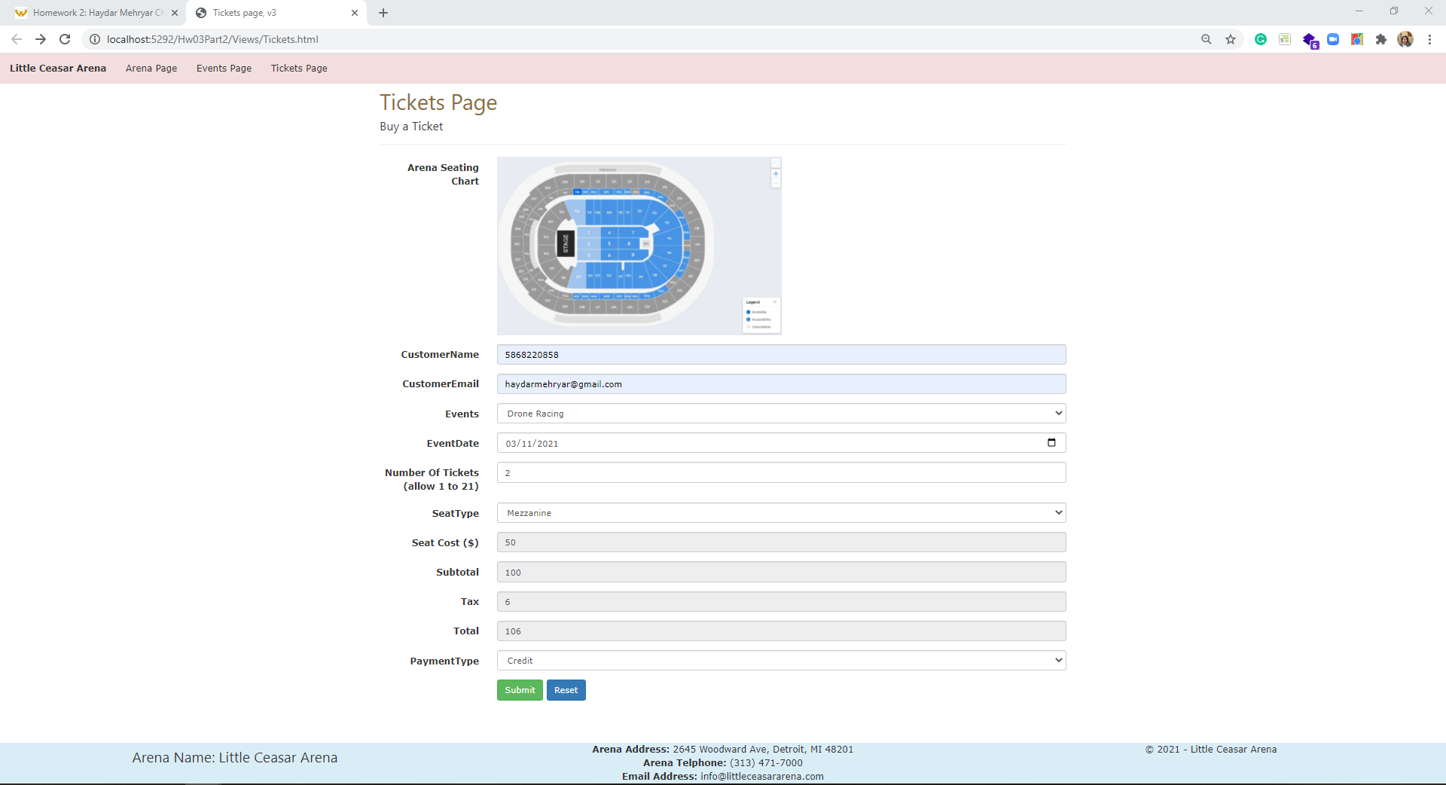

*[your www.tipjar.com/cgi-bin/test response screenshot here]\*\**

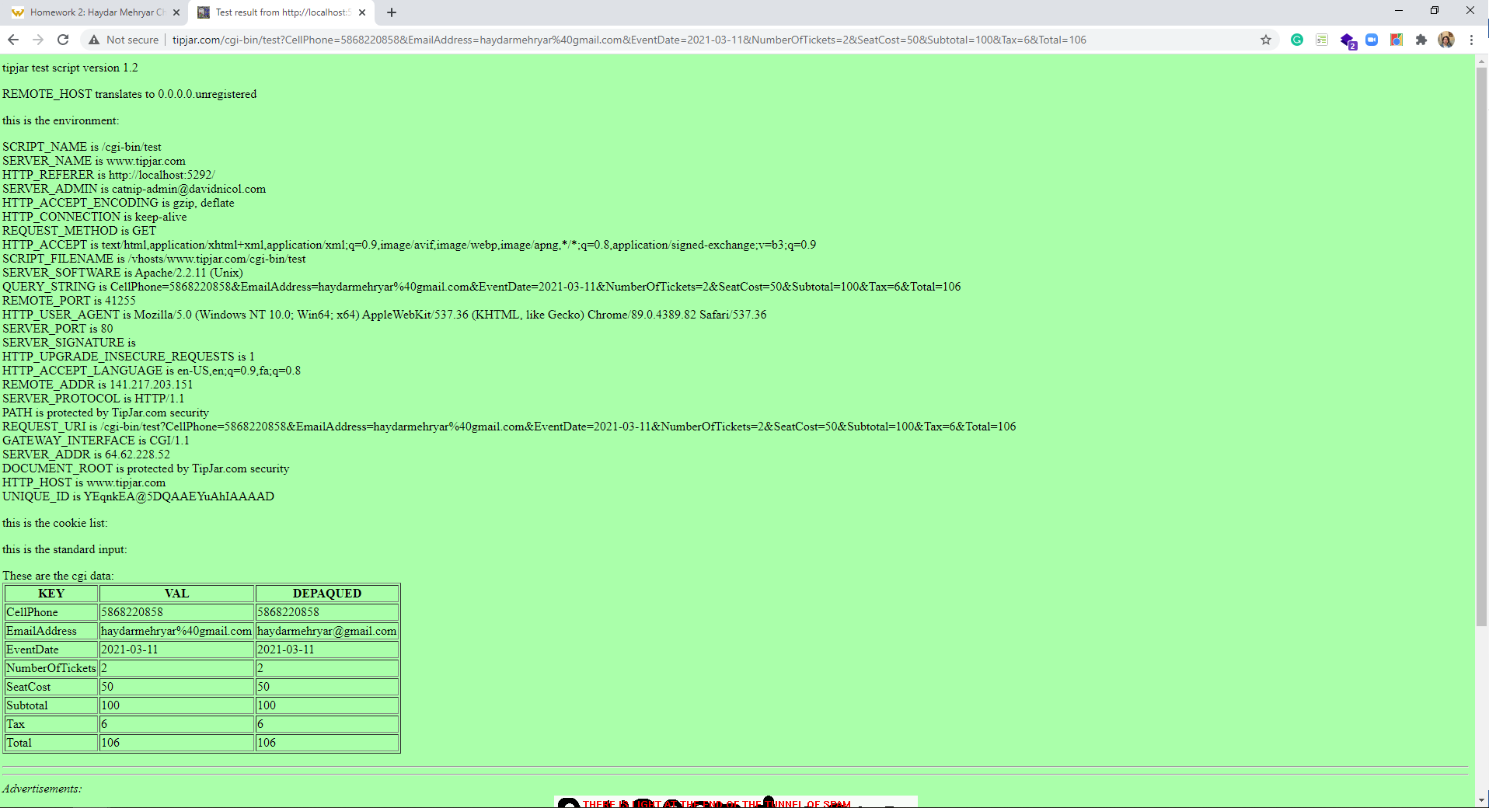

*[your Tickets page screenshot for another seat type and ticket count here]\*\**

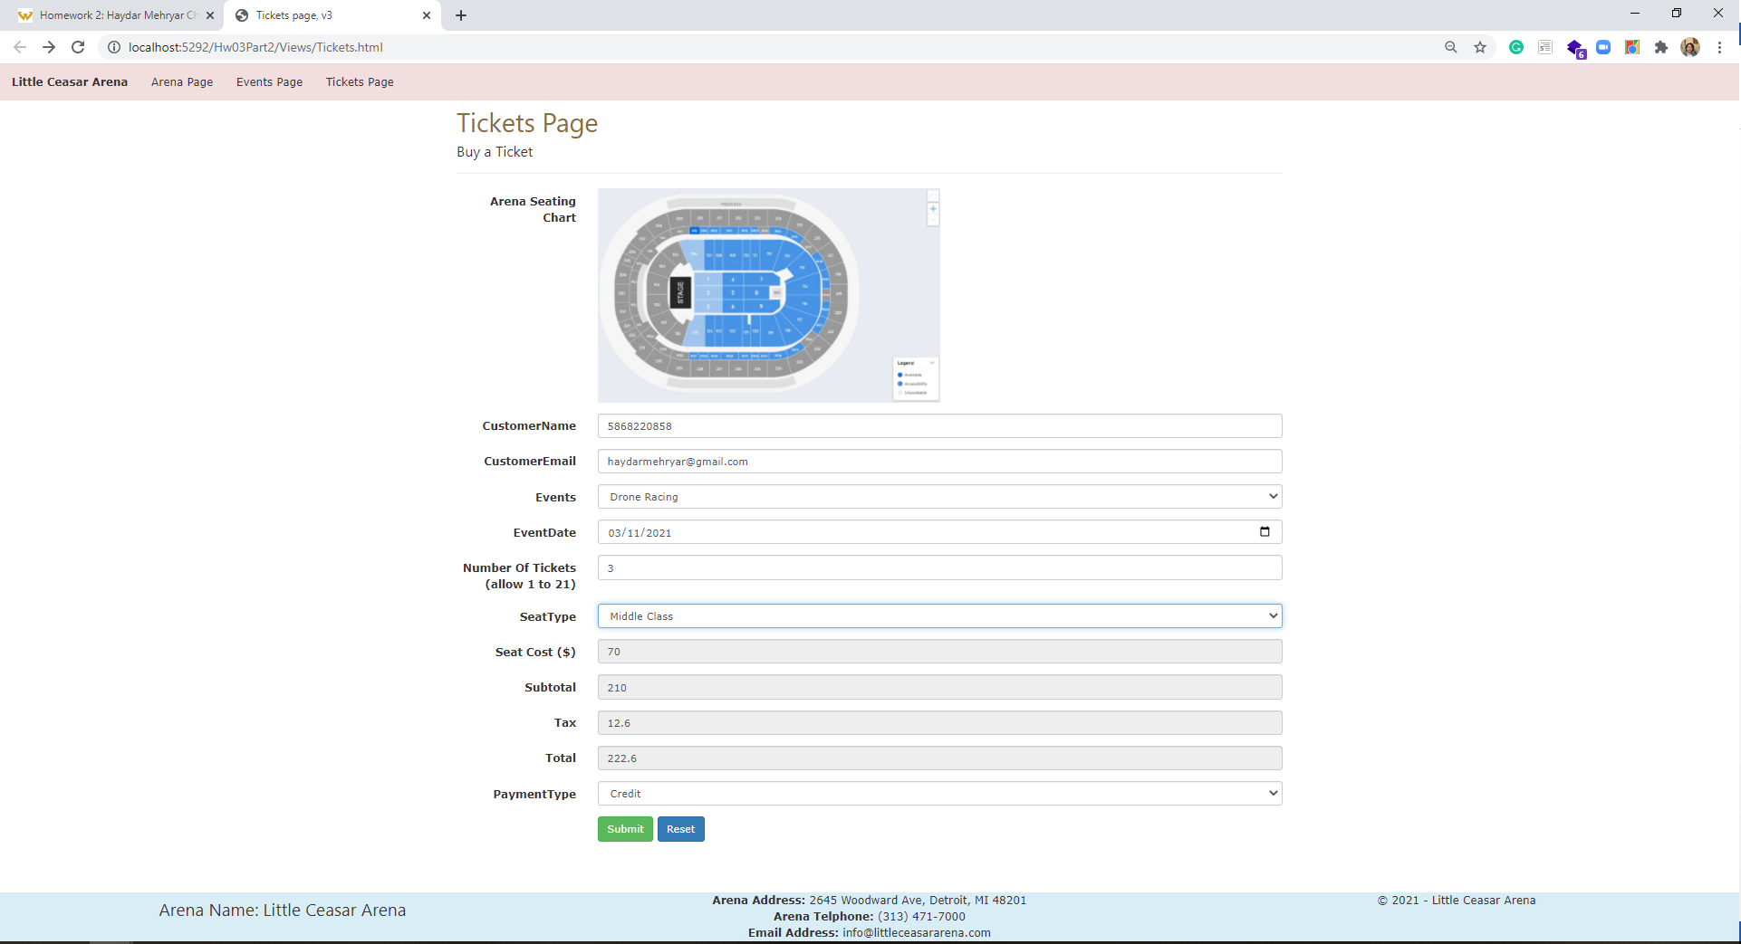

*[your www.tipjar.com/cgi-bin/test response screenshot here]\*\**

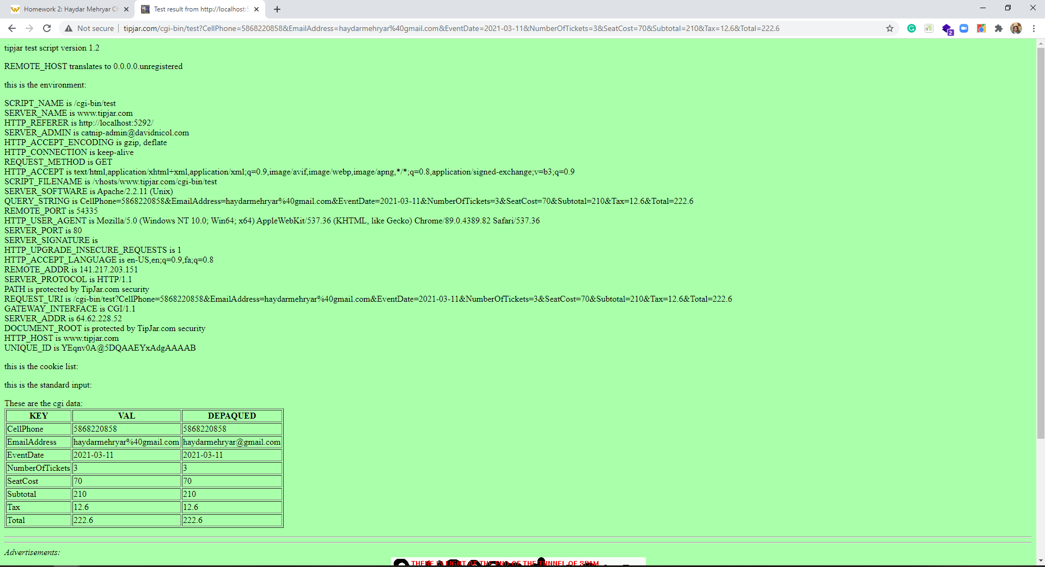

*[your Tickets page screenshot for another seat type and ticket count here]\*\**

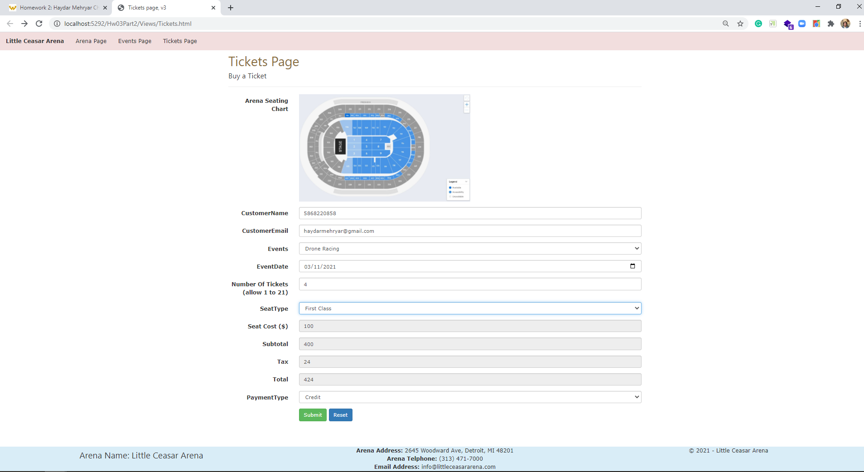

*[your www.tipjar.com/cgi-bin/test response screenshot here]\*\**

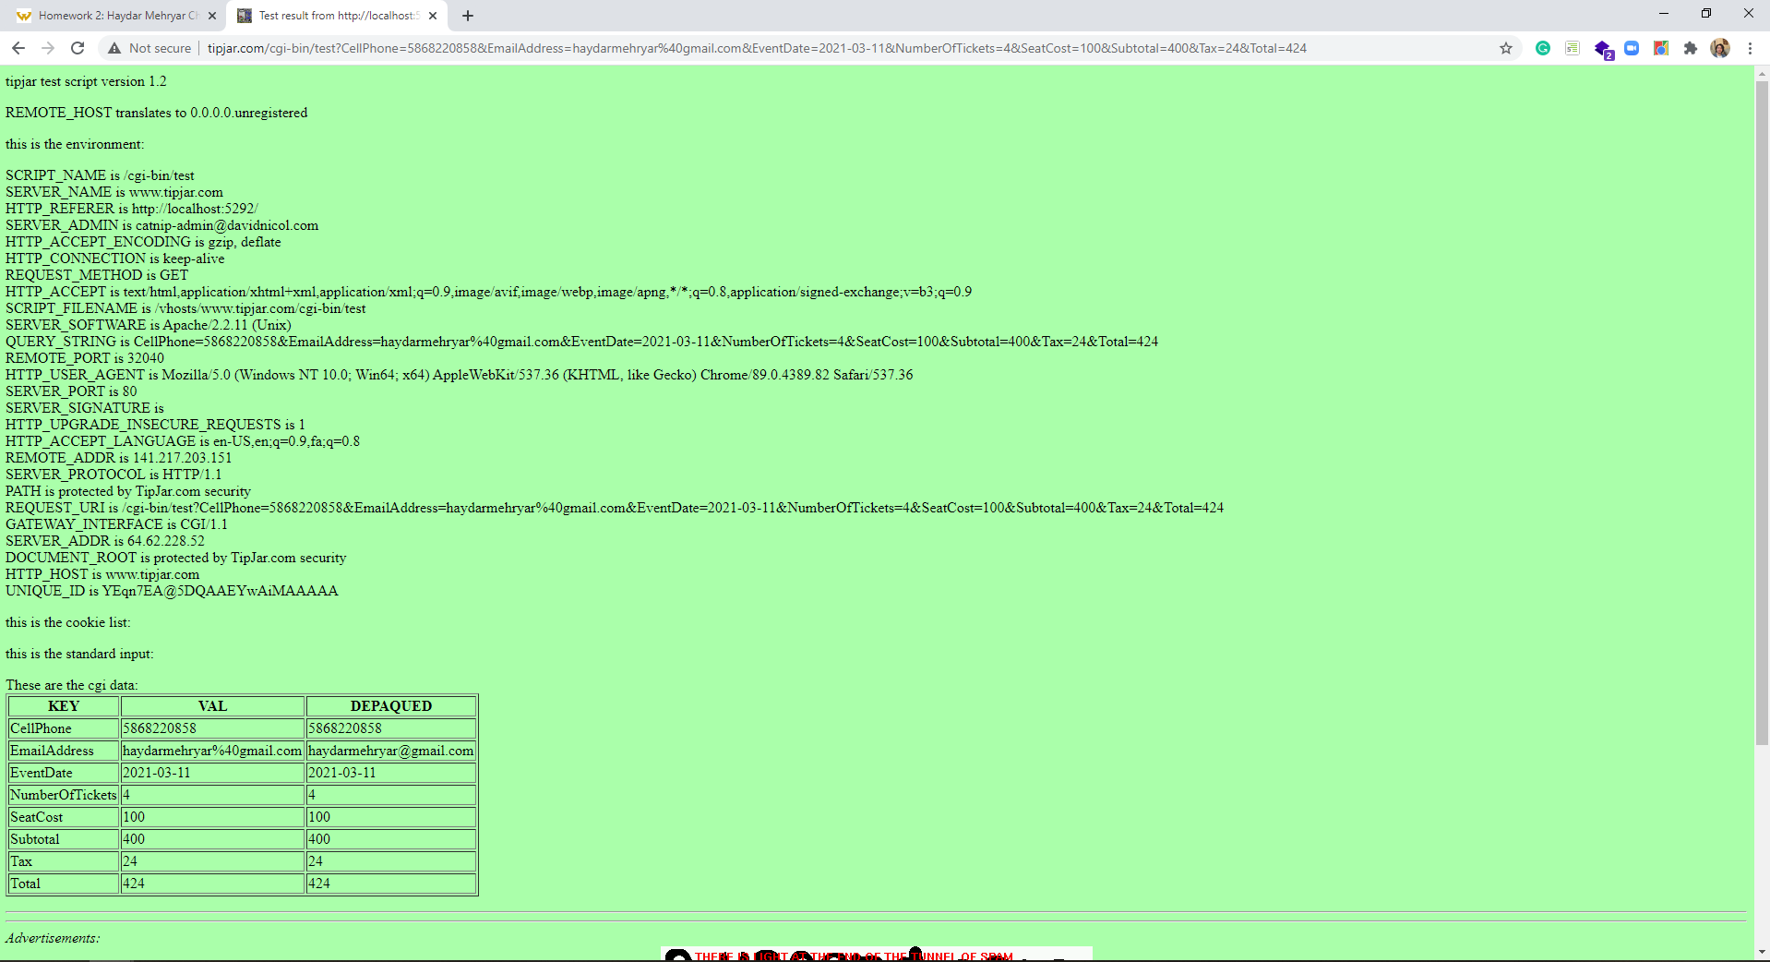

**CSS file**

*[your CSS code here]\**

body {

}

.arena-img {

width:400px;

}

.event-img-width {

width: 200px;

}

img.arena-seating-chart {

width:50%;

}

ul.navbar-customized {

list-style-type: none;

margin: 0;

padding: 0;

overflow: hidden;

/*background-color: #333;*/

}

ul.navbar-customized li {

float: left;

}

ul.navbar-customized li a {

display: block;

/*color: white;*/

text-align: center;

padding: 14px 16px;

text-decoration: none;

}

/* Change the link color to #111 (black) on hover */

li a:hover {

background-color: #e0cece;

text-decoration:none;

color:white;

}

.footer {

position: fixed;

left: 0;

bottom: 0;

width: 100%;

/*background-color: red;

color: white;*/

text-align: center;

}

**If possible, format your code like this:**

**Font “Courier New”**

**Font size “9”**

**Bold**

**\* Copying-and-pasting web page code to a Word document**

**macOS**

1) From within the HTML editor window, press **command-A** and press **command-C**.

2) From within the Word document, press **command-V**.

**Windows**

1) From within the HTML editor window, press **CTRL-A** and press **CTRL-C**.

2) From within the Word document, press **CTRL-V**.

**\*\* Copying-and-pasting a web page to a Word document**

**macOS**

1) From the browser window, press **shift-command-4-space**.

2) From within the Word document, **command-V**.

**Windows**

1) From the browser window, press **ALT-PrintScreen**.

2) From within the Word document, press **CTRL-V**.