**CSC 5750 – Principles of Web Technology**

**Homework 4 – [your name]**

**25 points – Due March 25, 5pm**

**Late deadline is March 27, 11:59pm, but 20% off**

**a)** Save this document with your name and the homework number somewhere in the file name.

**b)** Paste your code and screenshots into the document.

**c)** Gather the following files into a ZIP file with your name and the homework number somewhere in the file name:

● This document

● All HTML files

● All CSS files

● Image files

● Any other optional files specific to your implementation

**d)** Submit the ZIP file to Canvas where you downloaded this document.

You've been hired again by the arena to enhance the web site you created for them in Homeworks 1-3. Start with the web site you created in Homework 3, or the Homework 3 key on Canvas, and make the following changes to it. All files referenced here should exist in both a development and a production folder. The production folder was created in Homework 3, part 1 of 2.

**Arena page**

● Update the header comment.

● Add text ", v4" to the end of the title (in the <head> section).

No other changes are needed.

**Events page**

● Add text ", v4" to the end of the title (in the <head> section).

No other changes are needed.

**Tickets page**

● Add text ", v4" to the end of the title (in the <head> section).

● You may have used a combo box to select the seat type. This will be replaced by a set of radio buttons. Add JavaScript function **setSeats** to loop through the seats array, extract the seat types, and use them to build the radio buttons. Use DOM functions createElement, setAttribute, createTextNode, and appendChild to create and attach the radio buttons to an enclosing tag (<div> works). Use an HTML set of radio buttons as a guide. Insure that the first radio button is selected by default. For example:

inp.setAttribute("checked", true);

Also, note that the text for a radio button and breaks (<br>) between radio buttons are children of the radio button but of the enclosing tag. Write a message to the console that reports that the radio buttons were set.

● Modify function **seatTypeSelected** so that the seat type selection comes from the radio buttons, not another control.

● Modify the form action to go to the **Tickets Confirmation page** (described below) instead of **Tipjar**.

● Since there are data dependencies among the functions, use the following call sequence to insure that the next function doesn't begin until the previous function has completed:

loadSeats ® loadEvents ® setSeats ® setEvents ® seatTypeSelected

**Tickets Confirmation page**

● Create a **Tickets Confirmation page** that uses PHP to retrieve and display data sent from the Tickets page. Here is a sample page:

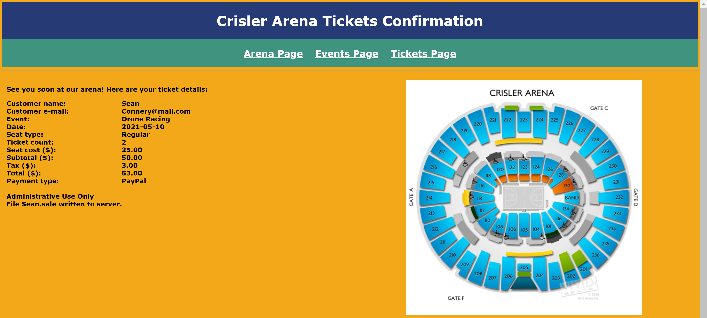

Also write file **<customer-name>.sale** that includes the tickets confirmation information, one datum per line. Write the file name to the page as shown. Here is a sample file:

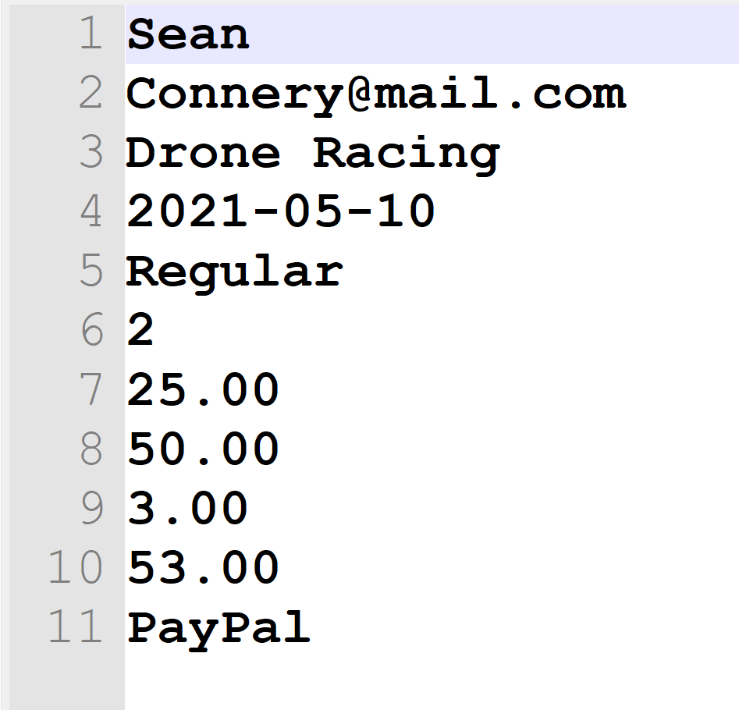

● Add text ", v4" to the end of the title (in the <head> section).

**Styles (CSS) page**

Make any style changes as needed.

**Data flow**

Here is a summary of the data flow in this web site:

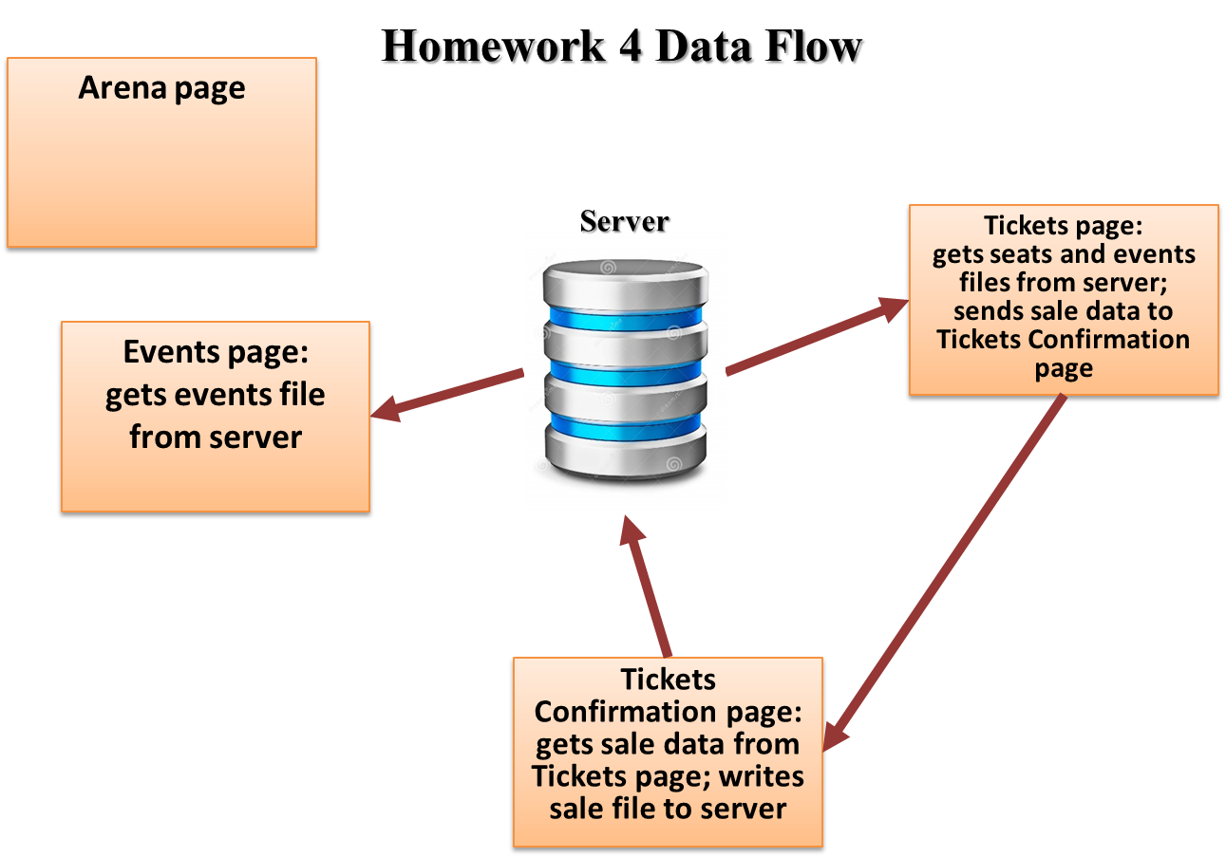

**Note:** use only relative links, not absolute links, to other files on your web site. This means there should be no drive letters or absolute paths, only relative paths, in your file references. You can test this by zipping your web site files, unzipping them in another folder, and then running your web site. There should be no linking errors if you used only relative links. The best approach is to put all web site files in one folder.

**Tickets page**

*[your Tickets page HTML code here]\**

**<!DOCTYPE html>**

**<html lang="en" xmlns="http://www.w3.org/1999/xhtml">**

**<head>**

**<title>Tickets page, v4</title>**

**<!-- Required meta tags -->**

**<meta charset="utf-8">**

**<meta name="viewport" content="width=device-width, initial-scale=1">**

**<!-- Bootstrap CSS -->**

**<!-- Latest compiled and minified CSS -->**

**<link rel="stylesheet" href="https://stackpath.bootstrapcdn.com/bootstrap/3.4.1/css/bootstrap.min.css" integrity="sha384-HSMxcRTRxnN+Bdg0JdbxYKrThecOKuH5zCYotlSAcp1+c8xmyTe9GYg1l9a69psu" crossorigin="anonymous">**

**<!-- W3.CSS link -->**

**<link rel="stylesheet" href="https://www.w3schools.com/w3css/4/w3.css">**

**<!-- DataTables CSS and script links -->**

**<link rel="stylesheet" type="text/css" href="https://cdn.datatables.net/1.10.23/css/jquery.dataTables.min.css">**

**<link href="../Contents/Content.css" rel="stylesheet" />**

**</head>**

**<body>**

**<ul class="navbar-customized bg-danger">**

**<li><a href="#"><b>Little Ceasar Arena</b></a></li>**

**<li><a href="/Views/Arena.html">Arena Page</a></li>**

**<li><a href="/Views/Events.html">Events Page</a></li>**

**<li><a href="/Views/Tickets.html">Tickets Page</a></li>**

**</ul>**

**<div class="container">**

**<h1 class="text-warning"> Tickets Page</h1>**

**<form method="post" action="TicketConfirmation.php">**

**<div class="form-horizontal">**

**<h4>Buy a Ticket</h4>**

**<hr>**

**<div class="form-group">**

**<label class="control-label col-md-2" for="ArenaSeatingChart">Arena Seating Chart</label>**

**<div class="col-md-10">**

**<img src="../Images/ArenaSeatingChart/seating-chart-01-little-seasar.JPG" class="arena-seating-chart" />**

**</div>**

**</div>**

**<div class="form-group">**

**<label class="control-label col-md-2" for="CustomerName">CustomerName</label>**

**<div class="col-md-10">**

**<input class="form-control text-box single-line" data-val="true" data-val-required="CustomerName is required!" id="CustomerName" name="CustomerName" value="">**

**<span class="field-validation-valid text-danger" data-valmsg-for="CustomerName" data-valmsg-replace="true"></span>**

**</div>**

**</div>**

**<div class="form-group">**

**<label class="control-label col-md-2" for="CustomerEmail">CustomerEmail</label>**

**<div class="col-md-10">**

**<input class="form-control text-box single-line" data-val="true" data-val-required="Email Address is required!" id="CustomerEmail" name="EmailAddress" type="email" value="">**

**<span class="field-validation-valid text-danger" data-valmsg-for="CustomerEmail" data-valmsg-replace="true"></span>**

**</div>**

**</div>**

**<div class="form-group">**

**<label class="control-label col-md-2" for="Events">Events</label>**

**<div class="col-md-10">**

**<select id="Events" class="form-control">**

**<!--<option value="1">The Millennium Tour 2021</option>**

**<option value="2">The Weekend</option>**

**<option value="3">Justin Bieber</option>**

**<option value="4" selected>Rage Agaist the Machine</option>**

**<option value="5">My Chemical Romance</option>**

**<option value="6">Alan Jackson</option>**

**<option value="7">Harry Styles</option>-->**

**</select>**

**</div>**

**</div>**

**<div class="form-group">**

**<label class="control-label col-md-2" for="EventDate">EventDate</label>**

**<div class="col-md-10">**

**<input class="form-control text-box single-line" data-val="true" data-val-required="EventDate is required!" id="EventDate" name="EventDate" type="date" value="">**

**<span class="field-validation-valid text-danger" data-valmsg-for="EventDate" data-valmsg-replace="true"></span>**

**</div>**

**</div>**

**<div class="form-group">**

**<label class="control-label col-md-2" for="NumberOfTickets">Number Of Tickets (allow 1 to 21)</label>**

**<div class="col-md-10">**

**<input class="form-control text-box single-line" data-val="true" data-val-required="NumberOfTickets is required!" id="NumberOfTickets" name="NumberOfTickets" value="1">**

**<span class="field-validation-valid text-danger" data-valmsg-for="NumberOfTickets" data-valmsg-replace="true"></span>**

**</div>**

**</div>**

**<div class="form-group">**

**<label class="control-label col-md-2" for="SeatTypeDiv">SeatType</label>**

**<div class="col-md-10">**

**<div id="SeatTypeDiv" >**

**</div>**

**<!--<select id="SeatType" class="form-control col-md-9">**

**<option value="1">First Class</option>**

**<option value="2">Middle Class</option>**

**<option value="3">Regular</option>**

**</select>-->**

**</div>**

**</div>**

**<div class="form-group">**

**<label class="control-label col-md-2" for="SeatCost">Seat Cost ($)</label>**

**<div class="col-md-10">**

**<input class="form-control text-box single-line" data-val="true" data-val-required="SeatCost is required!" id="SeatCost" name="SeatCost" type="tel" value="" readonly>**

**<span class="field-validation-valid text-danger" data-valmsg-for="SeatCost" data-valmsg-replace="true"></span>**

**</div>**

**</div>**

**<div class="form-group">**

**<label class="control-label col-md-2" for="Subtotal">Subtotal</label>**

**<div class="col-md-10">**

**<input class="form-control text-box single-line" data-val="true" data-val-required="Subtotal is required!" id="Subtotal" name="Subtotal" type="tel" value="" readonly>**

**<span class="field-validation-valid text-danger" data-valmsg-for="Subtotal" data-valmsg-replace="true"></span>**

**</div>**

**</div>**

**<div class="form-group">**

**<label class="control-label col-md-2" for="Tax">Tax</label>**

**<div class="col-md-10">**

**<input class="form-control text-box single-line" data-val="true" data-val-required="Tax is required!" id="Tax" name="Tax" type="tel" value="" readonly>**

**<span class="field-validation-valid text-danger" data-valmsg-for="Tax" data-valmsg-replace="true"></span>**

**</div>**

**</div>**

**<div class="form-group">**

**<label class="control-label col-md-2" for="Total">Total</label>**

**<div class="col-md-10">**

**<input class="form-control text-box single-line" data-val="true" data-val-required="Total is required!" id="Total" name="Total" type="tel" value="" readonly>**

**<span class="field-validation-valid text-danger" data-valmsg-for="Total" data-valmsg-replace="true"></span>**

**</div>**

**</div>**

**<div class="form-group">**

**<label class="control-label col-md-2" for="PaymentType">PaymentType</label>**

**<div class="col-md-10">**

**<select id="PaymentType" name="PaymentType" class="form-control col-md-9">**

**<option value="Credit">Credit</option>**

**<option value="Paypal">Paypal</option>**

**<option value="Venmo">Venmo</option>**

**</select>**

**</div>**

**</div>**

**<div class="form-group">**

**<div class="col-md-offset-2 col-md-10">**

**<input type="submit" value="Submit" class="btn btn-default btn-success">**

**<input type="reset" value="Reset" class="btn btn-default btn-primary">**

**</div>**

**</div>**

**</div>**

**</form>**

**</div>**

**<div class="footer bg-info">**

**<div class="row">**

**<div class="col-md-4">**

**<h3>**

**Arena Name: Little Ceasar Arena**

**</h3>**

**</div>**

**<div class="col-md-4">**

**<div><b>Arena Address:</b> 2645 Woodward Ave, Detroit, MI 48201</div>**

**<div><b>Arena Telphone:</b> (313) 471-7000</div>**

**<div><b>Email Address:</b> info@littleceasararena.com</div>**

**</div>**

**<div class="col-md-4">**

**<p>© 2021 - Little Ceasar Arena</p>**

**</div>**

**</div>**

**</div>**

**<script src="https://code.jquery.com/jquery-3.5.1.js"></script>**

**<script src="https://cdn.datatables.net/1.10.23/js/jquery.dataTables.min.js"></script>**

**<!-- Latest compiled and minified JavaScript -->**

**<script src="https://stackpath.bootstrapcdn.com/bootstrap/3.4.1/js/bootstrap.min.js" integrity="sha384-aJ21OjlMXNL5UyIl/XNwTMqvzeRMZH2w8c5cRVpzpU8Y5bApTppSuUkhZXN0VxHd" crossorigin="anonymous"></script>**

**<script type="text/javascript">**

**"use strict";**

**var seats;**

**// =[**

**// [**

**// "Regular",**

**// 25**

**// ],**

**// [**

**// "Mezzanine",**

**// 50**

**// ],**

**// [**

**// "Middle Class",**

**// 70**

**// ],**

**// [**

**// "First Class",**

**// 100**

**// ],**

**//];**

**$(document).ready(function () {**

**//================================================================**

**// Script-level variables**

**//================================================================**

**var subtotal = 0;**

**var tax = 0;**

**var total = 0;**

**//================================================================**

**// Setting SeatType Dropdown**

**//================================================================**

**loadSeats();**

**loadEvents();**

**//$("#SeatType").change(function () {**

**// var str = "";**

**// $("#SeatType option:selected").each(function () {**

**// var numberOfTickets = $("#NumberOfTickets").val();**

**// var seatCost = $(this).val();**

**// $("#SeatCost").val(seatCost);**

**// str += $(this).text() + " " + $(this).val() + " " + numberOfTickets;**

**// subtotal = numberOfTickets * seatCost;**

**// tax = subtotal * 0.06;**

**// total = subtotal + tax;**

**// console.log(subtotal);**

**// console.log(tax);**

**// console.log(total);**

**// $("#Subtotal").val(subtotal);**

**// $("#Tax").val(tax);**

**// $("#Total").val(total);**

**// });**

**//});**

**function loadSeats() {**

**$.getJSON("../Scripts/Seats.json", function (response) {**

**console.log(response);**

**var options = "";**

**response.forEach((row) => {**

**//options += '<option value="' + row[1] + '">' + row[0] + '</option>';**

**//id = "' + row[1] + '"**

**options += '<input type="radio" name="SeatType" value="' + row[1] + '"><label for="' + row[1] + '">' + row[0] + '</label><br>';**

**});**

**$('#SeatTypeDiv').append(options);**

**$('#SeatTypeDiv input[name="SeatType"]:first').prop("checked", true);**

**formChangeListener();**

**//var seatCost = $('#SeatTypeDiv input[name="SeatType"]:checked').val();**

**//$("#SeatCost").val(seatCost);**

**});**

**}**

**function formChangeListener() {**

**var $seatCost = $('#SeatTypeDiv input[name="SeatType"]:checked');**

**var seatCost = $seatCost.val();**

**console.log(seatCost);**

**var numberOfTickets = $("#NumberOfTickets").val();**

**//var seatCost = $(this).val();**

**$("#SeatCost").val(seatCost);**

**//str += $(this).text() + " " + $(this).val() + " " + numberOfTickets;**

**subtotal = numberOfTickets * seatCost;**

**tax = subtotal * 0.06;**

**total = subtotal + tax;**

**console.log(subtotal);**

**console.log(tax);**

**console.log(total);**

**$("#Subtotal").val(subtotal);**

**$("#Tax").val(tax);**

**$("#Total").val(total);**

**}**

**$('#SeatTypeDiv').change(function () {**

**formChangeListener();**

**});**

**$('#NumberOfTickets').on('input', function () {**

**formChangeListener();**

**});**

**function loadEvents() {**

**$.getJSON("../Scripts/Events.json", function (response) {**

**console.log(response);**

**var options = "";**

**response.forEach((row) => {**

**options += '<option value="' + row[0] + '">' + row[0] + '</option>';**

**});**

**$('#Events').append(options);**

**console.log("Event combo box is set");**

**})**

**}**

**})**

**</script>**

**</body>**

**</html>**

**If possible, format your code like this:**

**Font “Courier New”**

**Font size “9”**

**Bold**

**Tickets Confirmation page**

*[your Tickets Confirmation page HTML code here]\**

**<!DOCTYPE html>**

**<html>**

**<head>**

**<title>Tickets Confirmation page, v4</title>**

**<!-- Required meta tags -->**

**<meta charset="utf-8">**

**<meta name="viewport" content="width=device-width, initial-scale=1">**

**<!-- Bootstrap CSS -->**

**<!-- Latest compiled and minified CSS -->**

**<link rel="stylesheet" href="https://stackpath.bootstrapcdn.com/bootstrap/3.4.1/css/bootstrap.min.css" integrity="sha384-HSMxcRTRxnN+Bdg0JdbxYKrThecOKuH5zCYotlSAcp1+c8xmyTe9GYg1l9a69psu" crossorigin="anonymous">**

**<!-- W3.CSS link -->**

**<link rel="stylesheet" href="https://www.w3schools.com/w3css/4/w3.css">**

**<!-- DataTables CSS and script links -->**

**<link rel="stylesheet" type="text/css" href="https://cdn.datatables.net/1.10.23/css/jquery.dataTables.min.css">**

**<link href="../Contents/Content.css" rel="stylesheet" />**

**</head>**

**<body>**

**<div class="container ticket-Confirmation-page">**

**<!-- Title -->**

**<div class="leftTitle">**

**<h1>Little Ceasar Arena Ticket Confimation</h1>**

**</div>**

**<!-- Menu -->**

**<div class="menu">**

**<a href="Arena.html">Arena Page</a>**

**<a href="Events.html">Events Page</a>**

**<a href="Tickets.html">Tickets Page</a>**

**</div>**

**<hr>**

**<?php**

**$filename= $_POST["CustomerName"];**

**$filename.=".sale";**

**$myfile = fopen($filename, "w") or die("Unable to open file!");**

**fwrite($myfile,$_POST["CustomerName"]."\n");**

**fwrite($myfile,$_POST["EmailAddress"]."\n");**

**fwrite($myfile,$_POST["EventDate"]."\n");**

**fwrite($myfile,$_POST["SeatType"]."\n");**

**fwrite($myfile,$_POST["NumberOfTickets"]."\n");**

**fwrite($myfile,$_POST["SeatCost"]."\n");**

**fwrite($myfile,$_POST["Subtotal"]."\n");**

**fwrite($myfile,$_POST["Tax"]."\n");**

**fwrite($myfile,$_POST["Total"]."\n");**

**fwrite($myfile,$_POST["Total"]."\n");**

**fwrite($myfile,$_POST["PaymentType"]."\n");**

**fclose($myfile);**

**?>**

**<div class="col-md-6">**

**<div>**

**See you soon in our arena! Here are your ticket details.**

**</div>**

**<table class="ticket-Confirmation-tbl">**

**<tr>**

**<td>CustomerName</td>**

**<td>**

**<?php**

**echo($_POST["CustomerName"])**

**?>**

**</td>**

**</tr>**

**<tr>**

**<td>CustomerEmail</td>**

**<td><?php**

**echo($_POST["EmailAddress"])**

**?>**

**</td>**

**</tr>**

**<tr>**

**<td>EventDate</td>**

**<td><?php**

**echo($_POST["EventDate"])**

**?>**

**</td>**

**</tr>**

**<tr>**

**<td>SeatType</td>**

**<td><?php**

**echo($_POST["SeatType"])**

**?>**

**</td>**

**</tr>**

**<tr>**

**<td>NumberOfTickets</td>**

**<td><?php**

**echo($_POST["NumberOfTickets"])**

**?>**

**</td>**

**</tr>**

**<tr>**

**<td>SeatCost</td>**

**<td><?php**

**echo($_POST["SeatCost"])**

**?>**

**</td>**

**</tr>**

**<tr>**

**<td>Subtotal</td>**

**<td>**

**<?php**

**echo($_POST["Subtotal"])**

**?>**

**</td>**

**</tr>**

**<tr>**

**<td>Tax</td>**

**<td>**

**<?php**

**echo($_POST["Tax"])**

**?>**

**</td>**

**</tr>**

**<tr>**

**<td>Total</td>**

**<td>**

**<?php**

**echo($_POST["Total"])**

**?>**

**</td>**

**</tr>**

**<tr>**

**<td>PaymentType</td>**

**<td>**

**<?php**

**echo($_POST["PaymentType"])**

**?>**

**</td>**

**</tr>**

**</table>**

**</div>**

**<div class="col-md-6">**

**<img**

**src="../Images/ArenaSeatingChart/seating-chart-01-little-seasar.JPG" class="arena-seating-chart"**

**alt="Image Missing!">**

**</div>**

**</div>**

**<script src="https://code.jquery.com/jquery-3.5.1.js"></script>**

**<script src="https://cdn.datatables.net/1.10.23/js/jquery.dataTables.min.js"></script>**

**<!-- Latest compiled and minified JavaScript -->**

**<script src="https://stackpath.bootstrapcdn.com/bootstrap/3.4.1/js/bootstrap.min.js" integrity="sha384-aJ21OjlMXNL5UyIl/XNwTMqvzeRMZH2w8c5cRVpzpU8Y5bApTppSuUkhZXN0VxHd" crossorigin="anonymous"></script>**

**</body>**

**</html>**

**If possible, format your code like this:**

**Font “Courier New”**

**Font size “9”**

**Bold**

**Sequence 1**

*[your Tickets page screenshot for one seat type and ticket count here]\*\**

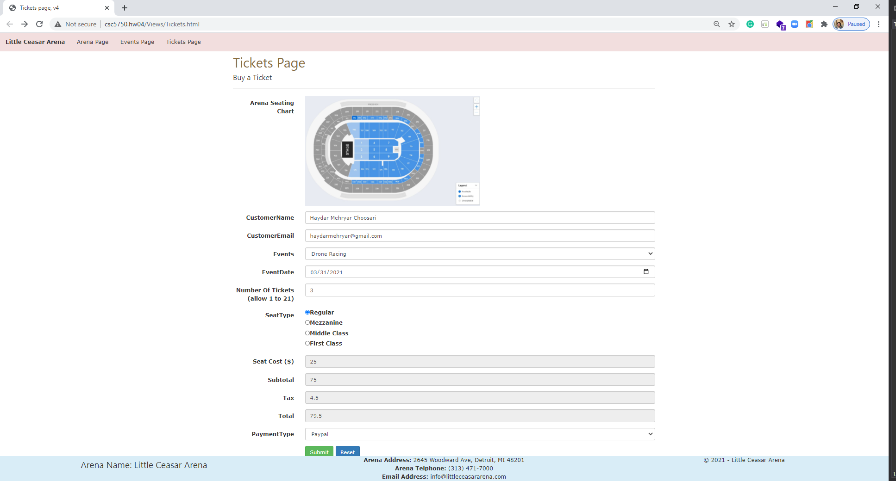

*[your Tickets Confirmation page screenshot here]\*\**

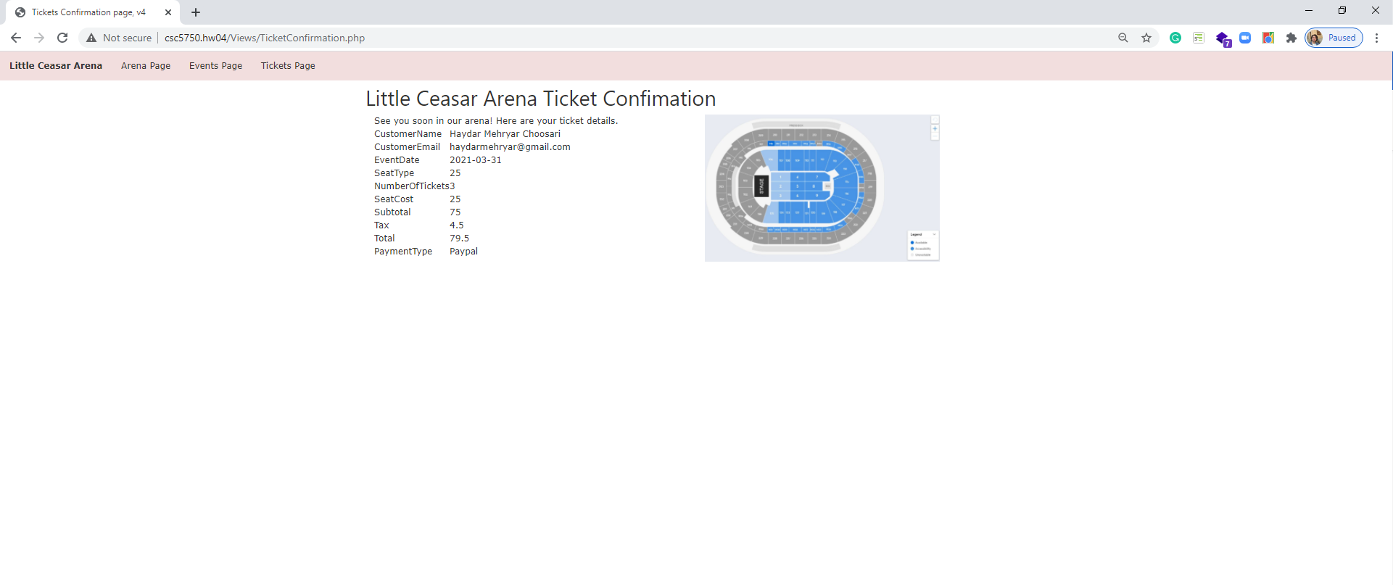

*[your sale file screenshot here]\*\**

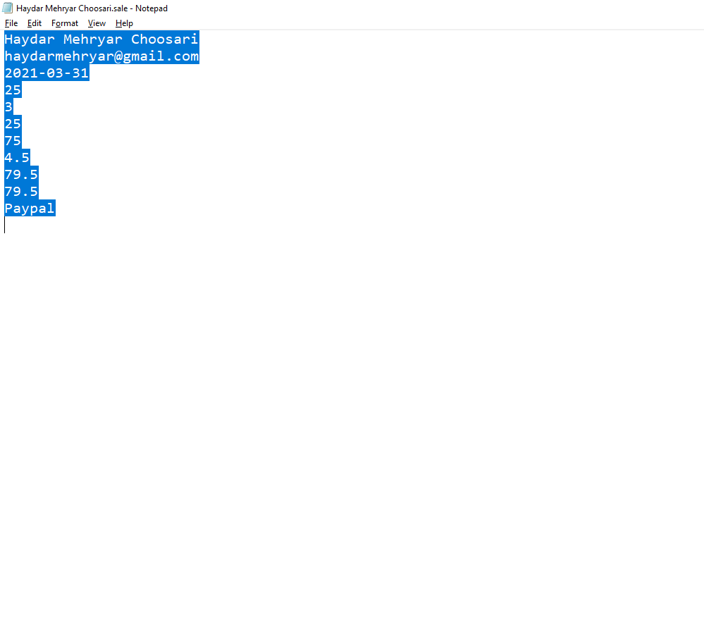

**Sequence 2**

*[your Tickets page screenshot for another seat type and ticket count here]\*\**

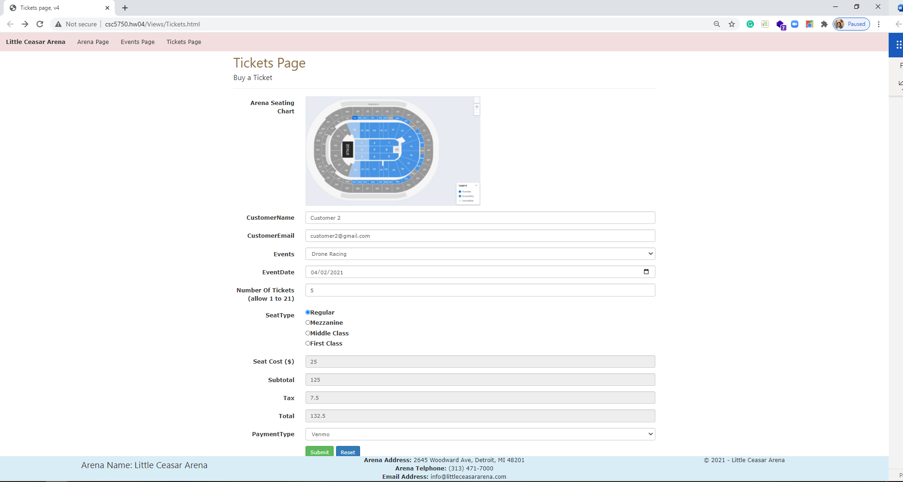

*[your Tickets Confirmation page screenshot here]\*\**

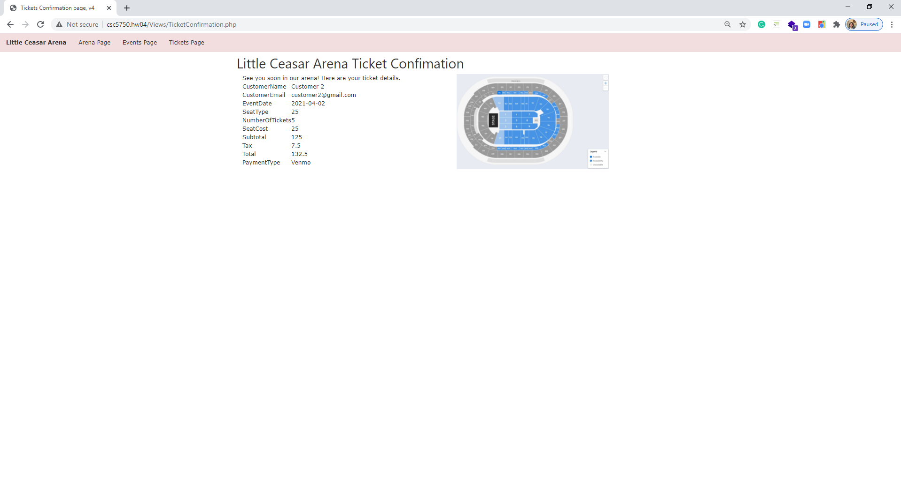

*[your sale file screenshot here]\*\**

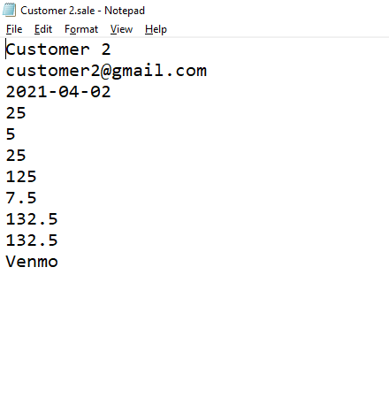

**Sequence 3**

*[your Tickets page screenshot for another seat type and ticket count here]\*\**

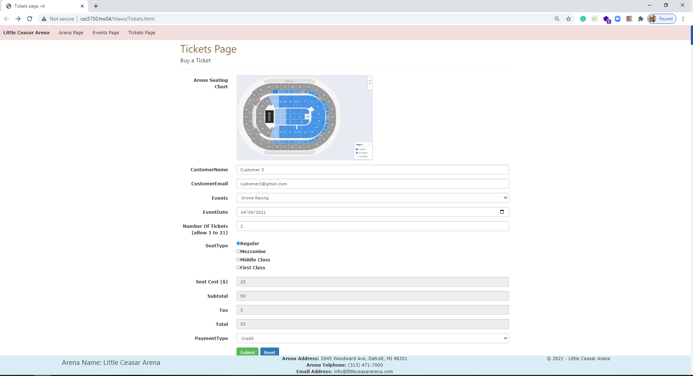

*[your Tickets Confirmation page screenshot here]\*\**

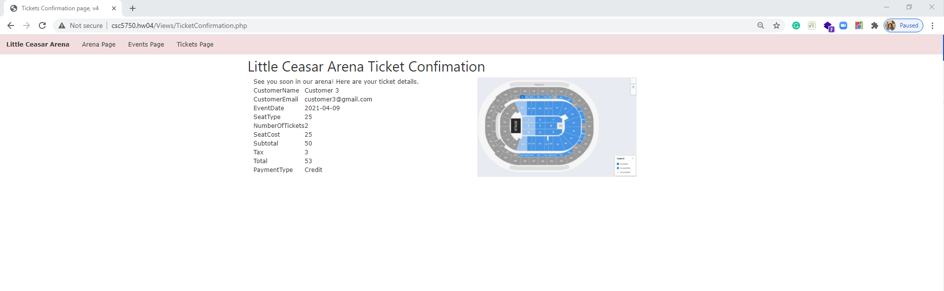

*[your sale file screenshot here]\*\**

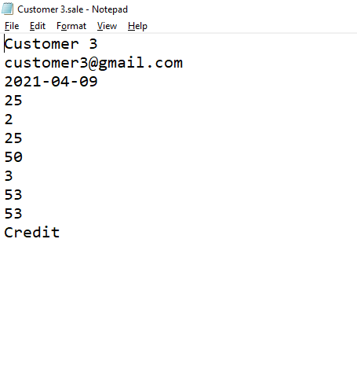

**CSS file**

*[your CSS code here]\**

**body {**

**}**

**.arena-img {**

**width:400px;**

**}**

**.event-img-width {**

**width: 200px;**

**}**

**img.arena-seating-chart {**

**width:50%;**

**}**

**.ticket-Confirmation-page img.arena-seating-chart {**

**width: 75%;**

**}**

**ul.navbar-customized {**

**list-style-type: none;**

**margin: 0;**

**padding: 0;**

**overflow: hidden;**

**/*background-color: #333;*/**

**}**

**ul.navbar-customized li {**

**float: left;**

**}**

**ul.navbar-customized li a {**

**display: block;**

**/*color: white;*/**

**text-align: center;**

**padding: 14px 16px;**

**text-decoration: none;**

**}**

**/* Change the link color to #111 (black) on hover */**

**li a:hover {**

**background-color: #e0cece;**

**text-decoration:none;**

**color:white;**

**}**

**.footer {**

**position: fixed;**

**left: 0;**

**bottom: 0;**

**width: 100%;**

**/*background-color: red;**

**color: white;*/**

**text-align: center;**

**}**

**If possible, format your code like this:**

**Font “Courier New”**

**Font size “9”**

**Bold**

**\* Copying-and-pasting web page code to a Word document**

**macOS**

1) From within the HTML editor window, press **command-A** and press **command-C**.

2) From within the Word document, press **command-V**.

**Windows**

1) From within the HTML editor window, press **CTRL-A** and press **CTRL-C**.

2) From within the Word document, press **CTRL-V**.

**\*\* Copying-and-pasting a web page to a Word document**

**macOS**

1) From the browser window, press **shift-command-4-space**.

2) From within the Word document, **command-V**.

**Windows**

1) From the browser window, press **ALT-PrintScreen**.

2) From within the Word document, press **CTRL-V**.