**CSC 5750 – Principles of Web Technology**

**Homework 5, part 2 of 2 – [your name]**

**25 points – Due April 22, 5pm**

**Late deadline is April 24, 11:59pm, but 20% off**

**a)** Save this document with your name and the homework number somewhere in the file name.

**b)** Paste your code and screenshots into the document.

**c)** Gather the following files into a ZIP file with your name and the homework number somewhere in the file name:

● This document

● All HTML files

● All CSS files

● Image files

● Any other optional files specific to your implementation

**d)** Submit the ZIP file to Canvas where you downloaded this document.

You've been hired again by the arena to enhance the web site you created for them in Homeworks 1-4. Start with the web site you created in Homework 4, or the Homework 4 key on Canvas, and make the following changes to it. All files referenced here should exist in both a development and a production folder. The production folder was created in Homework 3, part 1 of 2.

**Arena page**

● Update the header comment.

● Add text ", v5" to the end of the title (in the <head> section).

No other changes are needed.

**Events page**

● Add text ", v5" to the end of the title (in the <head> section).

No other changes are needed.

**Database build script**

● Create SQL script file **DatabaseBuild.sql** to:

a) Create database **dbTickets**.

b) Create table **tbTickets** with the following fields:

● ID – int, not null, auto increment (primary key)

● Name – varchar(45), not null

● Event – varchar(60), not null

● EventDate – varchar(20), not null

● Tickets – int, not null

● Total – decimal(15,2), not null

You may use the modeler in MySQL Workbench to create the SQL statements to generate the database and table.

c) Insert data for five ticket sales.

d) Query and return all rows and columns in table **tbTickets**.

● Run the SQL script file in MySQL Workbench to create database **dbTickets**.

**Database interface script**

● Create PHP script file **DatabaseInterface.php** that serves as an interface between the client pages and the database **dbTickets**. The client sends requests to the database calling this script file with the appropriate query string. It performs the following operations:

| Operation | Inputs from client | Output to client |
| --- | --- | --- |
| **Add**  ● Requested from the Tickets page.  ● Interface adds ticket sale to table tbTickets. | ● Request (add)  ● Name  ● Event  ● EventDate  ● Tickets  ● Total | ● Failure message.  OR  ● Success message with customer name. |
| **List**  ● Requested from the Tickets Confirmation page.  ● Interface retrieves all data from table tbTickets. | ● Request (list) | ● Failure message.  OR  ● All data from table **tbTickets** in JSON format. Data may be retrieved from the database, placed in a PHP array, and then encoded. |

To verify the SQL statements formed by this script, you can enter and test them in SQL script window on MySQL Workbench.

**Tickets page**

● Add text ", v5" to the end of the title (in the <head> section).

● Create function **updateTicketSales**. Within the function, use an AJAX or jQuery call to send an add request (request=add) to the database interface script. Include data (Name, Event, EventDate, Tickets, and Total) for the new ticket sale. The script will then send a SQL insert command to the database. Show an alert message containing the response message from the server. Note that this message may not actually appear since the browser is in the process of navigating to a new page.

● Add attribute **onsubmit** to the form to call function **updateTicketSales**.

**Tickets Confirmation page**

● Add text ", v5" to the end of the title (in the <head> section).

● Create function **loadTickets**. Within the function, use an AJAX or jQuery call to send a list request (request=list) to the database interface script. The script will then send a SQL select command to the database. Retrieve all the ticket sales data. Show the returned data using DataTables (like the Events page).

● Add attribute **onload** to the page to call function **loadTickets**.

Here is a sample page:

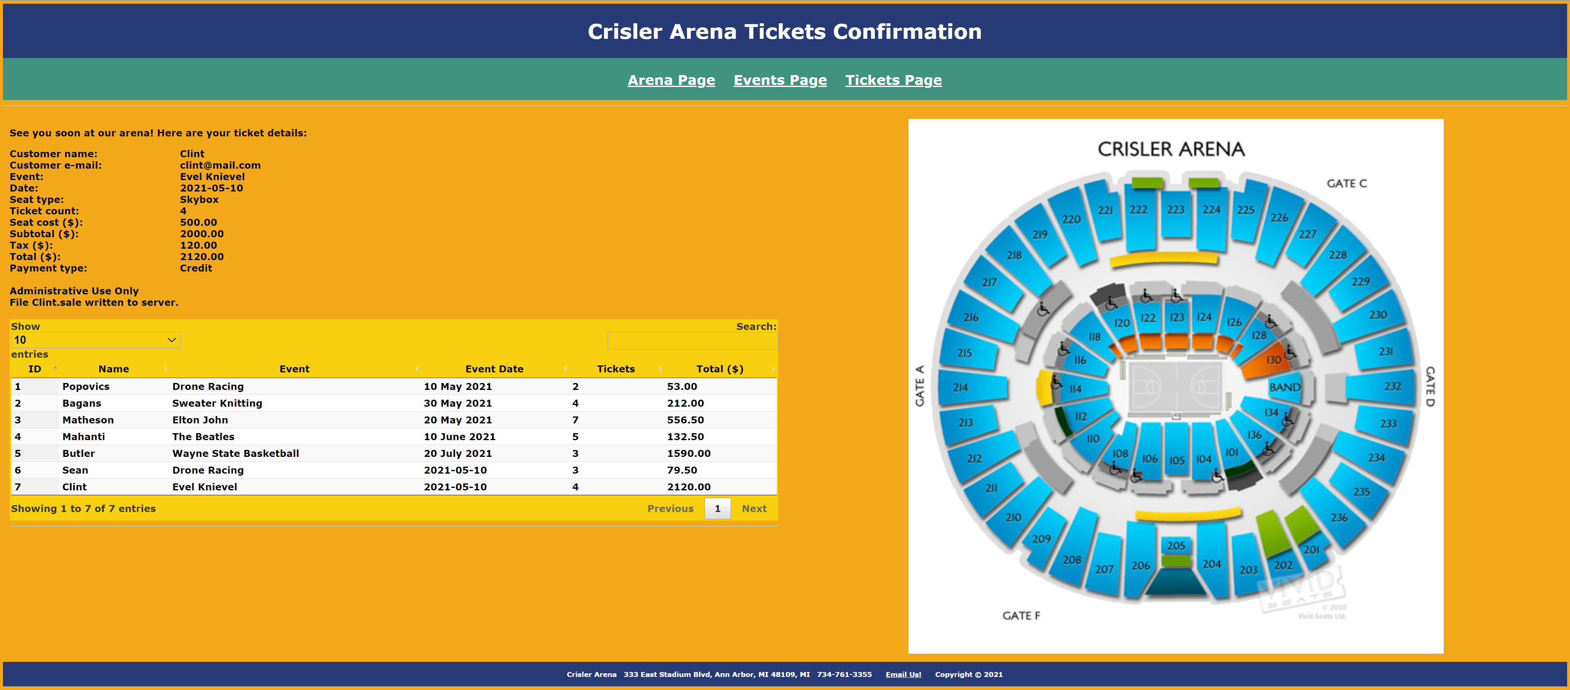

**Styles (CSS) page**

Edit the **Styles page** with any needed additional styles.

**Data flow**

Here is a summary of the data flow in this web site:

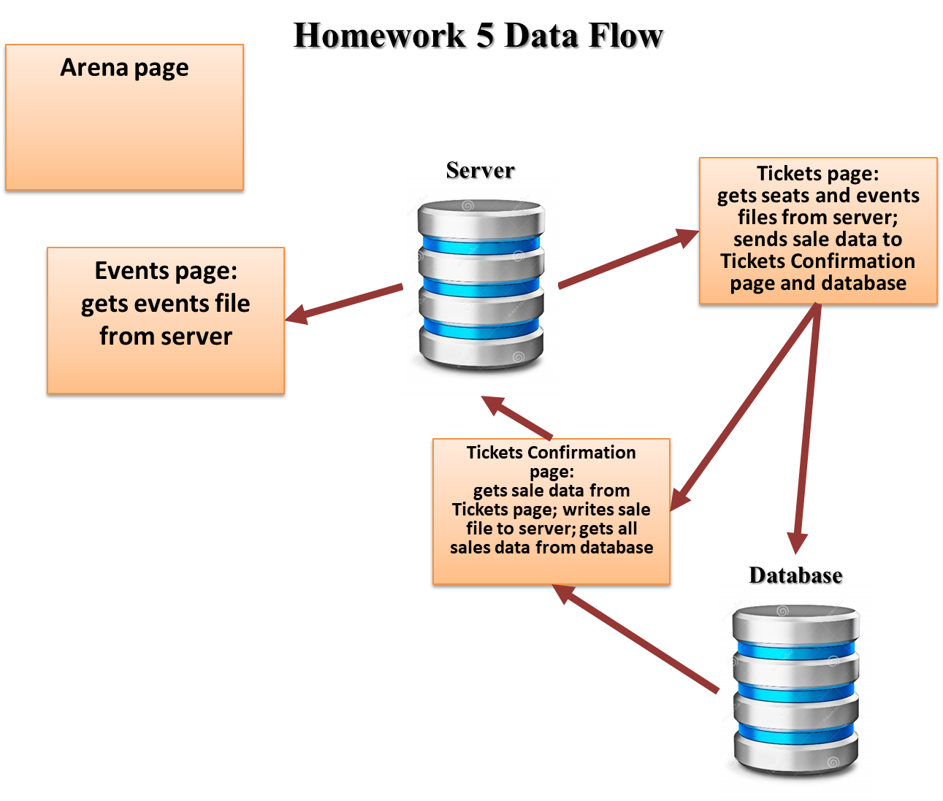

**Note:** use only relative links, not absolute links, to other files on your web site. This means there should be no drive letters or absolute paths, only relative paths, in your file references. You can test this by zipping your web site files, unzipping them in another folder, and then running your web site. There should be no linking errors if you used only relative links. The best approach is to put all web site files in one folder.

**Database build script**

*[your Database build script here]\**

**-- MySQL dump 10.13 Distrib 8.0.23, for Win64 (x86_64)**

**--**

**-- Host: 127.0.0.1 Database: dbtickets**

**-- ------------------------------------------------------**

**-- Server version** **8.0.18**

**/*!40101 SET @OLD_CHARACTER_SET_CLIENT=@@CHARACTER_SET_CLIENT */;**

**/*!40101 SET @OLD_CHARACTER_SET_RESULTS=@@CHARACTER_SET_RESULTS */;**

**/*!40101 SET @OLD_COLLATION_CONNECTION=@@COLLATION_CONNECTION */;**

**/*!50503 SET NAMES utf8 */;**

**/*!40103 SET @OLD_TIME_ZONE=@@TIME_ZONE */;**

**/*!40103 SET TIME_ZONE='+00:00' */;**

**/*!40014 SET @OLD_UNIQUE_CHECKS=@@UNIQUE_CHECKS, UNIQUE_CHECKS=0 */;**

**/*!40014 SET @OLD_FOREIGN_KEY_CHECKS=@@FOREIGN_KEY_CHECKS, FOREIGN_KEY_CHECKS=0 */;**

**/*!40101 SET @OLD_SQL_MODE=@@SQL_MODE, SQL_MODE='NO_AUTO_VALUE_ON_ZERO' */;**

**/*!40111 SET @OLD_SQL_NOTES=@@SQL_NOTES, SQL_NOTES=0 */;**

**CREATE DATABASE dbTickets;**

**--**

**-- Table structure for table `tbtickets`**

**--**

**DROP TABLE IF EXISTS `dbTickets`.`tbtickets`;**

**/*!40101 SET @saved_cs_client = @@character_set_client */;**

**/*!50503 SET character_set_client = utf8mb4 */;**

**CREATE TABLE `dbTickets`.`tbtickets` (**

**`ID` int(11) NOT NULL AUTO_INCREMENT,**

**`Name` varchar(45) NOT NULL,**

**`Event` varchar(60) NOT NULL,**

**`EventDate` varchar(200) NOT NULL,**

**`Tickets` int(11) NOT NULL,**

**`Total` decimal(15,2) NOT NULL,**

**PRIMARY KEY (`ID`)**

**) ENGINE=InnoDB DEFAULT CHARSET=latin1;**

**/*!40101 SET character_set_client = @saved_cs_client */;**

**--**

**-- Dumping data for table `tbtickets`**

**--**

**LOCK TABLES `dbTickets`.`tbtickets` WRITE;**

**/*!40000 ALTER TABLE `tbtickets` DISABLE KEYS */;**

**INSERT INTO `dbTickets`.`tbtickets` VALUES**

**(1,'Haydar Mehryar Choosari','Drone Racing','2021-03-31',3,79.50),**

**(2,'Customer 2','Drone Racing','2021-04-02',5,132.50),**

**(3,'Customer 3','Elton John','2021-04-09',2,53.00),**

**(4,'Customer 4','Sweater Knitting','2021-04-25',5,132.50),**

**(5,'Customer 5','Sweater Knitting','2021-04-28',3,79.50);**

**/*!40000 ALTER TABLE `tbtickets` ENABLE KEYS */;**

**UNLOCK TABLES;**

**/*!40103 SET TIME_ZONE=@OLD_TIME_ZONE */;**

**/*!40101 SET SQL_MODE=@OLD_SQL_MODE */;**

**/*!40014 SET FOREIGN_KEY_CHECKS=@OLD_FOREIGN_KEY_CHECKS */;**

**/*!40014 SET UNIQUE_CHECKS=@OLD_UNIQUE_CHECKS */;**

**/*!40101 SET CHARACTER_SET_CLIENT=@OLD_CHARACTER_SET_CLIENT */;**

**/*!40101 SET CHARACTER_SET_RESULTS=@OLD_CHARACTER_SET_RESULTS */;**

**/*!40101 SET COLLATION_CONNECTION=@OLD_COLLATION_CONNECTION */;**

**/*!40111 SET SQL_NOTES=@OLD_SQL_NOTES */;**

**-- Dump completed on 2021-04-22 16:08:39**

**If possible, format your code like this:**

**Font “Courier New”**

**Font size “9”**

**Bold**

**Database interface script**

*[your Database interface script here]\**

**<?php**

**// serves as an interface between the client pages and the database dbTickets**

**//connecting to db**

**$servername = "localhost";**

**$username = "root";**

**$password = "mysql";**

**$dbname = "dbTickets";**

**// Create connection**

**$conn = mysqli_connect($servername, $username, $password, $dbname);**

**// Check connection**

**if (!$conn) {**

**die("Connection failed: " . $conn->connect_error);**

**}**

**$methodName=$_GET['Request'];**

**//echo $methodName."<br/>";**

**// Display result**

**if ( $methodName == "update") {**

**$id= $_GET['id'];**

**$quantity=$_GET['quantity'];**

**echo $id;**

**echo $quantity;**

**echo "Im gonna update";**

**} elseif ( $methodName=="list") {**

**//echo "list: Begin<br/>";**

**$sql = "SELECT * FROM tbTickets";**

**$result = mysqli_query($conn, $sql);**

**if (mysqli_num_rows($result) > 0) {**

**// output data of each row**

**$rows = array();**

**while($row = mysqli_fetch_assoc($result)) {**

**// echo "ID: " . $row["ID"]. " - Name: " . $row["Name"]. " - Event: " . $row["Event"]." - EventDate: " . $row["EventDate"]**

**// ." - Tickets: " . $row["Tickets"]." - Total: " . $row["Total"]."<br>";**

**$rows[] = $row;**

**}**

**// decode the JSON from the database as we build the array that will be converted back to json**

**$jsonObject = array('data' => $rows);**

**print json_encode($jsonObject, JSON_UNESCAPED_SLASHES);**

**//print json_encode($rows);**

**} else {**

**echo "0 results";**

**}**

**//echo "list: End";**

**} elseif ( $methodName=="add") {**

**echo "add: Begin";**

**//$id= $_GET['id'];**

**$Name= $_GET['Name'];**

**$Event= $_GET['Event'];**

**$EventDate= $_GET['EventDate'];**

**$Tickets= $_GET['Tickets'];**

**$Total= $_GET['Total'];**

**//echo $id;**

**echo $Name;**

**echo $Event;**

**echo $EventDate;**

**echo $Tickets;**

**echo $Total;**

**$sql="INSERT INTO `dbtickets`.`tbtickets` (`Name`, `Event`, `EventDate`, `Tickets`, `Total`) VALUES ('".$Name."', '".$Event."', '".$EventDate."', '".$Tickets."', '".$Total."')";**

**//$sql="INSERT INTO tbtickets (Name, Event, EventDate, Tickets, Total) VALUES (".$Name."', '".$Event."', '".$EventDate."', '.$Tickets.', '.$Total.')";**

**//$sql = "INSERT INTO tbTickets (Name, Event, EventDate, Tickets, Total) VALUES ('".$Name."', '".$Event."', '".$EventDate."', '.$Tickets.', '.$Total.')";**

**$result = mysqli_query($conn, $sql);**

**echo "<br/>";**

**echo mysqli_insert_id($conn);**

**echo "add: End";**

**}else {**

**echo "Doing Nothing";**

**}**

**mysqli_close($conn);**

**?>**

**If possible, format your code like this:**

**Font “Courier New”**

**Font size “9”**

**Bold**

**Ticket page**

*[your Ticket page HTML code here]\**

**<!DOCTYPE html>**

**<html lang="en" xmlns="http://www.w3.org/1999/xhtml">**

**<head>**

**<title>Tickets page, v5</title>**

**<!-- Required meta tags -->**

**<meta charset="utf-8">**

**<meta name="viewport" content="width=device-width, initial-scale=1">**

**<!-- Bootstrap CSS -->**

**<!-- Latest compiled and minified CSS -->**

**<link rel="stylesheet" href="https://stackpath.bootstrapcdn.com/bootstrap/3.4.1/css/bootstrap.min.css" integrity="sha384-HSMxcRTRxnN+Bdg0JdbxYKrThecOKuH5zCYotlSAcp1+c8xmyTe9GYg1l9a69psu" crossorigin="anonymous">**

**<!-- W3.CSS link -->**

**<link rel="stylesheet" href="https://www.w3schools.com/w3css/4/w3.css">**

**<!-- DataTables CSS and script links -->**

**<link rel="stylesheet" type="text/css" href="https://cdn.datatables.net/1.10.23/css/jquery.dataTables.min.css">**

**<link href="../Contents/Content.css" rel="stylesheet" />**

**</head>**

**<body>**

**<ul class="navbar-customized bg-danger">**

**<li><a href="#"><b>Little Ceasar Arena</b></a></li>**

**<li><a href="/Views/Arena.html">Arena Page</a></li>**

**<li><a href="/Views/Events.html">Events Page</a></li>**

**<li><a href="/Views/Tickets.html">Tickets Page</a></li>**

**</ul>**

**<div class="container">**

**<h1 class="text-warning"> Tickets Page</h1>**

**<form method="post" action="TicketConfirmation.php">**

**<div class="form-horizontal">**

**<h4>Buy a Ticket</h4>**

**<hr>**

**<div class="form-group">**

**<label class="control-label col-md-2" for="ArenaSeatingChart">Arena Seating Chart</label>**

**<div class="col-md-10">**

**<img src="../Images/ArenaSeatingChart/seating-chart-01-little-seasar.JPG" class="arena-seating-chart" />**

**</div>**

**</div>**

**<div class="form-group">**

**<label class="control-label col-md-2" for="CustomerName">CustomerName</label>**

**<div class="col-md-10">**

**<input class="form-control text-box single-line" data-val="true" data-val-required="CustomerName is required!" id="CustomerName" name="CustomerName" value="">**

**<span class="field-validation-valid text-danger" data-valmsg-for="CustomerName" data-valmsg-replace="true"></span>**

**</div>**

**</div>**

**<div class="form-group">**

**<label class="control-label col-md-2" for="CustomerEmail">CustomerEmail</label>**

**<div class="col-md-10">**

**<input class="form-control text-box single-line" data-val="true" data-val-required="Email Address is required!" id="CustomerEmail" name="EmailAddress" type="email" value="">**

**<span class="field-validation-valid text-danger" data-valmsg-for="CustomerEmail" data-valmsg-replace="true"></span>**

**</div>**

**</div>**

**<div class="form-group">**

**<label class="control-label col-md-2" for="Events">Events</label>**

**<div class="col-md-10">**

**<select id="Events" class="form-control">**

**<!--<option value="1">The Millennium Tour 2021</option>**

**<option value="2">The Weekend</option>**

**<option value="3">Justin Bieber</option>**

**<option value="4" selected>Rage Agaist the Machine</option>**

**<option value="5">My Chemical Romance</option>**

**<option value="6">Alan Jackson</option>**

**<option value="7">Harry Styles</option>-->**

**</select>**

**</div>**

**</div>**

**<div class="form-group">**

**<label class="control-label col-md-2" for="EventDate">EventDate</label>**

**<div class="col-md-10">**

**<input class="form-control text-box single-line" data-val="true" data-val-required="EventDate is required!" id="EventDate" name="EventDate" type="date" value="">**

**<span class="field-validation-valid text-danger" data-valmsg-for="EventDate" data-valmsg-replace="true"></span>**

**</div>**

**</div>**

**<div class="form-group">**

**<label class="control-label col-md-2" for="NumberOfTickets">Number Of Tickets (allow 1 to 21)</label>**

**<div class="col-md-10">**

**<input class="form-control text-box single-line" data-val="true" data-val-required="NumberOfTickets is required!" id="NumberOfTickets" name="NumberOfTickets" value="1">**

**<span class="field-validation-valid text-danger" data-valmsg-for="NumberOfTickets" data-valmsg-replace="true"></span>**

**</div>**

**</div>**

**<div class="form-group">**

**<label class="control-label col-md-2" for="SeatTypeDiv">SeatType</label>**

**<div class="col-md-10">**

**<div id="SeatTypeDiv" >**

**</div>**

**<!--<select id="SeatType" class="form-control col-md-9">**

**<option value="1">First Class</option>**

**<option value="2">Middle Class</option>**

**<option value="3">Regular</option>**

**</select>-->**

**</div>**

**</div>**

**<div class="form-group">**

**<label class="control-label col-md-2" for="SeatCost">Seat Cost ($)</label>**

**<div class="col-md-10">**

**<input class="form-control text-box single-line" data-val="true" data-val-required="SeatCost is required!" id="SeatCost" name="SeatCost" type="tel" value="" readonly>**

**<span class="field-validation-valid text-danger" data-valmsg-for="SeatCost" data-valmsg-replace="true"></span>**

**</div>**

**</div>**

**<div class="form-group">**

**<label class="control-label col-md-2" for="Subtotal">Subtotal</label>**

**<div class="col-md-10">**

**<input class="form-control text-box single-line" data-val="true" data-val-required="Subtotal is required!" id="Subtotal" name="Subtotal" type="tel" value="" readonly>**

**<span class="field-validation-valid text-danger" data-valmsg-for="Subtotal" data-valmsg-replace="true"></span>**

**</div>**

**</div>**

**<div class="form-group">**

**<label class="control-label col-md-2" for="Tax">Tax</label>**

**<div class="col-md-10">**

**<input class="form-control text-box single-line" data-val="true" data-val-required="Tax is required!" id="Tax" name="Tax" type="tel" value="" readonly>**

**<span class="field-validation-valid text-danger" data-valmsg-for="Tax" data-valmsg-replace="true"></span>**

**</div>**

**</div>**

**<div class="form-group">**

**<label class="control-label col-md-2" for="Total">Total</label>**

**<div class="col-md-10">**

**<input class="form-control text-box single-line" data-val="true" data-val-required="Total is required!" id="Total" name="Total" type="tel" value="" readonly>**

**<span class="field-validation-valid text-danger" data-valmsg-for="Total" data-valmsg-replace="true"></span>**

**</div>**

**</div>**

**<div class="form-group">**

**<label class="control-label col-md-2" for="PaymentType">PaymentType</label>**

**<div class="col-md-10">**

**<select id="PaymentType" name="PaymentType" class="form-control col-md-9">**

**<option value="Credit">Credit</option>**

**<option value="Paypal">Paypal</option>**

**<option value="Venmo">Venmo</option>**

**</select>**

**</div>**

**</div>**

**<div class="form-group">**

**<div class="col-md-offset-2 col-md-10">**

**<input type="submit" value="Submit" class="btn btn-default btn-success" id="submitForm">**

**<input type="reset" value="Reset" class="btn btn-default btn-primary">**

**<!--<input type="button" value="run ajax" class="btn btn-default btn-success">-->**

**</div>**

**</div>**

**</div>**

**</form>**

**</div>**

**<div class="footer bg-info">**

**<div class="row">**

**<div class="col-md-4">**

**<h3>**

**Arena Name: Little Ceasar Arena**

**</h3>**

**</div>**

**<div class="col-md-4">**

**<div><b>Arena Address:</b> 2645 Woodward Ave, Detroit, MI 48201</div>**

**<div><b>Arena Telphone:</b> (313) 471-7000</div>**

**<div><b>Email Address:</b> info@littleceasararena.com</div>**

**</div>**

**<div class="col-md-4">**

**<p>© 2021 - Little Ceasar Arena</p>**

**</div>**

**</div>**

**</div>**

**<script src="https://code.jquery.com/jquery-3.5.1.js"></script>**

**<script src="https://cdn.datatables.net/1.10.23/js/jquery.dataTables.min.js"></script>**

**<!-- Latest compiled and minified JavaScript -->**

**<script src="https://stackpath.bootstrapcdn.com/bootstrap/3.4.1/js/bootstrap.min.js" integrity="sha384-aJ21OjlMXNL5UyIl/XNwTMqvzeRMZH2w8c5cRVpzpU8Y5bApTppSuUkhZXN0VxHd" crossorigin="anonymous"></script>**

**<script type="text/javascript">**

**"use strict";**

**var seats;**

**$(document).ready(function () {**

**//================================================================**

**// Script-level variables**

**//================================================================**

**var subtotal = 0;**

**var tax = 0;**

**var total = 0;**

**//================================================================**

**// Setting SeatType Dropdown**

**//================================================================**

**loadSeats();**

**loadEvents();**

**function loadSeats() {**

**$.getJSON("../Scripts/Seats.json", function (response) {**

**console.log(response);**

**var options = "";**

**response.forEach((row) => {**

**//options += '<option value="' + row[1] + '">' + row[0] + '</option>';**

**//id = "' + row[1] + '"**

**options += '<input type="radio" name="SeatType" value="' + row[1] + '"><label for="' + row[1] + '">' + row[0] + '</label><br>';**

**});**

**$('#SeatTypeDiv').append(options);**

**$('#SeatTypeDiv input[name="SeatType"]:first').prop("checked", true);**

**formChangeListener();**

**//var seatCost = $('#SeatTypeDiv input[name="SeatType"]:checked').val();**

**//$("#SeatCost").val(seatCost);**

**});**

**}**

**function formChangeListener() {**

**var $seatCost = $('#SeatTypeDiv input[name="SeatType"]:checked');**

**var seatCost = $seatCost.val();**

**console.log(seatCost);**

**var numberOfTickets = $("#NumberOfTickets").val();**

**//var seatCost = $(this).val();**

**$("#SeatCost").val(seatCost);**

**//str += $(this).text() + " " + $(this).val() + " " + numberOfTickets;**

**subtotal = numberOfTickets * seatCost;**

**tax = subtotal * 0.06;**

**total = subtotal + tax;**

**console.log(subtotal);**

**console.log(tax);**

**console.log(total);**

**$("#Subtotal").val(subtotal);**

**$("#Tax").val(tax);**

**$("#Total").val(total);**

**}**

**$('#SeatTypeDiv').change(function () {**

**formChangeListener();**

**});**

**$('#NumberOfTickets').on('input', function () {**

**formChangeListener();**

**});**

**function loadEvents() {**

**$.getJSON("../Scripts/Events.json", function (response) {**

**console.log(response);**

**var options = "";**

**response.forEach((row) => {**

**options += '<option value="' + row[0] + '">' + row[0] + '</option>';**

**});**

**$('#Events').append(options);**

**console.log("Event combo box is set");**

**})**

**}**

**function updateTicketSales() {**

**var name = $("#CustomerName").val();**

**var event = $("#Events").val();**

**var eventDate = $("#EventDate").val();**

**var numberOfTickets = $("#NumberOfTickets").val();**

**var total = $("#Total").val();**

**console.log(name, event, eventDate, numberOfTickets, total);**

**$.ajax({**

**url: "DatabaseInterface.php",**

**data: {**

**Request:"add",**

**Name: name,**

**Event: event,**

**EventDate: eventDate,**

**Tickets: numberOfTickets,**

**Total: total,**

**},**

**success: function (result) {**

**/*$("#div1").html(result);*/**

**console.log(result);**

**//alert(result);**

**}**

**});**

**}**

**$("#submitForm").click(function () {**

**updateTicketSales();**

**});**

**})**

**</script>**

**</body>**

**</html>**

**If possible, format your code like this:**

**Font “Courier New”**

**Font size “9”**

**Bold**

**Ticket Confirmation page**

*[your Ticket Confirmation page HTML code here]\**

**<!DOCTYPE html>**

**<html>**

**<head>**

**<title>Tickets Confirmation page, v5</title>**

**<!-- Required meta tags -->**

**<meta charset="utf-8">**

**<meta name="viewport" content="width=device-width, initial-scale=1">**

**<!-- Bootstrap CSS -->**

**<!-- Latest compiled and minified CSS -->**

**<link rel="stylesheet" href="https://stackpath.bootstrapcdn.com/bootstrap/3.4.1/css/bootstrap.min.css" integrity="sha384-HSMxcRTRxnN+Bdg0JdbxYKrThecOKuH5zCYotlSAcp1+c8xmyTe9GYg1l9a69psu" crossorigin="anonymous">**

**<!-- W3.CSS link -->**

**<link rel="stylesheet" href="https://www.w3schools.com/w3css/4/w3.css">**

**<!-- DataTables CSS and script links -->**

**<link rel="stylesheet" type="text/css" href="https://cdn.datatables.net/1.10.23/css/jquery.dataTables.min.css">**

**<link href="../Contents/Content.css" rel="stylesheet" />**

**</head>**

**<body>**

**<ul class="navbar-customized bg-danger">**

**<li><a href="#"><b>Little Ceasar Arena</b></a></li>**

**<li><a href="/Views/Arena.html">Arena Page</a></li>**

**<li><a href="/Views/Events.html">Events Page</a></li>**

**<li><a href="/Views/Tickets.html">Tickets Page</a></li>**

**</ul>**

**<div class="container ticket-Confirmation-page">**

**<!-- Title -->**

**<div class="leftTitle">**

**<h1>Little Ceasar Arena Ticket Confimation</h1>**

**</div>**

**<?php**

**$filename= $_POST["CustomerName"];**

**$filename.=".sale";**

**$myfile = fopen($filename, "w") or die("Unable to open file!");**

**fwrite($myfile,$_POST["CustomerName"]."\n");**

**fwrite($myfile,$_POST["EmailAddress"]."\n");**

**fwrite($myfile,$_POST["EventDate"]."\n");**

**fwrite($myfile,$_POST["SeatType"]."\n");**

**fwrite($myfile,$_POST["NumberOfTickets"]."\n");**

**fwrite($myfile,$_POST["SeatCost"]."\n");**

**fwrite($myfile,$_POST["Subtotal"]."\n");**

**fwrite($myfile,$_POST["Tax"]."\n");**

**fwrite($myfile,$_POST["Total"]."\n");**

**fwrite($myfile,$_POST["Total"]."\n");**

**fwrite($myfile,$_POST["PaymentType"]."\n");**

**fclose($myfile);**

**?>**

**<div class="col-md-6">**

**<div>**

**See you soon in our arena! Here are your ticket details.**

**</div>**

**<table class="ticket-Confirmation-tbl">**

**<tr>**

**<td>CustomerName</td>**

**<td>**

**<?php**

**echo($_POST["CustomerName"])**

**?>**

**</td>**

**</tr>**

**<tr>**

**<td>CustomerEmail</td>**

**<td><?php**

**echo($_POST["EmailAddress"])**

**?>**

**</td>**

**</tr>**

**<tr>**

**<td>EventDate</td>**

**<td><?php**

**echo($_POST["EventDate"])**

**?>**

**</td>**

**</tr>**

**<tr>**

**<td>SeatType</td>**

**<td><?php**

**echo($_POST["SeatType"])**

**?>**

**</td>**

**</tr>**

**<tr>**

**<td>NumberOfTickets</td>**

**<td><?php**

**echo($_POST["NumberOfTickets"])**

**?>**

**</td>**

**</tr>**

**<tr>**

**<td>SeatCost</td>**

**<td><?php**

**echo($_POST["SeatCost"])**

**?>**

**</td>**

**</tr>**

**<tr>**

**<td>Subtotal</td>**

**<td>**

**<?php**

**echo($_POST["Subtotal"])**

**?>**

**</td>**

**</tr>**

**<tr>**

**<td>Tax</td>**

**<td>**

**<?php**

**echo($_POST["Tax"])**

**?>**

**</td>**

**</tr>**

**<tr>**

**<td>Total</td>**

**<td>**

**<?php**

**echo($_POST["Total"])**

**?>**

**</td>**

**</tr>**

**<tr>**

**<td>PaymentType</td>**

**<td>**

**<?php**

**echo($_POST["PaymentType"])**

**?>**

**</td>**

**</tr>**

**</table>**

**<table class="table table-sm table-hover table-responsive table-responsive-lg display" style="width:100%" id="ticketsTable">**

**<thead>**

**<tr>**

**<th>ID</th>**

**<th>Name</th>**

**<th>Event</th>**

**<th>Event Date</th>**

**<th>Tickets</th>**

**<th>Total ($)</th>**

**</tr>**

**</thead>**

**<tfoot>**

**<tr>**

**<th>ID</th>**

**<th>Name</th>**

**<th>Event</th>**

**<th>Event Date</th>**

**<th>Tickets</th>**

**<th>Total ($)</th>**

**</tr>**

**</tfoot>**

**</table>**

**</div>**

**<div class="col-md-6">**

**<img**

**src="../Images/ArenaSeatingChart/seating-chart-01-little-seasar.JPG" class="arena-seating-chart"**

**alt="Image Missing!">**

**</div>**

**</div>**

**<div class="col-md-12">**

**</div>**

**<script src="https://code.jquery.com/jquery-3.5.1.js"></script>**

**<script src="https://cdn.datatables.net/1.10.23/js/jquery.dataTables.min.js"></script>**

**<!-- Latest compiled and minified JavaScript -->**

**<script src="https://stackpath.bootstrapcdn.com/bootstrap/3.4.1/js/bootstrap.min.js" integrity="sha384-aJ21OjlMXNL5UyIl/XNwTMqvzeRMZH2w8c5cRVpzpU8Y5bApTppSuUkhZXN0VxHd" crossorigin="anonymous"></script>**

**<script type="text/javascript">**

**"use strict";**

**$(document).ready(function () {**

**function loadTickets() {**

**$('#ticketsTable').DataTable( {**

**"ajax": 'DatabaseInterface.php?Request=list',**

**"columns": [**

**{ "data": "ID" },**

**{ "data": "Name" },**

**{ "data": "Event" },**

**{ "data": "EventDate" },**

**{ "data": "Tickets" },**

**{ "data": "Total" }**

**]**

**} );**

**$.ajax({**

**url: "DatabaseInterface.php",**

**data: {**

**Request:"list",**

**},**

**success: function (result) {**

**console.log(result);**

**}**

**});**

**}**

**loadTickets();**

**})**

**</script>**

**</body>**

**</html>**

**If possible, format your code like this:**

**Font “Courier New”**

**Font size “9”**

**Bold**

*[your Database build script run here]\*\**

*I ran it and, run result is shown in the output section*

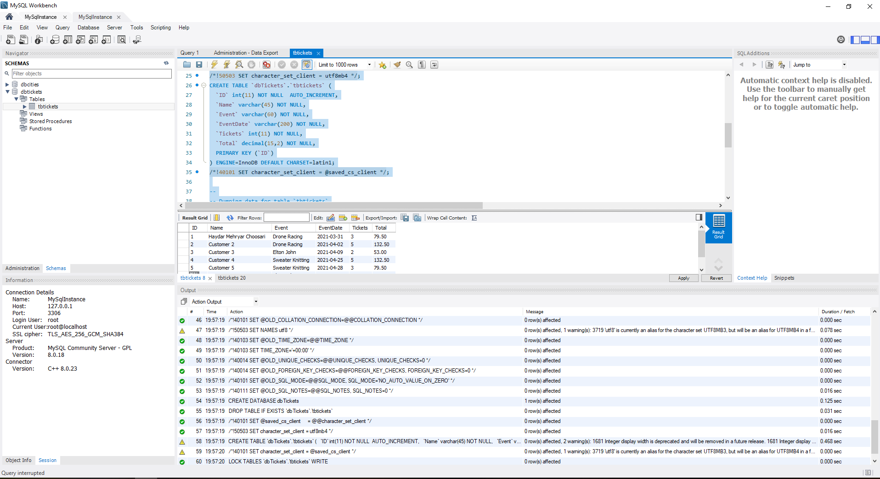

**Sequence 1**

*[your Tickets page screenshot for one seat type and ticket count here]\*\**

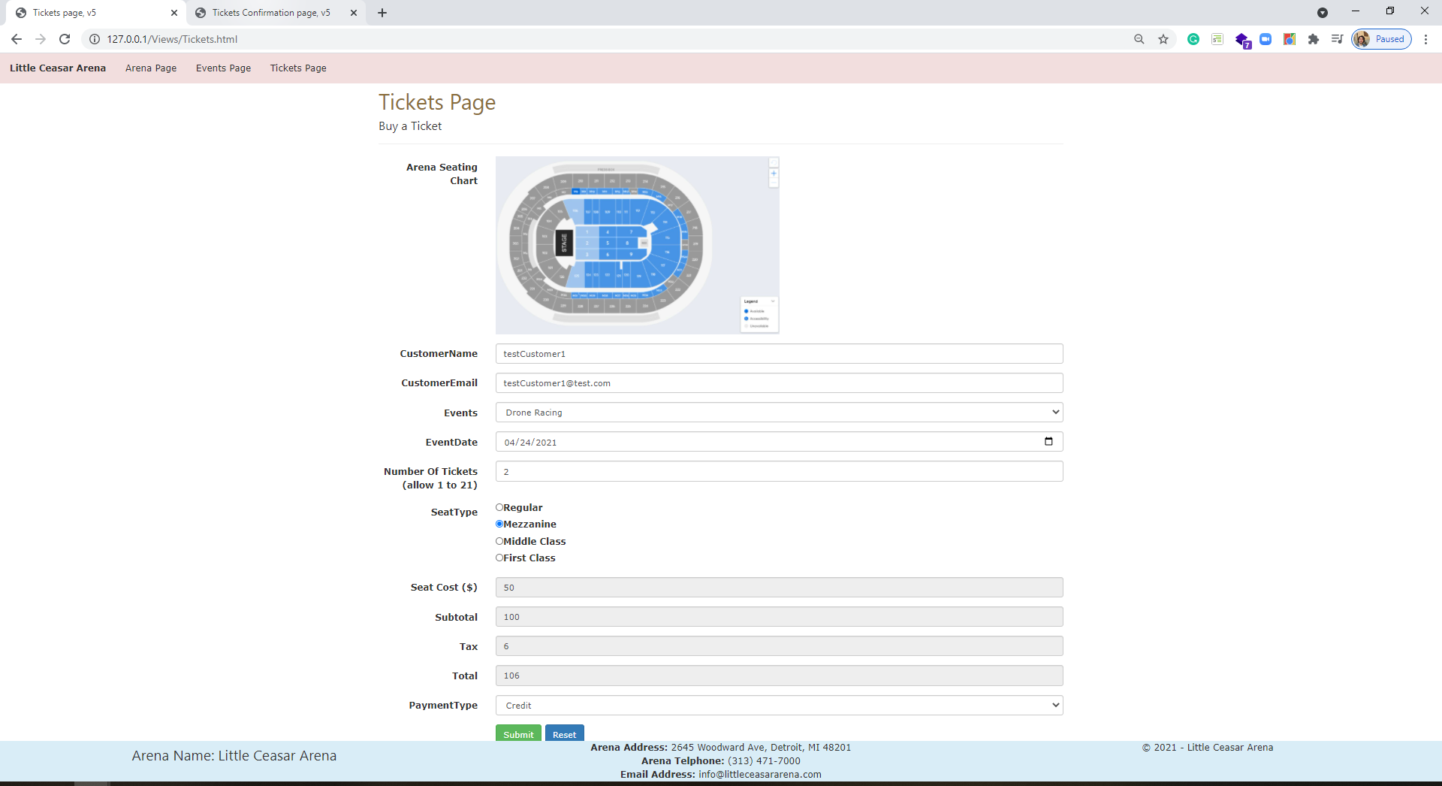

*[your Tickets Confirmation page screenshot here]\*\**

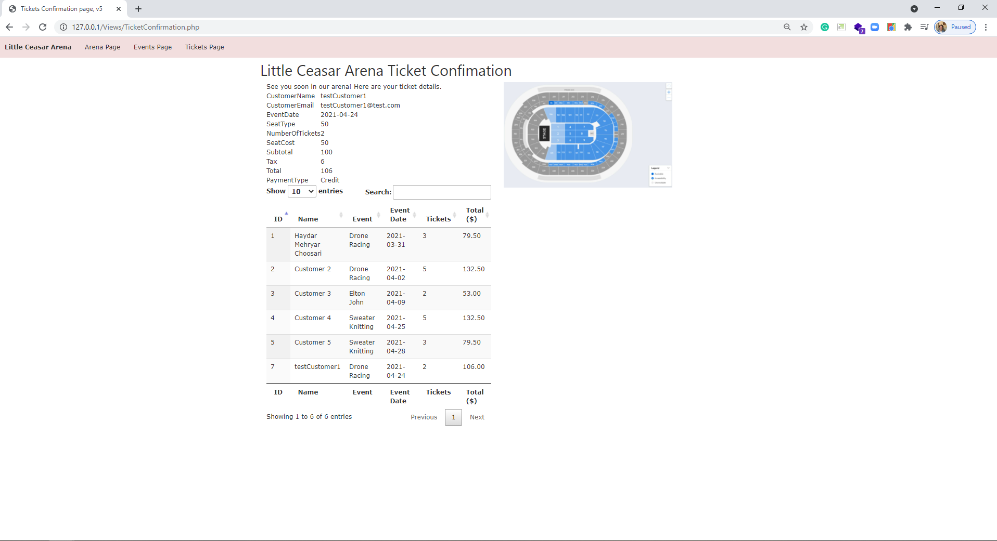

**Sequence 2**

*[your Tickets page screenshot for another seat type and ticket count here]\*\**

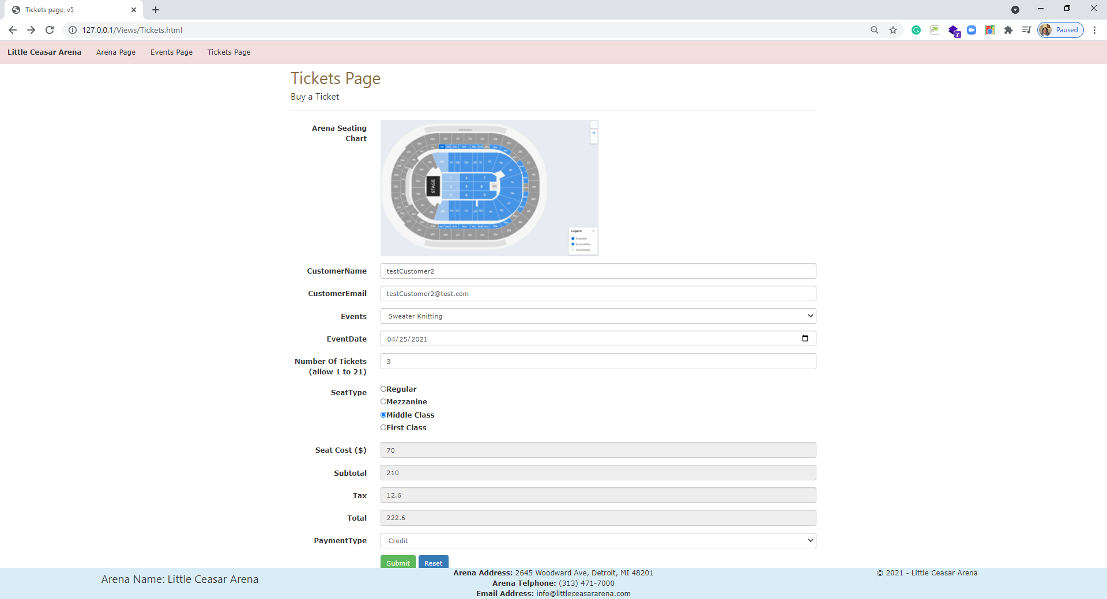

*[your Tickets Confirmation page screenshot here]\*\**

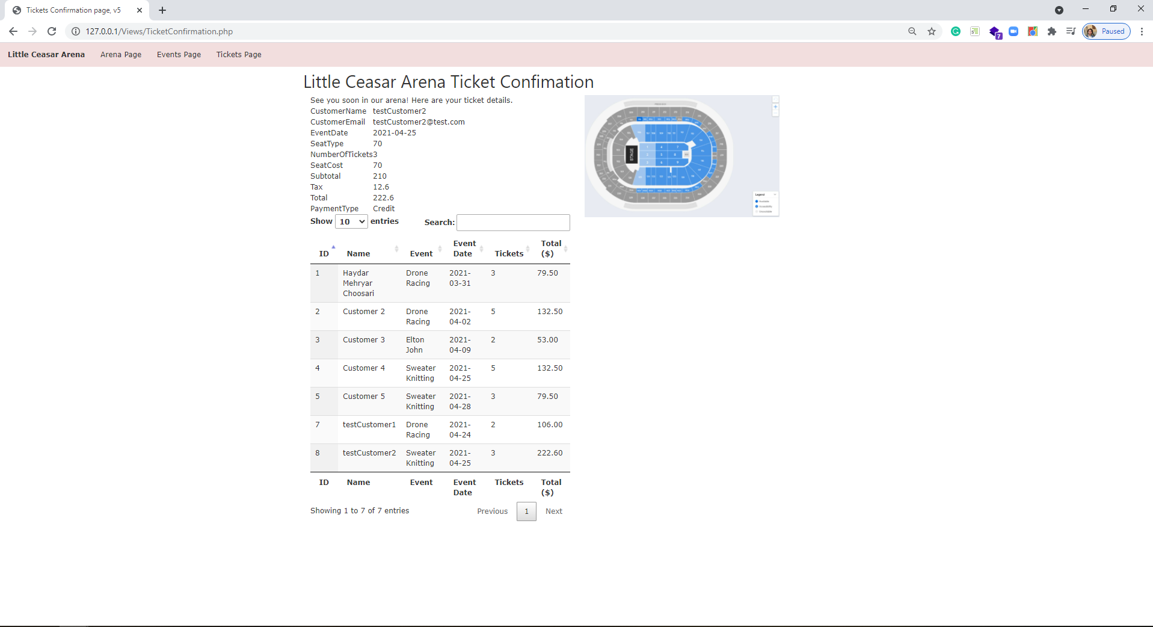

**Sequence 3**

*[your Tickets page screenshot for another seat type and ticket count here]\*\**

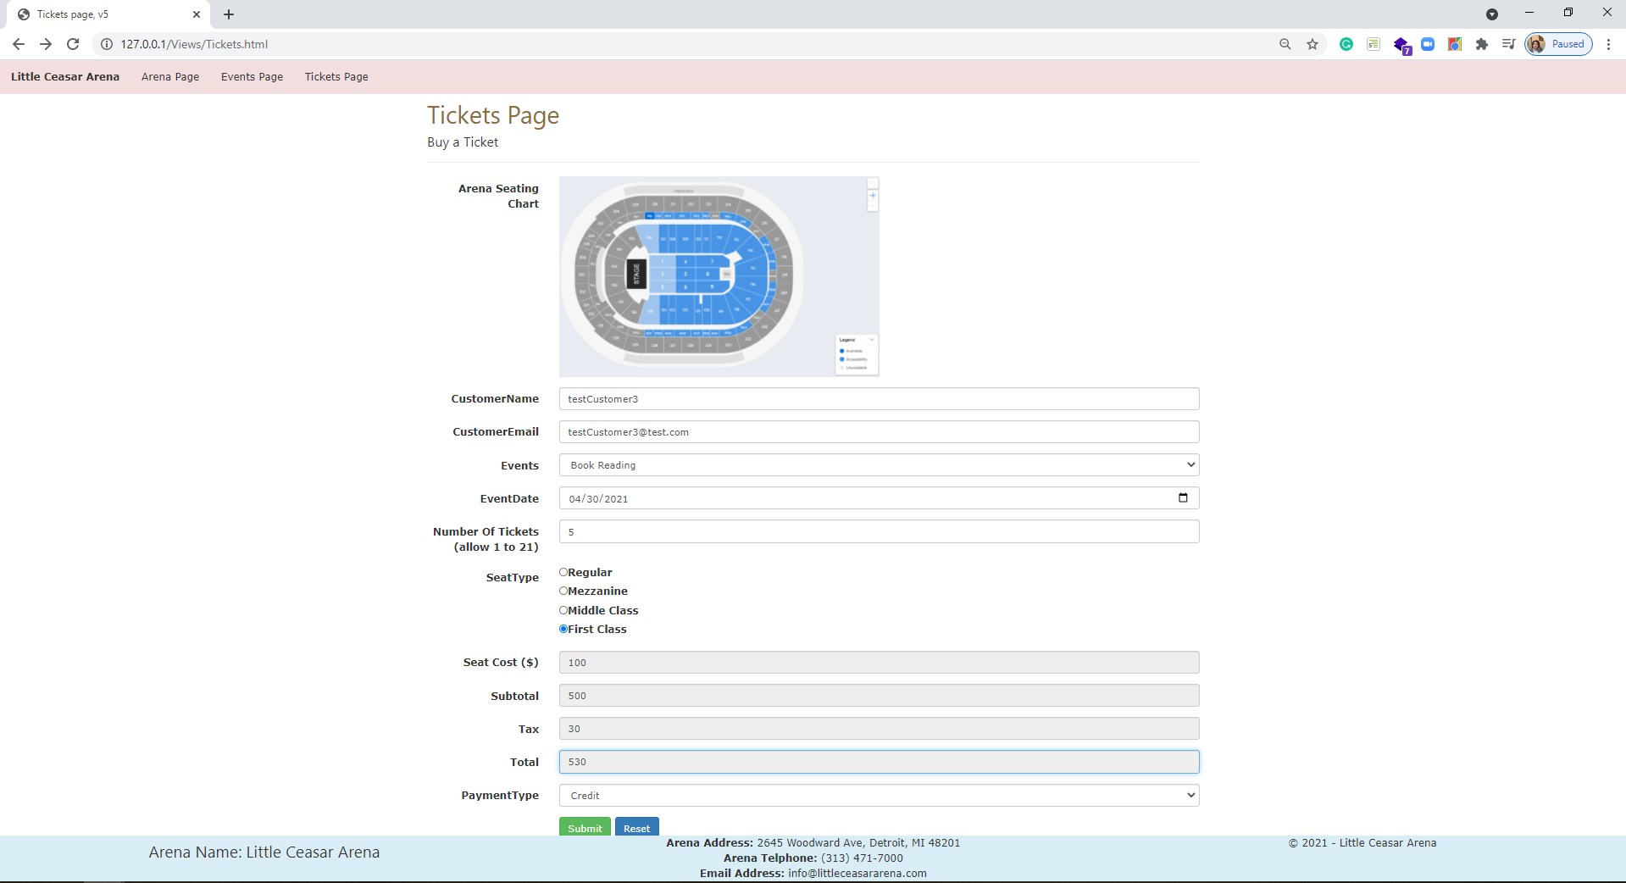

*[your Tickets Confirmation page screenshot here]\*\**

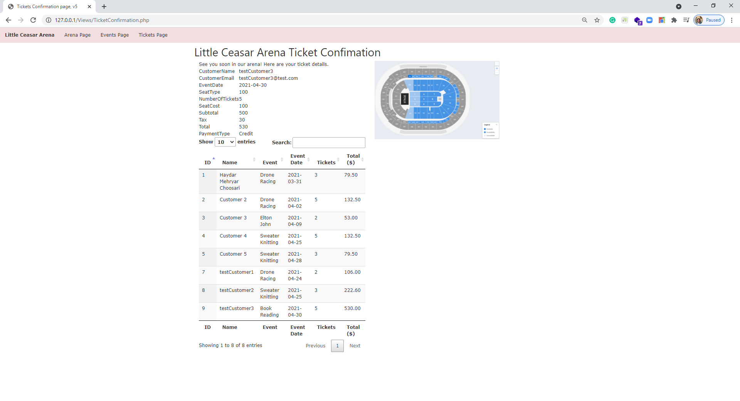

**CSS file**

*[your CSS code here]\**

**body {**

**}**

**.arena-img {**

**width:400px;**

**}**

**.event-img-width {**

**width: 200px;**

**}**

**img.arena-seating-chart {**

**width:50%;**

**}**

**.ticket-Confirmation-page img.arena-seating-chart {**

**width: 75%;**

**}**

**ul.navbar-customized {**

**list-style-type: none;**

**margin: 0;**

**padding: 0;**

**overflow: hidden;**

**/*background-color: #333;*/**

**}**

**ul.navbar-customized li {**

**float: left;**

**}**

**ul.navbar-customized li a {**

**display: block;**

**/*color: white;*/**

**text-align: center;**

**padding: 14px 16px;**

**text-decoration: none;**

**}**

**/* Change the link color to #111 (black) on hover */**

**li a:hover {**

**background-color: #e0cece;**

**text-decoration:none;**

**color:white;**

**}**

**.footer {**

**position: fixed;**

**left: 0;**

**bottom: 0;**

**width: 100%;**

**/*background-color: red;**

**color: white;*/**

**text-align: center;**

**}**

**If possible, format your code like this:**

**Font “Courier New”**

**Font size “9”**

**Bold**

**\* Copying-and-pasting web page code to a Word document**

**macOS**

1) From within the HTML editor window, press **command-A** and press **command-C**.

2) From within the Word document, press **command-V**.

**Windows**

1) From within the HTML editor window, press **CTRL-A** and press **CTRL-C**.

2) From within the Word document, press **CTRL-V**.

**\*\* Copying-and-pasting a web page to a Word document**

**macOS**

1) From the browser window, press **shift-command-4-space**.

2) From within the Word document, **command-V**.

**Windows**

1) From the browser window, press **ALT-PrintScreen**.

2) From within the Word document, press **CTRL-V**.