**CSC 5750 – Principles of Web Technology**

**Project 1 – [your name]**

**20 points – Due February 25, 5pm**

**Late deadline is February 27, 11:59pm, but 20% off**

**a)** Save this document with your name and the project number somewhere in the file name.

**b)** Paste your code and screenshots into the document.

**c)** Gather the following files into a ZIP file with your name and the project number somewhere in the file name:

● This document

● Any files specific to your extension

**d)** Submit the ZIP file to Canvas where you downloaded this document.

You've been hired to write a Google Chrome extension that displays time information. Download and unzip the extension **BrowserExtension-Google**. This was obtained from web page [developer.chrome.com/extensions/getstarted](https://developer.chrome.com/extensions/getstarted). Make the following changes to two of the files:

**Manifest.json file**

● Give your extension a name and description.

**Popup.js file**

● Instead of changing the page background color as the extension currently does, show an alert message with the following three lines:

ü The last time the extension icon was clicked. Use format yyyy-mm-dd, hh:mm:ss.

ü The current time the extension icon was clicked. Use format yyyy-mm-dd, hh:mm:ss.

ü The elapsed time between the last and current times. Use format hh:mm:ss.

Local storage may be used to store the current time so it is available for the next extension icon click. Your JavaScript will be placed in the following spot within the file:

changeColor.onclick = function(element)

{

let color = element.target.value;

chrome.tabs.query({active: true, currentWindow: true}, function(tabs)

{

… your JavaScript here …

});

};

**Chrome extension tips**

● A Chrome extensions FAQ is available at [developer.chrome.com/extensions/faq](https://developer.chrome.com/extensions/faq).

● Each time you edit the extension, you need to refresh it in the browser before you test your change.

● The extension will only work on pages whose URL begins with "developer.chrome.com". These will be visually indicated with the extension's colorful icon.

● If you encounter errors while running the extension and the refresh button disappears, **Remove** and then **Load unpacked** it.

● When you re-open Chrome, you need to **Cancel**, not **Disable**, the following message:

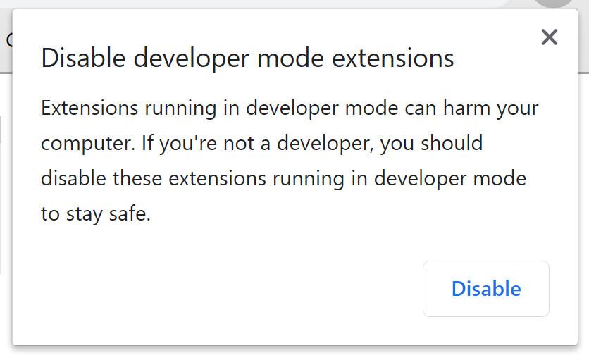

● You will probably have to adjust your browser window to view the alert message and access its dismiss button. If you can't reach it, press **ESC** twice.

**File references**

Here is a summary of how the extension files reference each other:

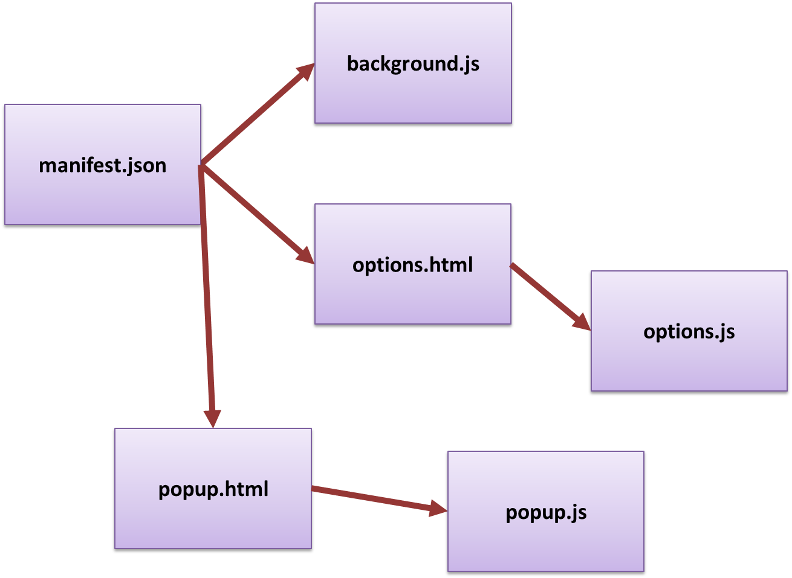

**Manifest.json**

*[your Manifest.json file here]\**

**{**

**"name": "CSC5750W21Project01",**

**"version": "1.0",**

**"description": "CSC5750 Winter 2021 Project 01, implementation of a browser extension",**

**"permissions": ["activeTab", "declarativeContent", "storage"],**

**"options_page": "options.html",**

**"background": {**

**"scripts": ["background.js"],**

**"persistent": false**

**},**

**"page_action": {**

**"default_popup": "popup.html",**

**"default_icon": {**

**"16": "images/get_started16.png",**

**"32": "images/get_started32.png",**

**"48": "images/get_started48.png",**

**"128": "images/get_started128.png"**

**}**

**},**

**"icons": {**

**"16": "images/get_started16.png",**

**"32": "images/get_started32.png",**

**"48": "images/get_started48.png",**

**"128": "images/get_started128.png"**

**},**

**"manifest_version": 2**

**}**

**If possible, format your code like this:**

**Font “Courier New”**

**Font size “9”**

**Bold**

**Popup.js**

*[your Popup.js file here]\**

**// Copyright 2018 The Chromium Authors. All rights reserved.**

**// Use of this source code is governed by a BSD-style license that can be**

**// found in the LICENSE file.**

**//Author: Haydar Mehryar**

**'use strict';**

**let changeColor = document.getElementById('changeColor');**

**function setLastTimeStr(timeStr) {**

**console.log("last time is going to be set as:"+ timeStr);**

**chrome.storage.sync.set({ 'lastTimeStr': timeStr }, function () {**

**console.log("Last Time is set");**

**})**

**}**

**function getDateObject(datestr) {**

**var parts = datestr.split(',');**

**var dateparts = parts[0].split('-');**

**var day = dateparts[0];**

**var month = parseInt(dateparts[1]) - 1;**

**var year = dateparts[2];**

**var timeparts = parts[1].split(':');**

**var hh = timeparts[0];**

**var mm = timeparts[1];**

**var ss = timeparts[2];**

**var date = new Date(0, 0, 0, hh, mm, ss, 0);**

**return date;**

**}**

**function gettimediffViaSeconds(t1, t2) {**

**var t1val = Number(t1.getHours() * 3600 + t1.getMinutes() * 60 + t1.getSeconds());**

**var t2val = Number(t2.getHours() * 3600 + t2.getMinutes() * 60 + t2.getSeconds());**

**var secDiff = Math.floor((t2 - t1)/1000);**

**console.log(secDiff);**

**var hours = Math.floor(secDiff / 3600);**

**var mins = Math.floor((secDiff % 3600) / 60);**

**var secs = (secDiff % 3600) % 60;**

**return (hours + ':' + mins + ':' + secs);**

**}**

**function gettimediff(t1, t2) {**

**var t1val = Number(t1.getHours() * 60 + t1.getMinutes());**

**var t2val = Number(t2.getHours() * 60 + t2.getMinutes());**

**var min = Math.floor((t2val - t1val) % 60);**

**var hours = parseInt((t2 - t1) / (1000 * 60 * 60));**

**return (hours + ':' + min + ':00');**

**}**

**changeColor.onclick = function(element) {**

**let color = element.target.value;**

**chrome.tabs.query({active: true, currentWindow: true}, function(tabs) {**

**//chrome.tabs.executeScript(**

**// tabs[0].id,**

**// {code: 'document.body.style.backgroundColor = "' + color + '";'});**

**var currentTime = new Date();**

**var currentTimeStr = currentTime.getFullYear() + "-" + currentTime.getMonth() + "-" + currentTime.getDay() + "," + currentTime.getHours() + ':' + currentTime.getMinutes() + ':' + currentTime.getSeconds();**

**var lastTimeStr;**

**chrome.storage.sync.get('lastTimeStr', function (data) {**

**if (data.lastTimeStr == 'undefined') {**

**console.log("lastTimeStr: set it for the first time")**

**lastTimeStr = currentTimeStr;**

**} else {**

**console.log("lastTimeStr: already exists on storage, so the value will be retrieve from it");**

**lastTimeStr = data.lastTimeStr;**

**}**

**setLastTimeStr(currentTimeStr);**

**var line1 = "lastTime: " + lastTimeStr;**

**console.log(line1);**

**var line2 = "currentTime: " + currentTimeStr;**

**console.log(line2);**

**var lastTimeDate = getDateObject(lastTimeStr);**

**var currentTimeDate = getDateObject(currentTimeStr);**

**var line3 = "Elapsed Time: "+gettimediffViaSeconds(lastTimeDate, currentTimeDate);**

**console.log(line3);**

**alert(line1 + "\n" + line2 + "\n" + line3);**

**})**

**});**

**};**

**If possible, format your code like this:**

**Font “Courier New”**

**Font size “9”**

**Bold**

**Extension output**

*[your browser page with three extension output screenshots here]*

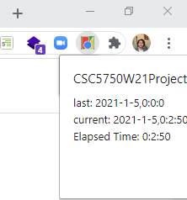

**\* Copying-and-pasting web page code to a Word document**

**macOS**

1) From within the HTML editor window, press **command-A** and press **command-C**.

2) From within the Word document, press **command-V**.

**Windows**

1) From within the HTML editor window, press **CTRL-A** and press **CTRL-C**.

2) From within the Word document, press **CTRL-V**.

**\*\* Copying-and-pasting a web page to a Word document**

**macOS**

1) From the browser window, press **shift-command-4-space**.

2) From within the Word document, **command-V**.

**Windows**

1) From the browser window, press **ALT-PrintScreen**.

2) From within the Word document, press **CTRL-V**.