**CSC 5750 – Principles of Web Technology**

**Project 2 – [your name]**

**20 points – Due April 8, 5pm**

**Late deadline is April 10, 11:59pm, but 20% off**

**a)** Save this document with your name and the project number somewhere in the file name.

**b)** Paste your code and screenshots into the document.

**c)** Gather the following files into a ZIP file with your name and the project number somewhere in the file name:

● This document

● Any files specific to your extension

**d)** Submit the ZIP file to Canvas where you downloaded this document.

You've been hired to utilize the Web Speech API. This API enables both speech recognition and speech synthesis. Information about the Web Speech API is available at [developer.mozilla.org/en-US/docs/Web/API/Web_Speech_API](https://developer.mozilla.org/en-US/docs/Web/API/Web_Speech_API).

In this project, you will enhance a web page that enables the user to enter text on the page and have it synthesized (spoken). Download the demonstration pages from [developer.mozilla.org/en-US/docs/Web/API/Web_Speech_API/Using_the_Web_Speech_API](https://developer.mozilla.org/en-US/docs/Web/API/Web_Speech_API/Using_the_Web_Speech_API). The one you will enhance is the Speak Easy Synthesis. Its folder looks like this:

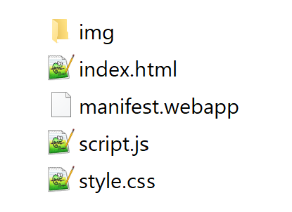

Open file **index.html** in your browser to see what the page does. Currently, it allows the user to enter some text, control the synthesized speech, and have the speech synthesized (spoken). You will enhance the page to retrieve text from the server and, when the user hovers over the text box, synthesizes the text. Make a copy of the folder so that you have the original and your development folder. Rename three of the files:

index.html ® <your-name>SpeechSynthesizerPage.html

script.js ® <your-name>SpeechSynthesizerScript.js

style.css ® <your-name>SpeechSynthesizerStyles.css

**FamousSpeech.txt**

Note the first line or two from your favorite speech. Create file **FamousSpeech.txt** and copy the text into it. Place the file in your development folder with the other files.

**SpeechSynthesizerPage.html**

Make the following changes to this page:

● Add a header comment.

● Add your name to the title and page header.

● Link to your external styles sheet.

● Add a link to the jQuery library. This will be needed for a jQuery call in file **SpeechSynthesizerScript.js**.

● Add a call to function **loadSpeech** (described below) when the page loads.

● Add a text area below the Play button. Give the text area an ID so that it can be accessed from file **SpeechSynthesizerScript.js**. Add a mouse over event to trigger a call to function **hoverSpeak** (described below).

● Link to your external script file.

**SpeechSynthesizerScript.js**

● Add function **loadSpeech** to make a jQuery call to retrieve file **FamousSpeech.txt** from the server. When the file is retrieved, place its contents in the text area in **SpeechSynthesizerPage.html**.

● Make a copy of function **speak** and call it **hoverSpeak**. Instead of speaking the text from the text box, modify the code to speak the text from the text area.

Here is what the page might look like:

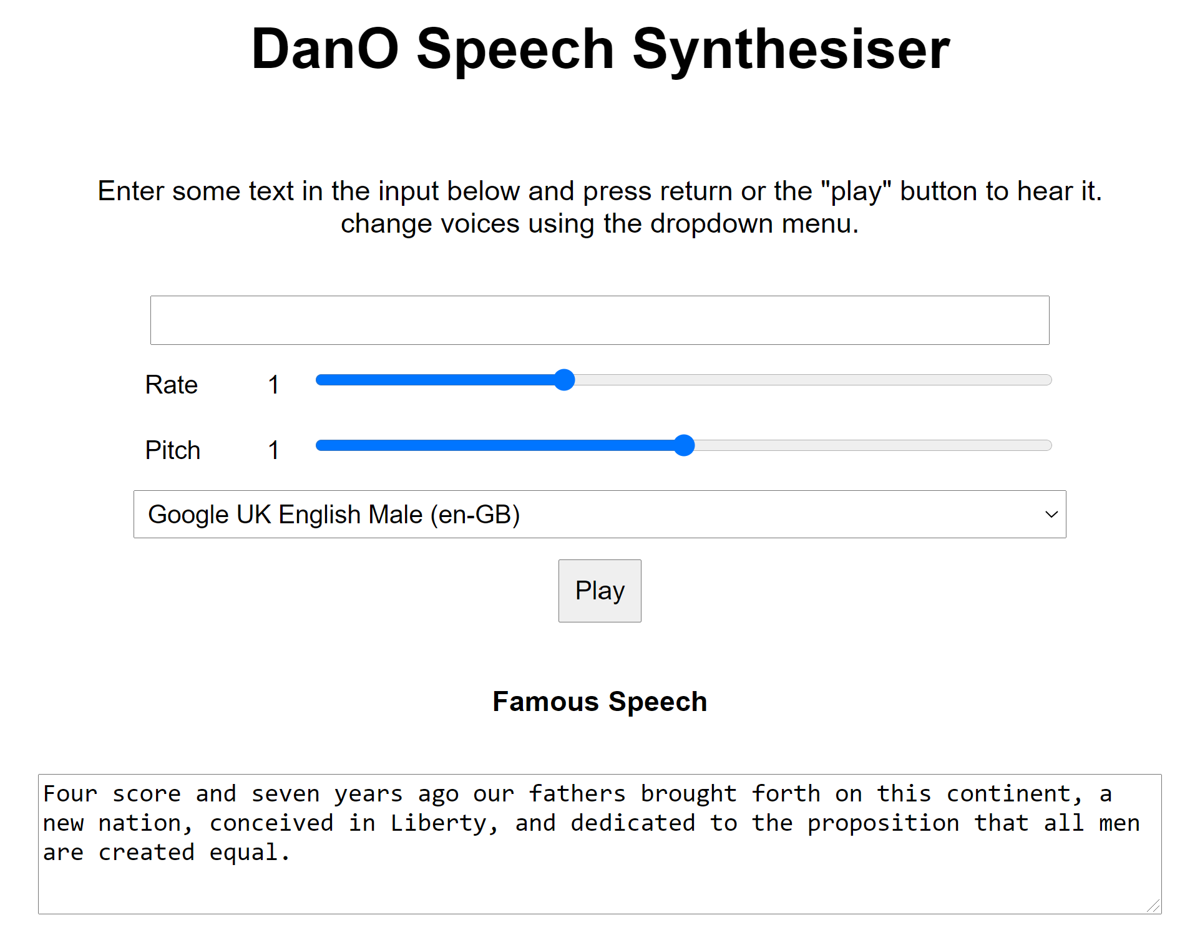

This web site must be run on your web application stack so place all web site files in a web server folder. Note that if you are using Chrome on macOS, you may have to insure that **Developer mode** is turned off. Here is what the screen looks like when **Developer mode** is turned on:



**SpeechSynthesizerPage.html**

*[your SpeechSynthesizerPage.html file here]\**

**<!DOCTYPE html>**

**<html>**

**<head>**

**<!--==================================================================**

**//**

**// Page: Haydar Mehryar Speech Synthesizer Page**

**// Description:**

**//**

**// This page allows the user to enter some text, control the sythesized speech**

**//**

**//=================================================================-->**

**<meta charset="utf-8">**

**<meta http-equiv="X-UA-Compatible" content="IE=edge,chrome=1">**

**<meta name="viewport" content="width=device-width">**

**<title>Haydar Mehryar Speech synthesiser</title>**

**<link rel="stylesheet" href="HaydarMehryarSpeechSynthesizerStyles.css">**

**<!--[if lt IE 9]>**

**<script src="//html5shiv.googlecode.com/svn/trunk/html5.js"></script>**

**<![endif]-->**

**</head>**

**<body>**

**<h1>Speech synthesiser</h1>**

**<p>Enter some text in the input below and press return or the "play" button to hear it. change voices using the dropdown menu.</p>**

**<form>**

**<input type="text" class="txt">**

**<div>**

**<label for="rate">Rate</label><input type="range" min="0.5" max="2" value="1" step="0.1" id="rate">**

**<div class="rate-value">1</div>**

**<div class="clearfix"></div>**

**</div>**

**<div>**

**<label for="pitch">Pitch</label><input type="range" min="0" max="2" value="1" step="0.1" id="pitch">**

**<div class="pitch-value">1</div>**

**<div class="clearfix"></div>**

**</div>**

**<select>**

**</select>**

**<div class="controls">**

**<button id="play" type="submit">Play</button>**

**</div>**

**<div class="label">**

**Famous Speech**

**</div>**

**<textarea type="text" class="txt" id="textArea" rows="4"></textarea>**

**</form>**

**<script src="jquery-3.6.0.js"></script>**

**<script src="HaydarMehryarSpeechSynthesizerScript.js"></script>**

**</body>**

**</html>**

**If possible, format your code like this:**

**Font “Courier New”**

**Font size “9”**

**Bold**

**SpeechSynthesizerScript.js**

*[your SpeechSynthesizerScript.js file here]\**

**var synth = window.speechSynthesis;**

**var inputForm = document.querySelector('form');**

**var inputTxt = document.querySelector('.txt');**

**var inputTxtArea = document.getElementById('textArea');**

**var voiceSelect = document.querySelector('select');**

**var pitch = document.querySelector('#pitch');**

**var pitchValue = document.querySelector('.pitch-value');**

**var rate = document.querySelector('#rate');**

**var rateValue = document.querySelector('.rate-value');**

**var voices = [];**

**function populateVoiceList() {**

**voices = synth.getVoices().sort(function (a, b) {**

**const aname = a.name.toUpperCase(), bname = b.name.toUpperCase();**

**if ( aname < bname ) return -1;**

**else if ( aname == bname ) return 0;**

**else return +1;**

**});**

**var selectedIndex = voiceSelect.selectedIndex < 0 ? 0 : voiceSelect.selectedIndex;**

**voiceSelect.innerHTML = '';**

**for(i = 0; i < voices.length ; i++) {**

**var option = document.createElement('option');**

**option.textContent = voices[i].name + ' (' + voices[i].lang + ')';**

**if(voices[i].default) {**

**option.textContent += ' -- DEFAULT';**

**}**

**option.setAttribute('data-lang', voices[i].lang);**

**option.setAttribute('data-name', voices[i].name);**

**voiceSelect.appendChild(option);**

**}**

**voiceSelect.selectedIndex = selectedIndex;**

**}**

**populateVoiceList();**

**if (speechSynthesis.onvoiceschanged !== undefined) {**

**speechSynthesis.onvoiceschanged = populateVoiceList;**

**}**

**function speak() {**

**if (synth.speaking) {**

**console.error('speechSynthesis.speaking');**

**return;**

**}**

**if (inputTxtArea.value !== '') {**

**var utterThis = new SpeechSynthesisUtterance(inputTxtArea.value);**

**console.log(utterThis);**

**utterThis.onend = function (event) {**

**console.log('SpeechSynthesisUtterance.onend');**

**}**

**utterThis.onerror = function (event) {**

**console.error('SpeechSynthesisUtterance.onerror');**

**}**

**var selectedOption = voiceSelect.selectedOptions[0].getAttribute('data-name');**

**for (i = 0; i < voices.length; i++) {**

**if (voices[i].name === selectedOption) {**

**utterThis.voice = voices[i];**

**break;**

**}**

**}**

**utterThis.pitch = pitch.value;**

**utterThis.rate = rate.value;**

**synth.speak(utterThis);**

**}**

**}**

**function speakOld(){**

**if (synth.speaking) {**

**console.error('speechSynthesis.speaking');**

**return;**

**}**

**if (inputTxt.value !== '') {**

**var utterThis = new SpeechSynthesisUtterance(inputTxt.value);**

**utterThis.onend = function (event) {**

**console.log('SpeechSynthesisUtterance.onend');**

**}**

**utterThis.onerror = function (event) {**

**console.error('SpeechSynthesisUtterance.onerror');**

**}**

**var selectedOption = voiceSelect.selectedOptions[0].getAttribute('data-name');**

**for(i = 0; i < voices.length ; i++) {**

**if(voices[i].name === selectedOption) {**

**utterThis.voice = voices[i];**

**break;**

**}**

**}**

**utterThis.pitch = pitch.value;**

**utterThis.rate = rate.value;**

**synth.speak(utterThis);**

**}**

**}**

**inputForm.onsubmit = function(event) {**

**event.preventDefault();**

**speak();**

**inputTxt.blur();**

**}**

**pitch.onchange = function() {**

**pitchValue.textContent = pitch.value;**

**}**

**rate.onchange = function() {**

**rateValue.textContent = rate.value;**

**}**

**voiceSelect.onchange = function(){**

**speak();**

**}**

**$(function () {**

**loadSpeech();**

**$("#textArea").mouseover(function () {**

**console.log("mouse over");**

**hoverSpeak();**

**});**

**})**

**function hoverSpeak() {**

**console.log("hover speak");**

**speak();**

**console.log("end: hover speak");**

**}**

**function loadSpeech() {**

**}**

**If possible, format your code like this:**

**Font “Courier New”**

**Font size “9”**

**Bold**

**Screenshot**

*[your SpeechSynthesizerPage screenshot here]*

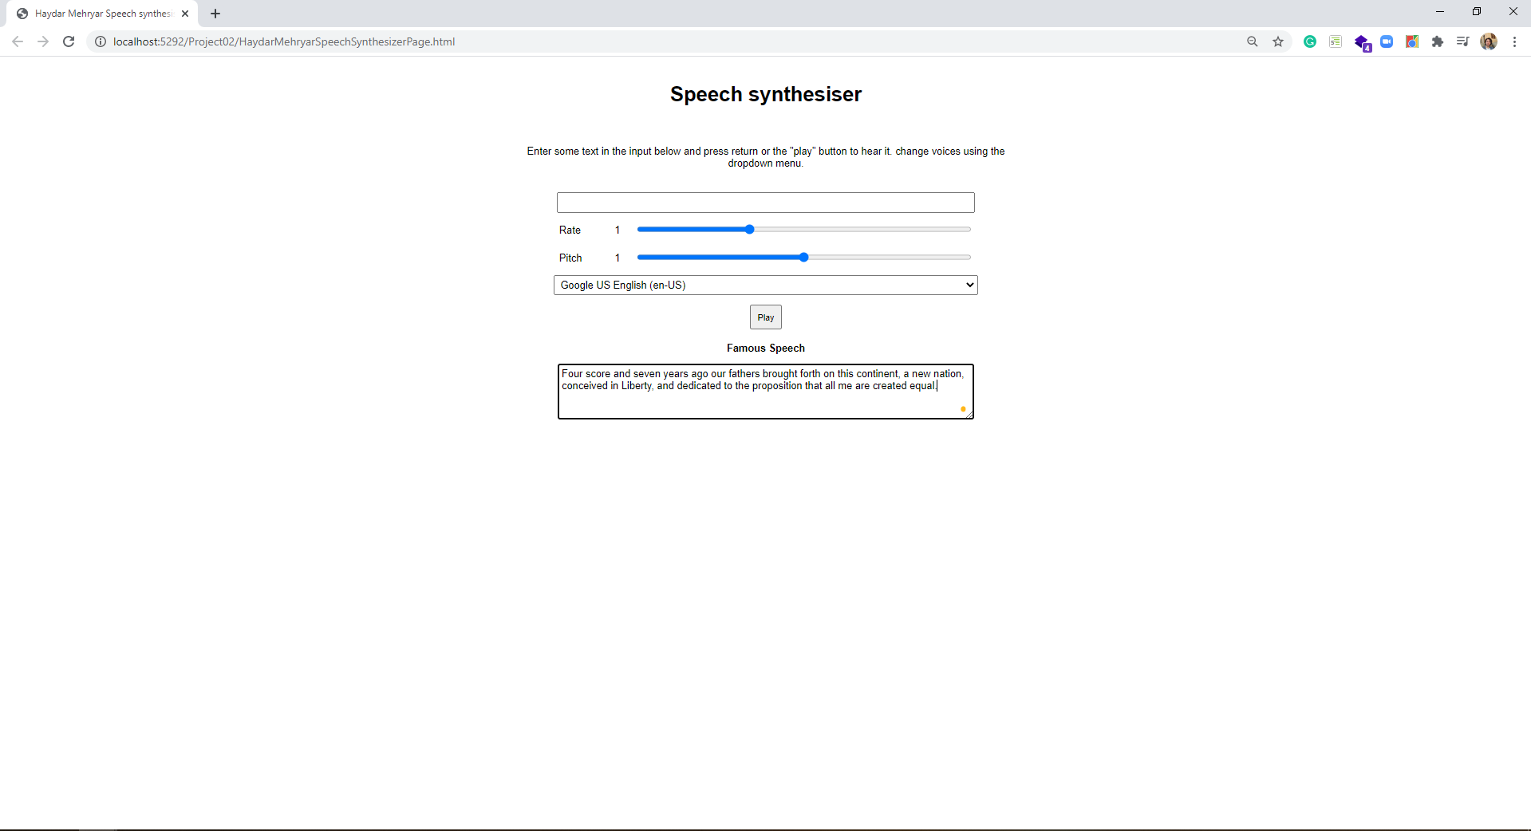

**\* Copying-and-pasting web page code to a Word document**

**macOS**

1) From within the HTML editor window, press **command-A** and press **command-C**.

2) From within the Word document, press **command-V**.

**Windows**

1) From within the HTML editor window, press **CTRL-A** and press **CTRL-C**.

2) From within the Word document, press **CTRL-V**.

**\*\* Copying-and-pasting a web page to a Word document**

**macOS**

1) From the browser window, press **shift-command-4-space**.

2) From within the Word document, **command-V**.

**Windows**

1) From the browser window, press **ALT-PrintScreen**.

2) From within the Word document, press **CTRL-V**.