**Assignment: 1 Linux_basics**

Name: Harsh M. Mekhiya   
email: [harshmekhiya191@gmail.com](mailto:harshmekhiya191@gmail.com)

**Tasks**

**1. Creating and Renaming Files/Directories**

**Create a directory named test_dir using mkdir.**

**Inside test_dir, create an empty file called example.txt.**

**Rename example.txt to renamed_example.txt using mv**

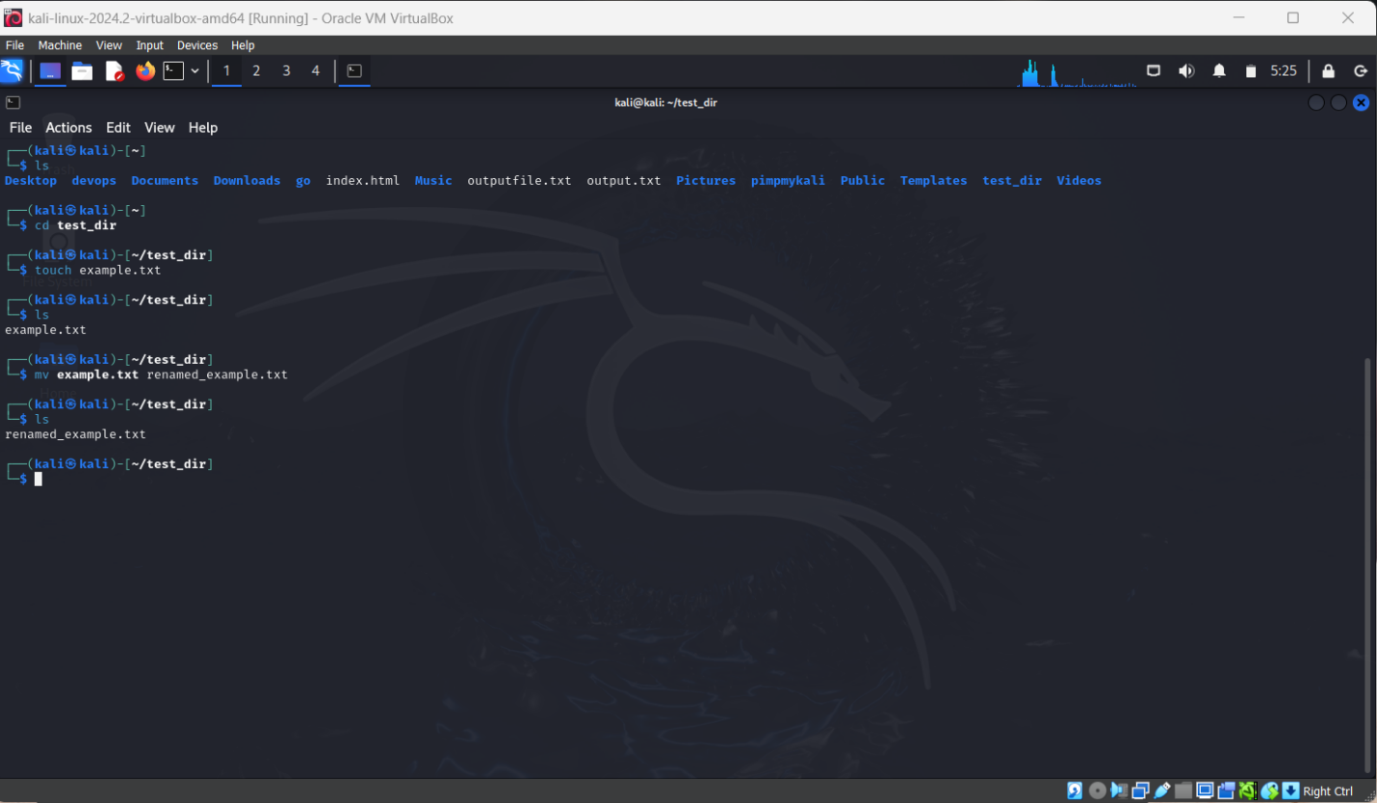

Explanation:

First of all I’ve used kali Linux from Virtualbox (VMware) in this I was at home and I’ve create a new directory using **< mkdir test_dir>** and then using < ls > I can see that dir.

Then ive do there by **< cd test_dir>** and create a file name example.txt by using **<touch example.txt >**.

Then for rename ive used < mv > command as **< mv example.txt renamed_example.txt >**.

**Task**

**2. Viewing File Contents**

**Use cat to display the contents of /etc/passwd.**

**Display only the first 5 lines of /etc/passwd using head.**

**Display only the last 5 lines of /etc/passwd using tail.**

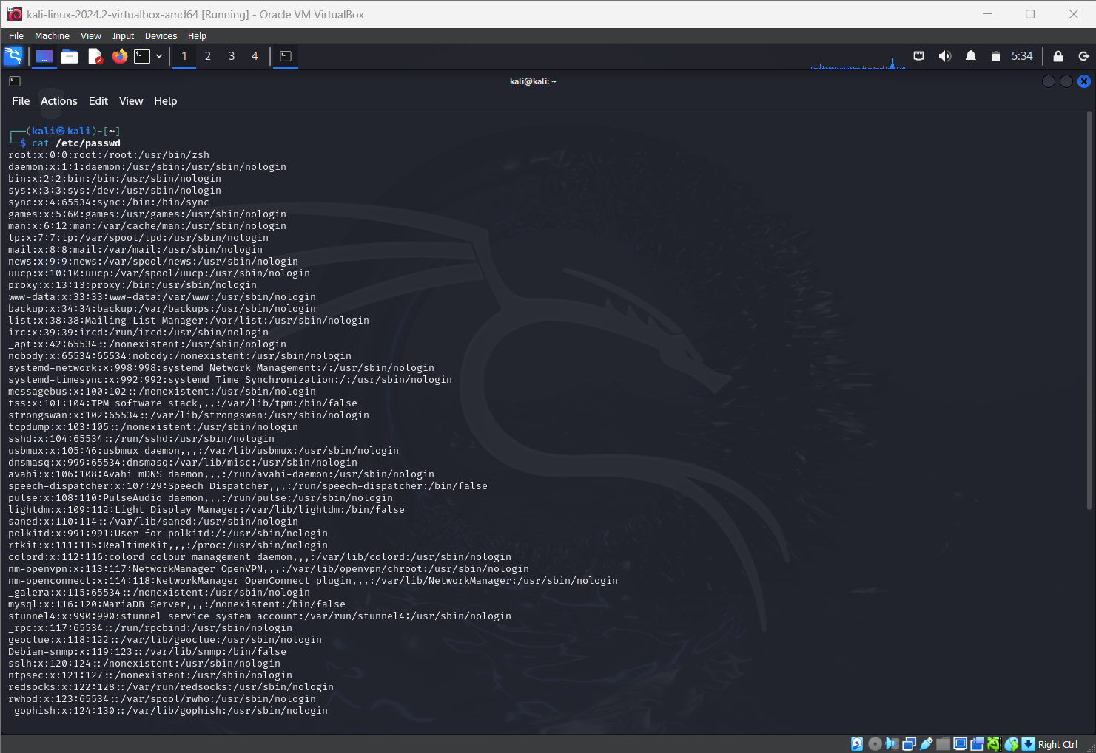

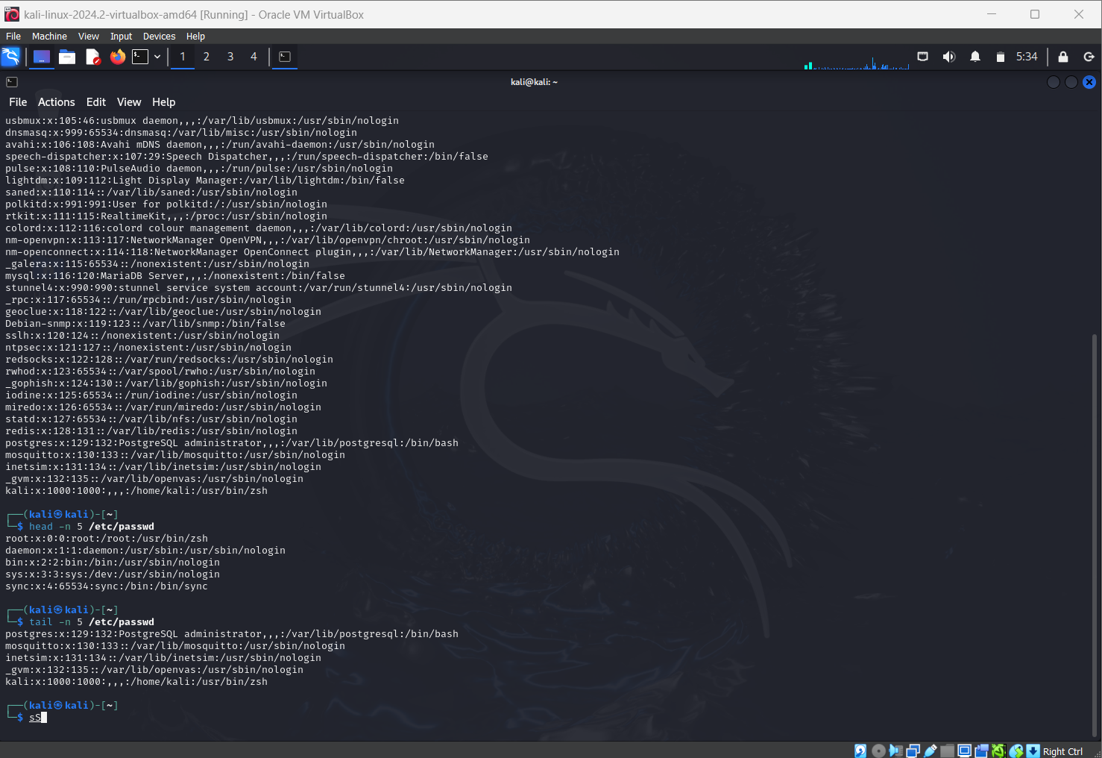

Explanation:

I started by using the **< cat /etc/passwd >** command, which displayed the complete contents of the file directly in the terminal.

Then, to view only the first few lines, I used the **< head -n 5 /etc/passwd >** command, which showed me just the first 5 lines of the file.

Finally, I used **< tail -n 5 /etc/passwd >** to display the last 5 lines of the same file.

**Task**

**3.Searching for Patterns**

**Use grep to find all lines containing the word "root" in /etc/passwd.**

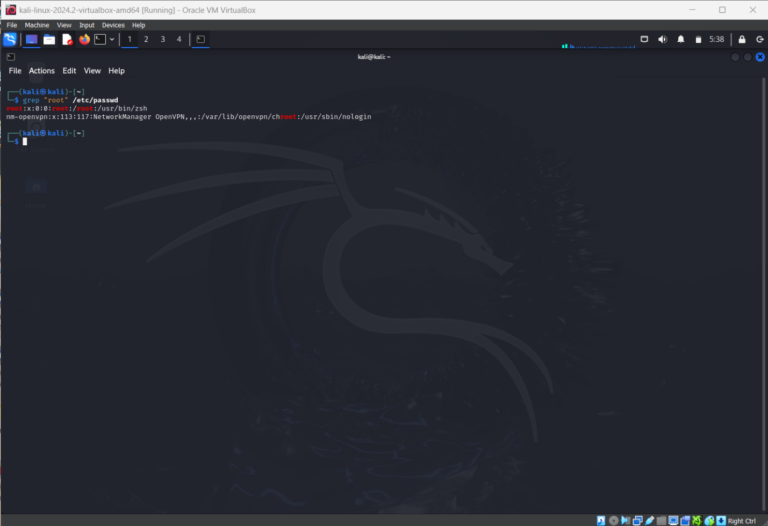

Explanation:

Here, I used the < grep "root" /etc/passwd > command to search for all lines containing the word “root” inside the /etc/passwd file.

**Task**

**4. Zipping and Unzipping**

**Compress the test_dir directory into a file named test_dir.zip using zip.**

**Unzip test_dir.zip into a new directory named unzipped_dir.**

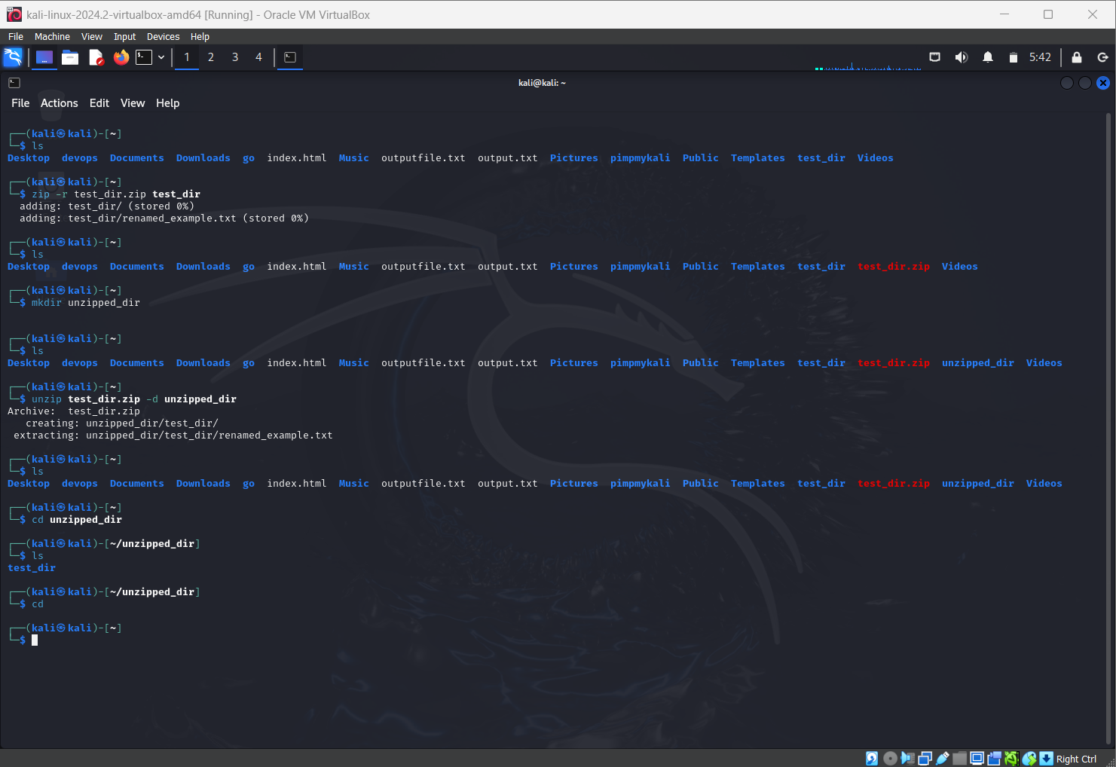

Explanation:

For this task, I practiced compressing and extracting directories. First, I created a directory called test_dir and then compressed it into a zip file using **< zip -r test_dir.zip test_dir >.** After that, I created a new folder called unzipped_dir with **< mkdir unzipped_dir >.** Finally, I extracted the contents of test_dir.zip into that folder using **< unzip test_dir.zip -d unzipped_dir >.** Where **-d** will redirect this extracting to the location of unzipped_dir.

**Task**

**5. Downloading Files**

**Use wget to download a file from a URL (e.g.,** [**https://example.com/sample.txt**](https://example.com/sample.txt)**).**

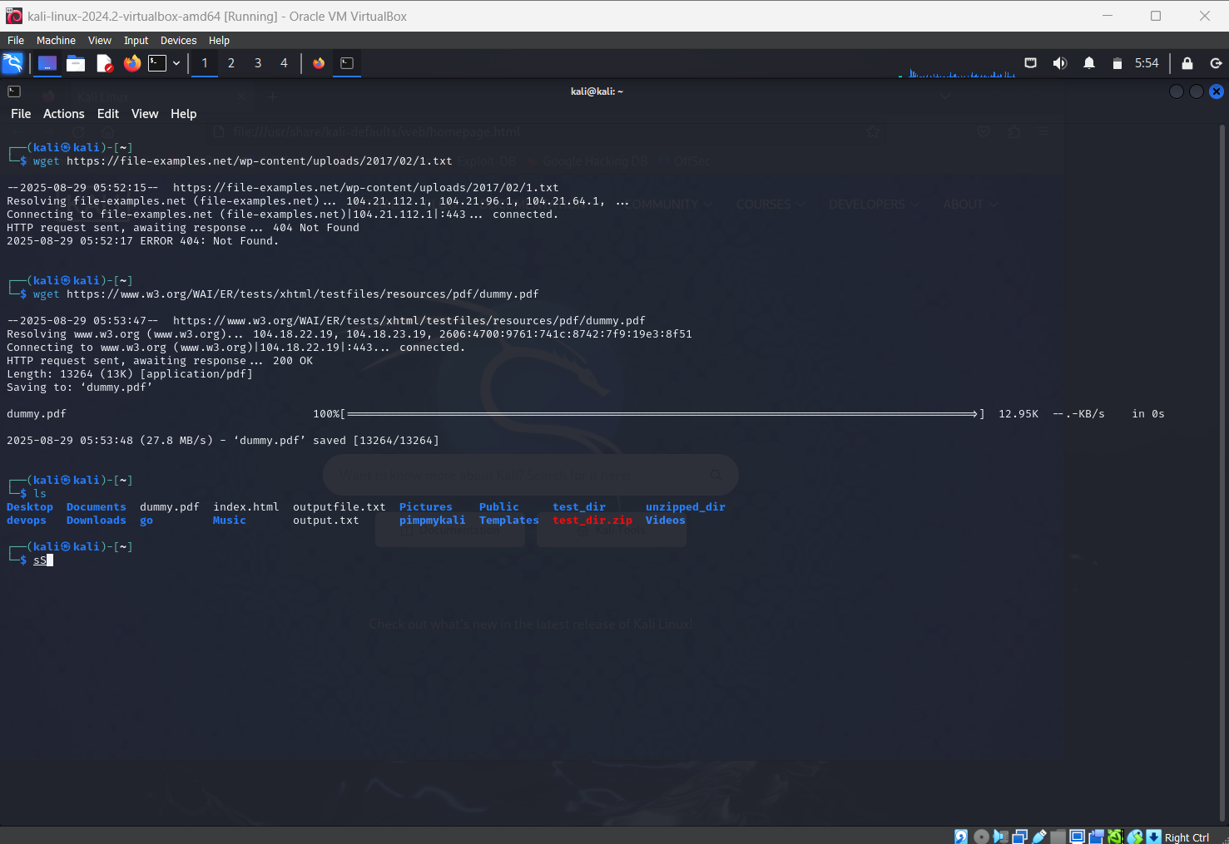

Explanation:

In this task, I used the < wget > command to download files from the internet. For example, I downloaded a sample text file using **< wget url >** and I was able to download or save that dummy.pdf. and moreover I delete that pdf by using **< rm dummy.pdf >**

**Task**

**6. Changing Permissions**

**Create a file named secure.txt and change its permissions to read-only for everyone using chmod.**

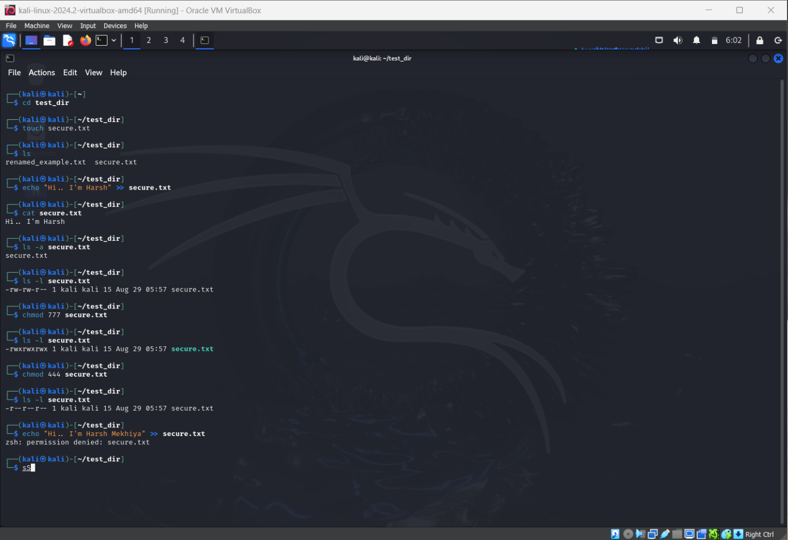

Explanation:

Here, I practiced file permissions in Linux. First, I created a file named secure.txt **using < touch secure.txt >**. Then, I changed its permissions to read-only for everyone using **< chmod 444 secure.txt >**. After running **< ls -l secure.txt >**, the output showed -r--r--r--, which means the owner, group, and others all have read-only access with no write or execute permission. And by using **< echo “text” >> secure.txt >** I was unable to update.

**Task**

**7. Working with Environment Variables**

**Use export to set a new environment variable called MY_VAR with the value "Hello, Linux!".**

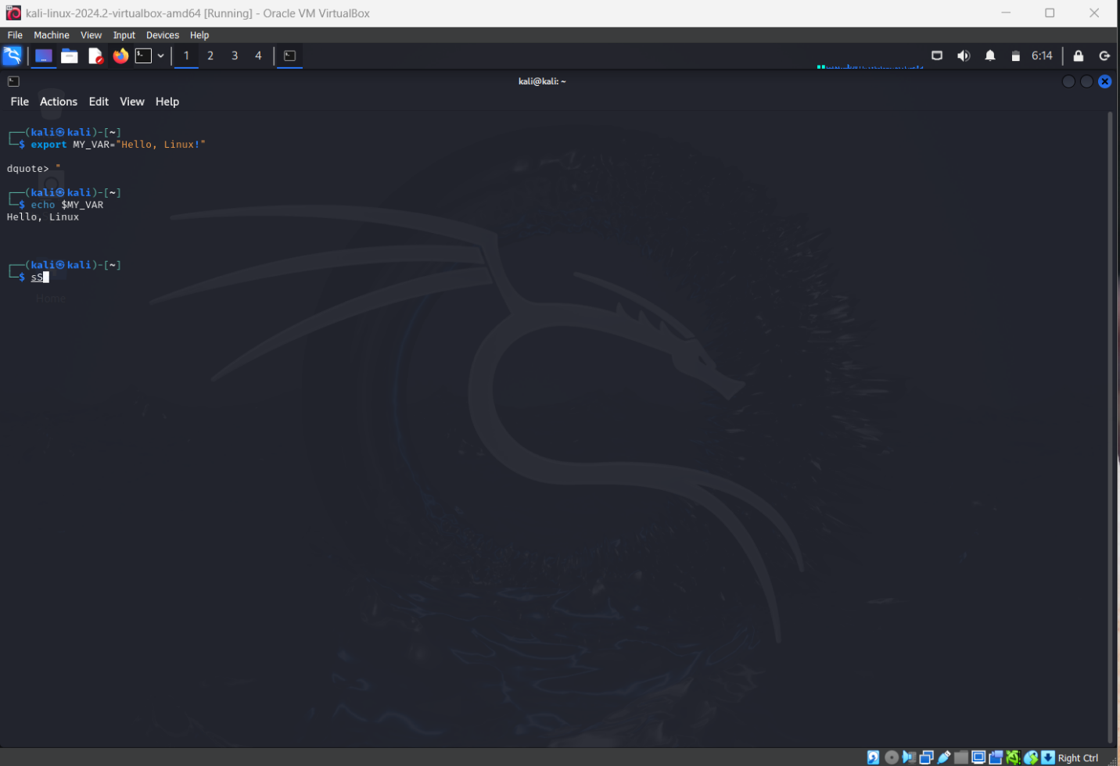

Explanation:

In this task, I learned how to set and use environment variables. I created a variable called MY_VAR using:

<export MY_VAR="Hello, Linux!" >

To verify it, I ran < echo $MY_VAR >, which displayed Hello, Linux! on the screen.

**Summary of Linux Tasks**

1. **Creating and Navigating Directories** – Learned how to create, list, rename, and move between directories and files using mkdir, ls, cd, touch, and mv.
2. **Viewing File Contents** – Practiced displaying files fully and partially with cat, head, and tail.
3. **Searching for Patterns** – Used grep to search for specific words (like “root”) inside files.
4. **Zipping and Unzipping** – Compressed and extracted directories using zip and unzip.
5. **Downloading Files** – Downloaded text files from the internet using wget.
6. **Changing Permissions** – Modified file permissions with chmod and understood read-only access (444).
7. **Working with Environment Variables** – Created and displayed environment variables using export and echo.