**ENGINE CONDITION**

**TREND MONITORING**

*Failure Prediction of an Aircraft Engine*

By

Shreyas S

Machine Learning Intern

Faststream Technologies

Arkere, Bangalore - 560076

****Email: [hello@shreyas.im](mailto:hello@shreyas.im)

**TABLE OF CONTENTS**

1. **Introduction 1**
   1. Background 1
   2. Engine Condition Trend Monitoring 2
   3. Machine Learning 3
   4. Objectives 4
   5. Dependencies and Tools 4
   6. Assumptions 4
2. **Methodology 6**
3. **Implementation 8**
   * 1. Generating Data 8
     2. Training Machine Learning Models 10
4. Multiple Linear Regression 11
5. Decision Tree Regression 11
6. Random Forest Regression 11
   * 1. Testing Machine Learning Models 12
7. **Results 13**
8. Visualization of Predictions 13
   * 1. Multiple Linear Regression 13
     2. Decision Tree Regression 14
     3. Random Forest Regression 15
9. Computing R2 Score 16
10. **Conclusions 18**
11. **Future Enhancements 19**
12. **References 20**
13. **Appendix 21**
14. **INTRODUCTION**

This report will be of interest for Pilots, Aircraft Engine Manufacturers, Data Scientists and Researchers. This report provides an overview of how Machine Learning algorithms can help predict the probability of failure of aircraft engines. This process is called Engine Condition Trend Monitoring.

* 1. **Background**

Faststream Technologies is a vanguard of technology solutions, specializing in Product & System Engineering, IoT, Big Data, Security, and Application Development with a global footprint across North America, EMEA, and APAC. With over 200+ clients, Faststream Technologies enables Digital Transformation for enterprises by delivering a flawless customer experience, business competence, and deep insights through an integrated set of disruptive technologies and expertise. We are passionate about delivering well-organized, inventive and world-class hardware and software solutions, with a focus on Healthcare, Aerospace, Semiconductors, Automotive, Consumer Electronics, Home Automation, Telecommunications, Security, Retail, and E-Commerce.

Faststream Technologies works at the juncture of business and technology, assisting clients with advancing their product and business performance through sustainable information technology solutions. Faststream Technologies drives innovation to help clients advance their product design, business processes, and application development. Our engineering team’s deep expertise in transforming design specs into marketable hardware products — through ASIC design services that include RTL design, design verification and physical design for digital and analogue/mixed-signal semiconductors — is a key differentiator to our suite of application development capabilities.

For today’s challenges like embedded processor SoC specifications, Faststream Technologies delivers all of the required firmware/embedded software, positioning us as the turnkey ‘concept-to-product’ design company. The team is led by a group of focused senior executives and Technologists who complement each other with significant industry experience in building turnkey solutions. Many of our technologists have multiple patents to their credit in the areas of Analog/Mixed-Signal Design, IoT and embedded systems.

* 1. **Engine Condition Trend Monitoring**

Engine Condition Trend Monitoring (ECTM) is defined as using engine operational data to find symptoms of damage, deterioration or excessive wear. Essentially, it’s a technique to continuously monitor the health of engines. By tracking a known set of parameters like altitude, noise from the fan blade, exhaust gas temperature of turbine, fuel flow of turbine, low pressure fan speed, high pressure rotor speed, mechanical problems in the engine, oil leaks, fuel pump etc., operators are able to predict needed maintenance before a failure occurs. This doesn’t stop the initial problem from happening but is a great tool to predict a failure before anything catastrophic occurs. [1]

Although flight crews are able to notice big or sudden changes to performance, ECTM will identify subtle changes over a period of time that a flight crew won’t. Every flight, the aircraft is in different environmental conditions that may not give a clear picture of performance to the flight crews. ECTM will calculate the information provided, correct it for standard day conditions and predict when the engine might fail. [2]

Properly trained, humans can manually do the analysis, but the risk for error is great. Computers and software is used to identify and interpret trends and aircraft operator is notified of any anomalies that need to be addressed. [3]

* 1. **Machine Learning**

Machine Learning is the science (and art) of programming computers so they can learn from data. For example, your spam filter is a Machine Learning program that can learn to flag spam given examples of spam emails (e.g., flagged by users) and examples of regular (non-spam) emails. The examples that the system uses to learn are called the training set. Each training example is called a training instance (or sample). In this case, the task T is to flag spam for new emails, the experience E is the training data, and the performance measure P needs to be defined; for example, you can use the ratio of correctly classified emails. This particular performance measure is called accuracy and it is often used in classification tasks. [4]

***Supervised Learning***

Machine Learning systems can be classified according to the amount and type of supervision they get during training. There are four major categories: supervised learning, unsupervised learning, semi-supervised learning, and Reinforcement Learning. In supervised learning, the training data you feed to the algorithm includes the desired solutions, called labels. [5]

***Unsupervised learning***

It is the machine learning task of inferring a function that describes the structure of "unlabelled" data (i.e. data that has not been classified or categorized). Since the examples given to the learning algorithm are unlabelled, there is no straightforward way to evaluate the accuracy of the structure that is produced by the algorithm—one feature that distinguishes unsupervised learning from supervised learning and reinforcement learning. [6]

* 1. **Objectives**

The goal of the project is to predict the probability of failure of an aircraft engine using three machine learning algorithms and comparing the performances of each algorithm.

* 1. **Dependencies and Tools**

1. Python – a general-purpose interpreted, interactive, object-oriented, and high-level programming language
2. Anaconda – a free and open source distribution of the Python and R programming languages for data science and machine learning related applications, that aims to simplify package management and deployment
3. Numpy – the fundamental package for scientific computing with Python.
4. Scipy - a Python-based ecosystem of open-source software for mathematics, science, and engineering
5. Pandas - pandas is an open source, BSD-licensed library providing high-performance, easy-to-use data structures and data analysis tools for the Python programming language.
6. Matplotlib – a Python 2D plotting library which produces publication quality figures in a variety of hardcopy formats and interactive environments across platforms
7. Sci-kit learn – a free software machine learning library for the Python programming language.
   1. **Assumptions**

* Data, in the absence of its availability, has been generated based on nominal value and random degradation.
* A minimum and maximum value for every component has been preset.
* An increase in the value of any one of the components beyond its maximum value, affects the probability of failure of that component.
* The failure of each component constitutes to the total probability of failure of the whole Turbine Engine.
* The Turbine Engine fails completely when the probability reaches 1.

The minimum value, value after which degradation starts and value when probability of failure reaches 1 under normal conditions are given below:

|  |  |  |  |
| --- | --- | --- | --- |
| **Components** | **Minimum value** | **Value after which degradation starts** | **Value when probability of failure reaches 1** |
| Fan Blade Noise | 130dB | 137dB | 143dB |
| Exhaust Gas Temperature of Turbine | 1300oC | 1900 oC | 2500 oC |
| Fuel Flow of Turbine | 5000kg/hr | 5500kg/hr | 6000kg/hr |
| Low Pressure Fan Speed | 12000rpm | 14000rpm | 16000rpm |
| High Pressure Rotor Speed | 10000rpm | 12000rpm | 14000rpm |

1. **METHODOLOGY**

Acquiring Field Data for Training

Train Machine Learning Algorithms with the field data

Save the Model

Acquire Field Data for Testing

Fit the saved Model to the Test Data

Predict the Probability of Failure

Visualize the Predictions

Compute R2 Score

Figure 1. Methodology Flow Diagram

* Historical data of multiple aircraft engines are collected for training machine learning algorithms as Training Set.
* The Training Set is used to train Machine learning models using Multiple Linear Regression, Decision Tree and Random Forest and are saved.
* Some more data of aircraft engines are collected to validate the machine learning models as Test Set.
* The saved models are then loaded to the Test Set.
* The probability of failure of the engine using the Test Set data is predicted.
* Graph is plotted against Age and Probability of Failure with one line representing nominal values and another line representing the random degradation values generated in the Test Set.
* Finally, R2 Score is computed for each engine and the results are compared.

1. **IMPLEMENTATION**

Since acquisition of real world data was not possible, datasets for training and testing purpose was generated.

Data for 1000 engines with random degradation have been generated as Training Set which is used to train the Machine Learning Models.

Data for one engine in 10 different scenarios with random degradation are generated as Test Set to validate the trained Machine Learning Model.

1. **Generating Data**

The Training and Test Set data is generated using a python library called NumPy. It has methods to randomly generate numbers in a given range, store them in an array and perform operations on them very efficiently.

Steps involved in generating data are:

1. Importing Libraries
2. Set the minimum and maximum values of each parameter
3. Loop 1000 times

Generate values for each parameter with random degradation

Generate probability of failure for each engine based on assumptions

Flow Diagram for generating data is given below:

Importing Libraries

Set minimum and maximum values for each parameter

i = 1

i = 1000 ?

True

False

i = i + 1

Generate values for each parameter with random degradation

Generate probability of failure for each engine based on assumptions

Stop

Figure 2. Flow Diagram for Generating Data

1. **Training Machine Learning Models**

Training Machine Learning models include the following steps:

1. Importing Libraries
2. Importing Dataset
3. Encoding Categorical Data
4. Avoid dummy variable trap
5. Splitting dataset
6. Applying Machine Learning Algorithm
7. Saving the model

Flow Diagram for the same is given below.

Importing Libraries

Importing Dataset

Encoding Categorical Data

Avoid Dummy Variable Trap

Splitting Dataset

Applying Machine Learning Algorithms

Saving the Model

Figure 3. Flow Diagram for Training Machine Learning Models

1. **Multiple Linear Regression**

Multiple Linear Regression is a linear approach to modelling the relationship between a scalar response (dependent variable) and multiple explanatory variables (independent variables). [7]

The model for Multiple Linear Regression, given n observations, is

for i = 1, 2, … , n

: Predicted value (dependent variable)

through : p distinct independent variables

: value of y when all the independent variables ( through ) are equal to zero

1. **Decision Tree Regression**

Decision tree builds regression models in the form of a tree structure. It breaks down a dataset into smaller and smaller subsets while at the same time an associated decision tree is incrementally developed.

The final result is a tree with decision nodes and leaf nodes. A decision node has two or more branches, each representing values for the attribute tested. Leaf node represents a decision on the numerical target. The topmost decision node in a tree which corresponds to the best predictor called root node. [8]

1. **Random Forest Regression**

The Random Forest Regression is a type of Machine Learning Algorithm that makes predictions by combining decisions from a sequence of base models. More formally we can write this class of models as:

*g(x) = f0(x) + f1(x) + f2(x) + …*

where the final model *g* is the sum of simple base models *fi*. Here, each base classifier is a simple Decision Tree. [9]

1. **Testing (Validating) Machine Learning Models**

Testing Machine Learning models include the following steps:

1. Importing Libraries
2. Importing Dataset
3. Encoding Categorical Data
4. Avoid dummy variable trap
5. Fitting Machine Learning Model to the Dataset
6. Computing Results

Flow Diagram for the same is given below:

Importing Libraries

Importing Dataset

Encoding Categorical Data

Avoid Dummy Variable Trap

Fitting Machine Learning Model to the Dataset

Computing Results

Figure 4. Flow Diagram for Training Machine Learning Models

1. **RESULTS**

The predictions are plotted in a graph for visualization purpose.

In a real world scenario, we would also compare the predicted value to the real world value and then compute the accuracy of each algorithm using R2 Score.

Due to the absence of real world data, the results of all the three algorithms are compared using R2 Score with the generated data.

1. **Visualization of Predictions**

For visualizing the results, graphs are plotted against Age and Probability of Failure. 5 scenarios are taken at once in a single graph.

Green line represents life of an engine under nominal conditions.

Red, blue, orange, yellow and black lines represent life of an engine with random degradation under different scenarios.

1. **Multiple Linear Regression**

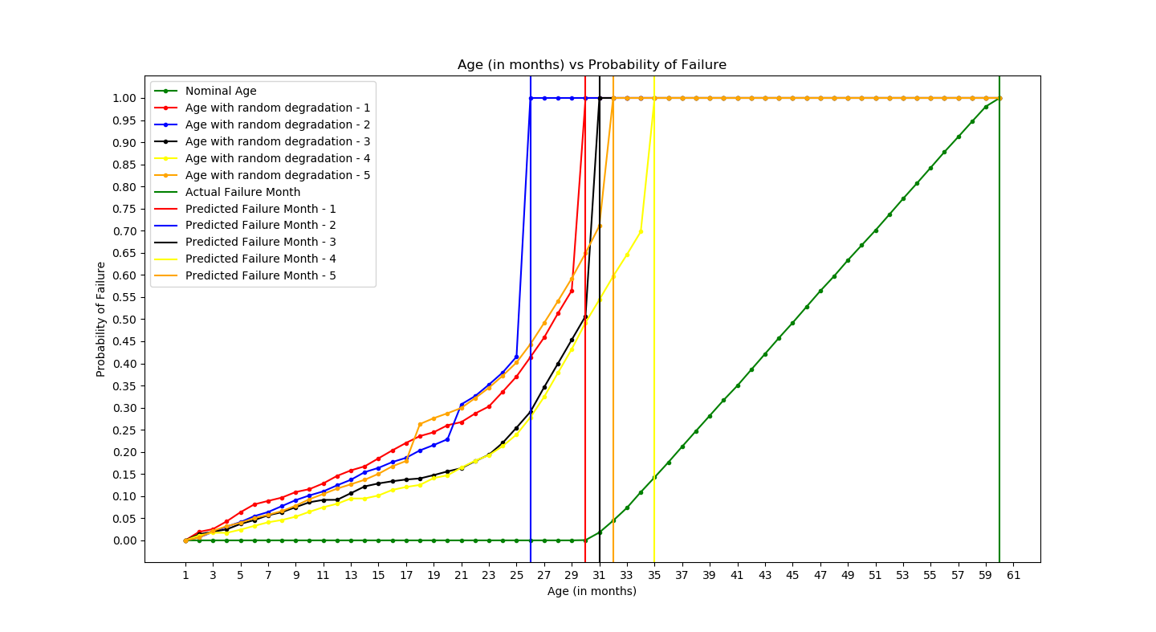

Figure 5. Multiple Linear Regression – Plot 1

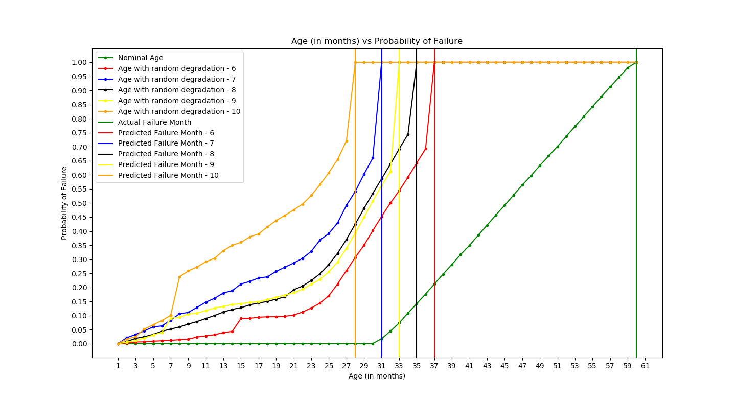

Figure 6. Multiple Linear Regression – Plot 2

1. **Decision Tree Regression**

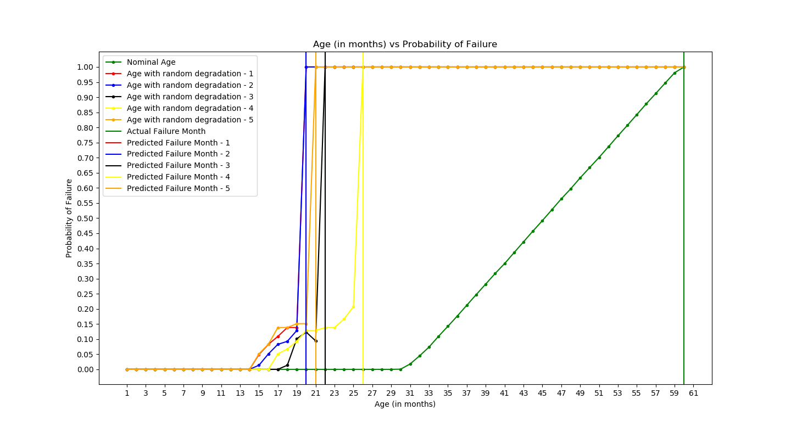

Figure 7. Decision Tree Regression – Plot 1

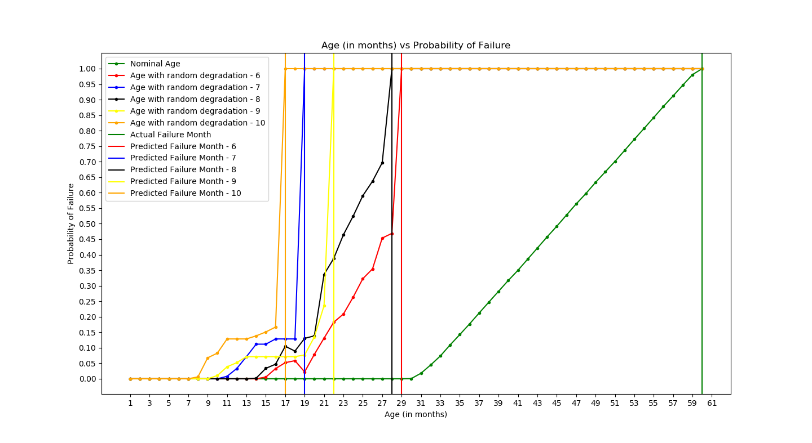

Figure 8. Decision Tree Regression – Plot 2

1. **Random Forest Regression**

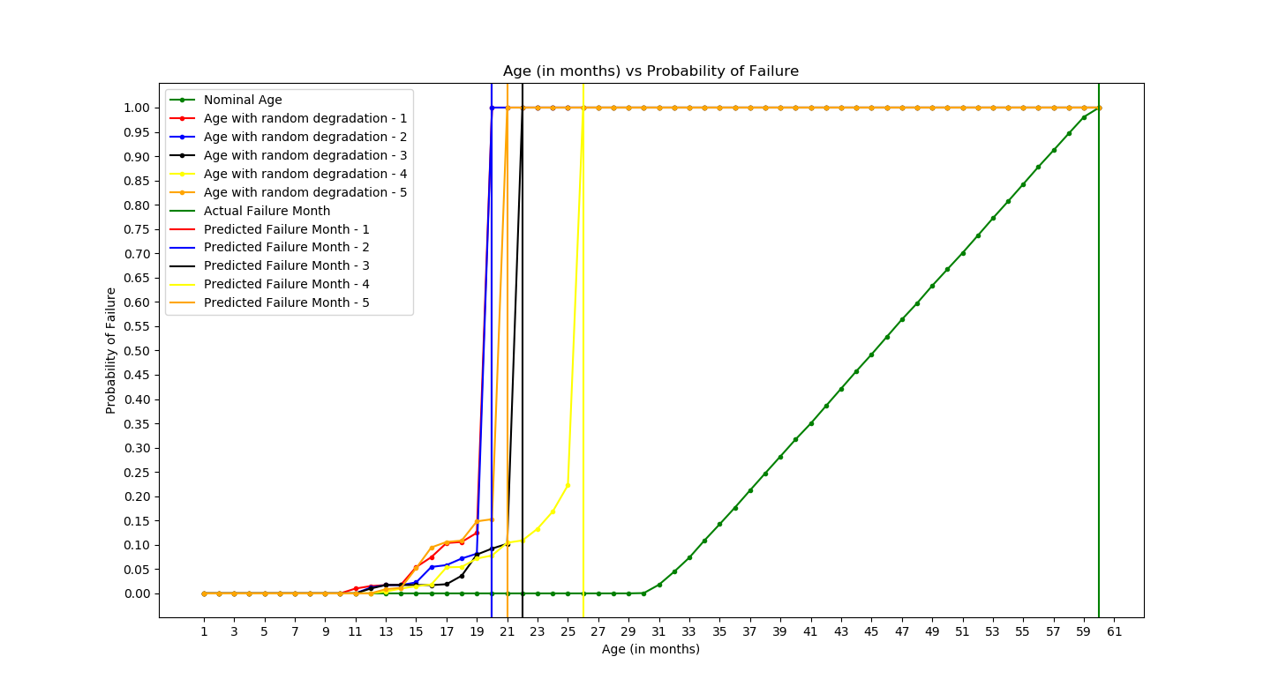

Figure 9. Random Forest Regression – Plot 1

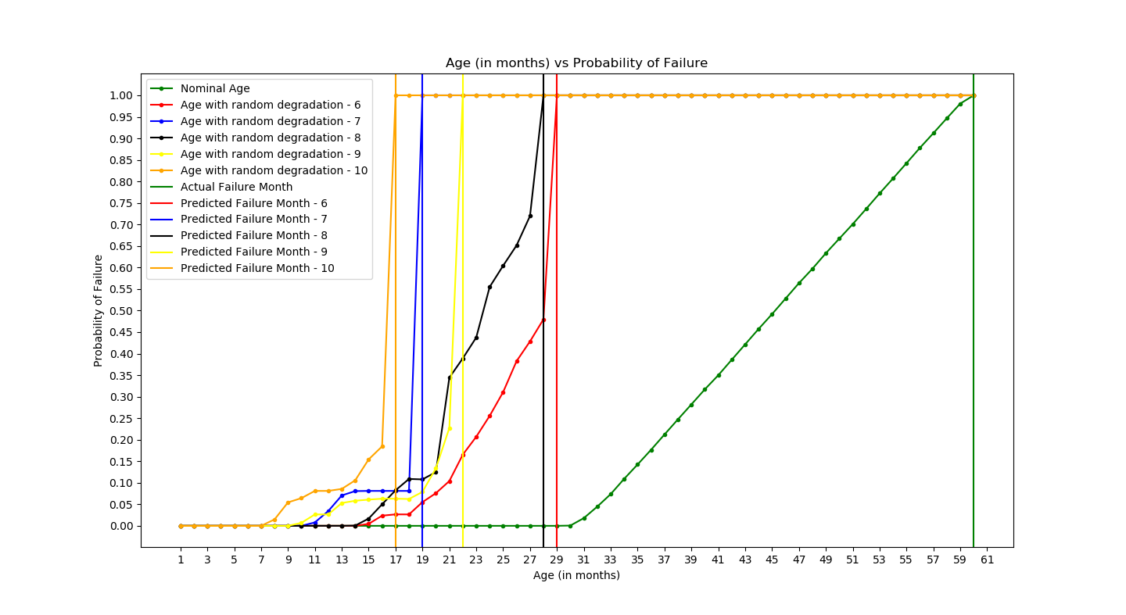

Figure 10. Random Forest Regression – Plot 2

1. **Computing R2 Score**

R2 Score is a statistical measure of how close the data are to the fitted regression line

where

VE = Explained Variance

VT = Total Variance

R2 is always between 0 and 1, 0 being the least and 1 being the highest.

The R2 scores of all the algorithms are listed below:

Table 1. R2 Scores Table

|  |  |  |  |
| --- | --- | --- | --- |
| **Test #** | **Multiple Linear Regression** | **Decision Tree** | **Random Forest** |
| 1 | ﻿0.6426537081434025 | ﻿0.9916717878571842 | ﻿0.9904481963081587 |
| 2 | ﻿0.7640205667302705 | ﻿0.9933298544803262 | ﻿0.9915195518315205 |
| 3 | ﻿0.6416514610273727 | ﻿0.9920002012067051 | ﻿0.9927865839222267 |
| 4 | ﻿0.8241786477160935 | ﻿0.9654130195500206 | ﻿0.9638597924640533 |
| 5 | ﻿0.7090612731879078 | ﻿0.9843549008663954 | ﻿0.9830647744139094 |
| 6 | ﻿0.8242803456712083 | ﻿0.997770065022233 | ﻿0.9977046840685472 |
| 7 | ﻿0.6043628289272571 | ﻿0.9975117997988555 | ﻿0.9942884196504841 |
| 8 | ﻿0.8486387889134056 | ﻿0.9987924602052374 | ﻿0.9981228140655145 |
| 9 | ﻿0.642274025348277 | ﻿0.9609628325590751 | ﻿0.9600466365473174 |
| 10 | ﻿0.7033402800678533 | ﻿0.9811984393073315 | ﻿0.9780603335006917 |

1. **CONCLUSION**

From the R2 Scores table, it is clear that the Decision Tree algorithm scores constantly higher than Random Forest and Multiple Linear Regression algorithms.

Random Forest algorithm’s results were very close to Decision Tree’s and is much better than Multiple Linear Regression.

Multiple Linear Regression comes last out of the three.

1. **FUTURE ENHANCEMENTS**

All the data used in this project was based on a few assumptions.

Next step would be to collect real world data from an actual aircraft engine and then perform predictive analysis in a similar manner.

1. **REFERENCES**
2. Joint Aviation Authorities Airline Transport Pilot’s Licence, Theoretical Knowledge Manual, Second Edition
3. QI Shufen and ZHANG Wanying, ‘Prognostic and Health Management System based on Flight Data’, College of Automation and Electronic Engineer, Qingdao University of Science &Technology, Qingdao 266042
4. "Engine performance trend analysis", Aircraft Engineering and Aerospace Technology, Vol. 44 Iss 7 pp. 23 – 25
5. M. Aznar Fernandez-Montesinos, P . Janssens and R.A. Vingerhoed, ‘Enhancing Aircraft Engine Condition Monitoring’, IFAC Emerging Intelligent Control Technologies, Hong Kong
6. Chantal Fry and Sukanya Manna, “Can we Group Similar Amazon Reviews: A Case Study with Different Clustering Algorithms”, *IEEE Tenth International Conference on Semantic Computing (ICSC),* March 2016
7. Afshan Ejaz, Zakia Turabee, Maria Rahim and Shakeel Khoja, “Opinion mining approaches on Amazon product reviews: A comparative study”, *2017 International Conference on Information and Communication Technologies (ICICT),* March 2018
8. Ahmed Yousuf Saber, ‘Short Term Load Forecasting using Multiple Linear Regression for Big Data’, [2017 IEEE Symposium Series on Computational Intelligence (SSCI)](https://ieeexplore.ieee.org/xpl/mostRecentIssue.jsp?punumber=8267146), December 2017
9. Aleena Swetapadma and Anamika Yadav, ‘Short term load forecasting using multiple linear regression for big data’, [2017 IEEE Symposium Series on Computational Intelligence (SSCI)](https://ieeexplore.ieee.org/xpl/mostRecentIssue.jsp?punumber=8267146), December 2017
10. Xianjun Xia, Roberto Togneri, Ferdous Sohel and David Huang, ‘Random forest regression based acoustic event detection with bottleneck features’, [2017 IEEE International Conference on Multimedia and Expo (ICME)](https://ieeexplore.ieee.org/xpl/mostRecentIssue.jsp?punumber=8014303), July 2017
11. **APPENDIX**

**Generating Normal Data:**

﻿import numpy as np

import pdb

import pandas as pd

head = ["engine", "month", "noise", "egt", "ff", "n1", "n2", "fp_noise", "fp_egt", "fp_ff", "fp_n1", "fp_n2", "total_fp"]

start_noise = 130

start_egt = 1300

start_ff = 5000

start_n1 = 12000

start_n2 = 10000

max_noise = 137

max_egt = 1900

max_ff = 5500

max_n1 = 14000

max_n2 = 12000

fp_noise = np.zeros(60)

fp_egt = np.zeros(60)

fp_ff = np.zeros(60)

fp_n1 = np.zeros(60)

fp_n2 = np.zeros(60)

total_fp = np.zeros(60)

range_noise = np.random.uniform(0.2, 0.24, size=59)

range_egt = np.random.randint(18, 24, size=59)

range_ff = np.random.randint(16, 19, size=59)

range_n1 = np.random.randint(65, 73, size=59)

range_n2 = np.random.randint(65, 73, size=59)

noise = np.cumsum(range_noise) + start_noise

noise = np.insert(noise, 0, start_noise)

egt = np.cumsum(range_egt) + start_egt

egt = np.insert(egt, 0, start_egt)

ff = np.cumsum(range_ff) + start_ff

ff = np.insert(ff, 0, start_ff)

n1 = np.cumsum(range_n1) + start_n1

n1 = np.insert(n1, 0, start_n1)

n2 = np.cumsum(range_n2) + start_n2

n2 = np.insert(n2, 0, start_n2)

noise_index = np.where(noise >= max_noise)[0][0]

fp_noise[noise_index: ] = (noise[noise_index:] - max_noise) / 0.06

fp_noise = fp_noise/100

fp_noise[fp_noise > 1] = 1

egt_index = np.where(egt >= max_egt)[0][0]

fp_egt[egt_index: ] = (egt[egt_index:] - max_egt) / 6

fp_egt = fp_egt/100

fp_egt[fp_egt > 1] = 1

ff_index = np.where(ff >= max_ff)[0][0]

fp_ff[ff_index: ] = (ff[ff_index:] - max_ff) / 5

fp_ff = fp_ff/100

fp_ff[fp_ff > 1] = 1

n1_index = np.where(n1 >= max_n1)[0][0]

fp_n1[n1_index: ] = (n1[n1_index:] - max_n1) / 20

fp_n1 = fp_n1/100

fp_n1[fp_n1 > 1] = 1

n2_index = np.where(n2 >= max_n2)[0][0]

fp_n2[n2_index: ] = (n2[n2_index:] - max_n2) / 20

fp_n2 = fp_n2/100

fp_n2[fp_n2 > 1] = 1

total_fp = (fp_noise + fp_egt + fp_ff + fp_n1 + fp_n2) / 5

df = pd.DataFrame(columns=head)

df['engine'] = np.ones(60)

df['month'] = np.arange(1, 61)

df['noise'] = noise

df['egt'] = egt

df['ff'] = ff

df['n1'] = n1

df['n2'] = n2

df['fp_noise'] = fp_noise

df['fp_egt'] = fp_egt

df['fp_ff'] = fp_ff

df['fp_n1'] = fp_n1

df['fp_n2'] = fp_n2

df['total_fp'] = total_fp

df.to_csv('../../data/normal_data.csv', index=False)

**Generating Training Data:**

﻿import numpy as np

import pdb

import pandas as pd

head = ["engine", "month", "noise", "egt", "ff", "n1", "n2", "fp_noise", "fp_egt", "fp_ff", "fp_n1", "fp_n2", "total_fp"]

start_noise = 130

start_egt = 1300

start_ff = 5000

start_n1 = 12000

start_n2 = 10000

max_noise = 137

max_egt = 1900

max_ff = 5500

max_n1 = 14000

max_n2 = 12000

df = pd.DataFrame(columns=head)

for engine in range(1, 1001):

months = np.arange(1, 61)

fp_noise = np.zeros(60)

fp_egt = np.zeros(60)

fp_ff = np.zeros(60)

fp_n1 = np.zeros(60)

fp_n2 = np.zeros(60)

total_fp = np.zeros(60)

range_noise = np.random.uniform(0.1, 0.55, size=59)

range_egt = np.random.randint(15, 41, size=59)

range_ff = np.random.randint(10, 34, size=59)

range_n1 = np.random.randint(68, 95, size=59)

range_n2 = np.random.randint(68, 95, size=59)

noise = np.cumsum(range_noise) + start_noise

noise = np.insert(noise, 0, start_noise)

egt = np.cumsum(range_egt) + start_egt

egt = np.insert(egt, 0, start_egt)

ff = np.cumsum(range_ff) + start_ff

ff = np.insert(ff, 0, start_ff)

n1 = np.cumsum(range_n1) + start_n1

n1 = np.insert(n1, 0, start_n1)

n2 = np.cumsum(range_n2) + start_n2

n2 = np.insert(n2, 0, start_n2)

noise_index = np.where(noise >= max_noise)[0][0]

fp_noise[noise_index: ] = (noise[noise_index:] - max_noise) / 0.06

fp_noise = fp_noise/100

fp_noise[fp_noise > 1] = 1

egt_index = np.where(egt >= max_egt)[0][0]

fp_egt[egt_index: ] = (egt[egt_index:] - max_egt) / 6

fp_egt = fp_egt/100

fp_egt[fp_egt > 1] = 1

ff_index = np.where(ff >= max_ff)[0][0]

fp_ff[ff_index: ] = (ff[ff_index:] - max_ff) / 5

fp_ff = fp_ff/100

fp_ff[fp_ff > 1] = 1

n1_index = np.where(n1 >= max_n1)[0][0]

fp_n1[n1_index: ] = (n1[n1_index:] - max_n1) / 20

fp_n1 = fp_n1/100

fp_n1[fp_n1 > 1] = 1

n2_index = np.where(n2 >= max_n2)[0][0]

fp_n2[n2_index: ] = (n2[n2_index:] - max_n2) / 20

fp_n2 = fp_n2/100

fp_n2[fp_n2 > 1] = 1

total_fp = (fp_noise + fp_egt + fp_ff + fp_n1 + fp_n2) / 5

total_fp[min(([np.where(fp_noise == 1)[0][0], np.where(fp_egt == 1)[0][0], np.where(fp_ff == 1)[0][0], np.where(fp_n1 == 1)[0][0], np.where(fp_n2 == 1)[0][0]])): ] = 1

data = pd.DataFrame({'engine': engine, 'month': months, 'noise': noise, 'egt': egt, 'ff': ff, 'n1': n1, 'n2': n2, 'fp_noise': fp_noise, 'fp_egt': fp_egt, 'fp_ff': fp_ff, 'fp_n1': fp_n1, 'fp_n2': fp_n2, 'total_fp': total_fp})

df = df.append(data, sort=False)

df.to_csv('../../data/train_data/train_data.csv', index=False)

**Generating Test Data:**

﻿import numpy as np

import pdb

import pandas as pd

import random

head = ["engine", "month", "noise", "egt", "ff", "n1", "n2", 'act_fp_noise', 'act_fp_egt', 'act_fp_ff', 'act_fp_n1', 'act_fp_n2', 'act_total_fp', "mlr_fp_noise", "mlr_fp_egt", "mlr_fp_ff", "mlr_fp_n1", "mlr_fp_n2", "mlr_total_fp", "dt_fp_noise", "dt_fp_egt", "dt_fp_ff", "dt_fp_n1", "dt_fp_n2", "dt_total_fp", "rf_fp_noise", "rf_fp_egt", "rf_fp_ff", "rf_fp_n1", "rf_fp_n2", "rf_total_fp"]

start_noise = 130

start_egt = 1300

start_ff = 5000

start_n1 = 12000

start_n2 = 10000

max_noise = 137

max_egt = 1900

max_ff = 5500

max_n1 = 14000

max_n2 = 12000

for engine in range(1, 11):

df = pd.DataFrame(columns=head)

df['month'] = np.arange(1, 61)

fp_noise = np.zeros(60)

fp_egt = np.zeros(60)

fp_ff = np.zeros(60)

fp_n1 = np.zeros(60)

fp_n2 = np.zeros(60)

total_fp = np.zeros(60)

range_noise = np.random.uniform(np.random.uniform(0.2, 0.5), np.random.uniform(0.5, 1.1), size=59)

range_egt = np.random.randint(np.random.randint(10, 35), np.random.randint(35, 75), size=59)

range_ff = np.random.randint(np.random.randint(10, 35), np.random.randint(35, 85), size=59)

range_n1 = np.random.randint(np.random.randint(50, 110), np.random.randint(110, 130), size=59)

range_n2 = np.random.randint(np.random.randint(45, 100), np.random.randint(100, 140), size=59)

random_month = np.random.randint(1, 24)

random_noise_increase = np.random.uniform(2, 2.5)

random_egt_increase = np.random.randint(160, 181)

random_ff_increase = np.random.randint(140, 161)

random_n1_increase = np.random.randint(350, 371)

random_n2_increase = np.random.randint(350, 371)

noise = np.cumsum(range_noise) + start_noise

noise = np.insert(noise, 0, start_noise)

egt = np.cumsum(range_egt) + start_egt

egt = np.insert(egt, 0, start_egt)

ff = np.cumsum(range_ff) + start_ff

ff = np.insert(ff, 0, start_ff)

n1 = np.cumsum(range_n1) + start_n1

n1 = np.insert(n1, 0, start_n1)

n2 = np.cumsum(range_n2) + start_n2

n2 = np.insert(n2, 0, start_n2)

all_params = ['noise', 'egt', 'ff', 'n1', 'n2']

sample_size = random.randint(0, 5)

samples = random.sample(all_params, sample_size)

for sample in samples:

if sample == 'noise':

noise[random_month:] += random_noise_increase

elif sample == 'egt':

egt[random_month:] += random_egt_increase

elif sample == 'ff':

ff[random_month:] += random_ff_increase

elif sample == 'n1':

n1[random_month:] += random_n1_increase

else:

n2[random_month:] += random_n2_increase

noise_index = np.where(noise >= max_noise)[0][0]

fp_noise[noise_index: ] = (noise[noise_index:] - max_noise) / 0.06

fp_noise = fp_noise/100

fp_noise[fp_noise > 1] = 1

egt_index = np.where(egt >= max_egt)[0][0]

fp_egt[egt_index: ] = (egt[egt_index:] - max_egt) / 6

fp_egt = fp_egt/100

fp_egt[fp_egt > 1] = 1

ff_index = np.where(ff >= max_ff)[0][0]

fp_ff[ff_index: ] = (ff[ff_index:] - max_ff) / 5

fp_ff = fp_ff/100

fp_ff[fp_ff > 1] = 1

n1_index = np.where(n1 >= max_n1)[0][0]

fp_n1[n1_index: ] = (n1[n1_index:] - max_n1) / 20

fp_n1 = fp_n1/100

fp_n1[fp_n1 > 1] = 1

n2_index = np.where(n2 >= max_n2)[0][0]

fp_n2[n2_index: ] = (n2[n2_index:] - max_n2) / 20

fp_n2 = fp_n2/100

fp_n2[fp_n2 > 1] = 1

total_fp = (fp_noise + fp_egt + fp_ff + fp_n1 + fp_n2) / 5

total_fp[min(([np.where(fp_noise == 1)[0][0], np.where(fp_egt == 1)[0][0], np.where(fp_ff == 1)[0][0], np.where(fp_n1 == 1)[0][0], np.where(fp_n2 == 1)[0][0]])): ] = 1

df['noise'] = noise

df['egt'] = egt

df['ff'] = ff

df['n1'] = n1

df['n2'] = n2

df['act_fp_noise'] = fp_noise

df['act_fp_egt'] = fp_egt

df['act_fp_ff'] = fp_ff

df['act_fp_n1'] = fp_n1

df['act_fp_n2'] = fp_n2

df['act_total_fp'] = total_fp

df['engine'] = engine

df.to_csv('../../data/test_data/test_data_' + str(engine) + '.csv', index=False)

**Training Multiple Linear Regression Model:**

﻿# Importing the libraries

import numpy as np

import matplotlib.pyplot as plt

import pandas as pd

from sklearn.preprocessing import LabelEncoder, OneHotEncoder

from sklearn.model_selection import train_test_split

from sklearn.linear_model import LinearRegression

import pickle

# Importing the dataset

dataset = pd.read_csv('../../../data/train_data/train_data.csv')

X = dataset.iloc[:, 1:12].values

y = dataset.loc[:, ['total_fp']].values

# Encoding categorical data

labelencoder_X = LabelEncoder()

X[:, 0] = labelencoder_X.fit_transform(X[:, 0])

onehotencoder = OneHotEncoder(categorical_features = [0])

X = onehotencoder.fit_transform(X).toarray()

# Avoiding dummy variable trap

categories = [0]

dummies = []

dummies_sum = 0

for category in categories:

dummies_sum += (dataset.iloc[:, category].unique().size) * category

dummies.append(dummies_sum)

X = np.delete(X, dummies, 1)

# Splitting the dataset

X_train, X_test, y_train, y_test = train_test_split(X, y, test_size=0.2, shuffle=False)

# Fitting Simple Linear Regression to the Training set

regressor = LinearRegression()

regressor.fit(X_train, y_train)

# Predicting the results

y_pred = regressor.predict(X_test)

y_pred[y_pred > 0.99] = 1

y_pred[y_pred < 0] = 0

# Saving the model

with open('../../../models/multiple_linear_regression/mlr_total_fp.pkl', 'wb') as f:

pickle.dump(regressor, f)

**Training Decision Tree Regression Model:**

﻿# Importing the libraries

import numpy as np

import matplotlib.pyplot as plt

import pandas as pd

from sklearn.preprocessing import LabelEncoder, OneHotEncoder

from sklearn.model_selection import train_test_split

from sklearn.tree import DecisionTreeRegressor

import pickle

# Importing the dataset

dataset = pd.read_csv('../../../data/train_data/train_data.csv')

X = dataset.iloc[:, 1:12].values

y = dataset.loc[:, ['total_fp']].values

# Encoding categorical data

labelencoder_X = LabelEncoder()

X[:, 0] = labelencoder_X.fit_transform(X[:, 0])

onehotencoder = OneHotEncoder(categorical_features = [0])

X = onehotencoder.fit_transform(X).toarray()

# Avoiding dummy variable trap

categories = [0]

dummies = []

dummies_sum = 0

for category in categories:

dummies_sum += (dataset.iloc[:, category].unique().size) * category

dummies.append(dummies_sum)

X = np.delete(X, dummies, 1)

# Splitting the dataset

X_train, X_test, y_train, y_test = train_test_split(X, y, test_size=0.2, shuffle=False)

# Fitting Simple Linear Regression to the Training set

regressor = DecisionTreeRegressor(random_state = 0)

regressor.fit(X_train, y_train)

# Predicting the results

y_pred = regressor.predict(X_test)

y_pred[y_pred > 0.99] = 1

y_pred[y_pred < 0] = 0

# Saving the model

with open('../../../models/decision_tree/dt_total_fp.pkl', 'wb') as f:

pickle.dump(regressor, f)

**Training Random Forest Regression:**

﻿# Importing the libraries

import numpy as np

import matplotlib.pyplot as plt

import pandas as pd

from sklearn.preprocessing import LabelEncoder, OneHotEncoder

from sklearn.model_selection import train_test_split

from sklearn.ensemble import RandomForestRegressor

import pickle

# Importing the dataset

dataset = pd.read_csv('../../../data/train_data/train_data.csv')

X = dataset.iloc[:, 1:12].values

y = dataset.loc[:, ['total_fp']].values

# Encoding categorical data

labelencoder_X = LabelEncoder()

X[:, 0] = labelencoder_X.fit_transform(X[:, 0])

onehotencoder = OneHotEncoder(categorical_features = [0])

X = onehotencoder.fit_transform(X).toarray()

# Avoiding dummy variable trap

categories = [0]

dummies = []

dummies_sum = 0

for category in categories:

dummies_sum += (dataset.iloc[:, category].unique().size) * category

dummies.append(dummies_sum)

X = np.delete(X, dummies, 1)

# Splitting the dataset

X_train, X_test, y_train, y_test = train_test_split(X, y, test_size=0.2, shuffle=False)

# Fitting Simple Linear Regression to the Training set

regressor = RandomForestRegressor(n_estimators = 10, random_state = 0)

regressor.fit(X_train, y_train)

# Predicting the results

y_pred = regressor.predict(X_test)

y_pred[y_pred > 0.99] = 1

y_pred[y_pred < 0] = 0

# Saving the model

with open('../../../models/random_forest/rf_total_fp.pkl', 'wb') as f:

pickle.dump(regressor, f)

**Validating Multiple Linear Regresison with Test Set:**

﻿# Importing the libraries

import numpy as np

import matplotlib.pyplot as plt

import pandas as pd

from sklearn.preprocessing import LabelEncoder, OneHotEncoder

from sklearn.linear_model import LinearRegression

import pickle

import csv

from sklearn.metrics import r2_score

# Importing the dataset

dataset = pd.read_csv('../../../data/test_data/test_data_1.csv')

# ==================================

# ==================================

# Noise

# ==================================

X_noise_data = dataset.loc[:, ['month', 'noise']]

X_noise = X_noise_data.values

# Encoding categorical data

labelencoder_X_noise = LabelEncoder()

X_noise[:, 0] = labelencoder_X_noise.fit_transform(X_noise[:, 0])

onehotencoder = OneHotEncoder(categorical_features = [0])

X_noise = onehotencoder.fit_transform(X_noise).toarray()

# Avoiding dummy variable trap

categories = [0]

dummies = []

dummies_sum = 0

for category in categories:

dummies_sum += (dataset.iloc[:, category].unique().size) * category

dummies.append(dummies_sum)

X_noise = np.delete(X_noise, dummies, 1)

# Loading and fitting the regression model

with open('../../../models/multiple_linear_regression/mlr_noise.pkl', 'rb') as f:

regressor = pickle.load(f)

# Predicting the results

y_pred_noise = regressor.predict(X_noise)

y_pred_noise[y_pred_noise > 0.98] = 1

y_pred_noise[y_pred_noise < 0] = 0

dataset['mlr_fp_noise'] = y_pred_noise

# ==================================

# EGT

# ==================================

X_egt_data = dataset.loc[:, ['month', 'egt']]

X_egt = X_egt_data.values

# Encoding categorical data

labelencoder_X_egt = LabelEncoder()

X_egt[:, 0] = labelencoder_X_egt.fit_transform(X_egt[:, 0])

onehotencoder = OneHotEncoder(categorical_features = [0])

X_egt = onehotencoder.fit_transform(X_egt).toarray()

# Avoiding dummy variable trap

categories = [0]

dummies = []

dummies_sum = 0

for category in categories:

dummies_sum += (dataset.iloc[:, category].unique().size) * category

dummies.append(dummies_sum)

X_egt = np.delete(X_egt, dummies, 1)

# Loading and fitting the regression model

with open('../../../models/multiple_linear_regression/mlr_egt.pkl', 'rb') as f:

regressor = pickle.load(f)

# Predicting the results

y_pred_egt = regressor.predict(X_egt)

y_pred_egt[y_pred_egt > 0.98] = 1

y_pred_egt[y_pred_egt < 0] = 0

dataset['mlr_fp_egt'] = y_pred_egt

# ==================================

# FF

# ==================================

X_ff_data = dataset.loc[:, ['month', 'ff']]

X_ff = X_ff_data.values

# Encoding categorical data

labelencoder_X_ff = LabelEncoder()

X_ff[:, 0] = labelencoder_X_ff.fit_transform(X_ff[:, 0])

onehotencoder = OneHotEncoder(categorical_features = [0])

X_ff = onehotencoder.fit_transform(X_ff).toarray()

# Avoiding dummy variable trap

categories = [0]

dummies = []

dummies_sum = 0

for category in categories:

dummies_sum += (dataset.iloc[:, category].unique().size) * category

dummies.append(dummies_sum)

X_ff = np.delete(X_ff, dummies, 1)

# Loading and fitting the regression model

with open('../../../models/multiple_linear_regression/mlr_ff.pkl', 'rb') as f:

regressor = pickle.load(f)

# Predicting the results

y_pred_ff = regressor.predict(X_ff)

y_pred_ff[y_pred_ff > 0.98] = 1

y_pred_ff[y_pred_ff < 0] = 0

dataset['mlr_fp_ff'] = y_pred_ff

# ==================================

# N1

# ==================================

X_n1_data = dataset.loc[:, ['month', 'n1']]

X_n1 = X_n1_data.values

# Encoding categorical data

labelencoder_X_n1 = LabelEncoder()

X_n1[:, 0] = labelencoder_X_n1.fit_transform(X_n1[:, 0])

onehotencoder = OneHotEncoder(categorical_features = [0])

X_n1 = onehotencoder.fit_transform(X_n1).toarray()

# Avoiding dummy variable trap

categories = [0]

dummies = []

dummies_sum = 0

for category in categories:

dummies_sum += (dataset.iloc[:, category].unique().size) * category

dummies.append(dummies_sum)

X_n1 = np.delete(X_n1, dummies, 1)

# Loading and fitting the regression model

with open('../../../models/multiple_linear_regression/mlr_n1.pkl', 'rb') as f:

regressor = pickle.load(f)

# Predicting the results

y_pred_n1 = regressor.predict(X_n1)

y_pred_n1[y_pred_n1 > 0.98] = 1

y_pred_n1[y_pred_n1 < 0] = 0

dataset['mlr_fp_n1'] = y_pred_n1

# ==================================

# N2

# ==================================

X_n2_data = dataset.loc[:, ['month', 'n2']]

X_n2 = X_n2_data.values

# Encoding categorical data

labelencoder_X_n2 = LabelEncoder()

X_n2[:, 0] = labelencoder_X_n2.fit_transform(X_n2[:, 0])

onehotencoder = OneHotEncoder(categorical_features = [0])

X_n2 = onehotencoder.fit_transform(X_n2).toarray()

# Avoiding dummy variable trap

categories = [0]

dummies = []

dummies_sum = 0

for category in categories:

dummies_sum += (dataset.iloc[:, category].unique().size) * category

dummies.append(dummies_sum)

X_n2 = np.delete(X_n2, dummies, 1)

# Loading and fitting the regression model

with open('../../../models/multiple_linear_regression/mlr_n2.pkl', 'rb') as f:

regressor = pickle.load(f)

# Predicting the results

y_pred_n2 = regressor.predict(X_n2)

y_pred_n2[y_pred_n2 > 0.98] = 1

y_pred_n2[y_pred_n2 < 0] = 0

dataset['mlr_fp_n2'] = y_pred_n2

# ==================================

# Failure Probability

# ==================================

X_data = dataset.loc[:, ['month', 'noise', 'egt', 'ff', 'n1', 'n2', 'mlr_fp_noise', 'mlr_fp_ff', 'mlr_fp_egt', 'mlr_fp_n1', 'mlr_fp_n2']]

X = X_data.values

# Encoding categorical data

labelencoder_X = LabelEncoder()

X[:, 0] = labelencoder_X.fit_transform(X[:, 0])

onehotencoder = OneHotEncoder(categorical_features = [0])

X = onehotencoder.fit_transform(X).toarray()

# Avoiding dummy variable trap

categories = [0]

dummies = []

dummies_sum = 0

for category in categories:

dummies_sum += (dataset.iloc[:, category].unique().size) * category

dummies.append(dummies_sum)

X = np.delete(X, dummies, 1)

# Loading and fitting the regression model

with open('../../../models/multiple_linear_regression/mlr_total_fp.pkl', 'rb') as f:

regressor = pickle.load(f)

# Predicting the results

y_pred = regressor.predict(X)

y_pred[y_pred < 0] = 0

y_pred[min(([np.where(y_pred_noise == 1)[0][0], np.where(y_pred_egt == 1)[0][0], np.where(y_pred_ff == 1)[0][0], np.where(y_pred_n1 == 1)[0][0], np.where(y_pred_n2 == 1)[0][0]])): ] = 1

dataset['mlr_total_fp'] = y_pred

# Writing to csv file

dataset.to_csv('../../../data/test_data/test_data_1.csv', index=False)

# ==================================

# Importing normal dataset

normal_dataset = pd.read_csv('../../../data/normal_data.csv')

X_normal = normal_dataset

y_normal = normal_dataset.loc[:, 'total_fp'].values

y_normal[y_normal > 1] = 1

# Plotting graph

plt.figure(figsize=(20, 15))

plt.plot(X_data['month'][0:60], y_normal[0:60], color = 'green', linestyle='-', marker='.', label='Age under normal conditions')

plt.plot(X_data['month'][0:60], y_pred.ravel(), color = 'blue', linestyle='-', marker='.', label='Predicted age under abnormal conditions')

plt.axvline(x=np.where(y_pred==1)[0][0]+1, color='red', label='Predicted Failure Month')

plt.axvline(x=np.where(y_normal==1)[0][0]+1, color='orange', label='Normal Failure Month')

plt.xticks(np.arange(1, 62, 2))

plt.yticks(np.arange(0, 1.05, 0.05))

plt.title('Age (in months) vs Probability of Failure')

plt.legend(loc='best')

plt.xlabel('Age (in months)')

plt.ylabel('Probability of Failure')

plt.show()

plt.savefig('../../../outputs/multiple_linear_regression/mlr_test_1.png')

# Calculating r2 score

y_actual = dataset['act_total_fp'].values

accuracy = r2_score(y_actual, y_pred)

**Validating Decision Tree Regression with Test Set:**

﻿# Importing the libraries

import numpy as np

import matplotlib.pyplot as plt

import pandas as pd

from sklearn.preprocessing import LabelEncoder, OneHotEncoder

import pickle

import csv

from sklearn.metrics import r2_score

# Importing the dataset

dataset = pd.read_csv('../../../data/test_data/test_data_1.csv')

# ==================================

# ==================================

# Noise

# ==================================

X_noise_data = dataset.loc[:, ['month', 'noise']]

X_noise = X_noise_data.values

# Encoding categorical data

labelencoder_X_noise = LabelEncoder()

X_noise[:, 0] = labelencoder_X_noise.fit_transform(X_noise[:, 0])

onehotencoder = OneHotEncoder(categorical_features = [0])

X_noise = onehotencoder.fit_transform(X_noise).toarray()

# Avoiding dummy variable trap

categories = [0]

dummies = []

dummies_sum = 0

for category in categories:

dummies_sum += (dataset.iloc[:, category].unique().size) * category

dummies.append(dummies_sum)

X_noise = np.delete(X_noise, dummies, 1)

# Loading and fitting the regression model

with open('../../../models/decision_tree/dt_noise.pkl', 'rb') as f:

regressor = pickle.load(f)

# Predicting the results

y_pred_noise = regressor.predict(X_noise)

y_pred_noise[y_pred_noise > 0.98] = 1

y_pred_noise[y_pred_noise < 0] = 0

dataset['dt_fp_noise'] = y_pred_noise

# ==================================

# EGT

# ==================================

X_egt_data = dataset.loc[:, ['month', 'egt']]

X_egt = X_egt_data.values

# Encoding categorical data

labelencoder_X_egt = LabelEncoder()

X_egt[:, 0] = labelencoder_X_egt.fit_transform(X_egt[:, 0])

onehotencoder = OneHotEncoder(categorical_features = [0])

X_egt = onehotencoder.fit_transform(X_egt).toarray()

# Avoiding dummy variable trap

categories = [0]

dummies = []

dummies_sum = 0

for category in categories:

dummies_sum += (dataset.iloc[:, category].unique().size) * category

dummies.append(dummies_sum)

X_egt = np.delete(X_egt, dummies, 1)

# Loading and fitting the regression model

with open('../../../models/decision_tree/dt_egt.pkl', 'rb') as f:

regressor = pickle.load(f)

# Predicting the results

y_pred_egt = regressor.predict(X_egt)

y_pred_egt[y_pred_egt > 0.98] = 1

y_pred_egt[y_pred_egt < 0] = 0

dataset['dt_fp_egt'] = y_pred_egt

# ==================================

# FF

# ==================================

X_ff_data = dataset.loc[:, ['month', 'ff']]

X_ff = X_ff_data.values

# Encoding categorical data

labelencoder_X_ff = LabelEncoder()

X_ff[:, 0] = labelencoder_X_ff.fit_transform(X_ff[:, 0])

onehotencoder = OneHotEncoder(categorical_features = [0])

X_ff = onehotencoder.fit_transform(X_ff).toarray()

# Avoiding dummy variable trap

categories = [0]

dummies = []

dummies_sum = 0

for category in categories:

dummies_sum += (dataset.iloc[:, category].unique().size) * category

dummies.append(dummies_sum)

X_ff = np.delete(X_ff, dummies, 1)

# Loading and fitting the regression model

with open('../../../models/decision_tree/dt_ff.pkl', 'rb') as f:

regressor = pickle.load(f)

# Predicting the results

y_pred_ff = regressor.predict(X_ff)

y_pred_ff[y_pred_ff > 0.98] = 1

y_pred_ff[y_pred_ff < 0] = 0

dataset['dt_fp_ff'] = y_pred_ff

# ==================================

# N1

# ==================================

X_n1_data = dataset.loc[:, ['month', 'n1']]

X_n1 = X_n1_data.values

# Encoding categorical data

labelencoder_X_n1 = LabelEncoder()

X_n1[:, 0] = labelencoder_X_n1.fit_transform(X_n1[:, 0])

onehotencoder = OneHotEncoder(categorical_features = [0])

X_n1 = onehotencoder.fit_transform(X_n1).toarray()

# Avoiding dummy variable trap

categories = [0]

dummies = []

dummies_sum = 0

for category in categories:

dummies_sum += (dataset.iloc[:, category].unique().size) * category

dummies.append(dummies_sum)

X_n1 = np.delete(X_n1, dummies, 1)

# Loading and fitting the regression model

with open('../../../models/decision_tree/dt_n1.pkl', 'rb') as f:

regressor = pickle.load(f)

# Predicting the results

y_pred_n1 = regressor.predict(X_n1)

y_pred_n1[y_pred_n1 > 0.98] = 1

y_pred_n1[y_pred_n1 < 0] = 0

dataset['dt_fp_n1'] = y_pred_n1

# ==================================

# N2

# ==================================

X_n2_data = dataset.loc[:, ['month', 'n2']]

X_n2 = X_n2_data.values

# Encoding categorical data

labelencoder_X_n2 = LabelEncoder()

X_n2[:, 0] = labelencoder_X_n2.fit_transform(X_n2[:, 0])

onehotencoder = OneHotEncoder(categorical_features = [0])

X_n2 = onehotencoder.fit_transform(X_n2).toarray()

# Avoiding dummy variable trap

categories = [0]

dummies = []

dummies_sum = 0

for category in categories:

dummies_sum += (dataset.iloc[:, category].unique().size) * category

dummies.append(dummies_sum)

X_n2 = np.delete(X_n2, dummies, 1)

# Loading and fitting the regression model

with open('../../../models/decision_tree/dt_n2.pkl', 'rb') as f:

regressor = pickle.load(f)

# Predicting the results

y_pred_n2 = regressor.predict(X_n2)

y_pred_n2[y_pred_n2 > 0.98] = 1

y_pred_n2[y_pred_n2 < 0] = 0

dataset['dt_fp_n2'] = y_pred_n2

# ==================================

# Failure Probability

# ==================================

X_data = dataset.loc[:, ['month', 'noise', 'egt', 'ff', 'n1', 'n2', 'dt_fp_noise', 'dt_fp_ff', 'dt_fp_egt', 'dt_fp_n1', 'dt_fp_n2']]

X = X_data.values

# Encoding categorical data

labelencoder_X = LabelEncoder()

X[:, 0] = labelencoder_X.fit_transform(X[:, 0])

onehotencoder = OneHotEncoder(categorical_features = [0])

X = onehotencoder.fit_transform(X).toarray()

# Avoiding dummy variable trap

categories = [0]

dummies = []

dummies_sum = 0

for category in categories:

dummies_sum += (dataset.iloc[:, category].unique().size) * category

dummies.append(dummies_sum)

X = np.delete(X, dummies, 1)

# Loading and fitting the regression model

with open('../../../models/decision_tree/dt_total_fp.pkl', 'rb') as f:

regressor = pickle.load(f)

# Predicting the results

y_pred = regressor.predict(X)

y_pred[y_pred < 0] = 0

y_pred[min(([np.where(y_pred_noise == 1)[0][0], np.where(y_pred_egt == 1)[0][0], np.where(y_pred_ff == 1)[0][0], np.where(y_pred_n1 == 1)[0][0], np.where(y_pred_n2 == 1)[0][0]])): ] = 1

y_pred[min(([np.where(y_pred_noise == 1)[0][0], np.where(y_pred_egt == 1)[0][0], np.where(y_pred_ff == 1)[0][0], np.where(y_pred_n1 == 1)[0][0], np.where(y_pred_n2 == 1)[0][0]])): ] = 1

dataset['dt_total_fp'] = y_pred

# Writing to csv file

dataset.to_csv('../../../data/test_data/test_data_1.csv', index=False)

# ==================================

# Importing normal dataset

normal_dataset = pd.read_csv('../../../data/normal_data.csv')

X_normal = normal_dataset

y_normal = normal_dataset.loc[:, 'total_fp'].values

y_normal[y_normal > 1] = 1

# Plotting graph

plt.figure(figsize=(20, 15))

plt.plot(X_data['month'][0:60], y_normal[0:60], color = 'green', linestyle='-', marker='.', label='Age under normal conditions')

plt.plot(X_data['month'][0:60], y_pred.ravel(), color = 'blue', linestyle='-', marker='.', label='Predicted age under abnormal conditions')

plt.axvline(x=np.where(y_pred==1)[0][0]+1, color='red', label='Predicted Failure Month')

plt.axvline(x=np.where(y_normal==1)[0][0]+1, color='orange', label='Normal Failure Month')

plt.xticks(np.arange(1, 62, 2))

plt.yticks(np.arange(0, 1.05, 0.05))

plt.title('Age (in months) vs Probability of Failure')

plt.legend(loc='best')

plt.xlabel('Age (in months)')

plt.ylabel('Probability of Failure')

plt.show()

plt.savefig('../../../outputs/decision_tree/dt_test_1.png')

# Calculating r2 score

y_actual = dataset['act_total_fp'].values

accuracy = r2_score(y_actual, y_pred)

**Validating Random Forest Regression with Test Set:**

﻿# Importing the libraries

import numpy as np

import matplotlib.pyplot as plt

import pandas as pd

from sklearn.preprocessing import LabelEncoder, OneHotEncoder

import pickle

import csv

from sklearn.metrics import r2_score

# Importing the dataset

dataset = pd.read_csv('../../../data/test_data/test_data_1.csv')

# ==================================

# ==================================

# Noise

# ==================================

X_noise_data = dataset.loc[:, ['month', 'noise']]

X_noise = X_noise_data.values

# Encoding categorical data

labelencoder_X_noise = LabelEncoder()

X_noise[:, 0] = labelencoder_X_noise.fit_transform(X_noise[:, 0])

onehotencoder = OneHotEncoder(categorical_features = [0])

X_noise = onehotencoder.fit_transform(X_noise).toarray()

# Avoiding dummy variable trap

categories = [0]

dummies = []

dummies_sum = 0

for category in categories:

dummies_sum += (dataset.iloc[:, category].unique().size) * category

dummies.append(dummies_sum)

X_noise = np.delete(X_noise, dummies, 1)

# Loading and fitting the regression model

with open('../../../models/random_forest/rf_noise.pkl', 'rb') as f:

regressor = pickle.load(f)

# Predicting the results

y_pred_noise = regressor.predict(X_noise)

y_pred_noise[y_pred_noise > 0.98] = 1

y_pred_noise[y_pred_noise < 0] = 0

dataset['rf_fp_noise'] = y_pred_noise

# ==================================

# EGT

# ==================================

X_egt_data = dataset.loc[:, ['month', 'egt']]

X_egt = X_egt_data.values

# Encoding categorical data

labelencoder_X_egt = LabelEncoder()

X_egt[:, 0] = labelencoder_X_egt.fit_transform(X_egt[:, 0])

onehotencoder = OneHotEncoder(categorical_features = [0])

X_egt = onehotencoder.fit_transform(X_egt).toarray()

# Avoiding dummy variable trap

categories = [0]

dummies = []

dummies_sum = 0

for category in categories:

dummies_sum += (dataset.iloc[:, category].unique().size) * category

dummies.append(dummies_sum)

X_egt = np.delete(X_egt, dummies, 1)

# Loading and fitting the regression model

with open('../../../models/random_forest/rf_egt.pkl', 'rb') as f:

regressor = pickle.load(f)

# Predicting the results

y_pred_egt = regressor.predict(X_egt)

y_pred_egt[y_pred_egt > 0.98] = 1

y_pred_egt[y_pred_egt < 0] = 0

dataset['rf_fp_egt'] = y_pred_egt

# ==================================

# FF

# ==================================

X_ff_data = dataset.loc[:, ['month', 'ff']]

X_ff = X_ff_data.values

# Encoding categorical data

labelencoder_X_ff = LabelEncoder()

X_ff[:, 0] = labelencoder_X_ff.fit_transform(X_ff[:, 0])

onehotencoder = OneHotEncoder(categorical_features = [0])

X_ff = onehotencoder.fit_transform(X_ff).toarray()

# Avoiding dummy variable trap

categories = [0]

dummies = []

dummies_sum = 0

for category in categories:

dummies_sum += (dataset.iloc[:, category].unique().size) * category

dummies.append(dummies_sum)

X_ff = np.delete(X_ff, dummies, 1)

# Loading and fitting the regression model

with open('../../../models/random_forest/rf_ff.pkl', 'rb') as f:

regressor = pickle.load(f)

# Predicting the results

y_pred_ff = regressor.predict(X_ff)

y_pred_ff[y_pred_ff > 0.98] = 1

y_pred_ff[y_pred_ff < 0] = 0

dataset['rf_fp_ff'] = y_pred_ff

# ==================================

# N1

# ==================================

X_n1_data = dataset.loc[:, ['month', 'n1']]

X_n1 = X_n1_data.values

# Encoding categorical data

labelencoder_X_n1 = LabelEncoder()

X_n1[:, 0] = labelencoder_X_n1.fit_transform(X_n1[:, 0])

onehotencoder = OneHotEncoder(categorical_features = [0])

X_n1 = onehotencoder.fit_transform(X_n1).toarray()

# Avoiding dummy variable trap

categories = [0]

dummies = []

dummies_sum = 0

for category in categories:

dummies_sum += (dataset.iloc[:, category].unique().size) * category

dummies.append(dummies_sum)

X_n1 = np.delete(X_n1, dummies, 1)

# Loading and fitting the regression model

with open('../../../models/random_forest/rf_n1.pkl', 'rb') as f:

regressor = pickle.load(f)

# Predicting the results

y_pred_n1 = regressor.predict(X_n1)

y_pred_n1[y_pred_n1 > 0.98] = 1

y_pred_n1[y_pred_n1 < 0] = 0

dataset['rf_fp_n1'] = y_pred_n1

# ==================================

# N2

# ==================================

X_n2_data = dataset.loc[:, ['month', 'n2']]

X_n2 = X_n2_data.values

# Encoding categorical data

labelencoder_X_n2 = LabelEncoder()

X_n2[:, 0] = labelencoder_X_n2.fit_transform(X_n2[:, 0])

onehotencoder = OneHotEncoder(categorical_features = [0])

X_n2 = onehotencoder.fit_transform(X_n2).toarray()

# Avoiding dummy variable trap

categories = [0]

dummies = []

dummies_sum = 0

for category in categories:

dummies_sum += (dataset.iloc[:, category].unique().size) * category

dummies.append(dummies_sum)

X_n2 = np.delete(X_n2, dummies, 1)

# Loading and fitting the regression model

with open('../../../models/random_forest/rf_n2.pkl', 'rb') as f:

regressor = pickle.load(f)

# Predicting the results

y_pred_n2 = regressor.predict(X_n2)

y_pred_n2[y_pred_n2 > 0.98] = 1

y_pred_n2[y_pred_n2 < 0] = 0

dataset['rf_fp_n2'] = y_pred_n2

# ==================================

# Failure Probability

# ==================================

X_data = dataset.loc[:, ['month', 'noise', 'egt', 'ff', 'n1', 'n2', 'rf_fp_noise', 'rf_fp_ff', 'rf_fp_egt', 'rf_fp_n1', 'rf_fp_n2']]

X = X_data.values

# Encoding categorical data

labelencoder_X = LabelEncoder()

X[:, 0] = labelencoder_X.fit_transform(X[:, 0])

onehotencoder = OneHotEncoder(categorical_features = [0])

X = onehotencoder.fit_transform(X).toarray()

# Avoiding dummy variable trap

categories = [0]

dummies = []

dummies_sum = 0

for category in categories:

dummies_sum += (dataset.iloc[:, category].unique().size) * category

dummies.append(dummies_sum)

X = np.delete(X, dummies, 1)

# Loading and fitting the regression model

with open('../../../models/random_forest/rf_total_fp.pkl', 'rb') as f:

regressor = pickle.load(f)

# Predicting the results

y_pred = regressor.predict(X)

y_pred[y_pred < 0] = 0

y_pred[min(([np.where(y_pred_noise == 1)[0][0], np.where(y_pred_egt == 1)[0][0], np.where(y_pred_ff == 1)[0][0], np.where(y_pred_n1 == 1)[0][0], np.where(y_pred_n2 == 1)[0][0]])): ] = 1

dataset['rf_total_fp'] = y_pred

# Writing to csv file

dataset.to_csv('../../../data/test_data/test_data_1.csv', index=False)

# ==================================

# Importing normal dataset

normal_dataset = pd.read_csv('../../../data/normal_data.csv')

X_normal = normal_dataset

y_normal = normal_dataset.loc[:, 'total_fp'].values

y_normal[y_normal > 1] = 1

# Plotting graph

plt.figure(figsize=(20, 15))

plt.plot(X_data['month'][0:60], y_normal[0:60], color = 'green', linestyle='-', marker='.', label='Age under normal conditions')

plt.plot(X_data['month'][0:60], y_pred.ravel(), color = 'blue', linestyle='-', marker='.', label='Predicted age under abnormal conditions')

plt.axvline(x=np.where(y_pred==1)[0][0]+1, color='red', label='Predicted Failure Month')

plt.axvline(x=np.where(y_normal==1)[0][0]+1, color='orange', label='Normal Failure Month')

plt.xticks(np.arange(1, 62, 2))

plt.yticks(np.arange(0, 1.05, 0.05))

plt.title('Age (in months) vs Probability of Failure')

plt.legend(loc='best')

plt.xlabel('Age (in months)')

plt.ylabel('Probability of Failure')

plt.show()

plt.savefig('../../../outputs/random_forest/rf_test_1.png')

# Calculating r2 score

y_actual = dataset['act_total_fp'].values

accuracy = r2_score(y_actual, y_pred)