Efficacy of Transdiagnostic Cognitive-behavioral Therapy for Assertiveness: A Randomized Controlled Trial

Tobias Hagberg[1]

Patrik Manhem[2]

Martin Oscarsson[3]

Fiona Michel[4]

Gerhard Andersson[5]

Per Carlbring[6]

01 July 2022

# Introduction

Experiences of stress, anxiety, and depression are often associated with avoidance. A person who is all too stressed from an ever-increasing workload may want nothing more than to tell their supervisor there are too many tasks on the table, yet still takes on another assignment when the supervisor asks. A person with social anxiety may want nothing more than to take part in social gatherings, yet chooses to abstain to avoid the feeling of being judged or scrutinized by others. A person who is depressed may want nothing more than to call a friend, yet chooses not to, as to not risk being put down if the friend were to not pick up the phone. These behaviors may all be associated with inadequate assertiveness, i.e., avoidance of constructively presenting one’s thoughts, feelings, needs, and wishes in relation to others.

Assertiveness can be difficult to delineate from social skills in general (Linehan, 1979), but a common definition is “direct, firm, positive […] action [enabling] us to act in our own best interests, to stand up for ourselves without undue anxiety, to exercise personal rights without denying the rights of others, and to express our feelings and needs […] honestly and comfortably” (Alberti & Emmons, 2017, p. 34). Examples include politely saying ‘no’ to a boss requesting undue overtime, actively participating in social activities, accepting/acknowledging a compliment without deflecting, and verbalizing feelings in personal relationships without acting out. Lack of assertiveness is associated with several psychological problems, including stress, anxiety, depression, and panic disorder, as well as emotional instability, strained relationships, and low self-esteem (Speed et al., 2018). While there are diagnoses, diagnostic tools, and treatment manuals for these conditions, no evidence-based interventions specifically target assertiveness for a broader population.

Assertiveness training in general, however, goes back to the very first behavioral therapies, for example, as described by Salter (1949) or Wolpe & Lazarus (1966). Assertiveness was presented as a behavioristic alternative to psychoanalysis. In the 1970s, the concept was popularized in self-help books by Alberti & Emmons (1974), Smith (1975), as well as Fensterheim & Baer (1975). Research in assertiveness training peaked in the 1980s (Speed et al., 2018). Although the behavioral techniques of the first wave of therapy were supplemented by cognitive restructuring techniques (e.g. Beck, 1979) in the following decades, techniques such as modeling and behavior rehearsal have remained active parts of treatments for psychological syndromes such as anxiety disorders and depression. The Linehan (1979) manual for assertion therapy combining behavior rehearsal with cognitive restructuring was a stepping stone towards Dialectical Behavior Therapy (DBT), of which assertion skills training in a group setting is an integral part Linehan (1993).

Building on the definition from Alberti & Emmons (2017), assertiveness can be operationalized as acting with respect to personal rights without infringing on the rights of others. Assertion, when made in a constructive way, thus takes into account not only the expected result of the interaction (e.g. having said no to someone else’s demand, or having made a request) but also negotiates the strength of the interaction with regards to both the importance of the relationship (e.g. “Having stated my refusal/request, what do I want the other person to think of me?”) and what Linehan (1993) refers to as ‘self-respect’ (“Having stated my refusal/request, what do I want to think of myself?”). Assertive behavior, using this definition, can be thought of the product of respect of rights of others, and respect of rights of self. This definition offers plenty of opportunities for idiographic and contextual descriptions of assertion in therapy, i.e. when designing in vivo behavioral experiments, regardless of cultural influences on what is considered to be acceptable behavior (within a family, community, society, et.c.).

Speed et al. (2018) conclude that while assertiveness training remains part of DBT, as well as acceptance and commitment therapy (ACT), general assertiveness training has otherwise fallen by the wayside in favor of interventions designed for specific psychiatric disorders. Very little research on assertiveness training has been published since the early 1980s. Recent exceptions include Baker & Jeske (2015), showing a negative relationship between social anxiety and assertiveness, Vagos & Pereira (2019) showing a negative relationship between mental distress in general and assertiveness, and Antúnez (2020), highlighting a link between circadian typology and different constructs related to mental health, among them levels of assertiveness. Speed et al. (2018) further conclude that there is potential for assertiveness training as an intervention for individuals suffering from anxiety and depression, and as a means to increase relationship satisfaction. The lack of contemporary evidence for the assertiveness construct and assertiveness training as a transdiagnostic intervention calls for new research on the subject.

The Western Australian Centre for Clinical Interventions (CCI) offers various self-help resources for mental health problems. These resources include Assert Yourself (Michel & Fursland, 2008), a series of ten modules with concepts and strategies primarily based on CBT, with a focus on assertiveness. While current evidence for assertiveness training is scarce, at best, there is great evidence for CBT for symptoms and syndromes associated with inadequate assertiveness. In a review of meta-analyses, Hofmann et al. (2012) conclude that CBT is one of the most effective forms of therapy. This includes the application for symptoms related to trauma and stress, as well as syndromes related to depression and anxiety. A review by Andrews et al. (2018) also lends support to internet-delivered CBT (iCBT) for anxiety and depression, showing an average between-group effect size = , compared to controls. Carlbring et al. (2018) have also shown that iCBT, on average, produces equivalent overall effects compared to face-to-face treatment. Both guided and unguided iCBT (i.e., with or without therapist support) have been shown to be effective, though guided iCBT tends to produce slightly larger effects (Baumeister et al., 2014). iCBT has further been proven effective in transdiagnostic applications, including interventions targeting stress (Day et al., 2013), procrastination (Rozental et al., 2015), and perfectionism (Rozental et al., 2017).

This study aims to evaluate the effects of an eight-week iCBT intervention for assertiveness, Respekt2, based on the Michel & Fursland (2008) modules, through a randomized controlled trial. The research questions are:

* What are the effects on assertiveness of guided and unguided participation in Respekt2, compared to a waitlist control?
* What are the effects of guided and unguided participation on measures of anxiety and depression, compared to the control?

# Method

## Ethics and pre-registration

Before recruitment started, the study received ethics approval from the Swedish Ethical Review Authority (Diary number: 2019-05165). The study was pre-registered at ClinicalTrials.gov (NCT04240249).

## Design

The study design follows the RCT criteria proposed by Chambless & Ollendick (2001), with a randomized allocation of participants to three groups: (1) Guided self-help intervention, (2) Self-help intervention (unguided), and (3) a ten-week Waitlist control. A sample size of 210 (70 per group) was decided on through an a priori power calculation according to guidelines for linear models set forth in Cohen (1988), assuming a between-group effect size of Cohen’s d of 0.8 on Adaptive and Aggressive Assertiveness Scales (AAA-S; Thompson & Berenbaum (2011)), power 0.9, alpha 0.05, and a 15% drop-out rate per week, with a duration of the intervention of 8 weeks in total.

## Participants

Participants were recruited from the public through advertisements on social media and other websites. Interested individuals were referred to a purpose-built website with more information on the study, including criteria for participation. Participants were required to be Swedish citizens, at least 18 years of age, have access to the internet, and be fluent in Swedish. Information on the website also included risks associated with participation, as well as terms and conditions for participation. People were invited to submit their email addresses and those who did were sent a link to complete online screening. The online self-report screening battery included measures of anxiety, depression, and assertiveness, as well as questions regarding socio-demographics, experiences of psychological treatment, any current medication, and motivation for participation.

In total, 657 individuals submitted their email addresses, of which 464 completed the screening questionnaire. Among those, 126 were excluded for meeting exclusion criteria. Exclusion criteria were concurrent psychological treatment, a recent change in psychotropic medication, lack of time and/or motivation for participation, and a rating of 15 or above on the PHQ-9 measure of depression. The remaining 338 individuals were invited to participate in the study. Of those, 253 accepted the invitation.

## Procedure

In accordance with the a priori power calculation, 210 participants were randomized to be included in the study. The remaining 43 individuals were offered access to treatment materials but were excluded from all analyses. The 210 participants were randomized to the three treatment conditions. Participants in the guided condition were randomized to one of two therapists. All randomization was performed by an independent third party at Stockholm University, using the online services random.org (Haahr, 2018) and sealedenvelope.com (Sealed Envelope Ltd., 2021).

## Measures

Data was collected using the below measures at four time points: Pre treatment (Week 0), midway During the intervention (Week 4), Post treatment (Week 8), and at 1 year Follow-up.

### Primary measures

Assertiveness style was measured using a Swedish translation (contributed by TH) of the Adaptive and Aggressive Assertiveness Scales (AAA-S; Thompson & Berenbaum (2011)) which contained 30 items, including “When someone I don’t know well borrows something from me and forgets to return it, I… a. Demand it back b. Ask if she/he is done and ask for it back” (a. and b. both scored 1 = Never, 5 = Always). The AAA-S has good and excellent internal consistency for aggressive (0.88) and adaptive (0.93) assertiveness, respectively. A Swedish translation (contributed by TH) of the Rathus Assertiveness Schedule (RAS; Rathus (1973)) was used as an additional measure of assertiveness style with 30 items, including “I find it embarrassing to return merchandise”, (+3 = Very characteristic of me, extremely descriptive, -3 = Very uncharacteristic of me, extremely nondescriptive).

### Secondary measures

Depression was measured using the Patient Health Questionnaire (PHQ-9; Kroenke et al. (2010)) which contained nine items, including “Feeling down, depressed, or hopeless” (0 = Not at all, 3 = Nearly every day). Anxiety was measured using the Generalised Anxiety Disorder 7-item Scale (GAD-7; Spitzer et al. (2006)) which contained seven items, including “Feeling nervous, anxious or on edge” (0 = Not at all, 3 = Nearly every day). Social anxiety was measured using the Liebowitz Social Anxiety Scale (LSAS-SR; Fresco et al. (2001)) which contained 24 items, including “Calling someone you don’t know very well” (Fear or anxiety, 0 = None, 3 = Severe; Avoidance, 0 = Never, 3 = Usually). These self-report measures have reported either good or excellent internal consistency (0.87, 0.89, 0.92, and 0.96, respectively).

## Intervention

The intervention was based on the Assert Yourself modules by Michel & Fursland (2008), adapted to Swedish by TH with permission from the copyright holders. The self-help material teaches the distinction between different types of assertiveness (constructive, aggressive, passive, and passive-aggressive). It also aids the reader in finding reasons to act more assertive and constructive. The material is inspired by and cites works by Alberti & Emmons (1974), Gambrill & Richey (1975), and Smith (1975), among others. In the material, assertiveness is described and operationalized based on the theoretic assumptions by Wolpe (1990) regarding reciprocal inhibition and classic conditioning: By assertively practicing the expression of feelings, wishes, and demands in anxiety-evoking situations and relationships (where the person previously were prone to non-assertive behaviors, e.g., subdued disappointment or anger), a person may experience less discomfort from autonomous anxiety responses, over time. This is to be practiced in vivo, not just by acting. The long-term goal is to learn how to inhibit anxiety by being assertive. In cases where a physical counterpart is missing and anxiety is invoked by places, objects, or words, Wolpe (1952) suggests relaxation as a means to inhibit the anxiety response.

The material also includes a rationale for cognitive restructuring with methods by Beck (1979), Clark (1986), Clark & Wells (1995), and Powell (2017). Through behavioral experiments, readers are to test the validity of negative thoughts, with the purpose of achieving greater flexibility in responses. Furthermore, the material includes a passage on progressive muscle relaxation, for the reader to recognize bodily tension, reduce general strain, and practice an active coping technique for stressful situations. Finally, chapters on specific challenges, such as saying no, dealing with criticism, and coping with disappointment, conclude the material.

The Swedish adaptation prompted some additions to Michel & Fursland (2008), some of which are presented in this paragraph. Based on recent research on exposure and inhibitory learning (e.g., Craske et al. (2008)), participants were encouraged to actively vary learning situations and work on new skills in as many environments as possible. In another new passage, inspired by the works on acceptance by Hayes (e.g., 2004) and others, participants were encouraged to actively search for and remain in the respondent discomfort they previously avoided. In line with Öst’s (2006) recommendations for applied tension, progressive muscle relaxation was introduced early in the intervention and expanded over several weeks. The written material was also complemented by downloadable audio with relaxation exercises, video of conversations and role-playing, and several new, interactive exercises.

Additional support for participants in the guided Self-help condition included weekly messages in the treatment platform, including homework feedback, encouragement, validation, psychoeducation, and answers to any questions. Time for guiding participants was allocated not to require more than 15 minutes per participant and week.

### Therapists

Both therapists supporting participants in the guided condition were final-year psychology students at Stockholm University, training to become clinical psychologists. Both had completed basic training in CBT and received continuous supervision from a licensed psychotherapist with more than two decades of iCBT experience.

## Data preparation

Five participants were excluded from the analyses due to wrongful inclusion as they were receiving concurrent psychological treatment.

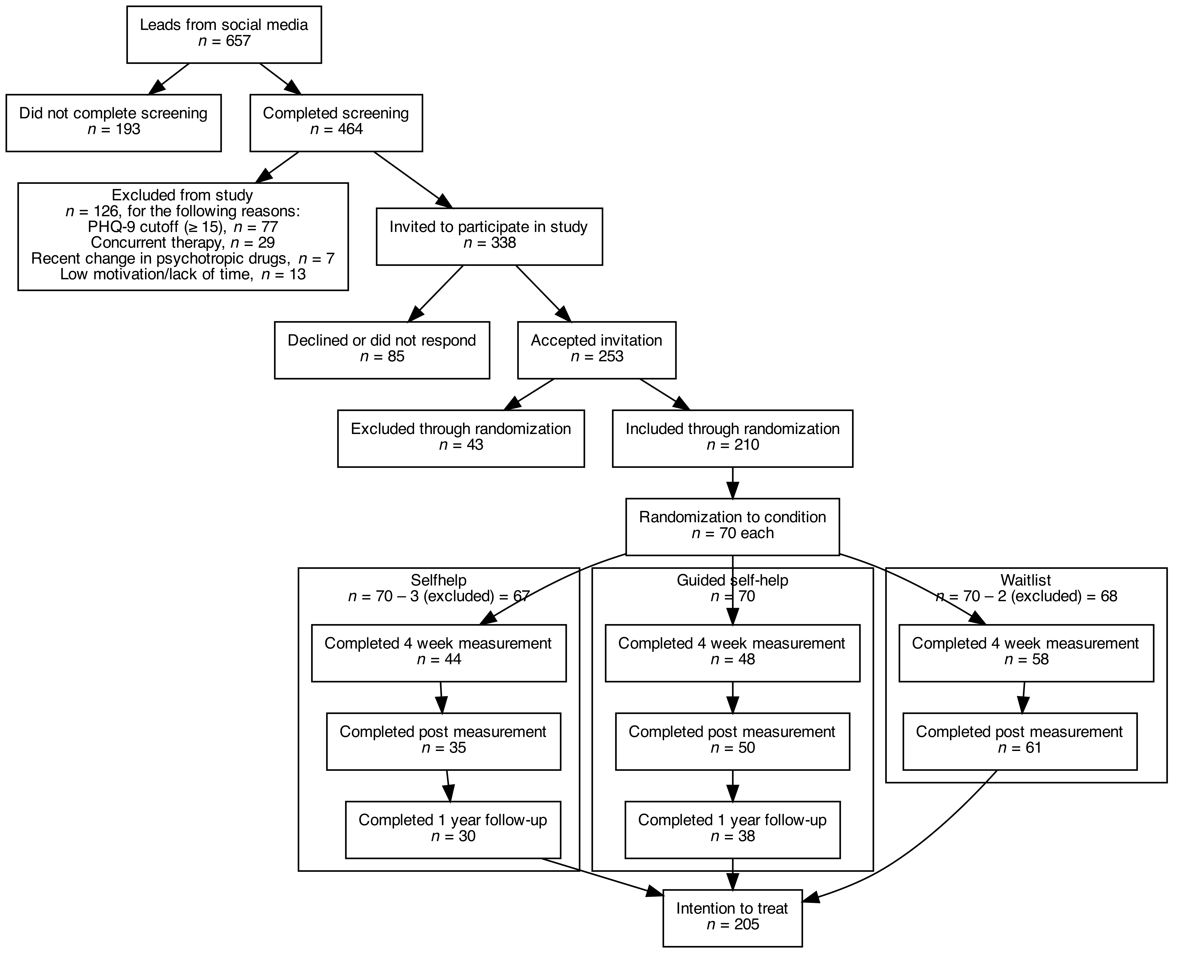

A total of 210 participants were included in the study through randomization; they were further randomized into groups Self-help, Support, and Waitlist, with 70 participants each.

## Analysis

All data were organized in one dataset and analyzed using R 4.1.1, using lmerTest (Kuznetsova et al., 2020), emmeans (Lenth, 2020), ggeffects (Lüdecke, 2018), performance (Lüdecke et al., 2022), and clinicalsignificance (Claus, 2022) packages. All syntax is available at <https://github.com/hmep/r2fu/>, together with anonymized data.

A linear mixed-effects model was fitted using unscaled data to estimate fixed effects of group, time, and group-time interaction, and random effects of participant (specifying a random intercept to control for individual differences), using an unstructured covariance pattern, and the REML method of estimation. Kenward-Roger approximations were used to estimate denominator degrees of freedom. Post-hoc pairwise comparisons of estimated marginal means were performed using T-tests with Bonferroni-corrected p-values. The proportions of participants showing reliable change and reaching clinical significance were determined in accordance with Jacobson & Truax (1991), using the ‘c’ definition to select the cutoff value. To honor the intention to treat principle in the analysis of clinical significance, any missing value was filled in with the value from the previous time point.

# Results

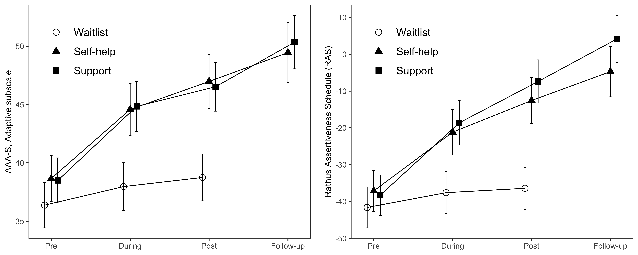

Plots of estimated fixed effects for two of the primary transdiagnostic scales used to measure skillful, assertive behaviors. Participants’ estimated means for both measures exhibit increasing levels of assertiveness during the course of treatment in the Support and Self-help groups, with negligable differences between the two treatment conditions. The trends continue beyond the Post time point, showing further increased estimated mean levels of assertive behaviors at 1-year Follow-up. The Waitlist group’s means recovered slightly, although not significantly, between the Pre and Post time points, for both measures.

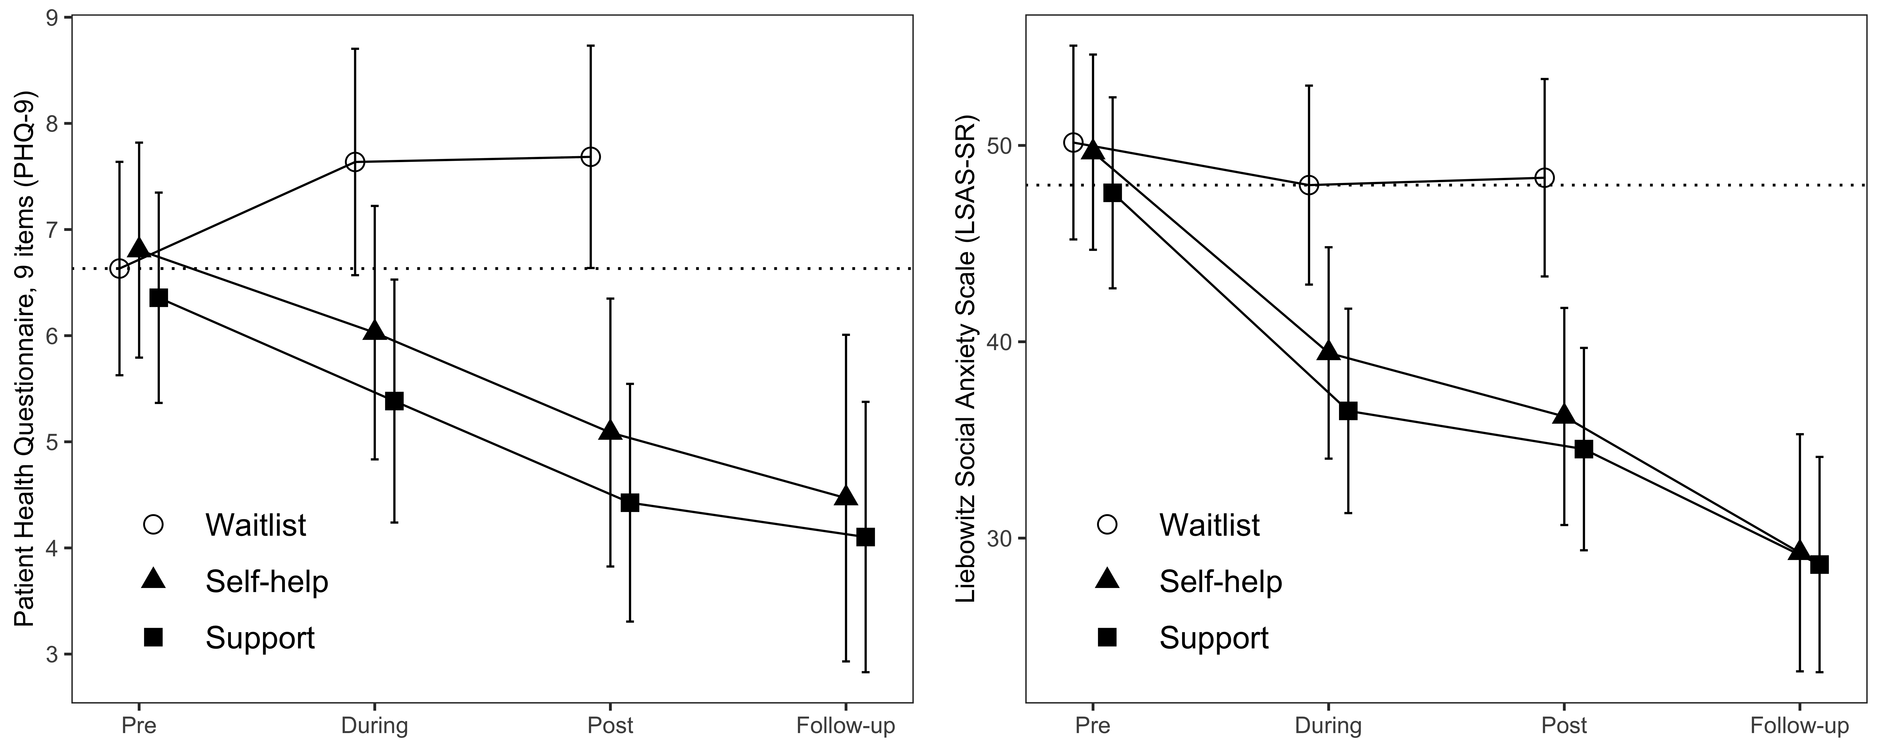

Plots of estimated fixed effects for secondary syndromal outcome measures. Participation in the Support and Self-help conditions lead to significant symptom alleviation between the Pre and Post as well as between Pre and 1-year Follow-up time points for depression and social anxiety, as captured with their respective measures. As with the transdiagnostic measures of assertive behaviors, the difference between the two time points was small or statistically inappreciable for both groups and both measures. The Waitlist control group did not significantly change between time points for either measure. However, to counteract even the slightest nocebo effect of Waitlist in the between-group comparisons the most conservative estimate for the Waitlist control condition was used; see dotted line.

## Treatment efficacy, primary and secondary measures

Mixed models for two of three primary measures of assertive behaviors revealed time group interaction effects: The Adaptive subscale of AAA-S, (, ) = , < , and the RAS, (, ) = , < , suggesting that participation in the treatment conditions did have an effect over time on assertive behaviors. However, the model for Aggressive subscale of AAA-S did not, (, ) = , = , indicating that the self-assessed expressed or perceived levels of aggressive assertions were not affected by participation in the intervention. Similarily, mixed models for two secondary measures of syndromal symptoms, PHQ-9 and LSAS-SR, revealed time group interaction effects, (, ) = , = , and (, ) = , < respectively, while the model for GAD-7 did not, (, ) = , = , indicating that estimated mean levels of depressive mood and social anxiety symptoms – but not those of generalized anxiety – were significantly affected by participation in the intervention.

### Within-group effects

For the primary transdiagnostic measures of skillful behaviors it is notable that both treatment groups Self-help and Guided self-help improved significantly during the course of the intervention, showing large within-group effects with regards to AAA-S Adaptive from Pre to Post, = , () = , < , = , and = , () = , < , = respectively. For the RAS, significant large effects on assertiveness were also found in the Self-help group, = , () = , < , = , and the Guided self-help group, = , () = , < , = . Both treatment groups showed sustained within-group effects on assertiveness at 1 year Follow-up when compared to the Pre-treatment measurement time point, measured with AAA-S Adaptive and the RAS, suggesting that assertive behaviors were still manifest well beyond the end of participation in the intervention. However, only in the Guided self-help group were significant Post to Follow-up comparisons found, for measures AAA-S Adaptive and the RAS, = , () = , = , = and = , () = , = , = respectively. In the Self-help group, there was no difference between Post and Follow-up time points for either measure, from = to = . This indicates, with regards to adaptive assertiveness, that therapist support provided some benefit to participants’ ability to generalize behaviors beyond the duration of the intervention. Table 1 summarizes significance tests of estimated marginal mean differences and effect sizes, including 95% confidence intervals.

Among the secondary measures of syndromal symptoms, depression as captured with PHQ-9 had decreased significantly from Pre only in the Guided self-help group, and only at Follow-up, = , () = , = , = , possibly indicating that therapist support benefits depressed participants on a longer rather than shorter time scale. Symptoms of social anxiety, however, decreased significantly for all four combinations of time points and groups. In the Self-help group, the effect from Pre to Post was = , () = , < , = , increasing to = , () = , < , = Pre to Follow-up. In the Guided self-help group, the effect from Pre to Post was = , () = , < , = , increasing to = , () = , < , = Pre to Follow-up. Although effect sizes for LSAS-SR was larger Pre–Follow-up than Pre–Post, there was no significant difference between Post and Follow-up in either group, = for Self-help and = for Guided self-help, suggesting that change in relief from symptoms of social phobia plateaued earlier than did change in manifest expressions of adaptive assertiveness. The within-group effects taken together indicate that the intervention was effective at addressing more contextually specific anxiety-induced avoidance and escape behaviors, replacing them with already desired assertive behaviors, to a larger extent than it was effective at helping participants struggling with generalized anxiety or depression to formulate reasons to start responding more flexibly.

### Between-group effects

Comparing against Waitlist, the effect of the Self-help condition on adaptive assertiveness using the AAA-S Adaptive primary measure was large at Post-treatment, = , () = , < , = , and even larger at 1-year Follow-up, = , () = , < , = . Similar effects at Post were found for the primary RAS measure = , () = , < , = , and at Follow-up, = , () = , < , = . These effects were not significantly different from those of the Guided self-help condition for AAA-S Adaptive, which compared against Waitlist were = , () = , < , = at Post, and = , () = , < , = at Follow-up, suggesting that participants working through the intervention on their own fared just as well as those who were supported by a therapist. The same phenomenon, and a large effect size, was observed on the RAS in the Guided self-help group, = , () = , < , = at Post, and = , () = , < , = at Follow-up. When it comes to assertive behaviors, excluding aggressive assertions, participants benefited from participation in the intervention, regardless of treatment condition.

Again comparing against Waitlist, there was no significant effect of the Self-help condition on reduction of social anxiety symptoms measured with LSAS-SR at Post-treatment, = , however, a large effect was found at Follow-up, = , () = , < , = , comparing against the lowest value collected (at During, half-way through the intervention, in order to cancel out any possible nocebo effect of the Waitlist condition; see Figure 3 for a graphic identification of time point). No effect on alleviation of depressive symptoms measured with PHQ-9 at Post was found comparing Waitlist and Self-help groups, = . Some evidence was found suggesting that depressive participants might benefit from therapist support, in that the Waitlist versus Guided self-help comparison for PHQ-9 revealed a moderate to large sized effect at Post, = , () = , = , = . However, this effect dissipated when the Follow-up comparison was instead made against the most conservative value collected in the Waitlist group (in this case Pre instead of Post; see Figure 3 for a graphic exploration of a possible nocebo effect, that is symptomatic worsening over time due to self-fulfilling expectations of hopelessness among participants waiting in line for treatment). Thus, the between-group effect on depression at Post should be interpreted with caution.

#### Clinical significant change

Adding to the picture that assertive behaviors increased and symptoms of depression and social phobia decreased as a consequence of participation in the intervention, there was a significant difference between the groups at Post in the number of participants that had recovered clinically, that is had moved across the cutoff for reliable and clinically significant change, into the category ‘Recovered’, with respect to AAA-S Adaptive, () = 7.92, = ; RAS, () = 14.92, < , and LSAS-SR, () = 7.54, = . However, there was no difference between groups at Post with regards to AAA-S Aggressive, = , PHQ-9, = , or GAD-7, = . At Follow-up, the difference in recovery rates between conditions was significant for both behavioral and syndromal measures: AAA-S Adaptive, () = 12.35, = ; RAS, () = 21.51, < ; PHQ-9, () = 11.87, = ; and LSAS-SR, () = 14.2, < ; but not for AAA-S Aggressive, = or GAD-7, = . See Table 2 for a summary of clinical recovery rates and the significance of pairwise tests against Waitlist.

Notably, a number of participants, = (%), (2) = , = in the Self-help group enjoyed clinical recovery with regards to adaptive assertiveness measured with AAA-S Adaptive at Post, increasing to = (%), (2) = , = at Follow-up. In the Guided self-help group the number of recovered participants at Post was non-significantly different from that of the Waitlist, while significantly different at Followup, = (%), (2) = , = . For assertiveness assessed with the RAS, the corresponding numbers and rates were = (%), (2) = , = for Self-help and = (%), (2) = , < for Guided self-help at Post, increasing to = (%), (2) = , < and = (%), (2) = , < respectively at Follow-up. Thus, the clinical significance findings are in agreement with the statistical analysis of change, confirming that adaptive expressions of assertiveness increased Pre to Post in both treatment groups. Clinical recovery measured with PHQ-9 Pre to Post indicate that the intervention, compared to Waitlist, was effective in moving a number of participants out of depression in the Guided self-help group, = (%), (2) = , = , but not so in Self-help group, pointing to that interaction with therapists might contribute to faster recovery for depressed participants. In addition, a significant number of participants in the Self-help group recovered from symptoms of social anxiety as captured with LSAS-SR, = (%), (2) = , = at Post, increasing to = (%), (2) = , = at Follow-up. In the Guided self-help condition, there was no significant number of recovered participants compared to Waitlist at Post, but = (%), (2) = , < at Follow-up. These clinical findings seem to pick up that symptoms of social anxiety continued to subside in the year following treatment, to the point that some participants had recovered. Combined with the clinically relevant recovery for assertive behaviors measured with AAA-S Adaptive and RAS, this could be a sign of generalization of assertive behaviors having continued to occur after the end of treatment, facilitating extinction of anxiety responses.

#### Reliable harm and deterioration

Checking for any signs of reliable harm, the most severe form of deterioration, a significant difference between groups in clinical significant change was found for the AAA-S Aggressive measure, () = 6.1, = , as = participants (%) had reached below the threshold for the category ‘Harmed’ while waiting to enter into treatment (see Table 2). However, post hoc testing did not reveal any significant pairwise differences between any of the treatment groups and the Waitlist group, = and = . No other instances of suspected reliable harm Pre to Post or Pre to Follow-up were identified for either measure. The next worst category in assessing reliable change is ‘Deteriorated’; in order to identify any possible cases of reliable deterioration *and* reliable harm, these two categories were collapsed into the conservative ad hoc category ‘Worsened’ – gathering participants that had moved into either of these two categories. Using the ‘Worsened’ portmanteau category, and checking clinical change Pre to Post treatment, we observed a significant difference between groups for LSAS-SR, () = 9.13, = , meriting a follow-up pairwise comparison. It revealed that the number of participants in the Waitlist condition that had either reached ‘Deteriorated’ or ‘Harmed’, going from Pre to Post treatment, was significant compared to the Guided self-help group, = 7 (), () = , = . The same held true comparing Pre to Follow-up, () = 8.41, = , where these individuals were significantly more than the number of worsened participants in both the Self-help group, () = , = , and the Guided self-help group, () = , = . Finally, a difference between groups was found for PHQ-9, () = 7.86, = , with post hoc testing revealing a difference for the Guided self-help group, = 12 (), () = , = . These findings reveal that the non-active Waitlist condition brought about adverse clinical change for % of participants with regards to social anxiety and % with regards to depression, highlighting the need to use caution comparing results for the treatment groups with those of the Waitlist condition, lest running the risk of artificially inflated effect sizes (especially for PHQ-9 for which estimated marginal means in fact increased over time; see Figure 3).

# Discussion

The current study advances current knowledge about a stand-alone transdiagnostic intervention targeting assertiveness, Respekt2, providing evidence for its effects on levels of assertive behaviors, and consequently its effects on symptoms of common psychiatric disorders of anxiety and depression. Having been more or less ignored as a construct in clincical research since the 1990’ies, despite its history as a target for the very first behavioral therapies in the 1950’ies (Speed et al., 2018), this study brings some much-needed and up-to-date data for assertiveness as a viable transdiagnostic goal in the treatment of various clincial problems.

We found large between-group effects on assertiveness of Self-help and Guided self-help participation in Respekt2, compared to Waitlist control. For AAA-S Adaptive and RAS at Post in the Self-help condition, = and = respectively. The corresponding effect sizes in the Guided self-help group was = and = respectively. Within-group effects from Pre to Post were also large: = for AAA-S Adaptive in the Self-group, and = in the Guided self-help group; = for the RAS in the Self-group, and = in the Guided self-help group. For AAA-S Adaptive in the Guided self-group, the = increase at 1 year Follow-up was also significant. Clinically speaking, = 15 (22%) of participants in the Self-help group had recovered with regards to AAA-S Adaptive at Follow-up, while = 18 (26%) of participants in the Guided self-help group had recovered at the same time point. The corresponding recovery rates for RAS were = 21 (31%) and = 25 (36%). We conclude that Respekt2 did help participants act more assertively, while not acting more aggressively, and that the effects were either sustained or more pronounced 1 year after the intervention.

Assessing the effect of the Respekt2 intervention on symptom burden with respect to depression and common anxiety disorders, we found no significant effects at Post for PHQ-9 or LSAS-SR in the Self-help group, compared with Waitlist. At Follow-up, however, we found a large between-group effect on LSAS-SR, = . Effects were also found in the Guided self-help group, where participants were supported by therapists: Compared with waitlist, participants exhibited moderate effects at Post for PHQ-9, = , and LSAS-SR, = respectively, as well as a large effect only for LSAS-SR at Follow-up, = . Within-group comparisons revealed moderate effects in the Self-help group for LSAS-SR, = Pre–Post, and large effects = Pre–Follow-up. Similar effects were found in the Guided self-help group, = Pre–Post, and = Pre–Follow-up. A moderate effect was found for PHQ-9 Pre–Follow-up for the Guided self-help group, = . These findings were supplemented by the analysis of clinical significant change, where, = 14 (21%) had recovered from social anxiety at Follow-up in the Self-help group, and = 18 (26%) in the group that were guided by therapists. In addition, = 18 (26%) in the Guided self-help group had recovered from depression at Follow-up. Thus, we found that Respekt2 clearly reduced symptoms of social anxiety across both treatment conditions, and over time possibly reduced symptoms of depression, to a moderate degree, among participants that were guided by therapists.

(Compare effects with literature for iCBT, Carlbring et al. (2018) (iCBT as effective as face-to-face treatment), Andrews et al. (2018) (iCBT effective, acceptable, average between-group effect size g = 0.8 compared to controls; results from Baumeister et al. (2014) concur, also pointing to guided iCBT producing somewhat larger effects than non-guided). Also, compare w/ frequencies or reliable change, e.g. Rozental et al. (2015).)

(Discuss effects as they related to sociodemographic baseline characteristics – 60% having previously been in therapy; Respekt2 possibly acting as a booster …, also a very pronounced sex difference, also level of use of medication.)

In line with Baumeister et al. (2014), the results of the current study suggest that while effects at Post and Follow-up between groups are comparable for all measures, being guided by a therapist in iCBT could entail some advantages, especially for longer-term outcomes. In the Guided self-help group, adaptive assertiveness had increased between end of treatment and 1-year Follow-up, and both analysis within-groups and of statistical change indicated that depression had decreased from pre-treatment to 1-year Follow-up both. These phenomena were not observed in the group where the participants were engaging with the intervention on their own. Speculatively, this might be explained by either increased willingness to participate in behavioral experiments through the effects of coaching, an increased ability to engage in behavioral experiments through active problem solving with the therapist, or increased ability to generalize findings from such experiments through better compliance to homework assignments, or any combination thereof. While the mechanisms of mediation and moderation remain to unravel, the presence of human support could increase adherence to the intervention through increased levels of accountability, as suggested by Mohr et al. (2011).

(Discuss reasons for non-responding with regards to GAD-7? Relate to the sample.)

Limitations: Although the effect sizes between groups and within treatment groups were substantial in the Respekt2 intervention, it is difficult to transfer the findings to the general population. Firstly, X, secondly, Y, … The current study also suffers from a number of limitations, among them Z (biased recruitment), Å (unclear operationalization of ‘assertiveness’), Ä (no validated scales), Ö (waitlist as control, related to reliable harm).

Future research: However, it is intriguing that …, and merits further investigation. Directions for future research could include … (how does assertiveness relate to relationship problems and work-related stress?)

Lösrykta tankar/stycken att eventuellt utveckla:

* Jämföra engagemang mellan grupperna? Antal inloggningar? Antal gjorda hemuppgifter?
* Diskutera huvudeffekter för AAA-S Aggressive och GAD-7 trots avsaknad av interation tid x grupp? Hur tänka?
* Samla upp viktigaste punkterna från uppsatsen.
* Problematisering av otydlig defintion av assertivenss. R2? Adaptiv, aggressiv? Passiv? Passiv-aggressiv? Icke-undvikande/icke-flykt? Det enda som är säkert är att definitionen nog endast bör rymma overta beteenden?
* Man kan ha olika uppfattning om vad som är aggressiv vs adaptiv självhävdelse, finns behov av att mäta dessa antaganden på något adekvat sätt. Att följa upp?
* Skalorna är inte validerade på svenska.
* Behöver testas med en klinisk population, inte bara allmänhet rekryterade via sociala medier.
* Hade varit bättre med också random slopes.
* Problem med ITT – fångar inte ev försämring … men vi får anta att regression to the mean gäller även här.
* Problematisering väntelista som kontroll, hantering av problem. It is noteworthy that the PHQ-9 mean of the non-active Waitlist control group increases as the participants wait in line to begin treatment; this might be due to the nocebo or ”reverse placebo” effect (Cuijpers et al., 2016; Furukawa et al., 2014), where participants’ expectations contribute to their mood actually worsening, which in turn risks inflating between group effect sizes. The other scales do not exhibit this possible problem. To mitigate any possible nocebo effect, the most conservative estimated marginal mean from either the Pre, During, Post time points was used for all within group pairwise comparisons for each scale.
* Jag vill säga något spekulativt om rimligheten och önskvärdheten att använda positivt formulerat, transdiagnostiskt beteendemål i behandling istf syndromal symptomreduktion. Relatera till utfallsmåtten PHQ9, GAD7, LSAS. Det är väntat att beteendemåtten (AAAS-ad/ag, RAS) sticker iväg snabbare än symtomreduktionsmåtten. Beteendeförändring borde föregå förändring i upplevelse (känslor, tankar). Validerar mao beteendeterapeutiska angreppssättet?
* För en replikering vore det intressant att använda andra transdiagnostiska skalor kopplade till värderat handlande, typ VLQ, och även SAAQ.
* En fördel med självständigt arbete (som när man går i ett självhjälpsprogram) är sannolikt att man tillskriver förbättringar till sig själv och egna förändrade beteenden än till kontakten med terapeuten – skulle spekulativt kunna utgöra en del av förklaringen till att självshjälpsgruppen gjort så stora framsteg på egen hand när effekten mäts med positivt formulerade självhävdelsebeteendemål. Med andra ord synliggörs faktiska beteendeförändringar möjligen bättre.
* …
* …

## References

Alberti, R., & Emmons, M. (1974). *Your perfect right* (2nd ed.). Impact.

Alberti, R., & Emmons, M. (2017). *Your perfect right: Assertiveness and equality in your life and relationships*. New Harbinger Publications.

Andrews, G., Basu, A., Cuijpers, P., Craske, M. G., McEvoy, P., English, C. L., & Newby, J. M. (2018). Computer therapy for the anxiety and depression disorders is effective, acceptable and practical health care: An updated meta-analysis. *Journal of Anxiety Disorders*, *55*(December 2017), 70–78. <https://doi.org/10.1016/j.janxdis.2018.01.001>

Antúnez, J. M. (2020). Circadian typology is related to emotion regulation, metacognitive beliefs and assertiveness in healthy adults. *PLOS ONE*, *15*, e0230169. <https://doi.org/10.1371/journal.pone.0230169>

Baker, A., & Jeske, D. (2015). Assertiveness and Anxiety Effects in Traditional and Online Interactions. *International Journal of Cyber Behavior, Psychology and Learning*, *5*, 30–46. <https://doi.org/10.4018/978-1-4666-5942-1>

Baumeister, H., Reichler, L., Munzinger, M., & Lin, J. (2014). *The impact of guidance on Internet-based mental health interventions: A systematic review* (No. 4; Vol. 1, pp. 205–215). <https://doi.org/10.1016/j.invent.2014.08.003>

Beck, A. T. (1979). *Cognitive Therapy of Depression*. Guilford Publications.

Carlbring, P., Andersson, G., Cuijpers, P., Riper, H., & Hedman-Lagerlöf, E. (2018). Internet-based vs. face-to-face cognitive behavior therapy for psychiatric and somatic disorders: an updated systematic review and meta-analysis. *Cognitive Behaviour Therapy*, *47*(1), 1–18. <https://doi.org/10.1080/16506073.2017.1401115>

Chambless, D. L., & Ollendick, T. H. (2001). Empirically Supported Psychological Interventions: Controversies and Evidence. *Annual Review of Psychology*, *52*(1), 685–716. <https://doi.org/10.1146/annurev.psych.52.1.685>

Clark, D. M. (1986). A cognitive approach to panic. *Behaviour Research and Therapy*, *24*(4), 461–470. <https://doi.org/10.1016/0005-7967(86)90011-2>

Clark, D. M., & Wells, A. (1995). A cognitive model of social phobia. In R. G. Heimberg, M. R. Liebowitz, D. A. Hope, & F. R. Schneier (Eds.), *Social phobia: Diagnosis, assessment, and treatment* (Vol. 41, pp. 22–23). The Guilford Press.

Claus, B. (2022). *Clinicalsignificance: Determine the clinical significance in clinical trials*. <https://CRAN.R-project.org/package=clinicalsignificance>

Cohen, J. (1988). *Statistical power analysis for the behavioral sciences (revised ed.)*. Lawrence Earlbaum Associates, Inc.

Craske, M. G., Kircanski, K., Zelikowsky, M., Mystkowski, J., Chowdhury, N., & Baker, A. (2008). Optimizing inhibitory learning during exposure therapy. *Behaviour Research and Therapy*, *46*(1), 5–27. <https://doi.org/10.1016/j.brat.2007.10.003>

Cuijpers, P., Cristea, I. A., Karyotaki, E., Reijnders, M., & Huibers, M. J. H. (2016). How effective are cognitive behavior therapies for major depression and anxiety disorders? A meta-analytic update of the evidence. *World Psychiatry*, *15*, 245–258. <https://doi.org/10.1002/wps.20346>

Day, V., McGrath, P. J., & Wojtowicz, M. (2013). Internet-based guided self-help for university students with anxiety, depression and stress: A randomized controlled clinical trial. *Behaviour Research and Therapy*, *51*(7), 344–351. <https://doi.org/10.1016/j.brat.2013.03.003>

Fensterheim, H., & Baer, J. L. (1975). *Don’t say yes when you want to say no*. Dell Publishing Company.

Fresco, D. M., Coles, M. E., Heimberg, R. G., Liebowitz, M. R., Hami, S., Stein, M. B., & Goetz, D. (2001). The Liebowitz Social Anxiety Scale: A comparison of the psychometric properties of self-report and clinician-administered formats. *Psychological Medicine*, *31*(6), 1025–1035. <https://doi.org/10.1017/S0033291701004056>

Furukawa, T. A., Noma, H., Caldwell, D. M., Honyashiki, M., Shinohara, K., Imai, H., Chen, P., Hunot, V., & Churchill, R. (2014). Waiting list may be a nocebo condition in psychotherapy trials: A contribution from network meta-analysis. *Acta Psychiatrica Scandinavica*, *130*, 181–192. <https://doi.org/10.1111/acps.12275>

Gambrill, E. D., & Richey, C. A. (1975). An assertion inventory for use in assessment and research. *Behavior Therapy*, *6*(4), 550–561.

Haahr, M. (2018). *RANDOM.ORG: True random number service. [online]*. <https://www.random.org>.

Hayes, S. C. (2004). Acceptance and commitment therapy, relational frame theory, and the third wave of behavioral and cognitive therapies. *Behavior Therapy*, *35*(4), 639–665. <https://doi.org/10.1016/S0005-7894(04)80013-3>

Hofmann, S. G., Asnaani, A., Vonk, I. J. J., Sawyer, A. T., & Fang, A. (2012). The efficacy of cognitive behavioral therapy: A review of meta-analyses. *Cognitive Therapy and Research*, *36*(5), 427–440. <https://doi.org/10.1007/s10608-012-9476-1>

Jacobson, N. S., & Truax, P. (1991). Clinical significance: A statistical approach to defining meaningful change in psychotherapy research. *Journal of Consulting and Clinical Psychology*, *59*(1), 12–19.

Kroenke, K., Spitzer, R. L., Williams, J. B. W., & Löwe, B. (2010). The Patient Health Questionnaire Somatic, Anxiety, and Depressive Symptom Scales: A systematic review. *General Hospital Psychiatry*, *32*(4), 345–359. <https://doi.org/10.1016/j.genhosppsych.2010.03.006>

Kuznetsova, A., Bruun Brockhoff, P., & Haubo Bojesen Christensen, R. (2020). *lmerTest: Tests in linear mixed effects models*. <https://github.com/runehaubo/lmerTestR>

Lenth, R. (2020). *emmeans: Estimated Marginal Means, aka Least-Squares Means*. <https://cran.r-project.org/package=emmeans>

Linehan, M. M. (1979). Structured Cognitive-Behavioral Treatment of Assertion Problems. In *Cognitive-behavioral interventions* (pp. 205–240). Elsevier. <https://doi.org/10.1016/B978-0-12-404480-7.50013-7>

Linehan, M. M. (1993). *Skills training manual for treating borderline personality disorder.* The Guilford Press.

Lüdecke, D. (2018). ggeffects: Tidy Data Frames of Marginal Effects from Regression Models. *Journal of Open Source Software*, *3*(26), 772. <https://doi.org/10.21105/joss.00772>

Lüdecke, D., Makowski, D., Ben-Shachar, M. S., Patil, I., Waggoner, P., & Wiernik, B. M. (2022). *Performance: Assessment of regression models performance*. <https://easystats.github.io/performance/>

Michel, F., & Fursland, A. (2008). *Assert Yourself*. Centre for Clinical Interventions. [www.cci.health.wa.gov.au/Resources/Looking-After-Yourself/Assertiveness](https://www.cci.health.wa.gov.au/Resources/Looking-After-Yourself/Assertiveness)

Mohr, D. C., Cuijpers, P., & Lehman, K. (2011). Supportive accountability: A model for providing human support to enhance adherence to eHealth interventions. *Journal of Medical Internet Research*, *13*, e30. <https://doi.org/10.2196/jmir.1602>

Öst, L.-G. (2006). *Tillämpad avslappning: manual till en beteendeterapeutisk coping-teknik*. L.-G. Öst.

Powell, T. J. (2017). *The Mental Health Handbook: A Cognitive Behavioural Approach*. Routledge.

Rathus, S. A. (1973). A 30-item schedule for assessing assertive behavior. *Behavior Therapy*, *4*(3), 398–406. <https://doi.org/10.1016/S0005-7894(73)80120-0>

Rozental, A., Forsell, E., Svensson, A., Andersson, G., & Carlbring, P. (2015). Internet-based cognitive-behavior therapy for procrastination: A randomized controlled trial. *Journal of Consulting and Clinical Psychology*, *83*(4), 808–824. <https://doi.org/10.1037/ccp0000023>

Rozental, A., Shafran, R., Wade, T., Egan, S., Nordgren, L. B., Carlbring, P., Landström, A., Roos, S., Skoglund, M., Thelander, E., Trosell, L., Örtenholm, A., & Andersson, G. (2017). A randomized controlled trial of Internet-Based Cognitive Behavior Therapy for perfectionism including an investigation of outcome predictors. *Behaviour Research and Therapy*, *95*, 79–86. <https://doi.org/10.1016/j.brat.2017.05.015>

Salter, A. (1949). Conditioned reflex therapy. *NY: Capricorn*, *106*.

Sealed Envelope Ltd. (2021). *Sealed Envelope. Simple randomisation service. [Online]*. <https://sealedenvelope.com/simple-randomiser/v1>.

Smith, M. J. (1975). *When I say no, I feel guilty: how to cope–using the skills of systematic assertive therapy*. Bantam.

Speed, B. C., Goldstein, B. L., & Goldfried, M. R. (2018). Assertiveness Training: A Forgotten Evidence-Based Treatment. *Clinical Psychology: Science and Practice*, *25*(1), 1–20. <https://doi.org/10.1111/cpsp.12216>

Spitzer, R. L., Kroenke, K., Williams, J. B. W., & Löwe, B. (2006). A Brief Measure for Assessing Generalized Anxiety Disorder. *Archives of Internal Medicine*, *166*(10), 1092. <https://doi.org/10.1001/archinte.166.10.1092>

Thompson, R. J., & Berenbaum, H. (2011). Adaptive and aggressive assertiveness scales (AAA-S). *Journal of Psychopathology and Behavioral Assessment*, *33*(3), 323–334. <https://doi.org/10.1007/s10862-011-9226-9>

Vagos, P., & Pereira, A. (2019). Towards a Cognitive-Behavioral Understanding of Assertiveness: Effects of Cognition and Distress on Different Expressions of Assertive Behavior. *Journal of Rational-Emotive and Cognitive-Behavior Therapy*, *37*(2), 133–148. <https://doi.org/10.1007/s10942-018-0296-4>

Wolpe, J. (1952). Objective Psychotherapy of the neuroses. *South African Medical Journal*, *20*(42), 825–829.

Wolpe, J. (1990). *The practice of behavior therapy*. Pergamon Press.

Wolpe, J., & Lazarus, A. A. (1966). *Behavior therapy techniques: A guide to the treatment of neuroses* (pp. ix, 198–ix, 198). Pergamon Press.

1. University of Somewhere
2. University of Nowhere
3. University of Nowhere
4. University of Nowhere
5. University of Nowhere
6. University of Nowhere