

**Green University of Bangladesh**

**Department of Computer Science and Engineering (CSE)**

**Faculty of Sciences and Engineering**

**Semester: (Fall, Year: 2022), B.Sc. in CSE (Day)**

**LAB REPORT NO # 2**

**Course Title:**

**Course Code: CSE 302 Section: 203 D2**

**Lab Experiment Name: (i) Create and Design My Class Routine using HTML Table Tag. (ii) Create and Design A Student Registration Form using HTML Form Tag.**

**Student Details**

|  |  |  |
| --- | --- | --- |
| **Name** | | **ID** |
| **1.** | H. M. Fahad | 183002002 |

**Lab Date : 25.10.2022**

**Submission Date : 01.10.2022**

**Course Teacher’s Name : Tanpia Tasnim**

**[For Teachers use only: Don’t Write Anything inside this box]**

|  |
| --- |
| **Lab Report Status**  **Marks: ………………………………… Signature: .....................**  **Comments: .............................................. Date: ..............................** |

**1. TITLE OF THE LAB EXPERIMENT**

(i) Create and Design My Class Routine using HTML Table Tag.

(ii) Create and Design A Student Registration Form using HTML Form Tag.

**2. OBJECTIVES/AIM**

* To design basic tables using HTML.
* To implement table using various table tag attributes like row span and col span.
* To gather knowledge of HTML form.
* To implement an interactive form using HTML.

**3. INTRODUCTION**

In the last two web programming lab class we learned how to design and implement a HTML TABLE and HTML FORM. Now I implement my lab experience in this lab report by implementing my Class Routine and Registration Form.

**4. PROCEDURE**

Step:1 : Download and Install Visual Studio.

Step 2: Install Live Server plugin (Clicking left side extension icon or ctrl+shift+x) in Visual Studio.

Step:3 : Open Visual Studio and Open A Folder.

Step 4: Create HTML with .html extension and CSS .css extension file and save it.

Step 5: Use deferent HTML and CSS tag to create expected web page.

Step 6: To seeing output click right bnt on the consol and select Open with live server.

**5. IMPLEMENTATION**

**HTML Code for Class Routine Page**

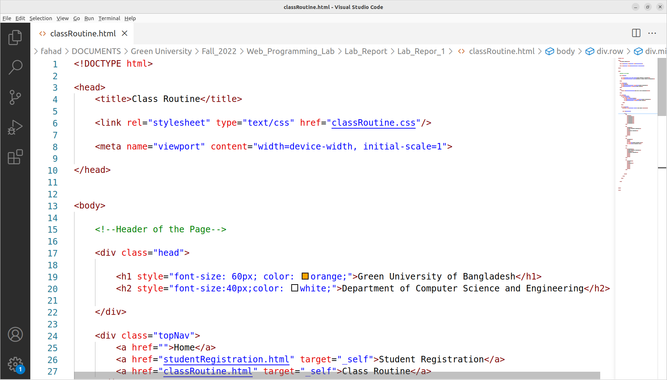

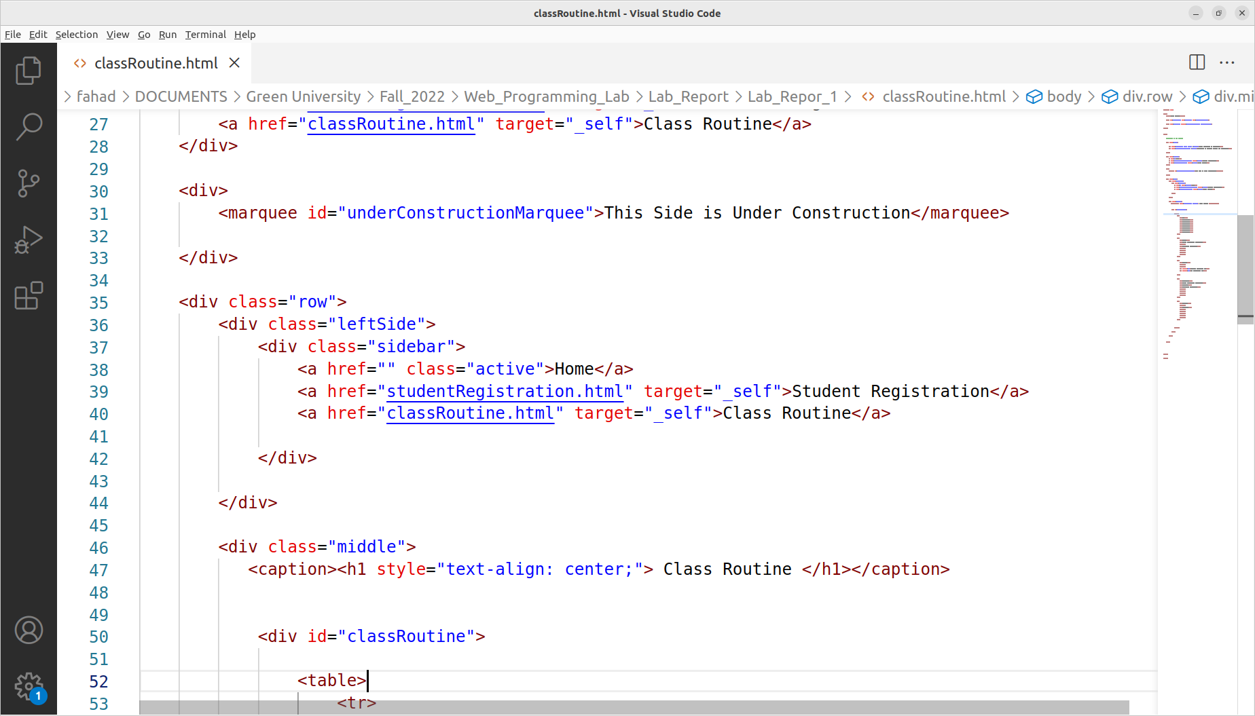

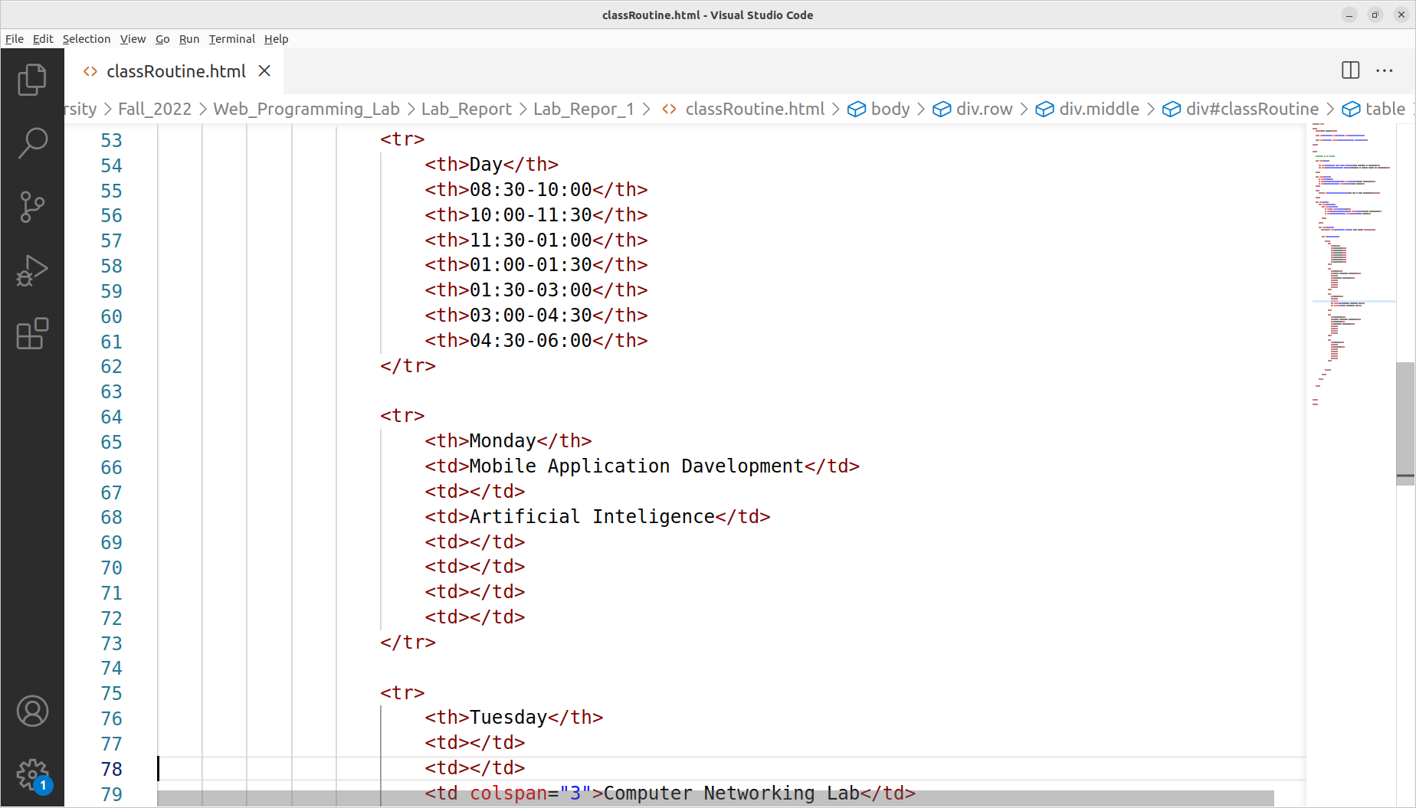

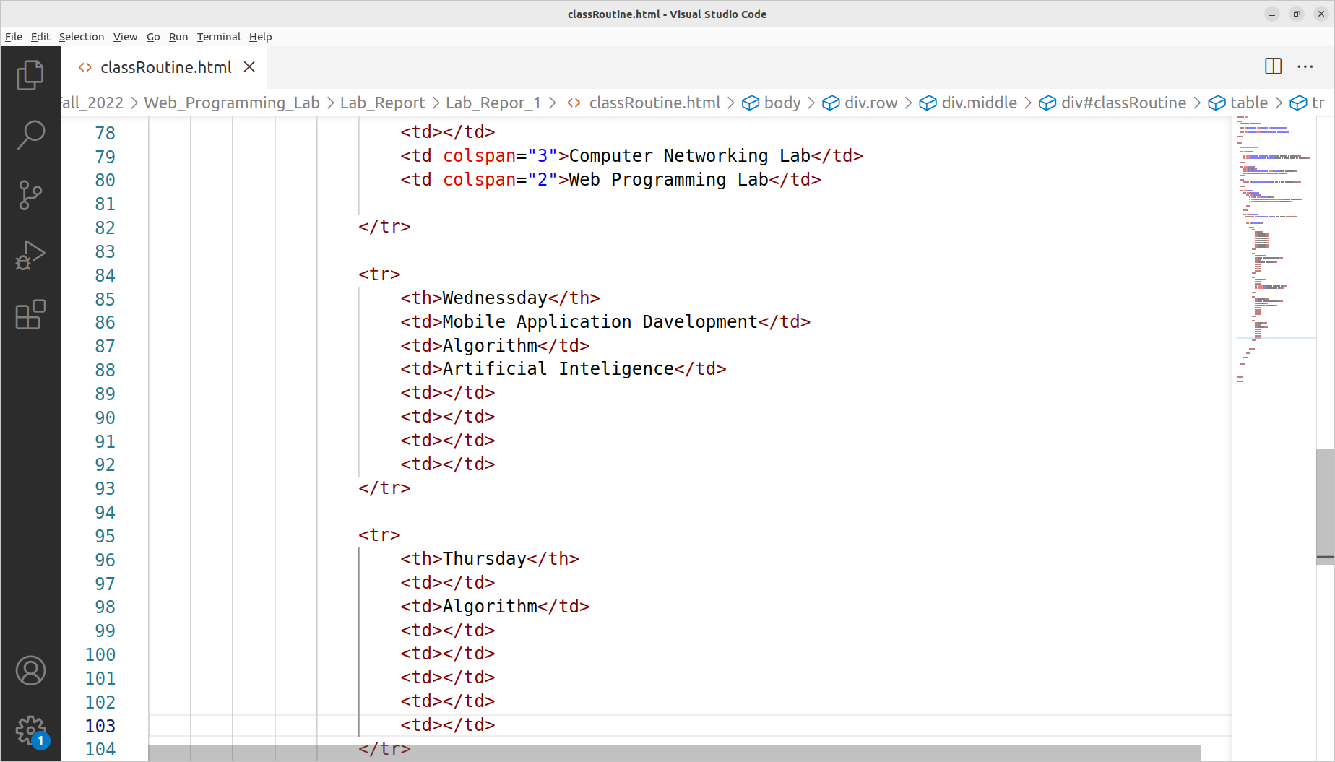

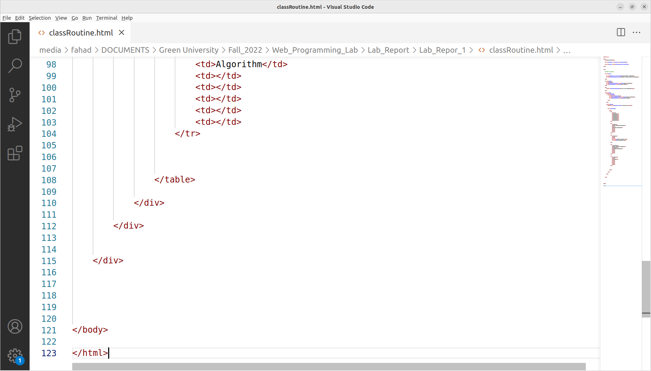**CSS Code Class Routine Page**

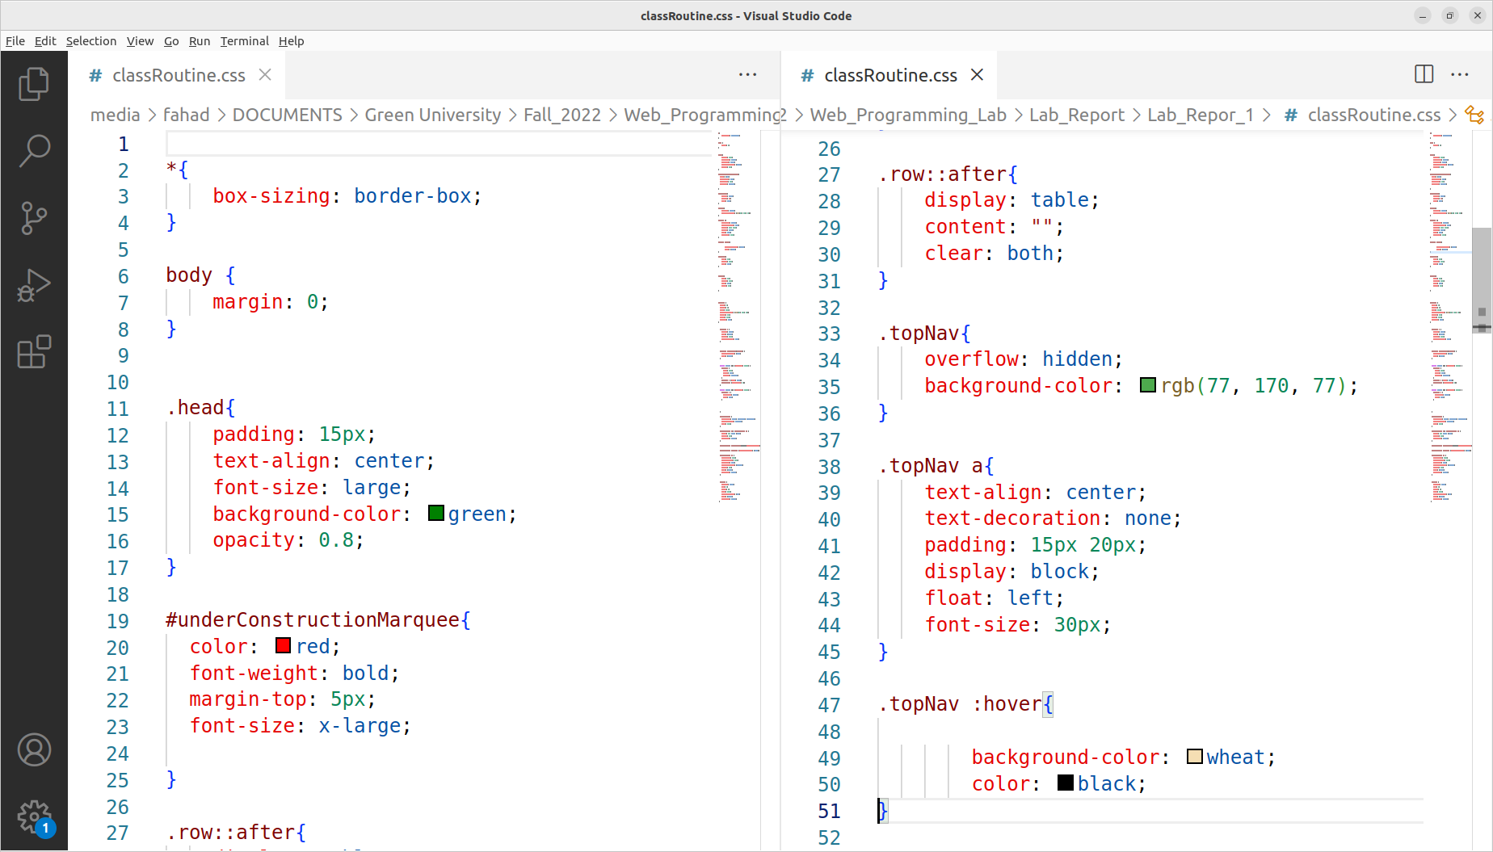

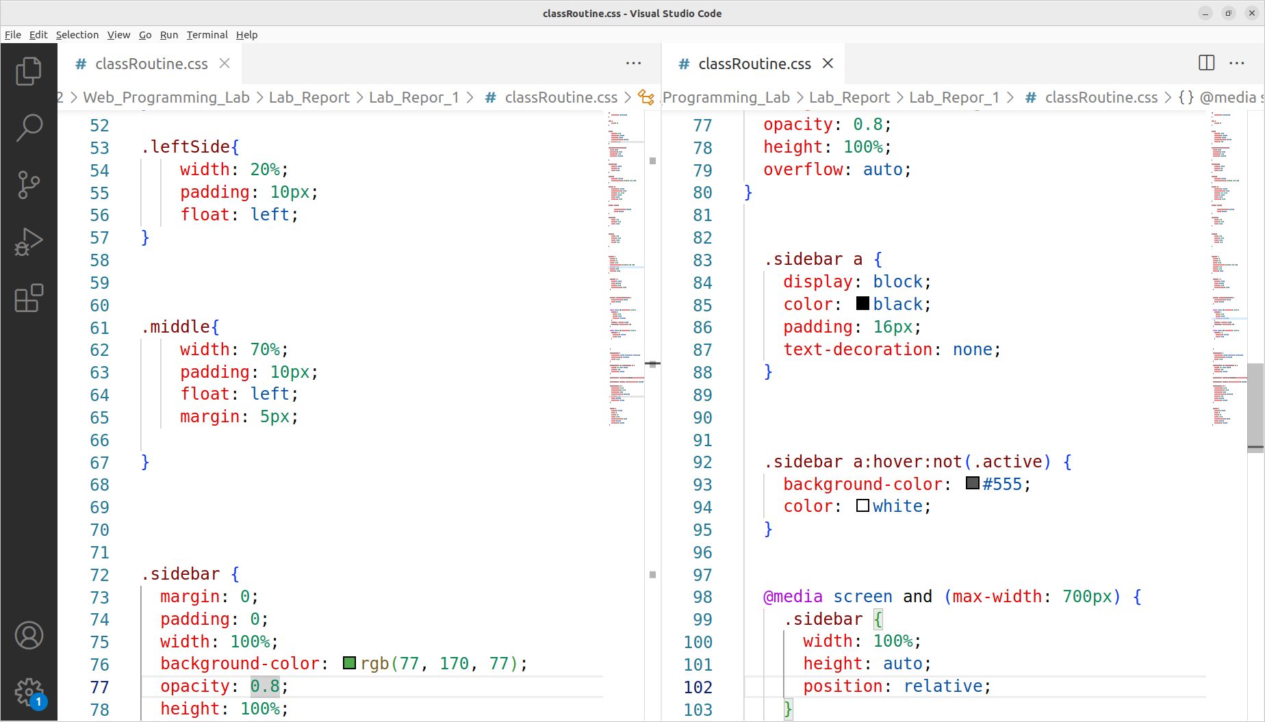

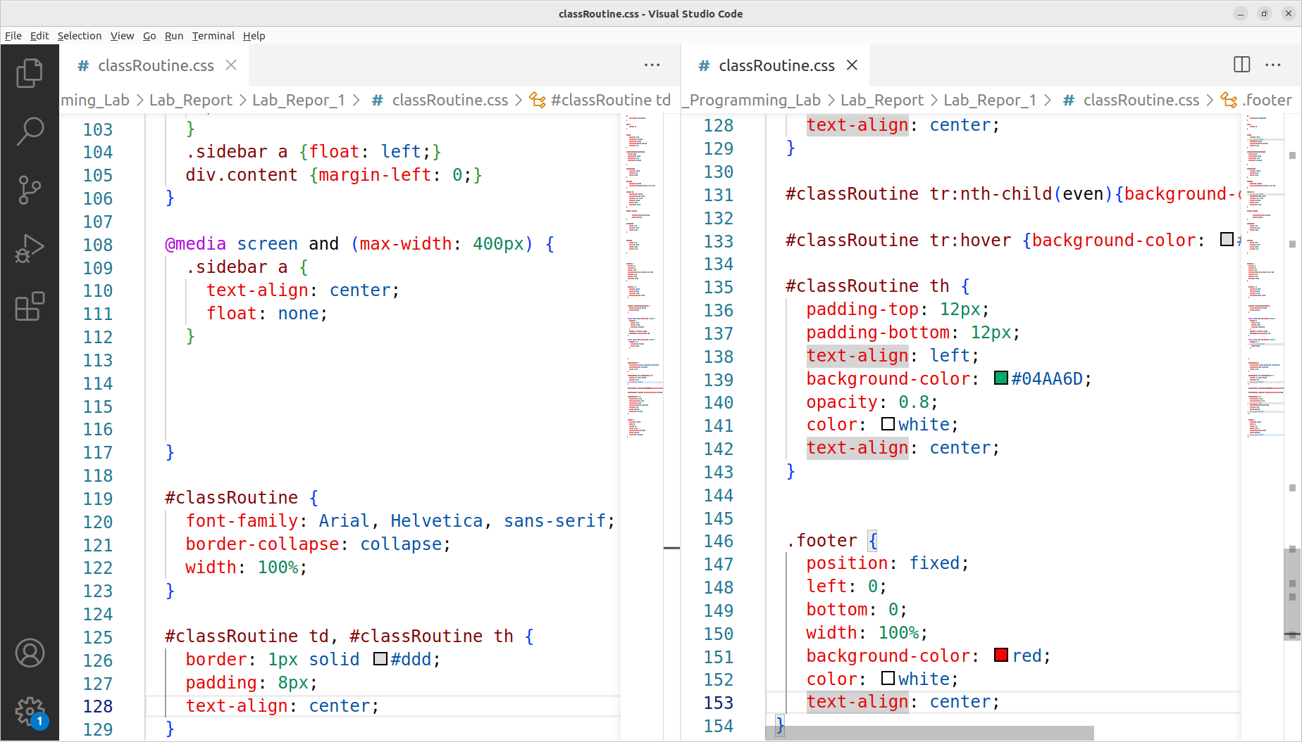

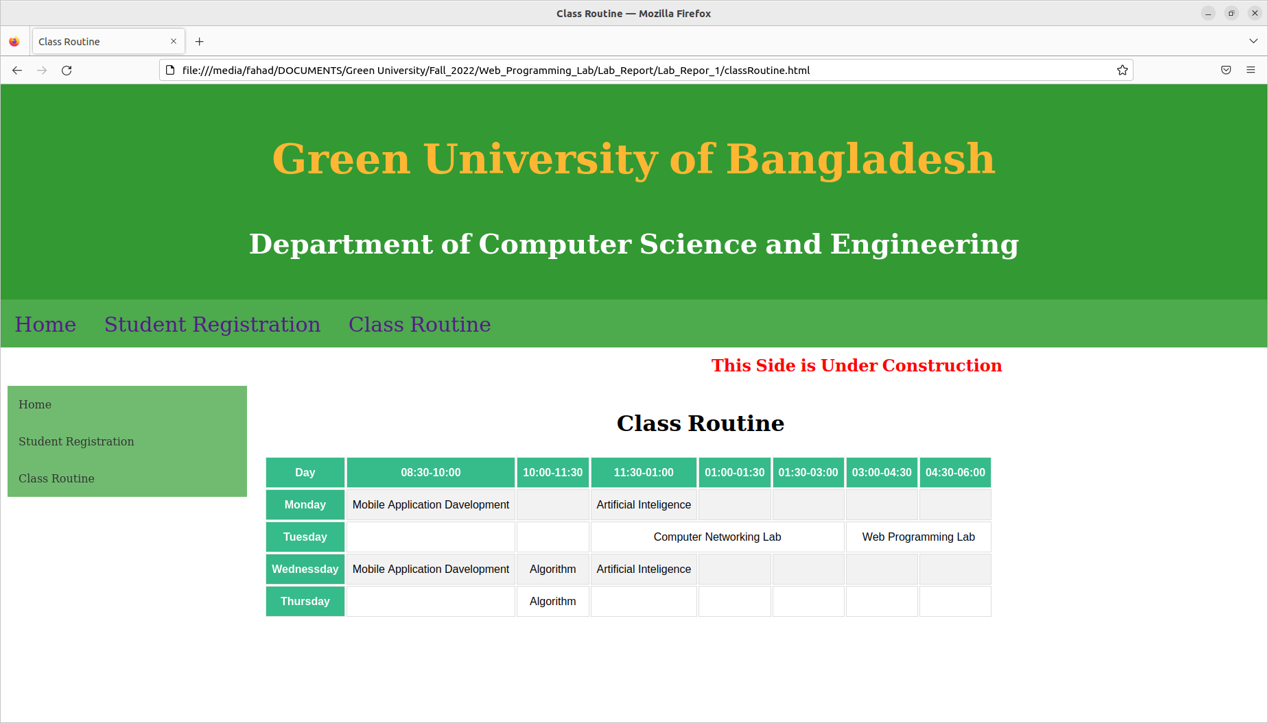**Class Routine Page Output:**

**HTML Code for Registration Form Page:**

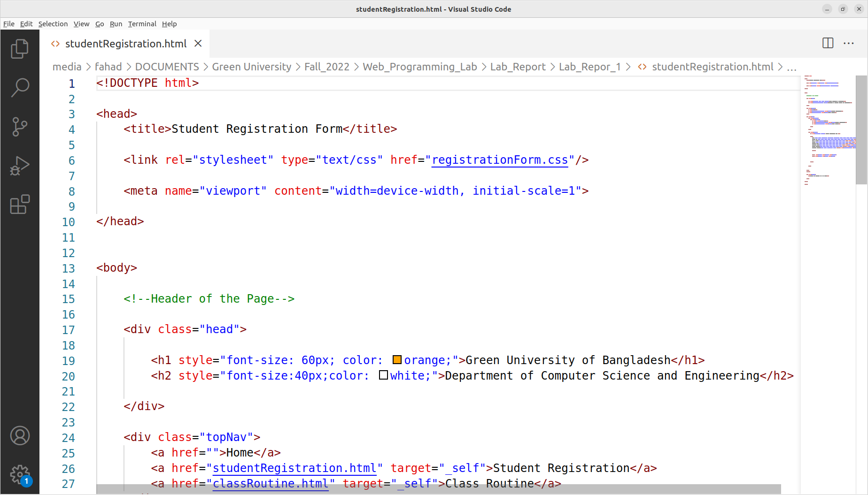

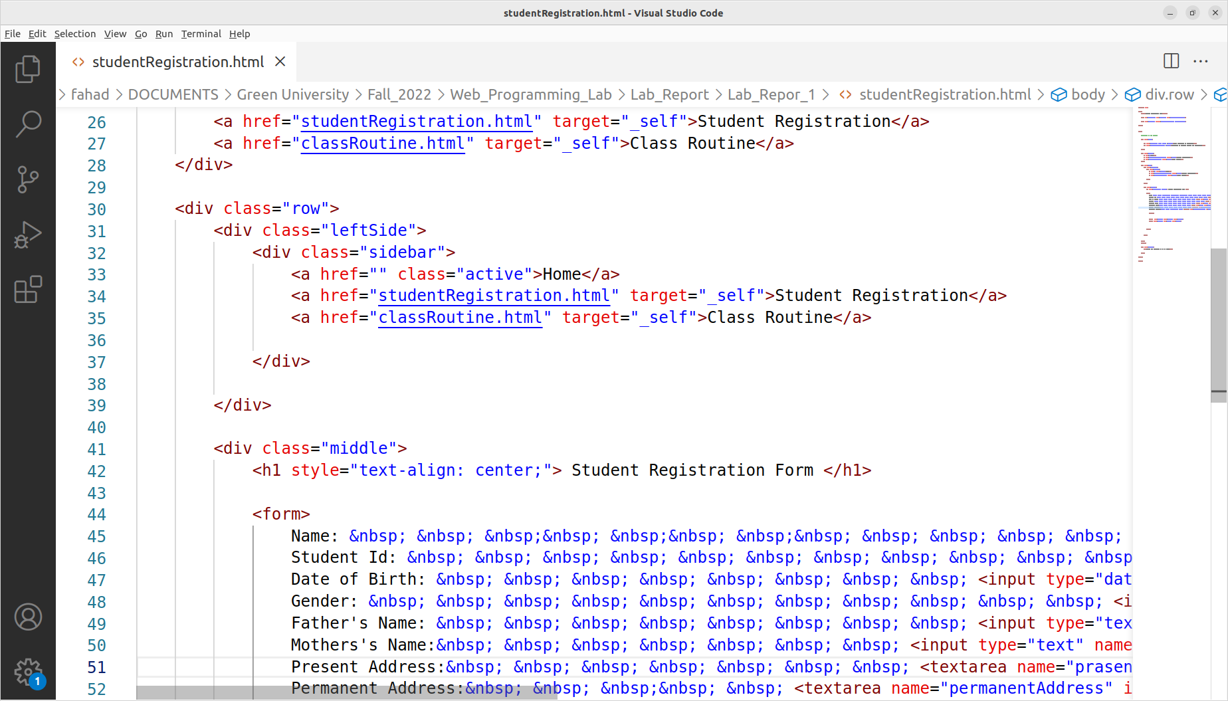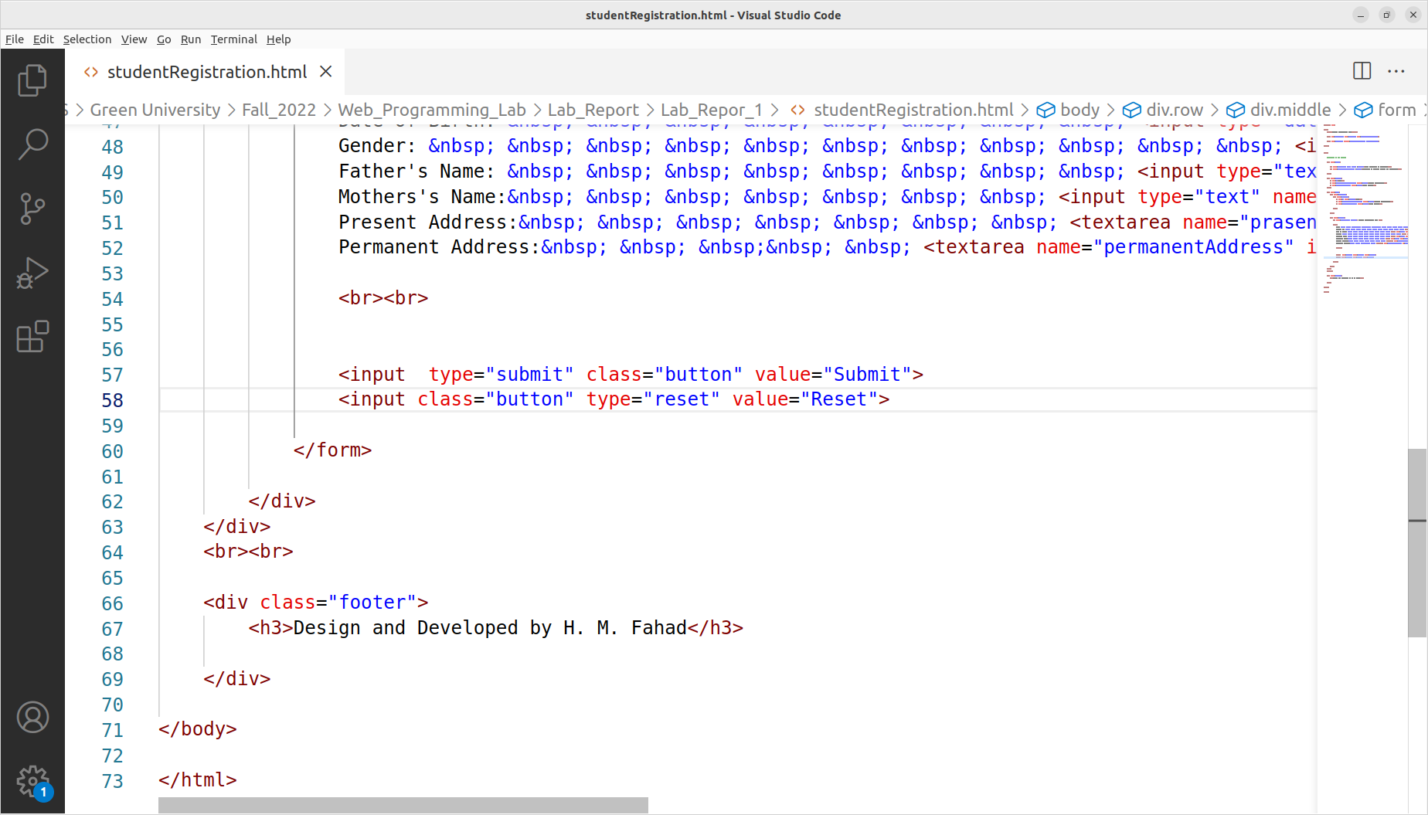

**CSS Code for Registration Form Page:**

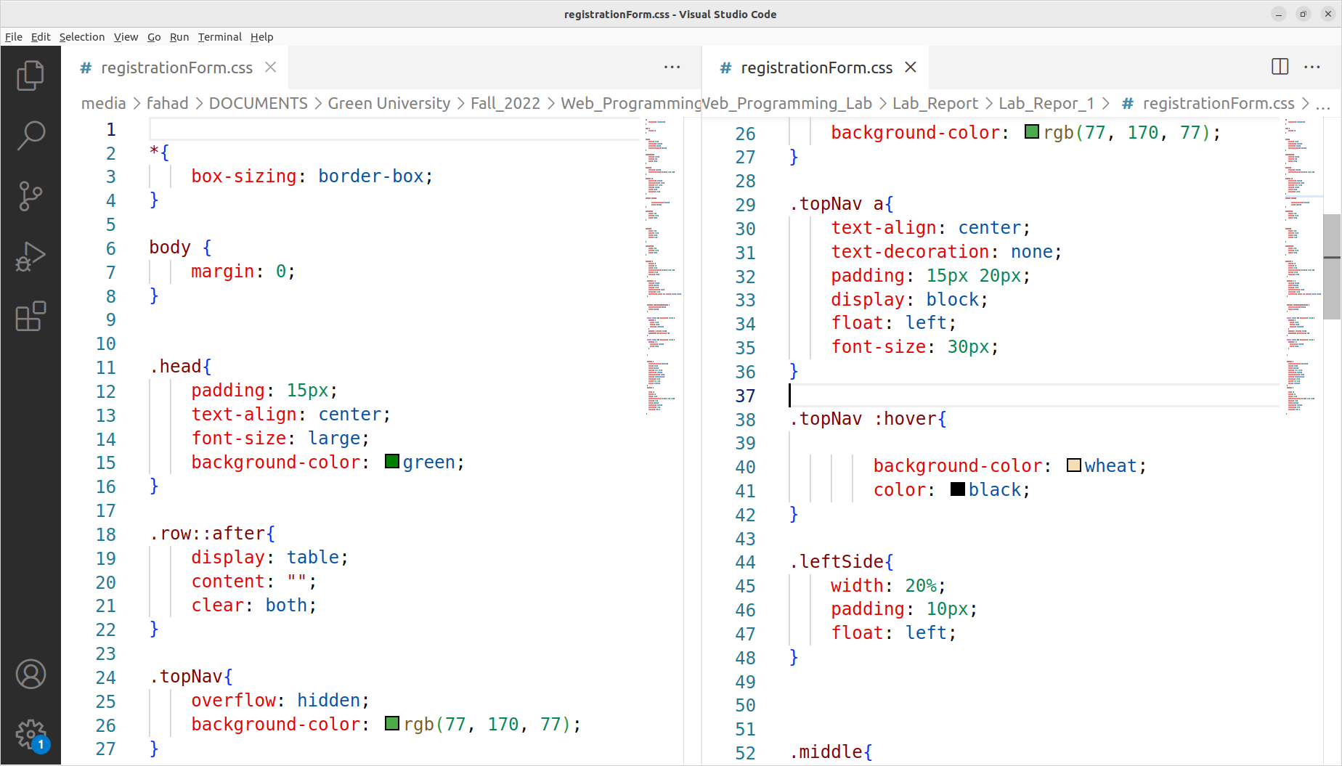

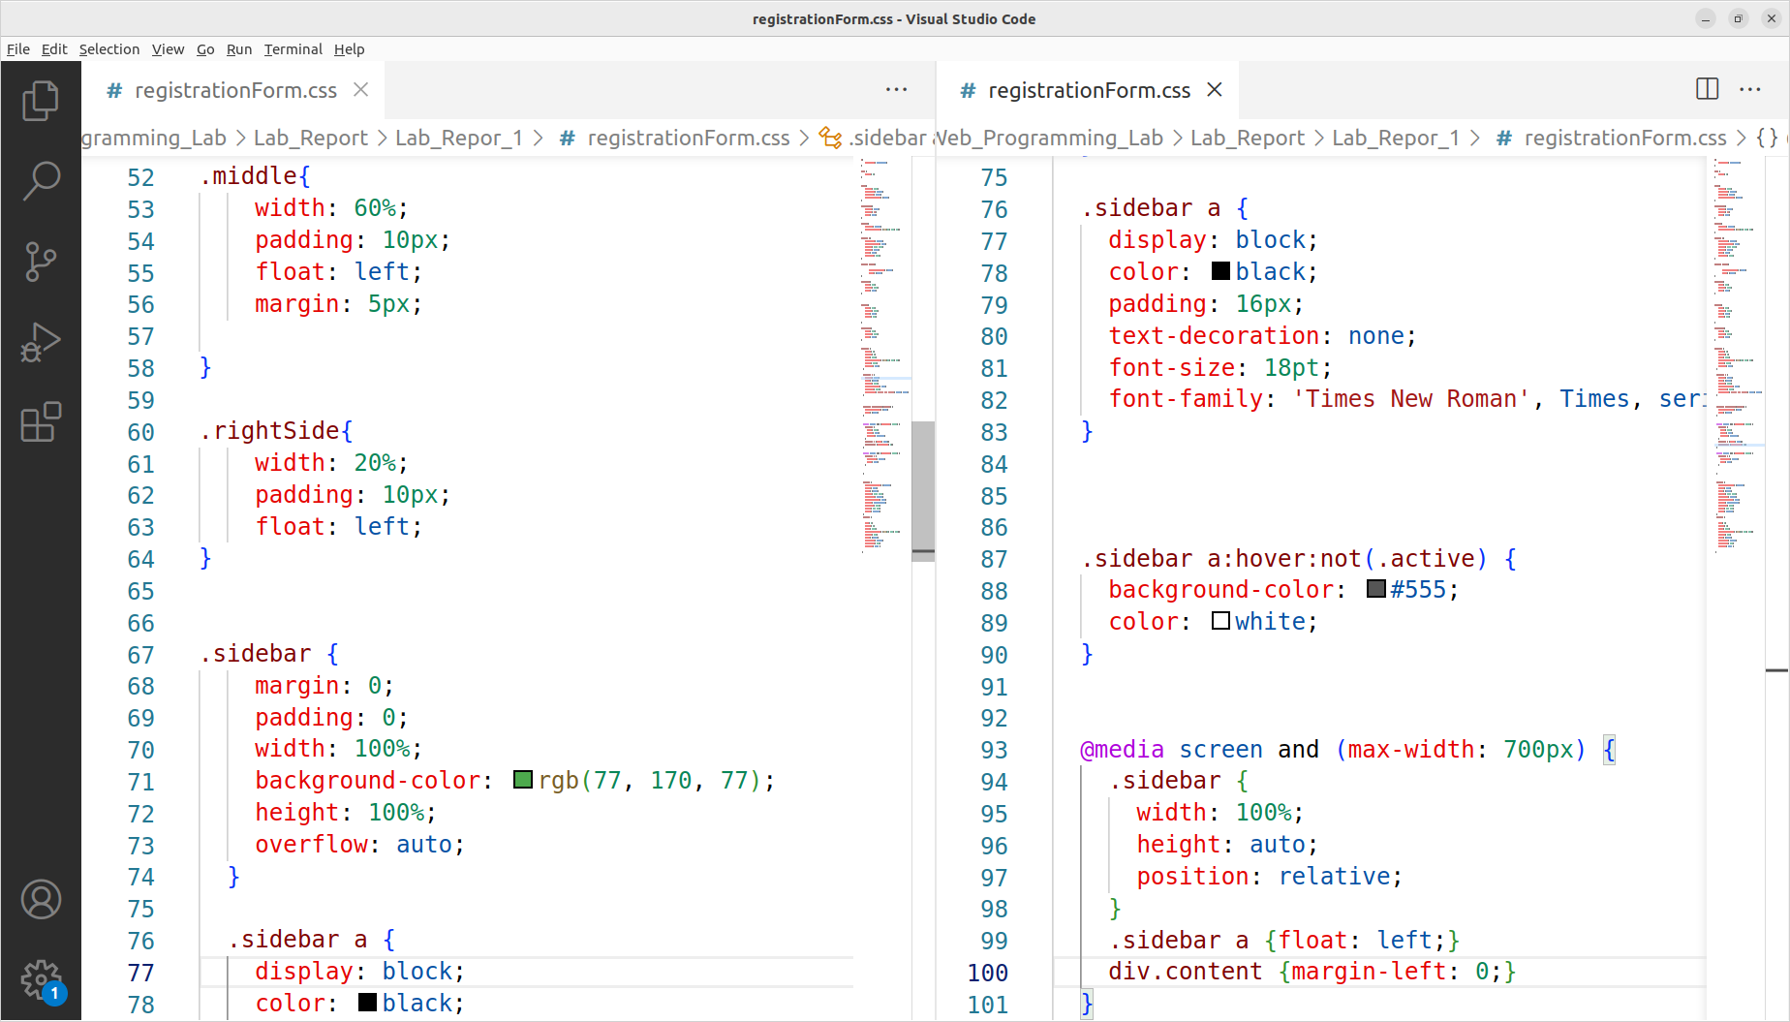

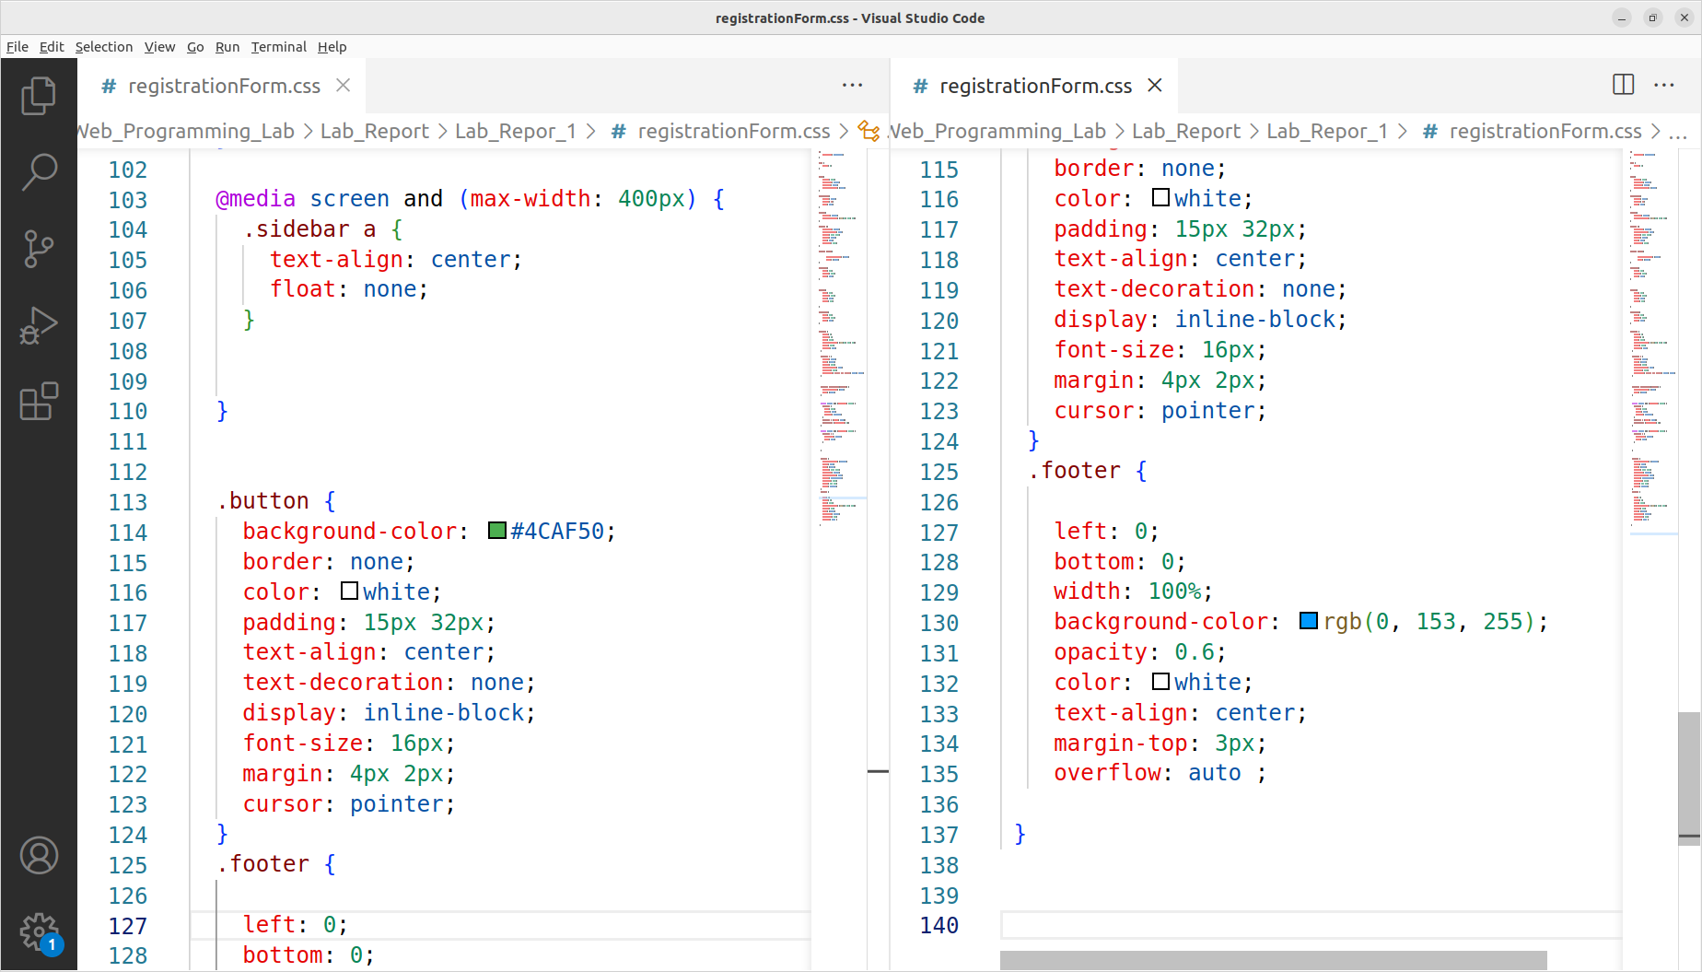

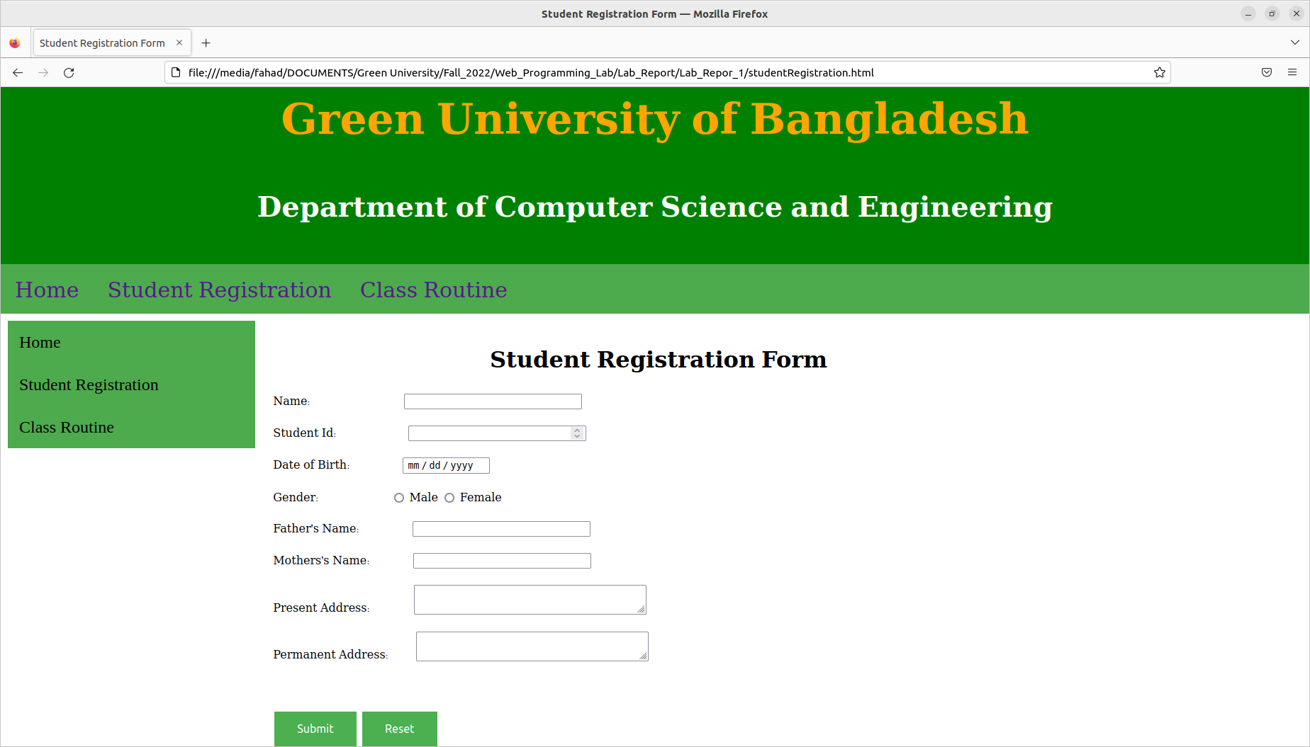

**Registration Form Page Output:**

**7. ANALYSIS AND DISCUSSION**

In the radio input type we must name is same for each option only value is different, So we need tow aware in this input type. We can use non breaking space “&nbsp” to equal our each input field and we can use a table within two column one is input label and another is input field to efficiently equal our input field left side alignment.

**8. SUMMARY**

To making this lab report I learned that Layout design is the basic and most important part of every web development. I think layout design is the initial step of a web development. So try to make a layout to make this lab report.

**9. REFERENCE**

To styling my web page I take help of [www.w3schools.com](http://www.w3schools.com/) web site and some styling code partially copy and modify from that web site but firstly I trying to understand this.