**UNITED NATIONS**

**CASE STUDY HANDBOOK ON**

**GENDER, PEACE AND SECURITY**

**for United Nations Infantry Battalions in peace operations and other military personnel**

1st edition

Department of Peace Operations   
Integrated Training Service  
Office of Military Affairs

PRODUCED BY

Office of Military Affairs Integrated Training Service

Department of Peace Operations Department of Peace Operations

United Nations Secretariat United Nations Secretariat

APPROVED BY

Jean-Pierre Lacroix

Under-Secretary-General for

Peace Operations

Department of Peace Operations

CONTACT

Policy and Doctrine Team

Office of Military Affairs

Department of Peace Operations

New York, NY 10017

Next review date: June 2025

Reference number: 2022.07

© United Nations 2022. This publication enjoys copyright under Protocol 2 of the Universal Copyright Convention. Nevertheless, governmental authorities or Member States may freely photocopy any part of this publication for exclusive use within their training institutes. However, no portion of this publication may be reproduced for sale or mass publication without the express consent, in writing, of the Office of Military Affairs, Department of Peace Operations of the United Nations.

CONTENTS

**ABOUT THIS HANDBOOK** 7

**HOW TO USE THIS HANDBOOK** 8

**CARANA COUNTRY SUMMARY** 15

**SECTION 1: COMMANDING AND PLANNING OPERATIONS** 26

**CASE STUDY 1: GENDER-RESPONSIVE PLANNING FOR MILITARY OPERATIONS** 28

-SELF-LEARNING 36

-MODERATED LEARNING 40

-FACILITATOR INSTRUCTIONS – MODERATED LEARNING 42

-ENACTED LEARNING 52

-FACILITATOR INSTRUCTIONS – ENACTED LEARNING 54

**CASE STUDY 2: CREATING AN ENABLING WORK ENVIRONMENT AS INFANTRY BATTALION COMMANDER FOR ALL TROOP PERSONNEL** 71

-SELF-LEARNING 82

-MODERATED LEARNING 85

-FACILITATOR INSTRUCTIONS – MODERATED LEARNING 87

-ENACTED LEARNING 97

-FACILITATOR INSTRUCTIONS: ENACTED LEARNING 99

**CASE STUDY 3: DEVELOPING GENDER-RESPONSIVE CIVIL ASSISTANCE PROJECTS** 117

-SELF LEARNING 123

-MODERATED LEARNING 126

-FACILITATOR INSTRUCTIONS: MODERATED LEARNING 128

-ENACTED LEARNING 138

-FACILITATOR INSTRUCTIONS: ENACTED LEARNING 140

**SECTION 2: CONDUCTING OPERATIONS** 158

**CASE STUDY 4: ACQUIRING GENDER-RESPONSIVE INFORMATION THROUGH PATROLS** 160

-SELF-LEARNING 167

-MODERATED LEARNING 170

-FACILITATOR INSTRUCTIONS: MODERATED LEARNING 172

-ENACTED LEARNING 182

-FACILITATOR INSTRUCTIONS: ENACTED LEARNING 184

**CASE STUDY 5: RESPONDING EFFECTIVELY TO VICTIMS AND SURVIVORS OF CONFLICT** 200

-SELF-LEARNING 210

-MODERATED LEARNING 213

-FACILITATOR INSTRUCTIONS: MODERATED LEARNING 215

-ENACTED LEARNING 225

-FACILITATOR INSTRUCTIONS: ENACTED LEARNING 227

**CASE STUDY 6: CREATING AN ENABLING WORK ENVIRONMENT FOR ALL TROOP PERSONNEL** 242

-SELF-LEARNING 250

-MODERATED LEARNING 253

-FACILITATOR INSTRUCTIONS: MODERATED LEARNING 255

-ENACTED LEARNING 266

-FACILITATOR INSTRUCTIONS: ENACTED LEARNING 268

**CASE STUDY 7: OPERATING GENDER-RESPONSIVE CHECKPOINTS** 284

-SELF-LEARNING 288

-MODERATED LEARNING 291

-FACILITATOR INSTRUCTIONS: MODERATED LEARNING 292

-ENACTED LEARNING 302

-FACILITATOR INSTRUCTIONS: ENACTED LEARNING 304

**ANSWERS** 320

CASE STUDY 1: GENDER-REPONSIVE PLANNING FOR MILITARY OPERATIONS 320

CASE STUDY 2: CREATING AN ENABLING WORK ENVIRONMENT FOR ALL TROOP PERSONNEL 322

CASE STUDY 3: DEVELOPING GENDER – RESPONSIVE QUICK IMPACT PROJECTS 324

CASE STUDY 4: ACQUIRING GENDER – RESPONSIVE INFORMATION THROUGH PATROLS 325

CASE STUDY 5: RESPONDING EFFECTIVELY TO VICTIMS AND SURVIVORS OF CONFLICT 327

CASE STUDY 6: CREATING AN ENABLING WORK ENVIRONMENT FOR ALL TROOP PERSONNEL 328

CASE STUDY 7: OPERATING GENDER – RESPONSIVE CHECKPOINTS 330

**ANNEXURES** 331

ANNEX 1: Terms and Definitions 331

ANNEX 2: United Nations Security Council Resolutions related to Women, Peace and Security 337

ANSWERS 340

CASE STUDY 1: GENDER-REPONSIVE PLANNING FOR MILITARY OPERATIONS 340

CASE STUDY 2: CREATING AN ENABLING WORK ENVIRONMENT AS INFANTRY BATTALION COMMANDER FOR ALL TROOP PERSONNEL 342

CASE STUDY 3: DEVELOPING GENDER-RESPONSIVE CIVIL ASSISTANCE PROJECTS 344

CASE STUDY 4: ACQUIRING GENDER-RESPONSIVE INFORMATION THROUGH PATROLS 345

CASE STUDY 5: RESPONDING EFFECTIVELY TO VICTIMS AND SURVIVORS OF CONFLICT 347

CASE STUDY 6: CREATING AN ENABLING WORK ENVIRONMENT FOR ALL TROOP PERSONNEL 348

CASE STUDY 7: OPERATING GENDER-RESPONSIVE CHECKPOINTS 349

# **ABOUT THIS HANDBOOK**

“I can say that I greatly appreciate this handbook. It is innovative in substance and format. It has succeeded in breaking down gender stereotypes where women are always victims and men the perpetrators of violence. Everyone will find something that they can relate to in this handbook.”

(Newly appointed United Nations Infantry Battalion Commander)

“I clearly understand the importance of gender, but did not know how to really integrate gender considerations in my own work until I went through this handbook. I found it really useful and practical. It provides concrete ideas for adopting a gender-responsive approach in a range of activities that a military peacekeeper would be involved in. The checklists are a must-read.”

(United Nations Operations Officer)

“The case studies presented in the handbook are a reflection of many conflict and post-conflict settings around the world. The self-learning reflection questions are all very interesting and complex. A truly valuable tool for peacekeepers on the ground and a great addition to the current predeployment training!”

(Patrol Team Leader, United Nations Infantry Battalion)

“I thought that gender was all about women. Now I know that it isn’t and that in fact it is much more than that, all thanks to this handbook. I now see how and why gender is critical to the work of military peacekeepers, and how it can contribute to fostering lasting peace. The exercises in the handbook provided me with an opportunity to practise and make mistakes in a safe environment. I look forward to applying this new knowledge in my upcoming deployment.”

(Sergeant of United Nations Infantry Battalion)

“This handbook is a very useful – and a much-needed – trainer resource. It provides step-by-step guidance on how to conduct a training exercise in its entirety – from preparations, to running the exercise and debrief instructions. It offers trainers the flexibility to not only choose a case study that is relevant to their needs and context, but also provides options on how to actually use each individual case study.”

(Trainer, Peacekeeping Training Centre)

# **HOW TO USE THIS HANDBOOK**

**Introduction**

The Case Study Handbook on Gender, Peace and Security is a training resource elaborated by the United Nations Office of Military Affairs and the Integrated Training Service in response to the growing need for practical, hands-on training on gender-responsive military operations in United Nations peace operations. The Case Study Handbook will be included as reference material in the package of specialized training materials for United Nations infantry battalions .

**Aim**

The Case Study Handbook is aimed at fostering gender-responsive military operations within United Nations peace operations, through the practical implementation of the women and peace and security agenda and its mandates. More specifically, the handbook will help troop-contributing countries (TCCs) to train military peacekeepers in gender-responsive military operations as part of their pre-deployment training. It will also provide a valuable resource for Military Gender Advisers in their in-mission training efforts.

**Target audience**

The primary target audience of the Case Study Handbook comprises:

* United Nations military peacekeepers who are part of an infantry battalion, who are commanding and planning operations, or who are conducting operations.

The secondary target audience includes:

* Other military personnel working in United Nations peace operations.
* Military Gender Advisers who are supporting mission efforts to integrate a gender perspective into the work of the military component in those peace operations.
* In-mission training units (U7).

**Methodology**

During the development process of this Handbook, over 140 stakeholders from United Nations departments, agencies and partners, peacekeeping personnel and peacekeeping training centres were consulted as part of a scoping study and training needs assessment. Following these consultations, specific gaps and needs related to gender and military operations were identified. This information informed the development of specific learning objectives that later enabled the identification of suitable case studies.

The case studies were reviewed at three different stages by a group of internal and external experts during the development of the detailed case studies. First, the case study outlines were circulated for review. The detailed case studies that were developed based on the input received were subsequently shared for further comments. The updated drafts were shared for final review and sign-off.

**Case studies**

The Case Study Handbook includes **seven case studies** that have been developed to cover the gaps and needs identified during the needs assessment and mapping phases. They are divided into two categories:

**Commanding and planning operations**

* **Case study 1**: Carrying out gender-responsive planning for military operations
* **Case study 2**: Creating an enabling environment as Infantry Battalion Commander for all troop personnel
* **Case study 3**: Developing gender-responsive civil assistance projects

**Conducting operations**

* **Case study 4**: Gender-responsive information acquisition through patrols
* **Case study 5**: Facilitating effective response to victims and survivors of conflict
* **Case study 6**: Creating an enabling environment for all troop personnel
* **Case study 7**: Operating gender-responsive checkpoints

Each case study can be utilized independently. Training providers are encouraged to select the case study or studies that are most suitable to their context and needs.

**Case-study context**

Each case study begins with the depiction of a situation, called the **setting**, from which the different actions must be determined. All settings in this Handbook use the larger **Carana** countrystudy as their context, so that names of regions, stakeholders, languages, etc. will be derived from Carana. A summary of the Carana country study is included at the beginning of the Handbook. Readers are encouraged to familiarize themselves with this summary – and ideally with the broader Carana country scenario – before commencing work on the case studies. In case this is not possible, specific reading time has been allocated in the moderated and enacted learning modalities for this purpose. Further details on how to run the case studies are included in the facilitator instructions (*see below).*

**Applicability of case studies**

While happening within the fictitious setting of Carana, the case studies presented in this Handbook are applicable to various regions across the world. Both the substance and illustrations included in this Handbook are reflective of this intention. Special care has also been taken throughout the Handbook to move away from gender stereotypes in the Handbook’s substantive and visual depictions. As such, the reader could come across a Military Gender Adviser who is a man, a woman former combatant, a male victim of conflict-related violence or an association of women entrepreneurs.

**Learning modalities**

For greater user-friendliness and outreach, each case study is presented in three distinct learning modalities:

* **Self-learning**: For individual military personnel who wish to learn more about how to integrate gender considerations into peacekeeping activities;
* **Moderated learning**: For classroom learning through group work and scenario-based exercises;
* **Enacted learning**: For classroom learning through simulation exercises.

**Self-learning**: For individual, self-paced learning outside a classroom setting. Participants are required to answer a set of reflection or quiz questions so as to encourage readers to consider the practical application of gender considerations in the execution of their tasks. Responses to the questions are included in a separate section at the end of the Handbook.

**Moderated learning**: Scenario-based exercises for a classroom setting, with a facilitator. Participants are given a specific task in relation to the case study. The task requires them to determine the best option to be pursued in each given context. Participants will choose from three options and justify their responses. Various injects that could have an impact on the situation will be added at different moments during the exercise in a bid to make the exercises more reflective of real life.

**Enacted learning**: Simulation exercises for classroom settings, with a facilitator. Participants are given a specific task in relation to the case study. They are allocated specific roles and are required to play these roles within the given context. Various injects that could have an impact of the situation will be added at different moments during the exercise in a bid to make the exercises more reflective of real life. The roll-out and the outcomes of the simulation exercise will serve to highlight what could (or should not) be done within this context.

A certain level of preparation is required for the moderated and enacted learning modalities, for instance with regards to the preparation of handouts, props or moderation of discussions. The Handbook proposes a **Facilitator checklist** for each case study in order to assist facilitators with optimal preparation for training delivery.

Instructions contained in the Facilitator checklists and elsewhere in the Handbook assume that participants do not have a copy of the Handbook. In the event that they do, facilitators are requested to adjust printing accordingly.

**Case study structure**

Each case study is structured as follows:

* Generic section, including **setting, checklist**, related **tools/resources**, and a **list of reference/ resource materials**;
* Self-learning modality with **reflection questions** and **quizzes**;
* Moderated learning modality with **in-class instructions for participants**;
* **Facilitator instructions** to conduct the exercises included in the moderated learning modality;
* Enacted learning modality with **in-class instructions for participants**;
* **Facilitator instructions** to conduct the exercises included in the enacted learning modality.

A list of acronyms and a summary of the Carana country scenario are presented at the beginning of the Handbook. A **glossary of terms and definitions** frequently used in the Handbook is provided as an Annex. These definitions are primarily drawn from United Nations sources, including policies, guidelines and Security Council resolutions. A list of **responses** to the reflection and quiz questions included in the self-learning modality is also proposed at the end of the Handbook.

**Legends and symbols**

To ensure user-friendliness, the three learning modalities are colour coded as follows:

|  |
| --- |
| Self-learning modality |
| Moderated learning |
| Enacted learning |

The Handbook also uses the following symbols/icons for ease of reference:

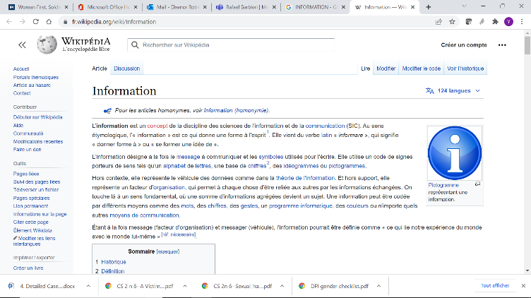

**Note!** Provides quick information on additional points that should be kept in mind.

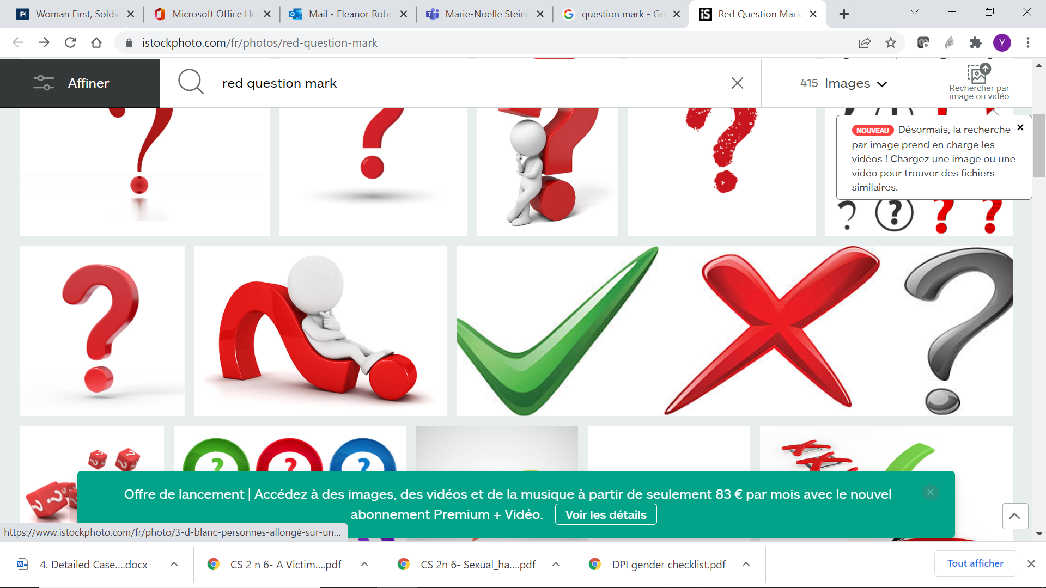 **Did you know?** Provides additional information to enhance understanding of the topic, for instance through definitions.

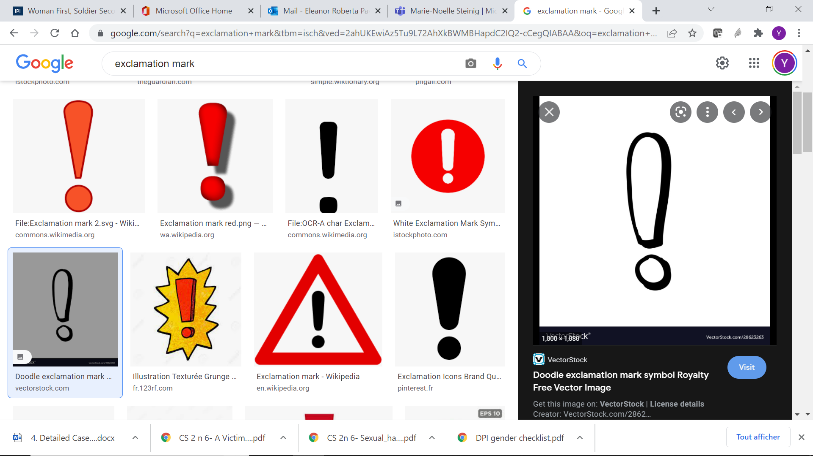 **Remember!** Provides practical tips to enhance learning and/or delivery.

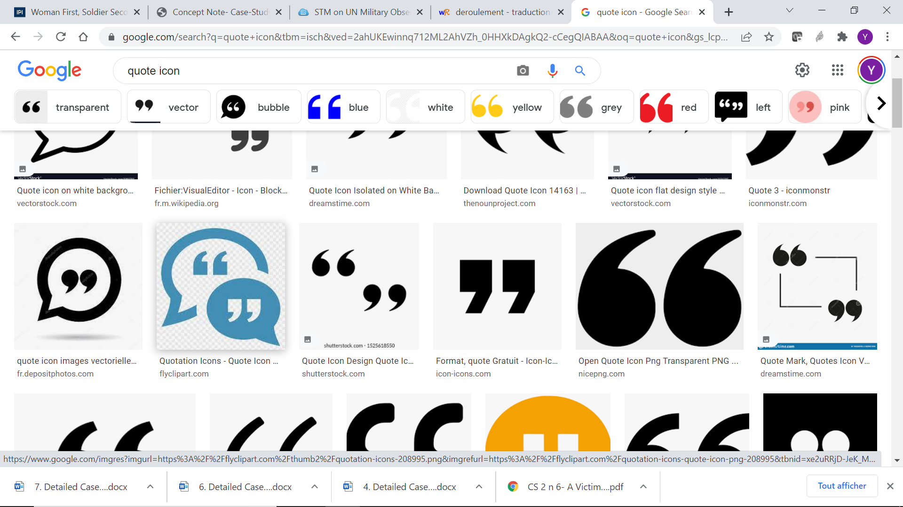 **Quotes:** Provides relevant quotations from United Nations or other sources.

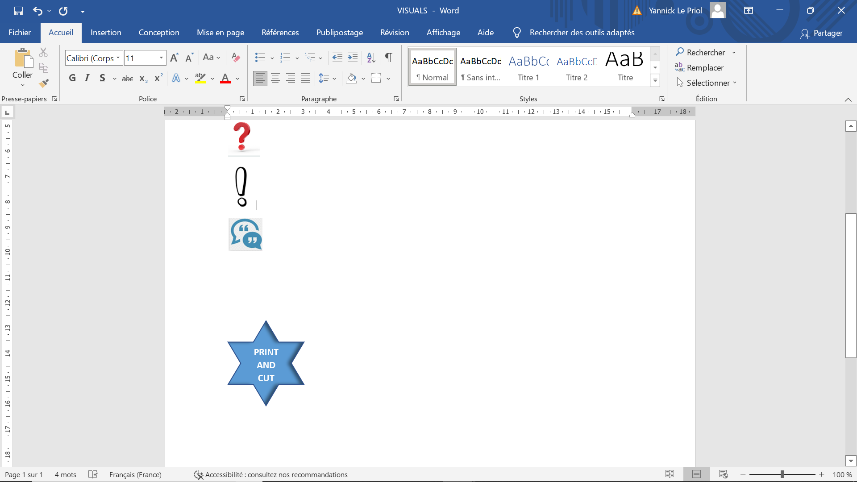Handouts/documents that need to be **printed and cut** out prior to the training.

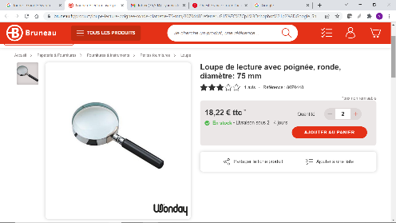

Indicates that facilitator needs to consult **further information** elsewhere in the case study and/or in the PowerPoint presentation.

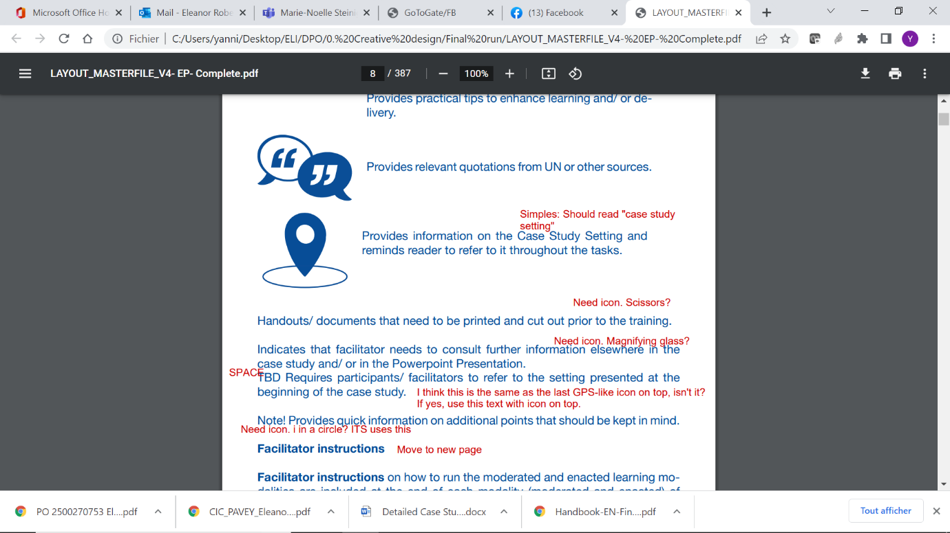   
Requires participants/facilitators to refer to the **setting** presented at the beginning of the case study.

**Facilitator instructions**

Facilitator instructions on how to run the moderated and enacted learning modalities are included at the end of each modality (moderated and enacted) of each case study.

The facilitator instructions contain the following:

* **Overview of exercise**: Includes task, duration and list of support materials;
* **Facilitator checklist**: Includes a list of elements that need to be prepared, consulted or considered prior to the training;
* **Delivery instructions**: Includes instructions on the preparation, introduction of task, delivery, debrief and use of the presentation;
* **Injects**: Includes injects that will need to be introduced by the facilitator in the course of the exercise.

All documents included in the facilitator instruction sections are intended for facilitators only. Participants’ versions of the same documents are included in the participants’ sections and also in the Facilitator Resource Package (see below).

**Supporting documents**

**(a) Presentations**

Each case study includes three presentations that will serve to reinforce learning for the moderated and enacted learning modalities. These presentations include one generic presentation on integrating gender into the work of the military that is applicable across all case studies, followed by two specific presentations – one for the moderated learning modality and another for the enacted learning modality. When conducting a case study, facilitators are invited to use the generic presentation, combined with the moderated or enacted presentation, according to the learning modality that they have predefined.

When conducting multiple case studies in a single training, facilitators are advised to cover the generic component only once. Facilitators can then introduce the specific presentations (moderated or enacted) related to each case study.

The presentations include explanations in the notes for each slide that could be used as a script for delivery. Facilitators are encouraged to draw on their own experience and to encourage participants to share their experience. Further details on how and when to use these presentations are included in the facilitator instructions.

**(b) Facilitator Resource Package**

Finally, the Handbook includes a QR-code to access the **Facilitator Resource Package** that includes print-friendly versions of all material required to conduct the case study in a classroom setting. In case the QR-code cannot be accessed, all documents will be included in the Peacekeeping Resource Hub.



Scan here!

**LIST OF ACRONYMS**

2IC Second-incommand

A4P Action for Peacekeeping

A4P+ Action for Peacekeeping Plus

AOR Area of responsibility

ASCOPE Areas, structures, capabilities, organizations, people, events

CDT Conduct and Discipline Team

CIMIC Civil-Military Coordination

CISC Combattants indépendants du sud Carana

CLA Community Liaison Assistant

CRSV Conflict-related sexual violence

DDR Disarmament, demobilization and reintegration

ELF Elassi Liberation Front

EP Engagement Platoon

ET Engagement Team

FDC Forces de la défense du Carana

GFP Gender Focal Point

IDP Internally displaced person

JMAC Joint Mission Analysis Centre

LGBTQI+ Lesbian, gay, bisexual, transgender, queer and intersex

MDMP Military decision-making process

MEDEVAC Medical evacuation

MGA Military Gender Adviser

MOU Memorandum of understanding

MPC Mouvement patriotique du Carana

MPKI Military Peacekeeping Intelligence

OHCHR Office of the United Nations High Commissioner for Human Rights

PDC Parti démocratique du Carana

PMERSCHII: PT Political, Military, Economic, Religious, Social, Cultural, History, Infrastructure, Information, Physical Infrastructure, Time

PMESII: PT Political, Military, Economic, Social, Information, Infrastructure, Physical Infrastructure, Time

SOP Standard operating procedure

TCC Troop-contributing country

UN United Nations

UNAC United Nations Assistance Mission in Carana

UNDP United Nations Development Programme

UNICEF United Nations Children’s Fund

UNPOL United Nations police

# **CARANA COUNTRY SUMMARY**

Figure 1

**Continent of Fasia**

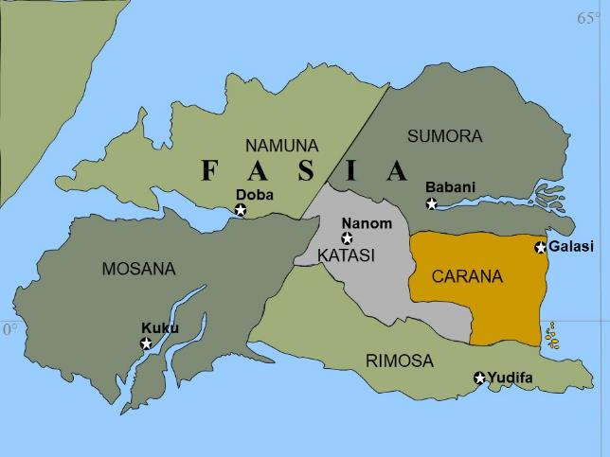

**Introduction**

Situated on the east coast of the continent of Fasia, Carana has a population of 17 million, primarily of ethnic Falin (60%), Kori (20%) and Tatsi (15%) groups. Carana has a young population, with 77% of Caranese under the age of 18. French is recognized as the official and administrative language of the country, but over 20 original languages or tribal dialects also exist. Major religions include Roman Catholic (40%), Protestant Lutheran or Baptist (35%) and Islam (20%), in addition to Indigenous beliefs (45%).

Following independence from France in 1986, Carana had a series of civilian and military rulers. Its current President, Jackson Ogavo of the Parti démocratique du Carana (PDC) is the first democratically elected President of the country. Having initially based itself on a liberal constitution that led to economic and social reforms resulting in economic prosperity, the Ogavo regime soon began to suppress all opposition groups. The replacement of all key Kori and Tatsi government ministers with members of Ogavo’s Falin tribe led to an increasingly repressive approach, administrative and economic inefficiency and corruption. All opposition to the government was met with either the threat or use of armed force, and eventually escalated into civil conflict in early 2014.

After a long-standing civil war, which left thousands of victims and caused more than 700,000 Caranese citizens to become internally displaced, the warring factions in the Carana civil war, the Government of Carana, the Mouvement patriotique du Carana (MPC), and the Combatants indépendants du sud Carana (CISC), finally engaged in peace negotiations in Kalari, Namuna.

In November 2020, the negotiations resulted in the signing of a ceasefire and peace agreement – the Kalari Peace Treaty. Negotiations were facilitated by the Fasia Union and paved the way for the creation of a United Nations Assistance Mission in Carana (UNAC) that would take over from the Fasia Union Advisory Mission in Carana.

**Ethnic distribution**

**arana**

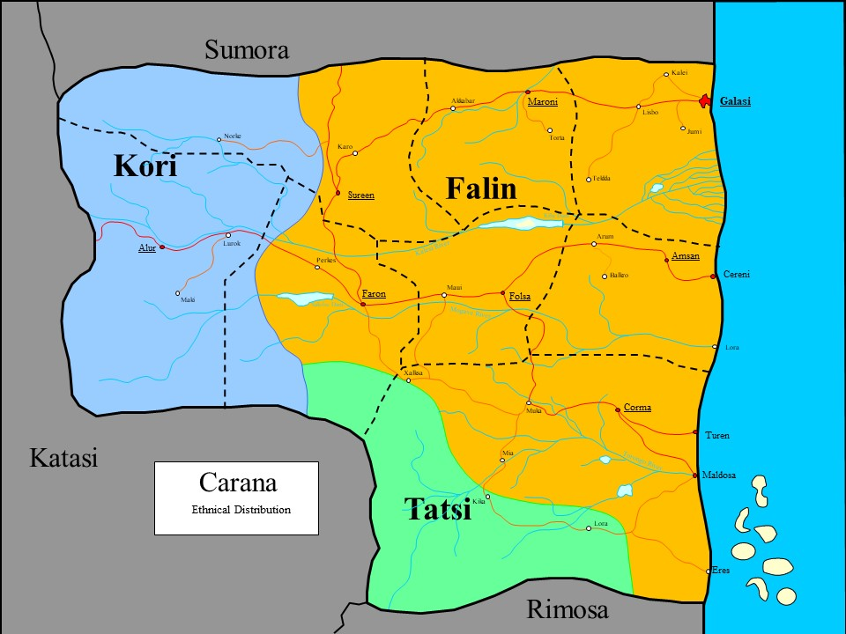

The population of Carana comprises more than 15 ethnic groups. Most of these groups are small in terms of the number of individuals and socially and politically marginalized. The three major ethnic groups, the Falin, Kori and Tatsi, represent 95% of the population. The Kori (20%) live in the west and are the dominant ethnic group in the Provinces of Tereni and Koloni. The Falin (60%) are the ethnic majority in the country and mainly live in the east and centre of Carana. The Tatsi (15%) live in the south and are the majority in Leppko Province.

The national borders of Carana are a result of the colonial period and do not represent the ethnic distribution of the region. The Falin make up 54% of the population of neighbouring Sumora, the Kori make up 65% of the population of Katasi, while the Tatsi make up 95% of the population of Rimosa.

**Religion**

According to the last census conducted in 2015, approximately 75% of the population of Carana is Christian. About 35% are Protestant Lutherans and Baptists, while 40% are Roman Catholic. Islam is practised by over 20% of the population, mainly in the south and west. The vast majority of Muslims are Sunni, who overwhelmingly live in the west of Carana. However, there are small but active Shia communities in the south of Carana and along the coastal plains. Several Sunni groups are extremist in nature and have instituted sharia law in the south-western areas of Leppko. On the other hand, syncretism and Indigenous beliefs form a vital part of the religious experience of many Caranese.

In terms of ethnic distribution, the majority of the Falin are Christians, while the majority of the Kori and Tatsi are Sunni Muslim. Indigenous beliefs, which have been embedded in the main religions, are practised by parts of the population.

**Government**

Carana is a presidential republic in line with the first Carana constitution, which was adopted by referendum in 1987. The President serves as Head of State, elected for a five-year term. The head of the Government is the Prime Minister, who is appointed by the President. The Prime Minister appoints the ministers and heads of the government departments.

Although the constitution supports a democratic political system, President Ogavo has gradually suppressed any effective opposition and since 2013, Carana has effectively been a one-party State. Today, the only legal political party is the Falin-dominated PDC. All members of parliament are members of PDC or have close ties to PDC.

**Natural resources**

Carana is rich in natural resources, which are not equally dispersed throughout the country. In the jungle-covered mountains of the west, rare wood and timber are the main natural resources. Diamonds are found along the Kalesi River in the Provinces of Mahbek and Barin. Copper is mined in the highlands west of Mia. Coal is mined in the Province of Hanno. Further alkali metals (lithium, sodium, potassium, etc.) are found in central Carana. Oil is found off the southern coastline of Carana.

**Mining**

The mining of coal, diamonds and copper constitutes an important contribution to the country’s GDP. Hanno Province has several coal mines in Akkabar and Maroni; Kika produces diamonds from the Gachal and Herla swamps. Copper is also mined in Lora and being exported from Maldosa. Owing to the conflict and weak infrastructure, exports, however, are only at about 15% of potential capacity.

Prior to 1997, the mining industry was controlled by private enterprises but since then, the Government has progressively taken control of the industry. Illegal exploitation of natural resources and exportation by private businesses to neighbouring countries is rife and armed groups and rogue security force elements are heavily involved.

Along with rare wood, timber and cotton, diamonds and copper are the main exports of Carana. Coal is mostly used in the country for the production of electricity.

**Nr**

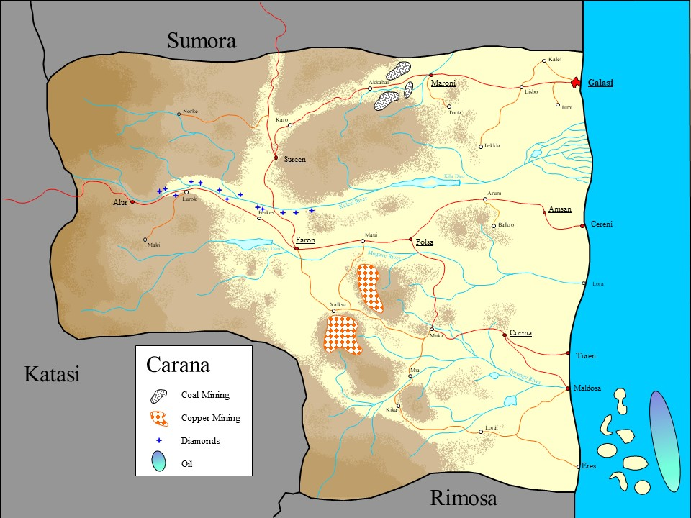

**Agriculture**

Agriculture is a relatively large sector in the economy of Carana, providing 27% of GDP and roughly 50% of the labour force . The north-east and central regions of Carana produce large quantities of agricultural products that not only feed the people of Carana, but are also used for export. The soil is fertilized by using the “slash-and-burn” technique on a large scale. The agricultural products are fruits, corn, grain (sesame seed), cocoa, coffee, ginger, groundnut, coconut, rice and maize.

Most of the agricultural land exists as small farm lots owned by the local population. Cotton is the only commodity produced on large farms using employed labour.

Approximately 31% of the total land area of Carana is used for agricultural purposes.

**Media**

There are approximately 20 daily newspapers, two radio stations and two television channels in the country. The radio stations are operated by state cooperatives while most newspapers are privately owned. The two largest newspapers are Government-owned and the Catholic Church publishes another. In additionally, there are some low-power, community radio stations and locally printed media with local and very limited distribution. A few months ago, MPC started producing a regional newspaper and operating one radio station. International newspapers are only available in the capital, Galasi. National newspapers are available in the provincial capitals and in some other towns.

In principle, the Ministry of Information controls all media. Censorship is very limited in the case of small, local media but nearly absolute in the case of the official radio stations and main newspapers. A significant part of the population is very active on social media, which they can access through mobile phones. Social media is used as a tool for awareness-raising and democratic mobilization, but also to spread hate speech and incite ethnic violence.

**Roads**

Carana has a system of paved roads, which connect most parts of the country to key urban centres. In the west and the north, these roads also ensure cross-border travel to and from neighbouring countries. Most paved roads can withstand the effects of the monsoon season.

Carana also has a dense network of partially robust unpaved roads and tracks. Unpaved roads and tracks are, for the most part, very vulnerable to damage from significant rain and flooding and deteriorate quickly if not maintained. The years of civil war, harsh weather, minimal investment and lack of maintenance have degraded them significantly, with the result that the road network is often impassable in the rainy season.

**Railways**

The two railway tracks, with a total length of 280 km, running on the routes Galasi – Akkabar and Maldosa – Mia are both operational but not reliable. The entire track system and loading facilities were built during the French colonial period. Even though the track from Maroni to Akkabar is operational, the northern line ends in Maroni because the railway bridge west of Maroni was damaged by flooding in March 2020.

**Harbours**

In Carana, there are three harbours for deep-water ships and some smaller harbours for fishing boats. The smaller harbours have no capacity to support the loading and unloading of ships, but they are suitable for coastal vessels. The main harbour in Galasi is well equipped with sufficient capacity for large ships and with roll-on/roll-off capability.

The harbour in Cereni has no roll-on/roll-off capability but does have cranes and sufficient transport equipment to handle heavy loads and containers. The harbour in Maldosa, which has railroad access, is mostly specialized in the transport of copper but is also capable of handling regular transport ships.

**Water and sanitation**

Only the capital and some larger cities have a water supply system for the central area of the city. All other towns and villages rely on wells and water trading. Potable water is available in most parts of the country but the quality of water varies. In dry areas south-west of Maldosa and west of Galasi, drinking water during the dry season is mostly taken from small ponds and slow-flowing brooks.

There is no system of sanitation and garbage removal in Carana, leading to persistent health problems and disease, particularly in heavily populated areas.

**Neighbouring countries**

Carana is located on the east coast of the continent of Fasia. The total area of Carana is 119,480 km2 with 300 km coastline. Carana has land boundaries of 1,500 km with its neighbouring countries, Rimosa (southern border), Katasi (western border) and Sumora (northern border).

Sumora is the main trading partner of Carana in the region. The relations between Carana and Sumora have traditionally been good, with ethnic Falins making up approximately 54 % of the population of Sumora. In the recent past, the Government of Sumora has tended to support the position of President Ogavo.

The relations between Carana andKatasiare strained. Carana has repeatedly accused Katasi of supporting MPC rebels with money, weapons and fighters; these allegations were not without foundation and have been corroborated by reports from a number of international organizations, although the scale of that support remains unclear. The Government of Carana therefore lays the blame for its inability to deal with MPC at Katasi’s door. Katasi hoped that supporting MPC would lead to the fall of the Ogavo regime and to better trade relations with Carana. These hopes have been stalled, both by the continued regime and the El Hasar insurgency that is further straining the relationship. Following a request by the Government of Katasi, French forces have been conducting counter-insurgency operations against El Hasar. El Hasar fighters have now been escaping into west Carana, causing instability and insecurity as they conduct attacks against the local population to obtain logistical supplies.

The relations between Carana and Rimosa are also tense. Rimosa has been in the grips of a civil war between two rival ethnic groups, the majority Tatsi, who hold nearly all positions of power in the country’s Government, and the Muslim minority of the Elassi, pastoralists who claim that they suffer ethnic discrimination and persecution. Most of the inter-ethnic fighting in Rimosa has taken place in northern Rimosa, near the border with Carana. The rebel group Elassi Liberation Front (ELF) has waged a guerrilla-style campaign against government forces and pro-government Tatsi militias and has established links to CISC for financial and logistical support. At times, all of the aforementioned groups cross the border into Carana and conduct raids in order to obtain food and supplies, posing a threat to the local population.

In addition, there is a political dispute between Rimosa and Carana over the ownership of some of the islands along the southern coastline of Carana, as well as over related fishing rights in the respective national territory. Oil was also discovered in the Labta Sea in the south-east of Carana, offshore of Maldosa. However, owing to the ongoing border dispute and the high start-up costs required for the exploitation of the oil resources, no company or consortium is currently willing to invest.

Caranese refugees (particularly the Falin) in Sumora and Rimosa have consistently been discriminated against and are often under attack by local police and armed forces. Rimosan (Tatsi) refugees in Carana and Katasi face similar treatment, as do Katasi refugees, to a lesser extent.

**Carana National Police**

The Carana National Police (CNP) has an estimated strength of approximately 7,100 police officers. Precise numbers cannot be ascertained owing to the high degree of fluctuation in the regional personnel bodies. The National Police has a history of being underfinanced, understaffed and insufficiently organized. Therefore, the organization is lacking basic administrative mechanisms and routines.

**Forces de la défense du Carana (FDC)**

FDC has a total strength of approximately 20,000 personnel (17,500 army, 1,600 air force, 900 navy). The chiefs of each branch report directly to the President.

The main service in FDC is the army, primarily but not solely recruited from the Falin people. Its senior leadership is almost wholly Falin. Troops, especially those employed in rural areas, face recurrent problems of non-payment of wages. A number of units are composed of integrated armed group members and lack both operational capacity and a commitment to upholding human rights and standards of conduct and discipline.

Women’s participation in the armed forces is low, with women soldiers and higher-ranking officers making up some 6% of FDC in total. During the Uroma regime and at the specific request of President Uroma, women were recruited and received substantial training abroad, which eventually led them to positions as senior officers. A small but steady recruitment of women soldiers continued over the following decades, although their status has deteriorated over time owing to the lack of political support for women’s participation.

**Mouvement patriotique du Carana (MPC)**

MPC is an avowed secular organization with broad appeal that has a total strength of 10,000 fighters and 10,000 to 20,000 supporters. The level of public support is high in the west and cuts across the different religions. It is structured into groups of 700 men. Each of these groups is led by a field commander and has a local network of supporters. The groups have no internally defined military structure, but a system of subcommanders with different numbers of fighters. Loyalty to the commanders is high and discipline is very good.

The official Headquarters of MPC is in Alur, but this is more of a symbolic HQ than an operational one. In some areas, MPC have taken over government and basic administrative functions. Because of broad public support for the rebels and dissatisfaction with the Government, the new role of MPC is well accepted by the largely Kori population in the west.

No detailed information on the equipment and training standards of MPC is currently available.

**Combattants indépendants du sud Carana (CISC)**

CISC is an unstructured formation of rebels with diverging backgrounds. Some members are Tatsi deserters from FDC, while others have fled the civil war in Rimosa and joined CISC, given the lack of alternatives. The total strength is estimated to be around 3,000 to 5,000 fighters. They are organized in company-strength formations (nominal battalion formations), many of which are understrength. Public support for CISC is based mainly in the Tatsi-dominated Leppko Province because of many acts of FDC violence against the population.

The movement has been successful in recruiting young men to its cause through a combination of anti-Muslim excesses by the government, religious zeal and the poor economic situation, as well as owing to recent rebel successes. The discipline and internal cohesion of this rebel group is low, as are the standards of training, although lately there is increasing evidence of the presence of experienced foreign extremists who have upped the tempo and quality of CISC operations.

No detailed information on the equipment and training standards of CISC is currently available.

**Militias, gangs and warlords**

During the years of fighting, several smaller armed groups have formed in Leppko. Some of these groups are fragmentations of CISC or deserters from the government forces. Other groups have arisen from local vigilante groups built to protect their villages from attacks by soldiers and rebels.

These groups operate mainly in the northern Leppko Province, chiefly for economic reasons (theft, illegal exploitation of resources, ransom) and are perceived as loyal to their leaders (warlords). Initial information indicates that these groups consist of between 300 and 1,000 fighters with light weapons.

The aims and loyalties of these groups are very difficult to ascertain and the boundary between local militias and armed bandits fluctuates. No such groups are part of the ongoing peace process.

**f**

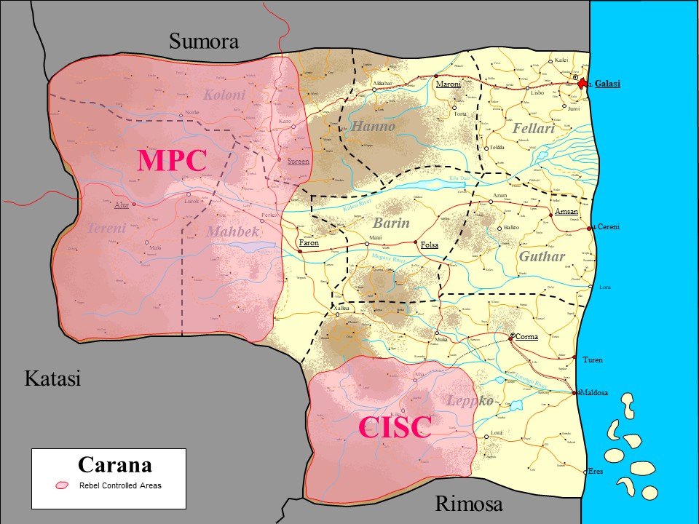

**El Hasar Islamist Group**

The El Hasar Islamist group was formed in 2018 in the neighbouring country of Katasi and became a “terror organization”, requesting its own state and engaging in guerrilla-type terror operations against the Government of Katasi. Recently, following anti-terror operations conducted by the Government of Katasi with the support of French forces, El Hasar fighters/elements crossed the border into Carana, in the western parts of the Koloni and Tereni Regions. Local communities report armed attacks and raids on villages by these elements, who have been stealing money, food, supply items such as spare parts, gas and ammunition. Reports also indicate violence against civilians, including rape, torture and other acts of physical violence.

Unconfirmed reports claim the fundamentalist elements from both the Tatsi and Kori communities are supporting and/or sympathizing with the El Hasar fighters/elements.

**Elassi Liberation Front (ELF)**

ELF was formed in 2018 in the neighbouring country of Rimosa and is conducting insurgency operations against the Government of Rimosa. They mainly operate south of the Carana border in Rimosa, but have begun to challenge CISC in southern Carana and collaborate with some CISC splinter groups. Recruitment for ELF has surged in both Carana and Rimosa during the past year. ELF plans the establishment of an Islamic Caliphate in Rimosa, possibly to be extended to Carana, as a non-negotiable objective, and is not part of the peace negotiations.

Carana communities along the border report armed attacks and raids on villages by ELF elements, who are reported to be stealing money, food, supply items like spare parts, gas and ammunition. Reports also indicate violence against civilians such as rape, torture and other acts of physical violence.

**Humanitarian situation**

As a result of the fighting, many people in Carana have fled their homelands, but most have remained in the country. An estimated 100,000 have taken refuge in the neighbouring countries of Sumora (approximately 40,000 refugees), Katasi (approximately 40,000 refugees) and Rimosa (approximately 20,000 refugees). Another 700,000 are settled in camps for internally displaced persons around the harbour cities, where they are now clustered in makeshift camps and shantytowns in or near urban areas. Most internally displaced persons currently live in the camps around Galasi. The majority arrived within the past 12 months.

The country of Rimosa, sharing a border of approximately 200 km with Carana, has suffered from civil conflict between the two rival ethnic groups, the majority Tatsi and the minority Elassi. As a result, approximately 30,000 Elassi have taken refuge in southern Carana. Most of these Elassi refugees are sheltered in Camp Lora near the village of Lora, approximately 50 km from the border with Rimosa, and are a source of potential instability within Tatsi-dominated Leppko Province. The Office of the United Nations High Commissioner for Refugees (UNHCR) and two non-governmental organization implementing partners, Refugees International and Care for the Children, maintain Camp Lora.

**Peace agreement**

In November 2020, negotiations for a ceasefire and peace agreement, the Kalari Peace Treaty, gave hope for an end to almost 10 years of civil war and a legacy of ethnic discrimination and conflict. Following negotiations facilitated by the Fasia Union, the ceasefire agreement paved the way for a United Nations Assistance Mission in Carana (UNAC), which took over from the Fasia Union Advisory Mission in Carana to assist in overseeing and verifying the ceasefire, as well as in the stabilization of the country.

Despite the cessation of violence, Carana remains a politically unstable country. The transitional government under the leadership of President Ogavo has had limited success in re-establishing order and the rule of law in the country. Small uprisings and violent clashes still occur in the rebel-controlled regions of west and south Carana.

* CASE STUDIES –

# **SECTION 1: COMMANDING AND PLANNING OPERATIONS**

This section includes the following case studies:

* + **Case study 1**: Carrying out gender-responsive planning for military operations
  + **Case study 2**: Creating an enabling work environment as Infantry Battalion Commander for all troop personnel
  + **Case study 3**: Developing gender-responsive civil assistance projects

|  |
| --- |
| **CASE STUDY 1**  **CARRYING OUT GENDER-RESPONSIVE PLANNING FOR MILITARY OPERATIONS** |

## **CASE STUDY 1: GENDER-RESPONSIVE PLANNING FOR MILITARY OPERATIONS**

|  |
| --- |
| LEARNING OBJECTIVES |
| * Identify specific grievances, security needs and priorities of diverse parts of the population, including men, women, boys and girls, using all available tools and resources * Acquire information on gender-specific concerns from a range of sources and stakeholders * Recognize the diverse roles of women, including as power brokers |

### SETTING

**Background**: You are an Officer in your Infantry Battalion and are part of a planning team consisting of personnel from the S-2 (Military Peacekeeping Intelligence), S-3 (Operations) and S-5 (Planning) branches. Following continued unrest in the past three days in the city of Corma, you have been tasked by your Infantry Battalion Commander to plan an operation aimed at ensuring the protection of civilians in the light of reports of an imminent attack. You are requested to secure the village centre, where shops are located, and to monitor roads leading from the nearby jungle to the village centre.

**Recent developments**: A group of men and women from the Falin majority have taken to the streets and carried out acts of violence against members and property of the Tatsi minority. The Tatsis have retaliated with support from armed groups hostile to the Ogavo government. Supported by neighbouring Rimosa, these armed groups operate from the jungles near Corma. They are largely composed of unemployed young adults from the Tatsi minority who have been mobilized by local warlords, primarily in support of economic ambitions. Despite the United Nations Children’s Fund (UNICEF) efforts over the past two years to empower young adults through vocational training, many have continued to join the armed groups in the hope of securing economic prosperity. The groups accuse the Ogavo government of systematic discrimination against minorities and economic favouritism towards Falin entrepreneurs.

**Triggers**: The recent clashes in Corma were triggered following the killing of two Falin men and one Falin woman by a group of Tatsi men. Tatsis have accused the Falins of allowing cattle owned by Falins to graze off crops cultivated by the Tatsis. With the ongoing drought, many farmers are unable to feed their livestock, leaving the cattle to wander into neighbouring plots.

**Damage**: In the resulting clashes, many people have been injured or killed, primarily men and young adults from both ethnic groups who are engaged in farm work. Public buildings and infrastructure such as schools and roads have been severely damaged. A maternity clinic located in the centre of Corma has also been targeted. Armed groups and criminal gangs have made use of the situation to loot and steal from shops, primarily run by Falin women, many of whom are also members of the Association of Female Entrepreneurs.

**Seeking a solution**: In a bid to calm tensions, a Falin political leader from the Parti démocratique du Carana (PDC) made an official visit to Corma and vowed to bring justice for the victims. The Carana Coal and Copper Miners’ Trade Union has also been actively seeking a solution to the situation. Trade Union representatives have been in discussion with elders from both communities since the beginning of the clashes.

### CHECKLIST: GENDER-RESPONSIVE PLANNING FOR MILITARY OPERATIONS

*The checklist will help you to answer various questions or carry out specific tasks included in this case study. It should be used in addition to or in combination with your own national military decision-making process and in accordance with United Nations policies, standard operating procedures and guidelines.*

|  |  |
| --- | --- |
|  |  |
| Assessment | Acquire information on the recent unrest from previous patrol reports, through Military Peacekeeping Intelligence (MPKI) and discussions with Gender Focal Point(s) (GFP(s)), the Military Gender Adviser in your sector, Military Protection Advisers, Women’s Protection Advisers, Human Rights Officers and Child Protection Officers. |
| Carry out a gender-responsive analysis of the human, geographical and information terrain (male/female breakdown of population, ethnic and religious affiliations of the population, minorities and persons belonging to the LGBTQI+ community, gender roles and norms, percentage of youth, key sources of income for men and women, level of education/literacy among all groups of the population, language(s) spoken, main sources of information for population, level of censorship, main rivers, mountains, neighbouring countries and cities, etc.). |
| Define security risks for men, women, boys, girls and non-binary members of the community. Be conscious of one’s own cultural background and bias when doing so. |
| Identify which groups have been most affected by the unrest, why and to what extent. |
| Acquire information on the recent unrest from previous patrol reports, through MPKI reports and discussions with thematic experts such as the Gender Focal Points in your Battalion, the Military Gender Adviser (MGA) in your sector or at Force Headquarters, Military Protection Advisers, Women Protection Advisers, Protection of Civilians Advisers, Human Rights Officers and Child Protection Officers. |
| Acquire and/or use quantitative data disaggregated by gender and age. |
| Acquire and/or analyse qualitative data that enable a better understanding of the gender roles, needs and perspectives of women and girls. |
| Analysis | Identify gendered conflict drivers, trends and patterns in conflict/violence, key threat actors, their intentions and gender dynamics within armed groups: who are the decision makers, who is close to the decision makers, what role do women play in armed groups, who are the primary targets, why, etc. |
| Carry out a risk assessment. Men, women, boys and girls may all face risks. The risks faced by each individual group may differ, however, because of intersectionalities such as age, ethnicity, religion, level of education, social status, etc. Determine possible reprisals for groups engaging with United Nations peacekeepers, define and plan actions that could mitigate these reprisals. |
| Consider drivers of peace alongside the traditional focus on drivers of conflict/violence. |
| Be conscious of one’s own gender bias and assumptions and minimize their impact by integrating different perspectives and consulting with a broad range of actors. |
| Coordination | In coordination with the S-9 (United Nations-Civil-Military Coordination (UN-CIMIC)) and the Engagement Platoon (EP), identify specific needs and grievances of men, women, boys and girls. |
|  | Ensure coordination – through UN-CIMIC personnel and/or chain of command – with other peacekeeping personnel present on the ground to ensure a comprehensive response for essential service provision to all, without discrimination. |

### COMMON ANALYSIS FRAMEWORKS

|  |  |
| --- | --- |
| ASCOPE | PMERSCHII-PT |
| Areas – Tribal/religious, political boundaries;  Structures – Sites of significance (places of worship, hospitals, maternity clinics, community centres, schools);  Capabilities – Local authorities’ capacity to provide key functions/services (public health, security, economy, education);  Organizations – Actors in the Area of Operations;  non-governmental organizations (NGOs), civil society organizations (CSOs) including women-led organizations, tribes, media;  People – Non-military actors such as religious leaders, village elders, labourers, refugees, women leaders or entrepreneurs, human rights activists, etc.  Events – Routine, cyclical, planned or spontaneous events that could affect military operations. Cultural or religious events, sports events, etc. | **Political** – Formal and informal political parties, party in power, opposition parties, recent or upcoming elections; male/female composition of political parties, women political leaders, women’s involvement in politics, positions of political parties towards women’s empowerment, minority rights, etc.;  **Military** – Size of military, ethnic composition, number of women in military, number of women in decision-making positions, level of public trust in military, allegations against the military (human rights violations, corruption, etc.);  **Economic** – Key economic activities, main economic partners, participation of women in the labour force, labour rights of women and men,primary sources of income for men and women, number of women-headed households, access to land and land ownership, level of unemployment according to age and sex;  **Religious** – Key religions, distribution of religions across ethnic groups, influence of religion/ religious leaders on politics and population, religious practices and their impact on men, women, boys and girls;  **Social** – Ethnic and language profiles of the population, age, level of education and income, role of women in society, ability of women to participate in politics and public life, etc.;  **Cultural** – Traditions and practices that impact men, women, boys and girls, routine or spontaneous cultural events and ceremonies;  **History** – Colonial past, any major historical events or laws that impacted politics and/or (groups of) population, notable women who have had an impact on history;  **Infrastructure** – Transport (roads, railways, airports, ports), public services (schools, hospitals, clinics, police stations, etc.), important public places (parks, markets, etc.), accessibility to these, impact of their absence/ dysfunction on the daily activities of men, women, boys and girls;  **Information** – Sources of information (radio, television, print media, Internet, mobile phones, social media, etc.), access to media and information by women, key sources of information used by specific population groups;  **Physical Infrastructure** – Geographic and artificial structures in the operating environment;  **Time** – Duration of an operation and how this could help or hinder each party. |
| PMESII  PMESII-PT |  |
| Political – Formal and informal political parties, party in power, opposition parties, recent or upcoming elections; male/female composition of political parties, women political leaders, positions of political parties towards women’s empowerment, minority rights, etc.;  Military – Size of military, ethnic composition, number of women in military, number of women in decision-making positions, level of public trust in military, allegations against the military (human rights violations, corruption etc.);  Economic – Key economic activities, main economic partners, participation of women in the labour force, labour rights of women and men, primary sources of income for men and women, number of women-headed households, access to land and land ownership, level of unemployment according to age and sex;  Social – Ethnic, religious and language profiles of the population, age, level of education and income, role of women in society, ability of women to participate in politics and public life, etc.;  Information – Sources of information (radio, television, print media, Internet, mobile phones, social media, etc.), access to media and information by women, key sources of information used by specific population groups;  Infrastructure – Transport (roads, railways, airports, ports), public services (schools, hospitals, maternity clinics, police stations, etc.), important public places (parks, markets, etc.), accessibility to these, impact of their absence/dysfunction on the daily activities of men, women, boys and girls;  Physical Infrastructure – Geographic and artificial structures in the operating environment;  Time – Duration of an operation and how this could help or hinder each party. |  |



**Note!** There are many variations in terms of how to use these analysis frameworks. You could either use them independently, or, in view of greater efficiency, you can filter each element of the PMERSCHII-PT and PMESII-PT frameworks through an ASCOPE analysis. For instance, for each element under the category “Political”, you could further consider the areas, structures, capabilities, organizations, people and events.

QUOTE

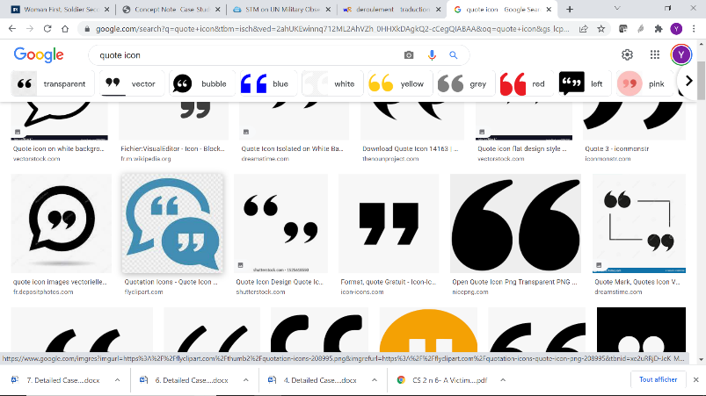 *“Dimensions of internal integration where progress is imperative include […] incorporation of gender data and expertise throughout the planning, monitoring and reporting process”*

United Nations, “Action for Peacekeeping+ Priorities for 2021-2023”, background paper, p.4.

### RESOURCE MATERIALS

United Nations, Department of Peace Operations, *Gender Equality and Women, Peace and Security*, resource package, January 2020. <https://peacekeeping.un.org/sites/default/files/gewps19_respack_v7_eng_digital.pdf>

United Nations, Department of Peace Operations, *The Protection of Civilians in United Nations Peacekeeping*, handbook. 2020. <https://peacekeeping.un.org/sites/default/files/dpo_poc_handbook_final_as_printed.pdf>

United Nations, Department of Peace Operations, “Uniformed Gender Parity Strategy 2018–2028”, 2018. <https://peacekeeping.un.org/sites/default/files/uniformed-gender-parity-2018-2028.pdf>

United Nations, Department of Peace Operations, *United Nations Infantry Battalion Manual*, January 2020. <https://peacekeeping.un.org/sites/default/files/3._military_-_1_united_nations_infantry_battalion_manual_unibam.pdf>

United Nations, Department of Peacekeeping Operations and Department of Field Support, “DPKO/ DFS Guidelines: Integrating a gender perspective into the work of the United Nations military in peacekeeping operations”, March 2010. <https://peacekeeping.un.org/sites/default/files/dpko_dfs_gender_military_perspective.pdf>

United Nations, Department of Peacekeeping Operations and Department of Field Support, “Policy on gender-responsive United Nations peacekeeping operations”, February 2018. <https://peacekeeping.un.org/sites/default/files/english_gender_responsive_united_nations_peacekeeping_operations_policy_1.pdf>

United Nations Department of Peacekeeping Operations, “Directive on sexual harassment in United Nations peacekeeping and other field missions, for military members of national contingents, military observers and civilian police officers” (DPKO/MD/03/00995), 2003. <https://police.un.org/en/directive-sexual-harassment-united-nations-peacekeeping-and-other-field-missions-military-members-of>

United Nations Entity for Gender Equality and the Empowerment of Women (UN-Women), “Women’s meaningful participation in negotiating peace and the implementation of peace agreements”, report of the expert group meeting, 2018. <https://www.unwomen.org/sites/default/files/Headquarters/Attachments/Sections/Library/Publications/2018/EGM-Womens-meaningful-participation-in-negotiating-peace-en.pdf>

United Nations, “Action for Peacekeeping+, priorities for 2021–2023”, background paper. <https://peacekeeping.un.org/sites/default/files/a4p_background_paper.pdf>

|  |
| --- |
| SELF-LEARNING |

## -SELF-LEARNING

### REFLECTION QUESTION

**What implicit or explicit bias could you or your colleagues have with regards to the roles and norms of men and women in the unrest in Corma? How could these biases influence your work?**

________________________________________________________________________________________________________________________________________________________________________________________________________________________________________________________________________________________________________________________________________________________________________________________________________________________________________________________________________________________________________________________________________________________________________________________________________________________________________________________________________________________________________________________________________________________________________________________________________________________________________________________________________________________________________________________________________________________________________________________________________________________________________________________________________________________________________________________________________________________________________________________________________________________________________________________________________________________________________________________________________________________________________________________________________________________________________________________________________________________________________________________________________________________________________________________________________________________________________________________________________________________________________________________________________________________________________________________________________________________________________________________________________________________________________________________________________________________________________________________________________________________________________________________________________________________________________________________________________________________________________________________________________________________________________________________________________________________________________________________________________________________________________________________________________________________________________________________________________________________________________________________________________________________________________________________________________________________________________________________________________________________________________________________________________________________________________________________________________________________________________________________________________________________________________________________________________________________________________________________________________________________________________________________________________

*(Please refer to p. 343 for answer)*

### QUIZ

**Please answer the following questions:**

1. When planning the operation that you were tasked with by the Infantry Battalion Commander, what type of information should you acquire?

(*cite 3 topics*)

1. _________________________________________________________
2. _________________________________________________________
3. _________________________________________________________

**Fill in the blanks using the following words in the right place: agents of positive change, analysis, sources of authority, DPKO/DFS policy on** **gender-responsive United Nations peacekeeping operations, roles**:

1. Gender ___________________ are the activities a household or a community expect women and men to do.
2. Gender _________________ studies different roles and tasks of men and women in a society.
3. Critical roles of women and girls in peace and security include as _____________ and as __________________.
4. The policy that guides peacekeepers on the women, peace and security agenda is the ___________________ of 2018.

**True or false?**

1. Gender is a social construct and can vary over time. __________________
2. In some societies today, men and women are equal. __________________
3. Gender equality is a human rights issue. __________________
4. Gender equality only benefits women. __________________
5. What do the following abbreviations stand for?

|  |  |
| --- | --- |
| **ASCOPE** | **PMERSCHII-PT** |
| **A**_______________  **S**_______________  **C**_______________  **O**_______________  **P**_______________  **E**_______________ | **P**_______________  **M**_______________  **E**_______________  **R**_______________  **S**_______________  **C**_______________  **H**_______________  **I**_______________  **I**_______________  **P**_______________  **T**_______________ |
| **PMESII**-**PT** |  |
| **P**_______________  **M**_______________  **E**_______________  **S**_______________  **I**_______________  **I**_______________  **P**_______________  **T**_______________ |  |

*(Please refer to table on common analysis frameworks for additional information).*



**Note!** While each troop-contributing country (TCC) has its own planning process, the United Nations military decision-making process (MDMP) is designed to complement national doctrine. The United Nations MDMP aims to enhance interoperability and facilitate combined operations.

*(Please refer to pp. 343 and 344 for answers).*

|  |
| --- |
| MODERATED LEARNING |

## -MODERATED LEARNING

### EXERCISE OVERVIEW

|  |
| --- |
| TASK |
| You are an Officer in your Infantry Battalion and are part of a planning team consisting of personnel from the S-2 (Military Peacekeeping Intelligence), S-3 (Operations) and S-5 (Planning) branches. Following continued unrest in the past three days in the city of Corma, you have been tasked by your Infantry Battalion Commander to plan an operation aimed at ensuring the protection of civilians (POC) in the light of reports of an imminent attack. You are requested to secure the village centre, where shops are located, and to monitor roads leading from the nearby jungle to the village centre.  Given the setting provided in the case study, how would you extract gender-responsive information – including data and analysis – in order to inform the planning of your operation?  Which of the options proposed below would you choose? Identify the advantages and shortcomings of the option you choose. |

|  |  |
| --- | --- |
|  | |
| OPTION 1 | Consult mission reports, including MPKI reports, Joint Mission Analysis Centre (JMAC) reports, POC threat assessments, checkpoint and patrol reports, etc. |
| OPTION 2 | Coordinate – through the United Nations Civil-Military Coordination (UN-CIMIC) Officer – with mission components, including gender, human rights and civilian components, etc. and with United Nations partners operating in the area. |
| OPTION 3 | Through the support of the UN-CIMIC Officer, acquire information from consultations with the local population, including women’s organizations, village elders and religious leaders. |

|  |  |
| --- | --- |
| DURATION | |
| 30 minutes | Presentation on integrating gender into the work of the military |
| 15 minutes | Break |
| 10 minutes | Introduction to exercise and division into groups |
| 20 minutes | Read Carana country summary and case study setting |
| 30 minutes | Deliberations in groups and preparation of responses |
| 45 minutes | Presentation of findings and debrief |
| TOTAL TIME REQUIRED: 2 hours 30 minutes | |

|  |  |
| --- | --- |
| SUPPORT MATERIAL | |
|  | Carana country summary |
|  | Case study setting |
|  | Exercise overview |
|  | Checklist |
|  | Common analysis frameworks |

## -FACILITATOR INSTRUCTIONS: MODERATED LEARNING

### EXERCISE OVERVIEW

|  |
| --- |
| TASK |
| You are an Officer in your Infantry Battalion and are part of a planning team consisting of personnel from the S-2 (Military Peacekeeping Intelligence), S-3 (Operations) and S-5 (Planning) branches. Following continued unrest in the past three days in the city of Corma, you have been tasked by your Infantry Battalion Commander to plan an operation aimed at ensuring the protection of civilians (POC) in the light of reports of an imminent attack. You are requested to secure the village centre, where shops are located, and to monitor roads leading from the nearby jungle to the village centre.  Given the setting provided in the case study, how would you extract gender-responsive information – including data and analysis – in order to inform the planning of your operation?  Which of the options proposed below would you choose? Identify the advantages and shortcomings of the option you choose. |

|  |  |
| --- | --- |
| What action would you take in the given context? | |
| OPTION 1 | Consult mission reports, including MPKI reports, Joint Mission Analysis Centre (JMAC) reports, checkpoint and patrol reports, etc. |
| OPTION 2 | Coordinate – through the United Nations Civil-Military Coordination (UN-CIMIC) Officer – with mission components, including gender, human rights and civil components, etc. and with United Nations partners operating in the area. |
| OPTION 3 | Through the support of the UN-CIMIC Officer, acquire information from consultations with the local population, including women’s organizations, village elders and religious leaders. |

|  |  |
| --- | --- |
| DURATION | |
| 30 minutes | Generic presentation on integrating gender into the work of the military |
| 15 MINUTES | Break |
| 10 MINUTES | Introduction to exercise and division into groups |
| 20 MINUTES | Read Carana country summary and case study setting |
| 30 MINUTES | Deliberations in groups and preparation of responses |
| 45 MINUTES | Presentation of findings and debrief |
| TOTAL TIME REQUIRED: 2 hours 30 minutes | |

|  |  |
| --- | --- |
| SUPPORT MATERIAL | |
|  | Carana country summary |
|  | Case study setting |
|  | Exercise overview |
|  | Checklist |
|  | Common analysis frameworks |
|  | Injects |
|  | PowerPoint presentations 1.1 (Integrating gender into the work of the military) and 1.2 (Carrying out gender-responsive planning for military operations – moderated).  *(Print presentation with notes pages and use as facilitator guide)* |
| Note! All support materials are available in the facilitator resource package under the folder entitled “Case Study 1 – Carrying out gender-responsive planning for military operations” | |

### FACILITATOR CHECKLIST

|  |  |  |
| --- | --- | --- |
| FACILITATOR CHECKLIST: MODERATED LEARNING | | |
| TO PRINT | | |
|  | Print exercise overview *(for all participants)* |  |
|  | Print Carana country summary *(for all participants)* |  |
|  | Print case study setting *(for all participants)* |  |
|  | Print checklist *(for all participants)* |  |
|  | Print common analysis frameworks document *(for all participants)* |  |
|  |  |  |
|  | Print and cut out injects *(two sets for each group, to be distributed* ***later*** *during exercise, simultaneously or sequentially)* |  |
|  | If desired, print or have available the facilitator instructions of this case study *(for facilitator/s who will deliver the case study)* |  |
|  | If desired, print PowerPoint presentations 1.1 (Integrating gender into the work of the military) and 1.2 (Carrying out gender-responsive planning for military operations – Moderated), including notes pages *(for facilitator/s who will deliver the case study)* |  |
| TO PREPARE | | |
|  | Familiarize yourself with relevant documents (Carana country summary and – where possible – the complete Carana scenario, as well as the facilitator instructions, case study setting, exercise instructions, checklist, common analysis frameworks document etc.) |  |
|  | Have PowerPoint Presentation ready on a USB stick/ computer for delivery |  |
|  | Prepare props for injects. How will the injects be presented (as newspaper/ television reports, by someone playing the role of broadcaster, in poster form, etc.)? At what moment of the exercise will the injects be presented (midway through the exercise, just before the end, if a specific incident takes place, etc.)? |  |
|  | How many breakout groups will you have? (This will depend on the total number of participants) |  |
|  | Where will each breakout group work? In different areas of the classroom? Are breakaway rooms available? If so, how many? Are they located close to the main classroom or do you need to plan for additional time for relocation? Can some breakout groups work outdoors? Does the weather permit outdoor work? |  |
|  | Does each breakout group require specific materials (flip charts, markers, etc.)? Are these available? |  |
|  | How will you divide participants into groups – randomly (for instance, according to tables/rows) or predetermined (according to participant profile, rank etc.). The latter option will require prior knowledge of participant profiles. Do you have that information? |  |
|  | How will you run the debrief of the exercise? Which questions will you focus on? Are there any participants with thematic expertise that you can draw from during the debrief? |  |
|  | What other elements could you add to the conclusion? Do you have any personal experiences or anecdotes to share? |  |

### DELIVERY

INTRODUCTION: GENERAL GUIDANCE AND INFORMATION ON HOW TO CONDUCT THE EXERCISE

To begin the exercise, open PowerPoint Presentation 1.1 (Integrating gender into the work of the military). You can explain to the participants that they will soon conduct a practical exercise on how to carry out gender-responsive planning for military operations. However, before beginning this exercise, you will run through a brief presentation – as a refresher – on how to mainstream gender into the work of the military.

To begin the discussion, you could ask participants if they have engaged in military planning. Many of them will probably say that they have, as this case study is intended for planners and commanders in infantry battalions. Then ask participants if they have carried out gender-responsive planning or if they have integrated gender considerations into their planning processes. There is a chance that many may reply that they have not. If some participants have carried out gender-responsive planning, you can invite them to briefly share their experience.

PRESENTATION

Following this initial discussion, you can now go through the slides of the PowerPoint presentation to explain the concepts and policy framework related to gender, why gender is important to the work of the military and how gender could be integrated into that work. Explain that this brief presentation will serve as a refresher in order to reinforce what they have already learned. Talking points are included in the notes pages of each slide and can be used as a guide. Make sure to encourage participants to share their personal experiences on the topic and clarify any questions that they may have.

Once you have gone through the presentation, explain to the participants that they will now have a short break (15 minutes). After the break, they will work in groups on a practical exercise.

**Note!** If you do not have sufficient time to respond to a question, or if you feel that it is better dealt with during or after the exercise, write down the question on a flip chart and explain to participants that you will revisit the question at a later stage.

**BREAK: 15 minutes**

BREAKOUT GROUPS

While participants are on their break, you are advised to display PowerPoint presentation 1.2 (Carrying out gender-responsive planning for military operations – Moderated) on screen.

When participants are back from their break, divide participants into groups of 4 or 5, depending on the total number of participants. Where possible, you should ensure that men and women participants are evenly distributed among the breakout groups. You may want to group participants of a similar rank together in order to facilitate discussions within the group. This, however, will require prior information on participant profiles/ backgrounds.

**Note!** If the physical classroom setting does not offer the possibility of splitting the participants into breakout groups, please moderate an open group discussion with the entire class.

EXERCISE

1. **Introduction to exercise**

When participants have been divided into groups, explain the learning objectives of the exercise. At this stage, you can also introduce the various documents that have been distributed:

* The **Carana country summary** provides a brief snapshot of the Carana scenario that is already familiar to the participants, with key information relevant to the case study that is being worked on;
* More information on the setting and context of the case study is included in the case study **setting**;
* Details of the task that needs to be carried out are explained in the **exercise overview**;
* The **checklist** serves as a guide for participants as they work on the case study;
* The **common analysis frameworks** document provides participants with a list of factors – including gender-responsive elements – that need to be taken into consideration when planning military operations.

You can now go through PowerPoint presentation 1.2. Briefly introduce the setting to the participants. Mention to them that more time will be given to read the setting.

Now explain the task that needs to be carried out. Explain that participants have three options to choose from, following which they also need to answer the other questions included in the task section. Invite participants to use the handouts provided during the session to assist them with the exercise.

1. **Group work**

Remind participants that they have **50 minutes** to complete the exercise, including approximately 20 minutes to read the handouts. Encourage participants to designate a rapporteur who will present the findings of the group during the plenary discussions.

Invite participants to begin the exercise. Encourage participants to use the checklist and the common analysis frameworks documents as guides.

During the exercise, make sure you rotate among the groups to answer any questions that participants may have and to gain some insights into the dynamics and discussions within each group. Make note of any interesting points or observations that you could raise during the debrief.

Remind participants of the time remaining 15 minutes, 10 minutes and 5 minutes before the end of the exercise.

1. **Injects**

You have been provided with several injects. These injects are aimed at influencing the participants’ reasoning and possibly changing their trajectory. **Do not share the injects at the beginning of the exercise**. You can determine an appropriate time during the exercise (halfway into the exercise or later) to share this information. You are encouraged to use innovative means to present the injects (props such as newspapers, radios, etc). You can also present the slide with injects for participants to see. If participants ask additional questions on the injects, try to answer them creatively, by making your own assumptions.

**Note!** You can either reveal all injects simultaneously, or sequentially, allowing some time to pass between each one. The PowerPoint slides on injects are designed for this purpose.

1. **Presentation of group work**

When the allotted exercise time has elapsed, invite each group to present its responses. You may let groups volunteer to begin, or, if there are no volunteers, you could designate a group to present. Each group has **5 minutes** to present.

****After each group presentation, you could facilitate a brief discussion. Did any of the other groups make a similar choice? Do the other groups agree with the arguments that were presented?

**Note!** In case of time constraints, you could carry out these brief discussions after every second or third group presentation. You can also choose to skip these brief discussions and instead spend more time on the final discussion.

K are outlined in the next section

DEBRIEF

There are no right or wrong answers in this exercise. All three options are equally valid. However, the richness and complexity of information tends to grow from one option to the next, with **OPTION 1** presenting the most straightforward and factual information, and **OPTION 3** presenting the richest, but also most complex and at times contradictory information. It is important to weigh the strengths and shortcomings of each option through a gender lens in order to be able to fill in any gaps and/or verify the information received.

In **OPTION 1 (consult mission reports)**, mission reports could offer you standardized and targeted information based on the tasks you need to accomplish. Is the information presented in those reports disaggregated by gender and age? Do the analyses that are provided cover all groups and subgroups of the population? For instance, do they identify threats and risks for men, women, boys and girls, but also for men, women, boys and girls of certain ethnic and/or religious groups, etc?

Information acquired through mission reports has a high level of accuracy and is relatively easy to access. It also allows for comparison with older reports, which can help to identify trends and follow the evolution of the situation. For instance, has the number of reported incidents of conflict-related sexual violence increased recently? Are specific groups who were not targeted before now experiencing acts of violence? Has the number of active women’s organizations increased or decreased? Did other events occur in parallel or are there circumstances that could lead to inferring causality?

On the other hand, mission reports may quickly become obsolete. Acts of unrest or violence could take place at any moment. Reports of such acts may not be immediately available or if they are, may lack detailed analysis or contextualization. For instance, while the reports may provide statistical data disaggregated by gender and age (for example, 120 persons, including 35 women, 3 girls and 5 boys were injured) they may fail to adequately explain why such incidents took place. Obtaining accurate, unbiased and factual information is essential in order to better respond to the situation.

**OPTION 2 (discuss with mission components)** offers similar advantages to OPTION 1 in terms of facilitation of analysis, accessibility and accuracy. This option offers the added advantage of facilitating direct discussion and potentially, coordination with the persons of interest. For instance, who is currently working on mine action or women’s economic empowerment? Have there been any recent projects on vocational training for youth? What have been the outcomes of these projects?

Varied reporting procedures and the multiplicity of areas of focus among mission components, however, makes comparison difficult.

**OPTION 3 (discuss with local population)** offers the unique advantage of obtaining first-hand information from those who are directly concerned by a specific project. Information acquired through such consultations will be rich in cultural analysis and anecdotes. For instance, local women may explain that they have come across several mines while on their way to fetch water from the river, or that men do not take their livestock to graze in a specific location anymore. Women are often well aware of what is happening at the local level and could be a valuable source of information. The local population could also provide explanations of certain traditions or practices. A village elder, for example, could explain that certain violent behaviour carried out by boys of a certain ethnic group is a rite of passage into manhood.

However, information acquired from the local population could be one-sided or biased and could lack objectivity. Cultural and language barriers may also complicate communication.

CONCLUSION OF PRESENTATION

Once the debrief is complete, you can go back to the PowerPoint presentation and go through the “Remember!” slide that includes key takeaways from the exercise. Key points to raise include the following actions:

* Acquire information from multiple sources
* Consider intersectionalities
* Use multiple analysis frameworks to acquire essential information

Ask participants if they have any questions or if they would like to add any other takeaways.

Lastly, thank participants for their active participation and encourage them to integrate gender considerations when they next plan for military operations.

### INJECTS

**PRINT AND CUT**

|  |  |
| --- | --- |
|  |  |
| INJECT 1 | The Association of Female Entrepreneurs has been conducting informal negotiations with leaders of both ethnic groups. |
| INJECT 2 | The leader of the Parti démocratique du Carana (PDC) who visited Corma has just made a public announcement that he will be running for the presidential elections scheduled for the following year. |
| INJECT 3 | The local radio has been transmitting information of an imminent attack against the Tatsis during their annual Kabaya festival, scheduled to take place in a week. |

|  |
| --- |
| ENACTED LEARNING |

## -ENACTED LEARNING

### EXERCISE OVERVIEW

|  |
| --- |
| TASK |
| You are part of a planning team consisting of personnel from the S-2 (Military Peacekeeping Intelligence), S-3 (Operations) and S-5 (Planning) branches. Following continued unrest in the past three days in the city of Corma, you have been tasked by your Infantry Battalion Commander to plan an operation aimed at ensuring the protection of civilians (POC), particularly the Tatsi, in the light of reports of an imminent attack. You are requested to secure the village centre, where shops are located, and to monitor roads leading from the nearby jungle to the village centre.  Together with a range of other stakeholders, you have been assigned one of the roles featured below. The facilitator will hand you individual instructions related to your specific role.  Given the setting described in the case study, you are invited to play your role with the aim of providing and/or acquiring as much gender-responsive information as possible in order to inform the preparation of the operation. Who should be consulted? Why? |

|  |  |
| --- | --- |
| OVERVIEW OF ROLES | |
|  | United Nations Military Planning Officer |
| 22. | United Nations Operations Officer 1 |
| 3. | United Nations Operations Officer 2 |
| 44. | United Nations MPKI Officer |
| 55. | United Nations Military GFP |
| 66. | UN-CIMIC Officer |
| 77. | United Nations Language Assistant |
| 88. | UNICEF representative |
| 99. | Local woman 1 |
| 110. | Local woman 2 |
| 111. | Village elder |
| 112. | Representative from the Association of Female Entrepreneurs |
| 13. | Observer 1 |
| 114. | Observer 2 |

|  |  |
| --- | --- |
| DURATION | |
| 10 minutes | Introduction to exercise and distribution of individual roles |
| 20 MINUTES | Read Carana country summary, case study setting and individual roles |
| 30 MINUTES | Simulation exercise |
| 45 MINUTES | Debrief |
| 15 MINUTES | Break |
| 30 MINUTES | Generic presentation on integrating gender into the work of the military |
| TOTAL TIME REQUIRED: 2 hours 30 minutes | |

|  |  |
| --- | --- |
| SUPPORT MATERIAL | |
|  | Carana country summary |
|  | Case study setting |
|  | Exercise overview |
|  | Individual role instructions (to be handed out by facilitator) |
|  | Checklist |
|  | Common analysis frameworks document |

## -FACILITATOR INSTRUCTIONS: ENACTED LEARNING

### EXERCISE OVERVIEW

|  |
| --- |
| TASK |
| You are part of a planning team consisting of personnel from the S-2 (Military Peacekeeping Intelligence), S-3 (Operations) and S-5 (Planning) branches. Following continued unrest in the past three days in the city of Corma, you have been tasked by your Infantry Battalion Commander to plan an operation aimed at ensuring the protection of civilians (POC), particularly the Tatsi, in the light of reports of an imminent attack. You are requested to secure the village centre, where shops are located, and to monitor roads leading from the nearby jungle to the village centre.  Together with a range of other stakeholders, you have been assigned one of the roles featured below. The facilitator will hand you individual instructions related to your specific role.  Given the setting described in the case study, you are invited to play your role with the aim of providing and/or acquiring as much gender-responsive information as possible in order to inform the preparation of the operation. Who should be consulted? Why? |

|  |  |
| --- | --- |
| OVERVIEW OF ROLES | |
|  | United Nations Military Planning Officer |
|  | United Nations Operations Officer 1 |
|  | United Nations Operations Officer 2 |
|  | United Nations MPKI Officer |
|  | United Nations Military GFP |
|  | UN-CIMIC Officer |
|  | United Nations Language Assistant |
|  | UNICEF representative |
|  | Local woman 1 |
|  | Local woman 2 |
|  | Village elder |
|  | Representative from the Association of Female Entrepreneurs |
|  | Observer 1 |
|  | Observer 2 |

|  |  |
| --- | --- |
| DURATION | |
| 10 minutes | Introduction to exercise and distribution of individual roles |
| 20 MINUTES | Read Carana country summary, case study setting and individual roles |
| 30 MINUTES | Simulation exercise |
| 45 MINUTES | Debrief |
| 15 MINUTES | Break |
| 30 MINUTES | Generic presentation on integrating gender into the work of the military |
| TOTAL TIME REQUIRED: 2 hours 30 minutes | |

|  |  |
| --- | --- |
| SUPPORT MATERIAL | |
|  | Carana country summary |
|  | Case study setting |
|  | Exercise overview |
|  | Individual role instructions (to be handed out by facilitator) |
|  | Checklist |
|  | Common analysis frameworks document |
|  | Injects |
|  | PowerPoint presentations 1.1 (Integrating gender into the work of the military) and 1.3 (Carrying out gender-responsive planning for military operations – Enacted), including notes pages *(for facilitator/s who will deliver case study)* |
| Note! All support materials are available in facilitator resource package under the folder entitled “Case study 1: carrying out gender-responsive planning for military operations”. | |

### FACILITATOR CHECKLIST

|  |  |  |
| --- | --- | --- |
| FACILITATOR CHECKLIST: ENACTED LEARNING | | |
| TO PRINT | | |
|  | Print Carana country summary *(for all participants)* |  |
|  | Print case study setting *(for all participants)* |  |
|  | Print exercise overview *(for all participants)* |  |
|  | Print checklist *(for all participants)* |  |
|  | Print and cut out individual role instructions *(one role per participant)* |  |
|  | Print and cut out injects *(one set for all participants, to be distributed later during exercise, simultaneously or sequentially)* |  |
|  | If desired, print or have available the facilitator instructions of this case study *(for facilitator/s who will deliver the case study)* |  |
|  | If desired, print PowerPoint presentations 1.1 (Integrating gender into the work of the military) and 1.3 (Carrying out gender-responsive planning for military operations – Enacted), including notes pages *(for facilitator/s who will deliver the case study)* |  |
| TO PREPARE | | |
|  | Familiarize yourself with relevant documents (Carana country summary and – where possible – the complete Carana scenario, as well as the facilitator instructions, case study setting, exercise instructions, checklist, common analysis frameworks document, etc.) |  |
|  | Have PowerPoint Presentation ready on a USB stick/computer for delivery |  |
|  | Prepare props for simulation and injects. Where will the simulation take place (makeshift office, with the local population, etc.)? How will the injects be presented (as newspaper/television reports, by someone playing the role of broadcaster, in poster form, etc.)? At what moment of the exercise will the injects be presented (midway through the exercise, just before the end, if a specific incident takes place, etc.)? |  |
|  | Consider where the simulation exercise can be run. Is the classroom large enough to conduct the exercise? Is it possible to run simulation exercises outdoors? Does the weather permit outdoor work? |  |
|  | How many simulation exercises will you run in parallel (depending on size of group)? |  |
|  | How will you allocate individual roles? Will you randomly hand out roles, invite participants to pick a role or allocate specific roles to specific participants? The latter option will require prior knowledge of participant profiles. Do you have that information? |  |
|  | How will you run the debrief of the exercise? Which questions will you focus on? Are there any participants with thematic expertise that you can draw from during the debrief? |  |
|  | What other elements could you add to the conclusion? Do you have any personal experiences or anecdotes to share? |  |

ROLE INSTRUCTIONS

**PRINT AND CUT**

**United Nations Military Planning Officer**

Your aim is to consult with as many people as possible. You solicit the support of the Military Peacekeeping Intelligence Officer, the Operations Officers and the UN-CIMIC Officer. You decide on the best strategy for acquiring and analysing information and brief your colleagues on what they should do.

You cannot directly involve the local population in the planning process but you can acquire information on the local population from the S-2 (MPKI) branch who would usually collect information from multiple sources such as the S-9 (UN-CIMIC) branch, the Military GFPs and the Engagement Platoons. You identify the type of information that you require from the local population and request the UN-CIMIC Officer to acquire this information for you.

**United Nations Operations Officer 1**

You are supporting the acquisition and analysis of information for a planned operation. Together with the other Operations Officer, you follow the guidance provided to you by the Military Planning Officer. You also speak to your Infantry Battalion’s GFP for advice.

**United Nations Operations Officer 2**

You are supporting the acquisition and analysis of information for a planned operation. Together with the other Operations Officer, you follow the guidance provided to you by the Military Planning Officer.

**United Nations MPKI Officer**

In addition to the information included in the setting, you mention that as a result of clashes in Corma, the transport of copper from Xallosa to the port in Maldosa has been suspended. Combined with the current economic difficulties resulting from the drought, you fear that this could ignite further hostilities among the Falins and the Tatsis.

**United Nations Military GFP**

You explain that engaging in acts of violence and dissidence is seen as a rite of passage into manhood, particularly among the Tatsis. You provide data disaggregated by gender and age on the number of victims in the most recent clashes: 120 people, including 35 women, 3 girls and 5 boys were injured (compared to 70 men the day before). This is an important development, since women and children had not been harmed on previous occasions. You explain that the women who were injured are the owners of shops that were looted. Information regarding the boys who were injured remains unavailable.

**UN-CIMIC Officer**

You speak with the local population and acquire the information requested by the Planning Officer. When you have the necessary information, you transmit this to the Planning Officer and/or Planning Team. You complement the information with your analysis, if needed.

**United Nations Language Assistant**

You facilitate communication between the local population and the peacekeepers. You are from the Falin ethnic community and at times add your personal analysis to what the local women say.

**UNICEF representative**

You mention that one of the major security concerns in Corma is the alarming increase in the number of young adults who are unemployed and who continue to join armed groups. Numerous attempts by UNICEF to end the recruitment of youth have not yielded the desired results.

**Local woman 1**

You are from the Falin ethnic community and are surprised to see a Tatsi woman joining in the consultations. You do not hesitate in voicing your opinion about the Tatsis, whom you blame for the recent clashes and Carana’s economic downfall more generally.

**Special note:** If/when you notice that the Tatsi woman is affected by your accusations, you continue to criticise the Tatsis even more.

**Local woman 2**

You are from the Tatsi ethnic community. You arrive late to the consultations because the bus was not available. You are destabilized when you see a Falin woman already at the consultations. If/when you are faced with accusations from the Falin woman, you stop talking.

**Special note***:* If the accusations from the Falin woman intensify, you decide to leave the consultations, explaining that you have to pick up your child from school.

**Village elder**

If approached by a peacekeeper, you propose to ask two (or more) local women to participate in consultations. You ask to be given a specific date and time so that you could transmit this information to the women concerned.

**Special note**: You forget to mention that the two women are from two ethnic groups (Falin and Tatsi). You have taken several initiatives to foster cohesion in the local community and are keen to create opportunities for women from all communities to interact.

**Representative from the Association of Female Entrepreneurs**

Your association has been conducting informal negotiations with leaders of both ethnic groups. Some of the members of your association have lost their husbands during the clashes. You are all calling for an end to this senseless violence.

**Observer 1**

You do not directly participate in the simulation. You observe the interactions among the various roles and make note of any key observations. You will share your observations with the group during the debrief of the simulation exercise. You will pay attention specifically to the following:

* How did the simulation go? Did the simulation run smoothly? What were your overall impressions of the simulation? Were the interactions always related to the task outlined at the beginning of the simulation?
* What were the most active roles? Why, in your opinion?
* Were there any challenges in the interactions? With whom? Why, in your opinion?
* What impact did the injects have on the overall simulation?

**Observer 2**

You do not directly participate in the simulation. You observe the interactions among the various roles and make note of any key observations. You will share your observations with the group during the debrief of the simulation exercise. You will pay attention specifically to the following:

* How did the simulation go? Did the simulation run smoothly? What were your overall impressions of the simulation? Were the interactions always related to the task outlined at the beginning of the simulation?
* What were the most active roles? Why, in your opinion?
* Were there any challenges in the interactions? With whom? Why, in your opinion?
* What impact did the injects have on the overall simulation?

### DELIVERY

INTRODUCTION: GENERAL GUIDANCE AND INFORMATION ON HOW TO CONDUCT THE EXERCISE

To begin the exercise, open PowerPoint presentation 1.3 (Carrying out gender-responsive planning for military operations – Enacted). You can explain to the participants that you will now conduct a simulation exercise on how to carry out gender-responsive planning for military operations.

Present the learning objectives of the case study at this point. In this case study, participants will learn how to:

|  |
| --- |
| LEARNING OBJECTIVES |
| * Identify specific grievances, security needs and priorities of diverse parts of the population, including men, women, boys and girls, using all available tools and resources * Acquire information on gender-specific concerns from a range of sources and stakeholders * Recognize the diverse roles of women, including as power brokers |

To start off the exercise, introduce participants to the various documents that were distributed:

* The **Carana country summary** provides a brief snapshot of the Carana scenario that is already familiar to the participants, with key information relevant to the case study that is being worked on;
* More information on the setting and context of the case study is included in the case study **setting**;
* **Overview of roles** provides insight on the various roles represented by other participants;
* **Individual roles and instructions** provide guidance on the specific role that each participant will play;
* The **checklist** serves as a guide for participants when working on the case study;
* The **common analysis frameworks** document provides participants with a list of factors – including gender-responsive elements – that need to be taken into consideration when planning a military operation.

ALLOCATION OF ROLES

Prior to the training, print and cut out all individual role instructions so that they are ready to be distributed in class. When you are ready to begin simulation exercise, explain to participants that they will each play a specific role in the simulation.

Distribute one role to each participant, or place the role instructions face-down on a table and request each participant to pick a role from the pile.

Explain to the participants that the roles that they have received may not correspond to their own gender identity, but that it is fine if that is the case. Invite participants to play their role according to the gender identity indicated in their individual instructions.

**Note!** If you wish, you can decide to assign specific roles to specific participants. However, this will require prior preparation and some knowledge of participant profiles.

Depending on the size of the group of participants, the simulation could be run in multiple formats:

1. It may be possible to run two or more simulations in parallel;
2. Depending on the size of the group, you may wish to assign several participants to share the same role, in particular the more general roles. For instance, in this case study, you could include multiple representatives from UNICEF, from the Association of Female Entrepreneurs, several local women or observers. This technique could also help if you observe that the group of participants is more reserved.



**Note!** Ideally, you should plan to have at least one observer for each simulation (in case of simulations being run simultaneously). If this is not possible, owing to a lack of participants, invite the observer or observers to rotate among the groups and make note of their observations.

PREPARATION

Describe the task that the participants are required to carry out using the relevant PowerPoint slide.

Give participants 20 minutes to read the Carana country summary, the setting and their individual roles in preparation for the simulation. Encourage participants to go through and use the checklist and common analysis frameworks during the simulation exercise.

SIMULATION

1. **Getting started**

When participants have completed their reading, to begin the simulation, invite members of the planning team from the S-2 (Military Peacekeeping Intelligence), S-3 (Operations) and S-5 (Planning) branches to identify themselves. Show the planning team their (makeshift) desk/work space. Invite the planning team to discuss planned actions and to interact with the other stakeholders.

Encourage other stakeholders to talk with each other in order to get to know each other and their positions.

Remind all participants that the main aim is to acquire as much gender-responsive information as possible to inform the planning of the operation. Also remind participants that they are required to play their role as indicated in the instructions.

Let the simulation run.

**Note!** If multiple simulations are being run simultaneously, invite those in key roles to identify themselves. Participants can then move to the locations where the simulation will be carried out. Ensure that these locations are sufficiently distanced from each other so that the different groups are not distracted. You could also use breakout rooms if available. If they are not available, use separate corners of the classroom or move one or several groups outdoors, weather permitting.

1. **Observation**

Facilitators are encouraged to observe and take notes during the simulation. Are specific questions related to gender being asked? Are the interactions smooth or conflictual? Do certain actions or behaviours lead to particular consequences?

You could later raise these observations during the debrief to highlight how relevant information could be acquired.



**Note!** Some of the roles contain instructions on the attitude or behaviour to be adopted. In some instances, these are deliberately stereotypical and may include, for instance, implicit or explicit personal bias. Use such behaviour as a point of discussion later during the debrief.

1. **Injects**

You have been provided with several injects. These injects are aimed at influencing the participants’ reasoning and possibly change their trajectory. **Do not share the injects at the beginning of the exercise**. You can determine an appropriate time to share the information with participants (halfway into the simulation exercise or later) and whether you share the injects simultaneously or sequentially (ideally sequentially, but be conscious of time constraints).

Distributing the injects to all participants while the simulation exercise is ongoing might be time-consuming and complicated. If you feel that this could be the case, use other means to share the information with participants. You could use innovative means, including props (newspapers with inject information that could be handed out, posters, cut-out image of a radio/television with inject information, etc.) or you and/or one of your co-facilitators could act to introduce the information (as a news broadcaster, journalist or third party). For instance, if the source of the inject is a report from Amnesty International, you could act as a representative of the organization, etc.). If participants ask additional questions about the injects, try to answer them creatively, by making your own assumptions.

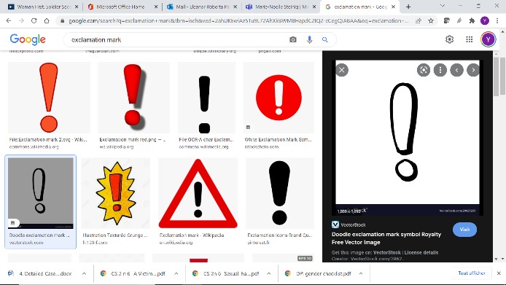

**Remember!** Make sure to prepare well in advance the way in which you will deliver the information contained in the injects.

1. **Wrap-up of simulation**

Let the simulation run for approximately 30 minutes. End the simulation when you believe the time is right, for instance when an important discussion has ended or if there are little or no ongoing discussions.

Inform participants that the simulation is now over. Congratulate them on their participation and invite them to return to their seats. Begin debrief.

DEBRIEF

1. **General debrief**

Start off with general questions about the simulation (15 minutes). Invite the observers to share their reactions first. Ask other participants what they think.

* How did the simulation go? Did the simulation run smoothly? What were your overall impressions of the simulation? Were the interactions always related to the task outlined at the beginning of the simulation?
* What were the most active roles? Why, in your opinion?
* Were there any challenges in the interactions? With whom? Why, in your opinion?
* What impact did the injects have on the overall simulation?



**Note!** Remind participants that several factors need to be carefully thought through when planning for consultations with the local women: date/time, accessibility, language, target audience, etc. Are you planning the consultations during a time where women might not be able to attend, for instance during market hours when some women sell their produce?

1. **Detailed debrief**

Next, move on to more substantive questions. Encourage participants to consult the checklist and common analysis frameworks as guides.

Below are possible questions that you could raise during the debrief. The discussions could take place in plenary. You are encouraged to select the most relevant questions, depending on how the simulation played out and according to the time available.

1. **Which option did the participants opt for?**

Participants could have taken a number of different actions in response to the situation. Below are some possible ideas:

**If participants decided to consult mission reports,** including MPKI reports, Joint Mission Analysis Centre (JMAC) reports, checkpoint and patrol reports, etc., it is important to highlight that mission reports could offer you standardized and targeted information based on the tasks that you need to accomplish. Is the information presented in those reports disaggregated by gender and age? Do the analyses that are provided cover all groups and subgroups of the population? For instance, do they identify threats and risks for men, women, boys and girls, but also for men, women, boys and girls of certain ethnic and/or religious groups etc?

Information acquired through mission reports has a high level of accuracy and is relatively easy to access. It also allows for comparison with older reports, which can help to identify trends and follow the evolution of the situation. For instance, has the number of reported incidents of conflict-related sexual violence increased recently? Are specific groups who were not targeted before now experiencing acts of violence? Has the number of active women’s organizations increased or decreased? Did other events occur in parallel or are there circumstances that could lead to inferring causality?

On the other hand, mission reports may quickly become obsolete. Acts of unrest or violence could take place at any moment. Reports of such acts may not be immediately available or if they are, may lack detailed analysis or contextualization. For instance, while the reports may provide statistical data disaggregated by gender and age (for example, 120 persons, including 35 women, 3 girls and 5 boys were injured) they may fail to adequately explain why such incidents took place. Obtaining accurate, unbiased and factual information is essential in order to better respond to the situation.

Participants could have also suggested a **discussion with mission components to obtain more information,** including gender, human rights and civil components and with United Nations partners operating in the area. This offers similar advantages to the option 1 (consulting reports) in terms of facilitation of analysis, accessibility and accuracy. This option offers the added advantage of facilitating direct discussion and potentially, coordination with the persons of interest. For instance, who is currently working on mine action or women’s economic empowerment? Have there been any recent projects on vocational training for youth? What have been the outcomes of these projects?

Varied reporting procedures and the multiplicity of areas of focus among mission components, however, makes comparison difficult.

Finally, participants might have also suggested a **discussion with the local population** to acquire information from women’s organizations, village elders and religious leaders. This offers the unique advantage of obtaining first-hand information from those who are directly concerned by a specific project. Information acquired through such consultations will be rich in cultural analysis and anecdotes. For instance, local women may explain that they have seen possible signs of mines while on their way to fetch water from the river, or that men do not take their livestock to graze in a specific location anymore. Women are often well aware of what is happening at the local level and could be a valuable source of information. The local population could also provide explanations of certain traditions or practices. A village elder, for example, could explain that certain violent behaviour carried out by boys of a certain ethnic group is a rite of passage into manhood.

However, information acquired from the local population could be one-sided or biased and could lack objectivity. Cultural and language barriers may also complicate communication.

*Ask participants if they have any other options.*

1. **What are the key conflict drivers and grievances for men, women, boys and girls?**

**Falin men**: Violence/threats during cattle herding, affected by drought, inter-ethnic violence, political majority

**Tatsi men:** Discriminated against by members of the Falin majority, threats of religious violence during Kabaya festival mentioned in the inject

**Women**: Targets of violence, victims of looting, threats of religious violence during Kabaya festival, difficulties in accessing public services, destruction of maternity clinic, husbands killed or injured

**Young Tatsi adults**: unemployment, discrimination, recruitment and use by armed groups, hypermasculinity, manipulation by local warlords, focus of youth empowerment programme by UNICEF

**Girls**: Schools are shut, victims of violence, forced marriage, recruitment by armed groups



**Note**! Remind participants to also consider intersectionalities of the population, including ethnic/ religious affiliation when possible. For an explanation of these intersectionalities, refer to the terms and definitions section at the end of the handbook.

1. **Who are/could be drivers of peace in this setting? Identify key local personalities, influencers and community groups who could contribute to defusing tensions.**

**Association of Female Entrepreneurs:** The unrest in Corma is hindering their economic activity. Several shops run by women have been destroyed. Some of the women have also been directly affected by the violence. They are the mothers or wives of people who have been killed during the unrest. They could be actively involved in deterring their husbands, brothers, sons and daughters from engaging in violence and/or joining armed groups.

**Carana Coal and Copper Miners’ Trade Unio**n: The unrest in Corma means that they cannot transport their copper to the port in Maldosa.

**Falin political leader from Parti démocratique du Carana**: As a contender in the upcoming presidential elections, he could be particularly interested in seeking an end to the violence. Be cautious about possible bias from the political leader in favour of the Falin majority.

Ask participants if they have identified any other drivers of peace. Invite them to share their ideas.



**Note! Women as informal or formal power brokers**: Participants must be encouraged to see beyond the traditional roles and norms usually allocated to/associated with women. They need to consider women’s roles as economic agents and informal or formal power brokers. For instance, could mothers be actively involved in deterring young sons and daughters from joining militant groups? Are women part of the militant groups? Do they play a leading role in the local political landscape or within militant groups?

1. **How do gender roles and norms drive or perpetuate violence?**

Young Tatsi adults may consider joining an armed group as an alternative path to employment, to seek justice/revenge or as a demonstration of adulthood. The vulnerabilities of this group (economic difficulties, unemployment, discrimination) could be – and often are – exploited by others, in this case the local warlords. For boys and young men, hypermasculinities linked to gender norms and expectations could pose a threat to certain groups of the population. Violence could be a sign of toxic masculinity that could foster certain types of threats against certain groups in the population. A culture of hypermasculinity could for instance increase the risk of conflict-related sexual violence as a tool of terror and destroy social cohesion in a certain group. Understanding how/why these hypermasculinities were created (cultural/religious traditions, colonial past, political manipulation of elite seeking to protect their own interests) can lead to more effective responses to reduce violence.

1. **What is the role of the media and politics in this setting?**

With a high capacity to mobilize certain groups of the population, the media – particularly social media – and politics can play an important role in fuelling or putting an end to violence. Encourage participants to think about who has access to which media. Print media, oral media, the Internet or mobile phones? For instance, do local women gather to listen to the radio at a certain time? How does the media address different groups of the population? What are the literacy rates among women? How do they influence the type of media accessed?

CONCLUSION OF DEBRIEF

Once the debrief is completed, respond to any outstanding questions raised by the participants.

Inform the participants that the simulation exercise and debrief are now over. Invite participants to take a break (15 minutes), after which you will run through some of the key elements that were raised during the simulation exercise.

**BREAK: 15 minutes**

PRESENTATION

During the break, you are advised to display PowerPoint presentation 1.1 (Integrating gender into the work of the military) on the screen.

When participants are back from their break, go through the PowerPoint presentation with participants. Talking points are included in the notes pages of each slide and can be used as a guide. Make sure to draw from the simulation exercise that was just completed. Remember to also encourage participants to share their personal experiences on the topic.

Conclude the presentation with the “Remember!” slide. Respond to any outstanding questions.

**Note!** If you do not have sufficient time to respond to a question, or if you feel that it is better dealt with at another time, write down the question on a flip chart and explain to participants that you will revisit the question at a later stage.

### INJECTS

**PRINT AND CUT**

|  |  |
| --- | --- |
|  |  |
| INJECT 1 | The Association of Female Entrepreneurs has been conducting informal negotiations with leaders of both ethnic groups. |
| INJECT 2 | The leader of the Parti démocratique du Carana (PDC) who visited Corma has just made a public announcement that he will be running for the presidential elections scheduled for the following year. |
| INJECT 3 | The local radio has been transmitting information of an imminent attack against the Tatsis during their annual Kabaya festival, scheduled to take place in a week. |