

A Report on

Cardio Vascular Disease Prediction

By - Hitesh Gupta

College – Parul University

E-mail: 170303105100@paruluniversity.ac.in

**INDEX**

|  |  |  |
| --- | --- | --- |
| SR NO. | TOPIC | PAGE NO. |
| 1 | INTRODUCTION | 3 |
| 2 | OBJECTIVE | 3 |
| 3 | HARDWARE AND SOFTWARE REQUIREMETS | 4 |
| 4 | MODEL SUMMARY | 5 |
| 5 | SCREENSHOTS | 6 |
| 6 | FUTURE SCOPE | 9 |
| 7 | CONCLUSION | 9 |
| 8 | BIBLIOGRAPHY AND REFERENCES | 10 |

**Cardio Vascular Disease Prediction**

**Introduction:**

The number of deaths caused by cardiovascular disease and stroke is predicted to reach 23.3 million in 2030. As a contribution to support prevention of this phenomenon, this project proposes a mining model using a Logistic classifier that could detect cardiovascular disease.

**Objective:**

1. Cardio Disease by Machine Learning will reduce time by predicting which is done manually by doctor, before.
2. Chances of human error will reduce in Medical field.
3. Hence, overall analyzing time will be reduced.
4. Patient who is affected by Cardio Disease Disease can be easily diagnosed and he will be cured rapidly.
5. Overall Test cost will also get reduced as man power gets reduced.

**Hardware and Software Requirements**

**Hardware Requirement:**

|  |  |
| --- | --- |
| Hardware Tools | Minimum Requirements |
| Processor | i5 or above |
| Hard Disk | 10GB |
| RAM | 8GB |
| Monitor | 17” Coloured |
| Mouse | Optical |
| Keyboard | 122 Keys |

**Software Requirements:**

|  |  |
| --- | --- |
| Software Tools | Minimum Requirements |
| Platform | Windows, Linus or MacOS |
| Operating System | Windows, Linus or MacOS |
| Technology | Machine Learning-Python |
| Scripting Language | Python |
| IDE | Pycharm (and Sublime) |

**Loss Graph:**

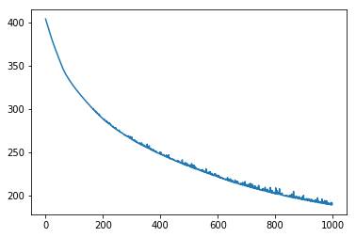

**Model Summary:**

|  |  |  |  |  |
| --- | --- | --- | --- | --- |
| INDEX | PRECISION | RECALL | F1-SCORE | SUPPORT |
| CardioDisease | **0.85** | **0.81** | **0.83** | **298** |
| Uninfected | **0.83** | **0.87** | **0.85** | **302** |
| Accuracy | **-** | **-** | **0.84** | **600** |
| Macro AVG | **0.84** | **0.84** | **0.84** | **600** |
| Weighted AVG | **0.84** | **0.84** | **0.84** | **600** |

**Screenshots:**

**Initial Window:**

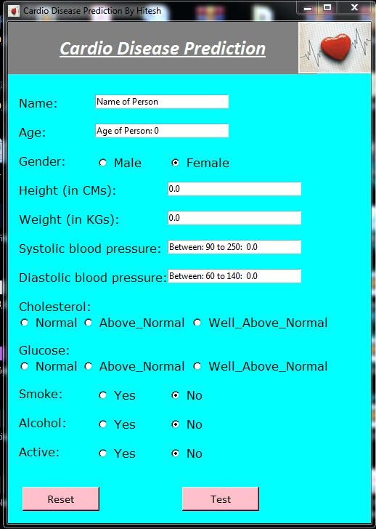

**Loading Information:**

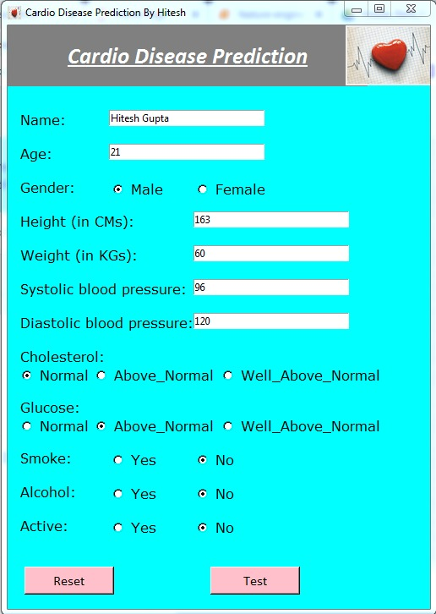

**Output:**

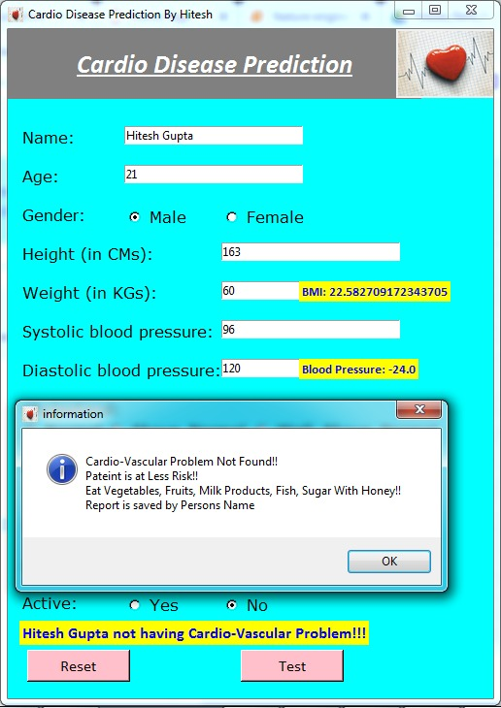

**After testing, a message box will pop-up displaying the result and some advice. Also, All the information will store in a txt file which is automatically named as Patient’s First name. Report File will contain all his information which was filled by User during testing as a RECORD and also contain the Result either he/she is infected by Cardio Disease or Not.**

**Confusion Matrix:**

Predicted Label

|  |  |
| --- | --- |
| **TN - 597**  True label | **FP - 48** |
| **FN - 24** | **TP - 603** |

**Future Scope:**

In Cardio Disease detection accuracy can also further improved by Training the model by Neural Networks using visual images instead of text data.

**Conclusion:**

In Cardio Disease Project, I have presented an approach for detecting cardio disease and automated detection of Cardio Disease. Also, I developed a strategy to train with machine learning, adaptable to detection of Cardio Disease with other types of parameters and also discuss to increase the predictive value with results.

**Bibliography and References:**

[1] iNeuron

[2] Sklearn libraries (https://scikit-learn.org/)

[3] WHO

[4] Algorithms Reference (https://towardsdatascience.com/), (https://medium.com)