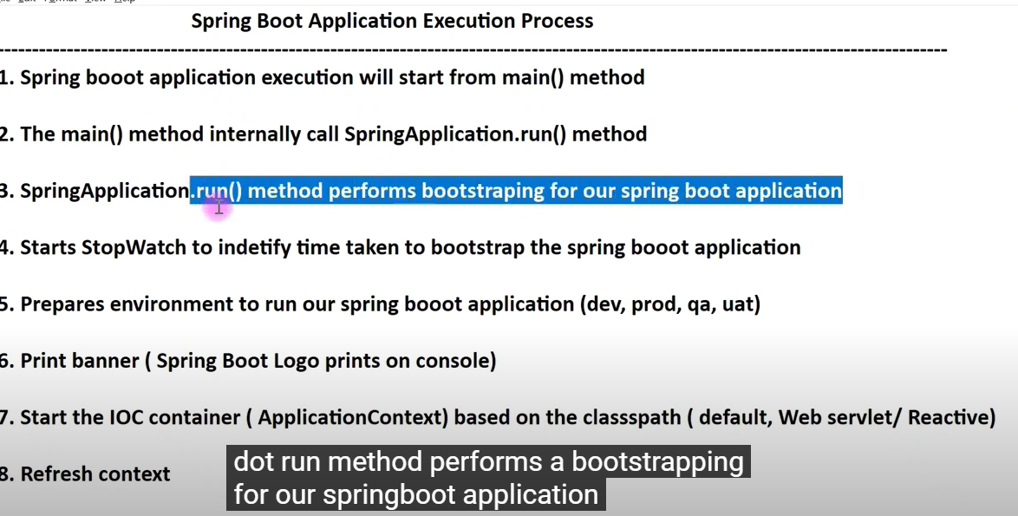
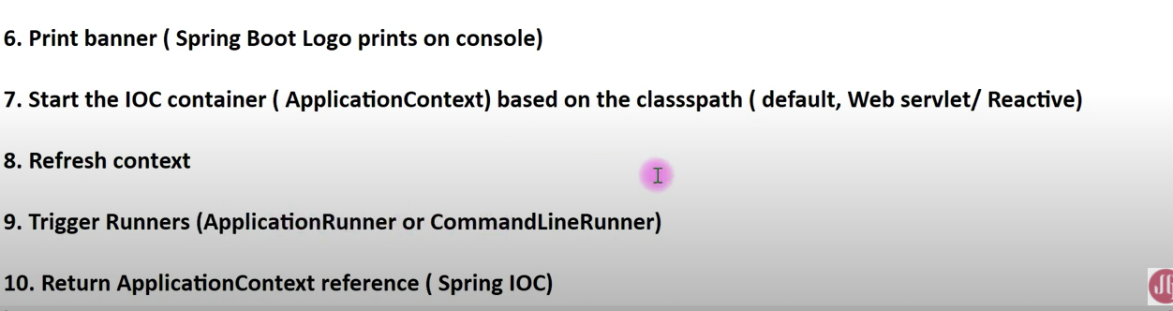

- Jar deloy
- War : deploy external server

- Devtools : make change and don’t need restart build

- Auto create table in spring boot
spring.jpa.hibernate.ddl-auto=update
- Validator in spring to check condition (email ,..)

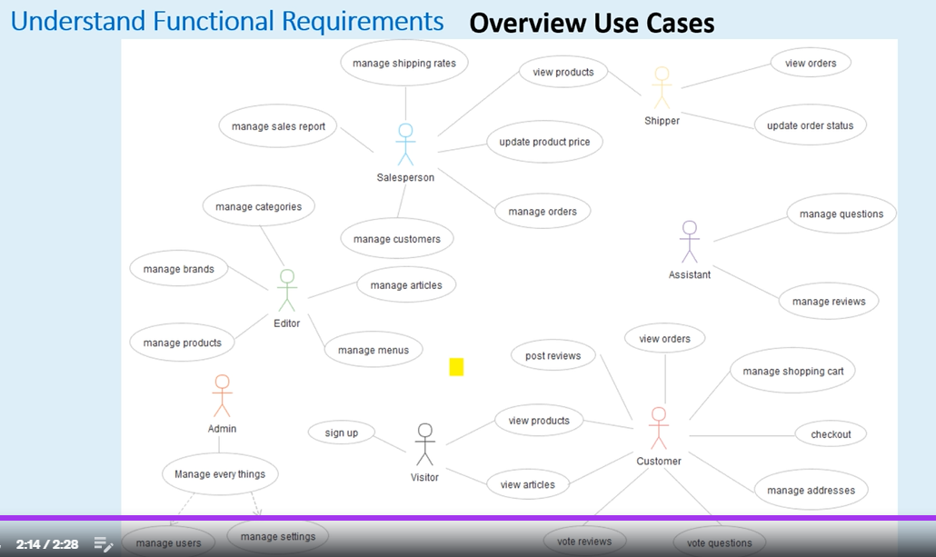
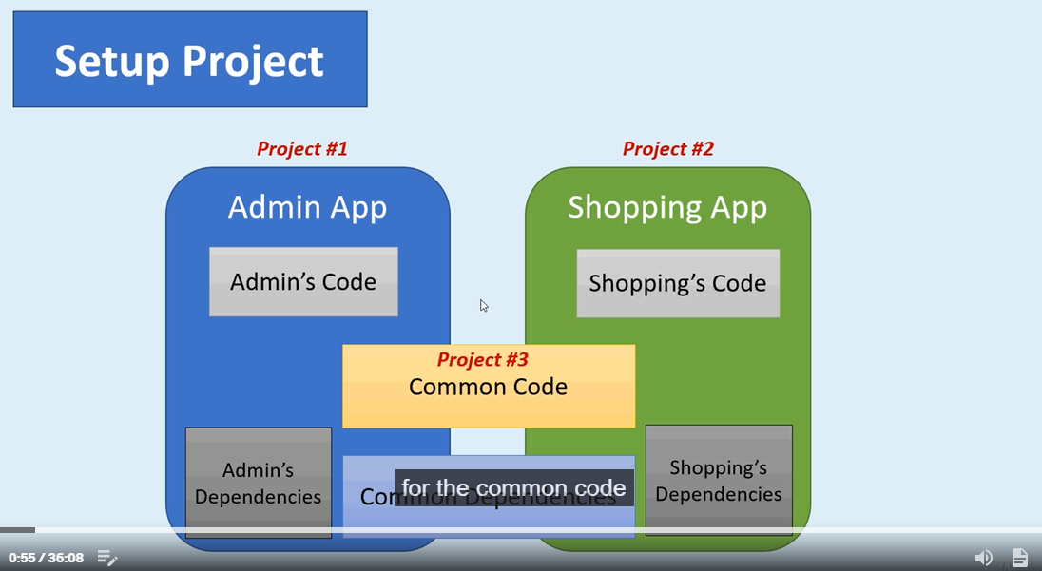
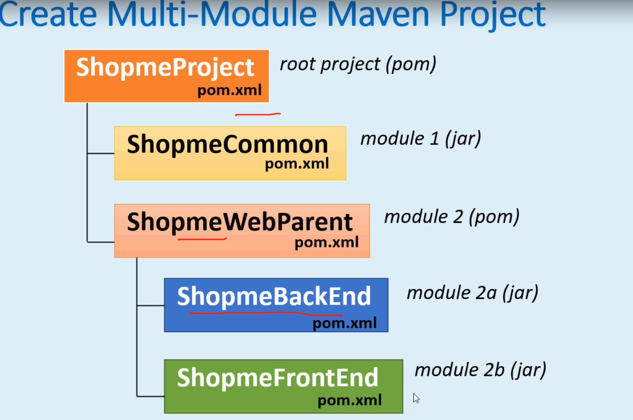
- ShopmeProject
- Pom.xml : add module
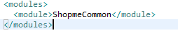
- ShopmeCommon
- Xoa test, Xoa main
- Pom.xml: delete plugin and test
- ShopmeWebParent
- Xoa plugin
