4th International Conference on Cyber Security and privacy in communication networks (ICCS) 2018

**Security Modeling of Parametric Capturing Tool (PCT) in Analytical Layer Service for e- Learning Resources**

**Harshit Mahajan1,Sunny Raikwar2, Shubham Dubey3, Shaligram Prajapat4**

1hmharsh3@gmail.com

2raikwar.sunny23@gmail.com

3shubhamdubey1312@gmail.com

4shaligram.prajapat@iips.edu.in

International Institute of Professional Studies

Devi Ahilya University Indore India

**Abstract.** Exam score is not enough for assessing any learner. In the current scenario marks are used as a tool to assess, maybe the learner is extraordinary fast in speed or possesses good analytical abilities which are not exactly counted by marks only. Secure objective Assessment should be done on various parameters. Since many online learning assessment methods require accessing multiple web pages on personal information which can also be useful in gathering much more information(Ignoring the hacker's perspective to exploit these details). With the help of JavaScript, many different parameters can be found out. For the experimental set-up, a library using JavaScript can be created which can gather data as per requirement and send this to a centralized server for further analysis. More specifically one student who earn any online certification from good university not as much worth as any offline full-time degree program from good university study below focus and making these online certification systems much reliable by a standard. This paper emphasizes on the creation of a javascript library to fetch the parameters related to online test and help to identify students behavior during training and online assessment, in secure environment without considering hacker's perspective.

Keyword- Parameter Capturing Tool (PCT), Analytics Layer, e-Learning resources

1. **INTRODUCTION**

Analytics is the discovery, interpretation, and communication of meaningful patterns in data. Analytics is to gain insight. It includes statistical or quantitative analysis (Refer Figure 1.0). In the education system, only marks cannot assess students, on top of that parameters and analytics are required for more precise assessment.

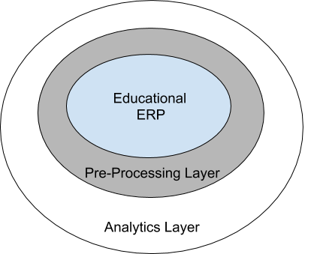

**Fig. 1.** - Conceptual Secure Schema of Analytics enabled Learning tool

E-Academics is a concept for bringing education online which involves accessing of web pages which can be helpful in collecting parameters. Many online platforms are available to promote e-learning which include online exam, training and quiz. Among all these platforms some of them provide analysis based on marks and some more parameters like time taken in solving question.

Technically this concept is one of the way towards improving quality and credibility of online education using available JavaScript features together in form of a standard library to track various aspects of current online education system. This concept does not improve system immediately and fetch lots of data (list of parameters and use of some of them listed below) and applying analytical and statistical techniques will provide way for improvement.

1. **RELATED WORK**

The work is reviewing some products those are contributing massively and have higher ranking among all web based learning platforms. The target products are selected on the basis of some certain parameters as Open Source availability, relevance and ease with respect to learning, contribution in today’s e-learning channel and their services. All the products taken in study are mentioned below.

* 1. **Following Open Source products have been considered before modeling of the PCT Tool**

*Moodle -*Moodle is an e-learning platform or course management system (CMS) - a free Open Source software package. In context of analytics, moodle provides a list of plugins out of which more useful resource found are “logs” and “Activity” plugins including exam and users’ rights customization services.

*Fedena -*All-in-one school management software and school management system with features like a timetable, attendance, parent-teacher-student communication and more. The platform was taken in study as it was having App frame, Data Plette, Data export plugins including Open Authentication System for signup. This enables fedena to rank itself in better position among other -learning platforms.

*MasterSoft. (IIT- Madras)-*Cloud-Based College Management System Software. Which enables an institution to manage course curriculum, and management of staff , library, examination including attendance as well.

Including these thousands of online learning, quiz and certification platforms are available some of which provide score and progress tracking feature or measure based on accuracy and time.All this involve some web URL to access. This web access can be used for improvement of quality by extracting some parameters about client machine. These parameters based upon target machine configuration which can later use for further in analytics for further enhancement .On web resource and forum like [stackoverflow some entries are also available for describing about what information one can access from the client's](https://stackoverflow.com/questions/8180296/what-information-can-we-access-from-the-client) device .The direction for accessing a list of parameters are suggested and using single JavaScript library can be used and one such library is “[clinetjs](https://clientjs.org)”.

More tools available to access some needed parameters with their own backend support are. Google Analytics, Piwik, clicky, Gauges, Mixpanel, Fox matrix, KISS matrix, Woopra, Adobe analytics, open web analytics etc.

**Table 1.** System for cloud based ERP and respective scope

|  |  |  |  |  |  |
| --- | --- | --- | --- | --- | --- |
| **Org. Type** | **Application type** | **Educational ERP** | **inbuilt Analytics Support ?** | **Scope of Analytics Layer on  e-ERP** | **Remark** |
| Private | both web and mobile platform | Applane | no support available | yes | <http://www.applane.com/> |
| open source | Web | goeschool | no support available | yes | <http://www.goeschool.com/> |
| Private | Web | trackmycase | no support available | yes | <http://www.trackmyclass.com> |

**Table 2.**  Table 2.0 Trends of educational ERP and Analytics for capturing Client Device information

|  |  |  |  |  |
| --- | --- | --- | --- | --- |
| **Analytics started in Year** | **Educational ERP** | **Status of Analytics Support** | **Information Captured by tools** | **Usage** |
| 2017-2018 | cloudems | [Feedback based analytics](http://www.cloudems.in/college-erp/online-feedback-and-analysis/) | based on Question in feedback form | enhancement based on feedback |
| 2017 | Moodle | [Custom Plugins](https://docs.moodle.org/33/en/Learning_analytics) | time, event, origin, ip | to monitor events |

Above list show comparison of educational platform and their own features from analytical point of view, from implementation perspective there are various tool available for parameter capture

**Table 3.** Available parameter capture tool

|  |  |
| --- | --- |
| **Tool name** | **Primary advantage** |
| Google analytics | Highly generalized **tool visualise** number of visits and time spent on website also with browser and country information |
| Adobe analytics | pitched purely as an enterprise level service |
| Mixpanel | designed for businesses that sell products and/or services |

**Table 4.** Available parameter capture libraries

|  |  |
| --- | --- |
| **Library name** | **Function** |
| clientjs | Provide methods for fetching parameters also categories theses methods with good documentation |
| openwebanalytics | Open source analytical library and tool show visualisation of various user visit related data |

These are some commonly used tools/libraries but lots of different tools are available with little variation from other with same core concept to track user behaviour intended to improve quality of service

Libraries simply provide raw data can be used as per need. Other commercial tools also provide extra analytical and visualisation layer. One new aspect of thinking is also using tool like **splunk** that just need link to live and raw data and based on data itself. It apply data mining techniques and show customised dashboard based on data itself

1. **PROBLEM STATEMENT**

In order to serve better, For e-ERP, there are various tools/systems/solutions available (ERP for education and academics) for capturing respondents device information. Documents and also in terms of analytics various platforms/tools/libraries are available but to be able to generate information as per table 4.0

**Table 3.**Potential Parameters for Capturing device information

|  |  |  |
| --- | --- | --- |
| **Captured  Information**  **From PCT** | **Benefits** | **Scope /contribution in assessment of learning /Useful for extension of Tool** |
| % of respondents on laptop/mobile/tablet for accessing specific resources | helpful to release updates accordingly for better user experience | tools can created accordingly for direct and fast access |
| Time spent on specific resource | useful in analysing demand of specific resource | estimation of personalized career path |
| How much processor concurrency and which graphics card is being used majorly, can extra computing power   be used which can be socially useful for computing and processing during test | useful for complex calculation that are beneficial to society | use extra computing power   for socially useful computing and processing during test |
| Which web browser is majorly used to design updates accordingly for social betterment | develop and test on that specific browser which is majorly used | useful in building extension for further enhancement for that specific browser(s) |
| Percentage of touchscreen device used to access these resources | testing can be done properly according to target device type | student can get better quality of education and resources |
| Zoom level need to be changed during access | provide feedback suggest to change design/font | better readability and positioning of content and different multimedia components |
| What major referral pages are accessed by this educational resources | student/user interest and goal can be identified | no need of wondering at different sites as targeted information can be achieved easily |
| Geographic location and language of major users to design content accordingly | suggest location for new CDN server for speed enhancement | content can designed accordingly |
| Is extra jsHeap can be used for social betterment | number of http request can managed accordingly | faster speed of page load can achieved |
| Different time-interval (like loading of different resources) for measure of efficiency | reduce delay in loading of important content | in low configuration or slower internet connection important content appear immediately than other multimedia resources |

And much more information can be generated with one single customized solution which can embed/link directly with any of the resource to generate data on web page access and provide in form of API for further processing.

1. **SECURITY MODELING OF PARAMETER CAPTURE TOOL**

To model the desired parameter capture tool (PCT) (shown in Figure 2), all the possible parameters that can be extracted about any client machine are listed in Annexure-1.Using the information about parameters one miniature is created on web resources [*http://easyhost.herokuapp.com*](http://easyhost.herokuapp.com/). which provide a generalized full stack support to gather all data (mansion above in Google site) about any client just by single script inclusion and provide JSON in form of REST API corresponding to the web application, which later on can be used in any kind of analytics as per requirement. Hence, a generalized model for online education platform can be created for more accurate analysis of similar course and data can be collected from all over the globe

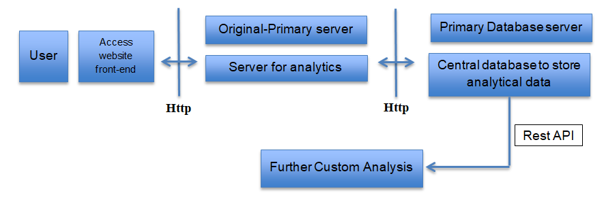**Fig. 2.** The Components of parameter capture tool (PCT)

***Algorithm Parmameter_Capture_Tool ( Input: User Credentials )***

***{***

Step-1: Allow e-Learning user/ knowledge seeker to logging through website using appropriate front end application.

Step-2: Using suitable protocol transfer the access credentials, to original primary server

Step-3: Access the primary database for desired information

Step-4: if (custom analysis = demand)

Use Rest API and perform further custom analysis

else

Store analytics data into central database

Step-5: return the server analytics using transfer protocol to provide Access of Analytics information to the user.

Step-6: End of Algorithm

}

* 1. *Experimental Setup*

The Stakeholders of PCT tools are students involved at geographically distributed locations, MOOC facilitators.

* 1. For working PCT

1. PCT Developers.
2. Web application owner who want to apply get their client machine configuration.
3. Data scientists who catch gathered data in raw (in this version: json) format and apply analytics for better results.
4. Those who are accessing resources and provide their system information for analytics.

*Input.*To the PCT

1. Application developer must include one unique script tag to enable this feature generated by PCT.
2. Client need to access resource to provide system parameters as input.

*Output.*From the PCT

1. In form of a table (online general dashboard)
2. By REST api to get updated data directly to analytical tool

DATA SET : JSON parameter set captured by PCT .The most abstract format of this is shown in Figure 4.0. The captured information can be analyzed from any suitable online tool.Sample response of WEKA is presented in Figure 3.

{

   "language": "en-US",

   "cookieEnabled": "true",

   "applicationName": "Netscape",

   "applicationCodeName": "Mozilla",

   "browserEngine": "Gecko",

   "clientSideTime": "26/2/2018 @ 9:14:42",

   "windowWidth": "1920",

   "windowHeight": "974",

   "colorDepth": "24",

   "pixelDepth": "24",

   "screenWidth": "1920",

   "screenHeight": "1080",

   "availableWidth": "1920",

   "availableHeight": "1040",

   "url": "http://easyhost.herokuapp.com/login.html",

   "os": "Windows 8.1",

   "Browser": "Chrome 63",

   "Mobile": "false",

   "fullUserAgent": "Mozilla/5.0 (Windows NT 6.3; Win64; x64) AppleWebKit/537.36 (KHTML, like Gecko) Chrome/63.0.3239.132 Safari/537.36",

   "hardwareConcurrency": "4",

   "maxTouchPoints": "0",

   "zoomLevel": "0",

   "supportFullCss3": "true",

   "referrer": "",

   "previousSites": "3",

   "javaEnabled": "false",

   "isOnline": "true",

   "networkEffectiveType": "4g",

   "isLocalStorageAvailable": "true",    "isProxy": "true",

   "navigationStart": "1519636482460",

   "unloadEventStart": "1519636482738",

   "unloadEventEnd": "1519636482738",

   "redirectStart": "1519636482463",

   "redirectEnd": "1519636482738",

   "fetchStart": "1519636482738",

   "domainLookupStart": "1519636482738",

   "domainLookupEnd": "1519636482738",

   "connectStart": "1519636482738",

   "connectEnd": "1519636482738",

   "secureConnectionStart": "0",

   "requestStart": "1519636482643",

   "responseStart": "1519636482735",

  "response End": "1519636482738",

  "domLoading": "1519636482747",

  "domInteractive": "0",

  "dom Content Loaded Event Start": "0",

  "domContentLoadedEventEnd": "0",

  "domComplete": "0",

  "loadEventStart": "0",

  "loadEventEnd": "0",

  "jsHeapSizeLimit": "2190000000",

  "totalJSHeapSize": "10000000",

  "usedJSHeapSize": "10000000",

  "domain Lookup Time In Ms": "0",

  "loadTimeTimeInMs": "0",

  "domContentLoadTimeInMs": "0",

  "local Ipv4": "10.240.64.51",

  "RENDERER": "WebKit WebGL",

  "VENDOR": "WebKit",

  "Graphics": "Google SwiftShader",

   "ip": "195.110.95.154",

   "loc": "51.4964,-0.1224",

   "org": "AS8220 COLT Technology Services Group Limited",

   "country_name": "GB",

   "stime": "Mon Feb 26 2018 09:14:45 GMT+0000 (UTC)",

   "remoteAddress": "::ffff:10.101.133.97",

   "remote Port": 10649,

   "localAddress": "::ffff:172.16.108.150",

   "localPort": 40328

}

Live result for  page: [easyhost.herokuapp.com](http://easyhost.herokuapp.com)  are shown in Figure 3.

Rest API to GET array of live data gathered from access of [page above](http://easyhost.herokuapp.com): <http://easyhost.herokuapp.com/alldata>

Data can directly entered into tool like weka to analyze and plot results

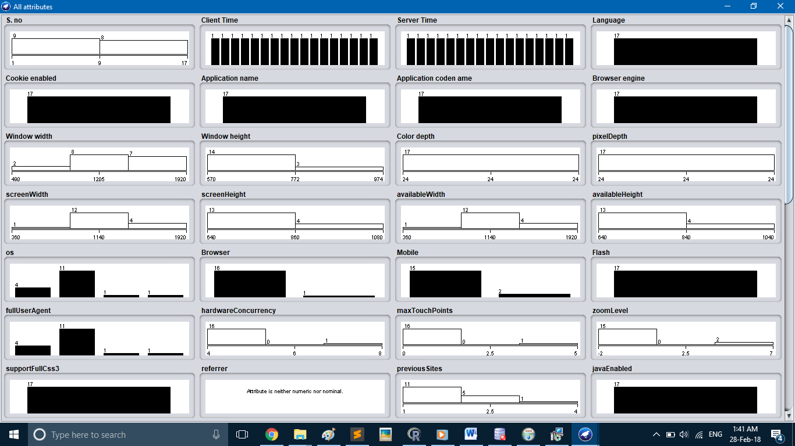

**Fig. 3.** Response after Analysis through WEKA

*General Classification of Obtained data (Only important parameters out of RAW JSON data set)*

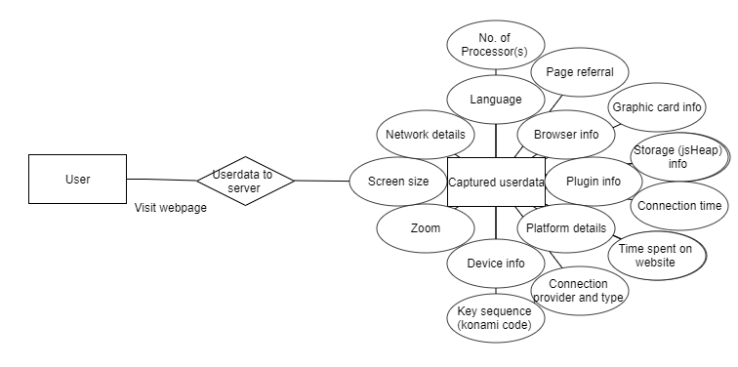

Figure 4. Most abstract form of parameters for user’s device ny PCT

1. **POSSIBLE APPLICATION**

Depending upon the situation and requirement gathered data can be analysed and used accordingly, some specific examples are

1. **Problem**: Online certification course are not considered as much preferable when compared to a university full time degree program

Possible reason for problem: These certification may be fake as no standards are available for validating these certifications, or answers in online exam may be copied from web on the spot (exception some websites have their own strong javascript library which monitor student and not to let open another tab or paste)

Possible contribution towards solution: One common library can be developed using the following parameters reliability of online test can be improved

* Time (both student side and actual time from server) taken for preparation (online video), time on discussion page for doubts and time for online test
* how much time devoted to other websites during preparation or test
* location and language extraction for cross check of proxy server
* operating system, browser, specific machine used each time, screen resolution, internet speed can be recorded

Above are some random parameters just for example to demonstrate difference between any online certificate and new standard certification which also show link among above parameters for proper validation depending upon situation and need more parameters like keystrokes and other user hardware like camera can still be accessed is a point of discussion

The primary change of this will be useful for those **students** who work hard for some certification but sometimes that original hard work also considered fake or brought online.

1. Improvement possible: online certification in terms of quality and responsiveness can be more better technically

way to improve: just by data obtained same student can be analysed of same difficulty level on different machines with different configuration now results like

* For **admin** of online test website parameters like most preferable screen size and graphic card available in most student machine may be helpful for designing new courses
* Parameters of machine can be combined with user registered information like target student average age comparison with their behavior (pattern of spending time during course),identified language barrier can be helpful for designing course content and measuring performance of instructor **useful for** both admin and student
* Preferable time of test correlation with success rate
* Best and most comfortable web browser for online training and training
* Region wise preferable device,os and browser comparison with success rate analysis will be helpful
* Specific example may be, if some **instructor** know common points like most user use mobile phone for some tutorial involver little part related to programming, it would be useful to design tasks for students that is possible on same machine like introducing online compiler along with traditional IDE

1. Usefulness for society: Determining computational capabilities of a remote student machine and comparing with required processing currently required the remaining resources and be efficiently used for longe calculation require heavy infrastructure like biological calculations which is for human betterment can be performed on available resources (with proper permission)

In short **goal** of all these parameters to improve quality of online certification and make them as reliable as any standard university certification by applying data analytics algorithms on live data

1. **TOOL USED:**

Developed own custom fullstack tool (developed in MEAN stack) for experiments related to javascript, linking of specific website visit to it’s dashboard and various conditions like same user reloads the page are tested and web hosting tool link: <http://easyhost.herokuapp.com>

for homepage visit dashboard: (username: admin, password: admin)

<http://easyhost.herokuapp.com/homevisits.html>

1. **CONCLUSION:**

With the assumption of absenteeism of hackers, this study it reveals that by accessing any one’s browser and system related data, who is accessing E-academics material, performance and credibility of learning resource can be improved. This method can not only contribute towards standardization of online learning resources but also provide lot of data (75+ parameters on one proper visit of user) for further analytics to improve service quality. To achieve this purpose for enhancement one full stack application can be developed that will issue unique javascript library link to valid and verified learning resource providers to include this library into their website. and that full stack application maintain record

for each visit on different elearning resource

1. **REFERENCES:**
2. Kohavi, Rothleder and Simoudis (2002). "Emerging Trends in Business Analytics". Communications of the ACM. 45 (8): 45–48. doi:10.1145/545151.545177.
3. "People analytics - University of Pennsylvania". Coursera.
4. Phillips, Judah "Building a Digital Analytics Organization" Financial Times Press, 2013, pp 7–8.
5. "Security analytics shores up hope for breach detection". Enterprise Innovation. Retrieved April 27, 2015.
6. Naone, Erica. "The New Big Data". Technology Review, MIT. Retrieved August 22, 2011.
7. Inmon, Bill; Nesavich, Anthony (2007). Tapping Into Unstructured Data. Prentice-Hall. ISBN 978-0-13-236029-6.
8. Wise, Lyndsay. "Data Analysis and Unstructured Data". Dashboard Insight. Retrieved February 14, 2011.
9. "Fake doctors' sick notes for Sale for £25, NHS fraud squad warns". London: The Telegraph. 26 August 2008. Retrieved 16 September 2011.
10. "Big Data: The next frontier for innovation, competition and productivity as reported in Building with Big Data". The Economist. May 26, 2011. Archived from the original on 3 June 2011. Retrieved May 26, 2011.
11. Ortega, Dan. "Mobility: Fueling a Brainier Business Intelligence". IT Business Edge. Archived from the original on July 5, 2011. Retrieved June 21, 2011.
12. Khambadkone, Krish. "Are You Ready for Big Data?". InfoGain. Archived from the original on March 14, 2011. Retrieved February 10, 2011.
13. U.S. Department of Education Office of Planning, Evaluation and Policy Development (2009). Implementing data-informed decision making in schools: Teacher access, supports and use. United States Department of Education (ERIC Document Reproduction Service No. ED504191)
14. Rankin, J. (2013, March 28). How data Systems & reports can either fight or propagate the data analysis error epidemic, and how educator leaders can help. Presentation conducted from Technology Information Center for Administrative Leadership (TICAL) School Leadership Summit.
15. Alan Norton (9 July 2012). "10 reasons why I avoid social networking services". TechRepublic. Retrieved 4 January 2016.