**3.4 Testing Report**

This report shows some of the samples I tried and their outcomes for my implementations for Assignment 2. Images I used are from the a2_images.zip

For the following sample, I used the Rainier1.png and Rainier2.png files.

When the images are first loaded up, there is converted into a grayscale image and are displayed.

Using an affine model, the RANSAC function returns with these matching key points as the best fit as plotted:

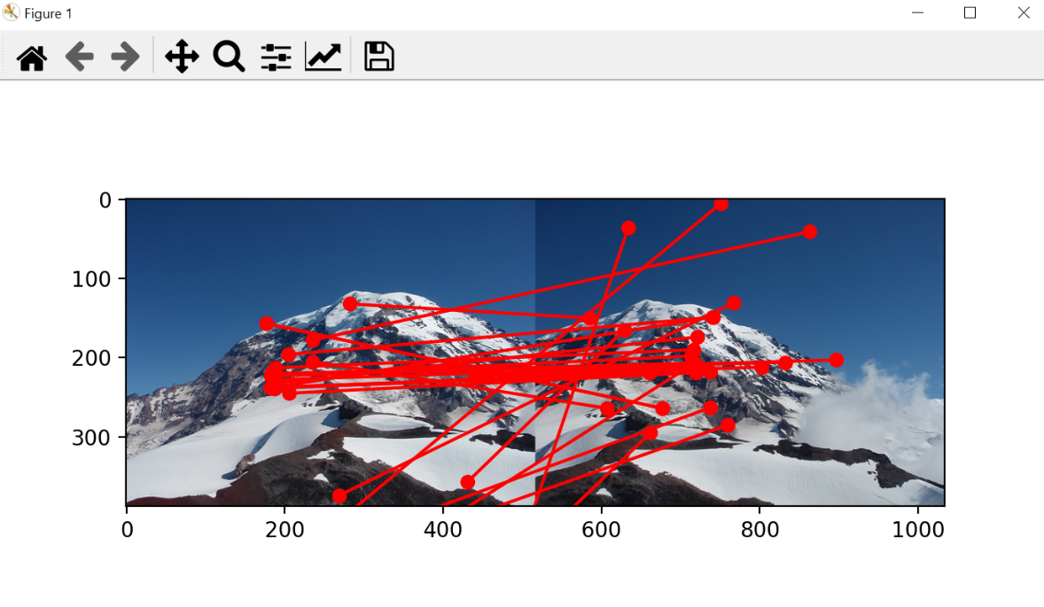The RANSAC function was ran here with 5 iterations, 3 minimum samples, a threshold boundary of 8, and 10 close data points that are required to asset that a model fits well to the data. This output appears to have many outliers and matching points that are not good. This may be due to the threshold boundary being a high number value, and only 5 iterations.

The output image stitch is shown like so after the RANSAC function was ran:

The stitching is a bit inaccurate, but major features such as the peak are pretty aligned with the destination image.

The RANSAC function was ran again using the same images and