Lab Mid Evaluation

Name :
M.Hussain

Roll No :
SU74-BSITM-F23-014

Department:
BS IT

Topology Diagram:
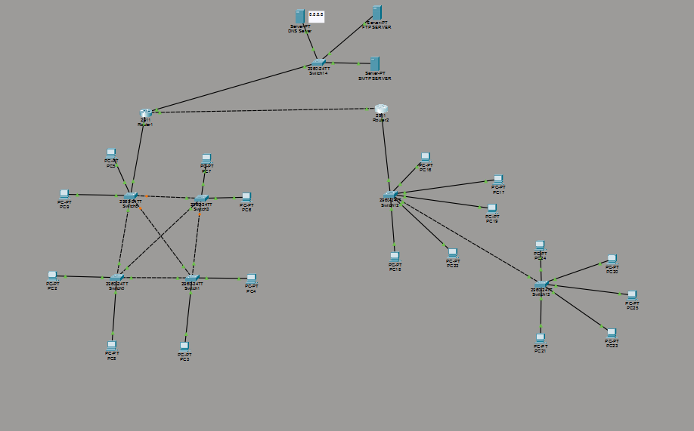

Router1:
Router#configure terminal
Enter configuration commands, one per line. End with CNTL/Z.
Router(config)#host
% Incomplete command.
Router(config)#host dhcp-server
dhcp-server(config)#interface gig
dhcp-server(config)#interface gigabitEthernet
% Incomplete command.
dhcp-server(config)#interface GigabitEthernet0/0
dhcp-server(config-if)#interface gig
dhcp-server(config-if)#iniip address 10.10.10.1 255.
^
% Invalid input detected at '^' marker.
dhcp-server(config-if)#exit
dhcp-server(config)#interface GigabitEthernet0/0
dhcp-server(config-if)#ip address 10.10.10.1 255.0.0.0
dhcp-server(config-if)#no shutdown
dhcp-server(config-if)#exit
dhcp-server(config)#ip dhcp
% Incomplete command.
dhcp-server(config)#ip dhcp ex
dhcp-server(config)#ip dhcp excluded-address 10.10.10.1
dhcp-server(config)#
dhcp-server(config)#ip dhcp pool 10.10.10.1
dhcp-server(dhcp-config)#nenetwork 10.10.10.0 255.0.0.0
dhcp-server(dhcp-config)#de nap
^
% Invalid input detected at '^' marker.
dhcp-server(dhcp-config)#de
dhcp-server(dhcp-config)#default-router 10.10.10.1
dhcp-server(dhcp-config)#dns-server 8.8.8.8
dhcp-server(dhcp-config)#exit
Router2:
dhcp-server>en
dhcp-server>enable
dhcp-server#configure terminal
Enter configuration commands, one per line. End with CNTL/Z.
dhcp-server(config)#interface gig
dhcp-server(config)#interface gigabitEthernet 0/1
dhcp-server(config-if)#ip address 195.168.10.1 255.255.255.0
dhcp-server(config-if)#no shutdown
dhcp-server(config-if)#exit
dhcp-server(config)#ip dhcp ex
dhcp-server(config)#ip dhcp excluded-address 195.168.10.1
dhcp-server(config)#ip dhcp pool 195.168.10.1
dhcp-server(dhcp-config)#network 195.168.10.1 255.255.255.0
dhcp-server(dhcp-config)#de
dhcp-server(dhcp-config)#default-router 195.168.10.1
dhcp-server(dhcp-config)#dns-server 8.8.8.8
dhcp-server(dhcp-config)#exit

Each Single Topology:
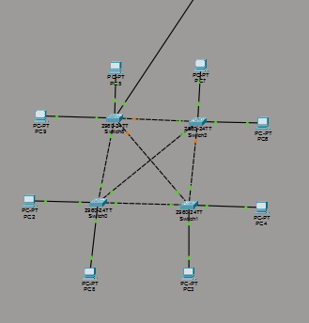

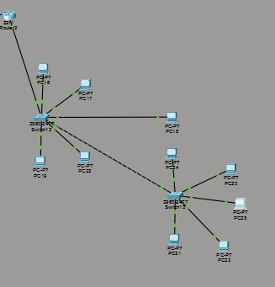

HTTP Server: 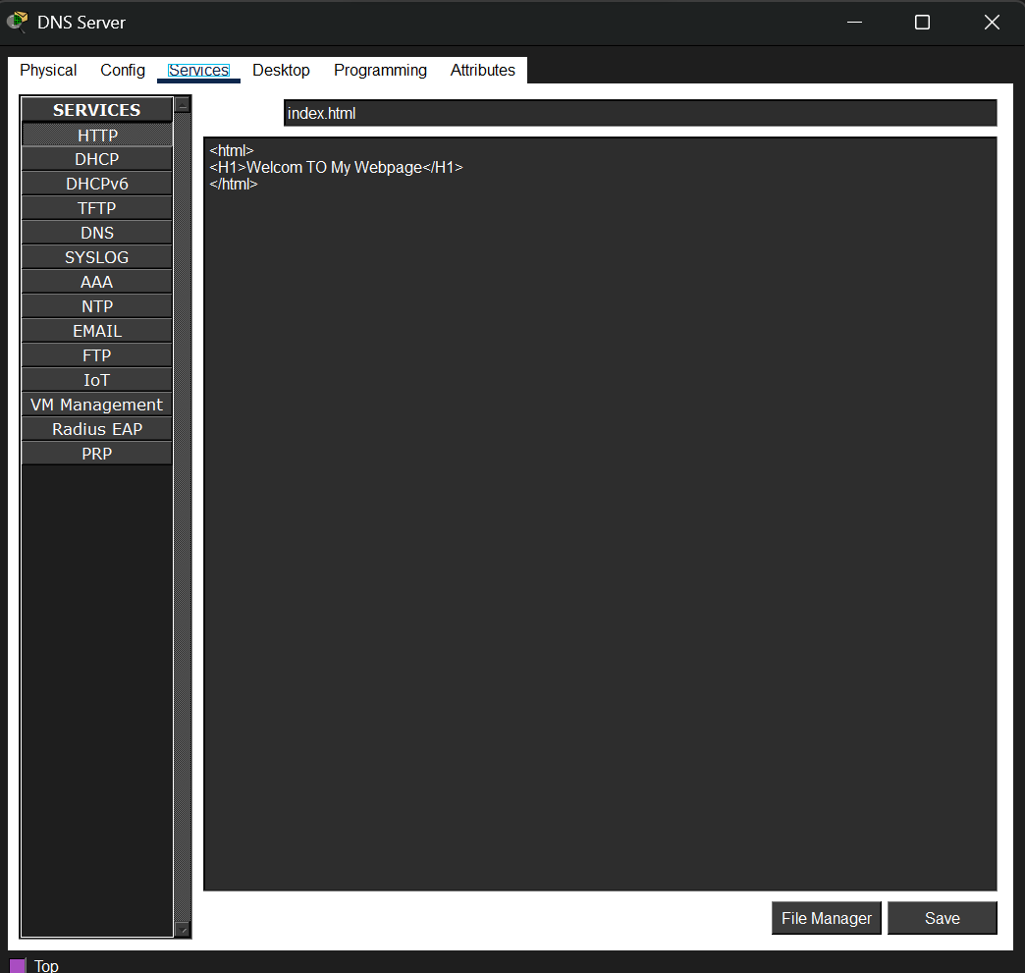

DNS:
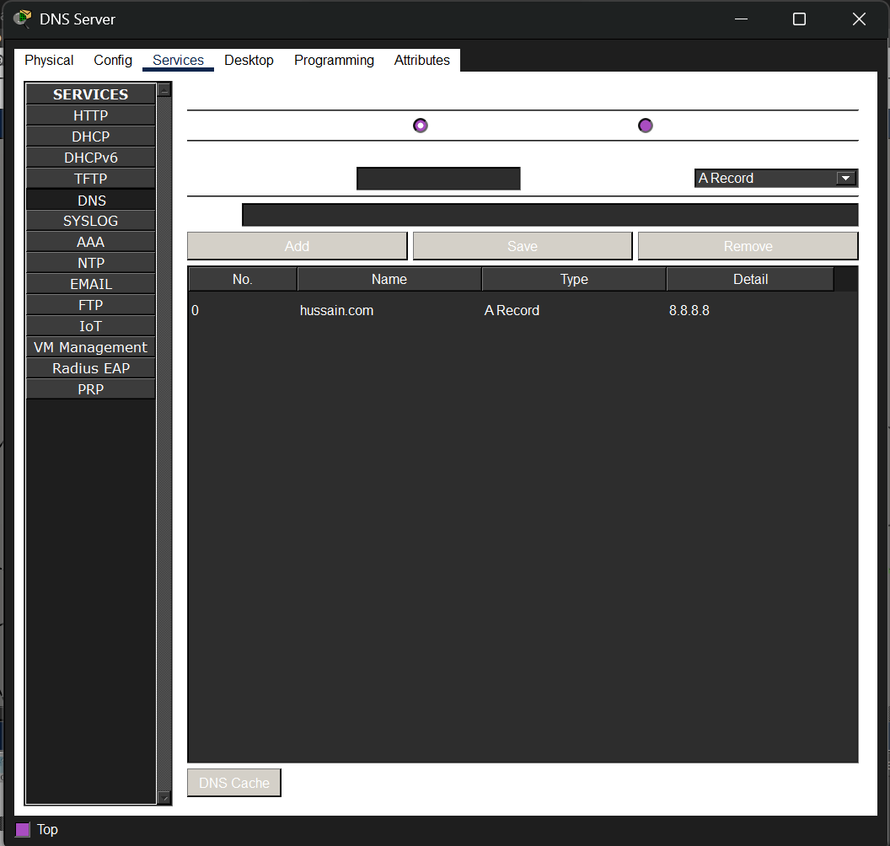

Email Server:

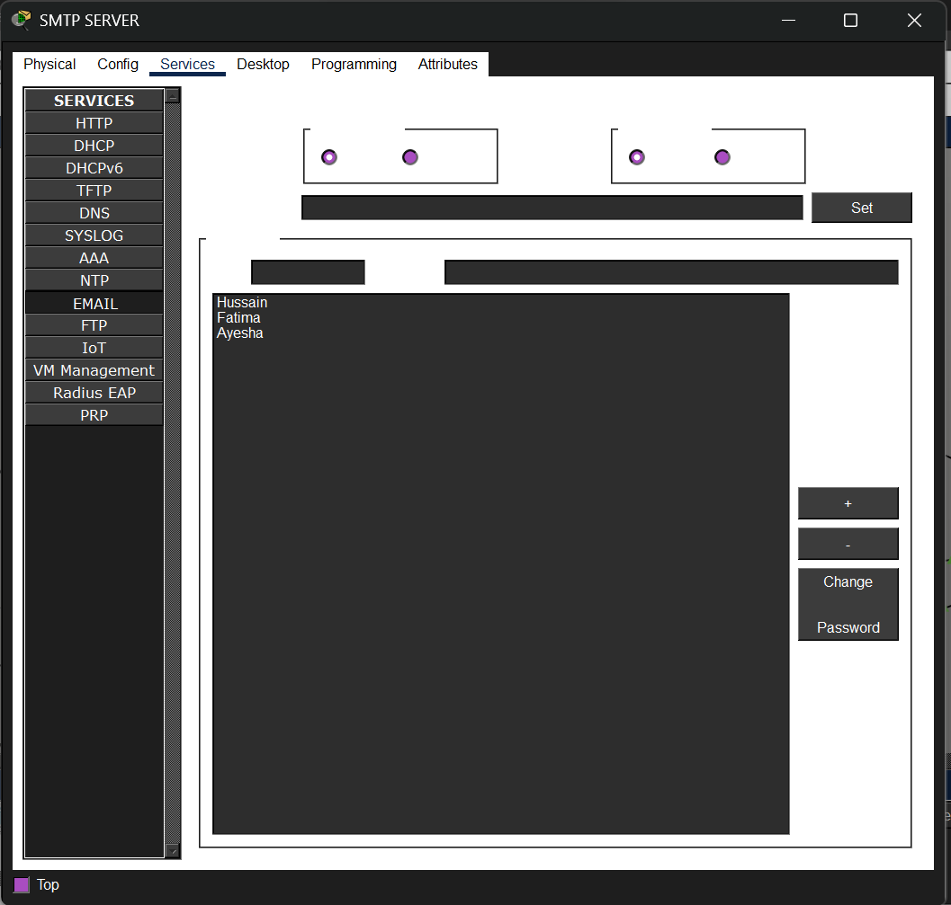

FTP Server:
