**Q1**

a. E

b. A

c. D

d. C

e. A

f. B

g. C

h. E

i. B

j. C

k. D

l. B

m. C

n. D

o. D

**Q2**

**(A)**

(i) 3 steps for Binary Search.

(ii) Linear Search is used when the list is not sorted. Binary Search is used when the list is sorted. Interpolation Search is used when the list is sorted with systematically distributed elements.

**(B)**

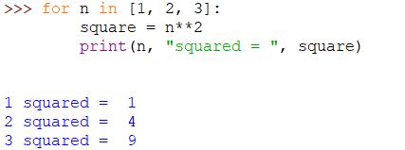

**(C)**

(i)

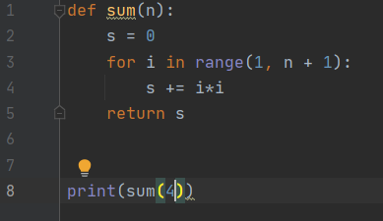

(ii)

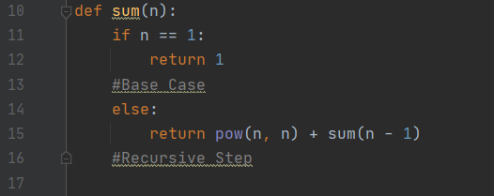

**Q3**

**(A)**

**(B)**

(i)

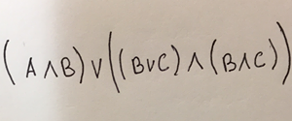

(ii)

(iii)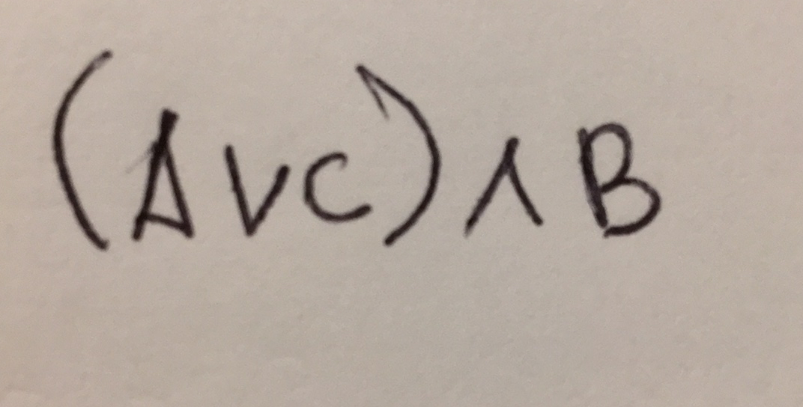

**(Q4)**

**(a)**

(i) (1/4) *8 = 2 The expected number of questions Jack answers correctly is 2.

**(b)**

