HMA TEST PROJECT

JEONG HONG MIN

2020.03.05

**Project Environment**

**Back-end:** ASP.NET Core 3.1, EF Core 3.1

**Front-end:** React.js, Redux-Saga, SCSS, Bootstrap, Kendo React UI, Typescript

**Database:** MS-SQL

**Attached Script File**

* HMA_Generated_Scripts.sql
* Create_Table_Version
* Create_Table_File
* Create_Table_Version_File_Mapping
* Create_Table_VersionType

**Source File**

* Github

<https://github.com/hmin5015/HMA>

**Database Setup**

**Diagram**

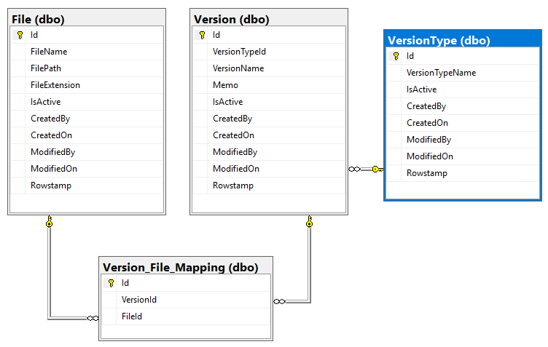

**Tables**

**VersionType:** The table that manages version types

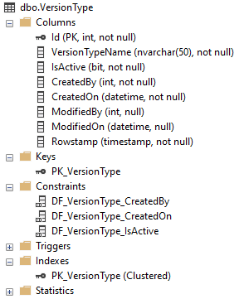

**Version:** The table that manages version

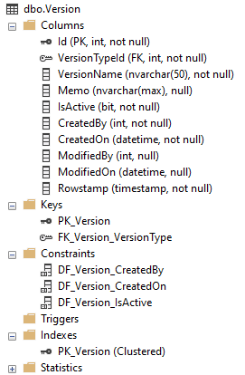

**File:** The table that manages file

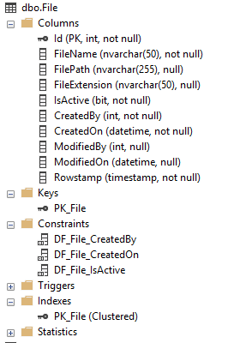

**VersionFileMapping:**

The mapping table that links the version table to the file table

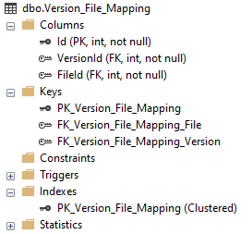

**Project (Back-end)**

Create a new empty ASP.NET Core web application.



Install NuGet package

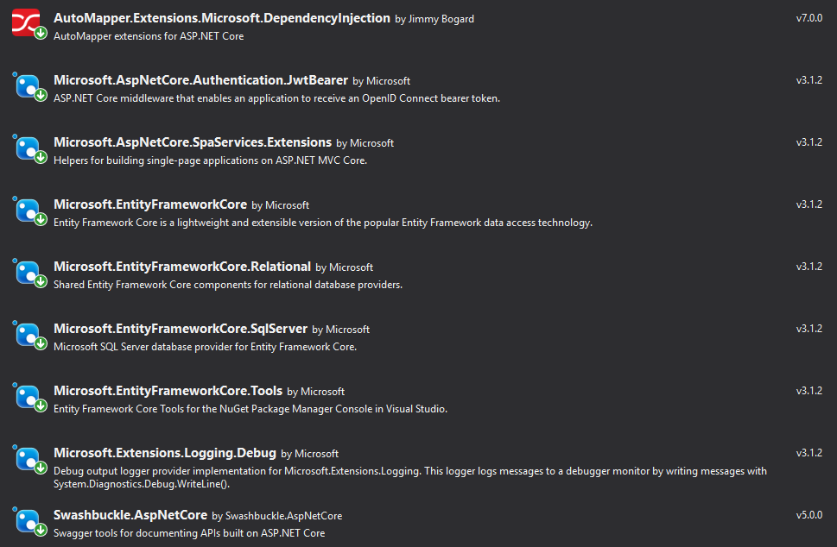

Modified appsettings.json to add dbcontext (Database connection string)

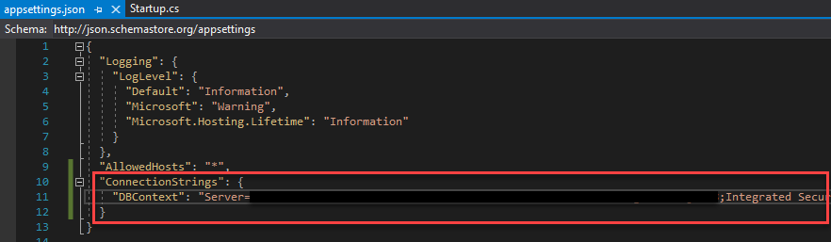

Added Models and Dtos folder and files

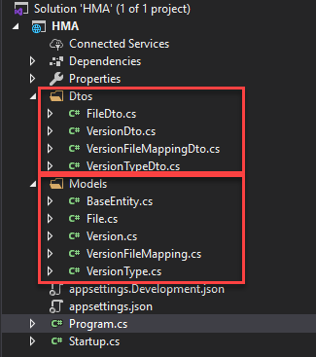

Startup.cs page setup

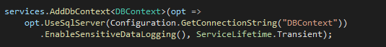

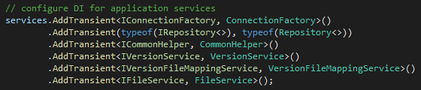

Added Core folder and AutoMapper.cs for mapping

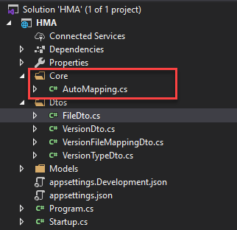

Add Data

* DBContext.cs
* IRepository.cs

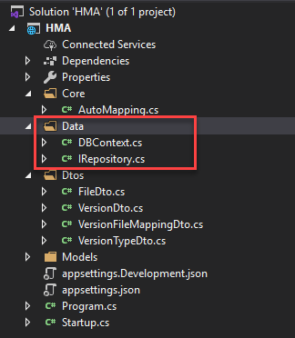

Add ConnectionFactory.cs to manage DB connection

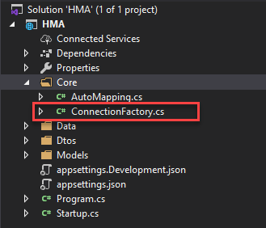

Added controllers page

* FileController.cs
* VersionController.cs



Added services

* FileService.cs
* VersionFileMappingService.cs
* VersionService.cs

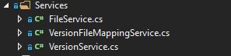

**Project (Front-end)**

1. Install node.js

URL - <https://nodejs.org/ko/download/>

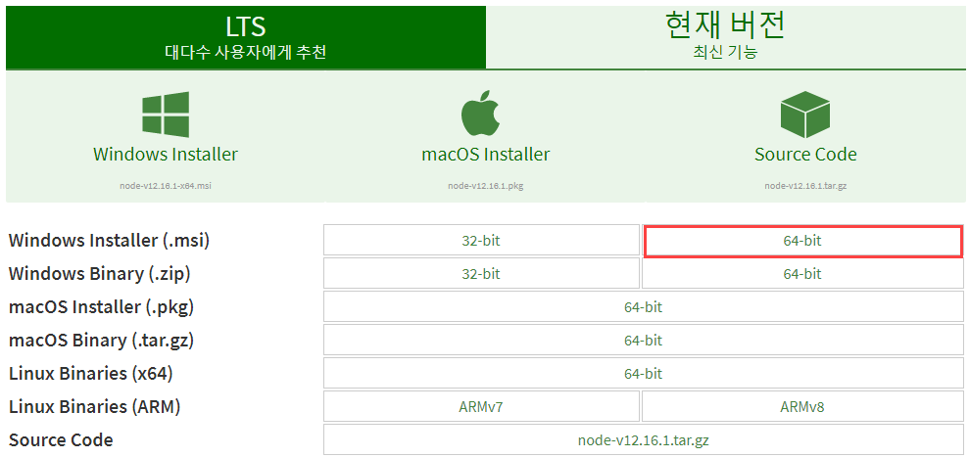

1. Install Yarn

URL – [https://classic.yarnpkg.com/en/docs/install/#windows-stable](https://classic.yarnpkg.com/en/docs/install/%23windows-stable)

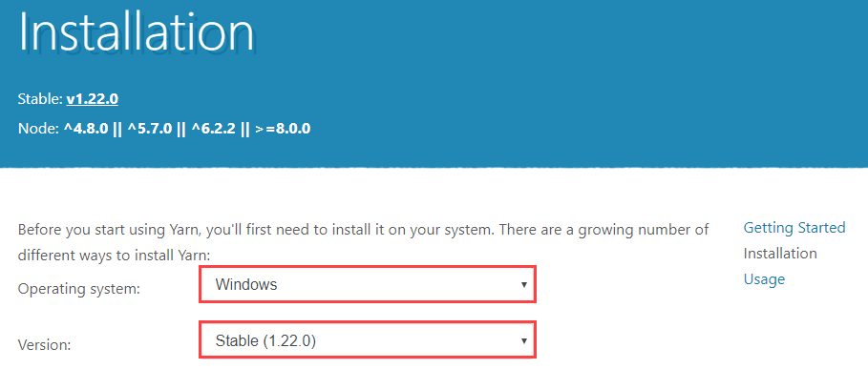

Install Package.json

* Kendo-React-ui
* Axios
* TypeScript
* Redux-saga

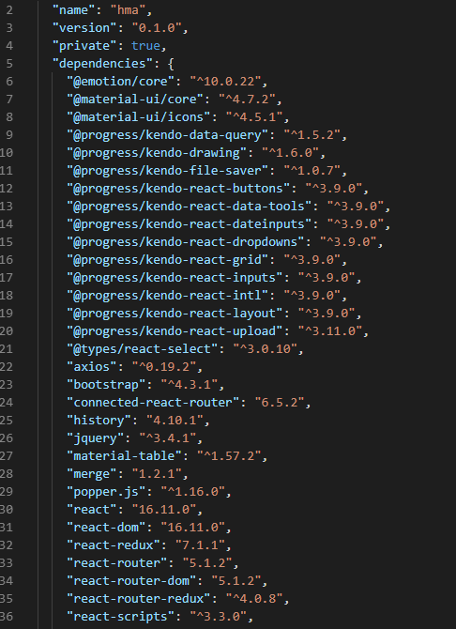

Install Material UI

* Visual Studio Code – Add Material UI with command as below

Ex) Yarn add @material-ui/core

Ex) Yarn add @material-ui/icons

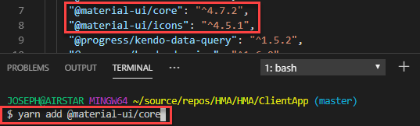

Install Axios

* Visual Studio Code – Add Axios with command as below

Ex) Yarn add axios

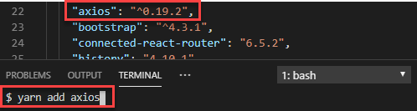

Install Redux-Saga

* Visual Studio Code – Add Redux-Saga with command as below

Ex) Yarn add redux-saga

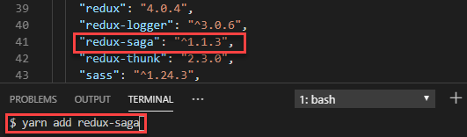

Add modules

* Redux-Saga, Reducer, Actions, Types

Added pages

* Version\VersionPage.tsx

Added types

* file.types.ts
* version.types.ts

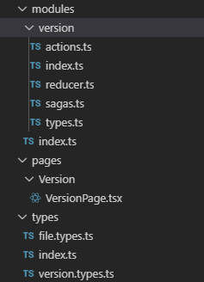

Added lib

* Helpers, icons, images, styles, utils

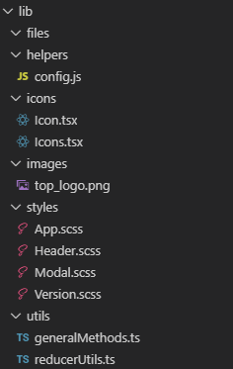

Add api folder and files

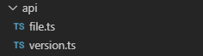

Add components, containers

