**Project Environment**

**Back-end:** ASP.NET Core 3.1, EF Core 3.1

**Front-end:** React.js (SPA), Redux-Saga, SCSS, Bootstrap, Kendo React UI, Typescript

**Database:** MS-SQL

**Database Setup**

**Tables**

**VersionType:** The table which manage version types

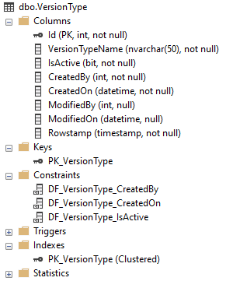

**Version:** The table which manage version

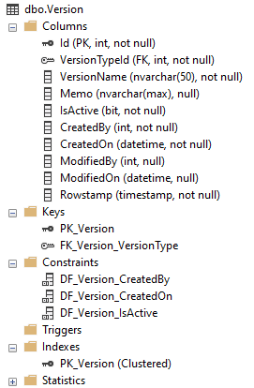

**File:** The table which manage file

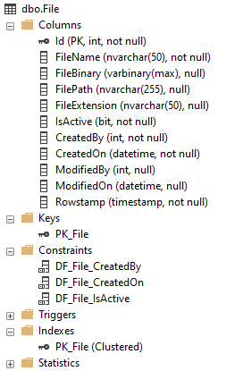

**VersionFileMapping: The table which mapping between version and file**

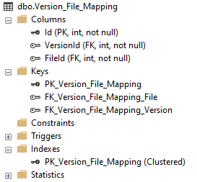

**Project**

1. Create a new empty ASP.NET Core web application.

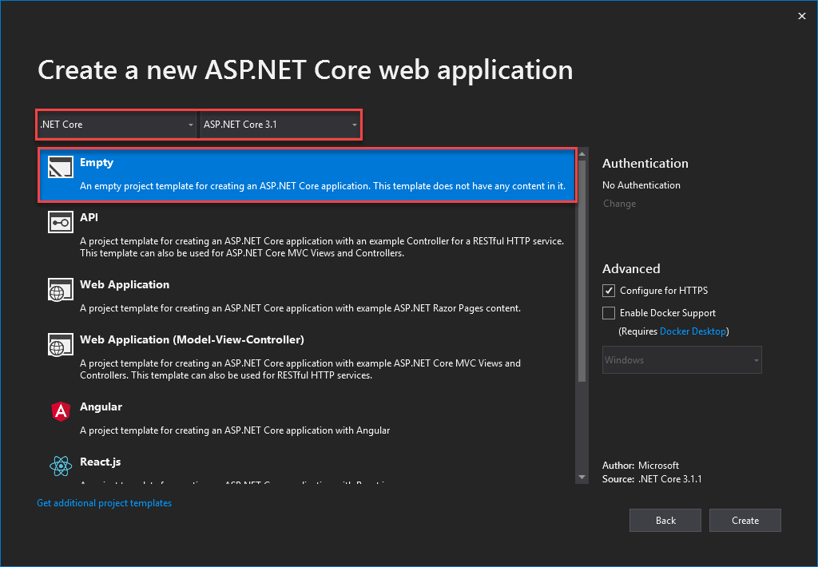

1. Install NuGet package

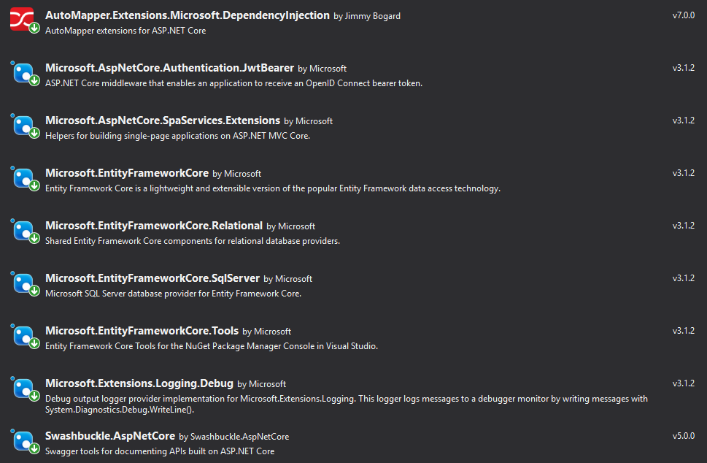

1. Modified appsettings.json to add dbcontext (Database connection string)

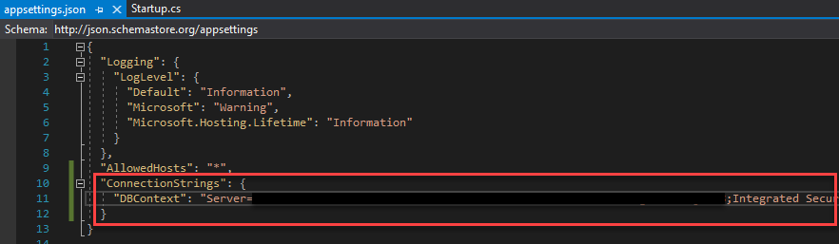

1. Add Models and Dtos folder and files

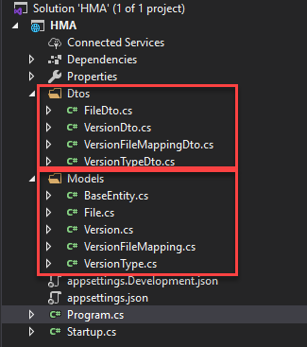

1. Add Core folder and AutoMapper.cs for mapping

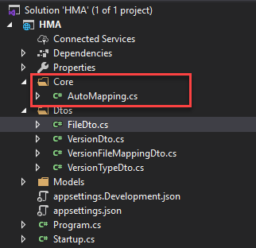

1. Add Data folder and add DBContext.cs, IRepository.cs

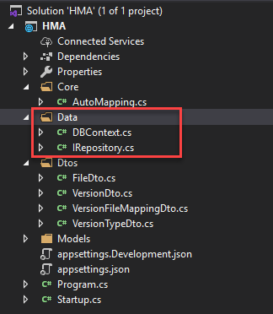

1. Modified Startup.cs page

**ConfigureServices**

* AddCors
* AddDbContext
* AddAutoMapper
* AddSwagger (Api Document)
* Configure Dependency Injection for application services
* AddSpaStaticFiles (for React.js single page application)

**Configure**

* UseCors (Cors Policy)
* UseSwagger
* UseSpa

1. Add ConnectionFactory.cs to manage DB connection

