Page01
And here is some random text 01
- Bullet01
- Bullet02

Page02
And here is some random text 02
accordion (bordererd)
Blah | Blubber
Lala | lalallalla

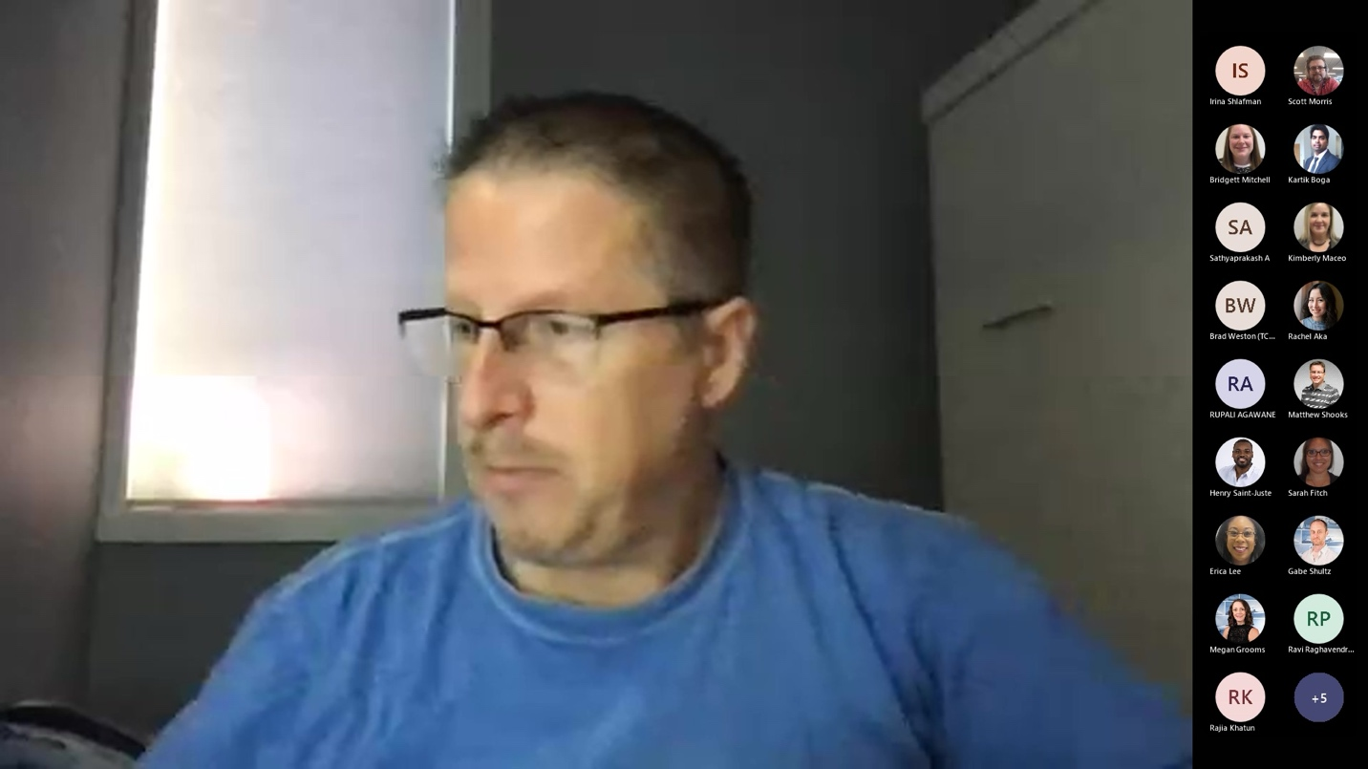

Page03
And here is some random text 03

