VIETNAM GENERAL CONFEDERATION OF LABOR
TON DUC THANG UNIVERSITY
FACULTY OF INFORMATION TECHNOLOGY



LE HOANG MINH – 523H0053
NGUYEN NGOC TU – 523H0111
DOAN THANH TRONG – 523H0108

ASSIGNMENT REPORT

Introduction To Information Security

HO CHI MINH CITY, 2026
VIETNAM GENERAL CONFEDERATION OF LABOR
TON DUC THANG UNIVERSITY
FACULTY OF INFORMATION TECHNOLOGY



LE HOANG MINH – 523H0053
NGUYEN NGOC TU – 523H0111
DOAN THANH TRONG – 523H0108

ASSIGNMENT REPORT

Introduction To Information Security

Advised by
Huynh Ngoc Tu, Ph. D

HO CHI MINH CITY, 2026
ACKNOWLEDGEMENT

We would like to express our sincere gratitude to Ms. Huynh Ngoc Tu, our instructor and mentor, for her valuable guidance and support throughout the report. She has been very helpful and patient in providing us with constructive feedback and suggestions to improve our work. She has also encouraged us to explore new technologies and knowledges. We have learned a lot from her expertise and experience. We are honored and privileged to have her as our teacher and supervisor.

Ho Chi Minh city, 20th April 2026.
Author
(Signature and full name)

Minh
Le Hoang Minh
Tu
Nguyen Ngoc Tu
Trong
Doan Thanh Trong

DECLARATION OF AUTHORSHIP
We hereby declare that this is our own project and is guided by Ms. Huynh Ngoc Tu; The content research and results contained herein are central and have not been published in any form before. The data in the tables for analysis, comments and evaluation are collected by the main author from different sources, which are clearly stated in the reference section.
In addition, the project also uses some comments, assessments as well as data of other authors, other organizations with citations and annotated sources.
If something wrong happens, we’ll take full responsibility for the content of my project. Ton Duc Thang University is not related to the infringing rights, the copyrights that We give during the implementation process (if any).
Ho Chi Minh city, 20th April 2026
Author
(Signature and full name)

Minh
Le Hoang Minh
Tu
Nguyen Ngoc Tu
Trong
Doan Thanh Trong

SUMMARY
This report presents a comprehensive analysis and implementation of the Role-Based Access Control (RBAC) mechanism within OpenMRS, an open-source electronic health record (EHR) system. The study initially identifies critical system privileges and high-level administrative roles to establish a foundational understanding of the platform's security architecture. Subsequently, a functional role hierarchy was designed and instantiated to systematically accommodate various clinical and administrative personnel. By applying role abstraction and inheritance principles, the designed hierarchy minimizes architectural redundancy and rigorously enforces the Principle of Least Privilege. Furthermore, the report critically evaluates the inherent limitations of the existing RBAC model, specifically highlighting scalability challenges such as role explosion and the critical absence of context-aware access constraints. To mitigate these structural vulnerabilities, the integration of advanced access control paradigms, notably Attribute-Based Access Control (ABAC) and dynamic privilege delegation, is proposed to enhance the system's overarching security posture and operational flexibility.
TABLE OF CONTENTS
LIST OF FIGURES v
LIST OF TABLES ix
ABBREVIATIONS x
CHAPTER 1. ACCESS CONTROL FOR EHR 1
1.1 Exercise 1 (1.0 point) 1
1.2 Exercise 2 (1.0 point) 2
1.3 Exercise 3 (2.0 point) 3
1.4 Exercise 4 (2.0 point) 7
1.4.1 Definition of Abstract Base Roles 7
1.4.2 The Inherited Role Hierarchy Matrix 8
1.4.3 Architectural Security Rationale 9
1.5 Exercise 5 (2.0 point) 10
1.6 Exercise 6 (2.0 point) 34
1.6.1 Challenges Encountered in the OpenMRS Access Control Model 34
1.6.2 Strategic Suggestions for Improvement 35

LIST OF FIGURES
Figure 1: Defining the main roles for the users of the system 6
Figure 2: Assign a role to Mary 6
Figure 3: Assign a role to Bob 7
Figure 4: Assign a role to Erica 7
Figure 5: Comprehensive list of defined roles in OpenMRS, illustrating the integration of abstract base roles and functional job titles 11
Figure 6: Detailed configuration of the 'Nurse' role, demonstrating the functional implementation of privilege inheritance from multiple base modules 1 12
Figure 7: Detailed configuration of the 'Nurse' role, demonstrating the functional implementation of privilege inheritance from multiple base modules 2 12
Figure 8: Detailed configuration of the 'Nurse' role, demonstrating the functional implementation of privilege inheritance from multiple base modules 3 13
Figure 9: Detailed configuration of the 'Nurse' role, demonstrating the functional implementation of privilege inheritance from multiple base modules 4 14
Figure 10: Detailed configuration of the 'Doctor' role, demonstrating the functional implementation of privilege inheritance from multiple base modules 1 14
Figure 11: Detailed configuration of the 'Doctor' role, demonstrating the functional implementation of privilege inheritance from multiple base modules 2 15
Figure 12: Detailed configuration of the 'Doctor' role, demonstrating the functional implementation of privilege inheritance from multiple base modules 3 15
Figure 13: Detailed configuration of the 'Doctor' role, demonstrating the functional implementation of privilege inheritance from multiple base modules 4 16
Figure 14: Detailed configuration of the 'Health Secrectary' role, demonstrating the functional implementation of privilege inheritance from multiple base modules 1 16
Figure 15: Detailed configuration of the 'Health Secrectary' role, demonstrating the functional implementation of privilege inheritance from multiple base modules 2 17
Figure 16: Detailed configuration of the 'Health Secrectary' role, demonstrating the functional implementation of privilege inheritance from multiple base modules 3 17
Figure 18: Detailed configuration of the 'Dentist' role, demonstrating the functional implementation of privilege inheritance from multiple base modules 1 18
Figure 19: Detailed configuration of the 'Dentist' role, demonstrating the functional implementation of privilege inheritance from multiple base modules 2 19
Figure 20: Detailed configuration of the 'Dentist' role, demonstrating the functional implementation of privilege inheritance from multiple base modules 3 19
Figure 21: Detailed configuration of the 'Dentist' role, demonstrating the functional implementation of privilege inheritance from multiple base modules 4 20
Figure 22: Detailed configuration of the 'Physiotherapist' role, demonstrating the functional implementation of privilege inheritance from multiple base modules 1 21
Figure 23: Detailed configuration of the 'Physiotherapist' role, demonstrating the functional implementation of privilege inheritance from multiple base modules 2 21
Figure 24: Detailed configuration of the 'Physiotherapist' role, demonstrating the functional implementation of privilege inheritance from multiple base modules 3 22
Figure 25: Detailed configuration of the 'Physiotherapist' role, demonstrating the functional implementation of privilege inheritance from multiple base modules 4 22
Figure 26: Detailed configuration of the 'Psychologist' role, demonstrating the functional implementation of privilege inheritance from multiple base modules 1 23
Figure 27: Detailed configuration of the 'Psychologist' role, demonstrating the functional implementation of privilege inheritance from multiple base modules 2 24
Figure 28: Detailed configuration of the 'Psychologist' role, demonstrating the functional implementation of privilege inheritance from multiple base modules 3 24
Figure 29: Detailed configuration of the 'Psychologist' role, demonstrating the functional implementation of privilege inheritance from multiple base modules 4 25
Figure 30: Detailed configuration of the 'Radiologist' role, demonstrating the functional implementation of privilege inheritance from multiple base modules 1 25
Figure 31: Detailed configuration of the 'Radiologist' role, demonstrating the functional implementation of privilege inheritance from multiple base modules 2 26
Figure 32: Detailed configuration of the 'Radiologist' role, demonstrating the functional implementation of privilege inheritance from multiple base modules 3 27
Figure 33: Detailed configuration of the 'Radiologist' role, demonstrating the functional implementation of privilege inheritance from multiple base modules 4 27
Figure 34: Detailed configuration of the 'Registration Clerk' role, demonstrating the functional implementation of privilege inheritance from multiple base modules 1 28
Figure 35: Detailed configuration of the 'Registration Clerk' role, demonstrating the functional implementation of privilege inheritance from multiple base modules 2 28
Figure 36: Detailed configuration of the 'Registration Clerk' role, demonstrating the functional implementation of privilege inheritance from multiple base modules 3 29
Figure 37: Detailed configuration of the 'Registration Clerk' role, demonstrating the functional implementation of privilege inheritance from multiple base modules 4 29
Figure 38: Detailed configuration of the 'System Administrator' role, demonstrating the functional implementation of privilege inheritance from multiple base modules 1 30
Figure 39: Detailed configuration of the 'System Administrator' role, demonstrating the functional implementation of privilege inheritance from multiple base modules 2 31
Figure 40: Detailed configuration of the 'System Administrator' role, demonstrating the functional implementation of privilege inheritance from multiple base modules 3 31
Figure 41: Detailed configuration of the 'System Administrator' role, demonstrating the functional implementation of privilege inheritance from multiple base modules 4 32
Figure 42: Detailed configuration of the 'Ambulance Personnel' role, demonstrating the functional implementation of privilege inheritance from multiple base modules 1 33
Figure 43: Detailed configuration of the 'Ambulance Personnel' role, demonstrating the functional implementation of privilege inheritance from multiple base modules 2 33
Figure 44: Detailed configuration of the 'Ambulance Personnel' role, demonstrating the functional implementation of privilege inheritance from multiple base modules 3 34

LIST OF TABLES
Table 1: Access Control Matrix detailing user role assignments, specific privileges, and the underlying security rationale 6
Table 2: Functional role hierarchy matrix illustrating the inheritance of abstract base roles and the assignment of additional direct privileges 9

ABBREVIATIONS

ABAC | Attribute – Based Access Control
EHR | Electronic Health Record
EMR  ISR  PHI  OpenMRS  RBAC | Electronic Medical Record  Interrupt Service Routine  Protected Health Information  Open Medical Record System  Role – Based Access Control

ACCESS CONTROL FOR EHR

Exercise 1 (1.0 point)
Based on the foundational information security principles of Confidentiality, Integrity, and Availability (the CIA triad), the following four privileges are identified as the most critical within the OpenMRS architecture:
- View Patients:
- Description: Authorizes users to query and access patient profiles, including sensitive demographic and clinical data.
- Importance: This privilege is fundamental to maintaining Confidentiality. Patient records contain highly sensitive Protected Health Information (PHI). Strictly regulating the View Patients privilege ensures that only authorized healthcare personnel can access this data, thereby mitigating the risk of unauthorized disclosure and ensuring compliance with privacy regulations.

- Add Patients:
- Description: Permits users to instantiate new patient records within the system's database.
- Importance: This privilege directly safeguards Integrity and Availability. Rigorous control over data entry ensures the system maintains accurate, authentic, and legitimate medical records. If mismanaged, unauthorized entities could inject duplicate or fabricated patient data, which compromises database integrity and degrades the overall reliability of clinical operations.

- Delete Patients:
- Description: Grants the capability to permanently eradicate patient records from the system.
- Importance: This is a high-risk privilege that poses a direct threat to Availability. The accidental or malicious deletion of patient records results in an irreversible loss of critical medical history. Such events can severely disrupt patient care and violate legal data retention requirements. Consequently, this privilege must be exclusively restricted to top-tier administrative roles.

- Manage Users:
- Description: Empowers administrators to govern user identities, including the provisioning of accounts, role assignment, and privilege modification.
- Importance: This represents a core administrative privilege that encompasses the entire CIA triad. If compromised, a malicious actor could execute privilege escalation, establish unauthorized backdoor accounts, or entirely circumvent existing access controls. This poses a catastrophic threat to the overarching security posture of the EMR system.

Exercise 2 (1.0 point)
Within the OpenMRS architecture, roles function as aggregations of privileges designed to enforce access control. Based on an analysis of the OpenMRS Demo environment, the following four built-in roles possess the most comprehensive sets of system privileges:
- System Developer:
This default role possesses the absolute highest tier of access within OpenMRS. It is strictly intended for system architects and technical administrators who require unrestricted capabilities to configure the core architecture, manage database schemas, modify operational modules, and interact with all internal APIs. Consequently, it bypasses standard clinical access controls, granting profound administrative and technical authority.

- System Administrator:
This role governs the overall operational security and functional configuration of the OpenMRS platform. It encompasses a vast array of administrative privileges, including user identity management, role-based access control (RBAC) enforcement, and systemic data oversight. This role is pivotal in maintaining data integrity and ensuring system-wide compliance with security policies.

- Privilege Level: Full:
Operating as a comprehensive aggregation of privileges, this role grants unrestricted access to nearly all available clinical and administrative modules. Users assigned this designation are authorized to execute high-risk operations across the application, making it appropriate solely for highly trusted, top-level system operators or chief medical informatics officers.

- Privilege Level: High:
This role provides an extensive spectrum of system privileges while strategically restricting a minimal set of the most sensitive administrative actions (e.g., core system configuration changes). It is engineered for advanced personnel who require broad operational access to fulfill complex clinical or managerial duties, effectively balancing operational flexibility with the Principle of Least Privilege.

Exercise 3 (2.0 point)
Based on the specified system requirements, the Access Control Matrix for the designated users has been defined to reflect a strict Role-Based Access Control (RBAC) hierarchy. The system provisions three distinct user identities, each assigned a specific tier of privileges:
- Medical Student: This role is intended for educational and observational purposes. Users are authorized to view patient information but are strictly prohibited from modifying any data, thereby preserving database integrity.
- Data Assistant: This role represents operational staff responsible for maintaining patient records. Users can view and edit existing patient data but lack the authorization to instantiate new patient records.
- Data Manager: This supervisory role holds extended authority over patient data. In addition to viewing and editing records, users can create new patient identities, governing the full patient data lifecycle.

Security Principles Applied:
- Confidentiality: Access to sensitive patient data is strictly compartmentalized based on role-specific responsibilities.
- Integrity: Editing and creation privileges are rigorously controlled to prevent unauthorized or accidental data modification.
- Availability: Proper role separation ensures that patient data remains accurate, consistent, and accessible for authorized clinical operations.

Username | Assigned Role | Privileges | Justification
Mary | Medical Student | View Patients | Principle of Least Privilege: Mary is granted read-only access to patient data. This is sufficient for educational purposes while effectively mitigating the risk of accidental or unauthorized modification of sensitive clinical information.
Bob | Data Assistant | View Patients  Edit Patients | Operational Necessity: Bob requires both read and write access to update existing patient records as part of his daily responsibilities. However, he is restricted from adding new patients to prevent duplicate or unauthorized record creation.
Erica | Data Manager | View Patients  Edit Patients  Add Patients | Managerial Authority: Erica holds a superset of privileges. The Add Patients privilege is exclusively reserved for trusted senior staff to ensure proper governance over the creation of new patient identities and to maintain overarching data integrity.
Table 1: Access Control Matrix detailing user role assignments, specific privileges, and the underlying security rationale

Implementation Evidence:
The aforementioned roles and user identities have been successfully configured within the OpenMRS Advanced Administration module.
Figure 1: Defining the main roles for the users of the system

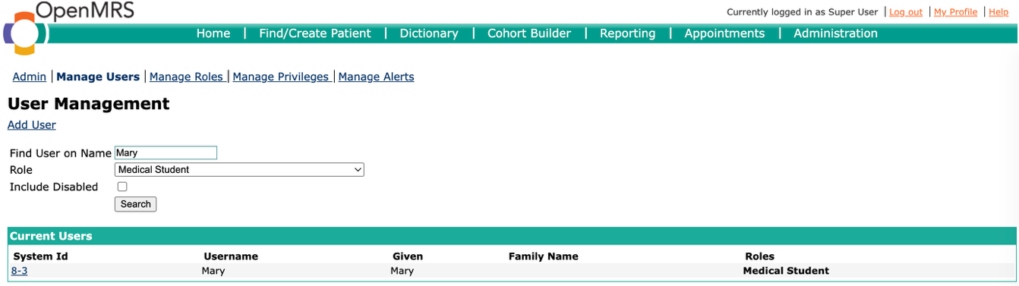
Figure 2: Assign a role to Mary

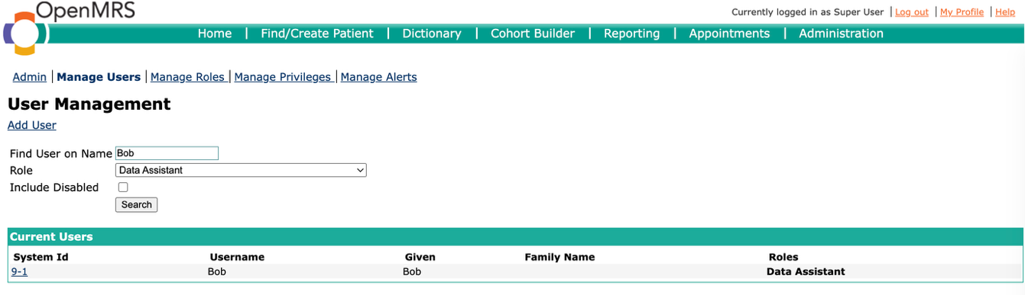
Figure 3: Assign a role to Bob

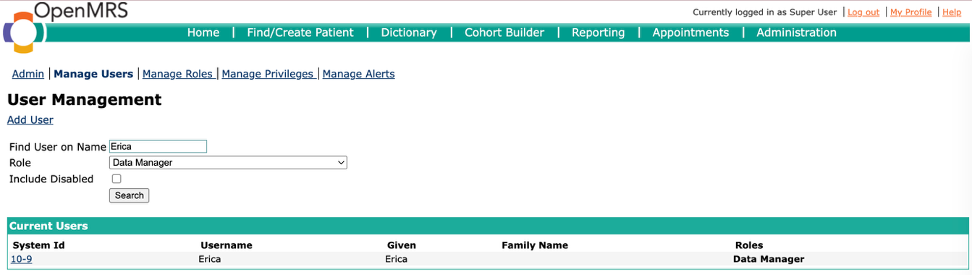
Figure 4: Assign a role to Erica

Exercise 4 (2.0 point)
To systematically manage the complex privilege matrix and eliminate redundancy within the OpenMRS RBAC framework, a Role Abstraction Strategy has been implemented. Rather than assigning privileges directly to job titles, the architecture introduces "Abstract Base Roles". These base roles function as inheritable privilege containers spanning common operational domains.

Definition of Abstract Base Roles
The following foundational modules have been established to streamline privilege inheritance:
- Base Patient Manager: Aggregates core demographic controls.
- Privileges:
- Add Patients
- Edit Patients
- View Patients

- Base Encounter Manager: Centralizes clinical interaction tracking.
- Privileges:
- Add Encounters
- Edit Encounters
- View Encounters

- Base Laboratory Manager: Consolidates testing and diagnostics operations.
- Privileges:
- Add Laboratory Orders
- Edit Laboratory Orders
- View Laboratory Orders

- Base Dietary Manager: Manages nutritional instructions.
- Privileges:
- Add Diet Orders
- Edit Diet Orders
- View Diet Orders

- Base Identity Administrator: Encompasses basic account provisioning.
- Privileges:
- Add Users
- Edit Users
- View Users

The Inherited Role Hierarchy Matrix
By applying the base roles defined above, the functional job titles are constructed through inheritance, minimizing direct privilege assignments:

Functional Role | Inherited Base Roles (Parent Roles) | Additional Direct Privileges
Nurse | Base Patient Manager  Base Laboratory Manager | Add/Edit/View Observations  Add/Edit/View Reports
Doctor | Base Patient Manager  Base Laboratory Manager  Base Encounter Manager | Add/Edit/View Visits
Health Secretary | Base Encounter Manager  Base Dietary Manager | (No additional privileges required)
Dentist | Base Encounter Manager Base Dietary Manager | (No additional privileges required)
Physiotherapist | Base Encounter Manager | Add/Edit/View Physiotherapy Orders
Psychologist | Base Encounter Manager | Add/Edit/View Psychology Orders
Radiologist | Base Laboratory Manager | Add/Edit/View Radiology Orders
Registration Clerk | Base Patient Manager  Base Identity Administrator | Add/Edit/View Appointments
System Administrator | Base Identity Administrator | Add/Edit User Passwords  Add/Edit/View Roles
Ambulance Personnel | (Standalone Role - No inheritance) | View Patients  Add Reports
Table 2: Functional role hierarchy matrix illustrating the inheritance of abstract base roles and the assignment of additional direct privileges

Architectural Security Rationale
This hierarchical design is grounded in several core information security principles:
- Principle of Least Privilege (PoLP): The granular nature of the base roles ensures that each functional role is provisioned with the exact minimum permissions necessary for its workflow, strictly mitigating the risk of over-privileging.
- Separation of Duties (SoD): High-risk administrative capabilities (e.g., role and password management) are intentionally isolated within the System Administrator profile, preventing clinical staff from tampering with access control mechanisms.
- Architectural Scalability: Utilizing inheritance modules significantly reduces administrative overhead. Any future policy changes regarding a specific domain (e.g., modifying encounter access) only require a single update to the corresponding Base Role, which automatically cascades to all inheriting operational roles.

Exercise 5 (2.0 point)
The theoretical Role-Based Access Control (RBAC) hierarchy designed in Exercise 4 was successfully instantiated within the OpenMRS environment. The implementation process followed a strict bottom-up architectural approach to ensure systemic integrity:
- Privilege Provisioning: Custom privileges that were not natively available in the OpenMRS Demo (e.g., Add/Edit/View Diet Orders, Add/Edit/View Physiotherapy Orders) were manually registered into the system's privilege repository.
- Base Role Instantiation: The abstract base roles (e.g., Base Patient Manager, Base Encounter Manager) were created and explicitly mapped to their respective atomic privileges.
- Functional Role Implementation & Inheritance Binding: The functional job roles (e.g., Doctor, Nurse) were constructed. Instead of assigning individual privileges, the principle of inheritance was applied. For instance, the Doctor role was configured to inherit all permissions from Base Patient Manager, Base Laboratory Manager, and Base Encounter Manager, with only the specific Add/Edit/View Visits privilege assigned directly.

This inheritance-based configuration significantly reduces the complexity of the access control matrix and streamlines future administrative modifications.

Implementation Evidence:
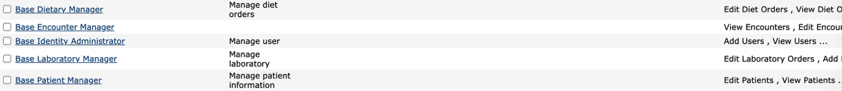
Figure 5: Comprehensive list of defined roles in OpenMRS, illustrating the integration of abstract base roles and functional job titles

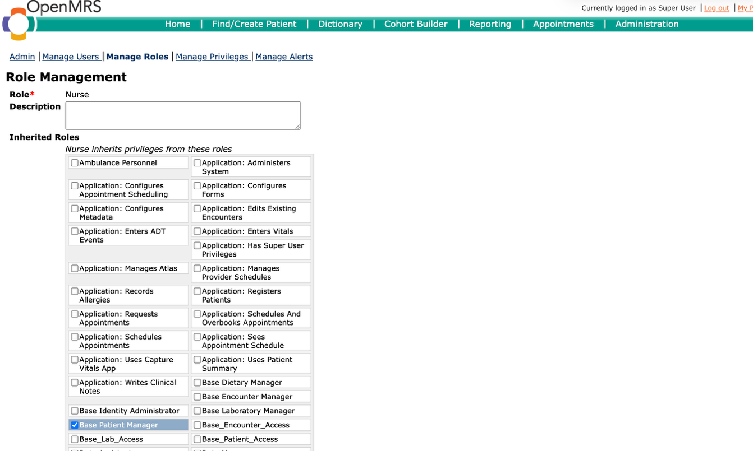
Figure 6: Detailed configuration of the 'Nurse' role, demonstrating the functional implementation of privilege inheritance from multiple base modules 1

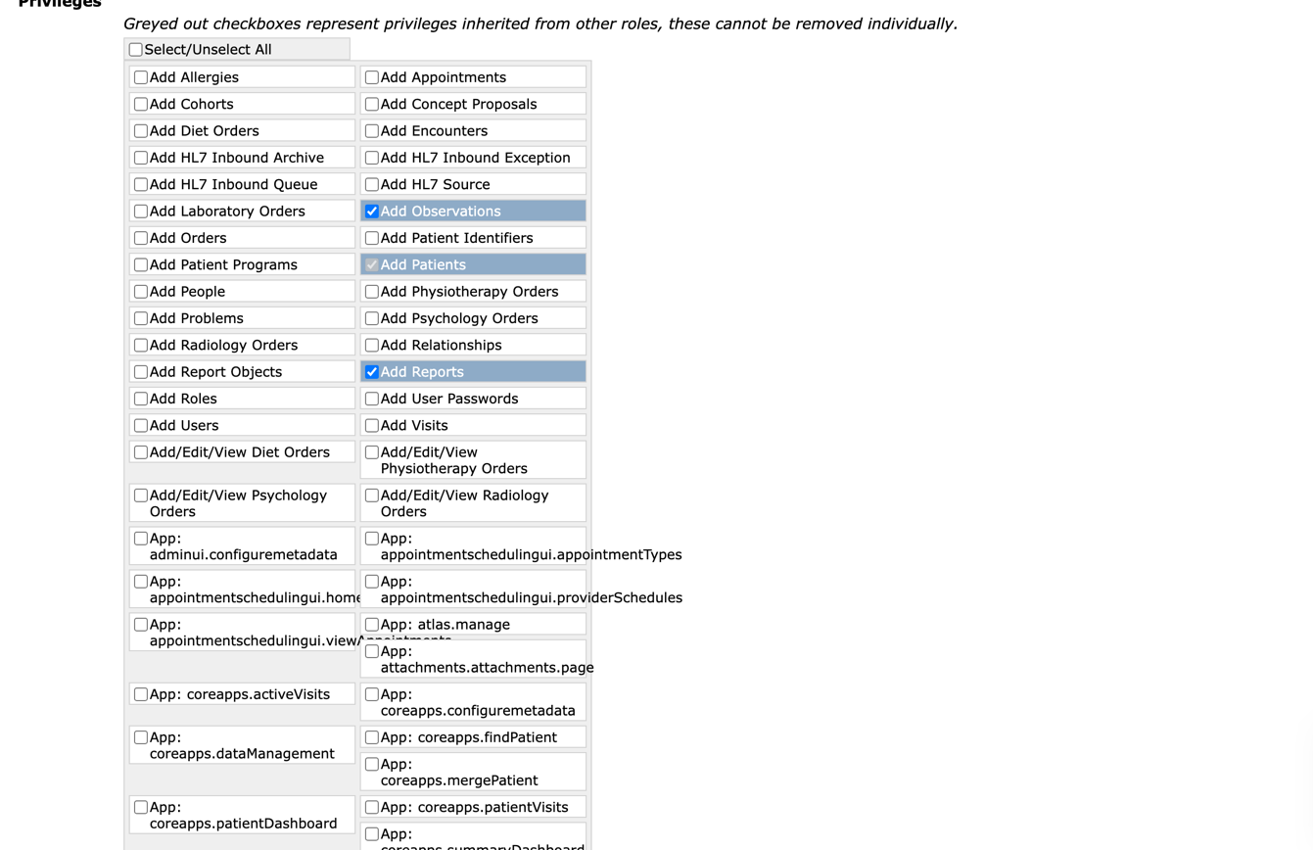
Figure 7: Detailed configuration of the 'Nurse' role, demonstrating the functional implementation of privilege inheritance from multiple base modules 2

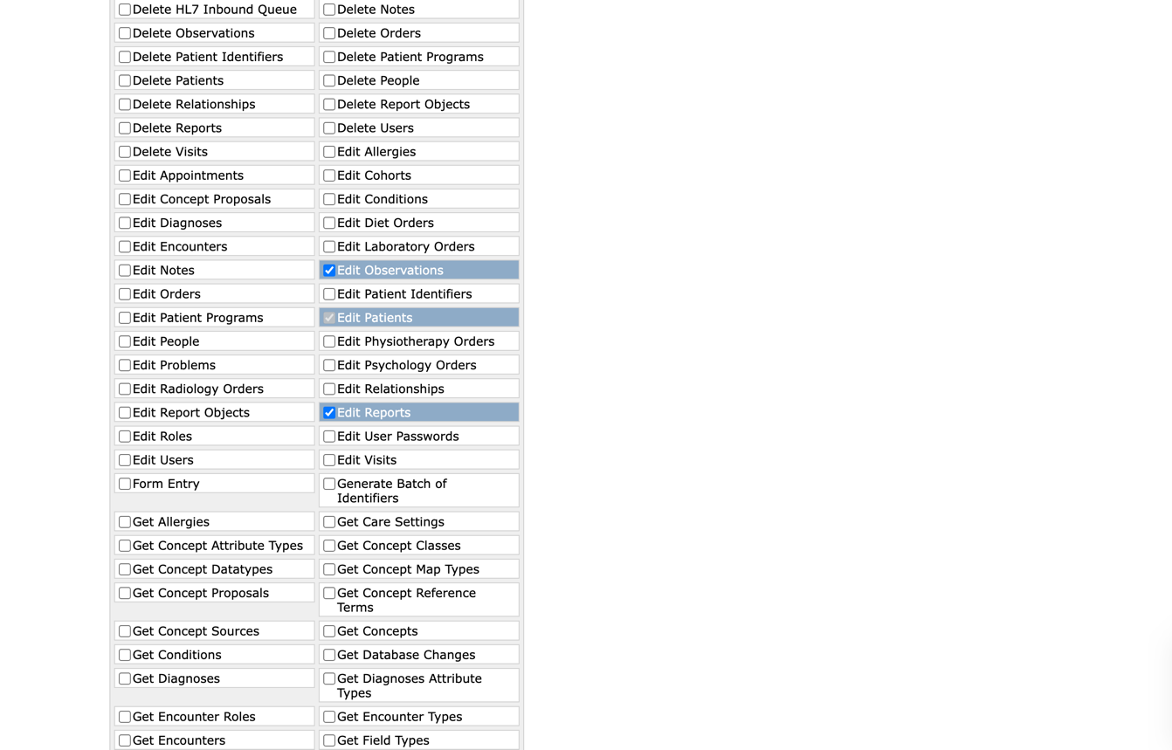
Figure 8: Detailed configuration of the 'Nurse' role, demonstrating the functional implementation of privilege inheritance from multiple base modules 3

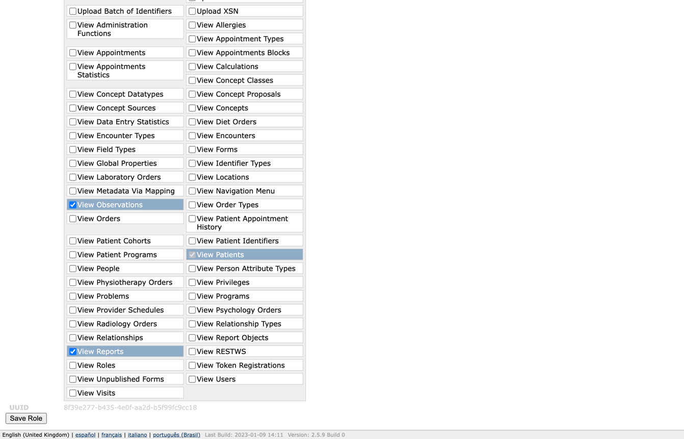
Figure 9: Detailed configuration of the 'Nurse' role, demonstrating the functional implementation of privilege inheritance from multiple base modules 4

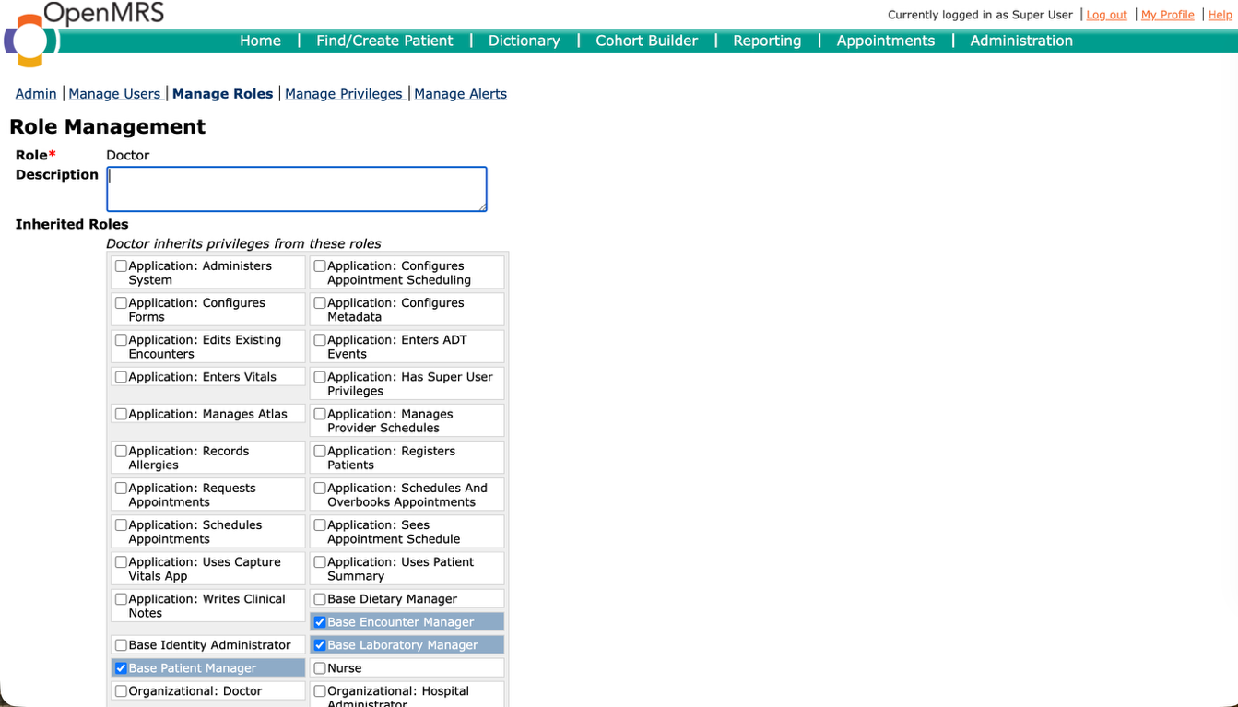
Figure 10: Detailed configuration of the 'Doctor' role, demonstrating the functional implementation of privilege inheritance from multiple base modules 1

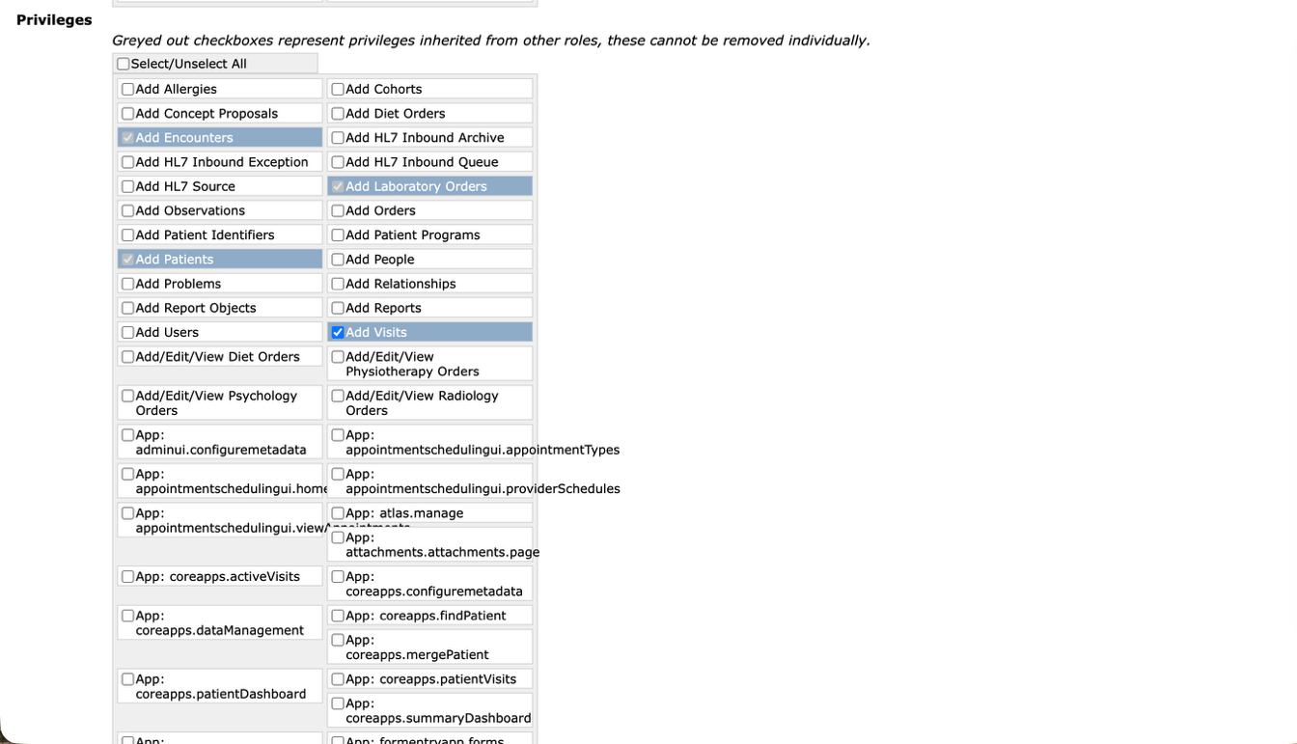
Figure 11: Detailed configuration of the 'Doctor' role, demonstrating the functional implementation of privilege inheritance from multiple base modules 2

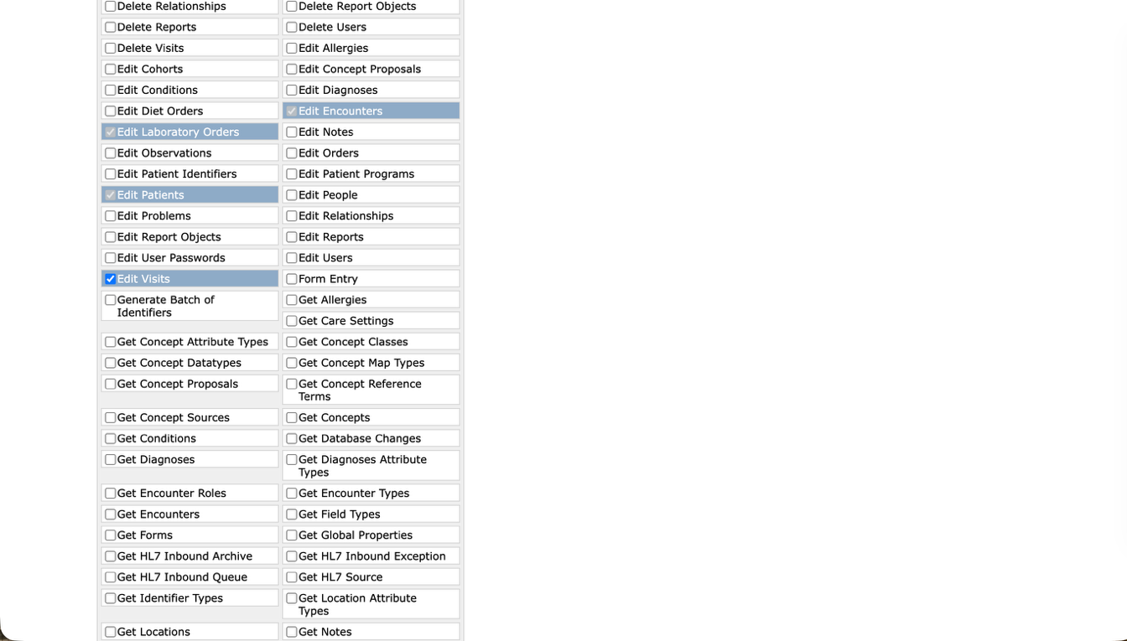
Figure 12: Detailed configuration of the 'Doctor' role, demonstrating the functional implementation of privilege inheritance from multiple base modules 3

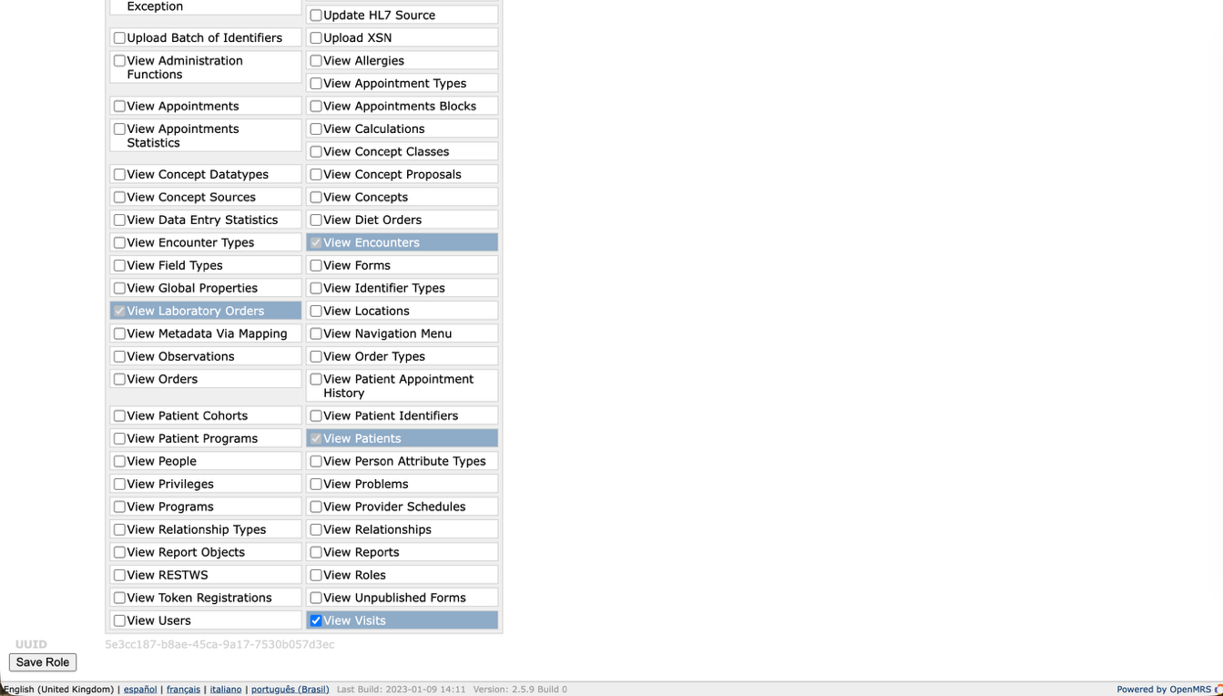
Figure 13: Detailed configuration of the 'Doctor' role, demonstrating the functional implementation of privilege inheritance from multiple base modules 4

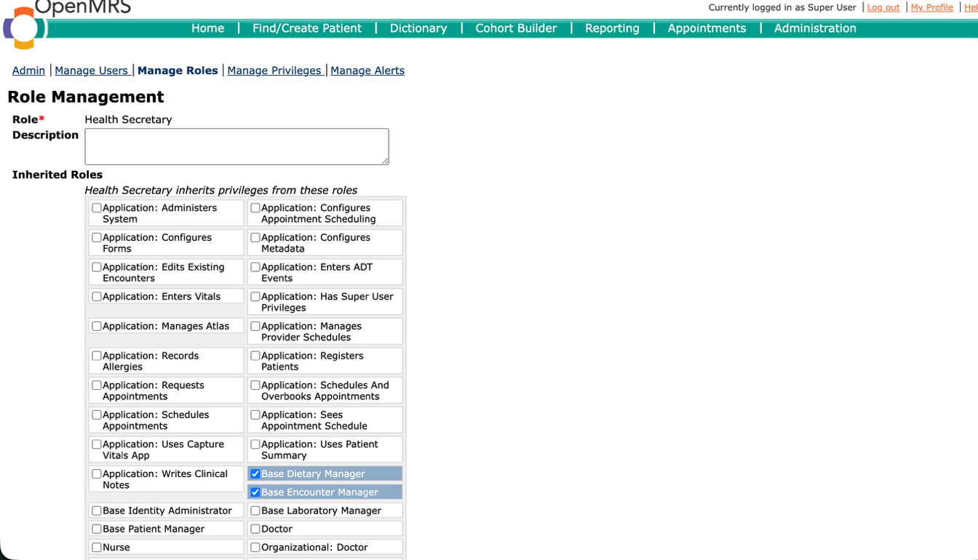
Figure 14: Detailed configuration of the 'Health Secrectary' role, demonstrating the functional implementation of privilege inheritance from multiple base modules 1

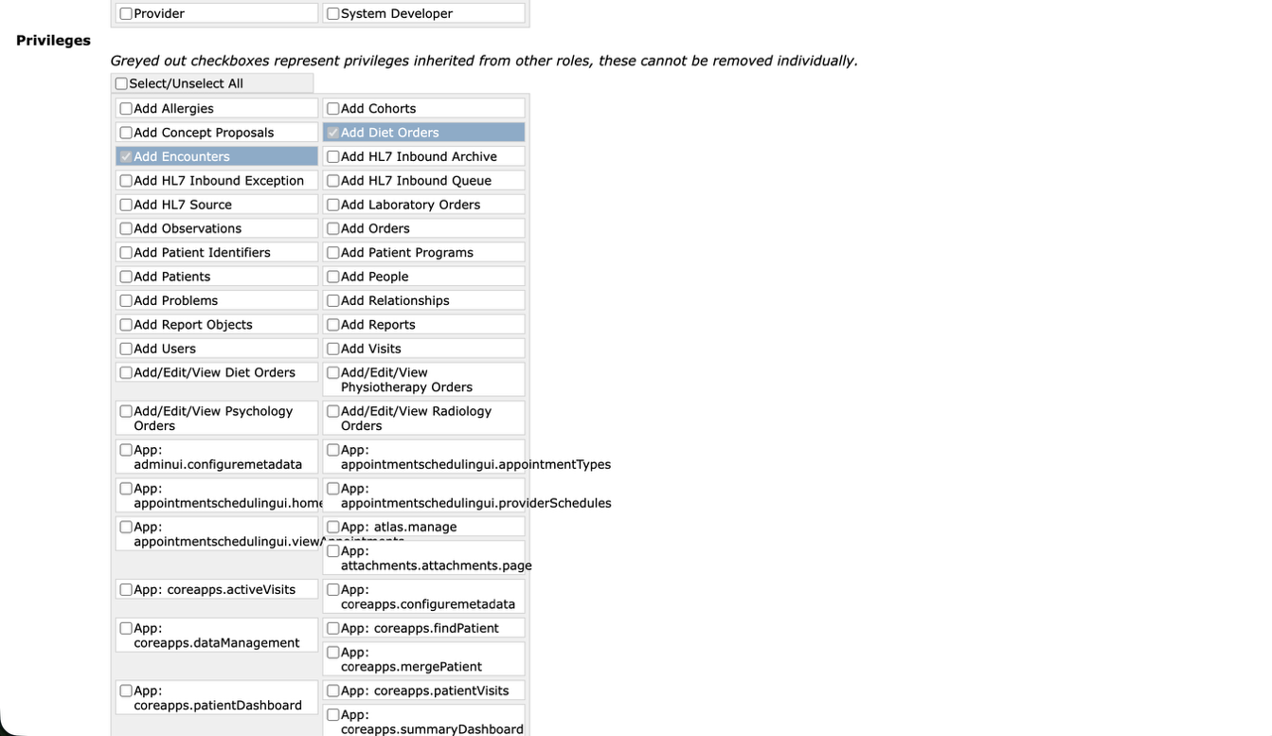
Figure 15: Detailed configuration of the 'Health Secrectary' role, demonstrating the functional implementation of privilege inheritance from multiple base modules 2

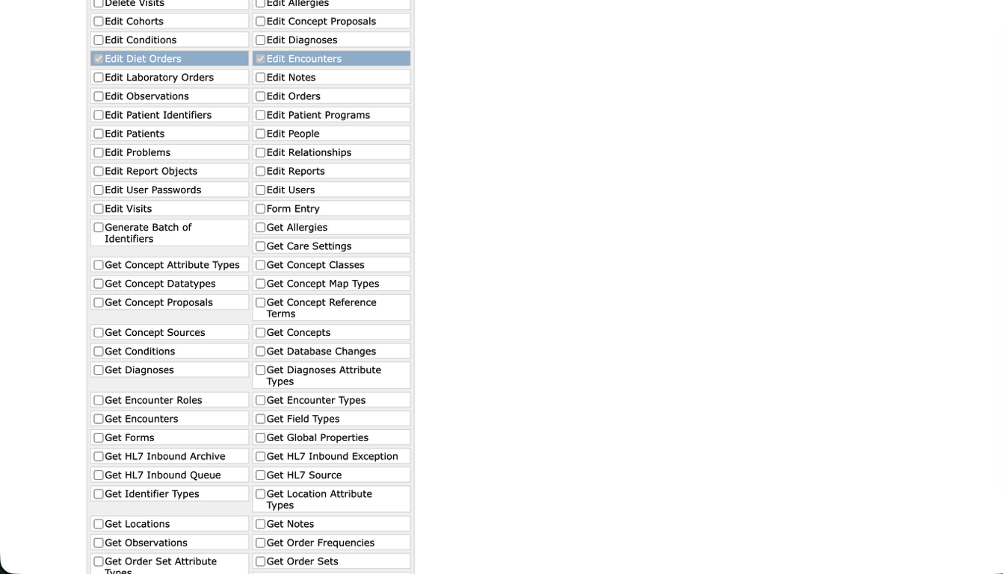
Figure 16: Detailed configuration of the 'Health Secrectary' role, demonstrating the functional implementation of privilege inheritance from multiple base modules 3

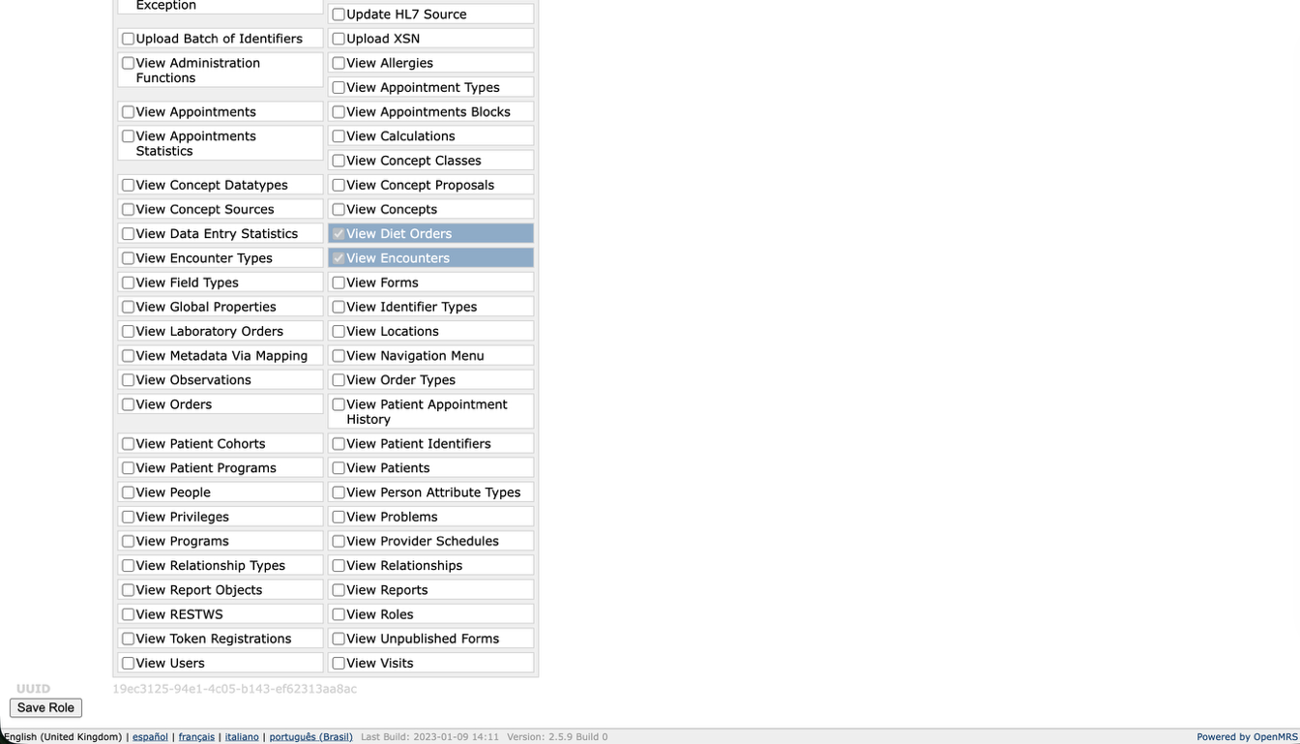Figure 17: Detailed configuration of the 'Health Secrectary' role, demonstrating the functional implementation of privilege inheritance from multiple base modules 4

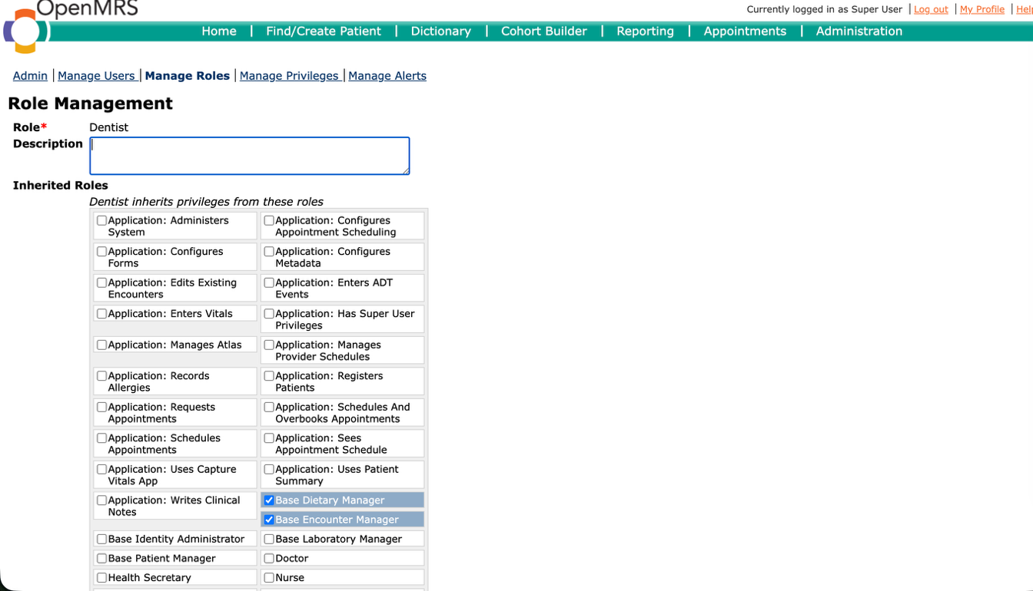
Figure 18: Detailed configuration of the 'Dentist' role, demonstrating the functional implementation of privilege inheritance from multiple base modules 1

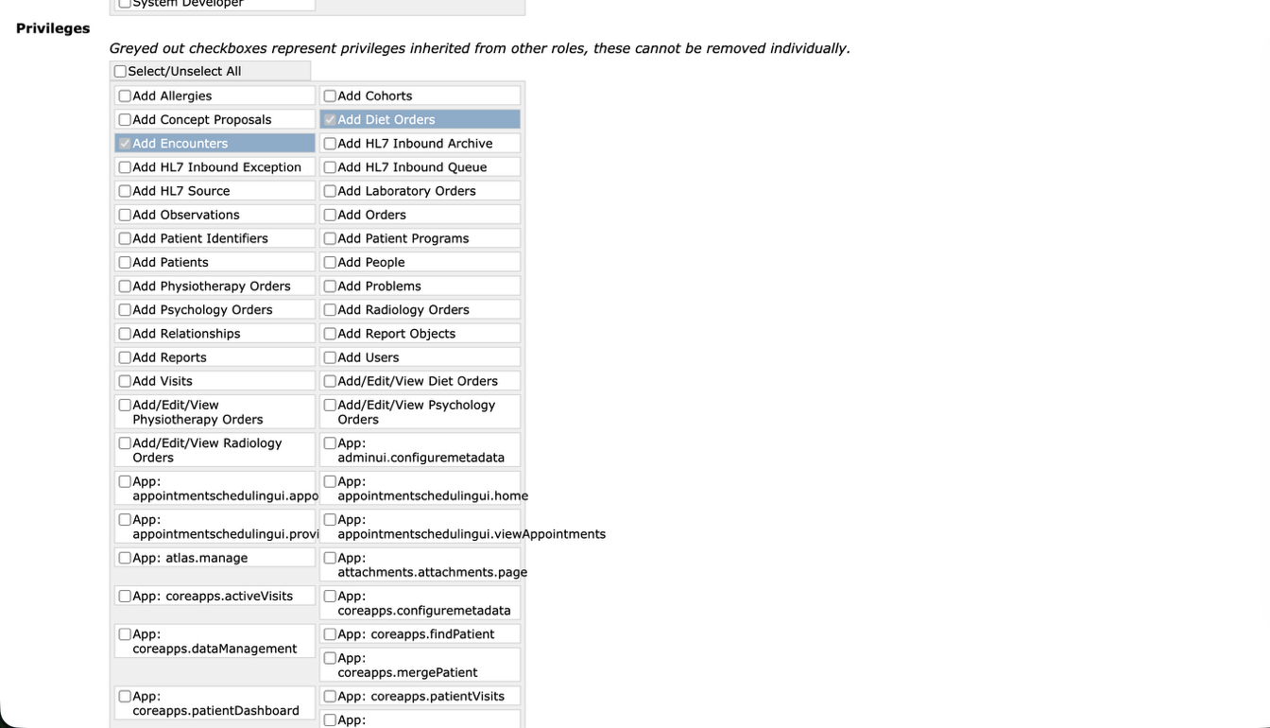
Figure 19: Detailed configuration of the 'Dentist' role, demonstrating the functional implementation of privilege inheritance from multiple base modules 2

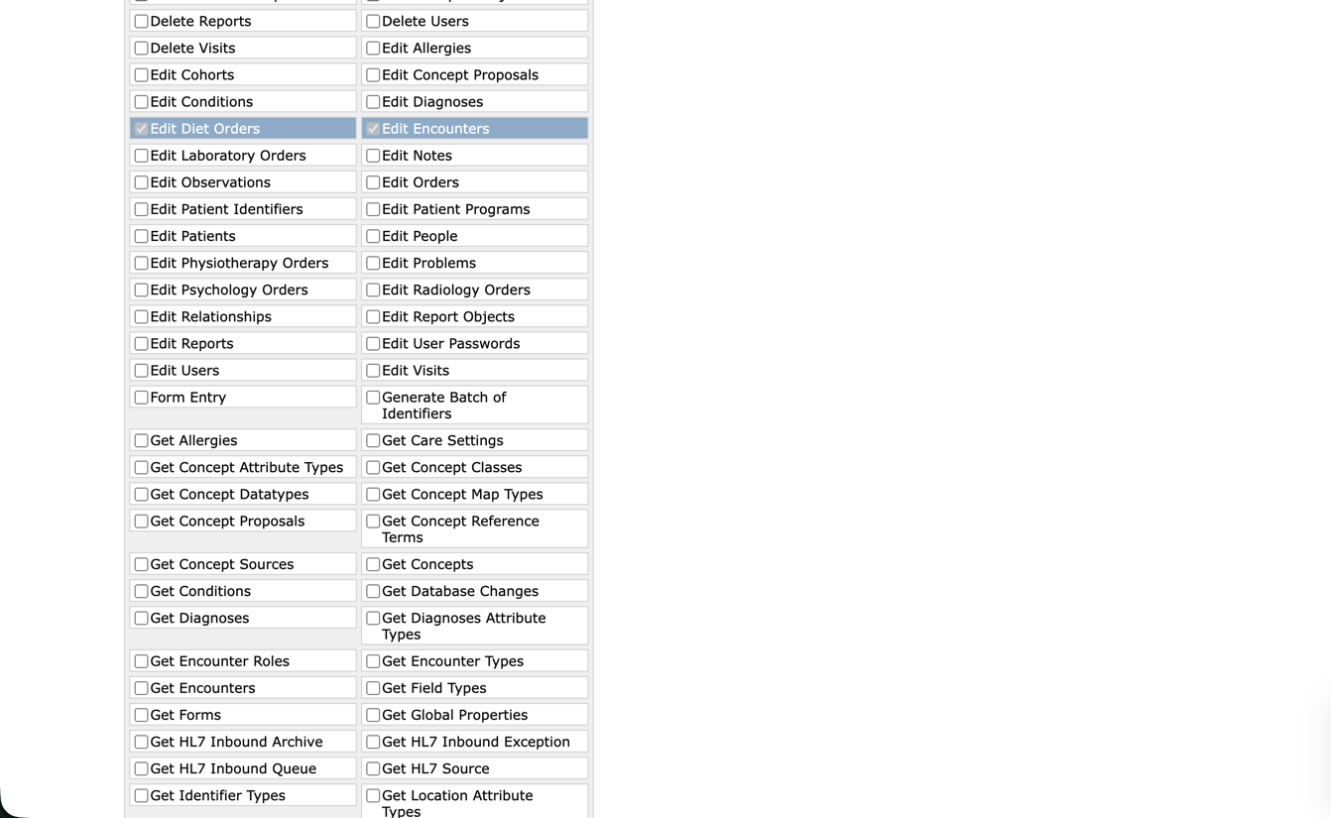
Figure 20: Detailed configuration of the 'Dentist' role, demonstrating the functional implementation of privilege inheritance from multiple base modules 3

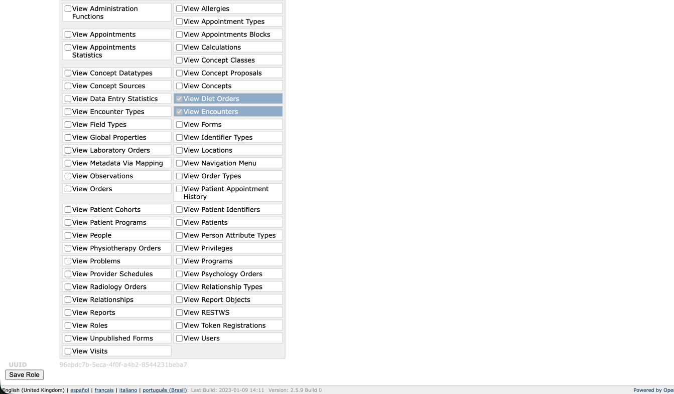
Figure 21: Detailed configuration of the 'Dentist' role, demonstrating the functional implementation of privilege inheritance from multiple base modules 4

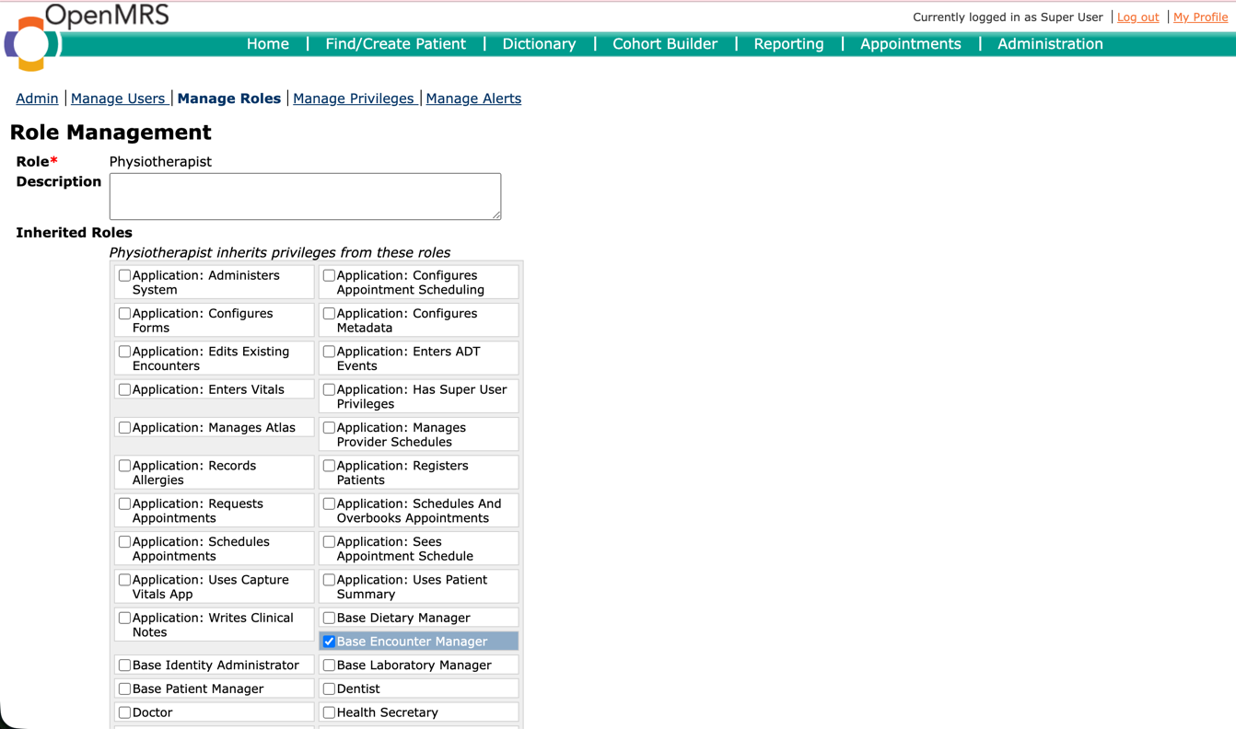
Figure 22: Detailed configuration of the 'Physiotherapist' role, demonstrating the functional implementation of privilege inheritance from multiple base modules 1

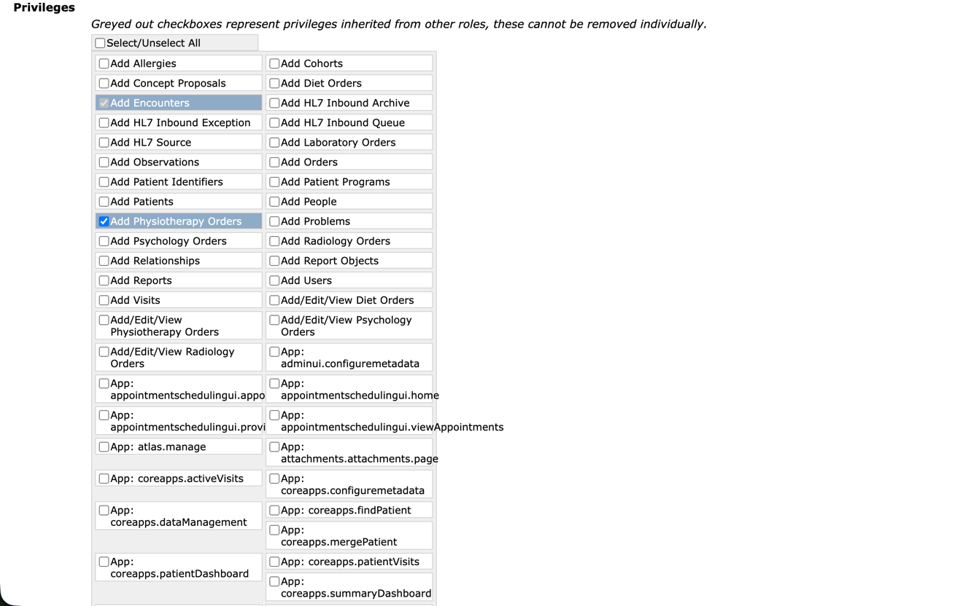
Figure 23: Detailed configuration of the 'Physiotherapist' role, demonstrating the functional implementation of privilege inheritance from multiple base modules 2

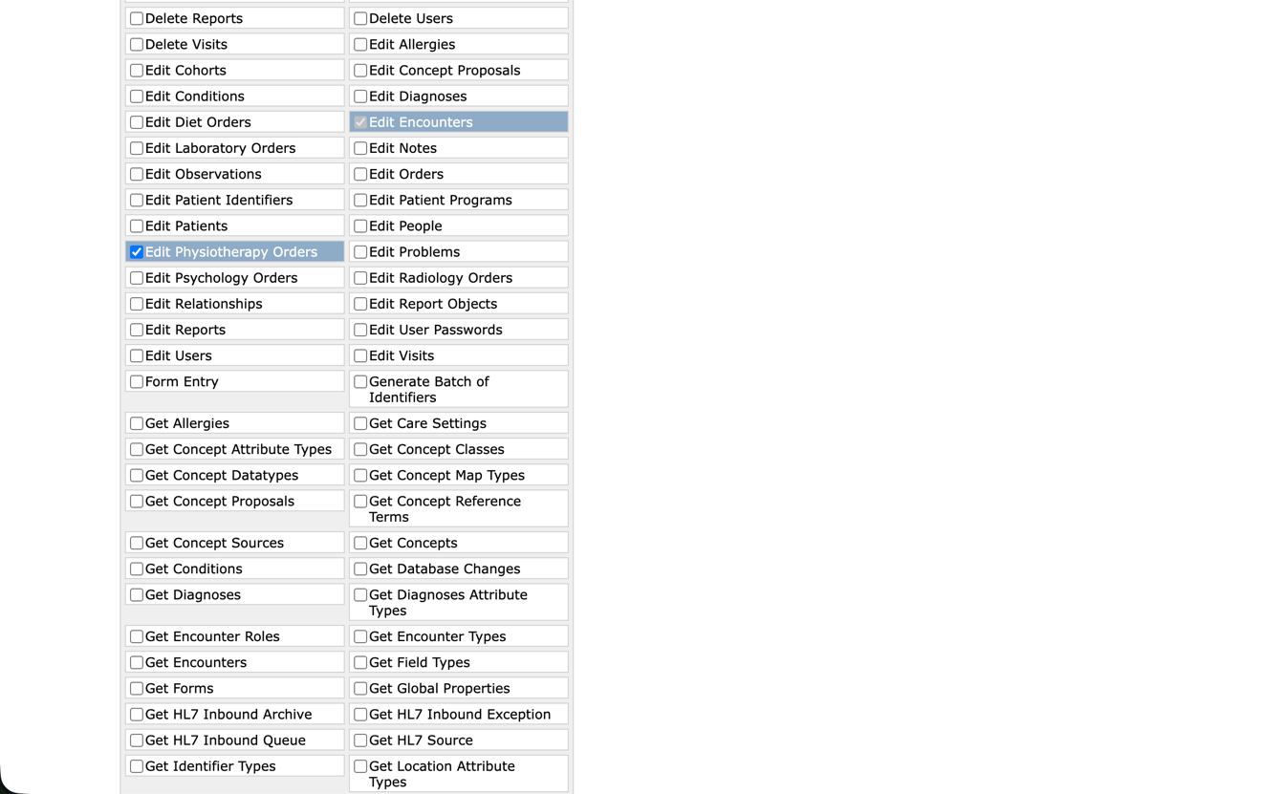
Figure 24: Detailed configuration of the 'Physiotherapist' role, demonstrating the functional implementation of privilege inheritance from multiple base modules 3

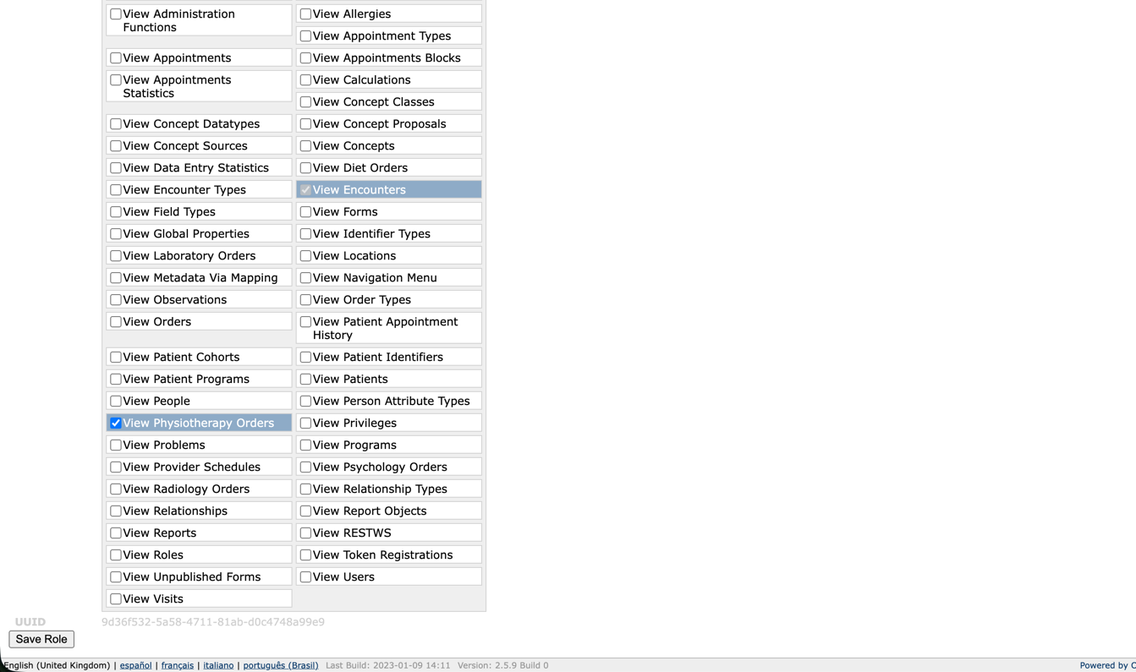
Figure 25: Detailed configuration of the 'Physiotherapist' role, demonstrating the functional implementation of privilege inheritance from multiple base modules 4

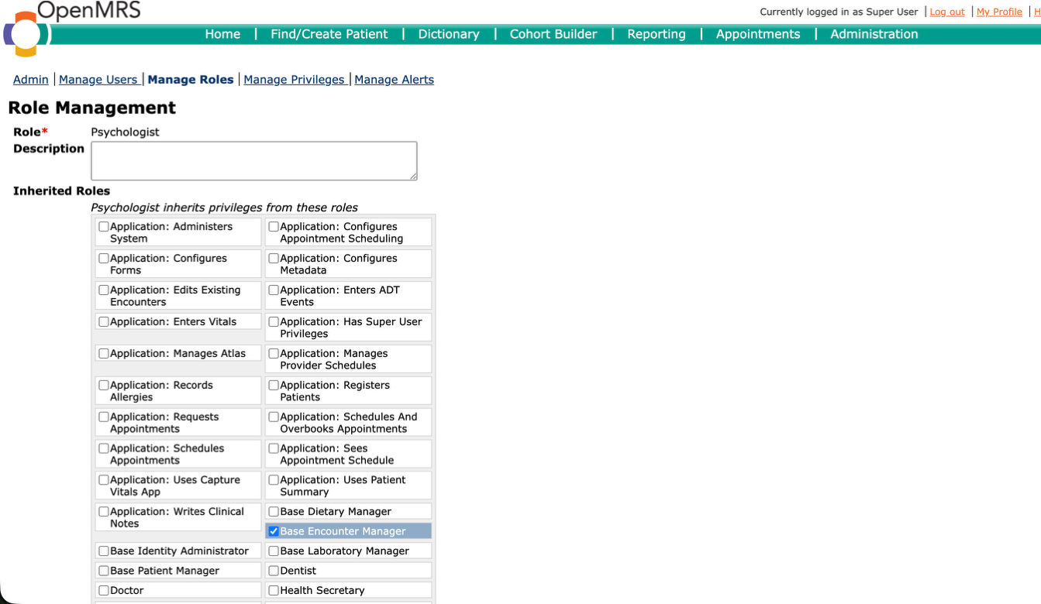
Figure 26: Detailed configuration of the 'Psychologist' role, demonstrating the functional implementation of privilege inheritance from multiple base modules 1

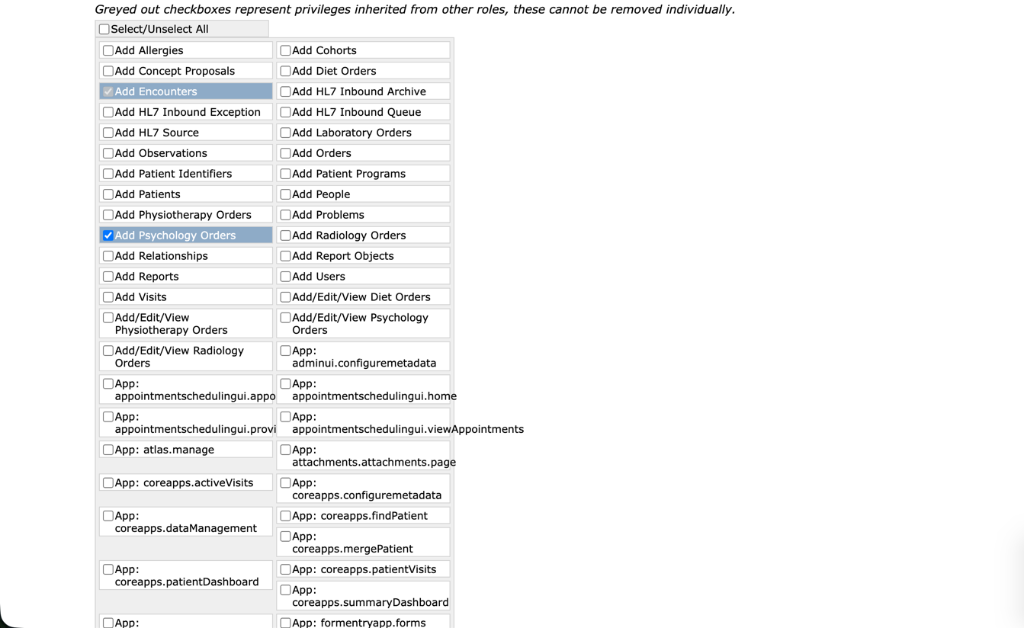
Figure 27: Detailed configuration of the 'Psychologist' role, demonstrating the functional implementation of privilege inheritance from multiple base modules 2

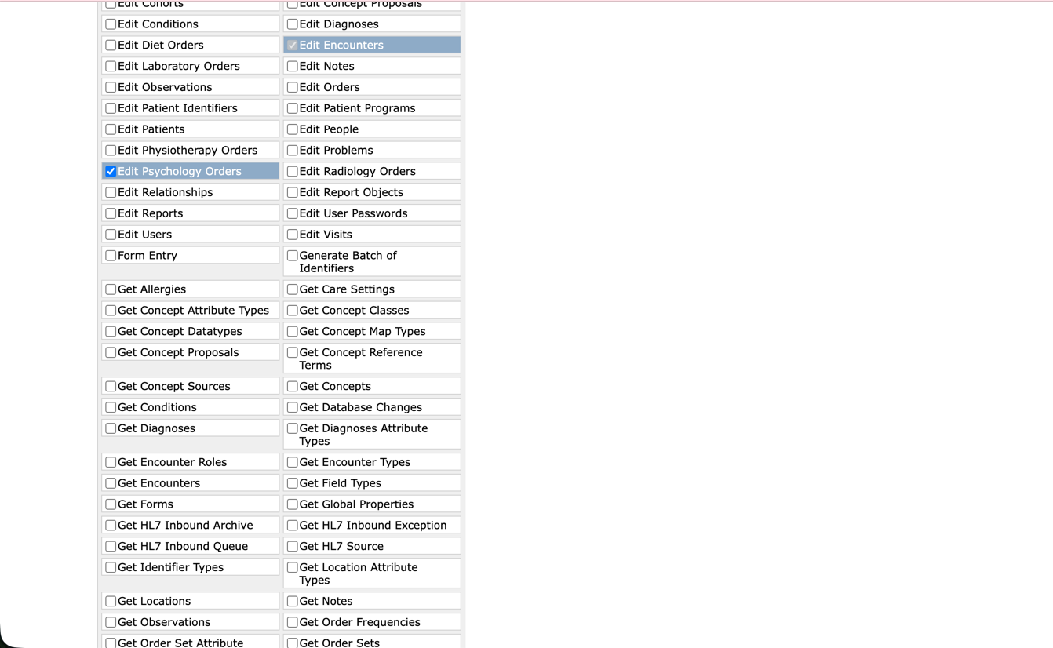
Figure 28: Detailed configuration of the 'Psychologist' role, demonstrating the functional implementation of privilege inheritance from multiple base modules 3

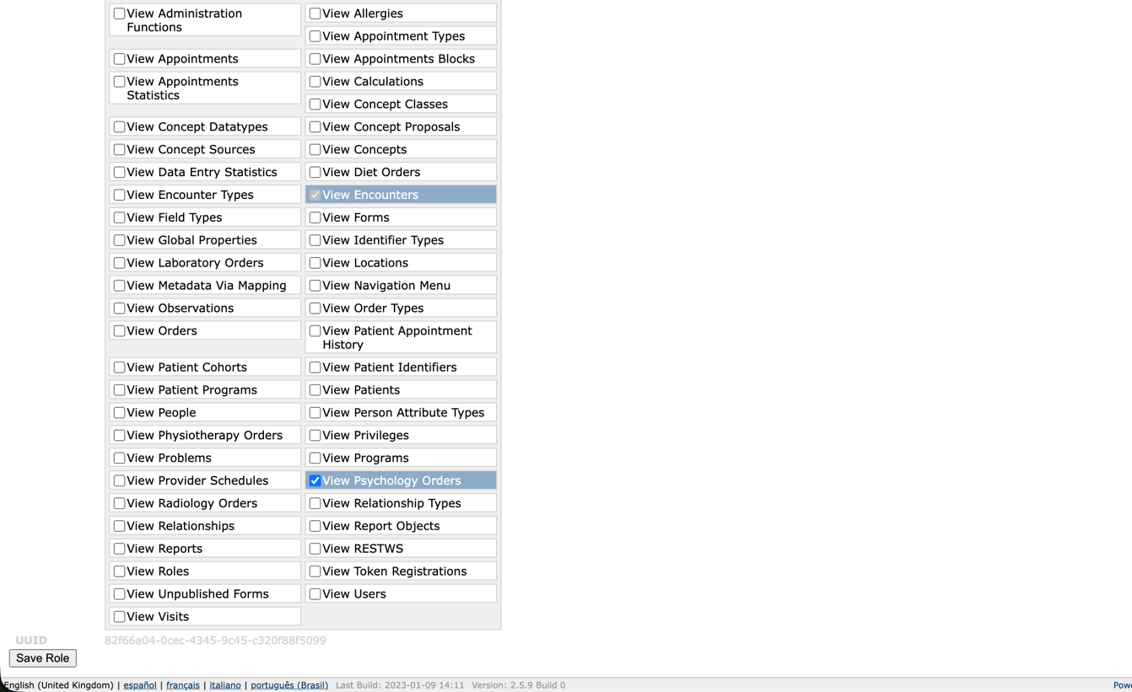
Figure 29: Detailed configuration of the 'Psychologist' role, demonstrating the functional implementation of privilege inheritance from multiple base modules 4

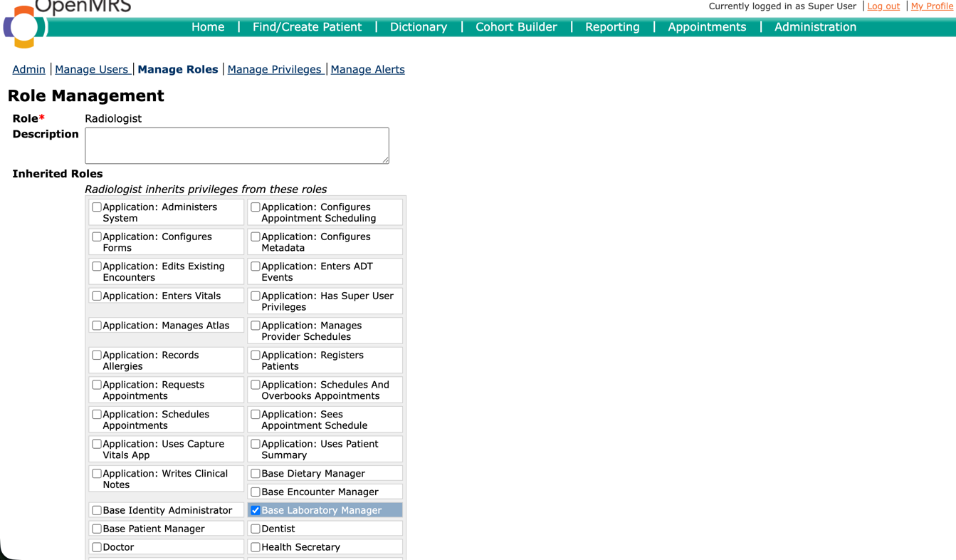
Figure 30: Detailed configuration of the 'Radiologist' role, demonstrating the functional implementation of privilege inheritance from multiple base modules 1

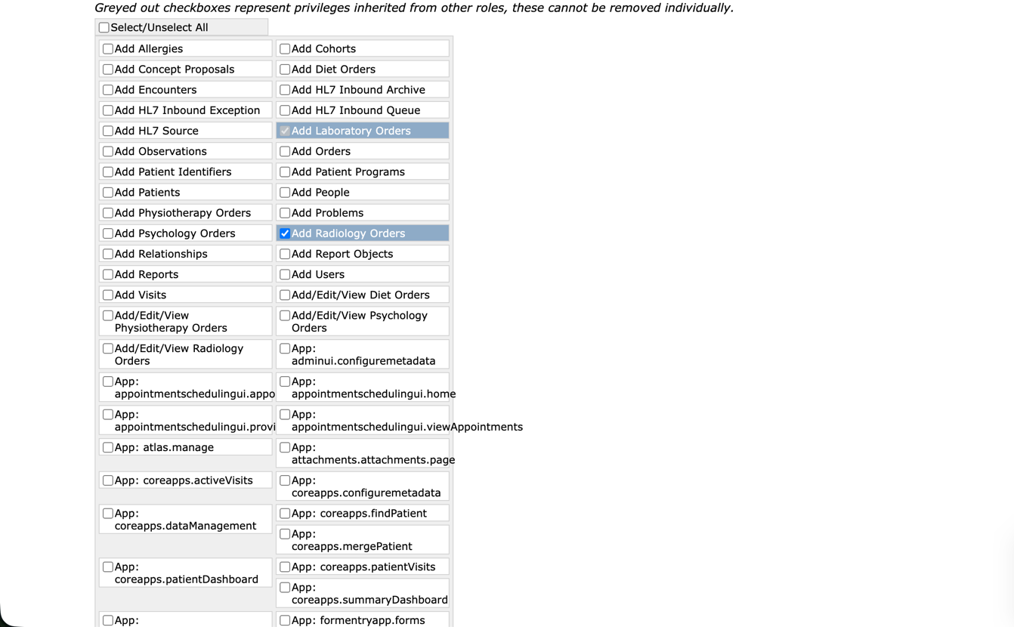
Figure 31: Detailed configuration of the 'Radiologist' role, demonstrating the functional implementation of privilege inheritance from multiple base modules 2

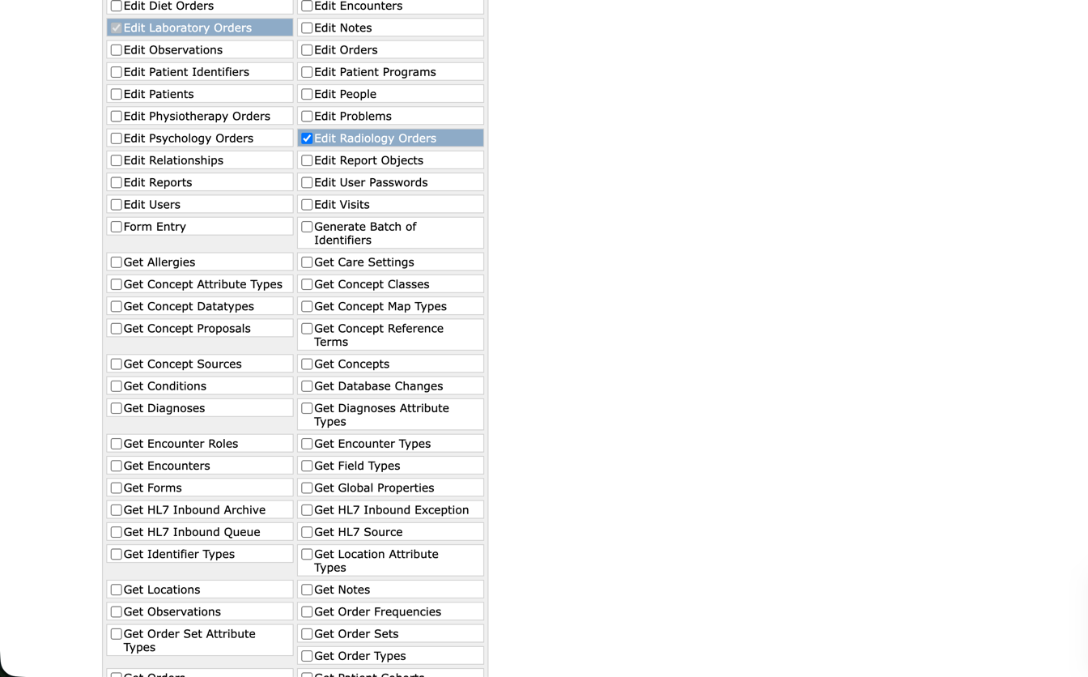
Figure 32: Detailed configuration of the 'Radiologist' role, demonstrating the functional implementation of privilege inheritance from multiple base modules 3

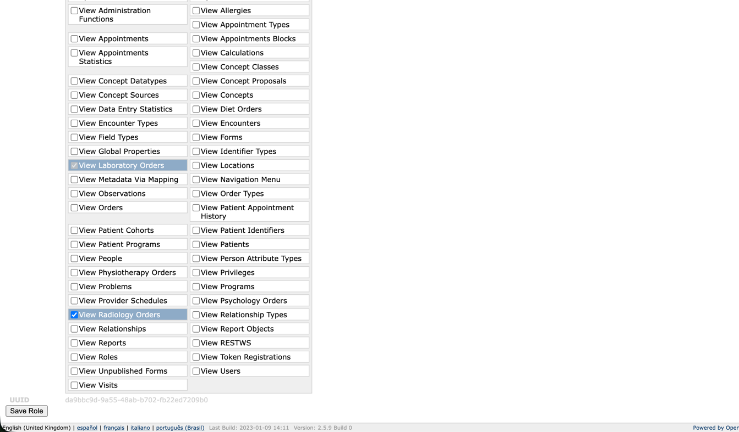
Figure 33: Detailed configuration of the 'Radiologist' role, demonstrating the functional implementation of privilege inheritance from multiple base modules 4

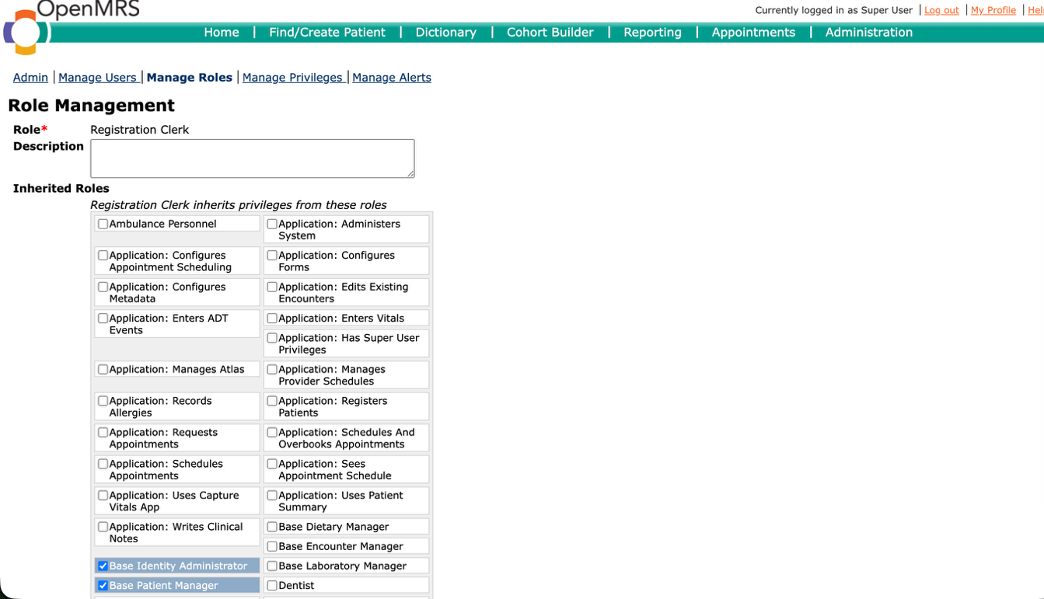
Figure 34: Detailed configuration of the 'Registration Clerk' role, demonstrating the functional implementation of privilege inheritance from multiple base modules 1

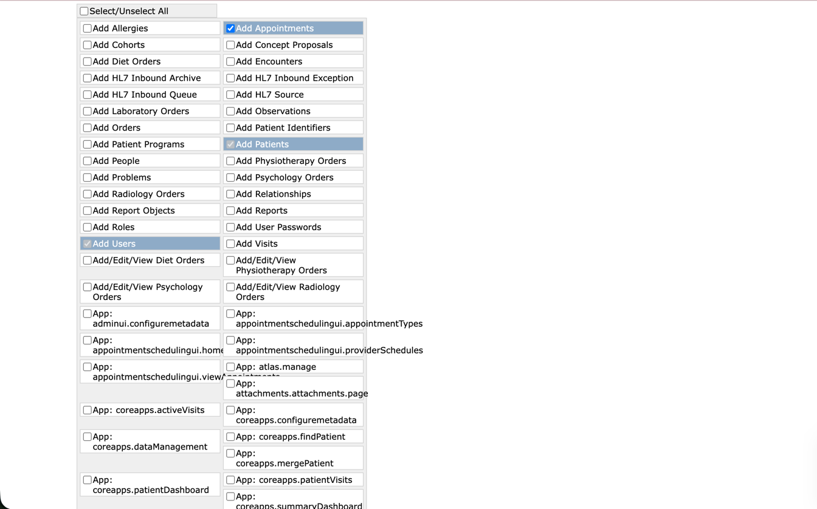
Figure 35: Detailed configuration of the 'Registration Clerk' role, demonstrating the functional implementation of privilege inheritance from multiple base modules 2

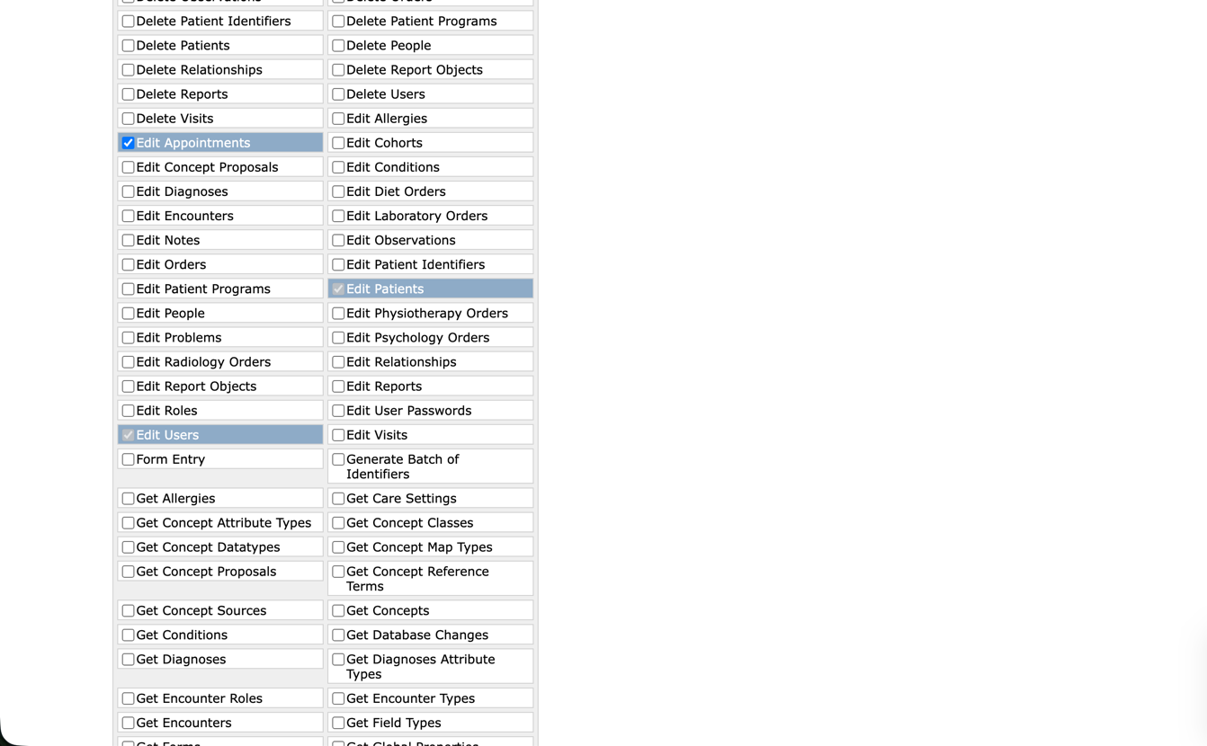
Figure 36: Detailed configuration of the 'Registration Clerk' role, demonstrating the functional implementation of privilege inheritance from multiple base modules 3

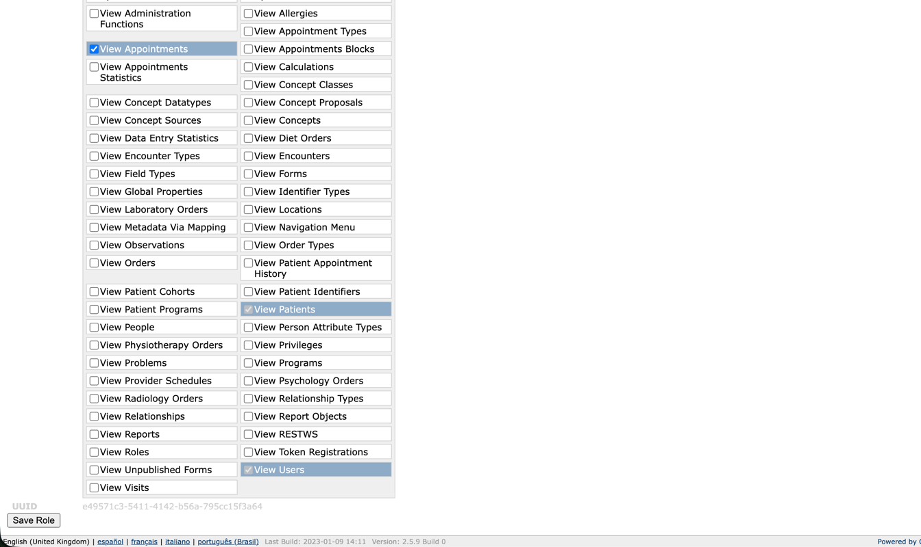
Figure 37: Detailed configuration of the 'Registration Clerk' role, demonstrating the functional implementation of privilege inheritance from multiple base modules 4

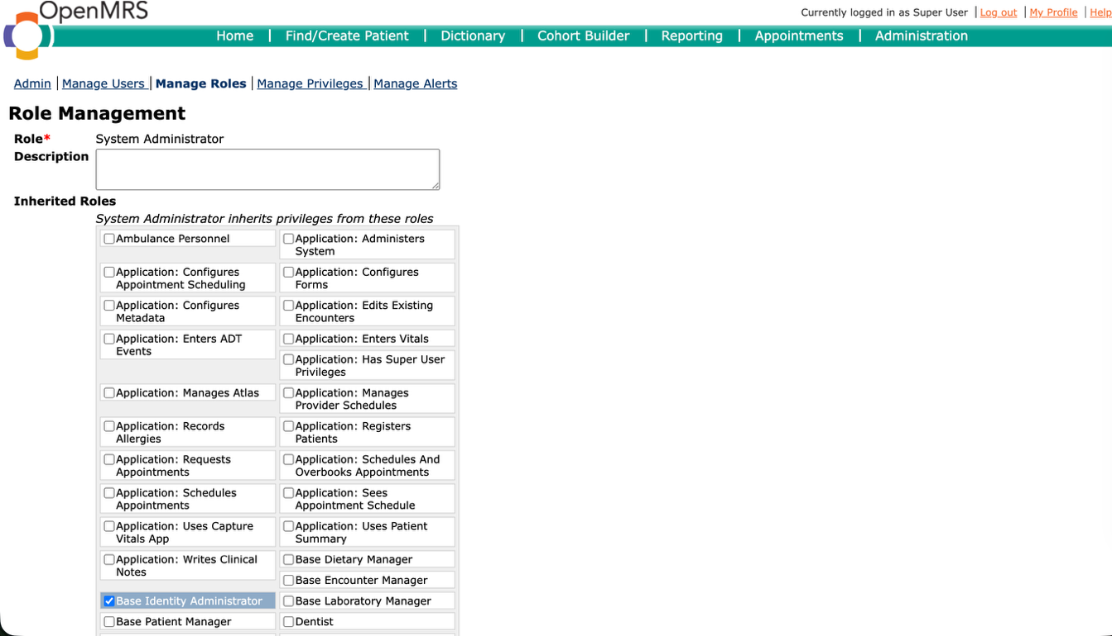
Figure 38: Detailed configuration of the 'System Administrator' role, demonstrating the functional implementation of privilege inheritance from multiple base modules 1

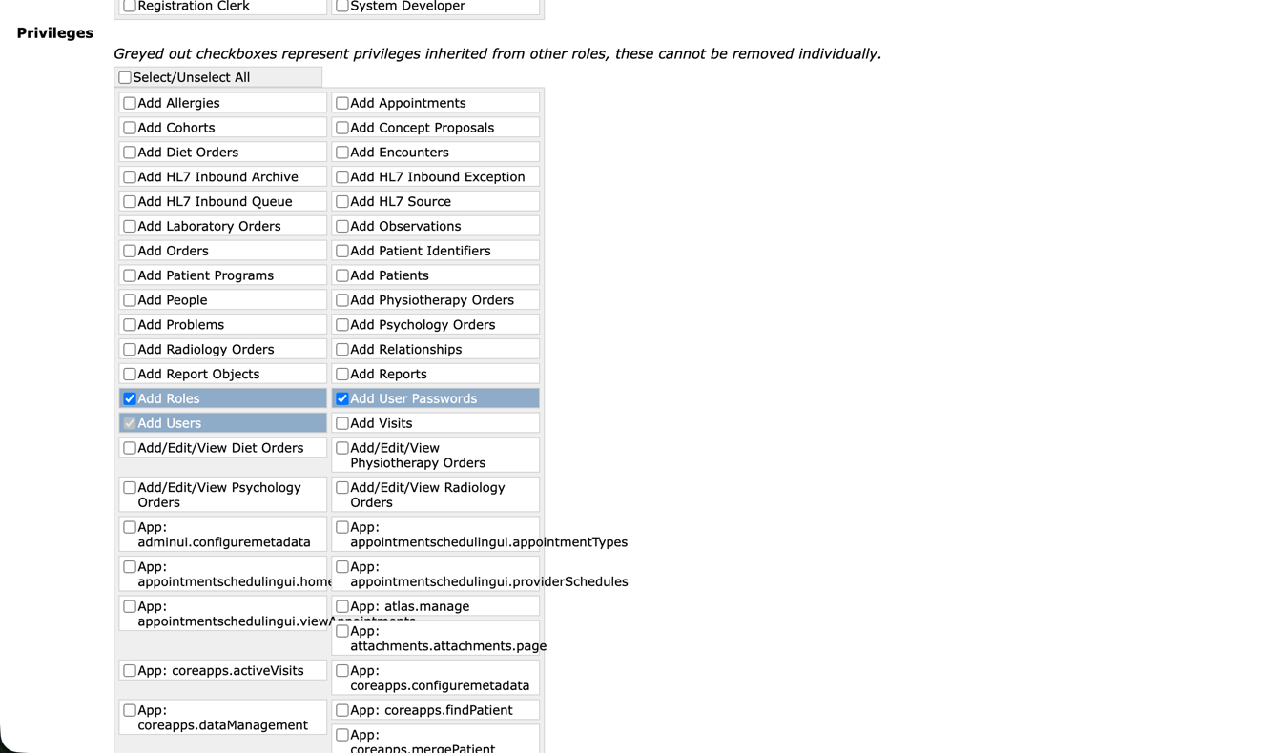
Figure 39: Detailed configuration of the 'System Administrator' role, demonstrating the functional implementation of privilege inheritance from multiple base modules 2

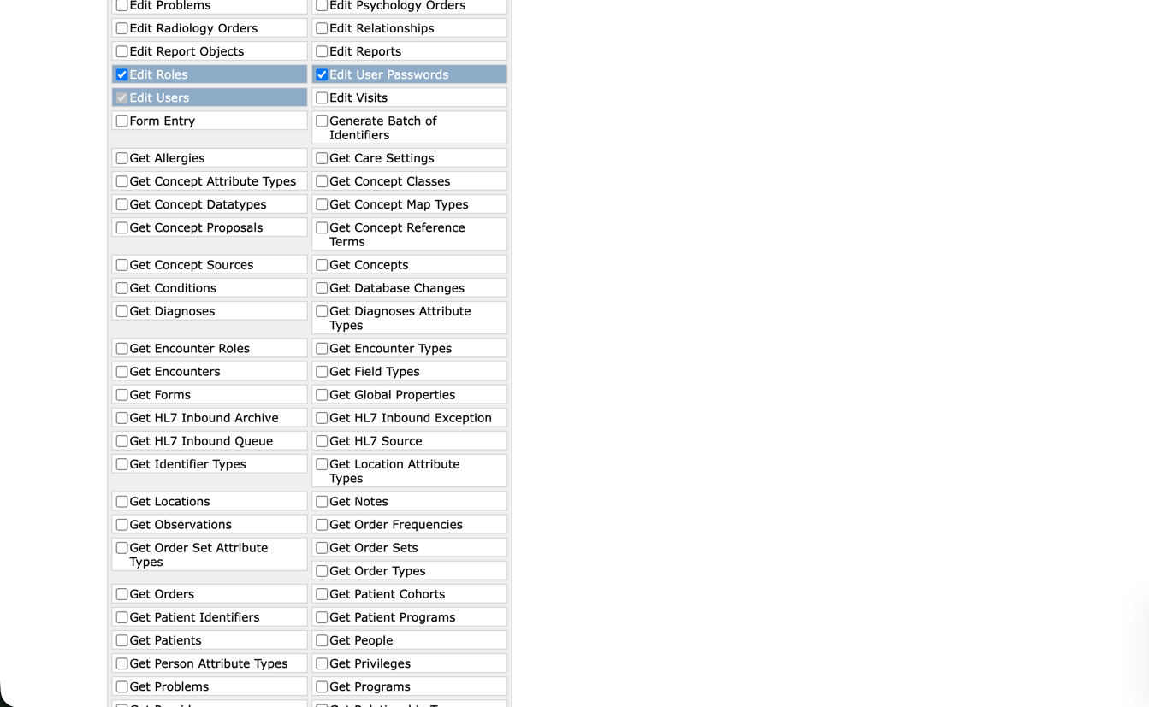
Figure 40: Detailed configuration of the 'System Administrator' role, demonstrating the functional implementation of privilege inheritance from multiple base modules 3

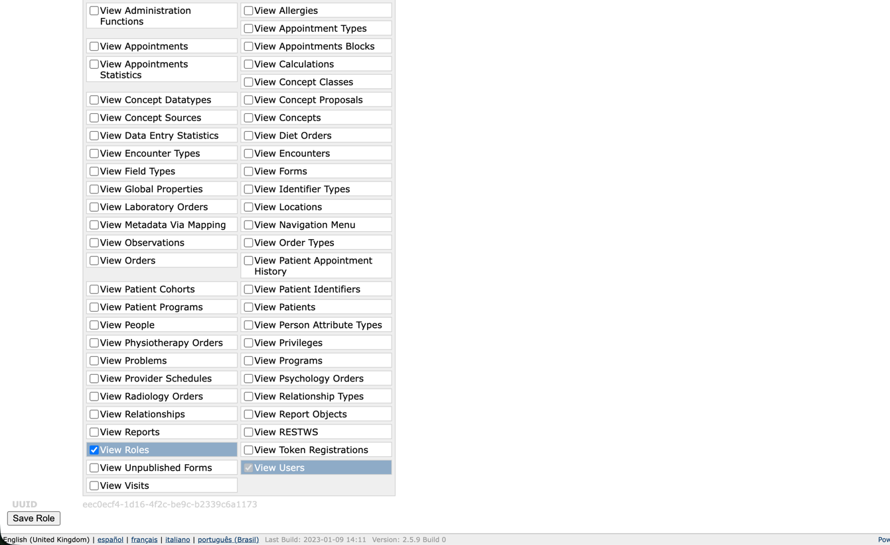
Figure 41: Detailed configuration of the 'System Administrator' role, demonstrating the functional implementation of privilege inheritance from multiple base modules 4

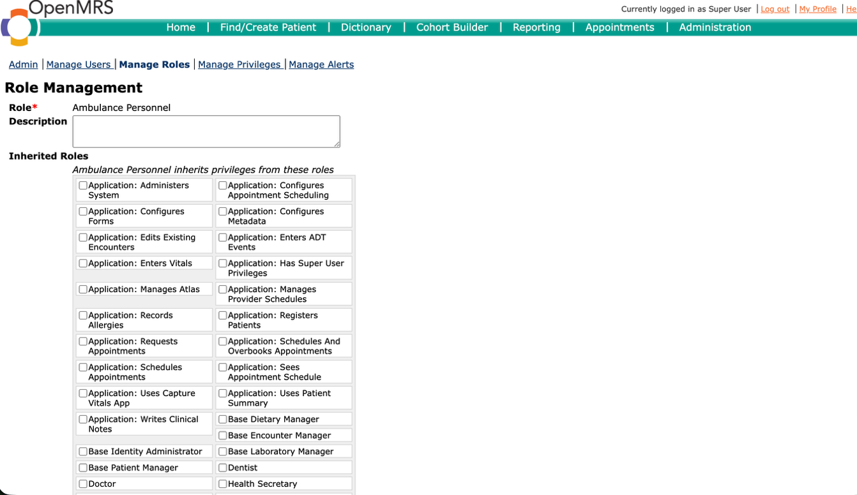
Figure 42: Detailed configuration of the 'Ambulance Personnel' role, demonstrating the functional implementation of privilege inheritance from multiple base modules 1

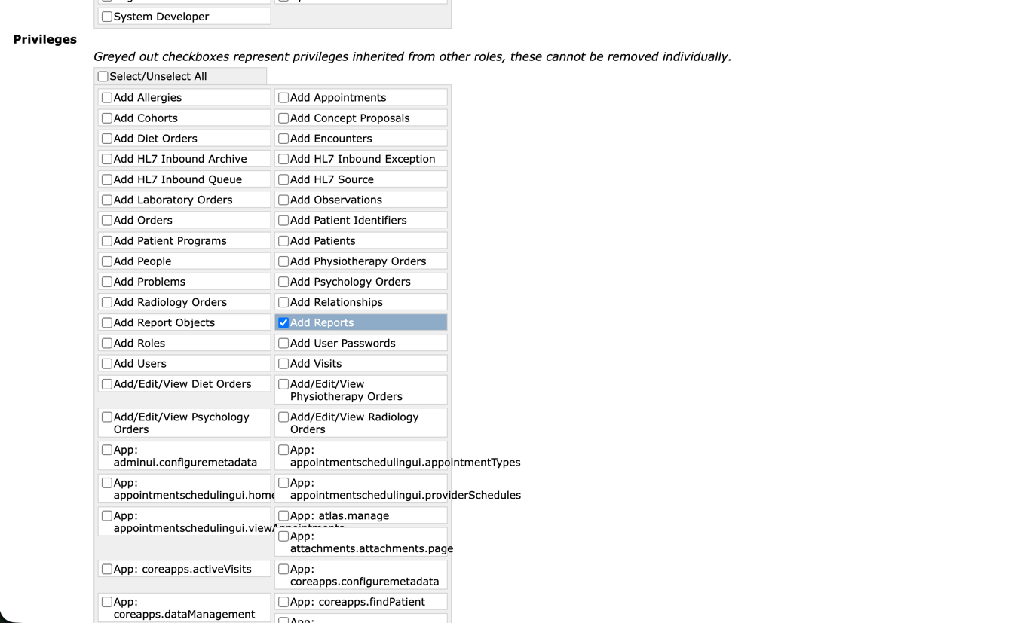
Figure 43: Detailed configuration of the 'Ambulance Personnel' role, demonstrating the functional implementation of privilege inheritance from multiple base modules 2

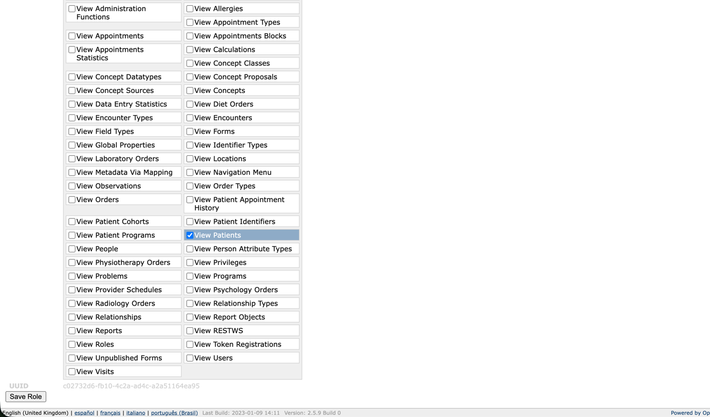
Figure 44: Detailed configuration of the 'Ambulance Personnel' role, demonstrating the functional implementation of privilege inheritance from multiple base modules 3

Exercise 6 (2.0 point)

Challenges Encountered in the OpenMRS Access Control Model
While the native Role-Based Access Control (RBAC) framework in OpenMRS provides a foundational security structure, several architectural challenges arise during implementation:
- Privilege Proliferation and Granularity Overload: The system relies on a vast, unstructured repository of highly granular privileges. Without an intuitive categorization framework, administrators face a significant cognitive burden when provisioning roles, which increases the likelihood of misconfigurations and violations of the Principle of Least Privilege.
- Inheritance Opacity and "Role Explosion": As the organizational structure scales, deeply nested role hierarchies become convoluted. This opacity makes it exceedingly difficult to accurately trace effective permissions across inheriting roles, inadvertently heightening the risk of privilege escalation or over – provisioning.
- Absence of Diagnostic and Visualization Tooling: The native administrative interface lacks graphical mapping capabilities. Administrators are forced to manually parse text-based matrices to audit access controls, rendering the auditing process highly inefficient and susceptible to human oversight.
- Lack of Context – Aware Access Controls: The rigid RBAC implementation fails to account for dynamic, real-time contextual factors – such as the user's current location, shift schedule, or active clinical relationship with the patient. This limitation exposes the system to potential unauthorized data access outside of legitimate care scenarios.

Strategic Suggestions for Improvement
To mitigate these vulnerabilities and optimize the security posture, the following enhancements are proposed:
- Semantic Privilege Clustering: Restructuring the monolithic privilege repository into logical, domain-specific modules (e.g., Clinical, Administrative, System Configuration) would significantly alleviate administrative cognitive load and streamline the role-provisioning workflow.
- Implementation of Graphical Auditing Interfaces: Integrating a visual, node-based user interface would allow security administrators to graphically map role hierarchies and instantaneously trace inherited privileges, drastically improving the accuracy and efficiency of compliance audits.
- Integration of Attribute – Based Access Control (ABAC): Augmenting the existing RBAC framework with ABAC mechanisms would introduce context-aware security policies. This would enable the system to evaluate dynamic attributes (e.g., verifying if a doctor is currently on shift or assigned to a specific ward) before granting data access, thereby fortifying data confidentiality.
- Standardized Out – of – the – Box (OOTB) Role Baselines: Providing a comprehensive library of pre-configured, industry-standard role templates (aligned with typical healthcare workflows) would minimize manual configuration errors and accelerate secure system deployment for new implementations.

THE END

