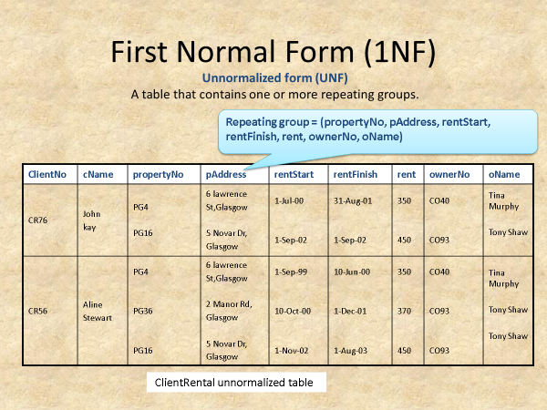

Un-normalized Form

**Answer**

**1st NF**

* The repeated data should be removed and put every data in every row.
* We remove repeating group

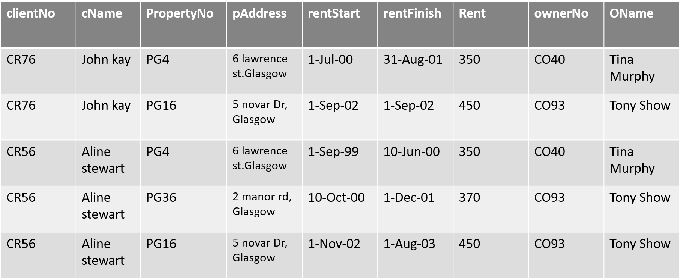

**2nd NF**

* Remove partial dependencies.
* If exist, remove it and add them by placing them in a new relation with a copy of their values.

**Client : (ClientNo, Cname)**

**PropertyRental : (clientNo, PropertyNo, rentStart, rentFinish)**

**Owner : (PropertyNo, pAddress, rent, ownerNO, oNAME)**

**3rd NF**

* Transitive dependencies

A -> B -> C

If A relates to B and B relates to C, then A is directly related to C, this is transitive dependencies.

**Client** : (clientNo, cName)

**Rental** : (clientNo, PropertyNo, rentStart, rentFinish)

**PropertyForRent** : (PropertyNo, pAddress, rent, ownerNo)

**Owner** : (ownerNo, oName)