

Using the OpenHMIS VM

Pathways Community Network Institute provides a development VM, intended for use by new developers to contribute to the refinement and expansion of the OpenHMIS project.

This document is also provided for those developers, new to the OpenHMIS project, with the goal to provide a quick on-ramp to contribution. This document shall guide the developer through:
- installing the necessary software (VirtualBox),
- downloading the VM,
- (**) Git’ing the most recent code for the OpenHMIS software and demo applications,
- exercising the demo applications,
- opening the development environment,
- (**) making a minor change, and
- (**) submitting code changes through Git.
(**) Some items have not yet been documented.

Finally, see the Access Appendix for usernames and passwords within the VM.

Installing the Necessary Software
We will start by installing the necessary software. Extracting the VM will require a freeware product called 7-zip and running the virtual machine will require a local installation of VirtualBox. 7-zip is a freeware archiving utility built by Igor Pavlov, and VirtualBox is a freeware virtualization product provided by Oracle While the VM runs on a Linux OS (CentOS), it can be run in many environments - Windows, Mac, Linux and Solaris.

- Download and install VirtualBox and the VirtualBox Extension Pack. (https://www.virtualbox.org/wiki/Downloads)
- When asked, install the network interfaces.

Downloading the VM
We will download the VM (a virtual hard drive including the operating system, software, and OpenHMIS code.

- Download the VM. (follow this link to Google Drive folder)
- Extract the VM using 7-zip.
- Open the VM in VirtualBox, either by double-clicking pathway.ova or by opening VirtualBox, clicking Start, and browsing to pathway.ova
- Login using the username and password found in the Access Appendix.

Git’ing the Most Recent Code
We will upload the VM’s code to the most recent OpenHMIS codebase.
- This is not yet documented. Sorry! We are currently looking at implementing EGit and Mylyn in the VM’s Eclipse installation to ease your pain getting the most recent code. Email xin.jin@pcni.org or steve.conners@pcni.org and we’ll work through it together.

Exercising the Demo Applications
We will start by opening the IntakeDemo (http://localhost:8080/IntakeDem/login) and log in using credentials found in the Access Appendix.
- (To make this work, the Tomcat service will need to be running. See ‘Opening the Development Environment’ step 4.)
- Log in using the credentials found in the Access Appendix.
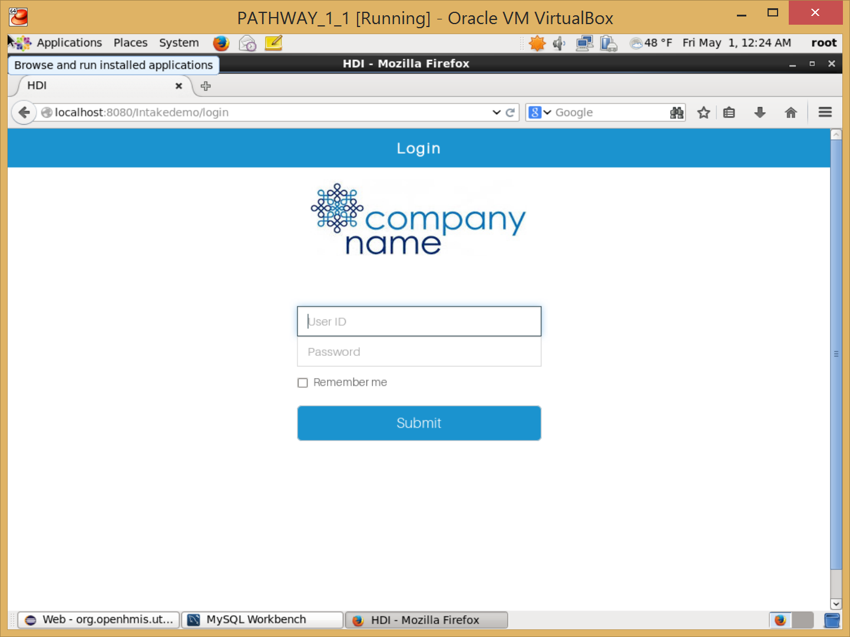
- Select an intake client - enter ‘S’
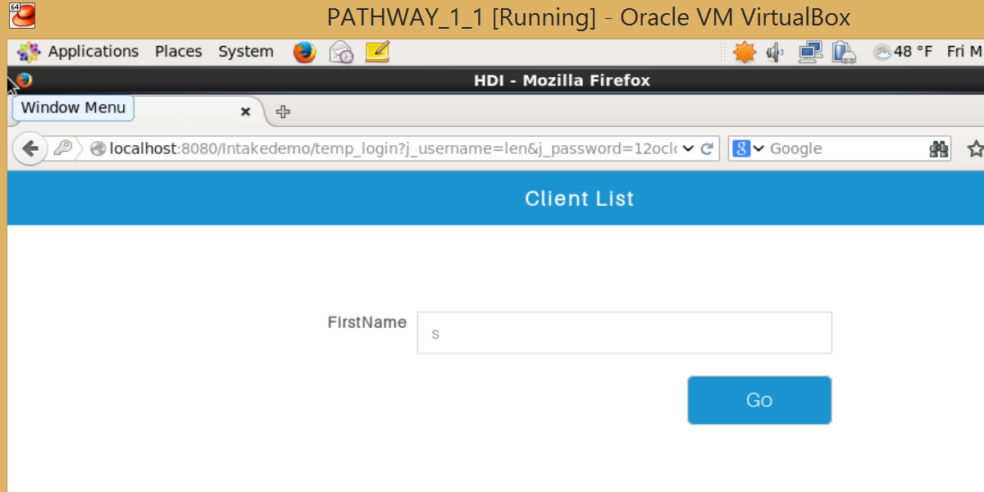
- Play! Let us know what works and what doesn’t. (xin.jin@pcni.og or steve.conners@pcni.org)

Opening the Development Environment
The VM has Eclipse pre-installed to allow contributions to the OpenHMIS project.
- Open Eclipse.
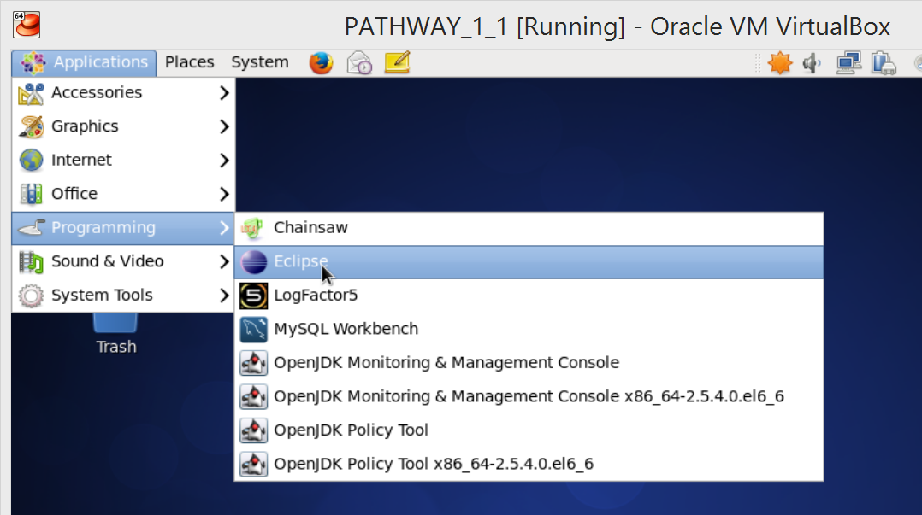
- Accept the default workspace.
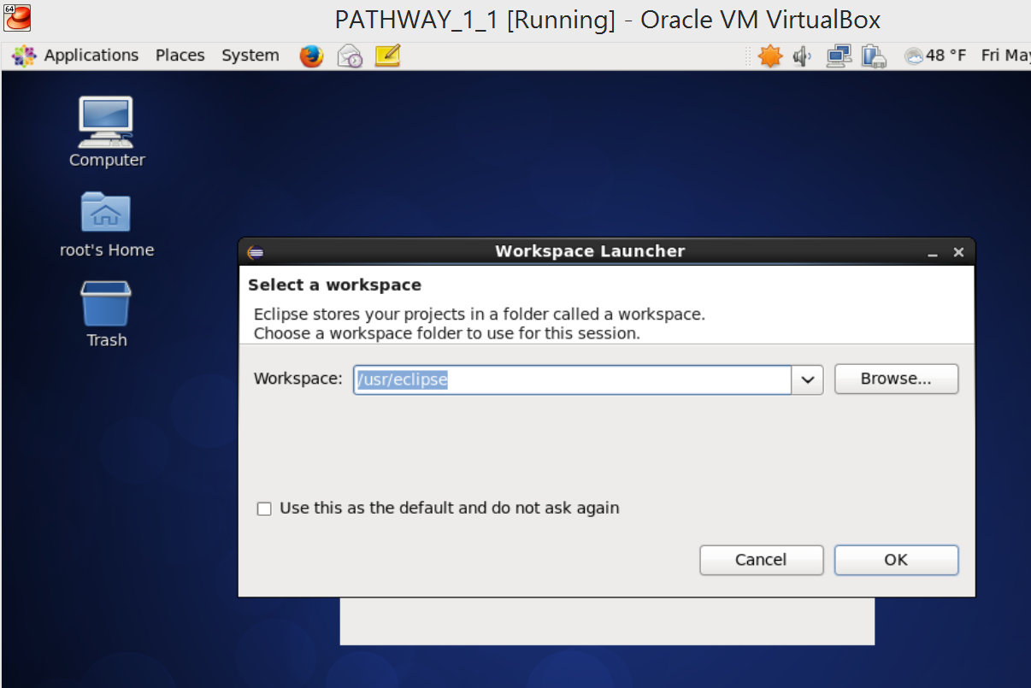
- You will see the IntakeDemo, OpenHMIS-master, and Tomcat v7.0 Server at localhost-config under Servers.
- Highlight the Tomcat v7.0 Server and push the run button to start the Tomcat service.
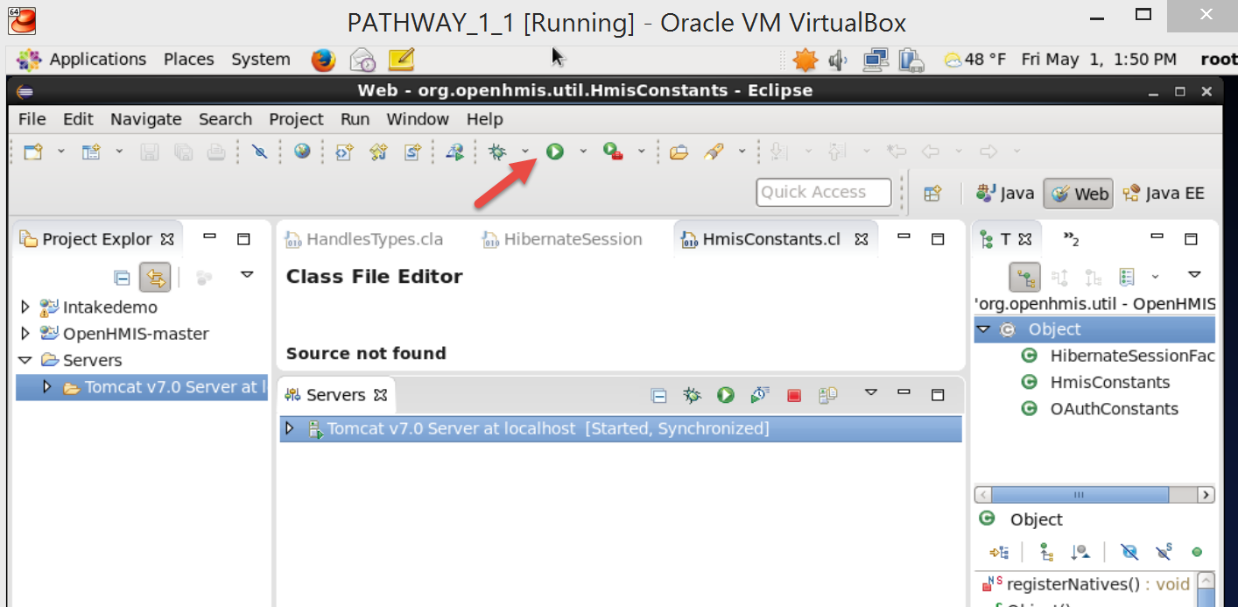

Making a Minor Change
Pathway’s goal is to provide others with an opportunity to commit real changes to our communities.
- This is not yet documented. Sorry! Email xin.jin@pcni.org or steve.conners@pcni.org and we’ll work through it together.

Submitting Code Changes Through Git
This is where you make REAL change, adding new functionality to ALL of our communities.
- This is not yet documented. Sorry! We are currently looking at implementing EGit and Mylyn in the VM’s Eclipse installation to ease your pain submitting the most recent code. Email xin.jin@pcni.org or steve.conners@pcni.org and we’ll work through it together.

Access Appendix
These are usernames and passwords used to access applications within the VM.
OS Access
username: root password: pathway
MySQL (open MySQL Workbench)
username: root password:
IntakeDemo (http://localhost:8080/Intakedemo/login)
username: len password: 12oclockhi
(verify using MySQL Workbench, checking the USER_INFO table)

Change History
2015/05/01 SJC Created
2015/05/04 SJC Code changes should be submitted through Git, not Pathways
Add suggestion to directly update or comment instructions
2015/05/06 SJC Update link to download VM to default to a file list in Google Drive
Update notes on EGit and Mylyn

