|  |  |  |  |
| --- | --- | --- | --- |
|  | [Pick the date] |  | |
|  | |  | |
| Photogallery  *PHP Web Project* | | | |
|  |  | |  |
|  |  | | Hanumant Mittal;Gurwinder Singh |
|  |  | | Gurwinder Singh |

Introduction

Photogallery is a web application where users are able to add their photos in different galleries .They can also a new gallery and add their photos to them.

Main functionalities:

* User Registration System
* User Login System
* File(Photos) Uploading
* Arranging Photos into different Galleries
* Adding Description and Title to both Photos and Galleries
* Access Control

Technical Specifications:

It is developed in PHP by using a popular framework named [Laravel](http://www.laravel.com/). It uses the inbuilt Model-View-Controller architecture (MVC). For deploying it requires a server which supports [PHP](http://www.php.net/) (5.5+) and MySQL and also the Laravel framework. The CSS and basic JS are implemented using Foundation CSS template.

Development Environment:

The application development has been done on a local windows PC using XAMPP.

The version used is XAMPP 7.0.2 which provides following support:

* PHP Version 7.0.2
* Architecture x86
* Server API: Apache 2.0 Handler
* Apache Version: Apache/2.4.18 (Win32) OpenSSL/1.0.2e PHP/7.0.2
* The MySQL server version is: 10.1.10-MaraiaDB
* pdo_mysql

The detailed instructions for getting the Laravel framework up and running (Installation and Server configurations) are given on their [website](http://www.laravel.com/docs/). It requires

* Installing and setting up composer.
* Creating a project directory and use create-project command to start creating project.
* Create a virtual Server if convenient (not necessary).

We used a text editor called [Sublime Text](http://www.sublimetext.com/). It gives features such as Syntax Highlighting, Directory Traversal, etc.

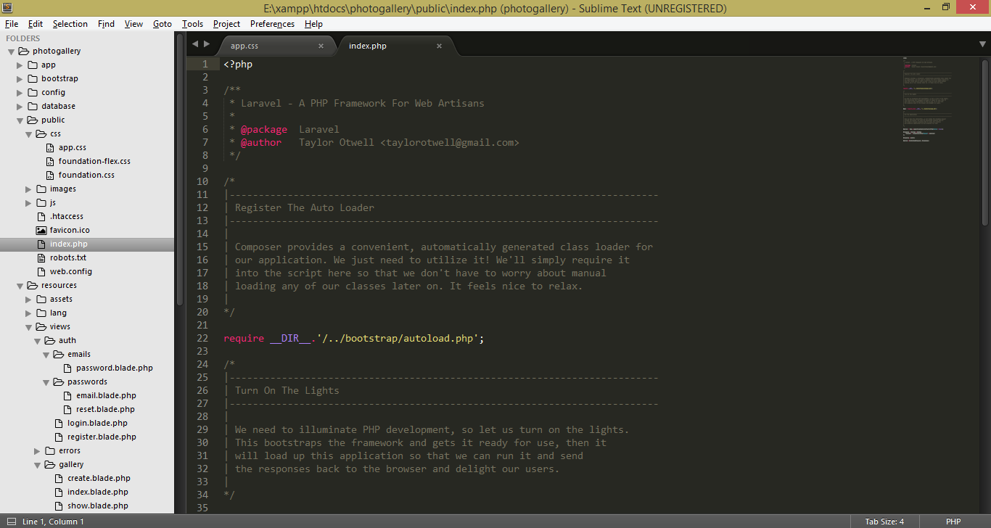

Implementation:

1. The controller files are initialized using command

php artisan make:controller <filename>

1. Then different controller functions are created.
2. We have to setup these in the routes.php file so that the server knows on which function is for which request.
3. Up to end of the project, following functions are added to Controller files.

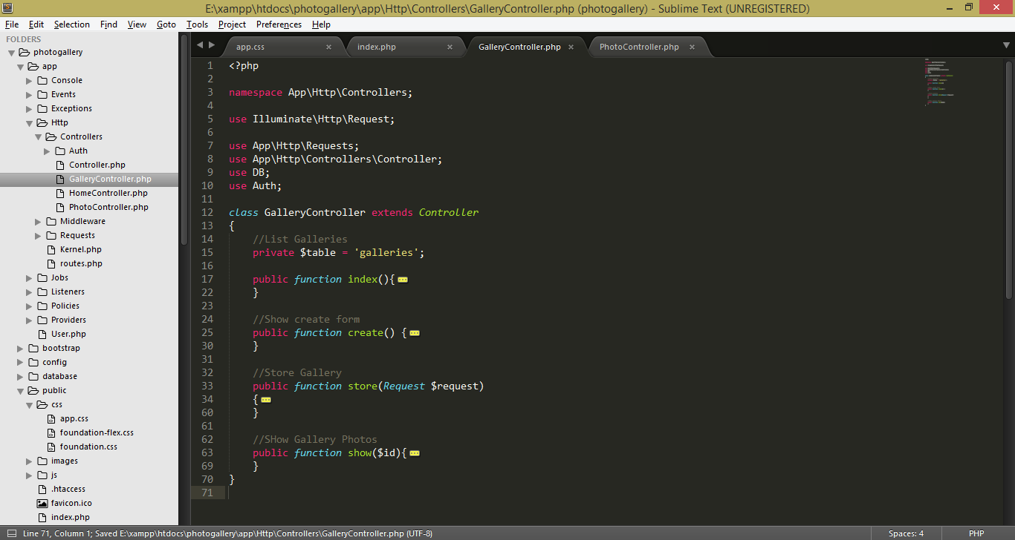

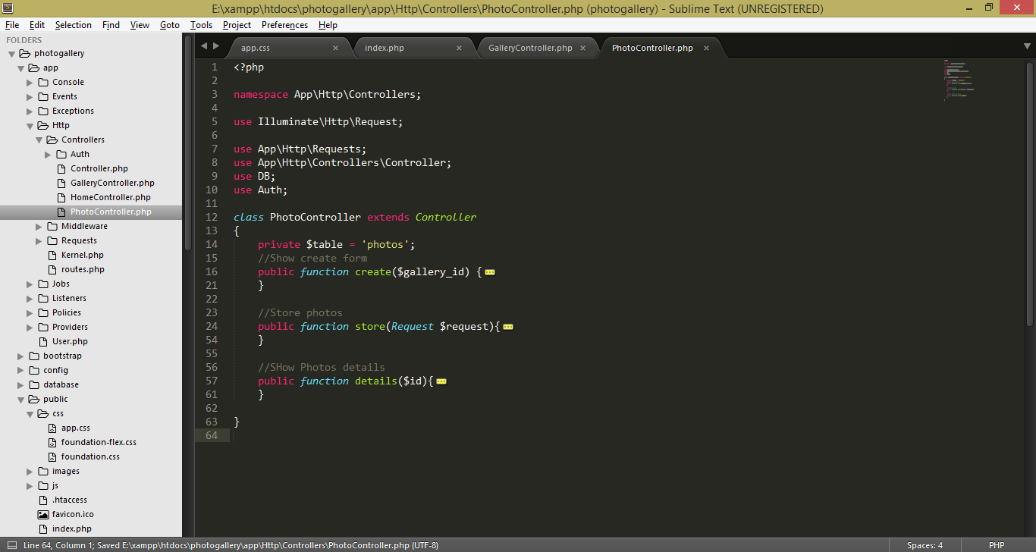

1. After that, we added the [Foundation CSS](http://www.foundation.zurb.com/) template by creating and editing files in ‘Views’. Views control how the page is going to like to the user end.
2. For convenience we stored the files in a local folder in the app itself (instead of using the CDN links).
3. Created and edited the view files in both Gallery and Photo section, and configured the controller files to render these views.
4. The main navigation bars links and, and main layout of the application is added in the main.blade.php file.