**Group 48 Design Record**

Ahmed Elmalawany, Andrew Glenwright, Jordan Lonneberg

October 10, 2020

# RTL Schematic

# Reports

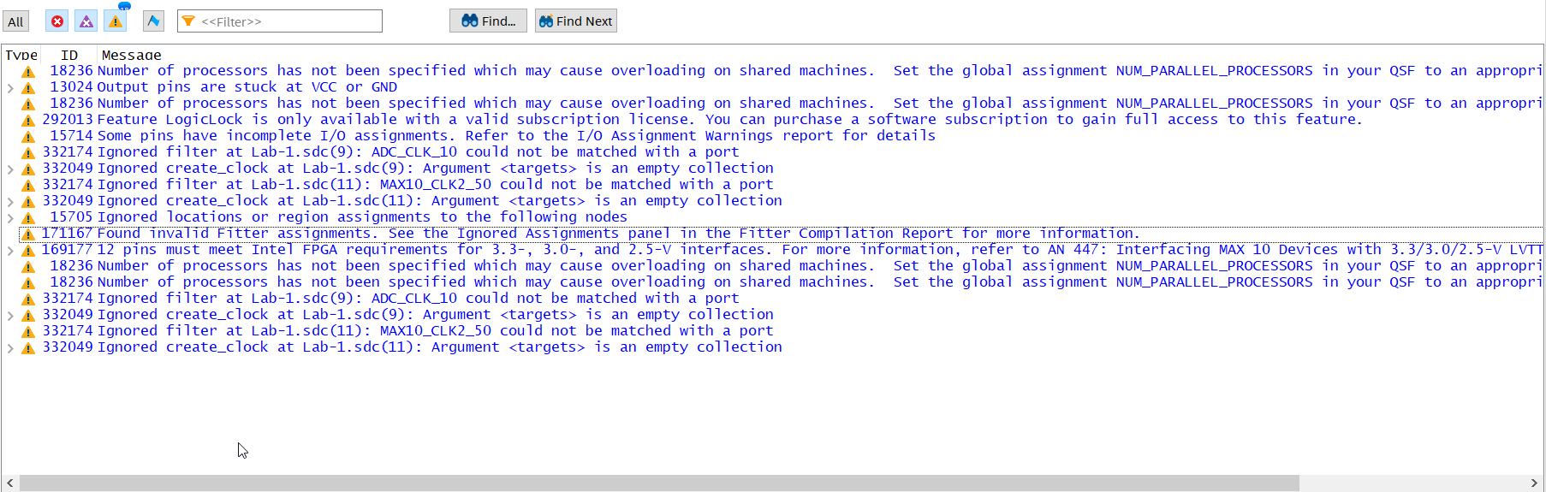No critical warnings or error messages were generated.

# Slow 1200 mV Model Fmax

# ­­

# Test Bench Results

## tb_mux2 Test Bench Results

## tb_top_level Test Bench Results

