Supplementary Information
Protein AI Model Disagreement Tracks AlphaFold Structural Confidence

Contents
Supplementary Figures S1-S11 (one figure per page).
Supplementary Tables S1-S8.

All underlying machine-readable tables and pipeline code (scripts 01-37) are archived with the manuscript at https://github.com/hmjpan/protein-ai-disagreement (results/ and figures/ directories). Statistical aggregation is protein-level with bootstrap inference throughout; the analysis plan and GO/NO-GO thresholds were fixed in config.yaml before the final analyses.

Supplementary Figures

Figure S1. Assay-level distribution of the Spearman correlation between disagreement and ensemble prediction error (median 0.032; Section 2.6).
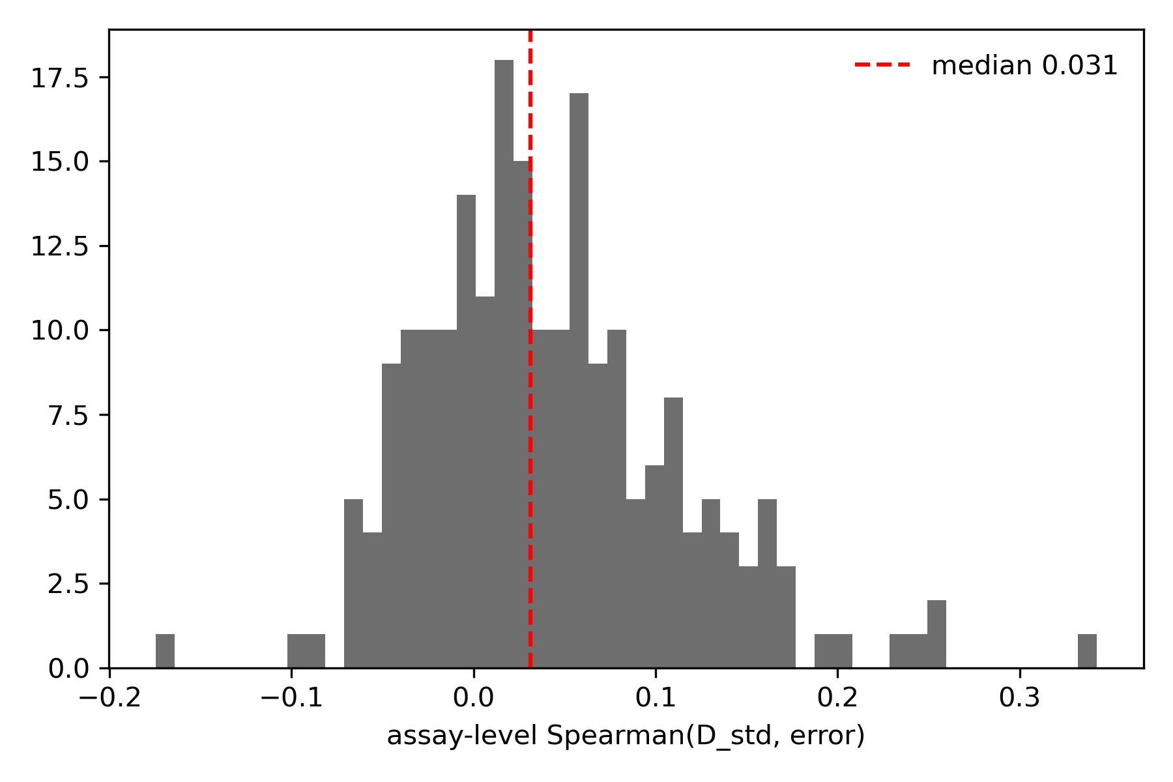

Figure S2. Mean ensemble prediction error by disagreement decile (monotonic: top decile 0.214 vs bottom decile 0.201).
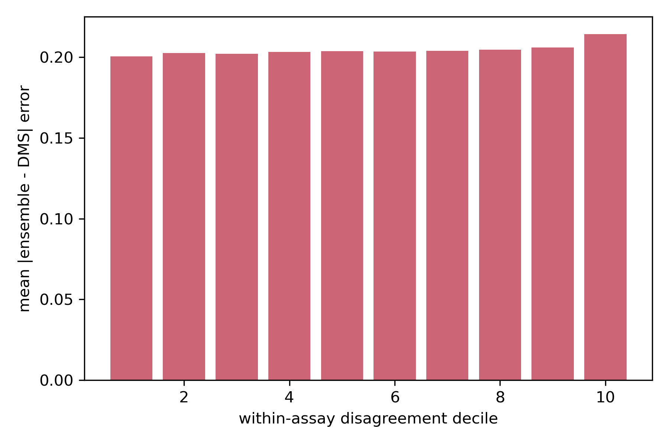

Figure S3. Disagreement versus distance to the nearest UniProt domain boundary (no boundary effect).
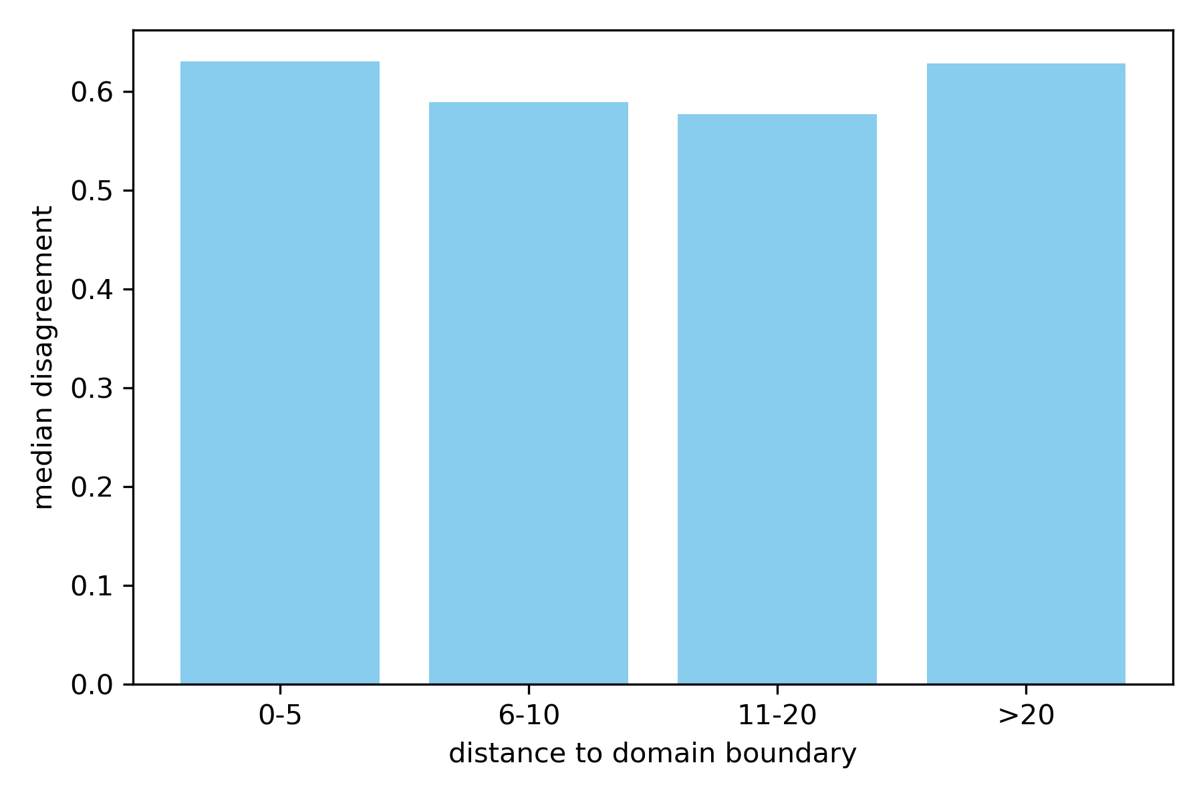

Figure S4. BioGate 5-fold UniProt-grouped cross-validation: protein-level Spearman distributions against all baselines.
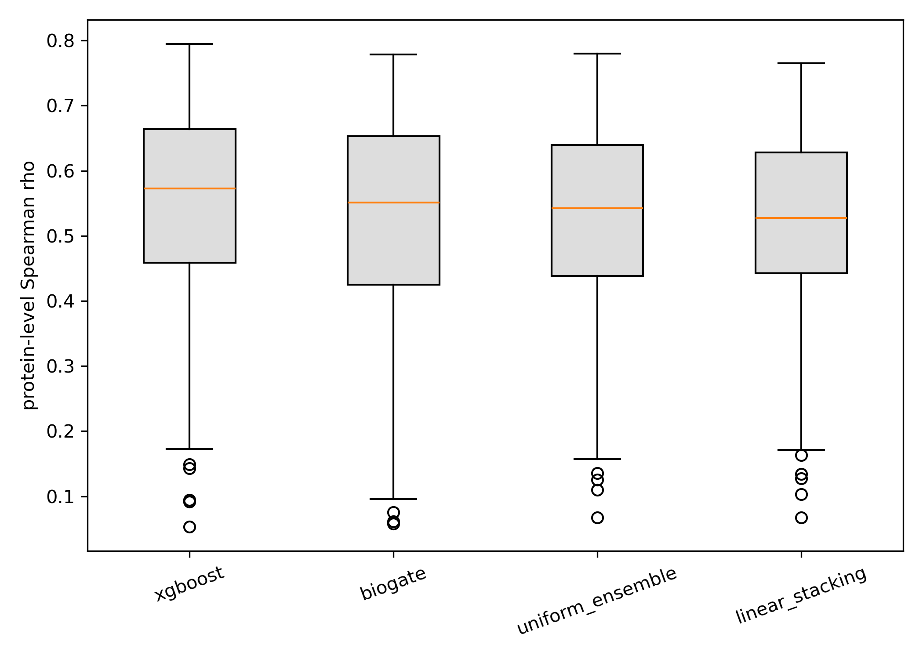

Figure S5. BioGate and XGBoost ablations (scores-only, context-only, scores+context; Table S5).
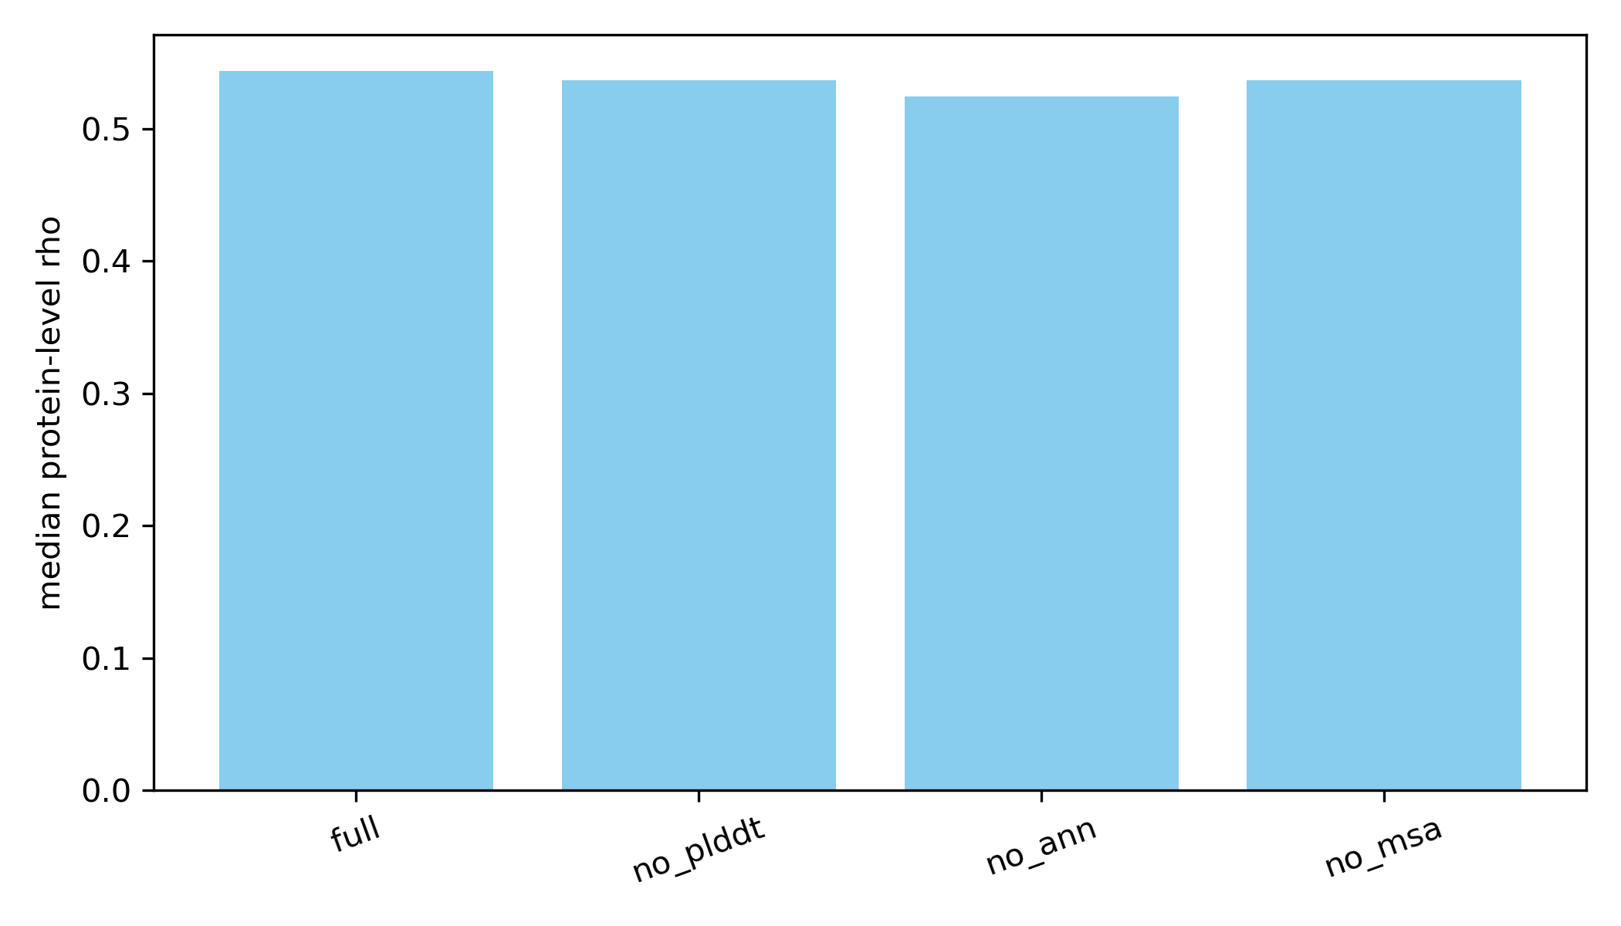

Figure S6. Leave-one-model-out sensitivity of the disagreement-error association (range 0.027-0.039).
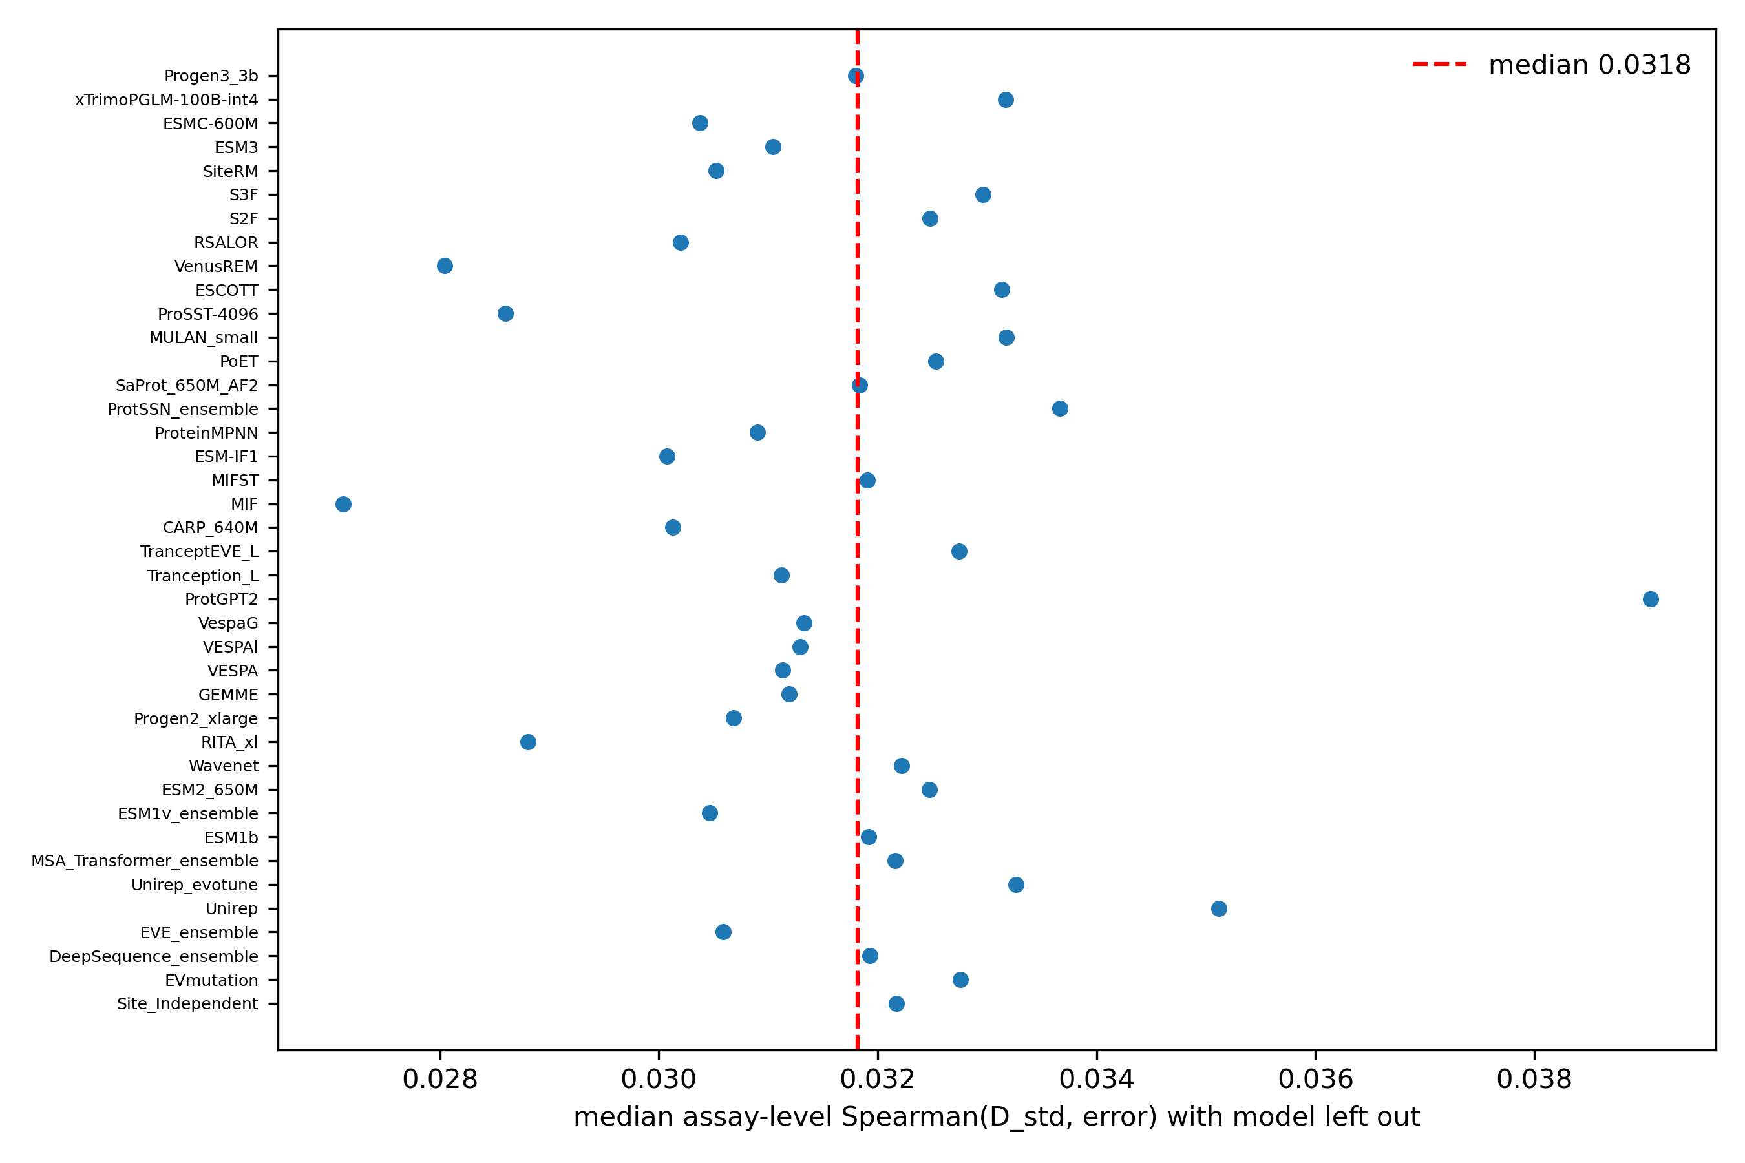

Figure S7. Percentile (u) versus inverse-normal (z) disagreement scale: median assay-level rho 0.145 vs 0.032 at fixed error definition.
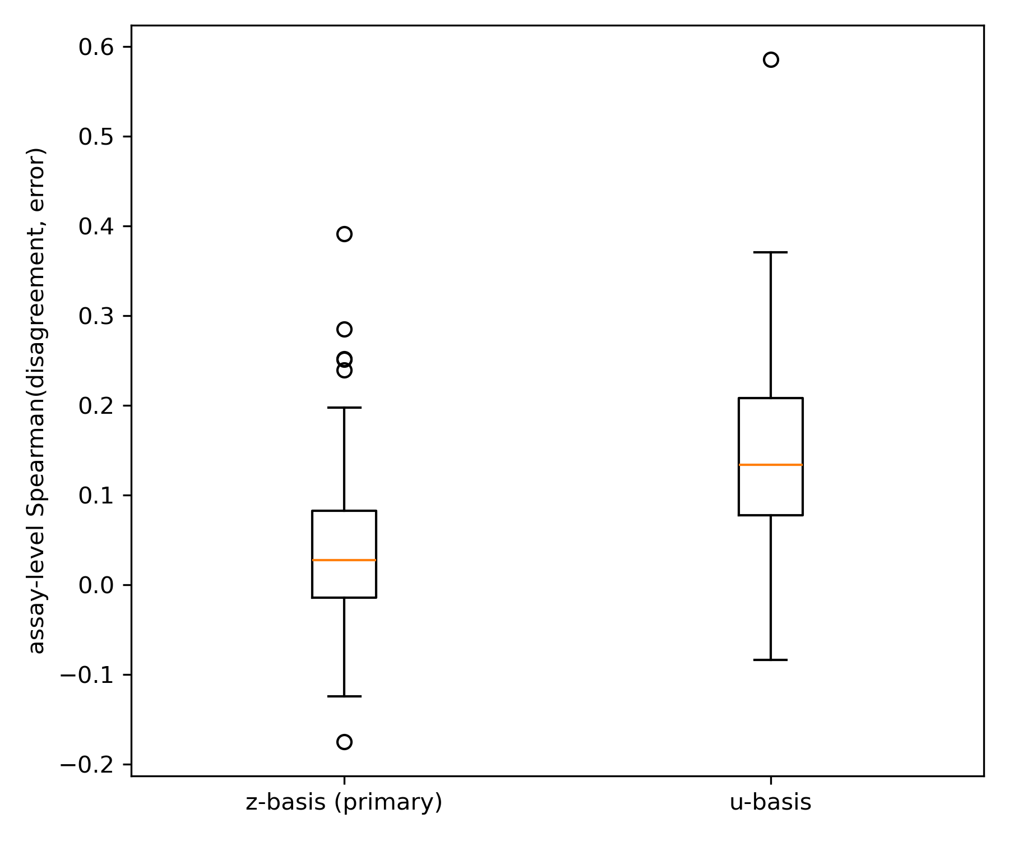

Figure S8. Disagreement-error association by assay selection type (stability 0.076, binding 0.057; activity 0.003, organismal fitness -0.004).
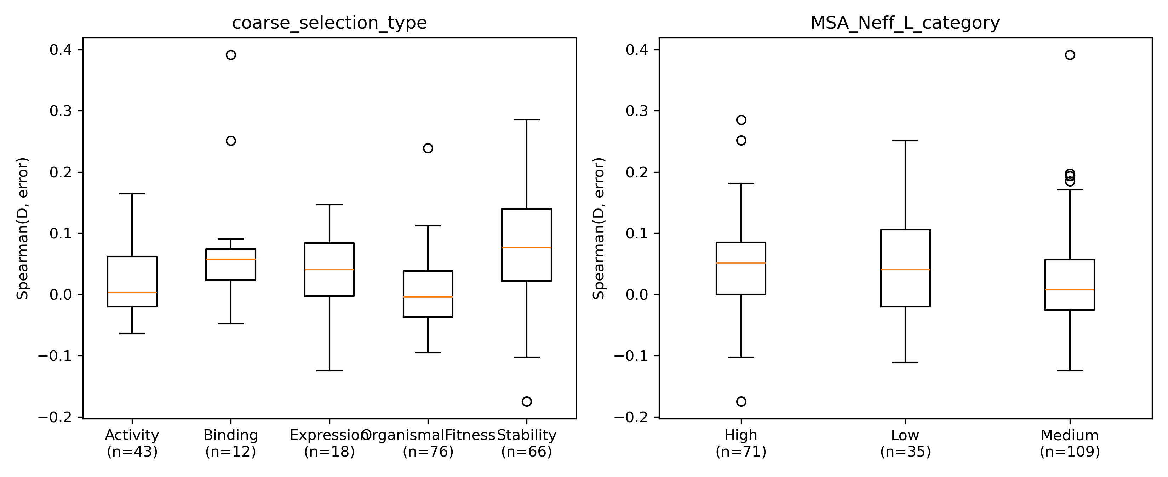

Figure S9. Residue mechanics (secondary structure, burial, contact density) versus family advantage or disagreement: null result.
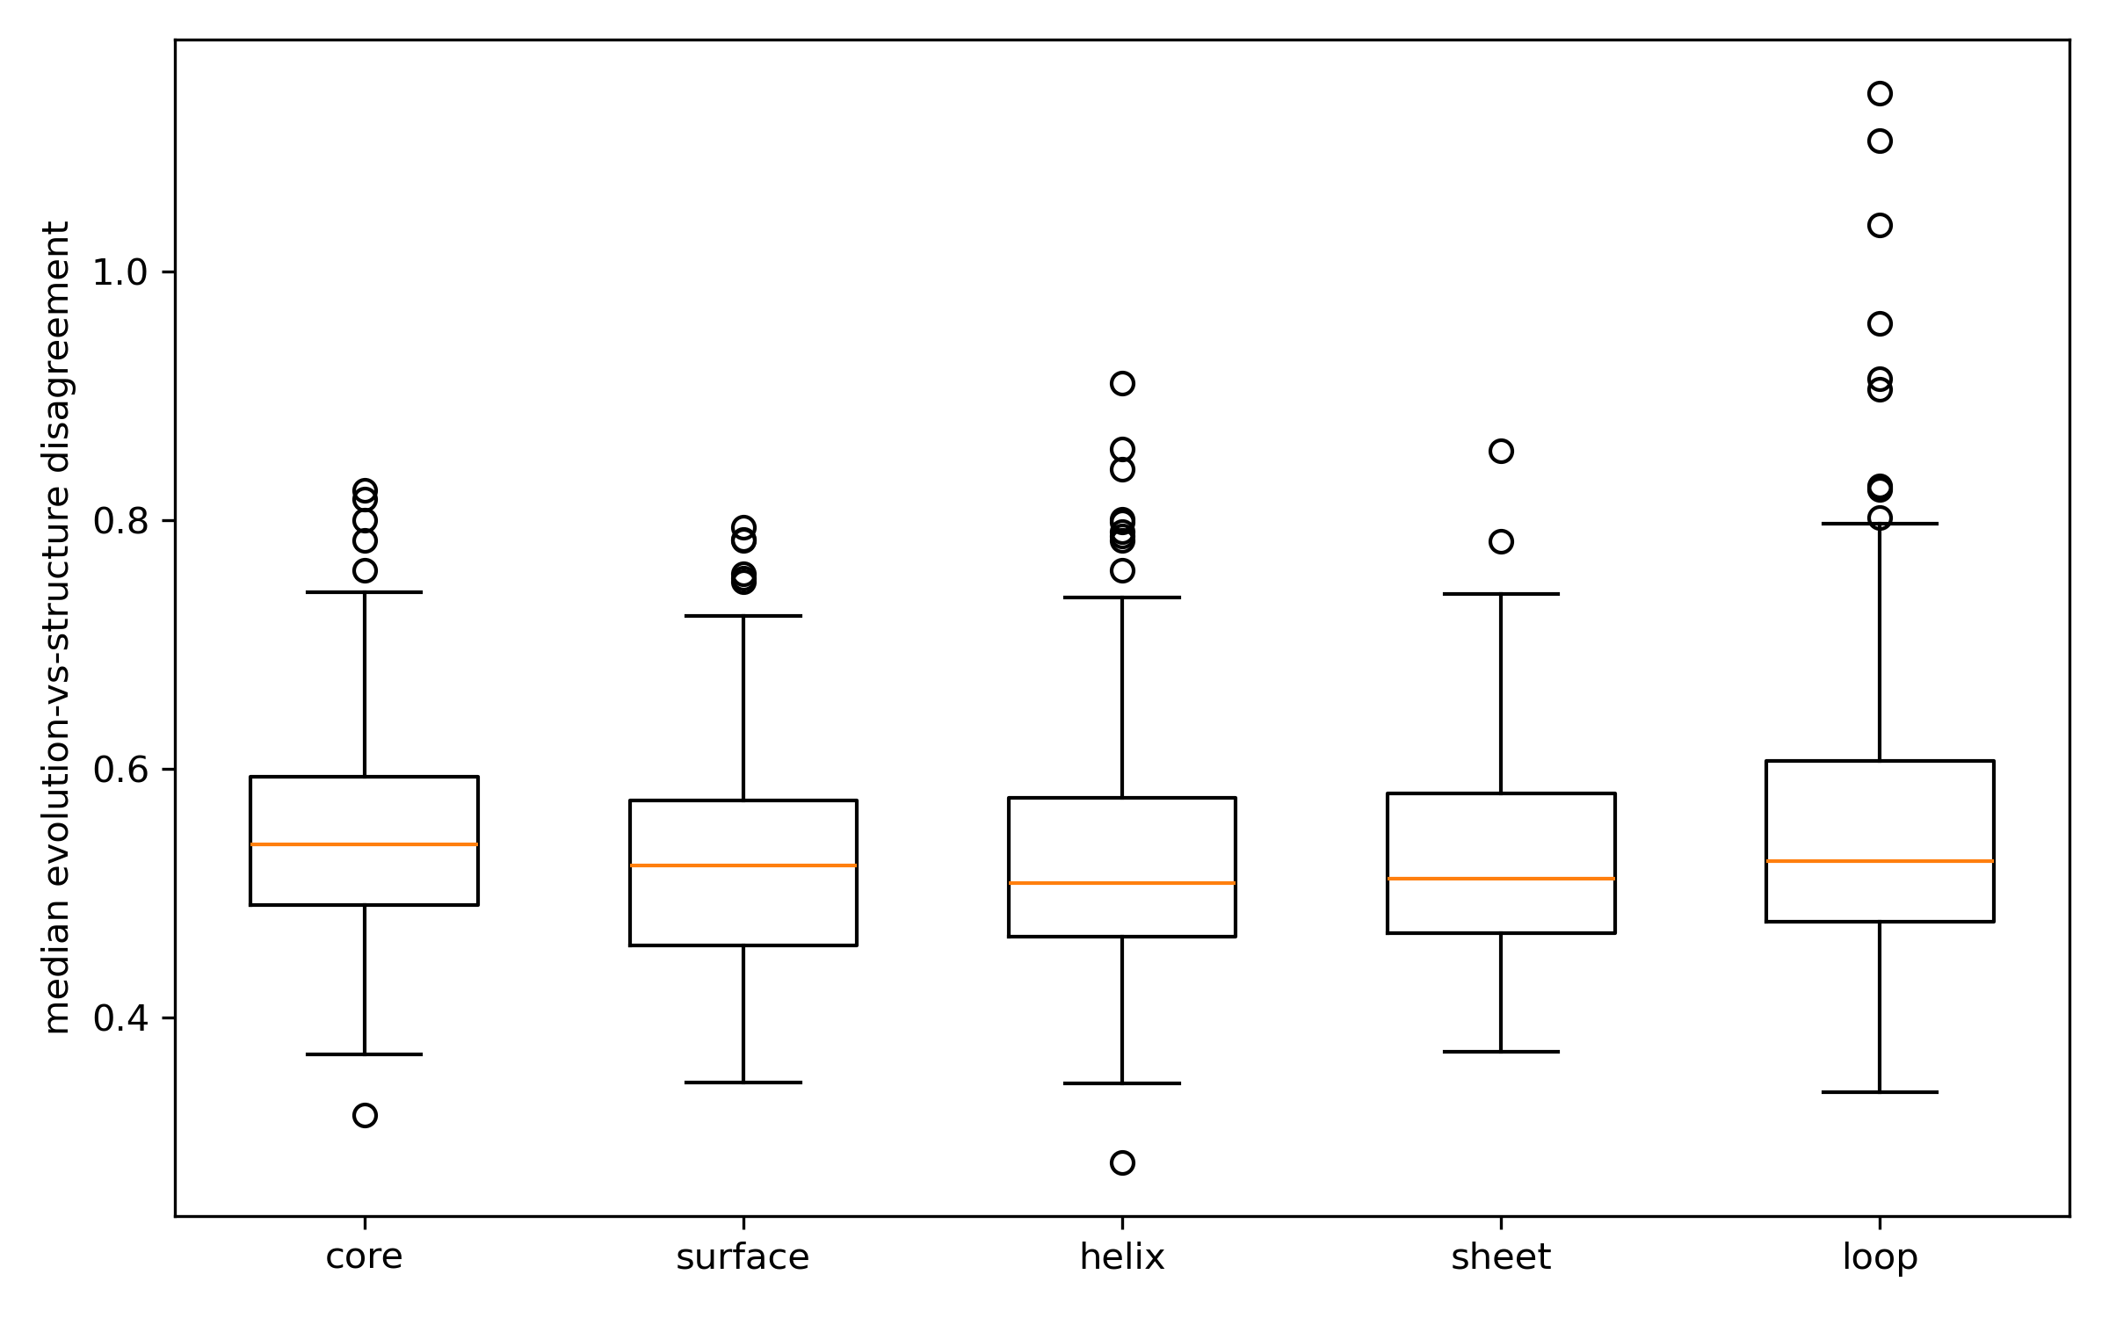

Figure S10. ESM-IF1 gain from experimental structures over AlphaFold2 by assay mean pLDDT (64 assays; low-confidence assays show MORE negative gain: -0.081 vs -0.023, difference -0.058, 95% CI -0.099 to -0.013).
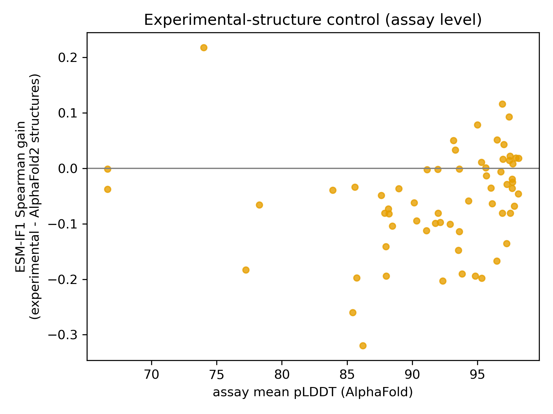

Figure S11. SSEmb distinct-architecture replication: residue-level Spearman between pLDDT and evolution-vs-SSEmb disagreement (median -0.067; 65.6% of 151 proteins negative).
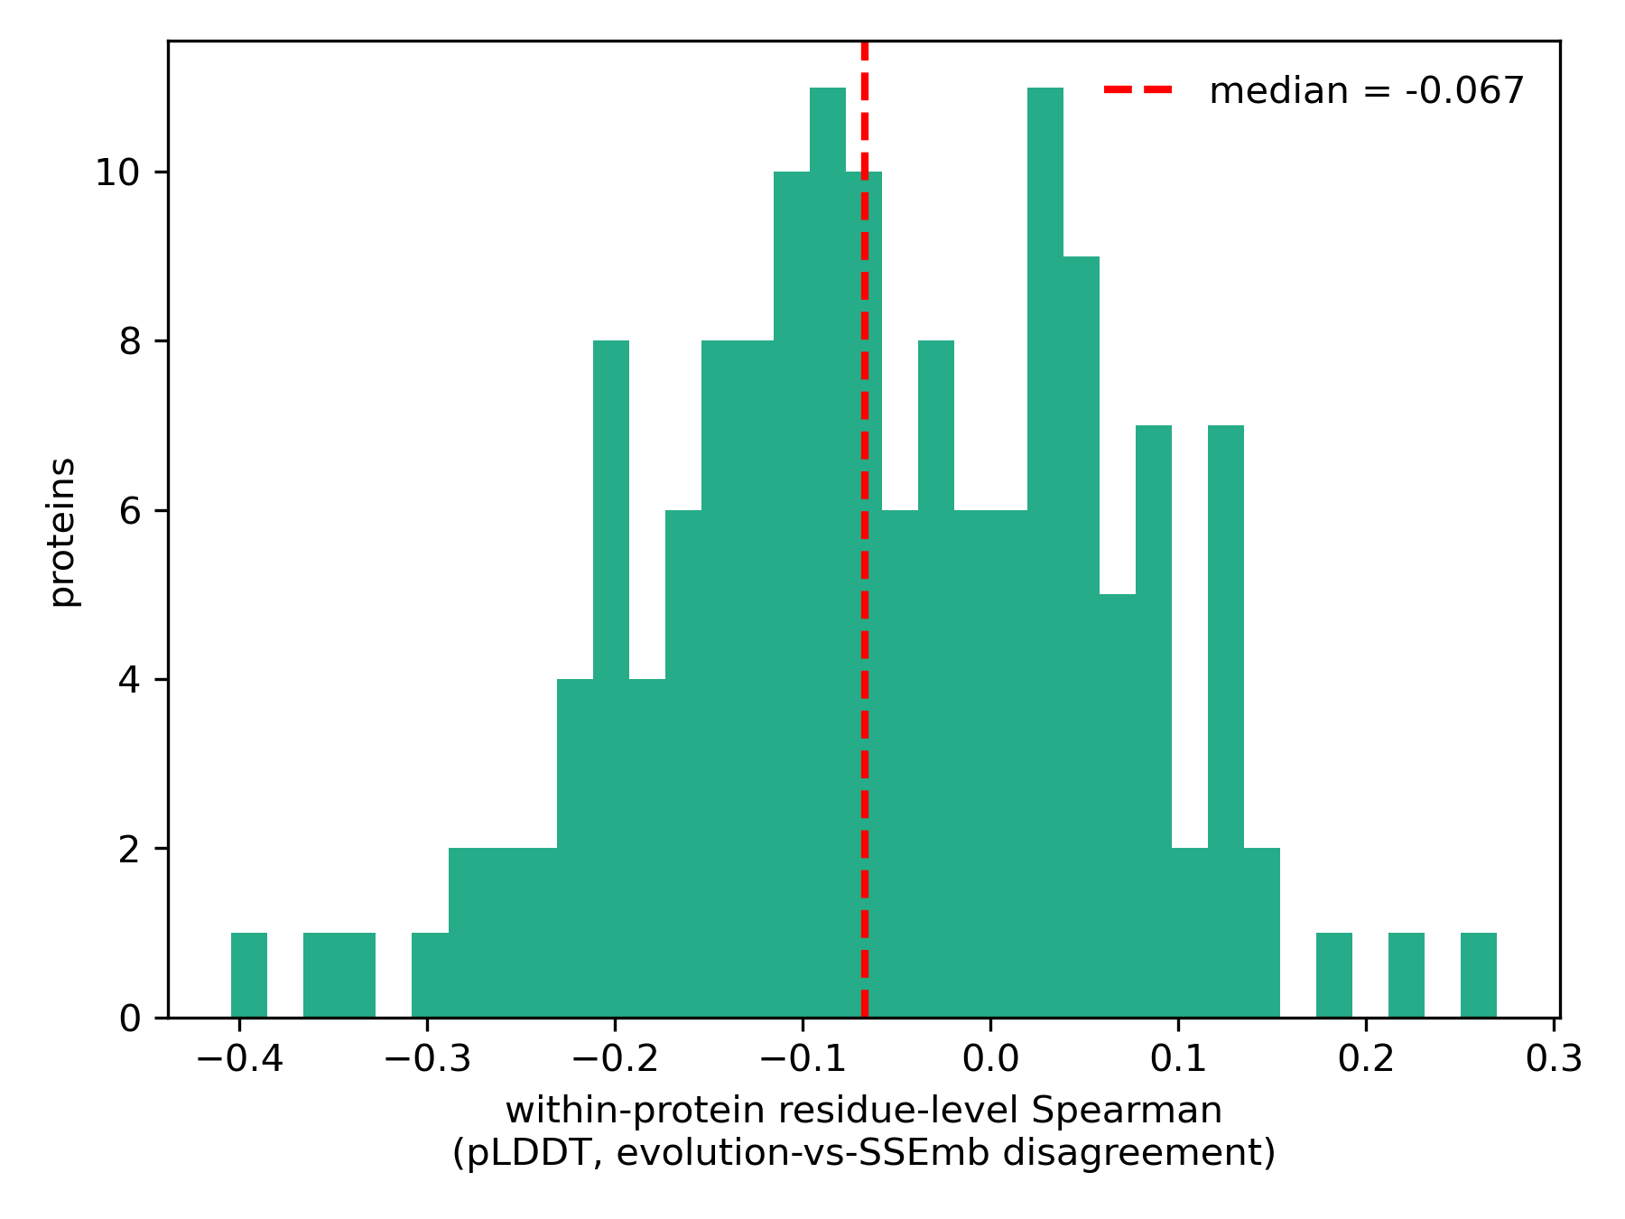

Supplementary Tables

Table S1. Residue-level pLDDT association across disagreement definitions.** D_std -0.078, D_MAD -0.076, D_pair -0.089, D_u -0.115 (median rho; all CIs exclude zero; 71-77% of proteins negative; four complementary definitions). Effect sizes (D_evo_struct): lowest-vs-highest pLDDT decile difference +0.057 (CI +0.013 to +0.084); Cohen's d 0.15 (CI 0.04-0.23); enrichment OR (low-pLDDT decile vs top-disagreement decile) median 1.84 (CI 1.62-2.04), pooled 1.49 (CI 1.35-1.65).
Definition | n proteins | median rho | 95% CI | frac proteins negative
D_MAD | 154 | -0.076 | -0.104 to -0.052 | 0.753
D_pair | 154 | -0.089 | -0.109 to -0.052 | 0.734
D_std | 154 | -0.078 | -0.101 to -0.040 | 0.714
D_u | 154 | -0.115 | -0.150 to -0.091 | 0.766

Table S2. Confound controls for the shared AlphaFold input.** (i) Asymmetry: residue-level rho(seq-vs-struct, pLDDT) = +0.01 vs rho(evo-vs-struct, pLDDT) = -0.04 (65% of proteins in the evo-struct direction); (ii) structure-model DMS correlation by pLDDT bin (ESM-IF1: 0.04 at <50, 0.47 at >=90; MIF: 0.03 vs 0.43; ProteinMPNN: 0.01 vs 0.22); (iii) structure-model score coverage = 100% at all pLDDT levels.
(i) Asymmetry of the residue-level association:
Pair | median rho vs pLDDT | n proteins
evolution vs structure | -0.041 | 154
sequence vs structure | 0.011 | 154
% proteins with more negative evo-vs-struct rho | 64% | -

(ii) Structure-model DMS correlation by pLDDT bin:
pLDDT bin | model | n variants | n assays | median rho DMS
pLDDT<50 | MIF | 42,273 | 69 | -0.032
pLDDT<50 | ESM-IF1 | 42,273 | 69 | -0.037
pLDDT<50 | ProteinMPNN | 42,273 | 69 | -0.007
50-70 | MIF | 42,607 | 111 | -0.123
50-70 | ESM-IF1 | 42,607 | 111 | -0.116
50-70 | ProteinMPNN | 42,607 | 111 | -0.054
70-90 | MIF | 157,897 | 180 | -0.263
70-90 | ESM-IF1 | 157,897 | 180 | -0.317
70-90 | ProteinMPNN | 157,897 | 180 | -0.142
>=90 | MIF | 446,394 | 199 | -0.433
>=90 | ESM-IF1 | 446,394 | 199 | -0.474
>=90 | ProteinMPNN | 446,394 | 199 | -0.225

(iii) Structure-model score coverage:
pLDDT bin | model | fraction scored
pLDDT<50 | MIF | 1
pLDDT<50 | ESM-IF1 | 1
pLDDT<50 | ProteinMPNN | 1
50-70 | MIF | 1
50-70 | ESM-IF1 | 1
50-70 | ProteinMPNN | 1
70-90 | MIF | 1
70-90 | ESM-IF1 | 1
70-90 | ProteinMPNN | 1
>=90 | MIF | 1
>=90 | ESM-IF1 | 1
>=90 | ProteinMPNN | 1

Table S3. Regime robustness across K = 4-7.** Consensus regimes track experimental Y at every K (Y_tolerant 0.26-0.30; Y_damaging 0.73-0.79); cross-assay position-level agreement 0.75-0.84 at every K; the structure-dissenting pattern emerges at K >= 6; ARI vs K = 6: 0.35 (K = 4), 0.58 (K = 5), 0.46 (K = 7).
K | structure-dissenting regime present | Y consensus-tolerant | Y consensus-damaging | cross-assay agreement | cross-assay pairs | ARI vs K=6
4 | False | 0.289 | 0.752 | 0.840 | 30 | 0.353
5 | False | 0.255 | 0.788 | 0.796 | 30 | 0.584
6 | True | 0.257 | 0.749 | 0.776 | 30 | 1.000
7 | True | 0.298 | 0.728 | 0.748 | 30 | 0.462

Table S4. Identity-threshold sensitivity.** 30% / 50% / 70% each exclude the same 35 clinical proteins; uniform AUROC 0.905 (n = 2,490) in all three settings.
Identity threshold | proteins excluded | variants | proteins | median uniform AUROC
30% | 35 | 60,214 | 2,490 | 0.905
50% | 35 | 60,214 | 2,490 | 0.905
70% | 35 | 60,214 | 2,490 | 0.905

Table S5. XGBoost ablations (5-fold UniProt-grouped CV, percentile space; median of per-fold medians).** scores only 0.509; context only 0.167; scores + context 0.551; uniform ensemble 0.542.
Configuration | median protein-level Spearman
scores_only | 0.509
context_only | 0.167
scores_context | 0.551
uniform_ensemble | 0.542

Table S6. Model panel composition.** Per core model: architecture, input modalities, AlphaFold-structure input, mechanistic-panel membership (model_panel_table.csv).
Model | Official family | Analysis family | Uses MSA | Uses structure | Structure input AlphaFold | In mechanistic panel
Site_Independent | MSA | evolution | True | False | False | True
EVmutation | MSA | evolution | True | False | False | True
DeepSequence_ensemble | MSA | evolution | True | False | False | True
EVE_ensemble | MSA | evolution | True | False | False | True
Unirep | Single sequence | single_seq | False | False | False | True
Unirep_evotune | MSA | evolution | True | False | False | True
MSA_Transformer_ensemble | MSA | evolution | True | False | False | True
ESM1b | Single sequence | single_seq | False | False | False | True
ESM1v_ensemble | Single sequence | single_seq | False | False | False | True
ESM2_650M | Single sequence | single_seq | False | False | False | True
Wavenet | MSA | evolution | True | False | False | True
RITA_xl | Single sequence | single_seq | False | False | False | True
Progen2_xlarge | Single sequence | single_seq | False | False | False | True
GEMME | MSA | evolution | True | False | False | True
VESPA | Single sequence | single_seq | False | False | False | True
VESPAl | Single sequence | single_seq | False | False | False | True
VespaG | Single sequence | single_seq | False | False | False | True
ProtGPT2 | Single sequence | single_seq | False | False | False | True
Tranception_L | MSA | evolution | True | True | True | True
TranceptEVE_L | MSA | evolution | True | True | True | True
CARP_640M | Single sequence | single_seq | False | False | False | True
MIF | Structure | structure | False | True | True | True
MIFST | Single sequence & Structure | hybrid | True | True | True | False
ESM-IF1 | Structure | structure | False | True | True | True
ProteinMPNN | Structure | structure | False | True | True | True
ProtSSN_ensemble | Single sequence & Structure | hybrid | False | True | False | False
SaProt_650M_AF2 | Single sequence & Structure | hybrid | False | True | True | False
PoET | MSA | evolution | True | False | False | True
MULAN_small | Single sequence & Structure | hybrid | False | True | True | False
ProSST-4096 | Single sequence & Structure | hybrid | False | True | False | False
ESCOTT | Structure & MSA | hybrid | False | True | True | False
VenusREM | Structure & MSA | hybrid | False | True | True | False
RSALOR | Structure & MSA | hybrid | False | True | True | False
S2F | Single sequence & Structure | hybrid | False | True | True | False
S3F | Single sequence & Structure | hybrid | False | True | True | False
SiteRM | MSA | evolution | True | False | False | True
ESM3 | Single sequence, Structure & Function annotations | hybrid | False | True | False | False
ESMC-600M | Single sequence | single_seq | False | False | False | True
xTrimoPGLM-100B-int4 | Single sequence | single_seq | False | False | False | True
Progen3_3b | Single sequence | single_seq | False | False | False | True

Table S7. Clinical paired deltas (10,000 protein bootstrap).** Full set: BioGate - uniform +0.039 [0.033, 0.045], best - uniform +0.056 [0.048, 0.064]. Strict set: BioGate - uniform +0.021 [0.011, 0.026], best - uniform +0.085 [0.077, 0.091], best - BioGate +0.061 [0.056, 0.066].
Set | Comparison | n proteins | median delta AUROC | 95% CI | frac positive
full | auroc_biogate - auroc_uniform | 1,530 | 0.039 | [0.033, 0.045] | 0.662
full | auroc_best - auroc_uniform | 1,530 | 0.056 | [0.048, 0.063] | 0.692
full | auroc_best - auroc_biogate | 1,530 | 0 | [0, 0.001] | 0.476
strict | auroc_biogate - auroc_uniform | 788 | 0.021 | [0.011, 0.026] | 0.588
strict | auroc_best - auroc_uniform | 788 | 0.085 | [0.077, 0.091] | 0.901
strict | auroc_best - auroc_biogate | 788 | 0.061 | [0.056, 0.066] | 0.933

Table S8. Held-out protein regime generalization.** Median regime-profile Spearman 0.94 (IQR 0.89-1.00, 100% positive, 185 proteins); dissenting regime held-out Y median 0.61, damaging in 72% of supported proteins; cross-assay replication on held-out proteins median 0.94 (28 pairs, 100% above chance).
Statistic | Value
Proteins with held-out support | 185
Median Spearman, held-out regime profile vs training profile | 0.943 (IQR 0.886-1)
Proteins with positive correlation | 1
Dissenting regime held-out Y (median) | 0.609
Proteins where dissenting regime damaging (Y > 0.5) | 0.724
Held-out cross-assay replication, median rho | 0.943 (28 pairs)
Cross-assay pairs above chance | 1
Per-protein values: results/statistics/heldout_regime_per_protein.csv.

