第二部分 系统分析

**一、项目需求收集**

**1.1需求获取**

**1.1.1调查问卷的方式获取需求**

首先，我们小组内的成员设计了一份餐厅点餐系统调查问卷，通过互联网收集了大家对点餐系统的意见与建议。

接下来，是我们的调查结果，也就是现实情况中，大众对于自助点餐系统的看法：

**1.1.2场景：**

|  |
| --- |
| * 顾客进入餐厅，选好座位，进入点餐APP首页。 * 顾客选择菜品加入购物车，同时可以对购物车菜品进行修改。 * 顾客确认购物车菜品，无误后提交订单。 * 前台工作人员接收订单并打印。 * 服务员将订单交给顾客。 * 上菜，顾客享用完毕结账离开。 |

**1.2需求定义**

|  |
| --- |
| **问题定义**  **1、餐饮市场目前的困境**  ∙纸质菜单印刷成本高，更新换代麻烦；  ∙顾客等待点餐时间过长；  ∙订单需要服务人员填写，核算工作麻烦。  **2、自助点餐系统的目标**  ∙满足顾客自助点餐的需求，操作更加方便快捷；  ∙减轻餐馆的服务压力，降低运营成本；  **3、自助点餐系统的范围**  ∙记录菜品的细节；  ∙实现订餐操作；  ∙不涉及付款。  **4、初始计划**  ∙提供一份供顾客填写的调查问卷；  ∙设计一个友好的用户界面，方便用户操作；  ∙提供一个高效率的用户点餐平台。  **5、推荐行动**  ∙发放调查问卷；  ∙回顾总结顾客调查问卷反映的信息；  ∙详细了解传统菜单所提供的菜品信息。 |

**1.3需求列表**

R1: 顾客浏览菜单页面，根据自己喜好选择菜品。

R2: 顾客查看已选菜品，可以对已选定的菜品进行修改。

R3: 顾客核对已选菜品，确认无误后提交订单。

R4: 系统将订单发送给前台工作人员。

R5: 前台工作人员登录系统、查看订单并打印。

R6: 打印之后的订单由服务员交给顾客。

R7: 顾客若是想增加菜品，可到前台告知工作人员。

R8: 管理员登录对菜品进行操作（增删改查）。

R9: 管理员登录汇总查询当天的销售情况。

**二、用例图、类图、序列图以及生成的协作图**

**2.1 Use-Case Diagram（用例图）：**

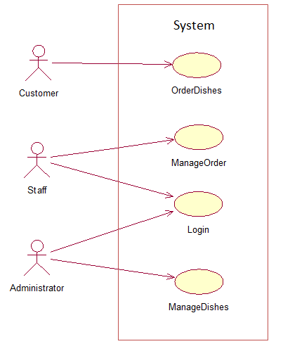

**Use-Case Description（用例描述）:**

|  |  |
| --- | --- |
| **Use-Case Title**： | OrderDishes |
| **Primary Actor:** | Customer |
| **Level:** | Sea level（user goal） |
| **Stakeholders:** | Customer、Staff |
| **Precondition:** | Customer has arrived in the restaurant |
| **Minimal Guarantee:** | Rollback of any uncompleted transaction;  System logs progress until failure |
| **Success Guatantee:** | Customer successfully completes order;  Order was created;network is available |
| **Trigger：** | Customer clicks on the "Submit Order" button |
| **Main Success Scenario：**  1.Customer has chosen dishes ;  2.Order for customer is created | |
| **Extensions:**  1.System can’t be started;  2.Customer is not satisfied with the dishes | |

|  |  |
| --- | --- |
| **Use-Case Title**： | ManageOrders |
| **Primary Actor:** | Staff |
| **Level:** | Sea level（user goal） |
| **Stakeholders:** | Customer、Staff |
| **Precondition:** | Orders were sent to the staff successfully;  Staff has entered the system |
| **Minimal Guarantee:** | Rollback of any uncompleted transaction;  System logs progress until failure |
| **Success Guatantee:** | System and network are available;  Staff has entered the main interface |
| **Main Success Scenario：**  1.Customer has sent the orders;  2.Staff can look over the orders;  3.Staff prints the orders; | |
| **Extensions:**  1.System can’t be started;  2.Network is not available and the data can’t be sent to the server | |

|  |  |
| --- | --- |
| **Use-Case Title**： | Login |
| **Primary Actor:** | Staff、Administrator |
| **Level:** | Sea level（user goal） |
| **Stakeholders:** | Staff、Administrator |
| **Precondition:** | The system is in the available state |
| **Minimal Guarantee:** | Rollback of any uncompleted transaction;  System logs progress until failure |
| **Success Guatantee:** | Administrator or staff provides a matching number and password |
| **Trigger：** | Administrator or staff clicks on the "login" button |
| **Main Success Scenario：**  1. Administrator or staff successes to open the system，enters the login interface ,inputs ID、password and clicks on the "login" button;  2.The operator’s information is valid and can enter the main interface | |
| **Extensions:**  1.System can’t be started;  2.The information is incorrect and not verified by database | |

|  |  |
| --- | --- |
| **Use-Case Title**： | ManageDishes |
| **Primary Actor:** | Administrator |
| **Level:** | Sea level（user goal） |
| **Stakeholders:** | Administrator |
| **Precondition:** | The system is in the available state;  Administrator has entered the system |
| **Minimal Guarantee:** | Rollback of any uncompleted transaction;  System logs progress until failure |
| **Success Guatantee:** | The system is in the available state  Adninistrator has entered the main interface |
| **Main Success Scenario：**  1. Administrator successes to open the system;  2.System shows the current dishes;  3.Administrator updates、inserts、deletes the current dishes; | |
| **Extensions:**  1.System can’t be started;  2.System-down and failure to modify the dishes | |

**2.2 Class Diagram（类图）:**

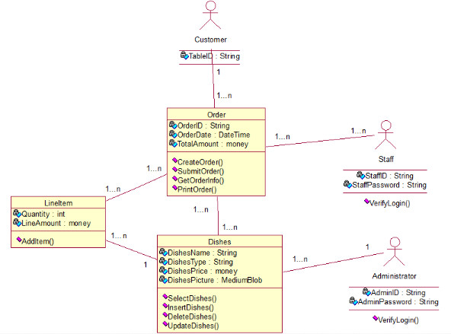

**2.3 Sequence Diagram（序列图）:**

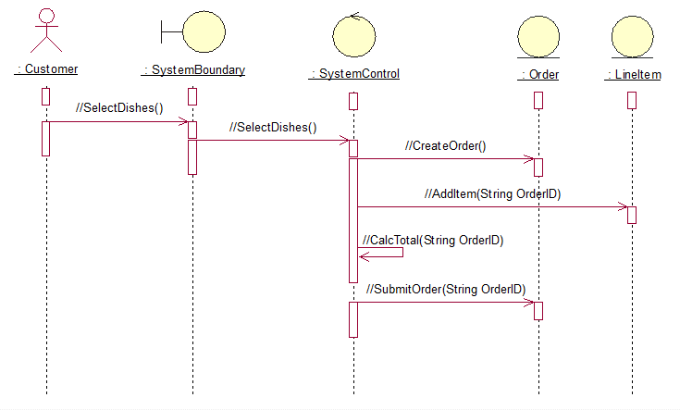

:OrderControl

:MainForm

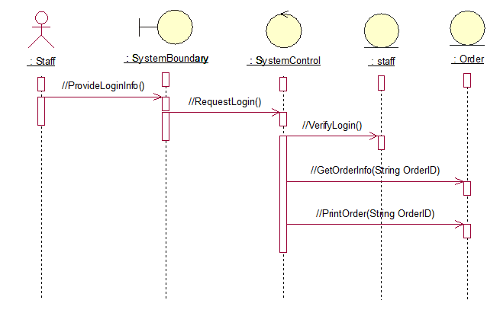

:OrderControl

:MainForm

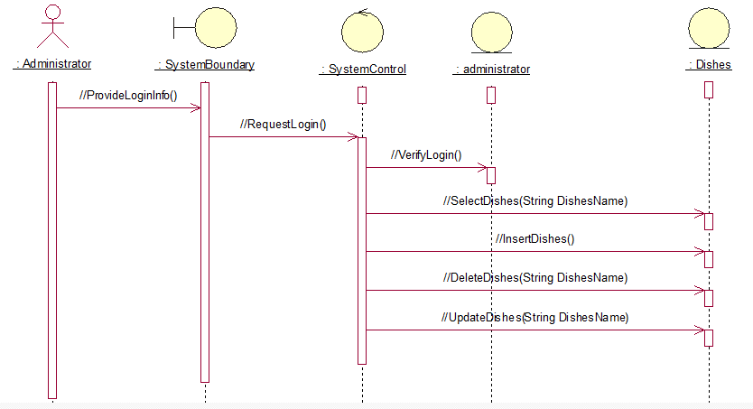

:OrderControl

:MainForm

**2.4 Collaboration Diagram（协作图）:**

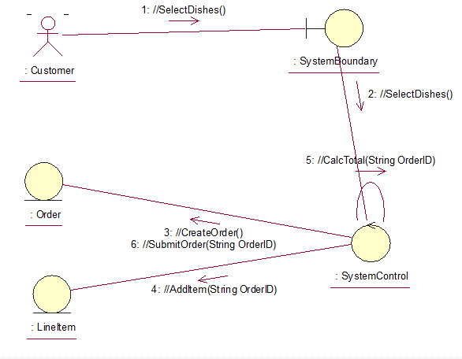

:OrderControl

:MainForm

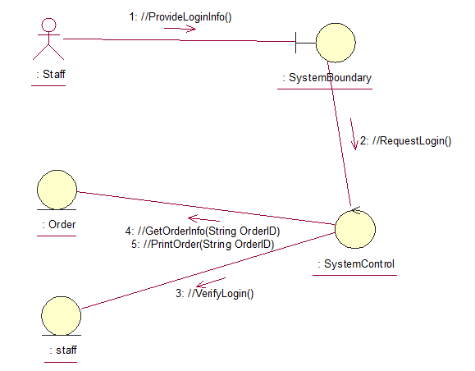

:OrderControl

:MainForm

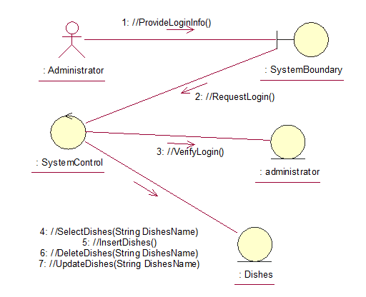

:OrderControl

:MainForm