**Final Report**

Jeffrey Ryu

College of Engineering and Computer Science, Syracuse University

Undergraduate Research of Exoskeleton

Professor Victor Duenas

Dec. 16th, 2021

**Table of Contents**

|  |  |  |  |
| --- | --- | --- | --- |
| **Introduction** | |  | **3** |
| **Details** | |  | **4** |
| **Conclusion** | |  | **8** |
|  |  | |  |

**Introduction**

During the Fall of 2021 semester in Syracuse University, I assisted the research on developing a control system for lower limb and ankle exoskeleton rehabilitation at Bionics, System, and Control Lab under Professor Victor Duenas. Although the background theories and research itself was beyond my comprehension, the Ph. D students studying the research helped me get an understanding of what we were doing. Mostly, my task was to adjust and improve fitment of number of exoskeleton parts such as footplate, braces, and sometimes the configuration of motor drive that feeds torque into the system.

**Detail**

When I joined the lab, the Ph. D students were busy with working on a research proposal for the lower limb device. During this time, I was provided with the literatures that form the basis of the research. Reading these improved my understanding, and the Ph. D students, Chen Hao and Jonathan were always willing to answer my questions and explain in detail. We set a regular time for me to visit the lab and exchanged contacts.

The goal of the research was to develop a control system for human locomotion while electric stimulation was applied for muscle actuation. The exoskeleton was already assembled and functional when I joined them, however, many tests were performed to tune the control systems. I also met Jade, who is a bioengineering student who has been participating in this research. Me and Jade were instructed with how to operate the experiment and deal with common malfunctions. We operated the Simulink codes to control the experiment while Jonathan wore the exoskeleton and electric stimulation on a treadmill. The sensors installed at each joint of the exoskeleton read the signals and actuation was applied in response, and the source of actuation is from an external electric motor drive connected with strings. I asked Chen Hao why the torque wasn’t provided directly to the joints, and he explained that this design choice was because of the motor’s size and weight being too large. The motor drive required constant supervision in case of malfunction, such as strings break away from the spool or the drive overheating and shutting down. We were instructed with how to operate the motor drives and solve common malfunctions during the experiment and we documented these procedures as seen below.

Figure : Procedure Example

Few improvements and improvisions were planned and conducted to the lower limb exoskeleton. One of them was the relocation of the strings that provide torque, installing pulleys and tubes to redirect the string to deliver torque along the rail located above the treadmill for stability and reduction of interferences. Another improvement was the redesigning of the hip braces for improved adjustability and fitment, utilizing 3D printing to produce the necessary parts. In performing these modifications, I needed the qualifications for machining the parts and I joined a machine shop’s safety training to learn how to safely drill, cut, and turn. With this, I helped Chen Hao produce the necessary modifications to parts he needed, one of which was modifying steel tubes and threading to fit acrylic tubes that guide the strings. This part was necessary for the relocation of the strings to provide the torque from the top rails.

Later, I discovered that my senior design project was also assigned to design the hip portion of the lower limb exoskeleton and having an understanding of the research provided guidance to my design team to understand the goal of the research. The rehabilitation exoskeleton is different and difficult from ordinary exoskeleton that actuates in response to the wearer’s movement, it provides actuation for the wearer’s movement.

As the proposal reached the stage where experiments gave the desired outcomes and were no longer needed, Jade and I moved on to preparing the ankle device. The premise of the ankle device is somewhat similar to the lower limb exoskeleton, it provides torque at the ankle to assist the ankle movement while walking. Additionally, this device required sensors to read muscle stimulation from bio signals, one at the tibialis and one at the soleus. Currently, the ankle device prototype has only a single piece worn on the left leg, and the joint assembly is shown in *Figure 2.*

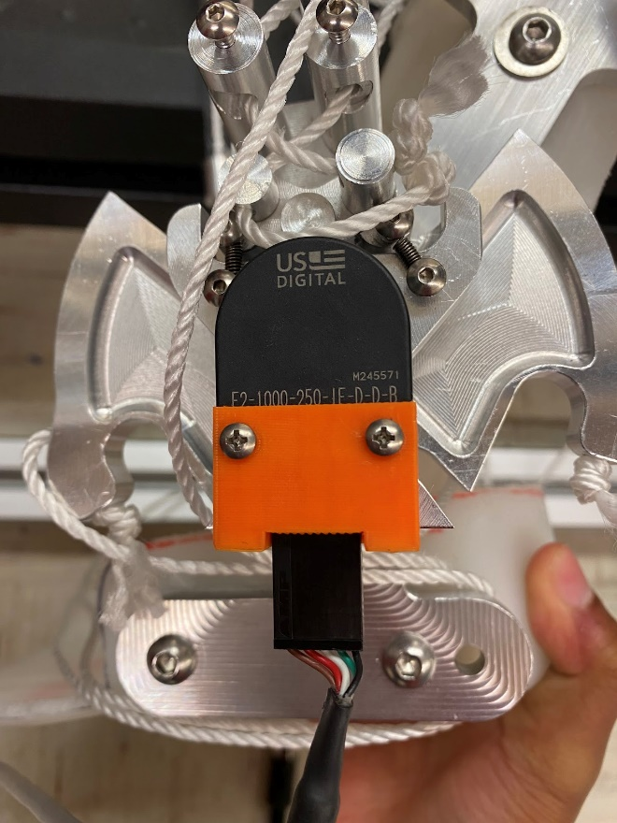

Figure : Ankle Device Joint

One of the problems from this joint assembly is the orientation of the encoder causing potential risk of the wires being damaged. As seen in *Figure 1,* the wires are pointed downward from the encoder, which means that they have to be bent upwards, causing tension and stress to the encoder socket. The encoder orientation cannot be changed due to the ankle device’s structure. This issue was noted and designing a new housing for the encoder was one of the proposed solutions.

On the other hand, the location of the sensor and the bulkiness of the sensors made it difficult to secure them onto the desired position due to the interference with the ankle device’s structure. One of the speculated solutions was to redesign the shin portion of the ankle device, however, it would need time to design and produce a new piece, so this was improvised to have it working at the moment. An incision to the foam pad was made to fit the tibialis sensor, while a 3D printed housing and Velcro straps were used to secure the soleus sensor as shown in *Figure 3.*

Figure : Sensors

Another adjustment was made to the foot plate of the ankle device, where it caused discomfort and pain during prolonged usage. The design was molded and fitted to someone else’s foot with composite material, and the sides were to narrow. The foot plate was still necessary for applying torque for the wearer, so the problematic parts were removed. The machine shop training helped me perform this modification, cutting off the side walls with a dremel under the supervision of the machine shop’s manager. This modification avoided damaging the structural strength or the ankle device’s performance and yielded improved comfort during the experiment.

**Conclusion**

I was interested in joining undergraduate research because of my interest in pursuing a graduate course, and this experience helped me know what it is like to study in a lab. The contents of the research further motivated me to pursue graduate courses, with most of the core materials behind the control theory requiring them to understand. I also learned that researching requires great deal of independence and motivation, but also team work as well. While at the lab, Chen Hao and Jonathan often exchanged opinions and tried to reach an agreement or come up with a solution. They also specialized in different ways, Chen Hao doing most of the mechanical part while Jonathan responsible for electrical and electronic part. From this, I learned that a good teamwork can not only distribute tasks, but also maximize personal specialization, and Jade was better at keeping track of things and documenting experiments while I worked on the physical end of modifying and installing parts. All in all, the tasks I have performed during my undergraduate research benefitted both me and the lab, and I learned more as I assisted the exoskeleton research.