Isaac Ibidun - 219070861 - [ibidun@my.yorku.ca](mailto:ibidun@my.yorku.ca)

Herman Lim - 217263310

Ruth Bezabeh - 216171795 - [ruttkas@my.yorku.ca](mailto:ruttkas@my.yorku.ca)

Mate Korognai - 218179457 - [korognaimat@gmail.com](mailto:korognaimat@gmail.com)

Muhammad Ehab Khan - 217560731 - [mek01@my.yorku.ca](mailto:mek01@my.yorku.ca)

**EECS 2311 Group 3 Project Brainstorming**

11th Jan 2023

**Round 1**

* School stuff
  + Schedule app
  + Note sharing app
    - Collaborative lecture note sharing
  + Calculator
    - Scientific calculator
    - Graphic
    - Derivatives/Integrals
    - Graphic logic
* Fun/Hobby/Leisure
  + Book/Show log app (2)
  + Game
* Reward system
* Expense tracker
* Password manager
* Digital instrument
* Shopping System
* Trip Scheduling System (2)
  + Uber trip
  + Plane Trip
  + Train Trip
* Delivery System
* Fitness Tracker

18th Jan 2023

**Round 2**

* Book/Show Log App
  + Rating System
  + Complete/Incomplete Media
  + Chapter / Episode / Timestamp
  + Personalized Organization
    - Folders
    - Tags
    - User comments
  + Categories
    - TV Show
    - Books
    - Movies
    - Webcomics
  + Recommendations
    - Genre Based
  + Filters
    - For Genre, Recommendation, Categories
  + Search function
    - Record
  + DARK MODE?
* Expense Tracker
  + Ability to add income
  + Ability to track categories for spending (food, clothes etc)
  + Budget tracker included
  + Ability to set spending/saving goals that are time-bound
  + Graphical Output
    - Spending Per Month
* ~~Trip Scheduling System~~

18th Jan 2023

**Round 3 - Vote Results**

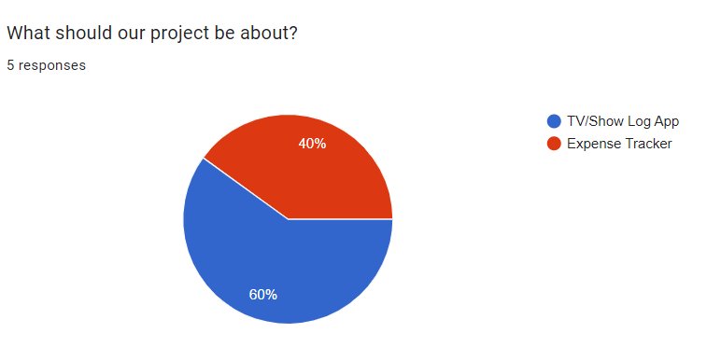

**Project Name Ideas**

* ~~Leisure Logger~~
* ~~Recreational Report~~
* MediaDB
  + DB stands for DataBase
* ~~Fun Tracker~~
* ~~MyProgress~~
* WhereWasI?
* Media Vault
* ~~__Review~~
* I Forgot
* UMedia

**Name Results**

Primary Choice: Media Vault

