FacilityFix
System Architecture Design & Mockup
Internship: Junior Software Developer Internship, YuvaIntern by Henry Harvin
Week 2 — System Architecture Design & Mockup
Project Type: Web-based college facility issue reporting and tracking system
Note: FacilityFix is a hypothetical project created for the internship assignment and is not currently deployed or used by any college.

System Overview
FacilityFix is a hypothetical web-based college facility issue reporting and tracking system. It is designed for students, faculty, and staff members to report issues related to college facilities and monitor their status. A Facility Coordinator manages submitted issues, sets the final priority, updates statuses, and records resolution details.
The proposed architecture follows a simple web-based client-server approach. Users interact with the system through a web interface, requests are handled by the application/backend, and relevant information is stored in a database. This structure keeps the system understandable, maintainable, and suitable for the defined project scope.

2. Architecture Diagram
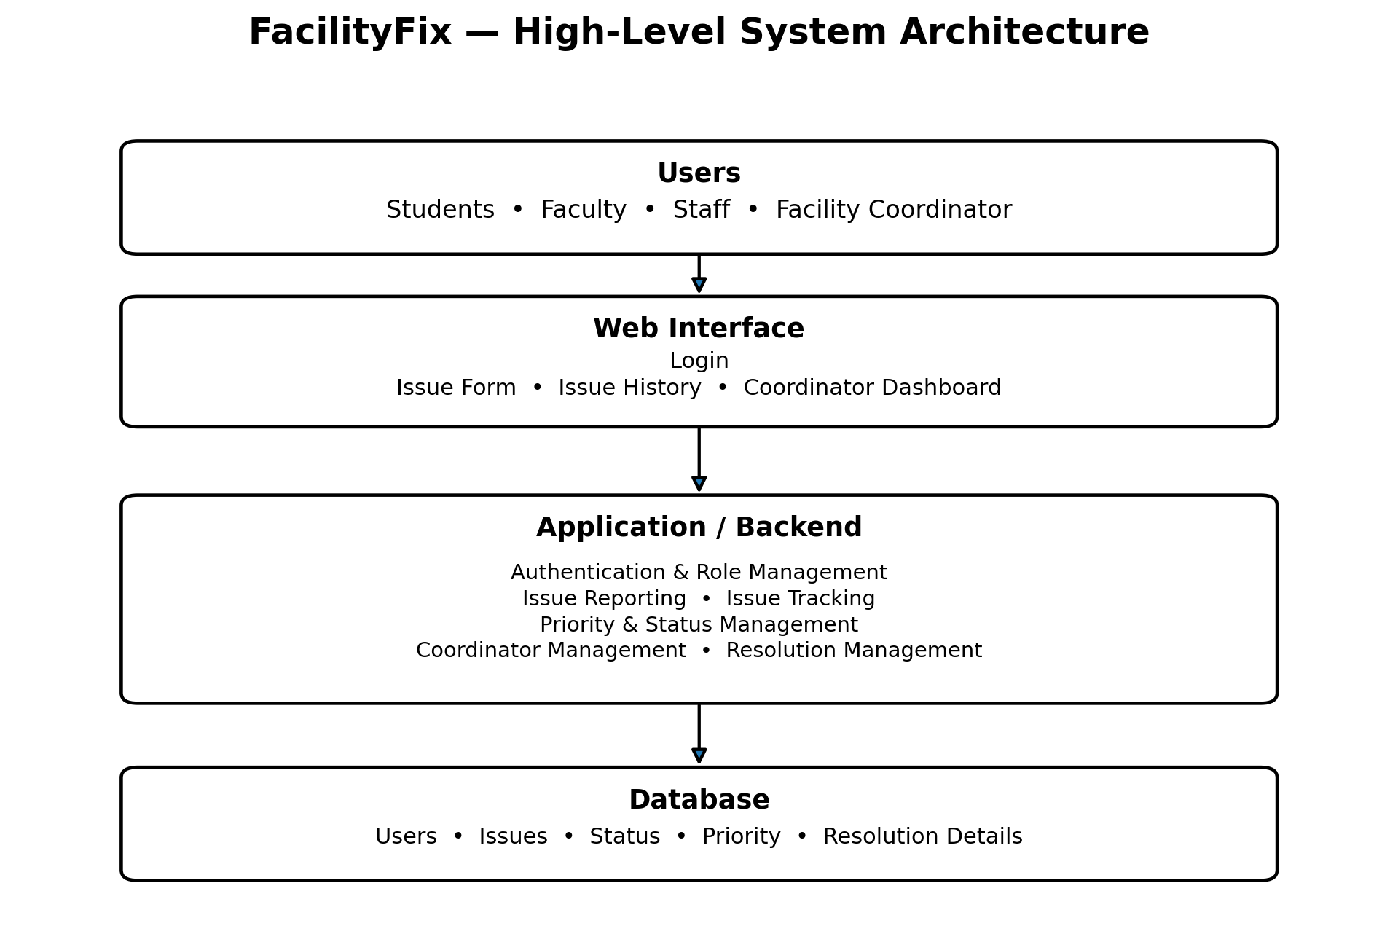
Figure 1: High-level architecture and primary data flow of FacilityFix.

3. Main Components and Modules
The system is divided into a web interface, application/backend layer, and database. The backend contains logical modules with clearly defined responsibilities.
Module | Responsibility
Authentication & Role Management | Handles basic account login and the roles of Students, Faculty, Staff, and the Facility Coordinator.
Issue Reporting | Allows users to submit a category, description, exact location, suggested priority, and optional photo.
Issue Tracking | Allows users to view their submitted issues and their current status and basic progress information.
Priority & Status Management | Allows the Facility Coordinator to review suggested priority, set the final priority, and update issue status.
Coordinator Management | Provides the Facility Coordinator with access to all issues and search/filter options by status, category, building/block, date, and priority.
Resolution Management | Allows the Facility Coordinator to add a resolution note and record the name of the person who resolved the issue.

4. Planned Technologies
Because FacilityFix is a hypothetical project, the following technologies represent a planned implementation approach rather than technologies already used in a deployed application.
- Frontend: HTML, CSS, and JavaScript
- Backend: Python with Flask
- Database: SQLite
- Architecture: Simple web-based client-server architecture

5. Data Flow and Module Interaction

5.1 Issue Reporting Flow
A Student, Faculty member, or Staff member logs in and enters issue details through the Issue Reporting module. The backend validates and processes the request, and the issue is stored in the database with the initial status of Submitted. The user can then view the issue through Issue Tracking.

5.2 Coordinator Flow
The Facility Coordinator logs in and accesses the coordinator dashboard. The coordinator can view all issues, search or filter them, review the suggested priority, set the final priority, and update the issue status. These changes are processed by the backend and stored in the database.

5.3 Resolution Flow
When an issue is resolved, the Facility Coordinator can add a resolution note and the name of the person who resolved it, and then change the status to Resolved. If the issue is still present, it can be reopened and moved through In Progress before being resolved again.

5.4 Module Interaction
The main interaction follows the path: User → Web Interface → Application/Backend → Database. Coordinator actions follow the same architecture when information is retrieved or updated. The backend acts as the central processing layer between the interface and stored data.

6. Security Considerations
- Role-based access will be used so that users and the Facility Coordinator receive appropriate permissions.
- Students, Faculty, and Staff will only be able to view their own submitted issues.
- The Facility Coordinator will have access to the management functions required for handling all issues.
- Passwords will be securely stored using password hashing.
- Input data will be validated before being stored in the database.
- Users will not be allowed to edit an issue after submitting it.

7. Scalability
The system is designed so that the number of users and reported issues can grow without requiring a complete redesign. The database structure will remain organized, and the application will keep separate responsibilities for different modules. If usage increases, the system can be moved to a larger database or stronger server environment with minimal changes to the system.

8. Maintainability
Maintainability will be supported by separating the system into logical modules with clear responsibilities. Consistent naming, coding practices, and basic documentation will make the application easier to understand and modify. This approach also allows a particular module to be improved without unnecessarily affecting the complete system.

9. External Integrations
FacilityFix is designed as a simple standalone web-based system, so no external integrations are required in the initial design. The planned system will handle user accounts, issue reporting, issue tracking, priority and status management, and resolution details within its own application and database. Features such as third-party authentication, notification services, payment gateways, external APIs, and other integrations are outside the current project scope. If required in the future, external services can be integrated after evaluating their security, reliability, and compatibility with the existing system.

10. Conclusion
The FacilityFix architecture provides a simple and structured design for a college facility issue reporting and tracking system. The proposed architecture separates the user interface, application/backend, and database, making the system easier to understand and maintain.
The different modules have clearly defined responsibilities, from authentication and issue reporting to status management and resolution handling. The planned data flow allows users to submit and track issues while giving the Facility Coordinator the required controls to manage them.
Security, scalability, and maintainability have also been considered while keeping the system within the defined project scope. Since FacilityFix is currently a hypothetical project, the architecture represents a planned design rather than an implemented system. The design can provide a practical foundation for future development of the application.

