Quantized CNN Accelerator: INT8 Convolution Core Design on FPGA
Lê Tiến Thành, Huỳnh Thiên Vũ, Hoàng Minh Nhật, Trịnh Trần Minh Quân
Khoa Vi mạch Bán dẫn - Ô tô, Phân hiệu Trường Đại học FPT tại TP.HCM, Việt Nam
GVHD: T.S Phạm Thế Vinh

Abstract—Convolutional Neural Networks (CNNs) deliver strong accuracy on image-based inference tasks, yet their deployment on resource-constrained edge Field-Programmable Gate Arrays (FPGAs) is fundamentally limited by global memory bandwidth: conventional frame-buffer models, which assume random whole-image access from DRAM, incur prohibitive read-port and on-chip storage costs when mapped directly onto reconfigurable logic. To address this bottleneck, this paper presents a Pixel Streaming architecture built around a single-cycle-latency, register-bounded INT8 Convolution Core for FPGA-based CNN acceleration. Rather than buffering an entire frame, the proposed design reconstructs a 3×3 spatial neighborhood on the fly from a single-pixel-per-cycle input stream using a cascaded dual-line-buffer generator with spatial reuse, while a dedicated Multiply–Accumulate (MAC) core executes quantized INT8 arithmetic with sign-extended INT32 accumulation and a saturation-clipping stage that restricts results back into the representable INT8 range. The design was described in Verilog RTL and verified through cross-check against an independently implemented Python Golden Model across three distinct 28×28 image datasets, achieving a 100% match rate (676/676 output pixels per dataset; 2,028/2,028 across all three datasets combined) with zero mismatches. Synthesis on Gowin EDA confirmed the efficiency of the streaming approach, consuming only 84 Look-Up Tables (LUTs), 105 Registers, 43 ALUs, 5 DSP slices, and 1 Block SRAM (BSRAM) primitive — under 1% of total device logic resources — while achieving a maximum operating frequency (Fmax) of 170.5 MHz, confirming suitability for real-time, resource-constrained edge inference.
Index Terms—FPGA, Convolutional Neural Network, INT8 Quantization, Pixel Streaming, Line Buffer, Multiply-Accumulate, Hardware Accelerator, Verilog RTL.
I. Introduction
The computational core of a CNN is the convolution layer, where every output feature is produced by a Multiply–Accumulate (MAC) reduction over a local receptive field; for a 3×3 kernel, each output pixel requires nine multiplications and eight additions, a cost that scales directly with feature-map resolution and channel depth. On general-purpose processors, this cost is absorbed by treating the image as a fully addressable array in DRAM, where arbitrary (x, y) coordinates are dereferenced on demand under an implicit assumption of near-infinite memory bandwidth and parallel access.
This assumption breaks down when the same computation is mapped onto edge FPGA fabric. Producing one 3×3 convolution result per clock cycle requires nine simultaneous pixel reads, which standard single- or dual-port embedded block memories cannot natively provide without replicating memory banks or accepting reduced clock frequency from added routing and multiplexer complexity. Latching an entire frame into flip-flop registers is similarly impractical: even a small 28×28 grayscale frame requires 28×28×8 = 6,272 bits of register storage, while a single Full-HD (1920×1080) 8-bit frame approaches 16.6 million bits — consuming the majority of available logic resources before any arithmetic datapath is instantiated. Prior work toward FPGA-based CNN acceleration has explored dedicated quantized-network engines [1], dataflow-optimized convolutional accelerator design [2], and mixed-precision throughput architectures [3], reflecting sustained demand for convolution engines that respect these on-chip resource constraints.
While [1] and [3] prioritize multi-channel and mixed-precision throughput through parallel MAC arrays, and [2] targets accelerator design under an implicit DRAM-resident frame-buffer model, this work instead isolates the single-channel streaming datapath itself — the sliding-window generation and INT8 MAC/clipping pipeline — as the unit of design and verification. This choice prioritizes per-pixel latency, on-chip storage footprint, and bit-exact numerical correctness over channel-level parallelism. The resulting scope reflects the goal of establishing a rigorously verified, resource-minimal streaming primitive suitable as a building block for larger multi-channel accelerators, rather than a complete multi-channel CNN engine.
To resolve this mismatch, this paper adopts a quantized INT8 numerical representation combined with a Pixel Streaming dataflow, in which the two-dimensional image is flattened into a continuous one-pixel-per-clock stream and the spatial neighborhood required for convolution is reconstructed incrementally in hardware rather than fetched from a stored global array. This eliminates both the multi-port memory requirement and the full-frame storage overhead described above, while the INT8 representation reduces datapath width relative to floating-point or wider fixed-point formats. The main contributions of this paper are summarized as follows:
- A stream-based sliding window generator built on a cascaded dual line-buffer microarchitecture that reconstructs a valid 3×3 spatial matrix directly from a sequential 1-pixel/clock stream, exploiting spatial reuse of each incoming pixel without storing or randomly addressing a global image array.
- A single-cycle-latency INT8 Convolution Core (conv_core_int8), registered at its input and output boundaries, implementing signed Multiply–Accumulate arithmetic (INT8 × INT8 → INT16, sign-extended and accumulated in INT32) together with a saturation-clipping stage that safely restricts the accumulator output back to the INT8 range [−128, 127].
- A complete cross-check verification flow against an independently implemented Python Golden Model, demonstrating a 100% bit-exact match across multiple test datasets, together with FPGA synthesis results confirming sub-1% logic utilization (84 LUTs, 105 Registers, 43 ALUs, 5 DSP blocks, 1 BSRAM) and a post-route maximum operating frequency of 170.5 MHz.
II. Proposed Hardware Architecture
The proposed Quantized CNN Accelerator is organized as two cooperating subsystems within a single synchronous pipeline (Fig. 1): a data-preparation subsystem — the stream-based sliding window generator (sliding_window.v) — and a compute subsystem — the INT8 Convolution Core (conv_core_int8.v). Quantized signed INT8 pixel data enters the sliding window generator at one pixel per clock cycle; once a spatial neighborhood has been fully populated, the resulting 3×3 window is forwarded, together with the corresponding kernel weights from kernel_rom.v, to the INT8 Convolution Core for MAC reduction and saturation clipping.
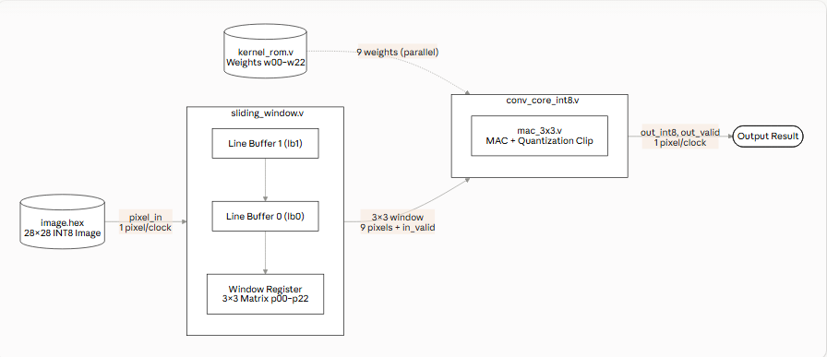
Fig. 1. Integrated block diagram of the proposed Pixel Streaming dataflow architecture.
A. Stream-Based Sliding Window Generator
A K×K spatial convolution requires simultaneous access to a local neighborhood of the input, defined by
Output(x,y) = Σᵢ Σⱼ Kernel(i,j)·Pixel(x+i, y+j), i,j ∈ [0, K−1].
Because the input arrives as a strictly sequential stream, hardware is directly exposed, at any given clock edge, only to the pixel occupying the bottom-right corner of the active convolution window; reconstructing the full 2D neighborhood therefore requires retaining a number of prior rows equal to K−1. For the 3×3 kernel adopted in this design (K = 3), exactly two cascaded line buffers are required.
Each line buffer (line_buffer.v) is a fully parameterizable Verilog module with configurable DATA_WIDTH (8 bits per pixel) and IMG_WIDTH (28, matching the MNIST-derived test images used in this study). Internally, it is implemented as a shift-register array of depth equal to IMG_WIDTH: on every active clock edge with shift_en asserted, all elements shift one position toward the higher index while the newest sample enters at index 0, and the output is tapped continuously from the deepest register. Because every element updates within the same clock edge via non-blocking assignment, the shift is a true single-cycle operation, and the module behaves as a fixed-latency FIFO of depth IMG_WIDTH: its output lags its input by exactly IMG_WIDTH clock cycles.
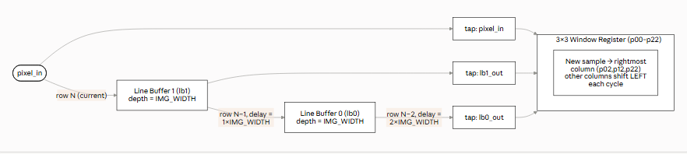
Fig. 2. Cascaded structure of the dual line-buffer (lb0, lb1) sliding-window generator.
Two instances of this module are cascaded inside the sliding-window generator (Fig. 2): the first (lb1) receives the raw incoming pixel stream directly, producing an output delayed by one full row (IMG_WIDTH cycles) relative to the live stream; the second (lb0) receives lb1's output as its own input, accumulating a further IMG_WIDTH-cycle delay, for a total delay of 2×IMG_WIDTH cycles. At any valid clock edge in steady state, the circuit thus exposes three vertically aligned pixels sharing the same column index across three consecutive rows: the live stream (bottom row), lb1's output (middle row), and lb0's output (top row) — each pixel held in the cascade being spatially reused across the multiple output windows it will contribute to as the window slides forward.
These three row-aligned taps feed a 3×3 register matrix (p00 through p22) that performs a 2D spatial shift every cycle: the rightmost column (p02, p12, p22) samples the three new row-taps, while every other register shifts one position to the left. This structure continuously holds the current 3×3 neighborhood as it slides across the frame at a rate of one column per clock cycle, without storing or randomly addressing the image as a global 2D array.
Window validity is tracked using two counters, col_cnt and row_cnt, which increment with every accepted pixel and roll over at row boundaries (col_cnt == IMG_WIDTH−1). The output-valid flag, out_valid, is asserted only once row_cnt ≥ 2 and col_cnt ≥ 2 (both zero-indexed), guaranteeing that all nine window registers hold genuine image data rather than post-reset zeros. This condition is first satisfied after a deterministic fill latency of 2×IMG_WIDTH+2 clock cycles; for IMG_WIDTH = 28, the first valid window appears on the 59th transferred pixel. After this initial latency, the generator sustains a peak throughput of exactly one valid 3×3 window per clock cycle within each row of valid columns — the theoretical maximum for a streaming interface — briefly deasserting out_valid for two cycles at the start of every subsequent row while col_cnt re-establishes validity, as detailed in Section III-B.
Because out_valid is asserted only once the window is completely populated, the generator implements Valid-Padding (no zero-padding) convolution: the output feature map is reduced in each dimension by (K−1) relative to the input, yielding a 26×26 feature map (676 pixels) from a 28×28 input. Preserving edge resolution would instead require a Same-Padding scheme — inserting zero-valued samples at the row/column boundaries of the stream — identified in Section IV as a direction for future work rather than a limitation of the present design.
B. INT8 MAC Core and Quantization Clipping
The INT8 Convolution Core (conv_core_int8.v) receives the nine-pixel window from the sliding window generator together with the nine corresponding kernel weights supplied by kernel_rom.v, and is organized into four cooperating sub-modules: mac_3x3.v, which performs the signed multiply–accumulate reduction; kernel_rom.v, which stores the 3×3 kernel as signed INT8 values loaded via $readmemh from a Python-generated kernel.hex file; relu.v, an optional rectified-linear-unit stage; and quant_clip.v, which applies saturation clipping to the accumulator result to produce the INT8 output range. For verification against the Python Golden Model — which performs convolution and clipping but does not apply rectification — the ReLU stage is disabled; enabling it would zero negative outputs in hardware while the reference model retains them, producing mismatches unrelated to the correctness of the arithmetic datapath itself.
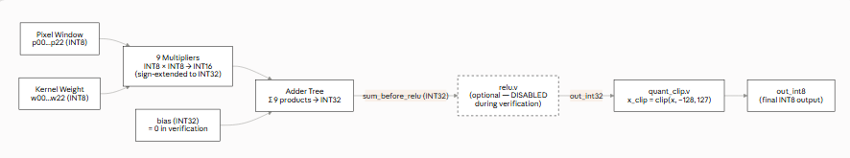
Fig. 3. Internal structure of the 3×3 signed MAC block (mac_3x3.v).
All pixel, weight, and intermediate signals are explicitly declared signed in the Verilog source (e.g., input signed [7:0] p00, output signed [31:0] sum). This is a functional necessity rather than a stylistic choice: the verification kernel is a Sobel vertical operator containing both positive and negative weights (Table II), and an unsigned interpretation would decode its two's-complement negative entries (e.g., 8'hFF as 255 rather than −1), corrupting every multiplication involving a negative weight.
TABLE I BIT-WIDTH SPECIFICATION OF THE INT8 CONVOLUTION CORE
Datapath Element | Data Type | Rationale
Input pixel | Signed INT8 | Quantized image data
Kernel weight | Signed INT8 | Kernel stored in INT8 format
Partial product | Signed INT16 | INT8×INT8 exceeds 8-bit range
MAC accumulator | Signed INT32 | Sum of 9 products exceeds INT16 range
Final output | Signed INT8 | Matches expected_output.hex format
TABLE II VERIFICATION KERNEL WEIGHTS (SOBEL VERTICAL)
Position | Decimal | Hex (2's compl.)
w00 / w20 | 1 | 01
w01 / w11 / w21 | 0 | 00
w02 / w22 | −1 | FF
w10 | 2 | 02
w12 | −2 | FE
Bit-width selection follows directly from worst-case magnitude analysis (Table I). Each operand is a signed INT8 in [−128, 127]; the largest-magnitude product is (−128)×(−128) = 16,384, and the most negative product is (−128)×127 = −16,256, so a single partial product spans [−16,256, 16,384] — exceeding the 8-bit range and therefore requiring each partial product to be represented in signed INT16. Because a full 3×3 convolution accumulates nine such products, the theoretical extreme sum spans [9×(−16,256), 9×16,384] = [−146,304, 147,456], a magnitude exceeding the signed INT16 range of [−32,768, 32,767]. Consequently, each 16-bit partial product is sign-extended (e.g., {{16{m00[15]}}, m00}) before entering the adder tree, and the accumulator itself — product_sum, sum_before_relu, and out_int32 — is implemented in signed INT32, guaranteeing overflow-free accumulation ahead of the final clipping stage.
Once INT32 accumulation is complete, quant_clip.v restricts the result to the representable INT8 range before it is registered as the module output, applying the piecewise rule
x_clip = 127 if x > 127; −128 if x < −128; x otherwise,
which mirrors the np.clip() operation used in the Python Golden Model, ensuring the two implementations remain directly comparable at every output sample. Representative clipping cases exercised during verification — including outputs that saturate at both the positive and negative rails — are reported together with the complete verification methodology in Section III.
Timing between the two halves of the core follows a fixed one-cycle relationship: when in_valid is asserted in cycle N, all nine window and weight operands are valid and the MAC computation begins; the clipped result is registered and out_valid asserted in cycle N+1. The nine-multiplier array, adder tree, and clipping logic between these two register boundaries are purely combinational; post-route static timing analysis reports a critical path of only two logic levels (Section III-C), consistent with a shallow, single-stage register-bounded datapath rather than a deeply pipelined multi-stage MAC. This single-cycle latency, appended to the sliding-window generator's initial fill latency (Section II-A), fully accounts for the pipeline depth observed between input and output streams during simulation.
III. Verification and Synthesis Results
A. Verification Methodology
In the integrated circuit design flow, verification is treated as a task distinct from, and prerequisite to, post-fabrication validation: whereas validation targets physical defects on a manufactured device, verification builds confidence that the RTL description implements the intended logical function correctly across the test cases exercised, since the cost of correcting a logic error after FPGA bring-up — or, more severely, after ASIC tape-out — is substantial. To this end, a cross-check methodology against an independent Golden Model was adopted rather than relying on visual inspection of the RTL. Python was selected as the implementation language for the Golden Model in preference to a second RTL description, since the differing programming paradigm of a high-level language reduces the risk of a common-mode failure — i.e., reproducing the same algorithmic mistake in both the reference and the design under test. The Python Golden Model produces three hexadecimal artifacts consumed by the RTL simulation environment: image.hex (input pixel stream), kernel.hex (kernel weights), and expected_output.hex (reference feature-map values).
A dedicated testbench, tb_compare_python_rtl.v, automates the comparison end to end. At elaboration, the testbench loads image.hex into the hardware input stream and expected_output.hex into an internal reference array via $readmemh. During simulation, every assertion of out_valid triggers a same-cycle 1:1 comparison between out_int8 and the corresponding reference value; matches increment a pass_count register, while mismatches increment fail_count and emit a diagnostic message identifying the failing sample.
B. Simulation Results
Simulation used ModelSim, with compilation and simulation fully scripted via Tcl (run_modelsim.do compiles all Verilog sources with vlog and launches vsim -voptargs="+acc" work.tb_compare_python_rtl; wave.do configures the observed signal set). A transcript reporting “# Errors: 0, Warnings: 0” was required before any waveform-based analysis was undertaken.
For the primary 28×28 test image (so.hex, MNIST-derived), the Sobel-vertical kernel described in Section II-B, Stride = 1, and Valid-Padding together yield a 26×26 (676-pixel) feature map. Comparison against the Python Golden Model, with the ReLU stage disabled for parity, produced 676 PASS and 0 FAIL results (Fig. 4), a 100% match rate confirming that the signed-arithmetic MAC and quantization-clipping datapath reproduce the reference computation bit-exactly.
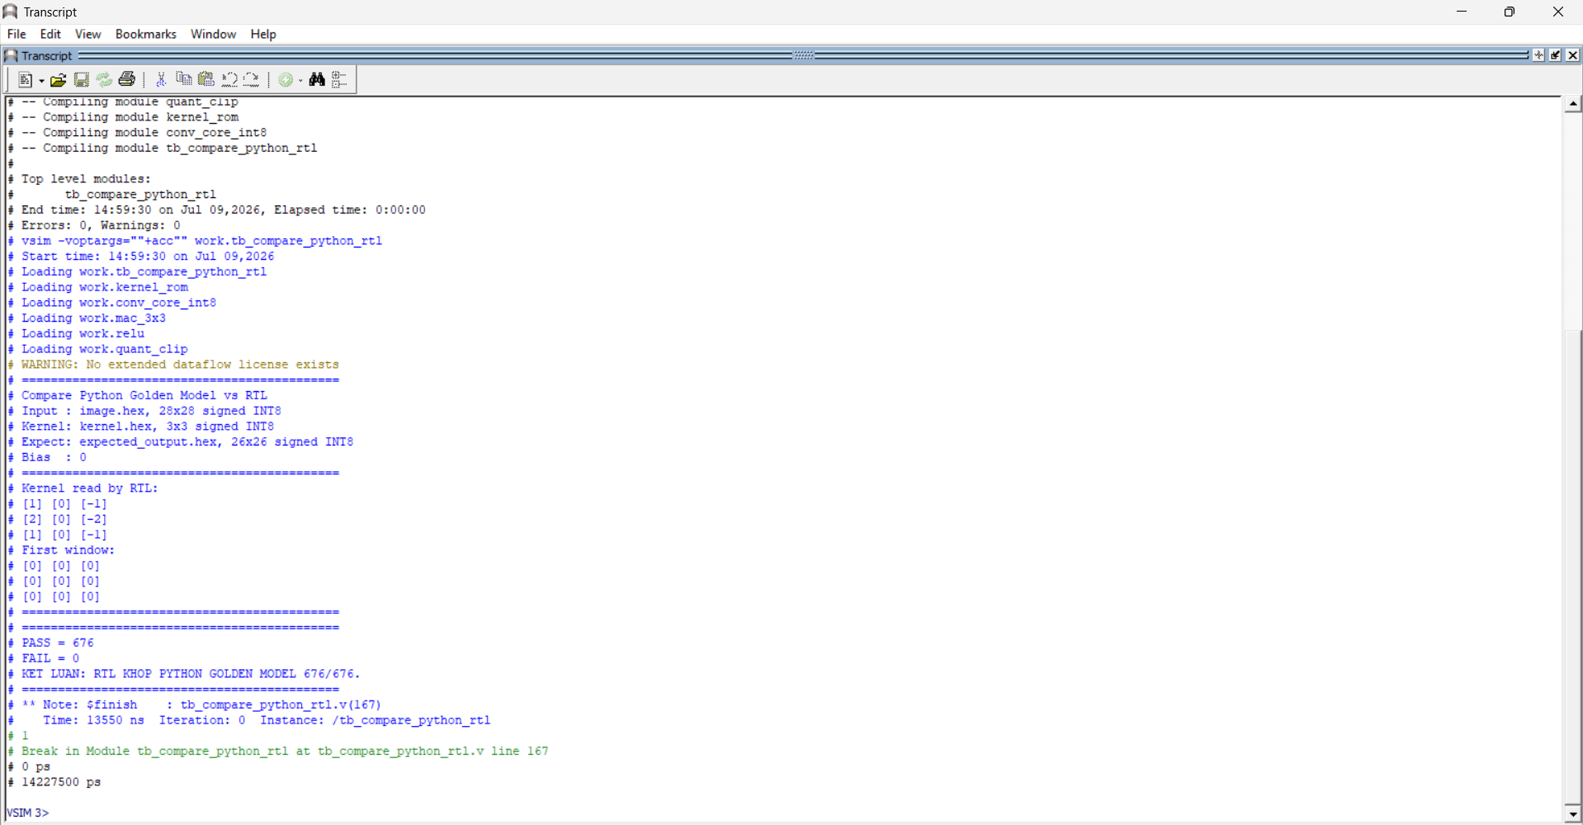
Fig. 4. ModelSim transcript reporting the PASS/FAIL outcome of the RTL vs. Python cross-check.
To rule out dependence on a specific pixel distribution, the same RTL was subsequently exercised against two additional 28×28 datasets generated by the Golden Model — an object image (vat.hex) and a footwear image (giay.hex) — each again evaluated over its full 676-pixel output. Table III summarizes the outcome: all three datasets returned a 100% match rate with zero mismatches, indicating that correctness is not an artifact of the initial test vector.
Test Dataset | I/O Size | Pixels | RTL vs. Python
Digit image (so.hex) | 28×28→26×26 | 676 | 100% (676 PASS, 0 FAIL)
Object image (vat.hex) | 28×28→26×26 | 676 | 100% (676 PASS, 0 FAIL)
Footwear image (giay.hex) | 28×28→26×26 | 676 | 100% (676 PASS, 0 FAIL)
TABLE III MULTI-SAMPLE VERIFICATION RESULTS
Table IV lists representative output samples selected specifically to exercise the quantization-clipping boundary rather than typical in-range values. Output index 160 (row 6, column 4) produces a pre-clip INT32 accumulation of −195, which both the Python Golden Model and the RTL clip to −128; index 201 (row 7, column 19) produces a pre-clip value of 203, clipped to 127 by both implementations. In-range values, such as −42 and 17 at indices 134 and 137, pass through unmodified. Agreement at every listed index, including both saturation directions, confirms that quant_clip.v correctly reproduces the np.clip() semantics of the reference model rather than merely avoiding overflow by coincidence.
TABLE IV REPRESENTATIVE OUTPUT COMPARISON, INCLUDING CLIPPING CASES

Idx | Row,Col | Pre-clip INT32 | Python / RTL INT8 | Result
0 | 0,0 | 0 | 0 / 0 | PASS
134 | 5,4 | −42 | −42 / −42 | PASS
137 | 5,7 | 17 | 17 / 17 | PASS
160 | 6,4 | −195 | −128 / −128 | PASS
201 | 7,19 | 203 | 127 / 127 | PASS
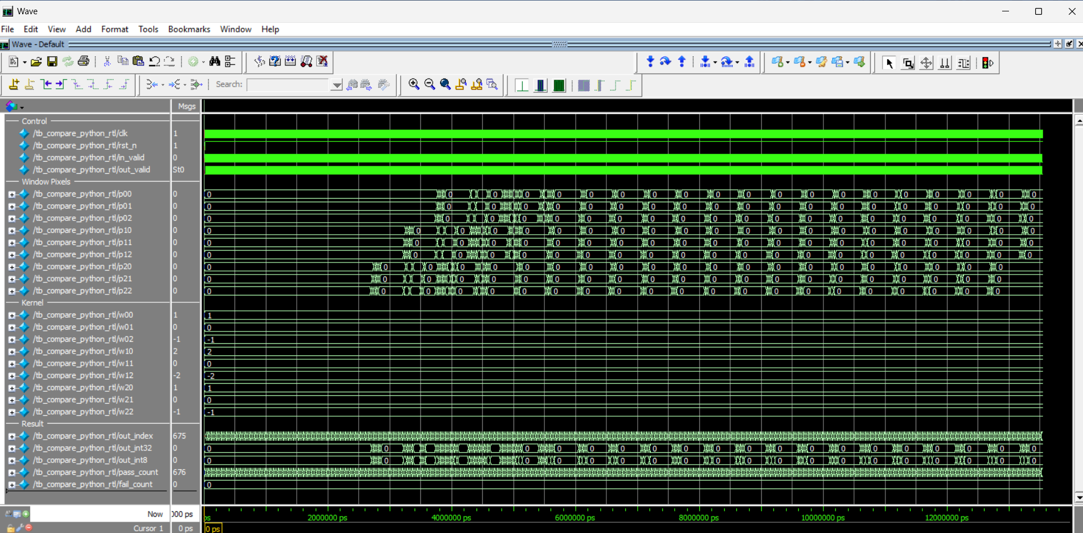
Fig. 5. Waveform showing the in_valid / out_valid timing relationship and pipeline latency.
Waveform inspection (Fig. 5) of in_valid, out_valid, and the internal pixel/product signals confirms the pipeline-latency behavior derived analytically in Section II-A: the design requires exactly 2×IMG_WIDTH+2 clock cycles to fill the cascaded line buffers before the first valid output, after which out_valid remains asserted for one output pixel per cycle across each row of valid columns, sustaining the peak target throughput within a row; out_valid deasserts for two cycles at the start of each new row while col_cnt re-establishes validity (Section II-A), before resuming at the same peak rate for the remainder of the row.
C. Hardware Utilization
The design was synthesized using Gowin EDA to evaluate feasibility for physical FPGA deployment. As summarized in Table V and Fig. 6, the synthesized design utilizes 84 LUTs, 105 Registers, and 43 ALUs — under 1% of the target device's total logic and register resources. Notably, the architecture leverages 5 dedicated DSP blocks (1 MULT12X12 and 4 MULTADDALU12X12) for high-efficiency arithmetic and 1 BSRAM primitive for line-buffer storage; the latter corresponds to approximately 2% of the device's available block RAM, slightly above the sub-1% figure that characterizes logic and register usage. Static timing analysis confirmed a maximum operating frequency (Fmax) of 170.5 MHz, which reflects the actual routed delay on the target FPGA fabric, ensuring robust real-time performance for edge inference applications.
TABLE V HARDWARE RESOURCE UTILIZATION (GOWIN EDA)
Metric | Utilization | Role
LUTs (Look-Up Tables) | 84 | Sliding-window control logic, MAC adder tree
Registers (Flip-Flops) | 105 | Line-buffer shift chain, 3×3 window registers
ALUs | 43 | Arithmetic operations in the Convolution Core
DSP Blocks | 5 | Parallel INT8×INT8 multiplications
BSRAM | 1 | Efficient cascaded line-buffer storage
Max Frequency (Fmax) | 170.5 MHz | Maximum stable system clock frequency
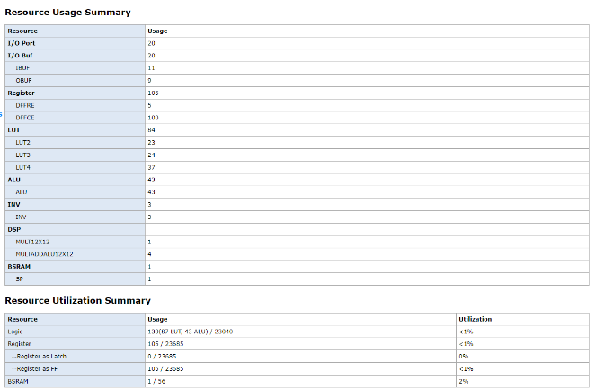
Fig. 6. Gowin EDA resource utilization report.
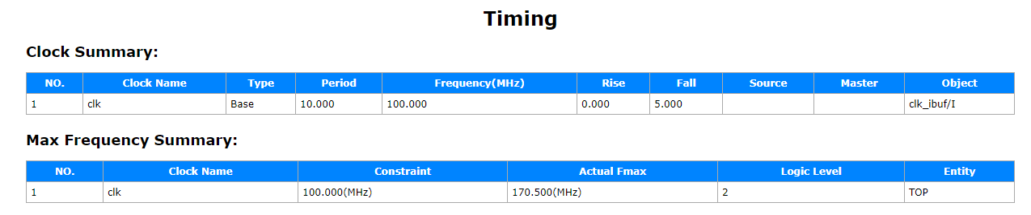
Fig. 7. Gowin EDA maximum operating frequency (Fmax) report.
IV. Conclusion
This paper presented the design, implementation, and verification of an INT8 Convolution Core for FPGA-based CNN acceleration, organized as a modular pipeline of Line Buffer, Sliding Window, Kernel ROM, MAC 3×3, and Quantization-Clipping blocks. By replacing conventional whole-frame buffering with a Pixel Streaming dataflow and a cascaded dual-line-buffer sliding-window generator, the design reconstructs the 3×3 spatial neighborhood required for convolution without random access to a stored global array, while INT8 quantization—with sign-extended INT32 accumulation and quantization clipping—keeps the arithmetic datapath narrow without sacrificing numerical correctness. Verification against an independently implemented Python Golden Model, using a cross-check methodology across multiple 28×28 datasets, produced a 100% bit-exact match (676/676 output pixels per dataset, 0 mismatches), including at the positive and negative saturation boundaries of the clipping function. Synthesis on Gowin EDA confirmed that these correctness guarantees were obtained at negligible hardware cost: under 1% of total device logic resources (84 LUTs, 105 Registers, 43 ALUs, 5 DSP slices, and 1 BSRAM primitive) and a maximum operating frequency (Fmax) of 170.5 MHz, demonstrating that latency, throughput, and hardware resource consumption can be jointly balanced in a streaming INT8 convolution engine suitable for real-time edge inference.
Several directions remain open for extending the present design. Integration of a standard AXI4-Stream interface would allow the Convolution Core to be composed with other IP blocks in a larger SoC pipeline without custom handshaking logic. Same-Padding control logic — inserting zero-valued boundary samples into the pixel stream — would preserve the input spatial resolution at the output, complementing the Valid-Padding behavior implemented in the current design. Beyond interface and padding extensions, future work may also generalize the architecture to multiple kernels and input channels, incorporate nonzero trained bias values and additional CNN layers such as Max Pooling and Fully Connected stages toward a complete accelerator, and validate the design on physical FPGA hardware to characterize operating frequency, resource usage, latency, and power consumption under real operating conditions.
References
[1] M. Tasci, A. Istanbullu, V. Tumen, and S. Kosunalp, "FPGA-QNN: Quantized Neural Network Hardware Acceleration on FPGAs," Applied Sciences, vol. 15, no. 2, p. 688, Jan. 2025.
[2] C. Zhang, P. Li, G. Sun, Y. Guan, B. Xiao, and J. Cong, "Optimizing FPGA-based Accelerator Design for Deep Convolutional Neural Networks," in Proc. 2015 ACM/SIGDA Int. Symp. Field-Programmable Gate Arrays (FPGA '15), Monterey, CA, USA, 2015, pp. 161–170.
[3] C. Latotzke, T. Ciesielski, and T. Gemmeke, "Design of High-Throughput Mixed-Precision CNN Accelerators on FPGA," in Proc. 32nd Int. Conf. Field-Programmable Logic and Applications (FPL), 2022.

