1. margin spaces reduce



1. logo size increase
2. make all pages google sheets
3. funding page should have images – image abstracts
4. move the people page tags to the menu; remove faculty option

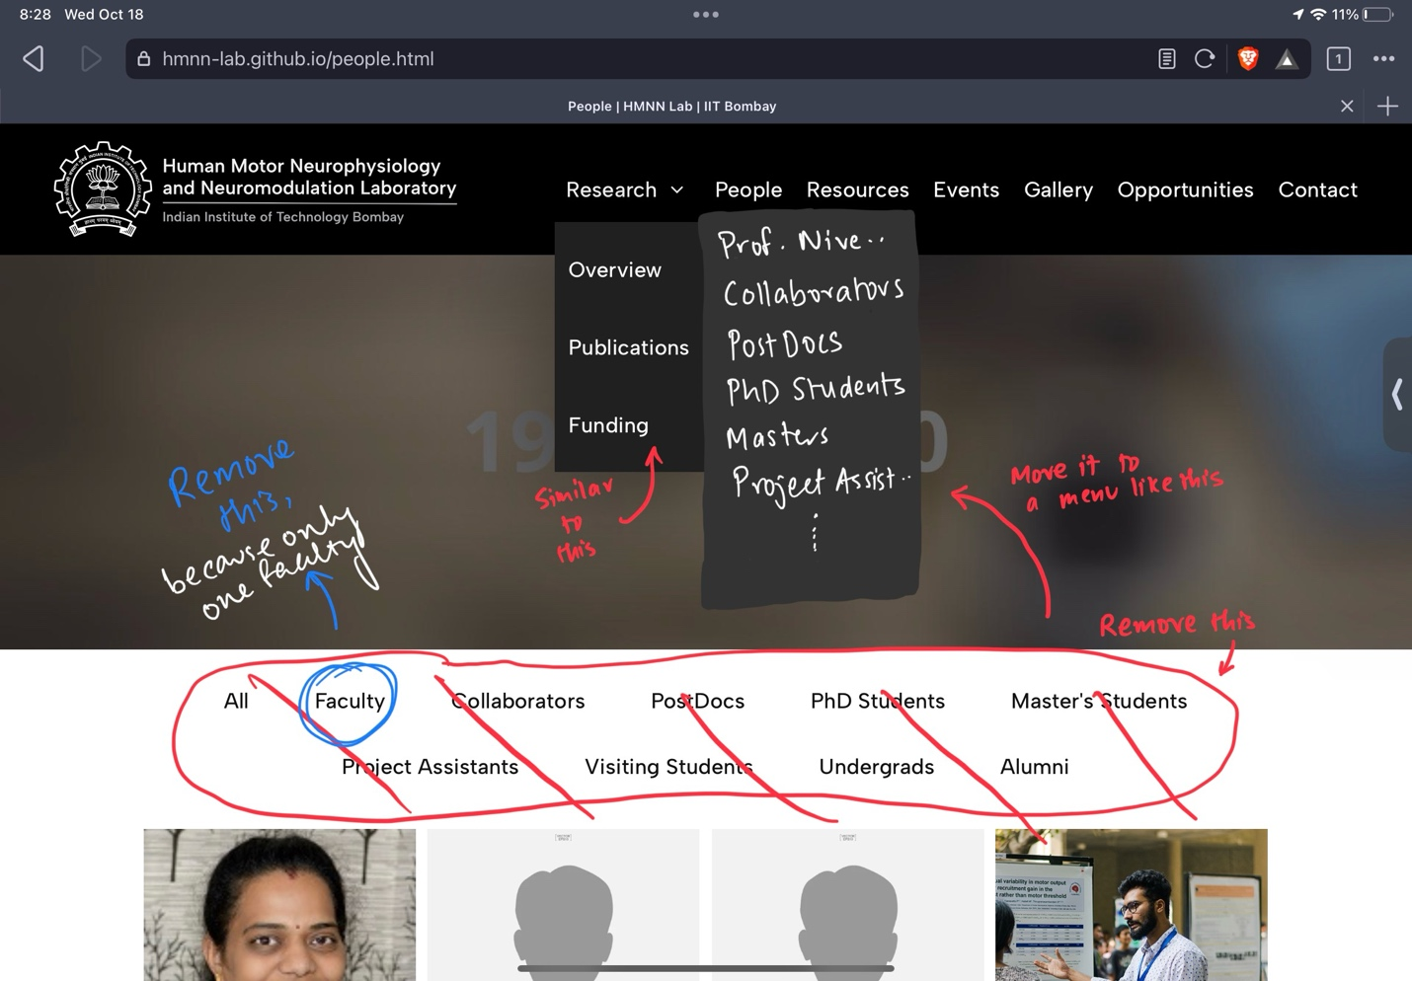

1. define gallery folder, upload all images from there – keep only one gdrive folder for all images
2. remove google scholar image, only Google Scholar hyperlink; add orcid
3. document the functioning of the entire website
4. decrease loading duration