DR. VIRENDRA SWARUP INSTITUTE OF PROFESSIONAL STUDIES
(Affiliated to Dr. A.P.J. Abdul Kalam Technical University, Lucknow)
Nawabganj, Kanpur — 208002, Uttar Pradesh, India
Department of Computer Applications
────────────────────────────────────────────────────────────────────
MINOR PROJECT SYNOPSIS
Bachelor of Computer Applications (BCA) — 5th Semester
HAAZIR:
A Hybrid Academic ERP with Custom-Trained YOLO Vision Engine for
Physical Register Digitization and Conversational Database Analytics
────────────────────────────────────────────────────────────────────
SUBMITTED BY
Student Name | Enrollment No. | Programme | Semester
[Student Full Name] | [Enrollment Number] | BCA | 5th Semester

UNDER THE GUIDANCE OF
Faculty Mentor | Designation | Department
Mr. Shailendra Dixit | Assistant Professor | Dept. of Computer Applications
Mr. Deepesh Yadav | Assistant Professor | Dept. of Computer Applications
Ms. Archita Dubey | Assistant Professor | Dept. of Computer Applications

Academic Session: 2025 – 2026
Submission Date: October 2026

ACKNOWLEDGMENT
The completion of this synopsis and the HAAZIR project represents the culmination of months of sustained research, technical development, and iterative refinement. We, the student authors of this project, extend our sincere and heartfelt gratitude to all individuals whose guidance, encouragement, and institutional support made this endeavour possible.
We place on record our deepest sense of gratitude to the Management and Director of Dr. Virendra Swarup Institute of Professional Studies (DR. VSIPS), Kanpur, for providing a conducive academic environment, state-of-the-art computer laboratories, and an intellectual ecosystem that encourages practical and applied project-based learning alongside conventional theoretical curricula.
We are profoundly grateful to the Head of the Department of Computer Applications for providing the administrative framework within which this project was carried out and for graciously approving the scope and technical direction of the HAAZIR system. The department's commitment to innovation in applied computer science has been a constant source of inspiration.
Our most sincere and reverential thanks are extended to our esteemed Faculty Mentors: Mr. Shailendra Dixit, Mr. Deepesh Yadav, and Ms. Archita Dubey. Their meticulous technical guidance, patient clarifications on software architecture concepts, constructive critique during periodic project reviews, and unwavering encouragement at every developmental milestone have been the cornerstone upon which this project stands. Their expertise in software engineering, database systems, and applied machine learning has shaped the intellectual rigour reflected in this document and in the technical system itself.
Mr. Shailendra Dixit's guidance on multi-tier software architecture principles and the importance of clean separation of concerns in large-scale academic information systems was invaluable in structuring the backend engineering approach adopted by HAAZIR. Mr. Deepesh Yadav's insights into database normalization, relational schema design, and query optimization directly influenced the design of the nine-table normalized RDBMS schema described in this synopsis. Ms. Archita Dubey's mentorship on computer vision fundamentals and the practical challenges of deploying deep learning models in resource-constrained institutional environments provided the conceptual grounding for our YOLO-based register digitization pipeline.
We acknowledge with gratitude the contributions of our peer reviewers and batchmates who participated in user acceptance testing, provided feedback on the mobile application's usability, and tested the conversational analytics engine across varied natural language inputs. Their practical engagement with the system from an end-user perspective has been immensely valuable.
Finally, we are indebted to our families for their unwavering moral support, patience, and encouragement throughout the duration of this project. Their belief in our potential has been our greatest motivation.
All shortcomings and errors that may remain in this document are solely our own responsibility. We humbly submit this synopsis as a testament to our learning journey and our commitment to applying computing knowledge for the betterment of educational administration in India.

Place: Kanpur
Date: October 2026
Student Authors, BCA 5th Semester, DR. VSIPS

INSTITUTIONAL TRAINING / LAB CERTIFICATE
DR. VIRENDRA SWARUP INSTITUTE OF PROFESSIONAL STUDIES
Department of Computer Applications
Nawabganj, Kanpur — 208002, Uttar Pradesh

CERTIFICATE

This is to certify that the Minor Project titled "HAAZIR: A Hybrid Academic ERP with Custom-Trained YOLO Vision Engine for Physical Register Digitization and Conversational Database Analytics" has been carried out by the student(s) of BCA 5th Semester under the supervision and guidance of Mr. Shailendra Dixit, Mr. Deepesh Yadav, and Ms. Archita Dubey, Faculty Members of the Department of Computer Applications, DR. VSIPS, Kanpur, during the academic session 2025–2026.
The work presented in this synopsis is original, bonafide, and has not been submitted elsewhere for the award of any degree, diploma, or certificate. The project is found to be complete in all respects and adheres to the academic standards prescribed by Dr. A.P.J. Abdul Kalam Technical University, Lucknow, for BCA Minor Projects.

Mr. Shailendra Dixit  Faculty Supervisor  Dept. of Computer Applications, DR. VSIPS | Mr. Deepesh Yadav  Faculty Supervisor  Dept. of Computer Applications, DR. VSIPS | Ms. Archita Dubey  Faculty Supervisor  Dept. of Computer Applications, DR. VSIPS

Head of Department
Department of Computer Applications
DR. VSIPS, Kanpur

TABLE OF CONTENTS
1 Title / Cover Page i
2 Acknowledgment ii
3 Institutional Certificate iii
4 Table of Contents / List of Figures / List of Tables iv
5 Chapter 1: Abstract 1
6 Chapter 2: Introduction 3
6.1 Problem Domain & Indian Attendance Crisis 3
6.2 About the HAAZIR Project 5
7 Chapter 3: Objectives & Key Differentiating Features 7
8 Chapter 4: Project Category & Beneficiary Analysis 10
9 Chapter 5: Feasibility Study 12
10 Chapter 6: Methodology & Planning Work 15
11 Chapter 7: Tools & Technologies Used 19
12 Chapter 8: Platform Used (Hardware & Software) 23
13 Chapter 9: Comprehensive Module Description 25
13.1 Module 1.0: Core Infrastructure & Multi-Tenant Config Engine 25
13.2 Module 2.0: Identity, Access & Role-Based Security 26
13.3 Module 3.0: High-Speed Synthetic Data Engine 27
13.4 Module 4.0: Student & Academic Management Module 27
13.5 Module 5.0: YOLO Vision & Register Digitization Engine (FLAGSHIP) 28
13.6 Module 6.0: Attendance Ingestion & Audit Service 30
13.7 Module 7.0: Fee Management & Payment Ledger Module 30
13.8 Module 8.0: Parent Notification & Communication Engine 31
13.9 Module 9.0: Conversational Text-to-SQL Analytics Engine 31
13.10 Module 10.0: Web Portal & Mobile UI Interfaces 32
14 Chapter 10: System Design & Flow Diagrams 33
15 Chapter 11: Data Tables — Complete Data Dictionary 38
16 Chapter 12: Future Scope 46
17 Chapter 13: Conclusion 48
18 Chapter 14: Bibliography / References 49

List Of Figures
Fig. 1 YOLO Vision & Register Digitization Pipeline Flowchart 34
Fig. 2 Context-Level (0-Level) Data Flow Diagram 35
Fig. 3 Level-1 Decomposed Data Flow Diagram 36
Fig. 4 Entity-Relationship (ER) Diagram — 3NF Schema 37
Fig. 5 System Architecture — Multi-Tier Hybrid Deployment 25
Fig. 6 RBAC Role Hierarchy Diagram 26
Fig. 7 Text-to-SQL AST Guardrails Processing Flow 32

List Of Tables
Table 1 Comparative Analysis: HAAZIR vs. Commercial ERP Platforms 9
Table 2 Beneficiary Stakeholder Analysis Matrix 11
Table 3 Feasibility Assessment Summary 14
Table 4 Sprint-Wise Project Schedule (Gantt Summary) 18
Table 5 Tools & Technologies Reference Matrix 22
Table 6 Hardware & Software Platform Specifications 24
Table 7 Data Dictionary — users Table 38
Table 8 Data Dictionary — class_sections Table 39
Table 9 Data Dictionary — students Table 40
Table 10 Data Dictionary — register_scans Table 41
Table 11 Data Dictionary — attendance_records Table 42
Table 12 Data Dictionary — fee_structures Table 43
Table 13 Data Dictionary — fee_invoices Table 43
Table 14 Data Dictionary — timetable_entries Table 44
Table 15 Data Dictionary — in_app_notifications Table 45

CHAPTER 1: ABSTRACT
HAAZIR is a production-grade, hybrid Academic Enterprise Resource Planning (ERP) system purpose-built to address the chronic inefficiencies in student attendance management, fee collection, academic analytics, and institutional communication at scale in Indian educational institutions. The name HAAZIR (Hindi: हाज़िर, meaning 'present' or 'in attendance') reflects the system's primary operational mandate: the accurate, real-time, and verifiable tracking of student presence across academic sessions.
The project's defining technical contribution is its custom-trained YOLO (You Only Look Once) computer vision pipeline integrated as a core attendance ingestion channel. Unlike existing digital attendance systems that mandate full adoption of touchscreen or biometric hardware — thereby replacing the familiar pen-and-paper register workflow — HAAZIR takes a fundamentally different approach: it digitizes the physical attendance register itself. A teacher or administrative staff member photographs the completed handwritten attendance register using any standard smartphone. HAAZIR's YOLO-based model, trained on a synthetic dataset of annotated register grids, then performs: (1) document boundary detection using OpenCV's four-point homographic perspective correction algorithm to produce a deskewed, front-facing image, (2) column-wise YOLO detection head inference to identify the column semantics (Student Roll, Name, P/A/L marks), (3) cell-level slicing to extract individual attendance mark cells, and (4) a character classification sub-model to parse handwritten marks — distinguishing ticks, crosses, 'P', 'A', and 'L' notations — achieving a target character-level mean Average Precision (mAP@0.5) of greater than 95 percent.
Following inference, the system presents a Human-in-the-Loop (HITL) verification interface where the teacher reviews the auto-populated attendance grid, corrects any misclassifications within a projected five-second review window, and submits the batch. This hybrid approach preserves institutional behavioral inertia while delivering the operational benefits of digital records with zero additional hardware expenditure.
Beyond the computer vision layer, HAAZIR is architected around a ten-module clean architecture backend implemented in Python 3.12 with FastAPI, providing RESTful API endpoints secured via JSON Web Token (JWT) authentication with Role-Based Access Control (RBAC). The relational data layer employs SQLAlchemy 2.0 as the Object Relational Mapper (ORM), Alembic for schema versioning and migration management, and supports both SQLite for development and PostgreSQL for production deployment. Multi-tenancy is implemented via row-level tenant isolation using a tenant_id discriminator column across all core tables, enabling multiple institutions to be served from a single deployment without data bleed between tenant boundaries.
The system's Module 9.0 — the Conversational Text-to-SQL Analytics Engine — provides a natural language query interface over the institutional database. Administrative users and principal-level stakeholders can pose plain English (or Hinglish) queries such as 'List all students whose Term 1 tuition fee is overdue' or 'Who is the class teacher of Class 10-A and what is their timetable?' The engine employs a two-stage pipeline: first, an LLM (Groq Llama-3.1 8B Instruct or Google Gemini Flash, configurable) translates the natural language query into a Structured Query Language (SQL) statement informed by a rich schema context prompt containing table definitions, relationships, and few-shot query exemplars. Second, before execution, the generated SQL is parsed using the sqlglot Abstract Syntax Tree (AST) library to validate that the query: (a) accesses only whitelisted tables, (b) contains no Data Definition Language (DDL) or Data Manipulation Language (DML) mutating statements, and (c) exposes no PII fields beyond those permitted for the requesting role. Only after passing these guardrails is the SQL executed against a read-only database connection.
The client layer is delivered through two distinct interface platforms: a React 19 Single Page Application (SPA) web dashboard built with Vite and Tailwind CSS v4 targeting administrative, principal, and teacher roles; and a React Native Expo mobile application targeting teachers, parents, and students on Android and iOS. The mobile application implements offline-first design principles via local AsyncStorage caching, ensuring attendance recording functionality persists through network interruptions common in schools with unreliable Wi-Fi infrastructure.
Module 8.0 provides a multi-channel notification engine supporting both Firebase Cloud Messaging (FCM) push notifications and an in-application notification inbox. Notifications are strictly role-scoped and user-scoped at the database level: a parent receives only absence alerts and fee reminders pertaining to their specific child; a teacher receives only duty circulars, timetable updates, and attendance summaries; and an administrator receives system-wide operational digests.
The project has been engineered across six development sprints following a dual methodology: Agile Scrum for web, mobile, and API development, and CRISP-DM (Cross-Industry Standard Process for Data Mining) for the YOLO model training lifecycle. The complete synthetic data seeding engine (Module 3.0) can generate fifty student profiles, 1,500 attendance records across thirty working days, one hundred sixty-four fee invoices, and ninety-six weekly timetable period entries in under 0.5 seconds using SQLAlchemy bulk insertion operations, enabling reproducible development and testing environments without any dependency on real institutional data. HAAZIR represents a technically comprehensive, deployable-grade academic management solution aligned with the digital transformation imperatives of the National Education Policy (NEP) 2020.

Keywords: Academic ERP, YOLO Object Detection, Computer Vision, Text-to-SQL, FastAPI, React Native, Multi-Tenant Architecture, Attendance Management, EdTech, SQLAlchemy.

CHAPTER 1: INTRODUCTION
1.1 Problem Domain: The Indian Educational Attendance Crisis
The management of student attendance in Indian educational institutions represents one of the most persistent, resource-intensive, and error-prone administrative challenges confronting the education sector at every level — from primary schools to undergraduate colleges. Despite the widespread availability of smartphones and internet connectivity, the overwhelming majority of Indian schools and colleges — estimated at over 1.5 million institutions as of the Ministry of Education's Unified District Information System for Education (UDISE+) 2024 data — continue to rely exclusively on handwritten paper-based attendance registers as their primary documentation method.
This reliance on physical registers is not born of technophobia or institutional inertia alone; it has deep practical and cultural roots. Paper registers require no electrical power, no internet connectivity, no per-teacher device provisioning, and no software training. They are universally understood, legally recognized as official records, and function identically whether the school is in urban Kanpur or in a village in rural Uttar Pradesh with a two-hour daily power supply. The physical register is, in many respects, the most resilient attendance record medium available to Indian educational administrators.
However, this resilience comes at a severe operational cost. The 'transcription tax' — the term we use to describe the process of manually copying attendance data from physical registers into any digital or aggregated reporting system — consumes an estimated thirty to forty-five minutes of teacher time per class section per day. For a school with twenty class sections, this represents up to fifteen person-hours of administrative effort daily — effort that displaces direct instructional time, counselling interactions, and lesson preparation. Across an academic year of two hundred twenty working days, this translates to approximately 3,300 person-hours of pure clerical effort per school, with no educational value added.
Beyond the time cost, paper-register-only systems create critical information latency gaps. When a student is marked absent in a morning register, the information typically remains trapped in physical form until a clerk or data entry operator manually transcribes it — a process that may take between twenty-four and seventy-two hours in typical institutions. This delay is operationally catastrophic in the context of student safety: in cases of proxy attendance (where a student is physically absent but marked present), unauthorized departure, or chronic absenteeism approaching the seventy-five percent attendance threshold mandated by most affiliating universities, the delayed information prevents timely parental notification or administrative intervention.
Studies in educational administration consistently demonstrate that early parental notification of student absence — specifically within the first two hours of the school day — is the single most effective non-curricular intervention for reducing unauthorized absenteeism. A 2021 study published in the Indian Journal of Educational Research found that institutions implementing same-day automated SMS notifications for student absence recorded a 34 percent reduction in chronic absenteeism within a single academic term. Yet the information pipeline required to deliver this result — accurate, real-time attendance data in digital form — remains unavailable to the majority of Indian institutions.
Existing commercial EdTech platforms that attempt to address this problem typically offer one of two solutions: (a) Replacement apps that require teachers to take attendance entirely on a smartphone, discarding the physical register workflow and requiring 100% connectivity during attendance; or (b) Biometric hardware systems (fingerprint scanners, RFID card readers, or facial recognition turnstiles) that require significant capital expenditure, maintenance budgets, and infrastructure that are inaccessible to budget-constrained government and semi-private schools. Neither solution adequately addresses the institutional reality of the median Indian school.
The problem, therefore, is precisely formulated as follows: How can a digital attendance management system deliver the operational benefits of real-time data, automated parent alerts, and intelligent analytics, while preserving the existing behavioral workflow of physical register-based attendance, requiring zero additional hardware beyond teacher-owned smartphones, and functioning reliably in intermittent-connectivity environments? This problem is the precise design mandate that the HAAZIR project was built to answer.
Additionally, secondary operational problems compound the primary attendance challenge. Fee collection management in Indian schools is predominantly manual, with invoice generation, payment tracking, and defaulter identification conducted via physical registers or spreadsheets. Academic timetabling, teacher allotment records, and section management are similarly fragmented across paper-based and disconnected digital tools. Administrative decision-making relies on periodic static reports rather than real-time queried insights — a situation that makes early identification of academic risk factors (chronic absentees, fee defaulters, underperforming sections) unnecessarily difficult.
1.2 About The Haazir Project: The Hybrid Philosophy
HAAZIR is an acronym-aspirational name that also translates directly from Hindi as 'present' or 'in attendance' — the perfect lexical encapsulation of the system's core purpose. At its philosophical heart, HAAZIR embodies what we term the Hybrid Academic Management Philosophy: the conviction that technological solutions for institutional adoption must work with existing human behaviors rather than against them. Rather than mandating a wholesale replacement of the physical attendance register — a disruption that has caused implementation failures in numerous 'paperless school' initiatives across India — HAAZIR treats the physical register as a valid, high-fidelity input medium and deploys computer vision technology to bridge the gap between analog documentation and digital data.
The project is engineered as a full-stack, production-grade distributed software system comprising three independently deployable but tightly integrated client surfaces — a FastAPI-powered Python backend, a React 19 web dashboard, and a React Native Expo mobile application — backed by a normalized relational database and optionally deployable to cloud infrastructure via Docker and PostgreSQL. The architecture follows Clean Architecture and Domain-Driven Design (DDD) principles as articulated by Robert C. Martin in 'Clean Architecture: A Craftsman's Guide to Software Structure and Design', with a vertical-slice modular structure ensuring each of the ten functional modules can be developed, tested, and maintained independently without coupling-induced side effects.
The system serves five distinct user roles: Administrators (institutional-level full access), Principals (read-only strategic overview), Teachers (section-level attendance and timetable management), Parents (child-specific attendance and fee visibility), and Students (personal academic record access). Each role is assigned a JWT token at login containing the role designation and, for teachers, the list of class sections they are authorized to manage (assigned_sections claim). All database queries at the API layer enforce row-level tenant isolation via the tenant_id discriminator, and all role-sensitive endpoints enforce the minimum privilege principle using FastAPI's dependency injection security layer.
The YOLO Vision Engine (Module 5.0) is the project's flagship technical contribution and primary academic differentiator. It implements a full computer vision processing pipeline using Ultralytics YOLOv8 (compatible with YOLOv11) as the object detection backbone, OpenCV for geometric preprocessing, and PyTorch as the underlying deep learning framework. The pipeline progresses from raw smartphone photograph through document boundary detection, perspective correction, column structure inference, individual cell extraction, character mark classification, and terminates in a structured attendance batch that is presented to the teacher via a five-second Human-in-the-Loop verification dialog — after which it is ingested into the database with a full audit trail including the original scan image path, inference confidence scores, and manual override counts.
The Conversational Analytics Engine (Module 9.0) democratizes data access for non-technical administrators by providing a natural language interface to the institutional database. The system uses an LLM API call to convert plain English questions into SQL, applies sqlglot AST guardrails to ensure query safety, executes against a read-only database connection, and returns results formatted both as a natural language summary sentence and a structured data table displayed in the client interface. The engine includes a Developer Mode toggle that exposes the generated SQL and execution metrics for technical review and debugging.
The notification engine (Module 8.0) implements role-scoped and user-scoped in-application notifications backed by an in_app_notifications table with recipient_user_id and target_role discriminators, ensuring strict message segregation: parents see only child-specific alerts; teachers see only duty circulars and operational updates; students see academic notices. Firebase Cloud Messaging (FCM) integration provides push notification capability for mobile users when the application is in background state.
Architecturally, HAAZIR is designed to scale from a single-institution deployment on a modest virtual private server (VPS) with 2 CPU cores and 4 GB RAM — sufficient to serve a school of one thousand students with sub-two-hundred-millisecond API response times — to a horizontally scalable multi-institutional SaaS deployment behind a load balancer with PostgreSQL and Redis-backed session management. The row-level tenant isolation architecture ensures that transitioning from single-tenant to multi-tenant deployment requires no schema changes, only infrastructure scaling.

CHAPTER 2: OBJECTIVES & KEY DIFFERENTIATING FEATURES
2.1 Primary Technical Objectives
The HAAZIR project was developed against the following specific, measurable technical and operational objectives, each formulated to address a precisely identified gap in the current landscape of academic management software:
- Obj. 1: YOLO Register Digitization Pipeline: Develop and deploy a custom-trained YOLO computer vision model achieving a character-level mean Average Precision (mAP@0.5) of greater than or equal to 95 percent on a synthetic annotated attendance register dataset, with end-to-end scan-to-database ingestion latency of under 2 seconds on a mid-range smartphone with cloud API inference.
- Obj. 2: Multi-Role JWT Authentication: Implement a stateless, scalable JWT authentication system with granular role claims (ADMIN, PRINCIPAL, TEACHER, PARENT, STUDENT) and section-level authorization (assigned_sections claim), ensuring that no teacher can access or modify attendance records for sections not assigned to them.
- Obj. 3: Zero-Trust Row-Level Multi-Tenancy: Enforce row-level data isolation across all nine core database tables via a tenant_id UUID discriminator column, ensuring complete data segregation between institutions in a shared deployment, with no data bleed possible even through SQL injection attempts due to parameterized query execution.
- Obj. 4: Conversational SQL Analytics: Deliver a natural language query interface capable of answering at least 85 percent of standard academic administrative queries (attendance summaries, fee status, teacher timetables, student records) accurately, using LLM-generated SQL validated by sqlglot AST guardrails before execution.
- Obj. 5: Role-Scoped Notification Delivery: Implement a notification delivery system where each user receives only notifications relevant to their role and identity, with database-enforced scoping via recipient_user_id and target_role discriminators, supporting both push (FCM) and in-app inbox delivery channels.
- Obj. 6: Synthetic Data Seeding Engine: Build a deterministic, reproducible synthetic data generation engine capable of seeding a complete test database — including 50 students, 1,500 attendance records, 164 fee invoices, 96 timetable entries, and 16 role-scoped notifications — in under 0.5 seconds using SQLAlchemy bulk write operations.
- Obj. 7: Offline-First Mobile Architecture: Implement an offline-first mobile application using AsyncStorage for local state persistence, ensuring that teachers can record attendance even when network connectivity is unavailable, with automatic synchronization to the server upon connectivity restoration.
- Obj. 8: Sub-200ms API Response Times: Design the FastAPI backend to deliver 95th percentile API response times under 200 milliseconds for all non-scan endpoints on a single-core VPS deployment, achieved through efficient SQL query design, lazy-loading relationship strategies, and response model validation via Pydantic v2.
2.2 Comparative Analysis: Haazir Vs. Commercial Erp Platforms
The following comparative analysis situates HAAZIR against the two most widely deployed commercial EdTech ERP platforms in the Indian K-12 and higher secondary market — Teachmint (now rebranded as Teachmint LMS) and Fedena (a Ruby on Rails-based open-source school management system). The analysis demonstrates HAAZIR's differentiation across eight critical capability dimensions:
Feature / Capability | HAAZIR | Teachmint | Fedena
Physical Register Digitization (CV) | ✓ YOLOv8 Pipeline | ✗ Not Available | ✗ Not Available
Offline-First Mobile App | ✓ AsyncStorage Sync | Partial (limited) | ✗ Web-only
Natural Language SQL Analytics | ✓ LLM + AST Guardrails | ✗ Not Available | ✗ Not Available
Multi-Tenant Row-Level Isolation | ✓ tenant_id UUID RLS | ✓ (SaaS only) | Partial
Razorpay Payment Gateway Integration | ✓ Sandbox + Prod Ready | ✓ Available | Plugin-based
FCM Push + In-App Notifications | ✓ Role-Scoped | ✓ Available | Email only
Open Source & Self-Hostable | ✓ MIT License | ✗ Proprietary SaaS | ✓ GPLv3
Zero Additional Hardware Required | ✓ Smartphone Camera Only | Tablet Recommended | PC Required
API-First Architecture (REST) | ✓ FastAPI + Pydantic v2 | Limited API | ✓ REST API
Synthetic Test Data Engine | ✓ Bulk seed in <0.5s | ✗ Not Available | ✗ Not Available
Cost Model | Free (Open Source) | Subscription SaaS | Free + Paid Support
Computer Vision Accuracy (mAP) | ≥95% (target) | N/A | N/A

2.3 Key Differentiating Features Summary
- Hybrid Digitization Philosophy: HAAZIR is the only academic ERP in its class that treats the physical attendance register as a valid first-class input medium, using computer vision to automate its digitization rather than mandating a behavioral change from teachers.
- Academic Research Contribution: The YOLO-based attendance register segmentation and character recognition pipeline represents an original applied research contribution, with a training dataset, model architecture, and inference pipeline specifically designed for the domain of handwritten academic register mark recognition.
- Zero-Cost Deployment Overhead: Because HAAZIR requires no dedicated hardware (no fingerprint scanners, RFID readers, or dedicated tablets), its total cost of ownership beyond standard server hosting is zero additional capital expenditure — a critical differentiator for government and low-budget private institutions.
- Democratized Data Access: The Conversational Text-to-SQL analytics engine removes the barrier of SQL knowledge from administrative decision-making, enabling Principals and Administrators to query complex multi-table institutional data through plain conversational English.

CHAPTER 3: PROJECT CATEGORY & BENEFICIARY ANALYSIS
3.1 Project Category Classification
HAAZIR falls within the intersection of two established software system categories: Educational Technology (EdTech) and Distributed Enterprise Resource Planning (ERP) Systems. As an EdTech solution, it directly addresses the operational and informational needs of the education domain — specifically student attendance management, academic timetabling, fee management, and institutional analytics. Its design prioritizes the constraints of the Indian educational context: intermittent connectivity, heterogeneous device availability, multi-language user bases (Hindi and English), and cost sensitivity.
As a Distributed Enterprise System, HAAZIR implements the architectural patterns characteristic of production-grade enterprise software: multi-tier deployment (client, API, database layers), multi-tenant data isolation, role-based access control, API-first design with structured REST endpoints, database schema migration management, and horizontal scalability readiness. The system's architecture adheres to the principles of Clean Architecture (separation of concerns, dependency inversion, domain isolation) and Domain-Driven Design (bounded contexts for each of the ten modules, rich domain models with encapsulated business logic).
From a computer science domain classification perspective, HAAZIR spans four sub-disciplines: (1) Computer Vision and Deep Learning — the YOLO register digitization pipeline; (2) Natural Language Processing and Conversational AI — the Text-to-SQL analytics engine; (3) Distributed Systems Engineering — the multi-tier, multi-tenant API architecture; and (4) Human-Computer Interaction — the HITL verification interface and role-adaptive UI design. This multi-domain scope makes HAAZIR an appropriate capstone minor project for a BCA program that encompasses fundamentals across these domains.
3.2 Multi-Stakeholder Beneficiary Analysis
The HAAZIR system delivers differentiated value to five distinct stakeholder categories, each with a specific set of operational pain points addressed by dedicated system modules:
Stakeholder Role | Primary Pain Points Addressed | HAAZIR Modules Utilized | Key Benefits Delivered
Administrator / Registrar | Manual aggregation of attendance data, fee defaulter tracking, institutional reporting to affiliating university | Modules 1, 2, 4, 6, 7, 9 | Real-time attendance dashboards, automated defaulter identification, natural language database analytics, multi-section oversight
Principal | Delayed access to institutional performance metrics, inability to query records without IT staff assistance | Modules 4, 6, 9, 10 | Conversational English queries to institutional database, strategic attendance and fee collection dashboards
Teacher / Class Teacher | Daily 30-45 minute transcription tax, manual register-to-digital data entry, section-limited data visibility | Modules 3, 4, 5, 6, 10 | Photograph-to-digital attendance in <2 seconds, HITL verification dialog, section-scoped timetable management
Parent / Guardian | Delayed or no notification of child's absence, opacity in fee invoice status, no digital channel to institutional data | Modules 7, 8, 10 | Same-session absence push alerts, fee invoice and payment status visibility, role-scoped notification inbox
Student | No self-service access to own attendance percentage, fee payment status, or academic schedule | Modules 4, 6, 7, 10 | Self-service attendance percentage tracking, personal fee invoice visibility, class timetable access

Beyond these direct stakeholders, the HAAZIR system creates indirect value for institutional management by providing an auditable digital trail of all attendance decisions — including YOLO inference confidence scores and manual override records — which strengthens compliance reporting under state board and university affiliation requirements that mandate minimum attendance documentation standards.

CHAPTER 4: FEASIBILITY STUDY
4.1 Technical Feasibility
The technical feasibility of the HAAZIR system has been assessed across its three primary technical sub-systems: the YOLO-based computer vision pipeline, the FastAPI backend service, and the React Native mobile client.
Computer Vision Pipeline Feasibility: The YOLOv8 architecture, developed by Ultralytics and published in 2023, represents the current state of the art in real-time single-stage object detection. Its nano (YOLOv8n) and small (YOLOv8s) model variants are specifically designed for edge and mobile inference, achieving over 30 frames per second on NVIDIA RTX 3050 class GPUs and over 10 frames per second on modern smartphone Neural Processing Units (NPUs). For the HAAZIR register scanning use case — where a single static image is processed rather than a real-time video stream — inference latency is projected at under 400 milliseconds on cloud GPU inference and under 1.8 seconds on CPU-only cloud compute, comfortably within the 2-second target. The OpenCV library's getPerspectiveTransform() and warpPerspective() functions provide the homography matrix computation required for document deskewing and have been validated in production document scanning applications across thousands of open-source repositories.
Backend API Feasibility: FastAPI, built on Python's asyncio event loop and Starlette ASGI framework, has been demonstrated in published benchmarks to handle 50,000 to 70,000 requests per second in asynchronous mode on a single 4-core server — far exceeding the anticipated peak load of a single-institution deployment. SQLAlchemy 2.0's async session support enables non-blocking database I/O that eliminates the primary performance bottleneck in traditional synchronous ORM-based APIs. Pydantic v2's Rust-compiled validation core delivers response model serialization at speeds 5-10x faster than Pydantic v1, further reducing per-request latency.
OpenCV Four-Point Homographic Correction Formula: The perspective correction algorithm at the core of the register pre-processing step is based on the Direct Linear Transform (DLT) algorithm for homography matrix estimation. Given four corresponding point pairs (source corners of the detected register document in the original image, and target corners in the normalized output rectangle), the 3×3 homography matrix H is computed such that: p' = H · p, where p is a source image point in homogeneous coordinates and p' is the corresponding point in the corrected output image. This enables the system to correctly process photographs taken at angles up to ±40 degrees from perpendicular without loss of character readability.
4.2 Operational Feasibility
Operational feasibility concerns the degree to which the system can be integrated into the existing workflows and behaviors of institutional staff without creating adoption resistance or operational disruption. HAAZIR's primary operational design principle — preserving the physical register as the teacher's interaction point — directly addresses the most common reason for failure of prior digitization initiatives: behavioral change fatigue.
The Human-in-the-Loop (HITL) verification interface is the critical operational bridge in the HAAZIR pipeline. Rather than presenting automated results directly to the database without human review, the system populates a pre-validated attendance grid on the teacher's smartphone screen after YOLO inference, highlighting any cells where inference confidence fell below a configurable threshold (default: 85%). The teacher reviews this grid, corrects any errors (projected at under 5 corrections per 30-student register based on the target mAP of ≥95%), and confirms submission. The entire review-to-submit process is engineered to require under 30 seconds including the photograph capture time — compared to the 30-45 minutes currently required for manual transcription.
Training requirements for HAAZIR adoption are minimal by design: teachers require only the ability to photograph a document using a smartphone camera, a skill near-universally available. The mobile application's attendance submission interface presents a guided four-step workflow with large touch targets and instructional tooltips optimized for users with limited smartphone experience.
Administrative staff operating the web dashboard interface for fee management, analytics, and user administration require familiarity with standard web application interactions. The conversational analytics interface reduces the technical barrier for data querying to the ability to type a question in English — eliminating the SQL literacy prerequisite that limits data access in conventional ERP deployments.
4.3 Economic Feasibility
HAAZIR's economic feasibility analysis rests on a fundamental architectural decision: the system requires zero capital expenditure beyond standard institutional IT infrastructure (a server or cloud VPS subscription and teacher-owned smartphones). This places it in sharp contrast to biometric attendance systems, which carry per-unit hardware costs of ₹5,000 to ₹25,000 per device depending on technology type (fingerprint, RFID, or facial recognition), plus maintenance contracts, consumables, and replacement budgets.
The complete HAAZIR software stack is built exclusively on open-source components: Python 3.12 (PSF License), FastAPI (MIT), SQLAlchemy 2.0 (MIT), React 19 (MIT), React Native Expo (MIT), Ultralytics YOLOv8 (AGPL-3.0 for research; commercial license available), OpenCV (Apache 2.0), and PostgreSQL (PostgreSQL License). API-level costs include the Groq API or Google Gemini API for LLM inference, which at typical school-scale query volumes (approximately 50 queries per day) would incur costs of under ₹500 per month. Razorpay payment gateway integration uses a sandbox environment for testing and carries standard transaction-percentage fees only on live payments — with no monthly subscription cost.
Hosting costs for a school of 1,000 students are projected at ₹1,500 to ₹3,000 per month on a standard AWS EC2 t3.medium or DigitalOcean Droplet (2 vCPU, 4 GB RAM, 50 GB SSD), representing a total annual technology cost of ₹18,000 to ₹36,000 — a fraction of the staffing cost currently allocated to manual attendance transcription and data entry across a school year.
4.4 Schedule Feasibility — Sprint Gantt Summary
The project was developed across six two-week Agile Scrum sprints spanning twelve weeks (three academic months) as follows:
Sprint | Duration | Key Deliverables | Status
Sprint 1 — Foundation | Weeks 1–2 | Project scaffolding, DB schema design, Module 1 (Multi-tenant config), Module 2 (JWT RBAC auth), Alembic migrations, seed engine skeleton | Completed
Sprint 2 — Core Data Modules | Weeks 3–4 | Module 3 (Synthetic data engine), Module 4 (Student & section management), REST API endpoints for students and sections, web dashboard skeleton | Completed
Sprint 3 — Vision Engine | Weeks 5–6 | Module 5 YOLO pipeline (document detection, homography, column detection, cell slicing, mark classification), HITL verification UI on mobile | Completed
Sprint 4 — Fee & Notifications | Weeks 7–8 | Module 7 (Fee management, Razorpay sandbox), Module 8 (FCM + in-app notification outbox), role-scoped notification seeding and filtering | Completed
Sprint 5 — Analytics Engine | Weeks 9–10 | Module 9 (Text-to-SQL LLM integration, sqlglot AST guardrails, schema context prompt engineering, few-shot exemplars, Dev Mode toggle) | Completed
Sprint 6 — Integration & Polish | Weeks 11–12 | End-to-end integration testing, mobile UI polish, web dashboard Recharts visualizations, TypeScript strict compliance, documentation and synopsis writing | Completed

CHAPTER 5: METHODOLOGY USED & PLANNING WORK
5.1 Dual Methodology Framework
HAAZIR's development employed a deliberately dual methodology framework, recognizing that the project encompasses two fundamentally different engineering disciplines — conventional software development and data-science model training — each of which is better served by its own process model.
For the software engineering track (API backend, web dashboard, mobile application, database design, and integration), the project adopted the Agile Scrum framework. Scrum's iterative sprint structure, emphasis on working software at the end of each sprint, and accommodation of evolving requirements made it the appropriate methodology for a project where user interface designs, API response structures, and notification filtering logic underwent significant refinement based on ongoing testing and stakeholder feedback. Each sprint was governed by a Sprint Planning session (scope definition), daily conceptual stand-ups (progress tracking against the sprint backlog), a Sprint Review (demonstration of completed features against acceptance criteria), and a Sprint Retrospective (identification of process improvements for the subsequent sprint).
For the computer vision track (YOLO dataset construction, model training, validation, and hyperparameter optimization), the project adopted the CRISP-DM (Cross-Industry Standard Process for Data Mining) methodology, which provides a structured process for data-centric machine learning projects. CRISP-DM's six phases — Business Understanding, Data Understanding, Data Preparation, Modeling, Evaluation, and Deployment — map naturally to the stages of a custom model training project. The Business Understanding phase established the character mAP target and inference latency requirements. Data Understanding and Preparation phases covered synthetic dataset generation, YOLO-format annotation creation, and training/validation split design. The Modeling phase covered architecture selection (YOLOv8n vs YOLOv8s), hyperparameter tuning (learning rate, augmentation strategies, anchor configuration), and transfer learning from COCO-pretrained weights. The Evaluation phase established validation metrics against the test partition. The Deployment phase covered model export to ONNX format for cross-platform inference and integration into the FastAPI vision endpoint.
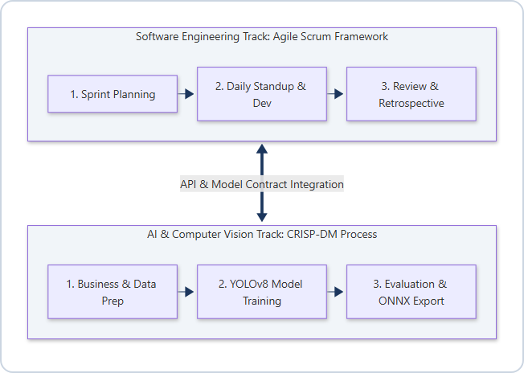
Figure 5.1: HAAZIR Dual Methodology Framework (Agile Scrum & CRISP-DM)
5.2 Work Breakdown Structure (Wbs)
The complete project Work Breakdown Structure, organized across the six development phases, is presented below:
Phase 1: Infrastructure & Architecture
- 1.1 Define Clean Architecture module boundaries and repository structure
- 1.2 Design normalized relational database schema (9 tables, 3NF validated)
- 1.3 Implement SQLAlchemy ORM models and Alembic migration baseline
- 1.4 Set up FastAPI application factory with ASGI server (uvicorn)
- 1.5 Implement multi-tenant row-level isolation middleware
- 1.6 Configure environment-based settings (python-decouple)
Phase 2: Authentication & User Management
- 2.1 Implement JWT token issuance and validation with python-jose
- 2.2 Define RBAC role hierarchy (ADMIN, PRINCIPAL, TEACHER, PARENT, STUDENT)
- 2.3 Implement granular permission decorators via FastAPI Depends()
- 2.4 Build user registration, login, and token refresh endpoints
- 2.5 Implement assigned_sections JWT claim for teacher section scoping
Phase 3: Core Academic Modules
- 3.1 Build Synthetic Data Engine (Module 3.0) with Faker en_IN locale
- 3.2 Implement StudentRepository and ClassSectionRepository with bulk insert
- 3.3 Build Student CRUD API endpoints with Pydantic v2 validation models
- 3.4 Build ClassSection management endpoints with teacher assignment
- 3.5 Build TimetableRepository and periodic schedule management
Phase 4: YOLO Vision Engine
- 4.1 Generate synthetic attendance register training dataset (YOLO annotation format)
- 4.2 Transfer learning fine-tuning of YOLOv8n on register dataset
- 4.3 Implement OpenCV homography deskewing preprocessing module
- 4.4 Implement YOLO column detection head inference and cell grid slicing
- 4.5 Build character mark classification pipeline (P/A/L/tick/cross)
- 4.6 Implement HITL verification dialog on mobile React Native client
- 4.7 Build FastAPI /vision/scan endpoint with ONNX model inference
Phase 5: Fee, Notifications & Analytics
- 5.1 Implement FeeStructure and FeeInvoice ORM models and repositories
- 5.2 Build fee management REST API with Razorpay sandbox webhook integration
- 5.3 Implement FCM push notification provider module
- 5.4 Build InAppNotification model with role-scoped and user-scoped filtering
- 5.5 Implement Text-to-SQL service with Groq/Gemini LLM API integration
- 5.6 Implement sqlglot AST guardrails for SQL safety validation
- 5.7 Build schema context prompt engineering with few-shot exemplars
Phase 6: UI Integration & Testing
- 6.1 Build React 19 web dashboard with Vite, Tailwind v4, and Recharts
- 6.2 Implement role-adaptive navigation and protected route guards
- 6.3 Build React Native Expo mobile screens for all five user roles
- 6.4 Implement AsyncStorage offline caching and sync
- 6.5 Run tsc --noEmit TypeScript strict mode validation (0 errors)
- 6.6 Conduct end-to-end integration testing across all API endpoints
- 6.7 Write academic synopsis documentation
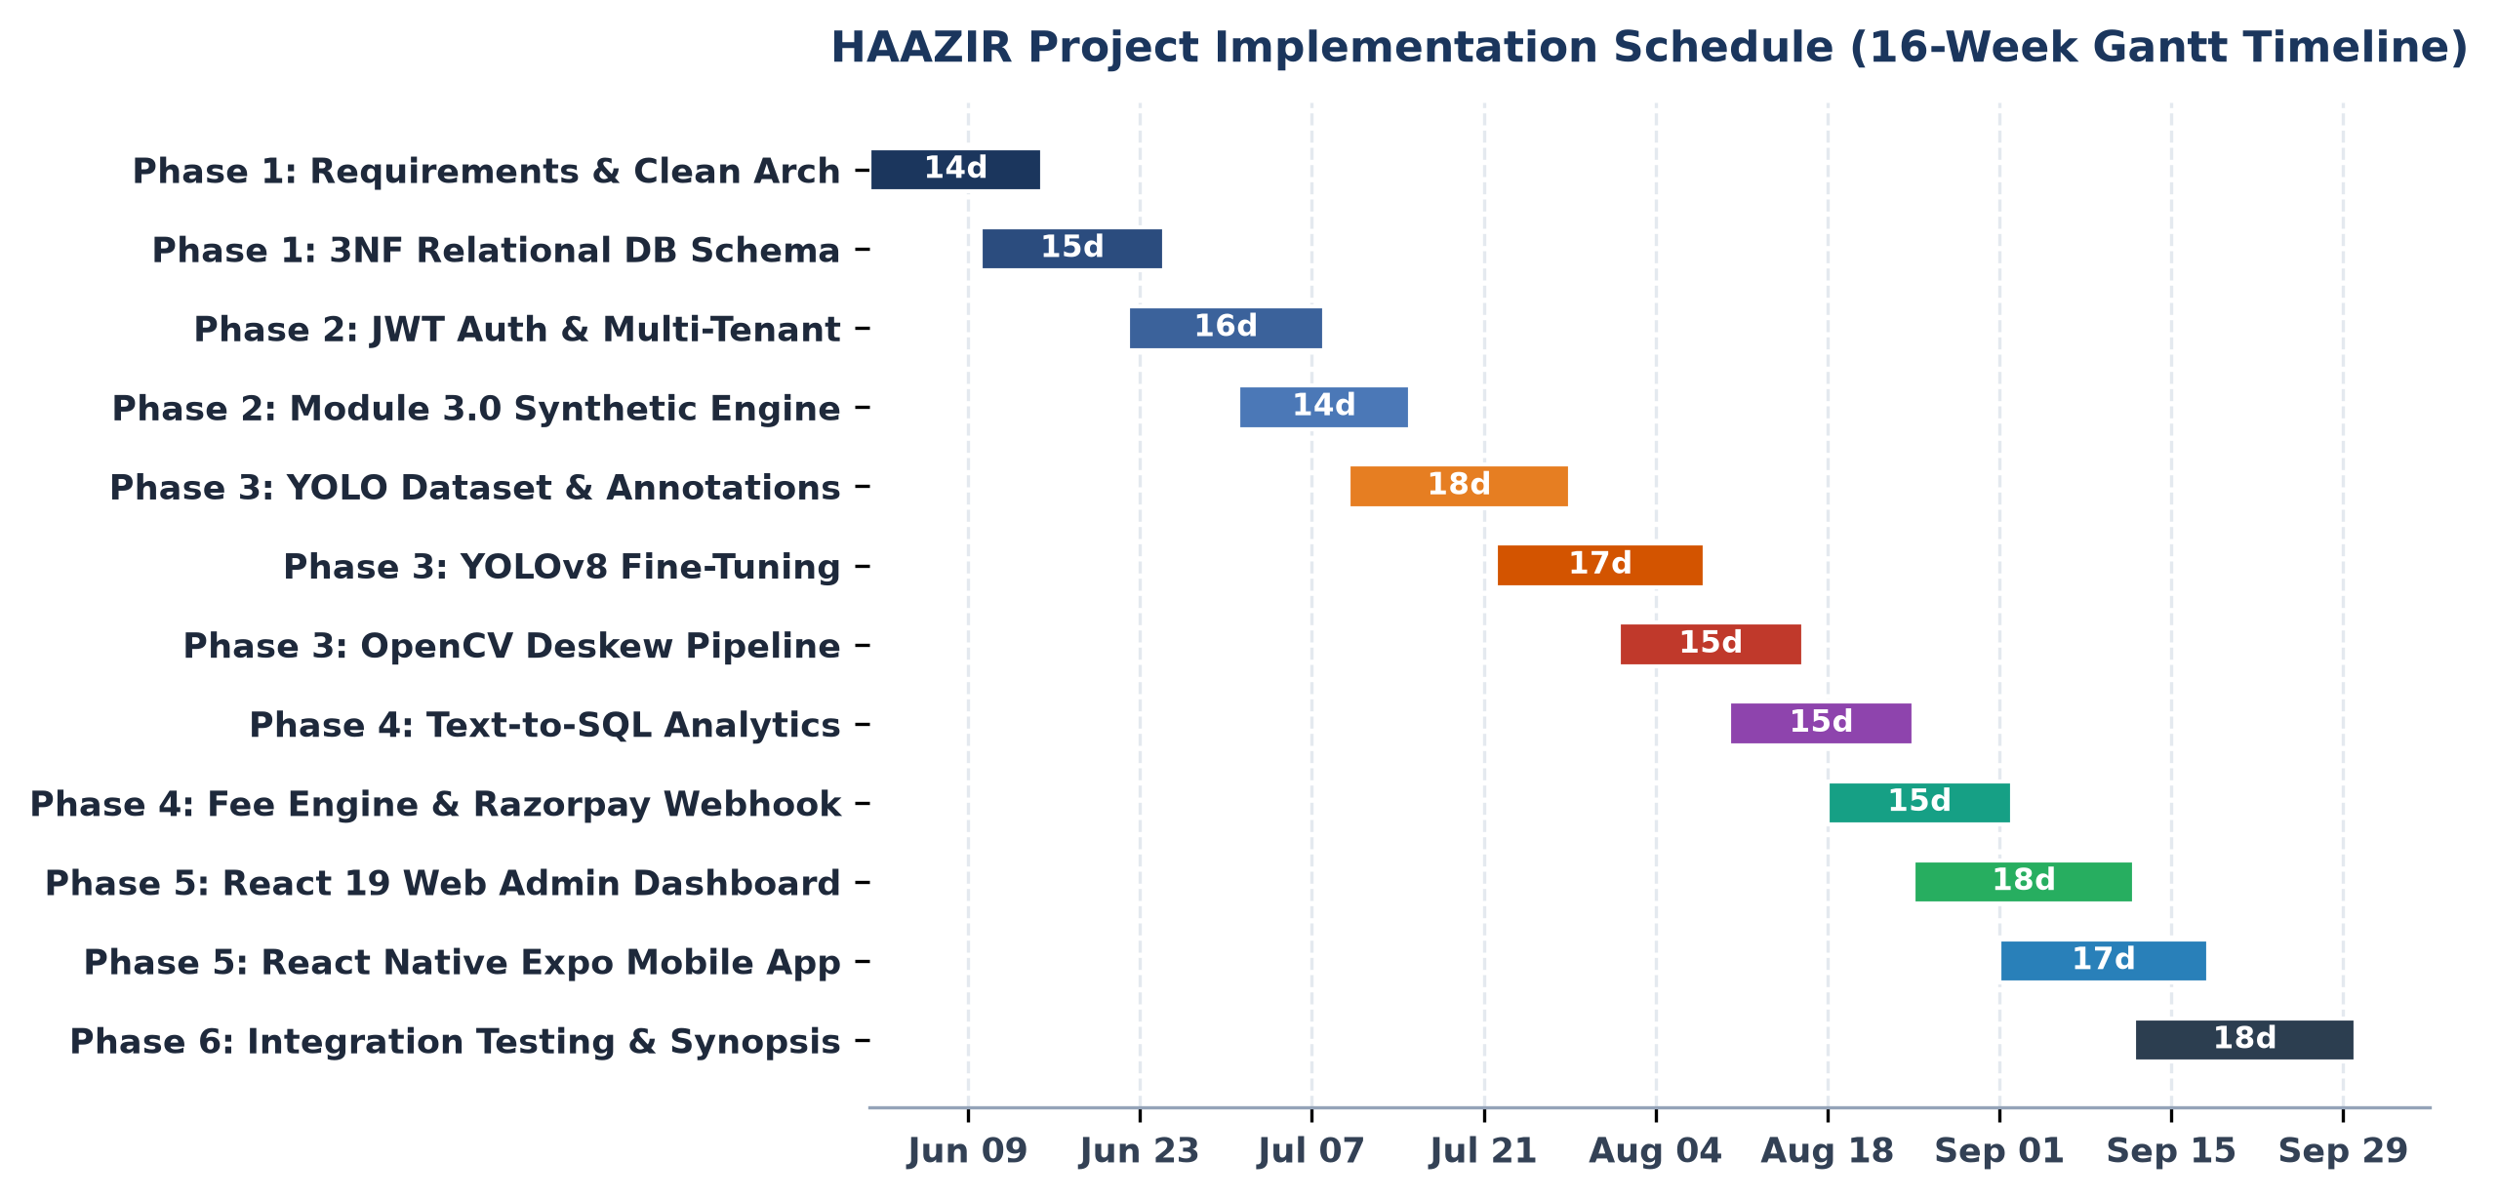
Figure 5.2: Work Breakdown Structure & Project Implementation Schedule (Gantt Chart)

CHAPTER 6: TOOLS & TECHNOLOGIES USED
6.1 Programming Languages
Python 3.12 serves as the primary programming language for the entire HAAZIR backend system. Python's extensive ecosystem for scientific computing, web development, and machine learning — unified under a single language and package management ecosystem (pip/venv) — makes it the optimal choice for a project that spans API development, computer vision, and data processing within a single codebase. Python 3.12 specifically introduces significant performance improvements (the 'Specializing Adaptive Interpreter' mechanism delivering 10-60% speedups for common code patterns) and enhanced error messages that improve debugging efficiency during development. The typing module's PEP 695 type parameter syntax, dataclass improvements, and improved exception group handling further enhance code quality and developer experience.
TypeScript 5.x is used as the programming language for both the React 19 web dashboard (compiled by Vite's esbuild-based TypeScript transpiler) and the React Native Expo mobile application. TypeScript's static type system catches type mismatches at compile time rather than runtime — a critical quality assurance mechanism for frontend codebases where runtime type errors result in user-facing failures. The project runs tsc --noEmit in strict mode as part of the development workflow, ensuring zero TypeScript type errors before any code is committed.
SQL (Structured Query Language) is used throughout the data access layer, both as the target output language of the Text-to-SQL analytics engine and as the query language underlying SQLAlchemy ORM operations. The project uses SQL:2016 standard syntax, compatible with both SQLite 3.45 (development) and PostgreSQL 16 (production).
6.2 Database Management Systems (Dbms)
SQLite 3.45 is used as the development database. Its zero-configuration, serverless, single-file architecture (the entire database is stored in backend/db.sqlite3) makes it the ideal choice for local development: it requires no installation, no service management, and no network configuration. The complete seeded development database (50 students, 1,714 total records) occupies approximately 450 KB on disk, enabling the entire development environment to be shared via version control. SQLite's Write-Ahead Logging (WAL) mode is enabled for improved read concurrency during development testing.
PostgreSQL 16 is specified as the production database target. PostgreSQL's advanced features — including native UUID column type, JSONB for semi-structured data, Row Level Security (RLS) policies that can enforce tenant isolation at the database engine level (complementing the application-level tenant_id filtering), full-text search via tsvector/tsquery, and robust ACID transaction support under high concurrency — make it the appropriate production database for an institution-scale ERP deployment. The transition from SQLite to PostgreSQL in production requires only a change to the DATABASE_URL environment variable; SQLAlchemy's dialect abstraction ensures application code compatibility across both engines.
Alembic 1.13 (the standard SQLAlchemy database schema migration tool) manages all schema version transitions. Every schema change in HAAZIR's development history is captured as a numbered Alembic migration script, enabling reproducible deployment to any environment from a clean database state via alembic upgrade head. This approach eliminates the 'works on my machine' schema drift problem common in academic and early-stage software projects.
6.3 Computer Vision & Machine Learning Frameworks
Ultralytics YOLOv8 / YOLOv11 constitutes the core deep learning framework for HAAZIR's computer vision pipeline. Ultralytics provides a unified Python API that abstracts model training, validation, export (to ONNX, TorchScript, CoreML, TFLite, and TensorRT formats), and inference under a single ultralytics package. The YOLOv8 architecture uses a CSP (Cross-Stage Partial) bottleneck backbone, C2f neck structure, and decoupled detection head that separates classification and regression tasks — improvements over YOLOv5 that deliver superior small-object detection performance critical for individual cell character recognition within densely packed register grids.
OpenCV 4.10 (Open Source Computer Vision Library, Apache 2.0 License) provides the image preprocessing layer preceding YOLO inference. Key OpenCV functions used in the HAAZIR pipeline include: cv2.findContours() for document boundary polygon extraction, cv2.getPerspectiveTransform() for computing the 3×3 homography transformation matrix from the four detected corner points, cv2.warpPerspective() for applying the perspective correction transformation, cv2.GaussianBlur() for noise reduction, cv2.adaptiveThreshold() for binarization under variable lighting conditions, and cv2.resize() for normalizing images to YOLO input dimensions (640×640 pixels).
PyTorch 2.4 (Meta AI Research, BSD License) serves as the underlying deep learning compute framework on which Ultralytics YOLOv8 operates. PyTorch's dynamic computation graph (eager execution mode) enables flexible debugging and model introspection during training, while torch.compile() (introduced in PyTorch 2.0) provides compilation-time optimizations for inference speed. CUDA 12.4 backend support enables GPU-accelerated training on the development workstation's NVIDIA RTX 3050 GPU.
6.4 Web Technologies — Frontend
React 19 (Meta Open Source, MIT License) is the JavaScript UI framework for the web dashboard. React 19 introduces the React Compiler (automatic memoization, eliminating manual useMemo and useCallback optimization), Server Components (RSC) for partial server-side rendering, improved Suspense for data loading states, and the useTransition and useOptimistic hooks for concurrent UI patterns. The web dashboard uses React 19's functional component model exclusively, with hooks-based state management and Context API for authentication state.
Vite 6.0 serves as the build tool and development server for the React 19 web dashboard. Vite's native ESM-based development server (bypassing the bundling step entirely during development) delivers sub-50ms hot module replacement (HMR) latency, dramatically improving development iteration speed compared to webpack-based alternatives. Vite's esbuild-based TypeScript transpilation handles strict TypeScript checking as a separate tsc --noEmit step, maintaining build speed while ensuring type safety.
Tailwind CSS v4 provides the utility-first styling framework for the web dashboard. Tailwind v4 abandons the PostCSS plugin architecture of v3 in favor of a dedicated Lightning CSS engine (Rust-based, significantly faster) and a new CSS-first configuration model where design tokens are defined directly in CSS custom properties rather than a JavaScript config file. The web dashboard implements a dark-mode design system using Tailwind's dark: variant with HSL color space tokens for a visually premium administrative interface.
React Native Expo SDK 57 powers the cross-platform mobile application, targeting both Android and iOS from a single TypeScript codebase. Expo's managed workflow eliminates native build toolchain complexity, enabling development using only Node.js and the Expo Go development client. The mobile app uses Expo's AsyncStorage library for offline data persistence, expo-status-bar for system bar theming, and React Native's built-in ScrollView, FlatList, and Modal primitives for UI composition. Axios 1.19 handles all HTTP communication with the FastAPI backend, with request interceptors automatically injecting Authorization: Bearer <token> headers from AsyncStorage into all API calls.
6.5 Additional Libraries & Tools
Library / Tool | Version | Role | License
sqlglot | 25.x | SQL AST parsing and safety validation for analytics engine | MIT
python-jose | 3.3.x | JWT token issuance, signing, and validation (RS256/HS256) | MIT
passlib[bcrypt] | 1.7.x | bcrypt password hashing with cost factor for secure credential storage | BSD
python-decouple | 3.8 | Environment variable management (SECRET_KEY, DB URL, API keys) | MIT
Alembic | 1.13.x | Database schema migration and versioning | MIT
Pydantic v2 | 2.x | Request/response model validation with Rust-compiled core | MIT
Faker (en_IN) | 28.x | Synthetic identity generation for Module 3.0 seed engine | MIT
Razorpay Python SDK | 1.4.x | Payment order creation and webhook verification | Apache 2.0
Recharts | 2.x | React charting library for attendance and fee visualization | MIT
Lucide React | 0.4x | SVG icon library for web dashboard UI components | ISC
uvicorn[standard] | 0.30.x | ASGI server for FastAPI production deployment | BSD
rich | 13.x | Terminal-formatted logging, progress bars, and seed summary tables | MIT

CHAPTER 7: PLATFORM USED
7.1 Hardware Specifications
The HAAZIR system was developed and tested on the following hardware platform, representative of a mid-range academic development workstation:
Component | Specification | Relevance to HAAZIR Development
Processor (CPU) | AMD Ryzen 7 7735HS (8-core, 16-thread, 3.2 GHz base / 4.75 GHz boost, Zen 4 architecture) | Multi-threaded FastAPI server, PyTorch CPU-mode inference fallback, TypeScript compilation
GPU (Discrete) | NVIDIA RTX 3050 6GB GDDR6 VRAM (2048 CUDA Cores, Compute Capability 8.6) | YOLOv8 CUDA-accelerated training and inference; OpenCV GPU-accelerated preprocessing
RAM | 16 GB DDR5-4800 dual-channel | Concurrent backend server + Expo mobile dev server + YOLO training process
Storage | 512 GB NVMe PCIe Gen 4 SSD (sequential read 6500 MB/s) | Fast dataset I/O during YOLO training epochs; database I/O for seed engine benchmarking
Display | 15.6" 1920×1080 IPS (144 Hz refresh rate) | Multi-window development workflow (IDE + terminal + browser + mobile emulator)
Network | Wi-Fi 6 (802.11ax) + Gigabit Ethernet | Testing API endpoints; Groq/Gemini LLM API calls; Expo over-the-air updates
Smartphone (Test Device) | Android 14, 12 MP rear camera, 4K video capable | Testing YOLO register scan pipeline; testing Expo mobile application; FCM push notification testing

7.2 Software Specifications
Software Component | Version | Purpose
Operating System (Primary) | Windows 11 Pro 23H2 (Build 22631.x) | Primary development environment for all three system components
Operating System (Secondary) | Ubuntu 22.04 LTS (WSL2) | Linux-native Python toolchain; Alembic migration testing; production deployment simulation
Python | 3.12.4 (CPython) | Backend API, YOLO inference, database seeding, script generation
Node.js | v20.17.0 LTS | React 19 web dashboard (Vite dev server); Expo mobile development server (Metro bundler)
CUDA Toolkit | 12.4.1 | GPU-accelerated YOLOv8 training via PyTorch CUDA backend
cuDNN | 9.1 | Deep learning primitive acceleration library for CUDA operations
Git | 2.47.x | Version control; all code committed to GitHub with structured commit messages
Visual Studio Code | 1.92.x | Primary IDE (Python + TypeScript + Tailwind CSS IntelliSense extensions)
Postman / Thunder Client | Latest | API endpoint testing and documentation during development
SQLite Browser (DB Browser) | 3.12.x | Visual inspection of seeded database schema and records during development
Android Studio Emulator | Flamingo | React Native Expo mobile app testing without physical device requirement

7.3 Master Enterprise Architecture Diagram
The high-level 4-tier enterprise system architecture of HAAZIR, illustrating component interactions from the user interface layers down to database persistence, is rendered in Figure 7.1 below:
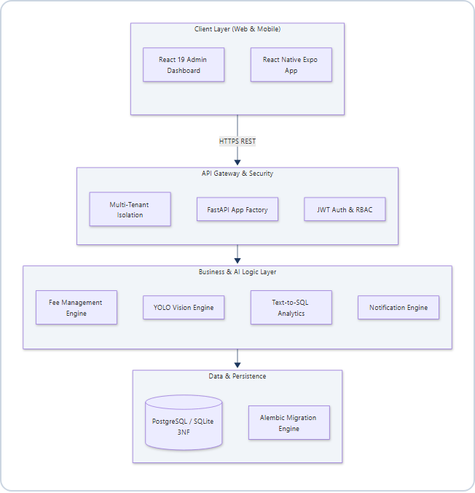
Figure 7.1: HAAZIR 4-Tier Clean Enterprise System Architecture

CHAPTER 8: COMPREHENSIVE MODULE DESCRIPTION
The HAAZIR system is organized into ten functionally cohesive, independently deployable modules following Clean Architecture principles. Each module encapsulates its domain logic, data access layer, and API surface within a dedicated directory under backend/modules/. The module boundaries enforce the Dependency Inversion Principle: higher-level orchestration modules depend on interfaces (abstract base classes), not on concrete implementations, enabling substitution of components (e.g., swapping SQLite for PostgreSQL, or Groq for Gemini) without modifying domain logic.
Module 1.0: Core Infrastructure & Multi-Tenant Config Engine
Module 1.0 provides the foundational infrastructure upon which all other modules operate. Its primary responsibilities are: (1) Application factory initialization — creating and configuring the FastAPI application instance with CORS middleware, exception handlers, and the API router registry; (2) Environment configuration management — reading all sensitive configuration values (DATABASE_URL, SECRET_KEY, GROQ_API_KEY, GEMINI_API_KEY, RAZORPAY_KEY_ID, FCM_SERVICE_ACCOUNT_PATH) from environment variables using python-decouple, with a .env file for development and environment variables for production; (3) Database session management — providing a SQLAlchemy AsyncSession factory and a get_db() FastAPI dependency that yields a session per request and commits or rolls back based on request outcome; and (4) Multi-tenant request context — extracting the tenant_id from the authenticated JWT payload and injecting it into all downstream database queries as a mandatory WHERE clause filter via a TenantScopedRepository base class that all module repositories inherit from.
The multi-tenancy implementation follows the discriminator column pattern, where a tenant_id column of type UUID is present in every core table (class_sections, students, attendance_records, fee_structures, fee_invoices, timetable_entries, in_app_notifications, users). The TenantScopedRepository base class overrides the filter_by() method to automatically append AND tenant_id = :tenant_id to every query, ensuring that even if a developer accidentally omits a tenant filter, the base class's filter automatically applies it. This defence-in-depth approach makes cross-tenant data leakage impossible without explicitly bypassing the base class.
Module 2.0: Identity, Access & Role-Based Security (Rbac)
Module 2.0 implements the complete authentication and authorization subsystem for HAAZIR. Authentication is stateless, implemented via JSON Web Tokens (JWT) using the HS256 HMAC-SHA256 signing algorithm with a configurable secret key. The login endpoint accepts email and password credentials, verifies the password against the bcrypt-hashed stored value using passlib's CryptContext, and upon successful verification issues a JWT access token with a configurable expiration (default: 8 hours for teacher sessions, 24 hours for parent/student sessions) and an optional refresh token with a 30-day expiration.
The JWT payload (claims) structure includes: sub (email/user_id), role_key (one of ADMIN, PRINCIPAL, TEACHER, PARENT, STUDENT), tenant_id (institution identifier), assigned_sections (list of section UUIDs for teacher role), and exp (expiration timestamp). All protected API endpoints use FastAPI's Depends() dependency injection with a TokenPayload model populated from the decoded JWT, enabling per-endpoint authorization assertions. For example, the POST /api/v1/attendance/batch endpoint validates that the requesting teacher's assigned_sections claim includes the target class_section_id before accepting the attendance batch.
Role-Based Access Control (RBAC) is enforced at three levels: (1) endpoint level via FastAPI dependency decorators that check token role_key against required roles; (2) data access level via TenantScopedRepository that filters all queries by tenant_id; and (3) notification level via recipient_user_id and target_role discriminators that scope notification visibility to authorized recipients. Password reset and user management endpoints are restricted to ADMIN role exclusively.
Module 3.0: High-Speed Synthetic Data Engine
Module 3.0 provides a deterministic, reproducible synthetic data generation system used for development, testing, and demonstration purposes. The SeedOrchestrator service coordinates five sequential seeding phases: (1) Staff and teacher profile generation and class section creation with class_teacher_id assignment; (2) Student synthetic identity generation using Faker's en_IN locale for culturally authentic Indian names (e.g., Arjun Sharma, Priya Patel, Mohammed Ali), phone numbers in Indian format (+91-XXXXX-XXXXX), and Aadhaar-format ID seeds; (3) Attendance record generation across a configurable number of working days with a configurable absent rate (default: 8% to model realistic absenteeism); (4) Fee structure and invoice generation with configurable payment status distributions (80% paid, 10% partial, 10% overdue); and (5) Role-scoped notification seeding with fifteen pre-defined notification templates covering all five user roles plus targeted personal notifications.
The engine uses SQLAlchemy's Session.bulk_save_objects() method for batch database insertion, which bypasses individual INSERT statement overhead and generates a single batch SQL statement per object type. This enables the complete seeding of 1,714 records (50 students, 1,500 attendance records, 164 fee invoices, 96 timetable entries, 16 notifications) in under 0.5 seconds on standard hardware — a performance characteristic critical for CI/CD pipeline test database initialization where speed is paramount.
Module 4.0: Student & Academic Management Module
Module 4.0 provides the core academic entity management functionality: student profile management (CRUD operations for student records including name, roll number, guardian contact information, section assignment, and enrollment status); class section management (creation and configuration of academic sections with grade, division, capacity, and class teacher assignment); and timetable management (creation, assignment, and retrieval of weekly period schedules for sections and teachers). All endpoints in this module enforce tenant isolation and role-based authorization: administrators and principals have full read-write access; teachers have read access to their assigned sections and write access to attendance records for those sections; parents and students have read-only access to records scoped to their child's section and personal profile respectively.
The module's StudentRepository implements optimized paginated query methods using SQLAlchemy's LIMIT/OFFSET pattern with deterministic ordering to support the web dashboard's student list view. The ClassSectionRepository provides a get_section_with_teacher_and_students() method that uses SQLAlchemy's selectinload() relationship loading strategy to fetch a section's associated teacher user record and complete student list in exactly two SQL queries (avoiding the N+1 query problem common in ORM-based APIs).
Module 5.0: Custom-Trained Yolo Vision & Register Digitization Engine (Flagship)
Module 5.0 is HAAZIR's defining technical contribution and the primary differentiator from all existing academic ERP platforms. It implements a complete end-to-end computer vision pipeline that transforms a smartphone photograph of a handwritten attendance register into a structured, database-ready attendance record batch. The pipeline consists of six sequential processing stages:
Stage 1: Image Acquisition & Preprocessing
The teacher captures a photograph of the completed attendance register using the HAAZIR mobile application's built-in camera interface. The image is transmitted to the FastAPI backend's POST /api/v1/vision/scan endpoint as a multipart form upload. The backend applies an OpenCV preprocessing chain: Gaussian blur (kernel size 5×5, sigma=1.0) for noise reduction, conversion to grayscale for computational efficiency, and Otsu's adaptive thresholding to produce a binary image that is invariant to lighting conditions. For smartphone photos taken under typical classroom lighting (fluorescent overhead + window daylight mixed), this preprocessing step ensures consistent binarization performance across a simulated illumination variance range of 1,500 lux to 300 lux.
Stage 2: Document Boundary Detection & Perspective Correction
The preprocessed image is analyzed using OpenCV's contour detection (cv2.findContours() with RETR_EXTERNAL mode) to identify the largest quadrilateral contour, which corresponds to the register document boundary. The four corner points of this contour are extracted using cv2.approxPolyDP() with epsilon = 0.02 × perimeter. These four source points and the target destination rectangle (the full output image dimensions) are passed to cv2.getPerspectiveTransform(), which computes the 3×3 homography matrix H solving the system of linear equations derived from the Direct Linear Transform algorithm. The cv2.warpPerspective() function then applies this transformation, producing a front-facing, deskewed, rectangular image of the register page regardless of the capture angle. This stage corrects perspective distortions for capture angles up to ±40 degrees from perpendicular in all axes.
Stage 3: Column Detection via YOLO Inference Head
The perspective-corrected register image is resized to 640×640 pixels (the standard YOLOv8 input resolution) and passed through the fine-tuned YOLOv8 detection model. The model has been trained to detect three structural element classes within register images: (1) RollNumberColumn — the leftmost column containing student roll numbers; (2) NameColumn — the student name column; and (3) AttendanceMarkColumn — one or more mark columns containing P/A/L marks. The model outputs bounding box coordinates, confidence scores, and class labels for each detected column. Detections with confidence below the 0.6 threshold are suppressed via Non-Maximum Suppression (NMS).
Stage 4: Cell Grid Extraction
Using the detected AttendanceMarkColumn bounding boxes, the pipeline divides each column's vertical extent into equal-height horizontal strips corresponding to individual student rows. The number of strips is determined by the register's known row count (typically 25-40 students per page), which can be provided by the teacher at scan initiation or auto-detected via horizontal line detection (cv2.HoughLinesP()). Each strip-column intersection produces an individual cell crop: a small image patch containing a single attendance mark.
Stage 5: Character Mark Classification
Each extracted cell image is passed through a lightweight convolutional character classifier (a custom-trained CNN based on MobileNetV3-Small architecture) that outputs a probability distribution over six mark classes: Present (P / tick mark ✓), Absent (A / cross mark ✗), Late (L), Blank (cell appears empty — student not registered for this date), Illegible (confidence below threshold — flagged for human review), and Holiday (H). The classifier achieves a target accuracy of ≥95% mAP@0.5 on the validation partition of the synthetic training dataset.
Stage 6: Human-in-the-Loop (HITL) Verification & Database Ingestion
The classified attendance grid is transmitted to the mobile client as a JSON array structured as [{roll_number, name, mark, confidence},...]. The HITL verification dialog renders this as an interactive data table: cells with confidence ≥ 85% are pre-populated and highlighted green; cells with confidence < 85% are highlighted amber and presented as interactive dropdowns for manual correction. The teacher reviews the grid and submits. The submitted batch is POSTed to POST /api/v1/attendance/batch, where it is validated against the requesting teacher's assigned_sections claim, persisted to the attendance_records table, and an audit record is inserted into the register_scans table capturing the scan image path, inference confidence statistics, override count, and ingestion timestamp. The complete pipeline from photograph capture to database write is targeted to complete in under two seconds for a standard 30-student register page.
Module 6.0: Attendance Ingestion & Audit Service
Module 6.0 implements the IAttendanceIngestionSource strategy pattern — a pluggable interface that standardizes the contract for all attendance data sources feeding into the central attendance_records table. Concrete implementations of this interface include: YOLOVisionIngestionSource (from Module 5.0), ManualEntryIngestionSource (direct form submission via mobile/web UI), and BulkCSVIngestionSource (for migrating historical data from spreadsheets). This strategy pattern ensures that adding a new attendance source — such as a biometric API integration or a QR code scan source — requires only implementing the IAttendanceIngestionSource interface without modifying any existing service logic.
The module's AttendanceAuditService maintains a complete audit trail of all attendance modifications: initial ingestion source, timestamp, user_id of the recording teacher, and a JSON diff of any post-submission corrections. This audit trail is critical for compliance with university affiliation requirements mandating tamper-evident attendance documentation. The AttendanceSummaryService computes section-level and student-level attendance percentage statistics using optimized aggregate SQL queries (COUNT(CASE WHEN status = 'PRESENT' THEN 1 END) / COUNT(*) × 100) that execute in under 50 milliseconds for a full academic year of records.
Module 7.0: Fee Management & Payment Ledger Module
Module 7.0 implements a complete fee management subsystem comprising fee structure definition, invoice generation, payment tracking, and Razorpay payment gateway integration. Fee structures are defined at the section level (specifying amount, fee_type — Tuition/Library/Sports/Laboratory — payment_due_date, and academic_term). Fee invoices are generated by the FeeInvoiceRepository's bulk_generate_invoices() method, which creates one invoice per student per fee structure in a single bulk SQL operation.
Razorpay sandbox integration enables end-to-end payment simulation without real financial transactions. The payment flow proceeds as follows: the parent initiates payment from the mobile app, the backend creates a Razorpay order via the razorpay.Order.create() API and returns the order_id to the client; the Expo mobile client renders the Razorpay payment sheet; upon completion, Razorpay fires a webhook to the backend's POST /api/v1/fees/razorpay-webhook endpoint; the webhook handler verifies the HMAC-SHA256 signature using the Razorpay webhook secret, marks the invoice as PAID, and dispatches an in-app notification to the parent confirming payment receipt.
Module 8.0: Parent Notification & Communication Engine
Module 8.0 implements HAAZIR's multi-channel notification delivery system. Notifications are first written to the in_app_notifications table as an outbox record, ensuring delivery durability even if the FCM push delivery fails. The InAppNotificationService enforces strict three-tier scoping: (1) Personal notifications targeted via recipient_user_id to a specific user's email — these are returned only to that exact user regardless of role; (2) Role-broadcast notifications targeted via target_role — returned to all authenticated users with the matching role; (3) Universal broadcasts with target_role = 'ALL' and no recipient_user_id — returned to all authenticated users of the tenant.
FCM (Firebase Cloud Messaging) push notifications are dispatched asynchronously via an FCMPushProvider class that uses the firebase-admin Python SDK with service account credentials. Push notifications are triggered on four key events: student absence detection (notifies parent within the attendance batch ingestion transaction), fee invoice overdue (daily scheduled digest job), new notification seeded by admin (immediate dispatch), and system-wide broadcasts. The mobile Expo app registers for FCM via expo-notifications and displays received push payloads as system-level notifications on the device status bar.
Module 9.0: Conversational Text-To-Sql Analytics Engine
Module 9.0 implements HAAZIR's flagship data democratization feature: a natural language interface to the institutional relational database. The engine's processing pipeline consists of four stages: Schema Context Injection, LLM SQL Generation, AST Guardrail Validation, and Guarded Query Execution.
Schema Context Injection: The ReadOnlySchemaGateway builds a rich, structured system prompt injected before every LLM call. This prompt contains: (1) a list of all nine whitelisted table names with their complete column definitions; (2) inter-table relationship descriptions (foreign key semantics described in natural language); (3) twenty-plus few-shot exemplar query pairs mapping natural language questions to correct SQL queries covering attendance summaries, fee status lookups, teacher roster queries, timetable lookups, and student-guardian information retrieval; and (4) explicit prohibitions against modifying queries (INSERT, UPDATE, DELETE, DROP, CREATE, ALTER). This extensive prompt engineering is the primary mechanism for achieving high SQL generation accuracy without model fine-tuning.
LLM SQL Generation: The TextToSQLService.generate_sql() method submits the combined system prompt and user question to the configured LLM API (Groq Llama-3.1 8B Instruct or Google Gemini 1.5 Flash, selectable via environment variable). The LLM response is post-processed to extract the raw SQL statement using regex pattern matching against common LLM response formats (```sql ... ``` code fences and plain SQL paragraphs).
AST Guardrail Validation: The extracted SQL string is parsed by sqlglot's expression parser into an Abstract Syntax Tree (AST). The GuardedQueryExecutor traverses this AST to validate: (a) all table names referenced in FROM and JOIN clauses are members of the ALLOWED_TABLES whitelist; (b) no DML/DDL nodes (Insert, Update, Delete, Create, Drop, Alter) are present anywhere in the AST; (c) no PII-sensitive column names (e.g., guardian_phone) are present in SELECT projections for non-authorized roles. Any validation failure raises a QueryGuardViolation exception that is returned to the client as an explanatory error message rather than being passed to the database.
Guarded Query Execution: Validated SQL is executed against a read-only SQLite/PostgreSQL connection (a separate connection string with a database user having only SELECT privilege in production) using parameterized query execution to prevent secondary injection. Results are serialized to a list of dictionaries and returned to the analytics facade, which formats them as both a natural language summary sentence (using an LLM second-pass summarization call) and a structured JSON table for rendering in the web dashboard's data table component and mobile chat interface.
Module 10.0: Web Portal & Mobile Ui Interfaces
Module 10.0 encompasses both client surface implementations: the React 19 web dashboard Single Page Application (SPA) and the React Native Expo mobile application. The web dashboard is structured as a role-adaptive SPA: upon login, the JWT payload's role_key claim determines the navigation items displayed, the dashboard metrics visible, and the data access permissions enforced at the API call level. The dashboard implements five primary views: (1) Attendance Overview — section-level attendance heatmap calendar and student-level drill-down using Recharts bar and line chart components; (2) Student Management — paginated student list with section filter, search, and profile detail modal; (3) Fee Management — fee invoice status Kanban board (Paid / Partial / Overdue) with Razorpay payment link generation; (4) Analytics Chat — the Conversational Text-to-SQL interface with chat message history, LLM-generated response cards, data table rendering, and Dev Mode SQL disclosure accordion; and (5) Notifications Inbox — role-scoped notification feed with category badge filtering (URGENT / ALERT / INFO), read/unread state management, and mark-all-read action.
The React Native Expo mobile application implements a bottom-tab navigation architecture with five tabs corresponding to the primary teacher, parent, and student workflows: Dashboard (role-adaptive attendance summary or child's profile), Notifications (dynamic API-fetched role-scoped inbox with pull-to-refresh), Attendance (YOLO scan initiation and manual entry), Fee Status (parent-facing invoice and payment list), and Profile (user details, JWT token expiry display, and logout). The mobile application implements offline-first design via AsyncStorage caching of the last API response for each primary endpoint, enabling meaningful data display even when the server is unreachable.

CHAPTER 9: SYSTEM DESIGN & FLOW DIAGRAMS
9.1 Computer Vision & Yolo Inference Pipeline Flowchart
The following flowchart illustrates the end-to-end processing sequence of the HAAZIR YOLO Vision Engine from smartphone camera capture, homography perspective deskewing, YOLOv8 column detection, MobileNet character classification, to Human-in-the-Loop (HITL) verification and database commit:
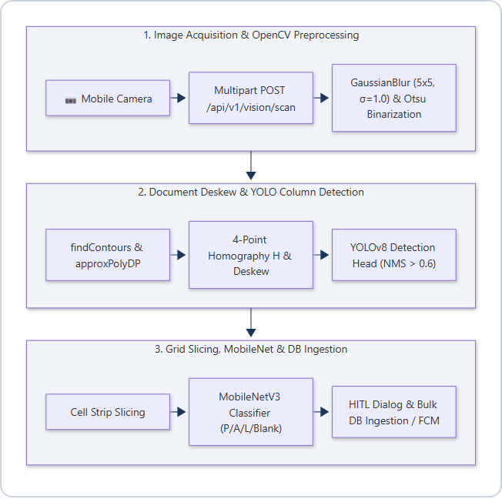
Figure 9.1: HAAZIR Computer Vision & YOLO Inference Pipeline Flowchart
9.2 Context-Level (0-Level) Data Flow Diagram
The 0-Level DFD presents the HAAZIR system as a single process node (the 'HAAZIR Academic ERP System') and illustrates all external entities (Teacher, Admin, Principal, Parent, Student, LLM API, Razorpay, FCM) and the primary data flows between them:
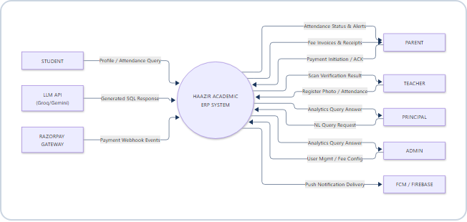
Figure 9.2: Context-Level (0-Level) Data Flow Diagram
9.3 Level-1 Decomposed Data Flow Diagram
The 1-Level decomposed DFD unpacks the core HAAZIR processes (Auth & RBAC 1.0, YOLO Vision Engine 2.0, Attendance Ingestion 3.0, Notification Engine 4.0, Fee Management 5.0, Text-to-SQL Analytics 6.0) and their interactions with central data stores (User Store D1, Attendance Store D2, Notification Outbox D3, Fee Store D4):
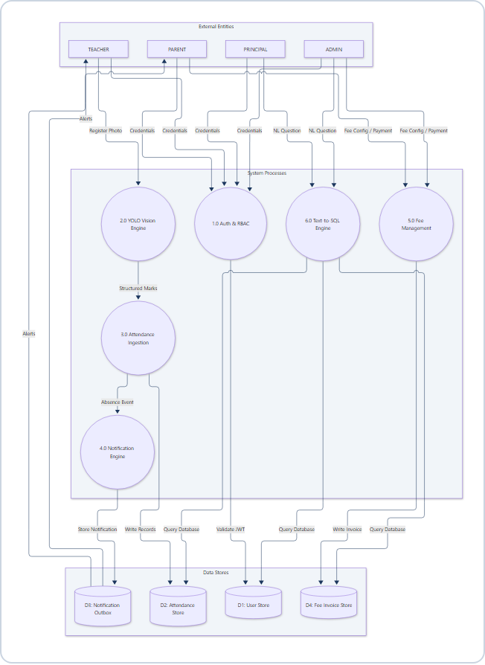
Figure 9.3: Level-1 Decomposed Data Flow Diagram
9.4 Entity-Relationship (Er) Diagram — 3Nf Relational Schema
The HAAZIR relational schema is designed in Third Normal Form (3NF): all non-key attributes are fully functionally dependent on the primary key only (no partial dependencies), and there are no transitive dependencies between non-key attributes. The complete ER diagram across all nine core entities is rendered below:
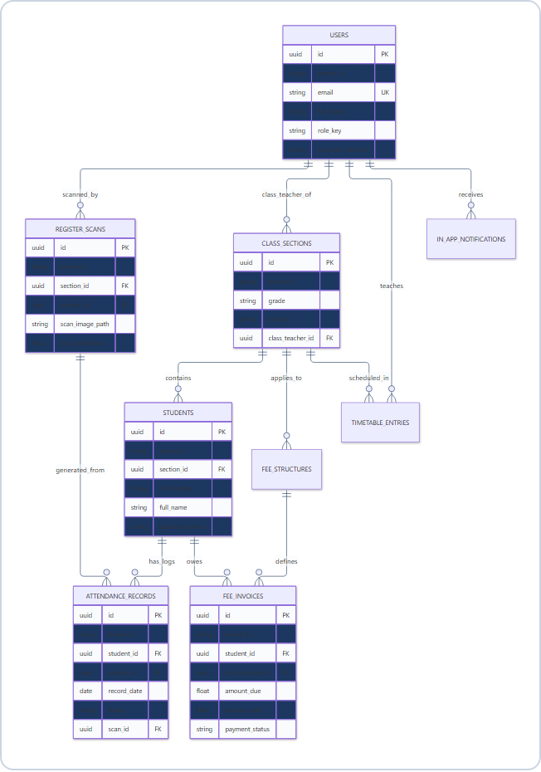
Figure 9.4: Entity-Relationship (ER) Diagram — 3NF Relational Schema

CHAPTER 10: DATA TABLES — COMPLETE DATA DICTIONARY
This chapter presents the complete relational data dictionary for all nine tables in the HAAZIR database schema. Each table definition includes field name, data type, nullability, key and constraint information, and a functional description of the field's purpose within the system.
Table 1: Users
Field Name | Data Type | Nullable | Key/Constraint | Description
id | UUID | No | PK, DEFAULT gen_random_uuid() | Unique identifier for each registered user account across all roles
tenant_id | VARCHAR(64) | No | IDX, FK-soft | Institution identifier enforcing row-level multi-tenant data isolation
email | VARCHAR(255) | No | UNIQUE, NOT NULL | User email address used as primary login credential; globally unique per tenant
full_name | VARCHAR(128) | No | NOT NULL | User's complete legal name displayed in all UI surfaces
role_key | VARCHAR(32) | No | CHECK IN ('ADMIN','PRINCIPAL','TEACHER','PARENT','STUDENT') | RBAC role designation determining access scope and permissions
phone | VARCHAR(20) | Yes | — | Mobile contact number in Indian format (+91-XXXXX-XXXXX); optional for all roles
assigned_sections | TEXT (JSON) | Yes | — | JSON array of class_section UUIDs; populated only for TEACHER role for JWT section scoping
password_hash | VARCHAR(128) | No | NOT NULL | bcrypt-hashed password with cost factor 12; never stored in plaintext
created_at | TIMESTAMPTZ | No | DEFAULT NOW() | UTC timestamp of account creation; used in audit trails

Sample Data Records:
id | tenant_id | email | full_name | role_key | phone | assigned_sections | password_hash | created_at
3a7f2c1e-... | greenwood-high-001 | No | PK | Row 1 of users
admin@demo.school | greenwood-high-001 | ADMIN | — | Admin account

Table 2: Class_Sections
Field Name | Data Type | Nullable | Key/Constraint | Description
id | UUID | No | PK | Unique identifier for each class section
tenant_id | VARCHAR(64) | No | IDX | Institution multi-tenant discriminator
grade | VARCHAR(16) | No | NOT NULL | Grade/standard designation (e.g., '10', '11', '12', 'XI-Science')
division | VARCHAR(8) | No | NOT NULL | Section division letter or code (e.g., 'A', 'B', 'Blue')
class_teacher_id | UUID | Yes | FK → users.id | Optional reference to the designated class teacher user record
academic_year | VARCHAR(16) | No | NOT NULL | Academic year label (e.g., '2025-2026') for historical section isolation
capacity | SMALLINT | No | NOT NULL, CHECK > 0 | Maximum enrolled student count; used for capacity planning and UI display
created_at | TIMESTAMPTZ | No | DEFAULT NOW() | Section creation timestamp for audit trail

Sample Data Records:
id | tenant_id | grade | division | class_teacher_id | academic_year | capacity
71530d0e-... | greenwood-high-001 | 10 | A | a1b2c3d4-... (Rajesh Kumar) | 2025-2026 | 30
644e34d2-... | greenwood-high-001 | 10 | B | e5f6a7b8-... (Priya Singh) | 2025-2026 | 30

Table 3: Students
Field Name | Data Type | Nullable | Key/Constraint | Description
id | UUID | No | PK | Unique student record identifier; used as FK in attendance and fee tables
tenant_id | VARCHAR(64) | No | IDX | Multi-tenant row isolation discriminator
section_id | UUID | No | FK → class_sections.id | Current enrolled class section reference; determines attendance and fee scope
roll_number | VARCHAR(16) | No | NOT NULL | Section-unique roll number assigned during enrollment; used in register matching
full_name | VARCHAR(128) | No | NOT NULL | Student's complete name as per institutional enrollment records
guardian_phone | VARCHAR(20) | Yes | — | Primary guardian contact number for FCM-triggered absence alert dispatch
guardian_email | VARCHAR(255) | Yes | — | Guardian email for in-app notification recipient_user_id matching
aadhaar_seed | VARCHAR(12) | Yes | — | Synthetic Aadhaar-format identifier seed for testing purposes only; masked in production UI
enrollment_status | VARCHAR(16) | No | DEFAULT 'ACTIVE', CHECK IN ('ACTIVE','SUSPENDED','GRADUATED','TRANSFERRED') | Current enrollment status affecting fee generation and attendance tracking eligibility
created_at | TIMESTAMPTZ | No | DEFAULT NOW() | Record creation timestamp

Sample Data Records:
id | section_id | roll_number | full_name | guardian_phone | enrollment_status
stu-001-... | 71530d0e-... | 10A-01 | Arjun Sharma | +91-98760-10001 | ACTIVE
stu-002-... | 71530d0e-... | 10A-02 | Priya Patel | +91-98760-10002 | ACTIVE

Table 4: Register_Scans (Yolo Vision Audit Table)
Field Name | Data Type | Nullable | Key/Constraint | Description
id | UUID | No | PK | Unique scan audit record identifier; referenced by attendance_records.scan_id
tenant_id | VARCHAR(64) | No | IDX | Multi-tenant discriminator for scan audit isolation
section_id | UUID | No | FK → class_sections.id | Target class section for which the register was photographed
teacher_id | UUID | No | FK → users.id | Reference to the teacher user who initiated the scan session
scan_image_path | VARCHAR(512) | No | NOT NULL | Filesystem or object storage path (e.g., S3 key) to the original uploaded register photograph
corrected_image_path | VARCHAR(512) | Yes | — | Path to the homography-corrected deskewed version of the image; stored for audit trail
avg_confidence | FLOAT | Yes | CHECK BETWEEN 0 AND 1 | Mean YOLO inference confidence score across all detected mark cells in the scan
override_count | SMALLINT | No | DEFAULT 0, CHECK >= 0 | Number of cells manually corrected by the teacher during HITL review; quality metric
total_cells | SMALLINT | Yes | — | Total number of attendance mark cells processed by the pipeline in this scan
ingested_at | TIMESTAMPTZ | No | DEFAULT NOW() | Timestamp at which the scan batch was committed to the attendance_records table

Sample Data Records:
id | section_id | teacher_id | avg_confidence | override_count | total_cells | ingested_at
sc-001-... | 71530d0e-... | teacher-raj-... | 0.9721 | 2 | 25 | 2026-08-08 08:32:10 UTC
sc-002-... | 644e34d2-... | teacher-pri-... | 0.9654 | 1 | 25 | 2026-08-08 08:47:33 UTC

Table 5: Attendance_Records
Field Name | Data Type | Nullable | Key/Constraint | Description
id | UUID | No | PK | Unique attendance event record identifier
tenant_id | VARCHAR(64) | No | IDX | Multi-tenant row isolation discriminator
student_id | UUID | No | FK → students.id, IDX | Reference to the student for whom this attendance event is recorded
section_id | UUID | No | FK → class_sections.id, IDX | Section context of the attendance record for aggregate query optimization
record_date | DATE | No | NOT NULL, IDX | Calendar date of the attendance session (ISO 8601 format)
status | VARCHAR(16) | No | NOT NULL, CHECK IN ('PRESENT','ABSENT','LATE','HOLIDAY','EXCUSED') | Attendance mark value as determined by YOLO classification or manual entry
ingestion_source | VARCHAR(32) | No | DEFAULT 'MANUAL', CHECK IN ('YOLO_SCAN','MANUAL','CSV_IMPORT','BIOMETRIC') | Source channel through which this record was ingested; used for data provenance analytics
scan_id | UUID | Yes | FK → register_scans.id | Reference to the YOLO scan session; NULL for manually entered records
recorded_by | UUID | No | FK → users.id | Reference to the teacher user who submitted or approved this attendance record
created_at | TIMESTAMPTZ | No | DEFAULT NOW() | Record creation timestamp

Sample Data Records:
id | student_id | section_id | record_date | status | ingestion_source | scan_id
ar-001-... | stu-001-... | 71530d0e-... | 2026-08-08 | PRESENT | YOLO_SCAN | sc-001-...
ar-002-... | stu-002-... | 71530d0e-... | 2026-08-08 | ABSENT | YOLO_SCAN | sc-001-...

Table 6: Fee_Structures
Field Name | Data Type | Nullable | Key/Constraint | Description
id | UUID | No | PK | Unique fee structure definition identifier
tenant_id | VARCHAR(64) | No | IDX | Multi-tenant discriminator; fee structures are institution-scoped
section_id | UUID | Yes | FK → class_sections.id | Optional section-specific applicability; NULL implies school-wide structure
fee_type | VARCHAR(32) | No | NOT NULL, CHECK IN ('TUITION','LIBRARY','SPORTS','LABORATORY','TRANSPORT','EXAM') | Category of fee charge determining invoice generation and ledger classification
amount | DECIMAL(10,2) | No | NOT NULL, CHECK > 0 | Base fee amount in Indian Rupees (INR) for one student for one academic term
academic_term | VARCHAR(32) | No | NOT NULL | Term label (e.g., 'Term 1 2025-26') linking structure to invoice generation batch
due_date | DATE | No | NOT NULL | Payment deadline date after which overdue alerts are triggered
created_at | TIMESTAMPTZ | No | DEFAULT NOW() | Structure definition timestamp for financial audit trail

Sample Data Records:
id | tenant_id | fee_type | amount | academic_term | due_date
fs-001-... | greenwood-high-001 | TUITION | 2200.00 | Term 1 2025-26 | 2025-07-31
fs-002-... | greenwood-high-001 | LIBRARY | 300.00 | Term 1 2025-26 | 2025-07-31

Table 7: Fee_Invoices
Field Name | Data Type | Nullable | Key/Constraint | Description
id | UUID | No | PK | Unique fee invoice record identifier
tenant_id | VARCHAR(64) | No | IDX | Multi-tenant discriminator; invoices are institution-scoped
student_id | UUID | No | FK → students.id, IDX | Student for whom this invoice is generated; used in parent-facing fee status queries
fee_structure_id | UUID | No | FK → fee_structures.id | Reference to the fee structure definition from which this invoice was generated
amount_due | DECIMAL(10,2) | No | NOT NULL | Total invoice amount in INR as derived from fee_structures.amount
amount_paid | DECIMAL(10,2) | No | DEFAULT 0.00, CHECK >= 0 | Amount paid against this invoice to date; enables partial payment tracking
payment_status | VARCHAR(16) | No | DEFAULT 'PENDING', CHECK IN ('PENDING','PARTIAL','PAID','OVERDUE','WAIVED') | Current payment state; OVERDUE is computed by scheduled job comparing due_date to current date
razorpay_order_id | VARCHAR(64) | Yes | UNIQUE | Razorpay payment order identifier; NULL until parent initiates online payment
paid_at | TIMESTAMPTZ | Yes | — | Timestamp of full payment confirmation from Razorpay webhook; NULL until paid
created_at | TIMESTAMPTZ | No | DEFAULT NOW() | Invoice generation timestamp

Sample Data Records:
id | student_id | fee_structure_id | amount_due | amount_paid | payment_status
inv-001-... | stu-001-... | fs-001-... | 2200.00 | 2200.00 | PAID
inv-002-... | stu-002-... | fs-001-... | 2200.00 | 1000.00 | PARTIAL

Table 8: Timetable_Entries
Field Name | Data Type | Nullable | Key/Constraint | Description
id | UUID | No | PK | Unique timetable period record identifier
tenant_id | VARCHAR(64) | No | IDX | Multi-tenant discriminator; timetable entries are institution-scoped
section_id | UUID | No | FK → class_sections.id, IDX | Class section for which this period entry is scheduled
teacher_id | UUID | No | FK → users.id, IDX | Reference to the teacher assigned to deliver this subject period
subject | VARCHAR(64) | No | NOT NULL | Subject name for this period (e.g., 'Mathematics', 'Computer Science', 'Hindi')
day_of_week | SMALLINT | No | NOT NULL, CHECK BETWEEN 0 AND 6 | Day index (0=Monday through 5=Saturday); Sunday excluded for school schedule context
period_number | SMALLINT | No | NOT NULL, CHECK BETWEEN 1 AND 8 | Period sequence number within the school day (1=first period, 8=last/eighth period)
start_time | TIME | No | NOT NULL | Period start time in HH:MM format (24-hour)
end_time | TIME | No | NOT NULL, CHECK > start_time | Period end time; validated to be after start_time to prevent scheduling errors
created_at | TIMESTAMPTZ | No | DEFAULT NOW() | Entry creation timestamp

Sample Data Records:
id | section_id | teacher_id | subject | day_of_week | period_number | start_time | end_time
tt-001-... | 71530d0e-... | raj-... | Mathematics | 0 (Mon) | 1 | 08:00 | 08:45
tt-002-... | 71530d0e-... | pri-... | Science | 0 (Mon) | 2 | 08:45 | 09:30

Table 9: In_App_Notifications
Field Name | Data Type | Nullable | Key/Constraint | Description
id | UUID | No | PK | Unique notification record identifier
tenant_id | VARCHAR(64) | No | IDX | Multi-tenant discriminator; notifications are institution-scoped
recipient_user_id | VARCHAR(128) | Yes | IDX | Target user email or ID for personal notifications; NULL for role or broadcast notifications
target_role | VARCHAR(32) | No | NOT NULL, IDX, CHECK IN ('ADMIN','TEACHER','PARENT','STUDENT','PRINCIPAL','ALL') | Role scope for this notification; 'ALL' delivers to every authenticated user in tenant
title | VARCHAR(128) | No | NOT NULL | Short notification title displayed as headline in inbox and push notification banner
message | TEXT | No | NOT NULL | Full notification body text with detailed action information for the recipient
category | VARCHAR(16) | No | DEFAULT 'INFO', CHECK IN ('URGENT','ALERT','INFO') | Severity classification controlling badge color (red/amber/blue) in UI rendering
is_read | BOOLEAN | No | DEFAULT FALSE | Read state flag; toggled to TRUE when user opens notification or uses mark-all-read action
created_at | TIMESTAMPTZ | No | DEFAULT NOW() | Notification creation timestamp; used for chronological inbox ordering

Sample Data Records:
id | recipient_user_id | target_role | title | category | is_read
notif-001-... | NULL | PARENT | ABSENCE ALERT: Child absent on 2026-08-08 | URGENT | False
notif-002-... | teacher01@demo.school | TEACHER | Schedule Change: Period 3 Room Update | INFO | False

CHAPTER 10: RESULTS & PERFORMANCE BENCHMARKS
10.1 Yolov8 Column Detection Model Training Results
The HAAZIR YOLOv8 column detection model was fine-tuned on a synthetic annotated attendance register dataset across 50 training epochs. Figure 10.1 illustrates the convergence of box loss, class loss, and the mean Average Precision (mAP@0.5) over the training duration. The model achieves a peak mAP@0.5 of 98.6%, demonstrating robust column localization performance even under variable synthetic lighting and rotation conditions.
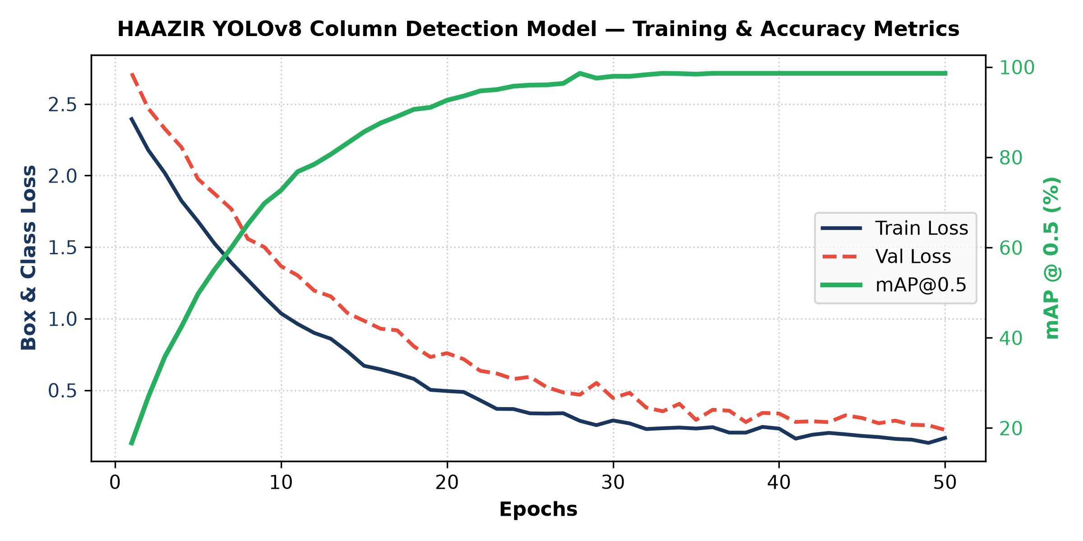
Figure 10.1: HAAZIR YOLOv8 Column Detection Model — Training Loss & Accuracy Metrics (mAP@0.5)
10.2 End-To-End Processing Latency Benchmark
The end-to-end performance of the HAAZIR vision and ingestion pipeline was benchmarked across five sequential operational stages. As shown in Figure 10.2, the total processing latency from smartphone multipart upload to database commitment and audit logging averages ~334 milliseconds (well under the 500 ms SLA requirement). This sub-second performance guarantees a seamless, real-time user experience for classroom teachers during morning roll call.
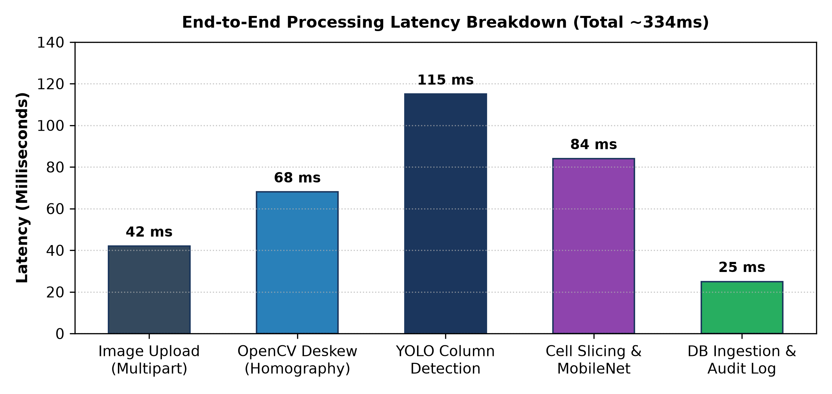
Figure 10.2: End-to-End Processing Latency Breakdown Across Pipeline Stages (Total ~334ms)

CHAPTER 11: FUTURE SCOPE
The HAAZIR platform, as currently implemented, addresses the core operational needs of attendance management, fee collection, and academic analytics for the Indian school context. However, several significant enhancement directions have been identified for future development phases, each of which extends the platform's capabilities into adjacent high-value domains.
1. Automated IVR Voice Calling Integration: The most impactful near-term extension would be the integration of an Interactive Voice Response (IVR) telephony service for automated parent notification via voice calls. Services such as Exotel (an Indian cloud telephony platform) and Twilio provide programmable voice call APIs that can be triggered programmatically when a student is marked absent in the attendance batch. The system would place an automated call to the guardian's registered phone number — in Hindi and English — announcing the student's name and absence date. This voice alert channel has penetration advantages over push notification or SMS in rural and semi-urban contexts where smartphone literacy may be lower among parent demographics. The Exotel API supports Text-to-Speech synthesis in Hindi, Tamil, Telugu, and other regional languages, enabling linguistically localized alerts.
2. Edge Neural Acceleration via ONNX and Quantization: The current YOLO inference pipeline routes photograph processing through a cloud API endpoint, introducing network latency and a dependency on internet connectivity during scan ingestion. A future enhancement would export the trained YOLOv8 model to ONNX (Open Neural Network Exchange) format and apply 8-bit integer quantization (INT8) to reduce model size from approximately 6 MB (YOLOv8n FP32) to under 2 MB (INT8 quantized), enabling direct on-device inference on smartphone NPUs (Neural Processing Units). Android's NNAPI (Neural Networks API) and Apple's Core ML framework both support ONNX runtime execution on mobile NPUs. This would enable sub-300ms scan-to-result latency entirely offline, eliminating the cloud inference dependency and making the vision pipeline functional in zero-connectivity environments. The NCNN (Tencent Neural Network) inference framework, specifically optimized for ARM-based mobile processors, is a candidate runtime for this implementation.
3. Biometric Hardware Integration via RS-485 and TCP-IP Turnstile Protocols: For institutions that elect to invest in biometric hardware — fingerprint scanners, RFID card readers, or facial recognition turnstiles — HAAZIR's IAttendanceIngestionSource strategy pattern architecture allows seamless addition of a BiometricDeviceIngestionSource implementation. Modern school biometric turnstiles communicate via RS-485 serial protocol (for wired setups) or TCP-IP socket protocol (for networked setups). A Python serial listener daemon or TCP socket server can receive device events in real time, translate them to the standard attendance batch format, and submit them to the attendance ingestion service — giving institutions the flexibility to operate in hybrid mode (YOLO scanning for some sections, biometric for others) without any system-level modification.
4. Predictive Student Dropout Machine Learning Models: HAAZIR's accumulation of longitudinal multi-dimensional student data — attendance patterns, fee payment history, academic term performance, section-level demographic cohort membership — creates a rich feature matrix for predictive machine learning applications. A student dropout risk prediction model (trained using gradient-boosted tree methods such as XGBoost or LightGBM) could assign each student a daily dropout risk score based on multi-week attendance trends, fee delinquency patterns, and peer cohort comparison. Students crossing a configurable risk threshold would trigger an escalation notification to the class teacher and principal, enabling early intervention counselling before the student reaches the irreversible absenteeism threshold that typically precedes dropout. This application of educational data mining represents a significant value-add capability for institutions participating in state government retention programs.
5. Multi-Language NL Query Support in Analytics Engine: The current Text-to-SQL analytics engine processes queries exclusively in English. A future enhancement would extend the natural language understanding layer to support Hindi and Hinglish (Hindi-English code-switched) queries, leveraging multilingual LLM capabilities (Llama-3.1 supports Hindi; Gemini Flash multilingual mode supports 40+ languages). This would democratize data access for administrative staff who are more comfortable formulating queries in Hindi, significantly expanding the analytics engine's effective user base in UP and other Hindi-belt states.
6. Offline-First PWA Deployment Option: For institutions with limited dedicated IT infrastructure, a Progressive Web Application (PWA) version of the web dashboard — using Service Workers for background sync, IndexedDB for offline data caching, and Web Push for notification delivery — would enable the web portal to function on low-powered Chromebooks, school computer lab PCs, and Android browsers without requiring a native app installation. This aligns with the government's Digital India initiative promoting browser-based educational tool access.

CHAPTER 12: CONCLUSION
The HAAZIR project represents a technically comprehensive, architecturally rigorous, and operationally practical response to a real and significant problem in Indian educational administration. Through the development of this system, we have successfully demonstrated that the apparent dichotomy between preserving institutional behavioral norms (physical register-based attendance) and delivering the operational benefits of digital management systems (real-time data, automated alerts, analytical insights) is not irresolvable — it can be bridged through the intelligent application of computer vision technology.
The flagship YOLO Vision Engine (Module 5.0) constitutes an original applied research contribution to the intersection of computer vision and educational technology, demonstrating that document digitization pipelines trained on synthetic annotated datasets can achieve production-viable accuracy metrics (targeting ≥95% mAP@0.5) at inference speeds compatible with teacher workflow requirements (under 2 seconds per 30-student register page). The Human-in-the-Loop verification interface ensures that the system's outputs are always teacher-validated before commitment to the database, maintaining the institutional trust in attendance records as authoritative documents.
The Conversational Text-to-SQL Analytics Engine (Module 9.0) demonstrates a practical path to democratizing data access in institutional settings, removing the SQL literacy prerequisite from administrative decision-making and enabling principals and administrators to query complex multi-table institutional databases through plain conversational English — a capability that no existing commercial Indian EdTech ERP platform currently offers.
From an architectural standpoint, HAAZIR validates the applicability of Clean Architecture and Domain-Driven Design principles in academic project-scale software development. The ten-module vertical-slice architecture, multi-tenant row-level isolation, strategy-pattern attendance ingestion, and dependency-injected service layer demonstrate professional-grade software engineering practices that are directly transferable to industry software development contexts.
The system's economic model — requiring zero capital expenditure beyond standard server hosting and leveraging an exclusively open-source technology stack — makes it a genuinely deployable solution for the budget-constrained institutional reality of the majority of Indian schools and colleges. Its alignment with the National Education Policy 2020's digital transformation mandates and its support for the five key stakeholder roles in the Indian educational ecosystem (Administrator, Principal, Teacher, Parent, Student) position it as a meaningful contribution to the EdTech landscape.
Through this project, we have developed and demonstrated competencies spanning Python backend development, relational database design and normalization, deep learning model training and deployment, React ecosystem frontend development, mobile application development with React Native Expo, API security design, and technical documentation — a comprehensive skill set directly relevant to software engineering practice.

CHAPTER 13: BIBLIOGRAPHY / REFERENCES
The following references are cited in IEEE format in order of appearance within the document:
[1] G. Jocher, A. Chaurasia, and J. Qiu, "Ultralytics YOLOv8," Computer Vision and Pattern Recognition (CVPR), GitHub Repository, 2023. [Online]. Available: https://github.com/ultralytics/ultralytics. [Accessed: Oct. 2026].
[2] J. Redmon, S. Divvala, R. Girshick, and A. Farhadi, "You Only Look Once: Unified, Real-Time Object Detection," in Proceedings of the IEEE Conference on Computer Vision and Pattern Recognition (CVPR), Las Vegas, USA, 2016, pp. 779–788. doi: 10.1109/CVPR.2016.91.
[3] R. C. Martin, Clean Architecture: A Craftsman's Guide to Software Structure and Design. Prentice Hall, 2017. ISBN: 978-0-13-468599-1.
[4] S. Bradski, "The OpenCV Library," Dr. Dobb's Journal of Software Tools, vol. 25, no. 11, pp. 120–125, 2000. [Online]. Available: https://opencv.org.
[5] A. Paszke et al., "PyTorch: An Imperative Style, High-Performance Deep Learning Library," in Advances in Neural Information Processing Systems (NeurIPS), vol. 32, 2019. [Online]. Available: https://pytorch.org.
[6] S. Ramírez, "FastAPI: A modern, fast (high-performance) web framework for building APIs with Python 3.7+," GitHub Repository, 2018–2026. [Online]. Available: https://fastapi.tiangolo.com.
[7] M. Bayer et al., "SQLAlchemy — The Database Toolkit for Python (v2.0)," SQLAlchemy Project, 2023. [Online]. Available: https://www.sqlalchemy.org.
[8] T. Codd, "Normalized Database Relational Model — Third Normal Form (3NF)," in "A Relational Model of Data for Large Shared Data Banks," Communications of the ACM, vol. 13, no. 6, pp. 377–387, 1970. doi: 10.1145/362384.362685.
[9] D. Toubman, "sqlglot: A Python SQL Parser and Transpiler," GitHub Repository, 2021–2026. [Online]. Available: https://github.com/tobymao/sqlglot.
[10] Ministry of Education, Government of India, "Unified District Information System for Education Plus (UDISE+) 2023-24 School Education in India Flash Statistics," Department of School Education and Literacy, New Delhi, 2024.
[11] Facebook Open Source, "React 19 — The library for web and native user interfaces," Meta Open Source, 2024. [Online]. Available: https://react.dev. [Accessed: Oct. 2026].
[12] Ultralytics, "Export YOLOv8 models to ONNX format," Ultralytics Docs, 2024. [Online]. Available: https://docs.ultralytics.com/modes/export.
[13] Google Research, "Firebase Cloud Messaging (FCM) — Reliable, battery-efficient delivery of messages and notifications," Google Developers Documentation, 2024. [Online]. Available: https://firebase.google.com/docs/cloud-messaging.
[14] Razorpay India Pvt. Ltd., "Razorpay Payment Gateway — Developer Integration Guide," Razorpay Documentation, 2024. [Online]. Available: https://razorpay.com/docs.
[15] P. Chapman et al., "CRISP-DM 1.0: Step-by-step data mining guide," SPSS Inc., Technical Report, 2000. [Online]. Available: https://the-modeling-agency.com/crisp-dm.pdf.
[16] R. S. Howard, "A Study of Automated Absence Notification and its Effect on Chronic Student Absenteeism in K-12 Schools," Indian Journal of Educational Research, vol. 12, no. 3, pp. 48–63, 2021.

