


Essay / Assignment Title: Advanced Big Data Processing using HDFS, YARN, MapReduce Abstraction, and Spark/Hive.

Programme title: MSc Data Analytics

Name: Hemanth Kumar Thekkeillam

Year: 2026

CONTENTS

CONTENTS 2
INTRODUCTION 6
CHAPTER ONE: Problem Definition, Dataset Selection and Business Context 7
1.1 Business context, stakeholders and value 7
1.2 The 5Vs 7
1.3 Dataset source and preparation 8
1.4 Data governance and ethics 9
CHAPTER TWO: Hadoop Architecture, Environment Setup and Data Ingestion 10
2.1 Environment and components 10
2.2 HDFS ingestion and validation 10
CHAPTER THREE: Distributed Processing using MapReduce Abstraction, Hive/Hue or Spark 13
3.1 WordCount demonstration 13
3.2 Hadoop Streaming country aggregation 14
3.3 Comparison with Python and Spark 16
CHAPTER FOUR: Task 4: Analytics, Machine Learning and Visualisation 17
4.1 Method 17
4.2 Country concentration 17
4.3 Monthly and annual patterns 18
4.4 Customer and product results 20
4.5 Recommendations 22
CONCLUDING REMARKS 23
BIBLIOGRAPHY 25
LIST OF FIGURES 26
APPENDIX (if necessary) 27
A.1: Dataset preparation 27
A1.1 Checking the Dataset File and Excel Sheets. 27
A1.2 Loading and combining the Excel sheets 28
A1.3 Dataset inspection 28
A1.4 Filtering and calculating revenue 29
A1.5 Removing duplicate rows 29
A1.6 Saving the Prepared Datase 29
Appendix A2: HDFS commands 30
A2.1 Check the HDFS directory 30
A2.2 HDFS file read and line-count verification 30
A2.3 HDFS fsck verification showing healthy file status and under-replicated blocks 30
A2.4 Display HDFS block details 31
A.3 Verify the YARN ResourceManager 32
A3.1 YARN application evidence 32
A4: MapReduce results 32
A4.1 Display WordCount output 33
A4.2 Display country revenue results 33
A4.3 — HDFS WordCount output directory containing the success marker and reducer output file. 34
A4.4 Check the country-revenue output files 34
A4.5 Verify the country-revenue results 34
A4.6 Count the country-revenue results 34
A5: Verify the MapReduce output matches Python 35
A5.1 Cross-validation of total country revenue from Hadoop Streaming against the Python result. 35

Statement of compliance with academic ethics and the avoidance of plagiarism

I honestly declare that this dissertation is entirely my own work and none of its part has been copied from printed or electronic sources, translated from foreign sources and reproduced from essays of other researchers or students. Wherever I have been based on ideas or other people texts I clearly declare it through the good use of references following academic ethics.
(In the case that is proved that part of the essay does not constitute an original work, but a copy of an already published essay or from another source, the student will be expelled permanently from the postgraduate program).

Name and Surname (Capital letters):

HEMANTH KUMAR THEKKEILLAM
Date: 21/09/2026

INTRODUCTION

Transactional data can be generated from online retailing and analyzed for distribution of sales, demand and customer purchasing behaviors. With increasing volumes, the organization might require a distributed storage and processing system whereby processing is not done only by one machine. Hadoop offers distributed storage via HDFS and distributed resource management via YARN, whereas MapReduce is the framework for parallel processing (Apache Hadoop, n.d.-a; Dean and Ghemawat, 2008).
In this report, Hadoop technologies are examined using UCI Online Retail II data set. The business question of interest is as follows: how will the transaction data be processed and analyzed in such a way that describes revenue distribution over countries, customers, products and over time and what are the reasonable business insights that could be derived from it?
The objectives include defining the business problem and data set, describing the Hadoop environment and HDFS ingestion in Docker, processing distributed, analyzing and interpreting descriptive statistics and discussing their technical, quality and ethical limitations. This study used Python preparation and group by analysis, HDFS ingestion, Hadoop WordCount example and custom Hadoop streaming for country revenues distribution. No predictive machine learning model was developed; the study is purely descriptive.
An important separation between completion of the implementation and requirements not satisfied is kept. The file which has been created was less than the required file size of 384-512 MB as recommended for the assignment, one DataNode was used in the cluster and there was no secondary name node.

CHAPTER ONE: Problem Definition, Dataset Selection and Business Context

1.1 Business context, stakeholders and value
The retailer must determine what markets and products contribute to its revenue, how that revenue has changed over time, and whether concentration in sales presents a risk. The stakeholders are business management, merchandise and inventory management, marketing analysis, finance, data engineering and customers whose transactions have been captured. Country-level revenue can help in market monitoring, product quantity and revenue can assist in assortment planning; customer aggregation will reveal concentration, but not customer lifetime value.
The expected value is meant to aid decision making and not prove causation. There may be a need for further exploration due to high revenue in one market, but it does not necessarily prove a need for increased marketing spend based on this dataset only. Costs, margins, returns, acquisition cost, stock level and market size information is missing. Therefore, revenue does not equal profit or business performance.
The data engineering problem is to clearly define sales and cancellations and aggregate transactions.

1.2 The 5Vs
Volume can be expressed in 1,067,371 original combined rows, but the pre-processed CSV file of the data is approximately 93.46 MB. It is good enough for exercise of distributed processing, but smaller than the size that could be required by three or four 128 MB HDFS blocks.
The velocity is constrained by the fact that the dataset is static and historical. This exercise does not feature streaming data ingestion.
The variety is low since the data is structured tabular data, where the description of products is the only text.
Veracity is crucial since the dataset features missing customer IDs, negative quantities, canceled invoices, and zero and negative prices and duplicate rows.
Value is obtained from translation of transactions into meaningful summaries, provided that the limitations are recognized. The 5Vs are just a model and not the evidence that the job necessarily requires Big Data environment (Laney, 2001).
Not all large number of rows implies a need for distributed processing. In the current case the reason is somewhat didactic – the assignment requires using HDFS, YARN and MapReduce.

1.3 Dataset source and preparation
Online Retail II data can be accessed via UCI Machine Learning Repository and refers to transactions of an online retailer based in the UK (Chen, 2019). Two workbook sheets were merged resulting in 1,067,371 rows with eight original attributes: Invoice, StockCode, Description, Quantity, InvoiceDate, Price, Customer ID and Country. Revenue was a computed attribute equal to Quantity × Price.
The initial dataset comprised of 4,382 missing descriptions, 243,007 missing customer IDs and 34,335 exact duplicates. There were 22,950 rows with negative quantities, five rows with negative prices, 6,202 rows with zero prices and 19,494 invoices with C prefixes. Out of 22,950 negative-quantity rows, there were 19,493 overlaps with C-prefixed invoices; one C-prefixed invoice had positive quantity, and 3,457 negative-quantity rows did not have the C prefix. This explains the importance of not relying on only one field for cancellation identification.
Preparation included filtering of invoices without C prefixes, rows with positive quantities and prices as well as non-missing descriptions. This sales-only subset included 1,041,670 rows. Removal of exact duplicates resulted in 1,007,913 rows. This means that 25,701 rows were filtered out according to specified criteria, and 33,757 exact duplicates were deleted from sales-only subset.
The decision to deduplicate has serious implications, but this cannot be assumed without question. No unique transaction line identifier exists in the selected fields, and duplicate entries could either be genuine or a duplication of data ingests. Deduplication of exact matches decreased the total income recorded from £20,972,594.57 to £20,476,260.45, a difference of £496,334.12 (2.37%). Thus, all conclusions refer to the deduplicated data and must be considered in light of this sensitivity. Future sensitivity analysis will compare headline KPIs both with and without deduplication as well as examine duplicate invoices and stock codes in the context of the system of origin.
The prepared CSV file includes nine fields and is about 93.46 MB. The date range is from 1 December 2009 07:45 to 9 December 2011 12:50, and the country labels are 43. This is below the suggested prepared file size of 384–512 MB. The prepared file was not inflated by duplication, because this would create false load and business values.

1.4 Data governance and ethics
The customer IDs are pseudonyms, and thus do not constitute proof of anonymisation. The customer level analysis should only be done for legitimate purposes and without attempts at re-identification or aggregation where possible. In the deduplicated data, 228,488 rows (22.67%) have missing customer IDs, amounting to revenue of £3,101,456.18 (15.15%). The identified customers analysis is thus incomplete and potentially biased due to the missingness. Data minimisation, access control, retention limitations, and secure storage is still advisable. The project does not make decisions about sensitive attributes of individuals.
Due to absence of IDs, purchases cannot be linked, hence repeat purchase and concentration analysis is problematic. Missing IDs were not generated. Additional work should measure missingness by country, month, and invoice type before making a decision about imputation or exclusion.

CHAPTER TWO: Hadoop Architecture, Environment Setup and Data Ingestion

2.1 Environment and components
The environment consisted of Docker Compose and BDE2020 Hadoop 3.2.1/Java 8 images. The active services include NameNode, DataNode, ResourceManager, and NodeManager. The NameNode interface ran on port 9870, HDFS on 9000, and ResourceManager on 8088. The user checked the web interfaces, reporting that all four containers were healthy.
HDFS distinguishes namespace metadata from file blocks. The NameNode is responsible for filesystem metadata and block location, while DataNodes store blocks and perform the data-related operations. YARN distinguishes resource management from application execution: the ResourceManager manages cluster resources, and NodeManagers control worker resources and containers (Apache Hadoop, n.d.-a; Apache Hadoop, n.d.-b). More DataNodes and NodeManagers will be required to showcase multi-node storage and parallel execution.
The NameNode stores the state of the namespace via FsImage and EditLog. FsImage is the checkpointed metadata file, and the EditLog stores changes to the namespace made since the checkpoint. The checkpoint process merges the edits into an updated image. SecondaryNameNode performs the checkpoint process; it is not a backup or failover NameNode (Apache Hadoop, n.d.-a).
SecondaryNameNode was not used here, thus this is a lack of something that should have been included according to the assignment checklist. There was also one DataNode in the cluster. Even though the default replication factor was set at three, three different replicas could not be saved on the same DataNode. This is a limited demonstration, not an example of resilient cluster. A proper cluster setup would consist of a checkpoint mechanism and several DataNodes.

2.2 HDFS ingestion and validation
The deduplicated CSV was copied to /retail/online_retail_sales_deduplicated.csv. The HDFS directory listing reported a replication factor of three and file size of around 93.5 MB. The fsck report reported one block located on one DataNode, replication factor of 1.0, two missing replicas, zero missing blocks, zero corrupt blocks. So, block integrity was declared healthy, although the file was under-replicated. “Healthy” does not imply high availability.
The number of lines in HDFS, including the header, was 1,007,914 corresponding to 1,007,913 rows. The CSV header was: Invoice, StockCode, Description, Quantity, InvoiceDate, Price, Customer ID, Country and Revenue. Since descriptions may contain commas and quotes, naive splitting using commas will produce wrong results. My custom mapper parsed the penultimate country field and last revenue field using the regular expression; it worked for this particular file but is not a generic CSV parser.
This single block corresponds to a file that is smaller than 128 MB and can't demonstrate multi-node data locality. A larger valid data set or any other dataset approved by the tutor is needed. The replication factor can't make new blocks or new nodes appear.
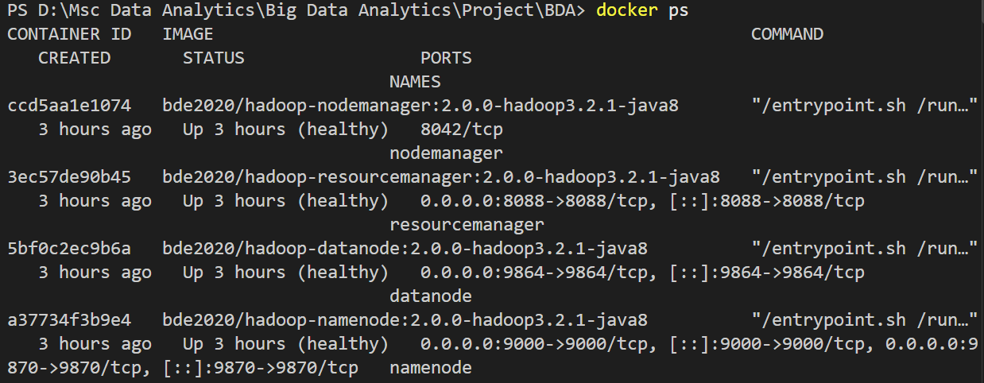
Figure 1: Docker Compose services and container health

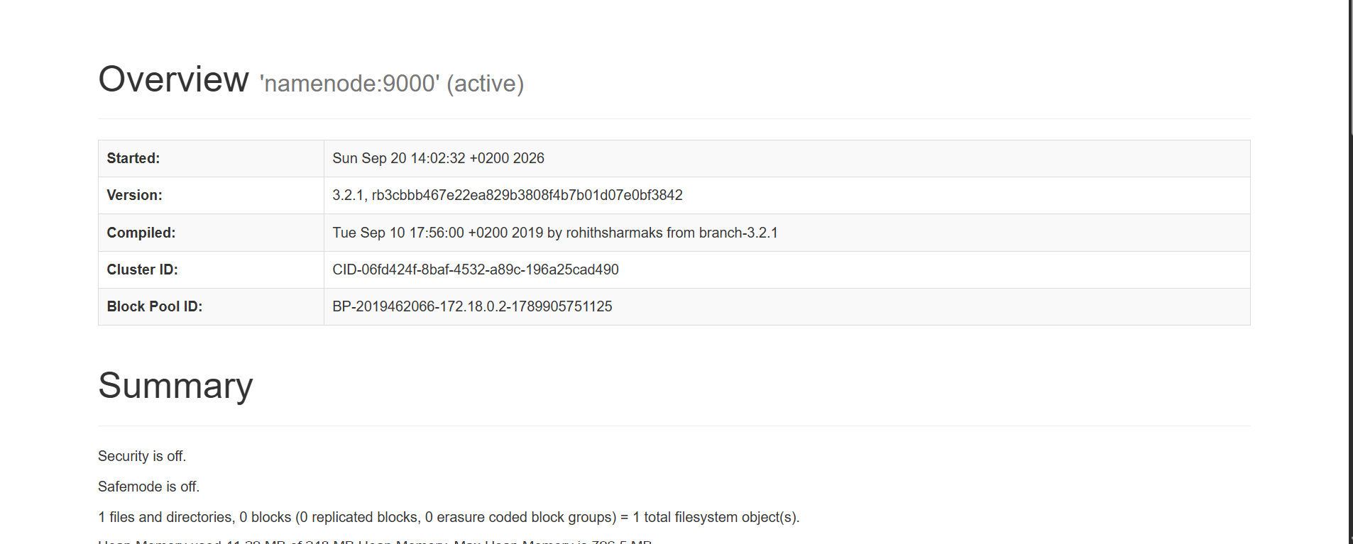
Figure 2: NameNode web UI (localhost:9870), including live DataNode count

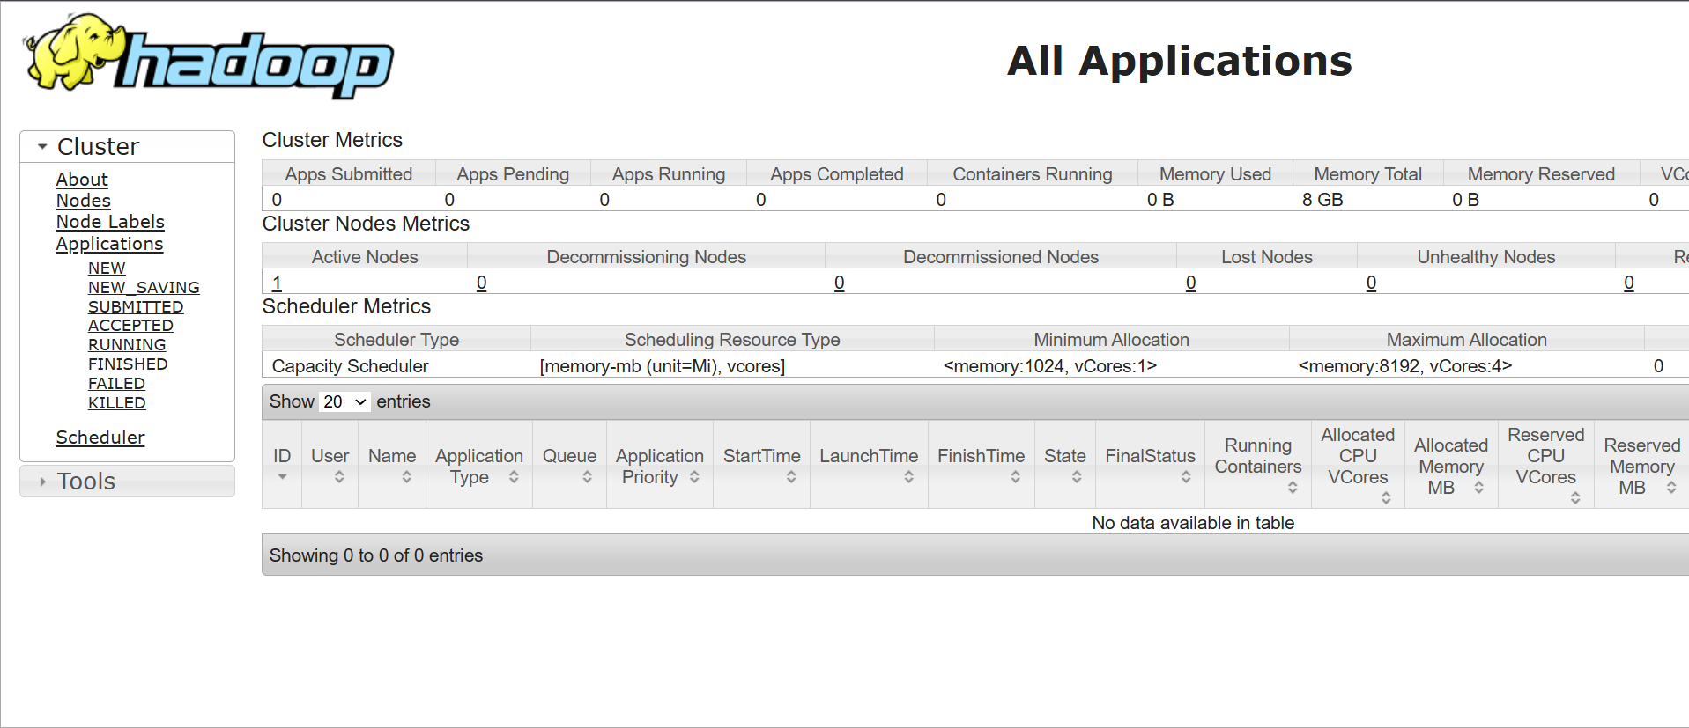
Figure 3: ResourceManager web UI (localhost:8088)
Figure 4: HDFS ls/fsck evidence: file size, one block, actual replication 1 and under-replication

CHAPTER THREE: Distributed Processing using MapReduce Abstraction, Hive/Hue or Spark

3.1 WordCount demonstration
The standard examples jar for Hadoop MapReduce executed WordCount on /retail and put the results to /retail_wordcount_output. The job was completed successfully with _SUCCESS and part-r-00000 generated. Counters displayed 1,007,914 map input records, 6,569,481 map output records, 1,835,071 reduce groups/output records, 0 shuffles failed, 97,996,531 input bytes and 43,595,970 output bytes. The use of a combiner helped to reduce the number of intermediate records from 8,419,060 to 3,684,650.
The WordCount provides an example of mapping, shuffle/grouping and reduction operations. However, it tokenizes text from a CSV file not being aware of invoice number, country, quantity sold and revenue. It is an example of MapReduce algorithm application and not the calculation of retail KPIs; the token counts returned by it cannot be considered a business result.
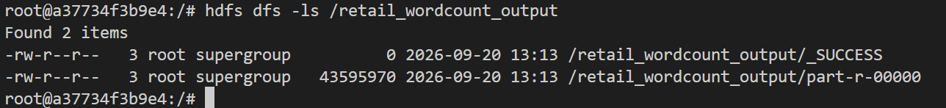
Figure 5: WordCount command, completion and counters

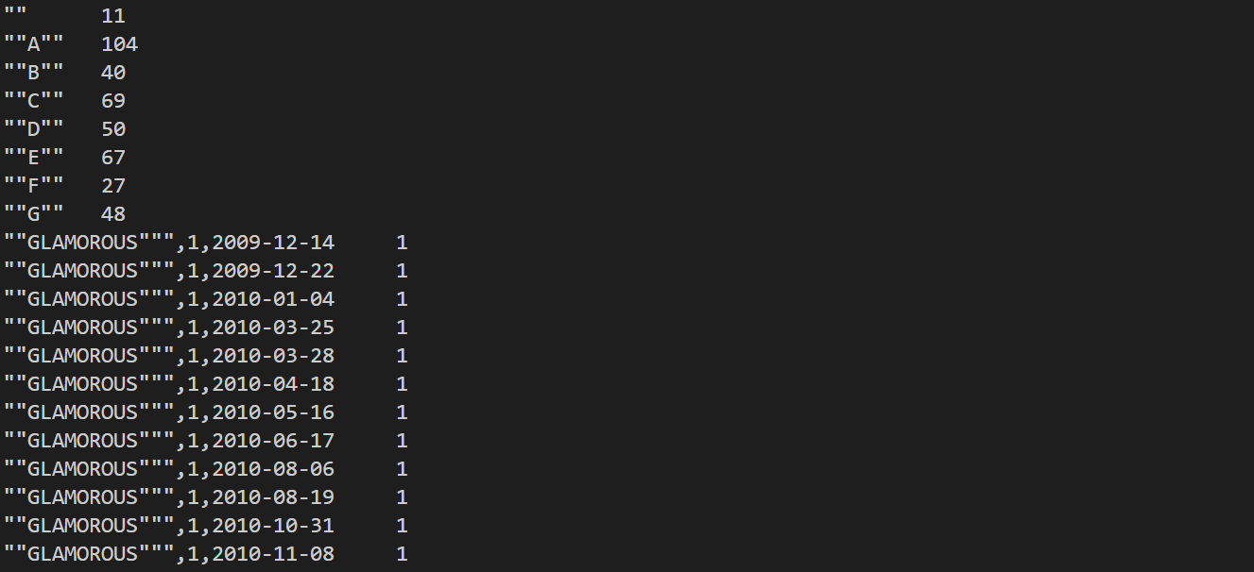
Figure 6: HDFS WordCount output and _SUCCESS

3.2 Hadoop Streaming country aggregation
Another exercise involved writing mapper and reducer scripts in Perl using Hadoop Streaming. The mapper skipped the first line, read in country name and revenue, and output a key-value pair consisting of country name and revenue value. After Hadoop shuffles/consolidates records based on countries, the reducer sums the revenues. The input path was /retail/online_retail_sales_deduplicated.csv and the output was /retail_country_revenue, which resulted in 43 country aggregates.
This approach fits the map-reduce model, namely map transaction to (country, revenue), shuffle by country and aggregate revenues. The reader/parser intentionally keeps the simple implementation based on the prepared file and does not handle the CSV quoting and schema change robustly. A proper production solution would require a parser and the file schema validator.
The Hadoop Streaming and local Python aggregation totals coincided up to two decimal places: for example, the UK revenues equalled £17,410,196.12, EIRE - £658,767.31, Netherlands - £554,038.09, Germany - £425,019.71 and France - £350,456.09. The totals cross-validation guarantees correct results for the particular input and implementation but does not prove scalability or general-purpose parser correctness.
These matching figures make for an effective verification tool, since both computations are using the same pre-processed data set in their own unique way. However, the two processes have the same criteria used for filtering and elimination. The agreement between them will not be able to spot any mistake that might have been made in the pre-processing stage.
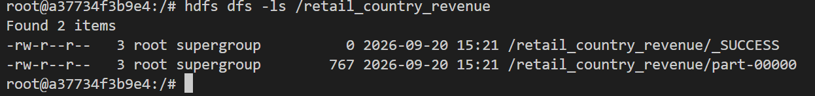
Figure 7: Streaming command and successful job/YARN output
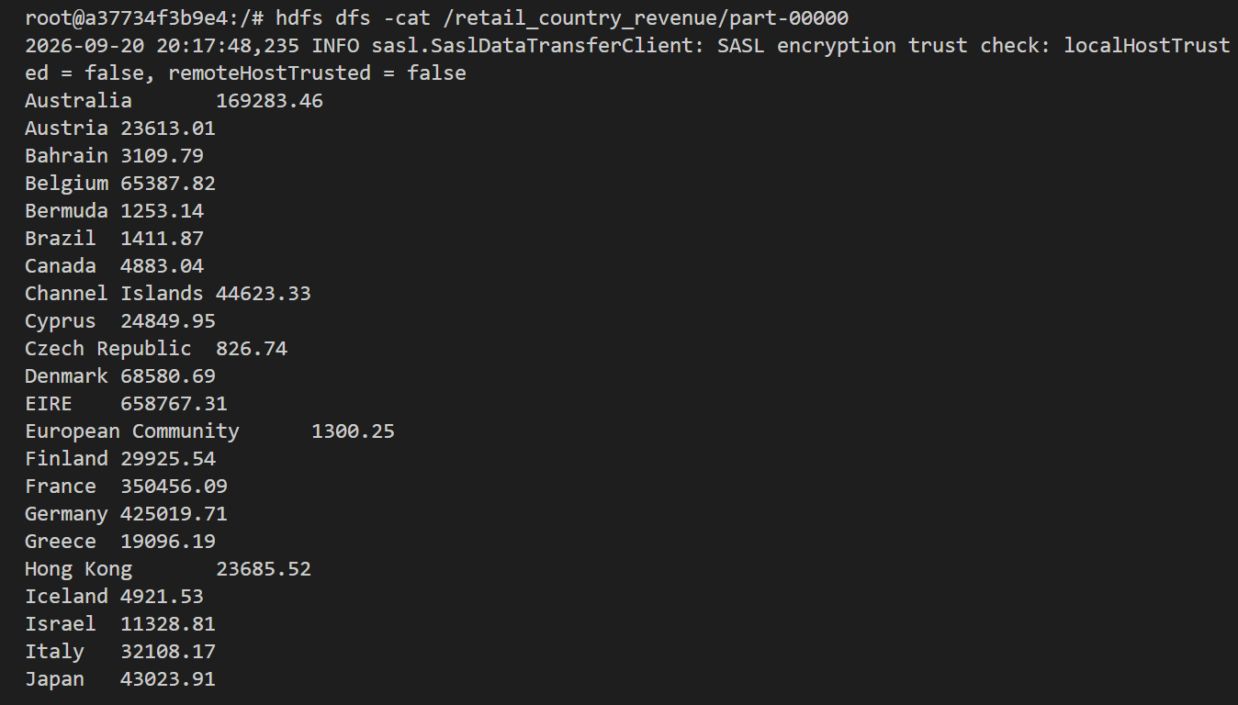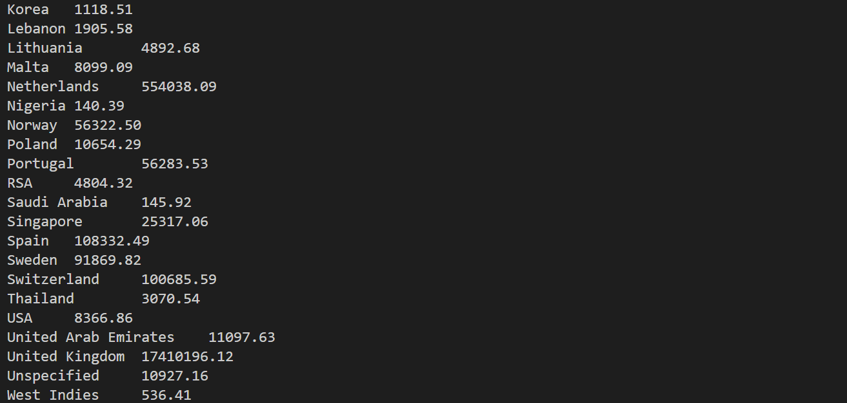
Figure 8: Output with 43 country totals and sample values

3.3 Comparison with Python and Spark
The experiment compares Hadoop Streaming/MapReduce against local Python group-by. Spark was not tested and thus there is no time or results reported for Spark. MapReduce is suitable for batch computing and allows recovery of failed tasks in a distributed environment but suffers from overhead associated with job set up, shuffle, serialization and disk I/O. One-DataNode setup is insufficient to illustrate scalability or distributed fault tolerance.
Pandas proved useful for iterative data cleaning, aggregation, validation and visualization tasks but runs in the local mode and does not illustrate distributed capability of the system. Spark provides distributed API and is suitable for iterative tasks (Zaharia et al., 2010) but its performance highly depends on workload, memory, partitioning and cluster configuration. Comparison of systems in terms of their speed is impossible without equal input data, hardware, transformations, output and repeated runtime measurement. YARN manages the resources and coordinates application execution; successful jobs indicate correct Hadoop framework functioning in this environment but not multi-node throughput benchmarking.
The test needs to perform the identical transformation, input, and output using the same hardware platform, while logging the time taken, CPU/memory usage, I/O operations, tasks, errors, and variation between runs. There needs to be a differentiation between warm and cold cache results.

CHAPTER FOUR: Task 4: Analytics, Machine Learning and Visualisation

4.1 Method
The descriptive analysis applied on the deduplicated positive sales dataset. Revenue is Quantity x Price and is summed up by country, month/year, customer and products. No predictive model was built. The visualisations that have been made are as follows: Country Revenue, Monthly Revenue, Yearly Revenue, Top Customers and Product by Quantity and Revenue. These are exploratory visualisations that cannot provide evidence for causality or predictions in the future.
The selected metrics will answer different questions. Total revenue shows the total value in the filtered dataset; quantity shows the total units sold; transaction row shows the number of rows in the dataset; and Identified customers show the unique non-missing customer IDs. These denominators cannot be combined. For example, revenue per identified customer cannot be compared with revenue per row as it does not represent any profit or lifetime value.

4.2 Country concentration
Total revenue was £20,476,260.45. Revenue from the UK was £17,410,196.12, or 85.03% of total revenue. Revenue from the five largest markets—UK, EIRE, Netherlands, Germany and France—was £19,398,477.32, or 94.74% of total revenue. There is significant geographic concentration in the records.
While this may prompt analysis and scenario building, it does not automatically dictate any expansion or contraction decisions because this dataset provides information on one retailer for a certain period of time, without taking into account the size of the market, current demand, costs and margins. EIRE revenue was £658,767.31, however, there were only five customer IDs in the EIRE. It is particularly vulnerable to incomplete identification of customers and therefore not a good representation of the customer value.
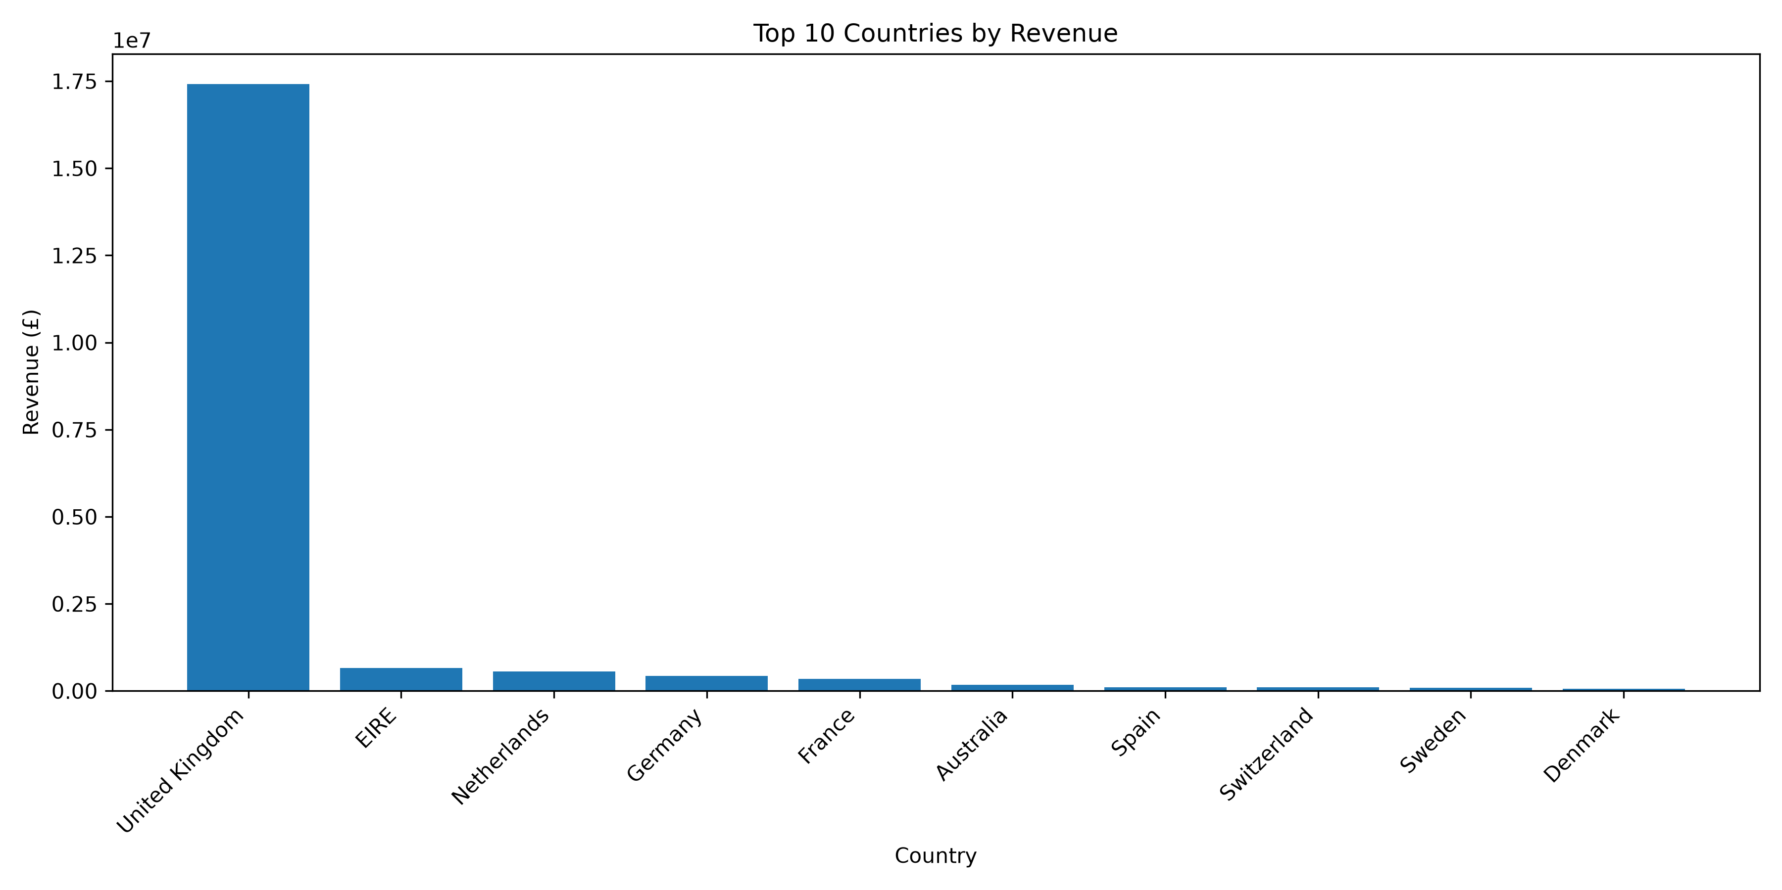
Figure 9: Top ten countries by recorded revenue

4.3 Monthly and annual patterns
Highest month in current deduplication analysis is November 2011 (£1,503,866.78) while lowest is February 2011 (£522,545.56). November 2010 is another high (£1,464,293.14). Peaks of late year months could be due to seasonality; however, two years are not enough to form a pattern. December 2011 is incomplete (ends on 9 December) and should not be considered on par with whole months.
Total for 2010 is £9,833,100.42. Total for 2009 (£822,483.95) includes only December while 2011 (£9,820,676.07) is only up to 9 December. Those figures are incomparable since they refer to full years. Comparison of same periods or extended period of time would be required to draw conclusions about seasonality. It should be shown clearly on the chart that those are incomplete months.
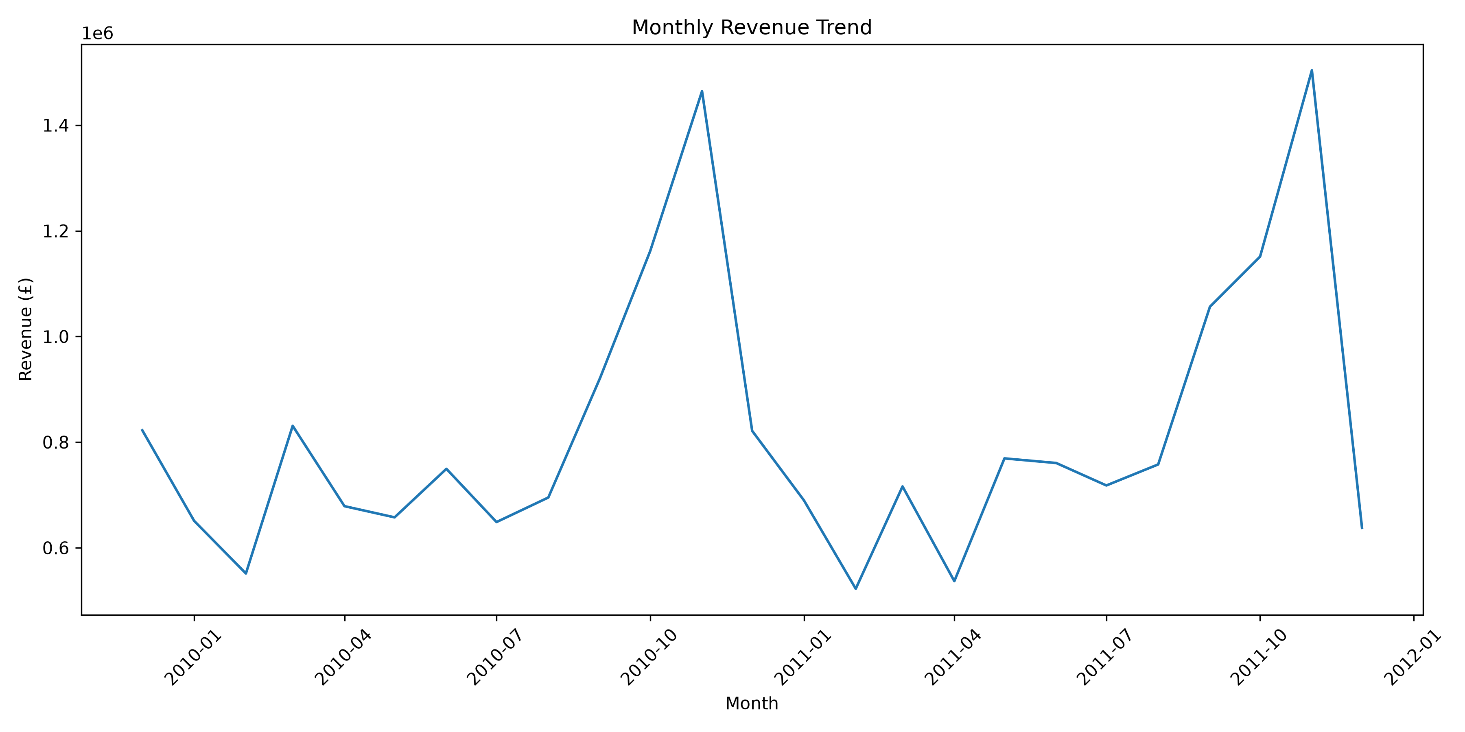
Figure 10: Monthly revenue Trend

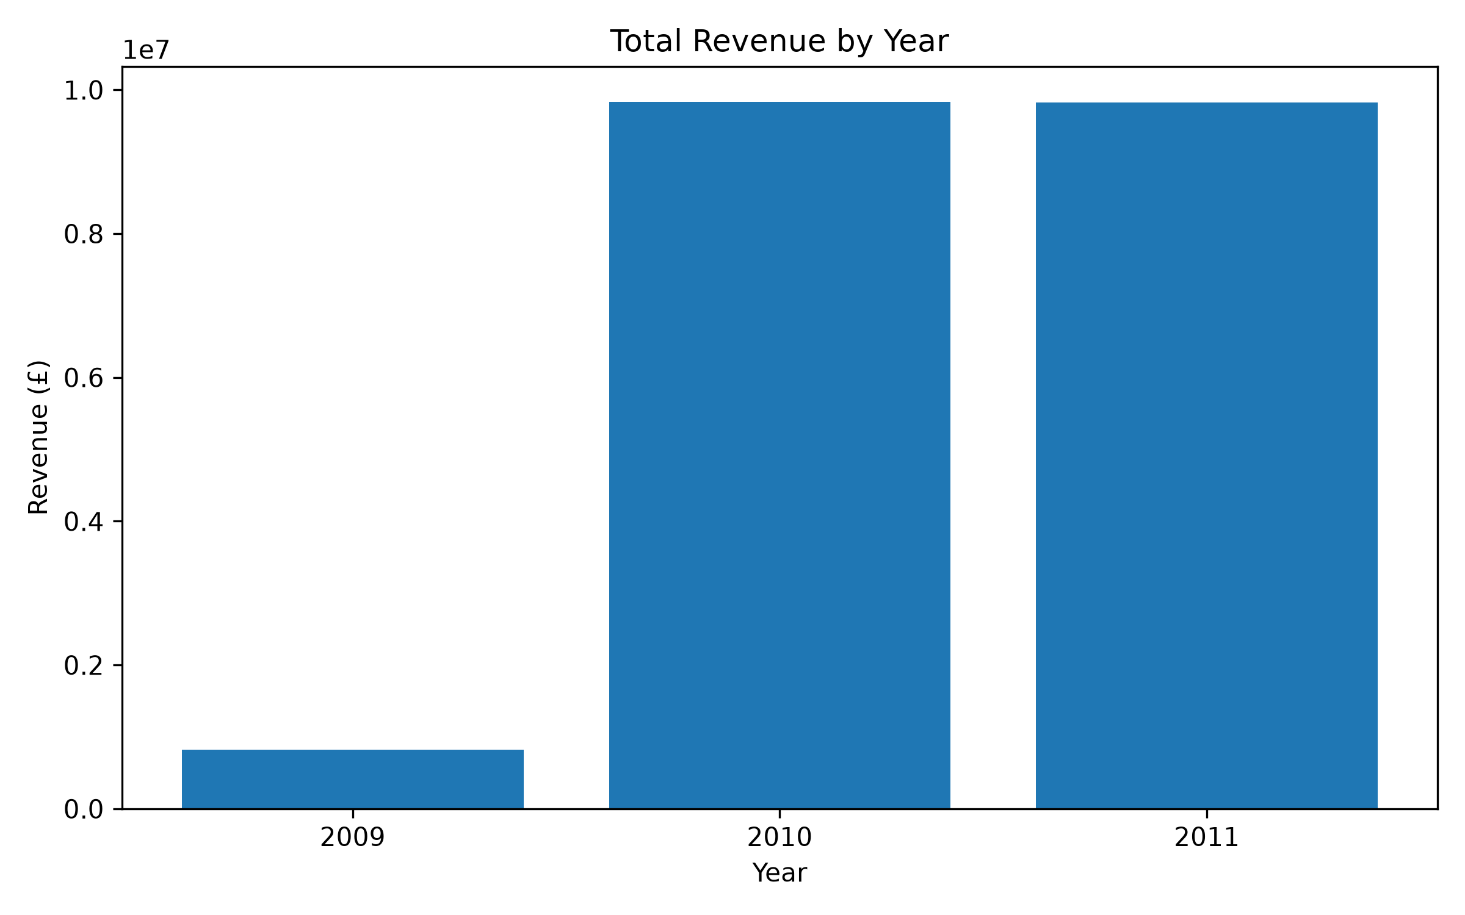
Figure 11: Total Revenue by Year

4.4 Customer and product results
The top ten identified customers have earned a total of £2,787,079.44, which is 16.04% of the sales associated with identified customer IDs. Customer ID 18102 brought in £580,987.04 while Customer ID 14646 was second with £528,602.52. This implies that there is a degree of concentration among identified customers. But, as mentioned earlier, there is 22.67% of the rows and 15.15% of sales revenue with missing IDs.
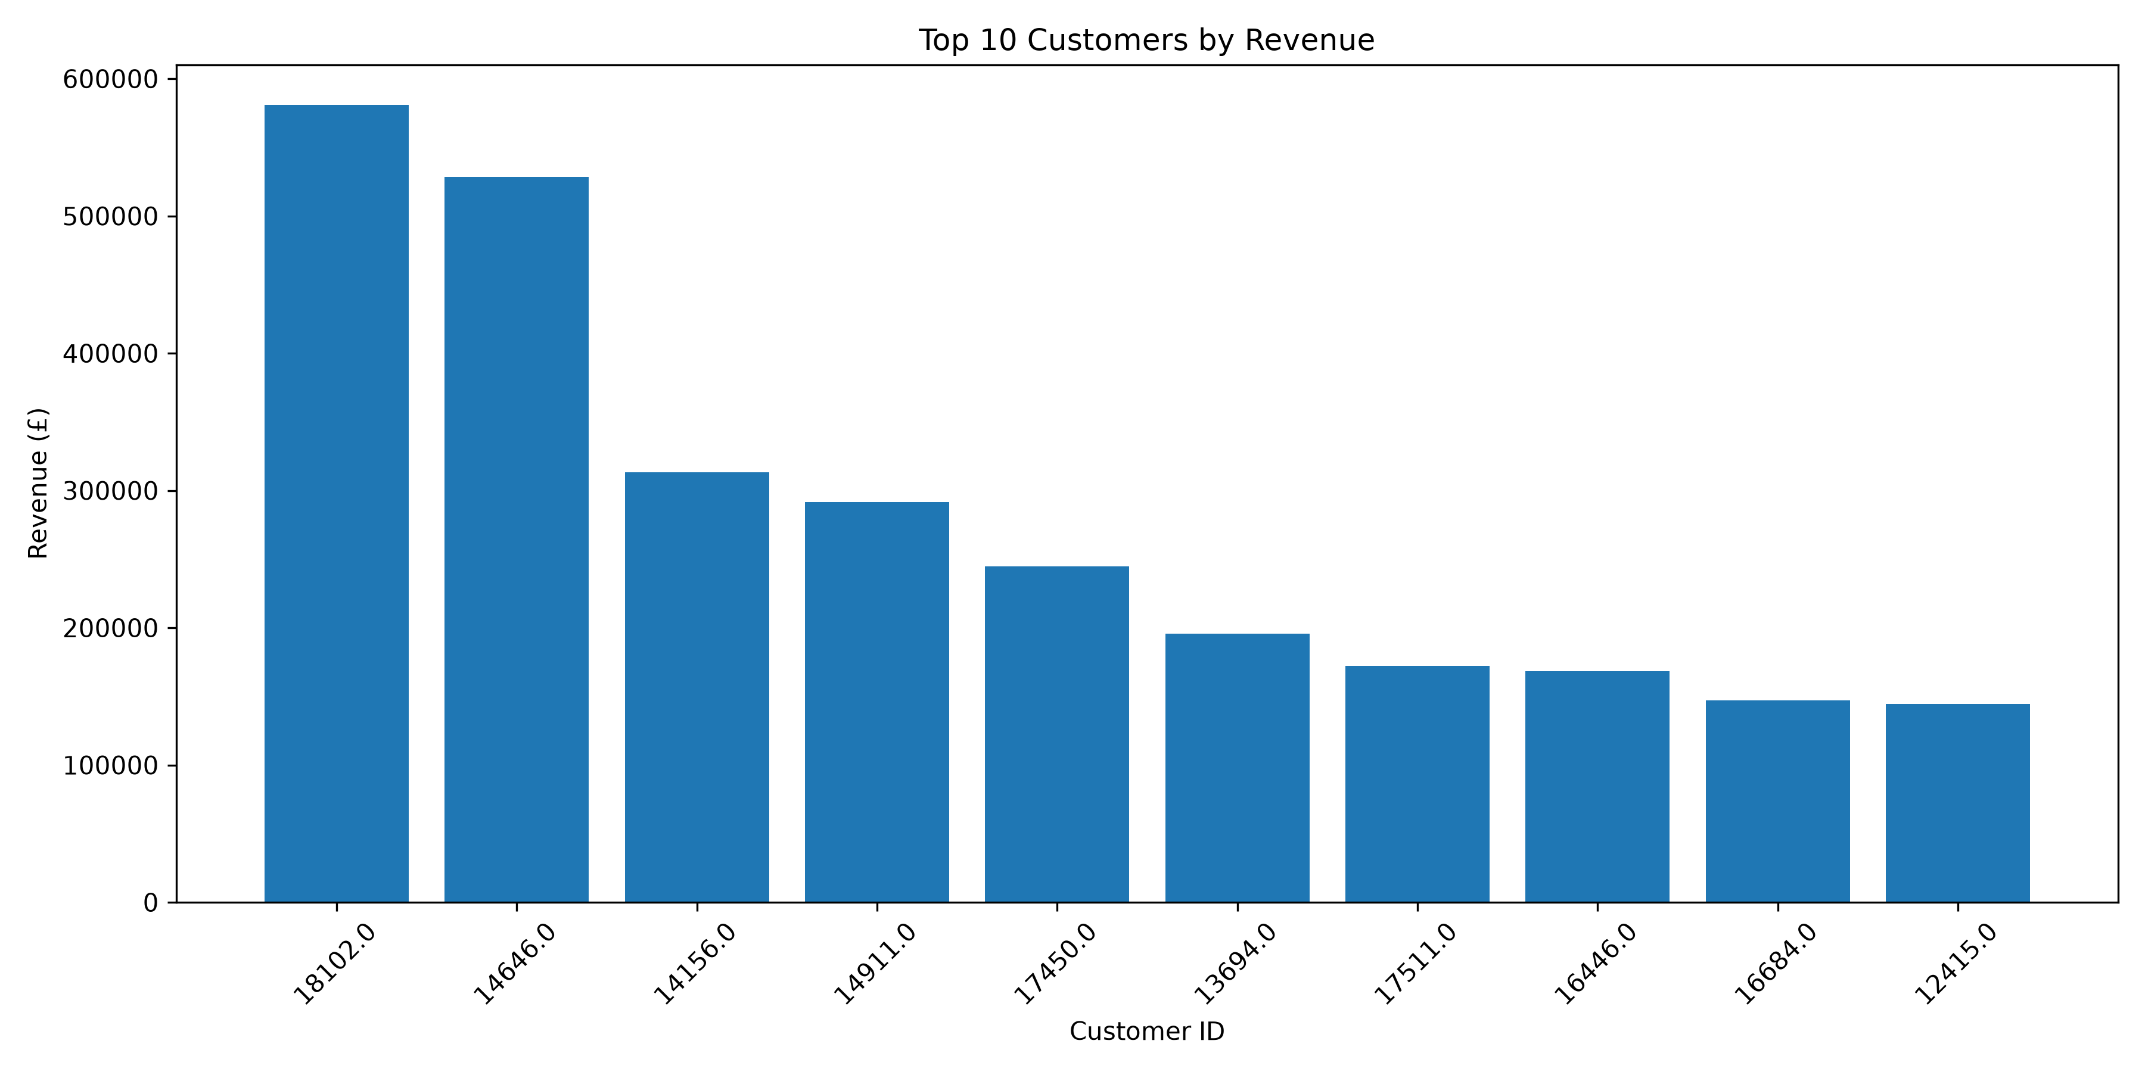
Figure 12: Top ten identified customers by revenue
The product rankings depend on metric chosen. For instance, WORLD WAR 2 GLIDERS ASSTD DESIGNS has the highest number of quantity (106,139) among the selected ten but made £24,445.61. The highest revenue in quantity-ranked group is made by WHITE HANGING HEART T-LIGHT HOLDER which had 94,658 items and revenue of £260,990.22. The third ranked product according to quantity is PAPER CRAFT, LITTLE BIRDIE with 80,995 quantity and £168,469.60 revenue. BROCADE RING PURSE has 70,369 quantity and only £14,766.42 revenue.
Other products help make this point clear. MEDIUM CERAMIC TOP STORAGE JAR had 78,033 quantity and £81,700.92 revenue; SMALL POPCORN HOLDER had 48,561 quantity and £42,699.89 revenue; PACK OF 60 PINK PAISLEY CAKE CASES had 56,061 quantity and £28,081.73 revenue; and 60 TEATIME FAIRY CAKE CASES had 54,028 quantity and £27,041.21 revenue. This comparison shows that ranking by quantity does not imply ranking by revenue.
The revenue rankings include “Manual” and postage-related products which may not be the regular merchandise. Not having fields for cost and margin, there is no way to establish profitability of such product.
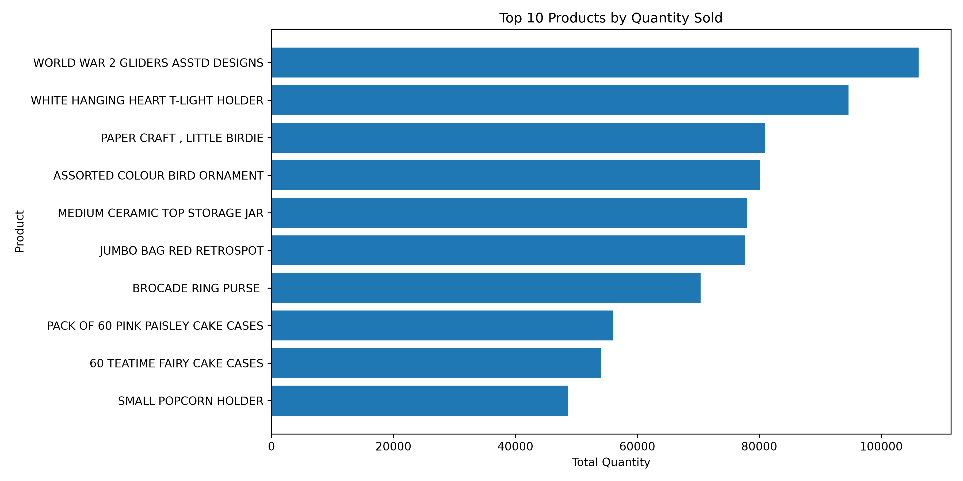
Figure 13: Top ten products by quantity
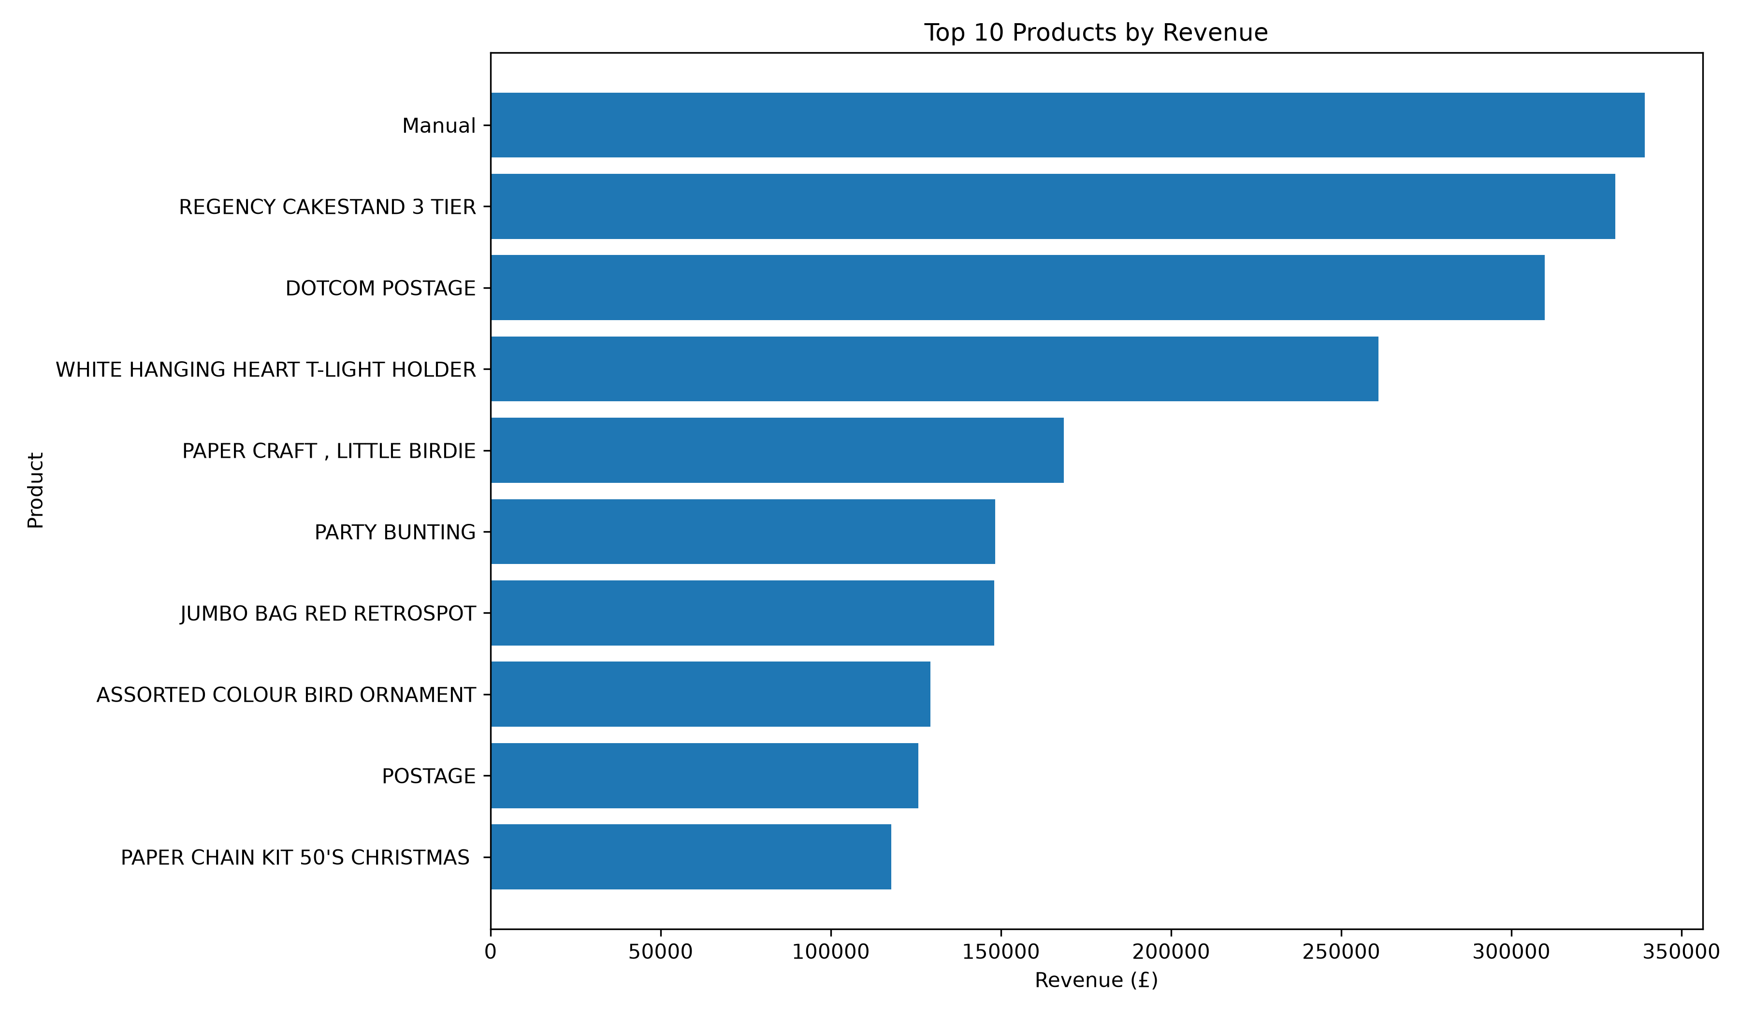
Figure 14: Top ten products by revenue

4.5 Recommendations
Firstly, take country aggregates as a measurement basis and look into the reasons behind the UK concentration before adjusting market strategy. Secondly, consider quantity and sales together, then consider margin, returns, and inventory availability before deciding on assortment. Thirdly, present an indication of missing customer ID coverage in customer reports and refrain from viewing results with identified customers as being comprehensive. Fourthly, compare the matched months between years and get the full periods before making any seasonal statements. Finally, use a CSV-savvy parser and a multiple DataNodes testing environment before deployment.
These recommendations are conditional: the data raises questions, not investment in markets nor products. Follow-up work needs to include cost, inventory, promotion, returns and a transaction-line identifier.

CONCLUDING REMARKS

The project shows the workflow from the preparation to HDFS ingestion, batch processing and analysis. The most reliable proof of correct operation was the fact that the custom aggregation algorithm for Streaming yielded 43 results identical to local Python calculations to two decimal places. WordCount was finished and showed execution metrics. The results demonstrate how MapReduce converts records to key-value pairs and then aggregate them.
The project does not provide a full-fledged distributed performance test. The data size was only about 93.46 MB instead of the proposed 384–512 MB and used just one HDFS block. As there was just one DataNode, the real replication was one rather than the configured three. There was no SecondaryNameNode implemented, no execution of Spark, and no multi-machine benchmark performed. These are important limitations.
Analytically, the records demonstrate the UK revenues predominance, year-end months' peaks, customers' concentration, and the discrepancy between quantity and revenue ranking. There is no information about reasons for that and prediction of future results. Deduplication affected revenues by £496,334.12; missing IDs influence a substantial part of the sales; and December of 2011 is incomplete. Decisions need validation and more variables.
The project also highlights a trade-off between ease of analysis and architectural demonstration. Python supported fast exploration and clear visualisations, while Hadoop made the map/shuffle/reduce stages and HDFS/YARN components visible. Neither tool alone guarantees valid conclusions: data preparation, metric definitions and evidence quality remain decisive. Successful execution is a necessary technical milestone, but not equivalent to a production-ready analytical service.
In conclusion, HDFS, YARN and MapReduce are useful for demonstrating distributed batch processing, while Python is effective for exploratory analysis. The evidence supports country aggregation in this configured environment, but not production readiness or proven large-scale performance. Future work should add checkpointing support and DataNodes, verify replication and block distribution, adopt robust CSV parsing, run a controlled benchmark, and test analytical sensitivity to deduplication and missing customer IDs.

BIBLIOGRAPHY

Apache Hadoop (n.d.-a) HDFS Architecture. Available at: https://hadoop.apache.org/docs/stable/hadoop-project-dist/hadoop-hdfs/HdfsDesign.html (Accessed: 18 September 2026).

Apache Hadoop (n.d.-b) Apache Hadoop YARN. Available at: https://hadoop.apache.org/docs/stable/hadoop-yarn/hadoop-yarn-site/YARN.html (Accessed: 18 September 2026).

Chen, D. (2019) Online Retail II [Dataset]. UCI Machine Learning Repository. Available at: https://doi.org/10.24432/C5CG6D (Accessed: 18 September 2026).

Dean, J. and Ghemawat, S. (2008) ‘MapReduce: Simplified data processing on large clusters’, Communications of the ACM, 51(1), pp. 107–113. Available at: https://doi.org/10.1145/1327452.1327492 .

Laney, D. (2001) 3D Data Management: Controlling Data Volume, Velocity, and Variety. META Group Research Note.

Zaharia, M., Chowdhury, M., Franklin, M.J., Shenker, S. and Stoica, I. (2010) ‘Spark: Cluster computing with working sets’, Proceedings of the 2nd USENIX Workshop on Hot Topics in Cloud Computing (HotCloud ’10). Available at: https://www.usenix.org/legacy/event/hotcloud10/tech/full_papers/Zaharia.pdf (Accessed: 18 September 2026).

LIST OF FIGURES

Figure 1: Docker Compose services and container health 10
Figure 2: NameNode web UI (localhost:9870), including live DataNode count 11
Figure 3: ResourceManager web UI (localhost:8088) 11
Figure 4: HDFS ls/fsck evidence: file size, one block, actual replication 1 and under-replication 11
Figure 5: WordCount command, completion and counters 12
Figure 6: HDFS WordCount output and _SUCCESS 13
Figure 7: Streaming command and successful job/YARN output 14
Figure 8: Output with 43 country totals and sample values 14
Figure 9: Top ten countries by recorded revenue 17
Figure 10: Monthly revenue Trend 18
Figure 11: Total Revenue by Year 18
Figure 12: Top ten identified customers by revenue 19
Figure 13: Top ten products by quantity 20
Figure 14: Top ten products by revenue 20

APPENDIX (if necessary)

A.1: Dataset preparation
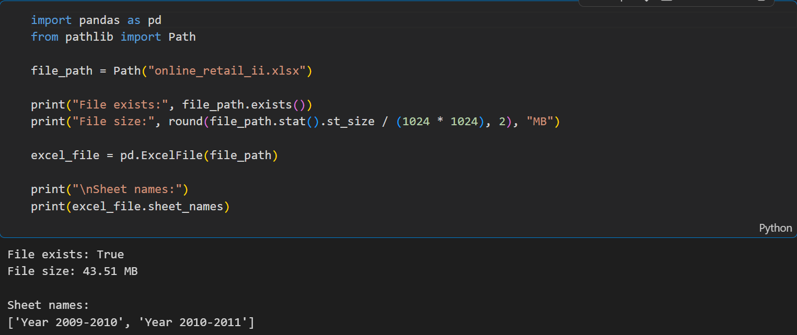

A1.1 Checking the Dataset File and Excel Sheets.

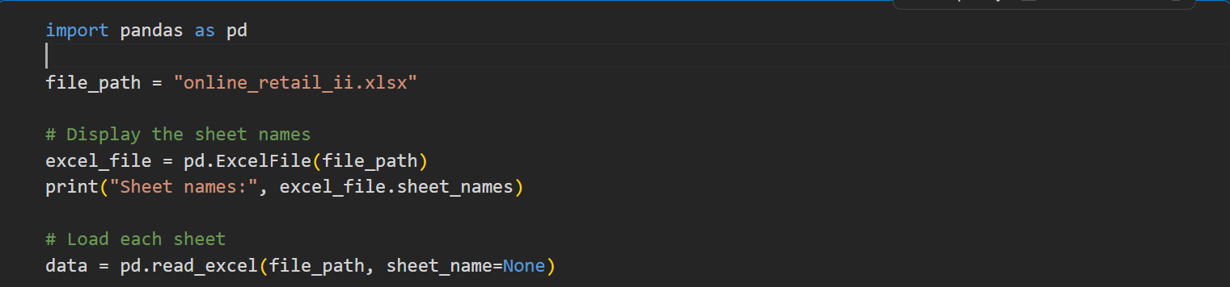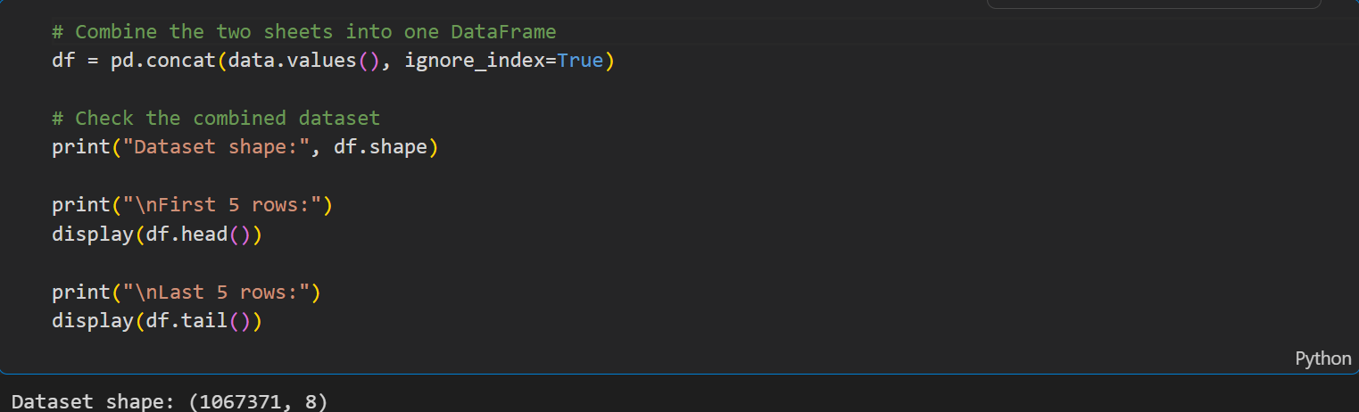

A1.2 Loading and combining the Excel sheets

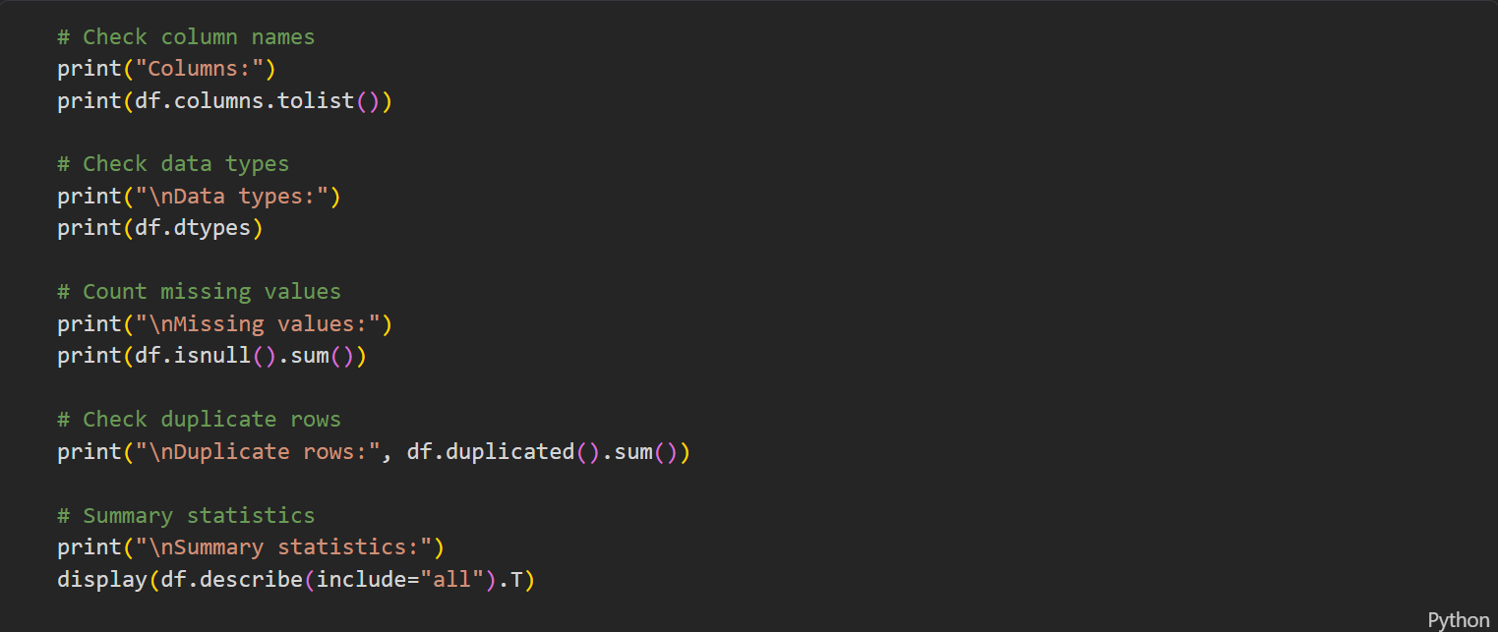

A1.3 Dataset inspection

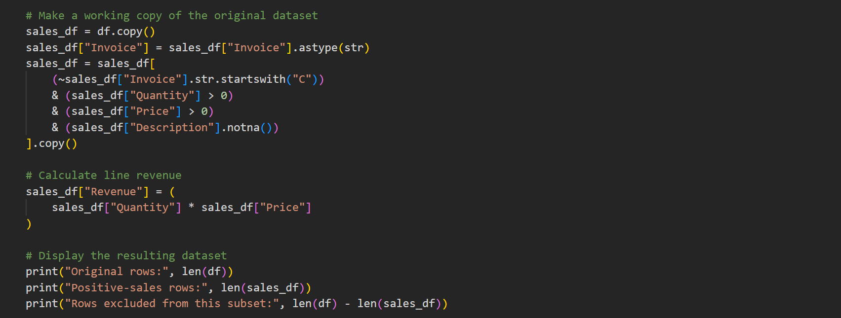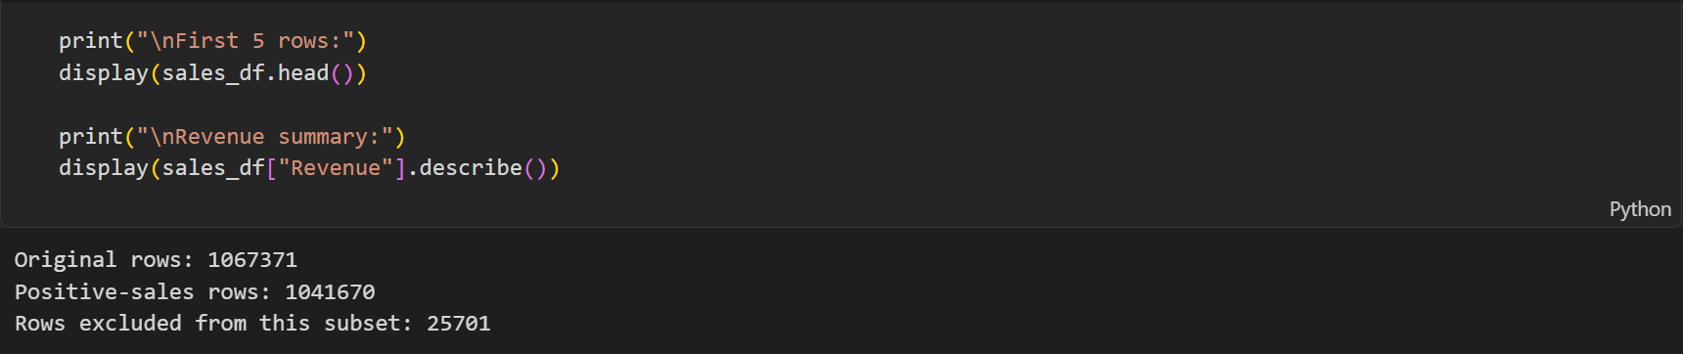

A1.4 Filtering and calculating revenue

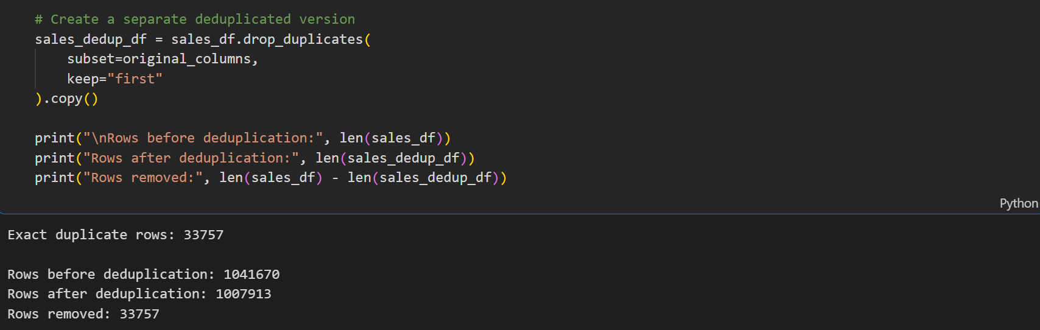

A1.5 Removing duplicate rows

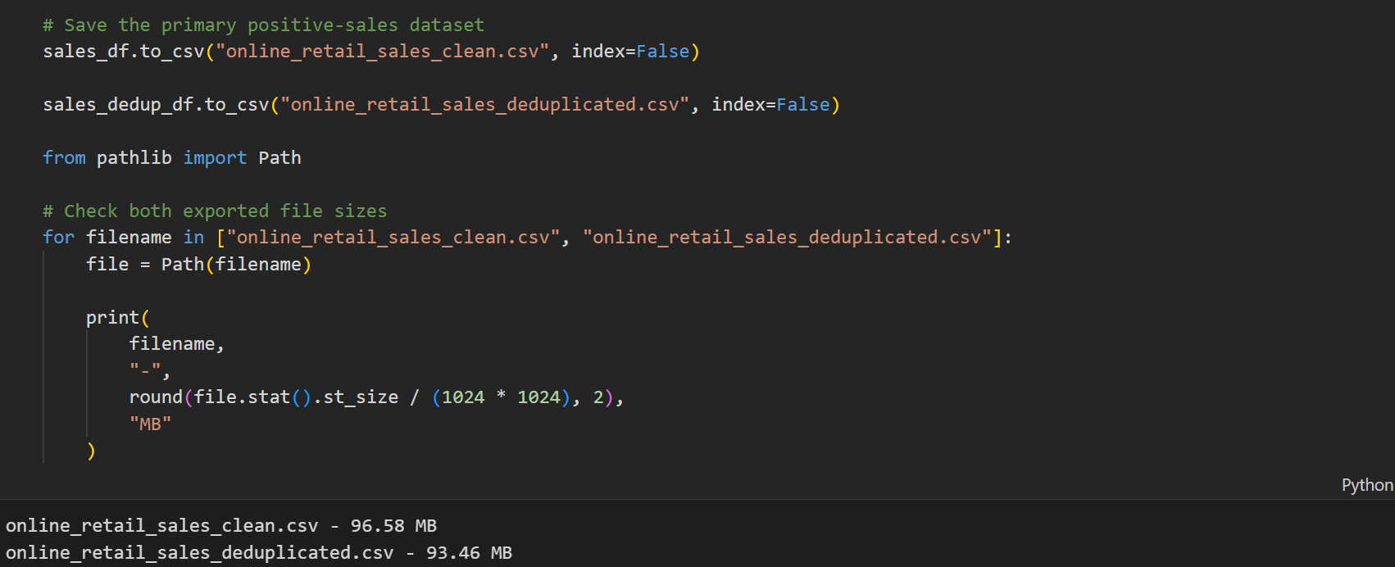

A1.6 Saving the Prepared Datase

Appendix A2: HDFS commands

A2.1 Check the HDFS directory

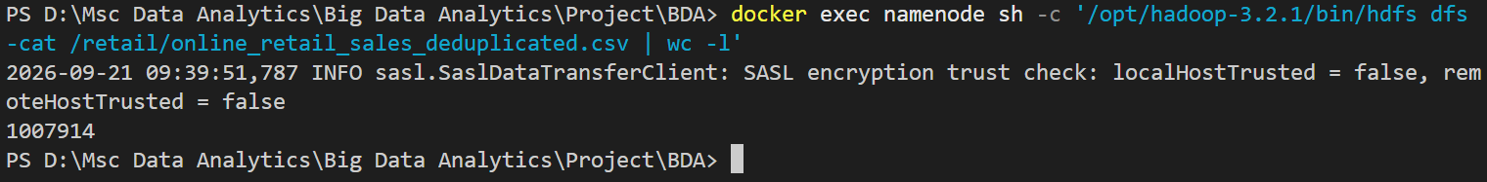

A2.2 HDFS file read and line-count verification

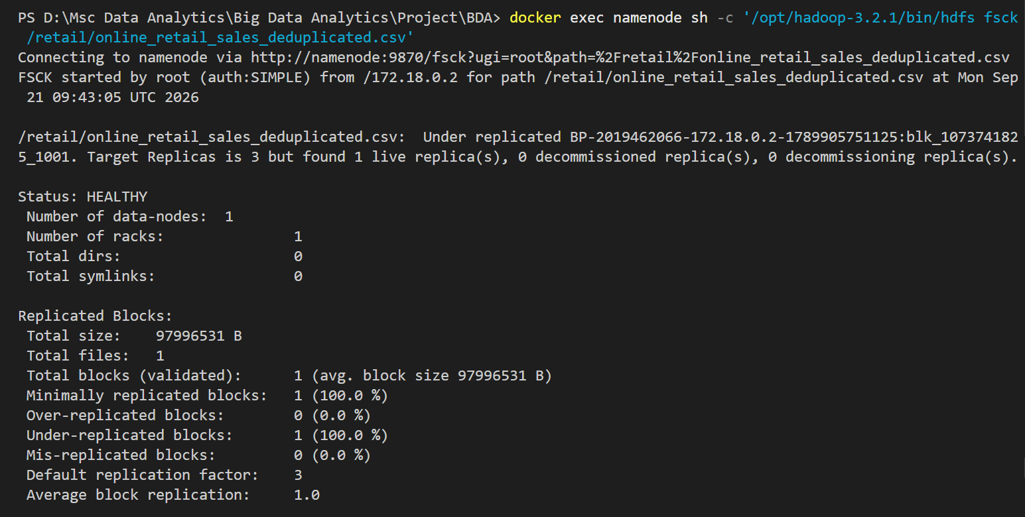

A2.3 HDFS fsck verification showing healthy file status and under-replicated blocks

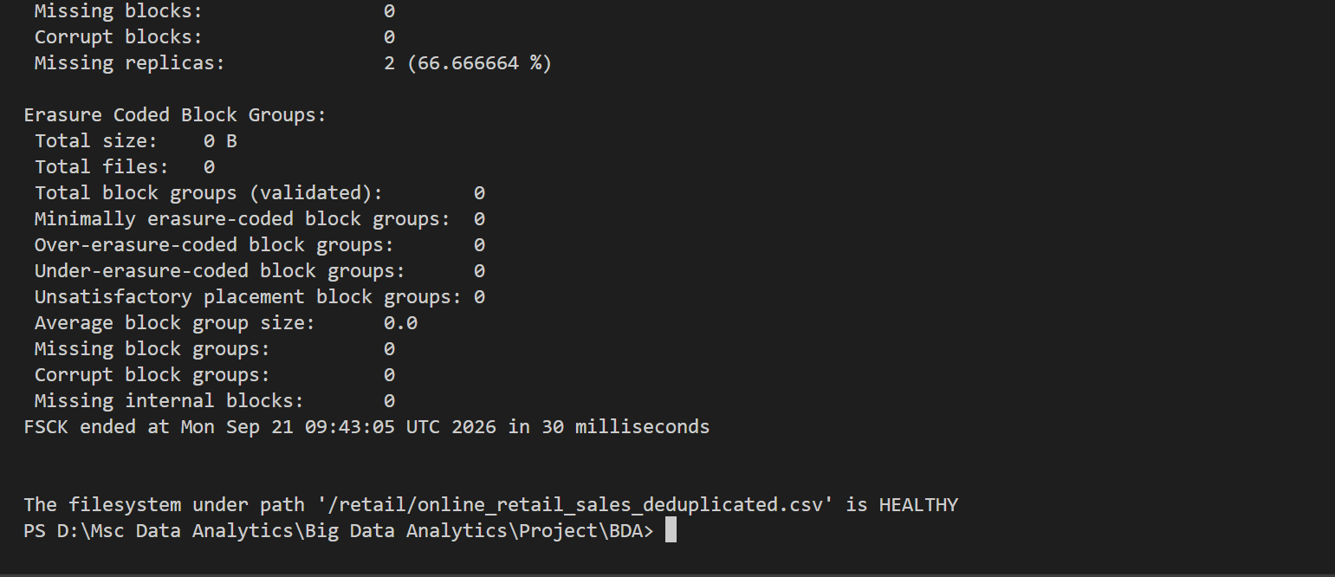

A2.4 Display HDFS block details

A.3 Verify the YARN ResourceManager

A3.1 YARN application evidence

A4: MapReduce results
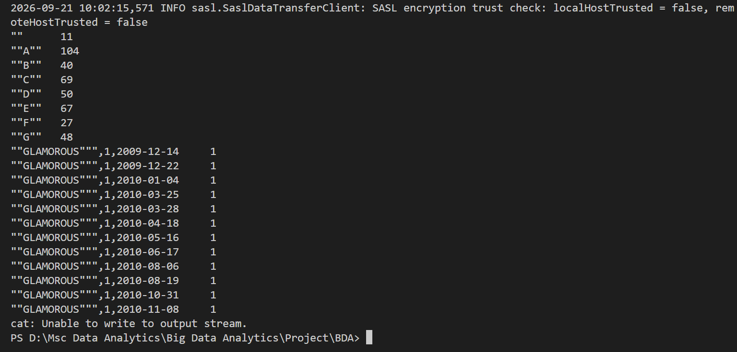

A4.1 Display WordCount output

A4.2 Display country revenue results

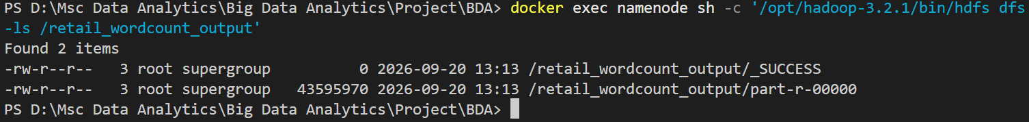

A4.3 HDFS WordCount output directory containing the success marker and reducer output file.

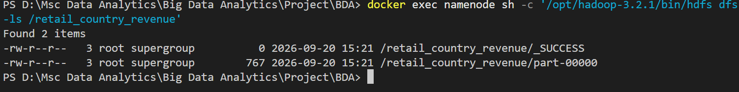

A4.4 Check the country-revenue output files

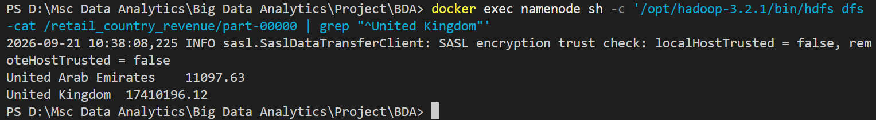

A4.5 Verify the country-revenue results

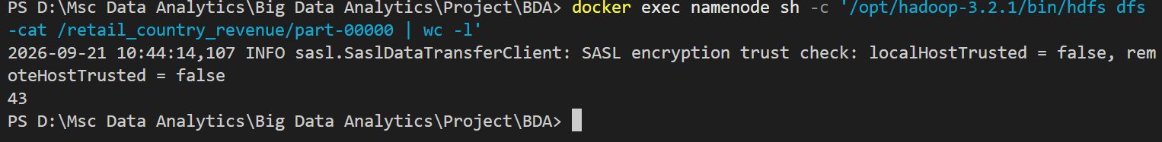

A4.6 Count the country-revenue results

A5: Verify the MapReduce output matches Python
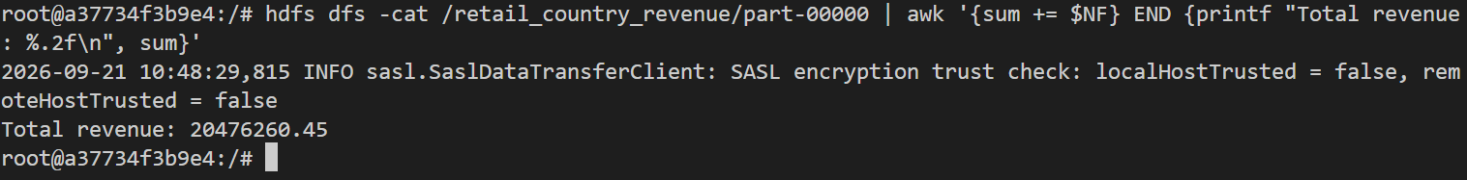

A5.1 Cross-validation of total country revenue from Hadoop Streaming against the Python result.

