



Essay / Assignment Title: Real Estate Property Management Database

Programme title: MSc Data Analytics

Name: Hemanth Kumar Thekkeillam

Year:2026

CONTENTS

CONTENTS 2
INTRODUCTION 5
CHAPTER ONE: Database Design for a Real Estate Agency 7
1.1 Background and Problem Statement 7
1.2 Aim and Objectives 7
1.3 Scope and Requirements 8
1.4 Entity-Relationship Design 9
1.5 Relational Design and Normalisation 10
1.6 Design Rationale 11
CHAPTER TWO: Database Implementation 13
2.1 Development Environment 13
2.2 Database and Table Implementation 14
2.3 Data Population 15
2.4 SQL Queries and Data Analysis 17
2.5 Joins and Subqueries 18
2.6 Reporting and Window Functions 20
2.7 Trigger and Data Integrity 21
2.8 Testing and Validation 23
CHAPTER THREE: CAP Theorem and Database Availability 24
CONCLUDING REMARKS 26
BIBLIOGRAPHY 27
APPENDIX (if necessary) 28
Appendix A: SQL Source Code 28
Appendix B: Entity Relationship Diagram 28
Appendix C: Additional Query Outputs 29
Figure C1: Property records with assigned agents. 29
Figure C2: Client transaction history. 30
Figure C3: Monthly summary of completed transactions. 30
Figure C4: Agent ranking based on completed transactions. 31
Figure C5: Transaction and property status verification. 32
LIST OF FIGURES 33

Statement of compliance with academic ethics and the avoidance of plagiarism

I honestly declare that this dissertation is entirely my own work and none of its part has been copied from printed or electronic sources, translated from foreign sources and reproduced from essays of other researchers or students. Wherever I have been based on ideas or other people texts I clearly declare it through the good use of references following academic ethics.
(In the case that is proved that part of the essay does not constitute an original work, but a copy of an already published essay or from another source, the student will be expelled permanently from the postgraduate program).

Name and Surname (Capital letters):

HEMANTH KUMAR THEKKEILLAM

Date: 20/09/2026

INTRODUCTION

The management of information concerning properties is critical for real estate companies as it is an activity that involves a number of processes. Those are keeping track of the properties, managing clients, property allocation, organizing showings, and conducting transactions. When all this information is stored separately in various spreadsheets or records, it may be hard to keep track of the data and to ensure consistency. A relational database helps organize such records and establish relationships among them.
This paper presents the design and implementation of the Real Estate Property Management Database for Berealty. The database is implemented via MySQL and MySQL Workbench. The goal of the database is to model the primary activities of a property management company functioning in Berlin. The database includes property listings, property categories, agents, clients, viewings, and real estate transactions. There is also a report function included which uses SQL queries and the trigger for changing the status of a property in case a transaction becomes completed.
A relational database is one in which data is stored in tables, and relationships exist between those tables using keys. Relational database design helps avoid unnecessary replication of data. According to Connolly and Begg (2015), the process of database design entails analyzing the information needs of an organization and converting them into a corresponding data structure. The database design used in this project will be based on the business functions outlined in the scenario of the assignment.
The main purpose of this assignment is to create a working relational database that is capable of supporting property management operations at Berealty and illustrate the practical applications of database design, SQL, data manipulation, and reporting.
Objectives include identification of system requirements, development of the entity relationship diagram, creation of relational tables and their constraints, insertion of sample data into the database, development of SQL queries for different purposes, and assessment of the importance of the CAP theorem in the context of database availability and consistency.
Methodology includes a practical database development approach. At first, the business requirements are determined and then entities, attributes, and relationships are determined and converted into relational tables. The tables are created using MySQL Workbench and populated with made up data. SQL queries run in order to get and analyse the information. Lastly, the trigger and database outcomes are reviewed to determine whether the implementation fulfills the project requirements.
The report consists of three chapters. In Chapter One, requirements and database design are provided. In Chapter Two, implementation, queries, reporting, and testing are explained. Chapter Three provides an overview of the CAP theorem in relation to the property management database.

CHAPTER ONE: Database Design for a Real Estate Agency

1.1 Background and Problem Statement
The Berealty system needs a database that will facilitate storage of information about the property and the operations that relate properties, customers, and agents. A property may be allocated an agent, belong to a customer, be seen by potential customers, and be involved in transactions. Therefore, operations create relationships which should be represented appropriately.
When information about the property is stored in several independent files, similar information regarding the same agent or customer may have to be entered several times. It is likely to cause problems if such information changes because it may be entered in one file, but not in others, leading the business to use various versions of the same information.
A relational database can address some of these challenges through the use of separate tables for storing each major type of information and linking these tables with identifiers. According to Elmasri & Navathe (2016), relational database design involves arranging data in relations and imposing certain constraints on the relationships between the records.
Berealty requires that the system enable the access of the data on properties, assigned agents, clients, viewing details, and any transaction information. Management reports are also important such as completed transactions for various time intervals.
Hence, the main challenge that is faced by the development of this project is the way to organize the connected real estate data in an organized database.

1.2 Aim and Objectives
The goal is to create a relational database for Berealty, which will be implemented in MySQL.
The goals are:
- Identification of the information necessary for property management.
- Development of an entity-relationship model that shows entities, attributes, and their relationships.
- Implementation of the entity-relationship model in relational tables with primary and foreign keys.
- Filling of the database with made-up data.
- Creating SQL queries for property, agent, client, viewing, and transaction management.
- Retrieving and analyzing the data by implementing joins, subqueries, aggregation, and window functions.
- Implementation and testing of the trigger that changes the status of the property after a transaction is done.
- Discussion of the relation between the CAP theorem and the distributed version of the system.

1.3 Scope and Requirements
The database concentrates on the fundamental operational functions of a real estate agency. There are six main operational entities included in the database: agent, client, property, property viewing, real estate transaction, and lookup tables including property type, listing type, and transaction type.
The database stores information on property address, district, property category, listing category, price, status, and agent responsible for it. Information on clients includes contact details, category, budget range, and date of registration. Agent's information includes contact details, employment date, and agent's activity status.
Information in the viewing table includes a client, the property he/she viewed, the agent who was conducting the viewing, date, viewing result and notes. Transaction table contains information on the property, client, agent, transaction category, date, amount and transaction status.
The database employs fictitious sample data for demonstrating purposes only. The database is not intended for a real-time operation and does not include functions such as payments processing, contracts storage, identification verification and up-to-date real estate market information.

1.4 Entity-Relationship Design
Entity-relationship modeling captures the basic objects within the business and the relationships among them. According to Connolly and Begg (2015), ER modeling enables the representation of data needs prior to implementation into tables.
The key entities for the Berealty database are:
Agent: Contains information about agent identification, name, email, telephone number, hiring date, and employment status.
Client: Contains information about client identification, name, email, telephone number, client type, budget constraints, and registration date.
Property: Contains information about property identification and property code, address, district, city, postal code, property type, listing type, bedrooms, bathrooms, area, asking price, status, assigned agent, and owner client.
Property Viewing: Contains information about viewing identification, property, client, agent, viewing date, result, and notes.
Real Estate Transaction: Contains information about transaction identification, property, client, agent, transaction type, transaction date, amount, and transaction status.
Property Type, Listing Type, and Transaction Type: Lookup entities storing reusable values for categories, including Apartment, House, Sale, Rent, and Reservation.
The associations depend on the business process. An agent can handle several properties, but each property is assigned to only one agent in the implemented schema. A client can be the owner of several properties, but a property can have only one client who owns the property. A property can have many viewings and transactions during its lifetime. A viewing will have one property, one client, and one agent associated with it. A transaction will also have one property, one client, and one agent associated with it. The lookup tables are used to have controlled categories for the entities. For instance, a property can refer to one property type and one listing type.
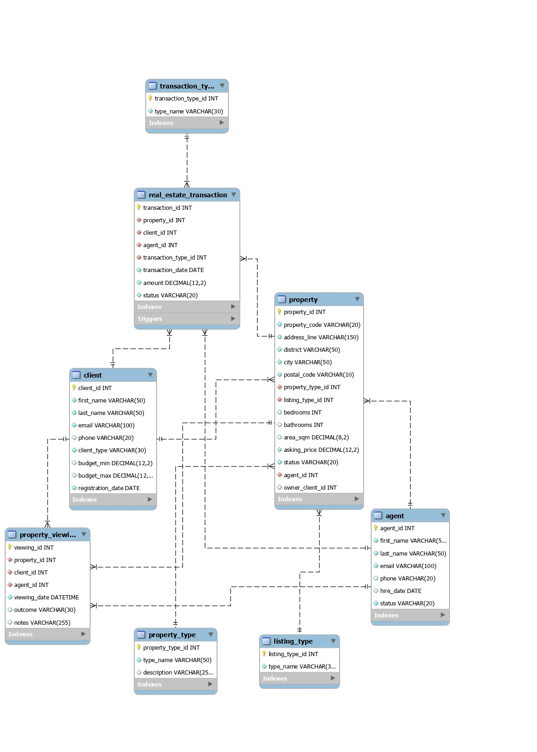

Figure 1: Entity-relationship diagram for the Berealty property management database.
The ER diagram should match the implemented database tables and their keys. This alignment is important because the conceptual model should accurately describe the database that was actually created.

1.5 Relational Design and Normalisation
ER model was translated into relational tables. Every table will have a unique identifier in the form of a primary key. Foreign keys link tables and ensure that invalid references are not created.
For instance, the table "property" will have agent_id and owner_client_id that refer to existing agents and clients in the agent table and client table. Thus, no property can refer to a non-existent agent or owner.
Normalisation is done to properly organize data and avoid any duplications. As per Elmasri & Navathe (2016), normalization enables identification of undesirable dependencies in the relations.
The design follows the key concepts of first, second, and third normal forms
First Normal Form (1NF): Each field holds only one value, not a set of values. For instance, the first name and last name of the agent are stored separately, and each viewing is entered as a separate record.
Second Normal Form (2NF): Non-key attributes must be fully functionally dependent on the primary key. The primary keys used in the main tables include a single column, for example, agent_id, client_id, and property_id, which means that their descriptive attributes are functionally dependent on record ID.
Third Normal Form (3NF): Non-key attributes must not be dependent on other non-key attributes. Category descriptions are separated into lookup tables, not stored repeatedly in operational tables.
For instance, property type name is stored in the property_type table while property type id is stored in the property table. This approach ensures that there is no need to enter the same category description for each property.

1.6 Design Rationale
The use of the relational model in the database is due to the nature of the business data as it is highly inter-related. The primary and foreign keys enable inter-relations, while NOT NULL and UNIQUE constraints facilitate the enforcement of certain data requirements.
The unique constraint has been set for email in agent and client tables to avoid the entry of duplicate email addresses in them. Identifiers and other necessary fields have been defined as NOT NULL where required. The data types used for money and decimal amount ensure that the business data contains financial values.
Use of lookup tables helps manage categories efficiently, while the use of viewing and transaction tables ensures the preservation of all activity history. This way, the same client or property may occur several times in different activity records, but the complete information about clients and properties will not be replicated.
The current design was created not only for operational purposes, but also for management reporting. However, its drawback is that some business rules, such as avoiding overlapping reservations or a single active transaction per property, cannot be enforced using constraints.

CHAPTER TWO: Database Implementation

2.1 Development Environment
The database was developed using MySQL and MySQL Workbench. MySQL Workbench enables developers to develop schemas, execute SQL commands, view tables and query outputs
A different schema called berealty was created for this project. This ensures that the schema for the current project is separated from other schemas on the local MySQL server.
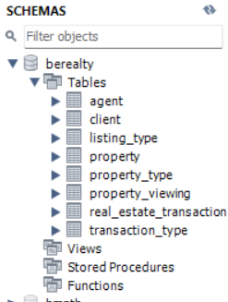
The process entailed creating lookup tables, operation tables, populating them with records, developing a trigger and running SQL queries. Data definitions and manipulations of MySQL were used to create the schema and populate it with records. MySQL documents provide details on SQL commands used in creation and modification of databases and inserting, updating and deleting records.

Figure 2: Berealty schema in MySQL Workbench.

2.2 Database and Table Implementation
The database contains the following main tables:
Table | Purpose
agent | Agent information
client | Client information
property | Property details
property_viewing | Property viewing records
real_estate_transaction | Transaction records
property_type | Property categories
listing_type | Sale or rent
transaction_type | Transaction categories

First, the look-up tables had to be designed and populated since the tables containing information about properties and transactions were dependent on them. Second, the agent table and client table were designed and populated before entering the information in the tables about properties and activities.
The table of properties includes foreign key columns that refer to property type, listing type, agent, and owner client. The viewing table refers to property, client, and agent. The transaction table refers to property, client, agent, and transaction type.
It is done in accordance with the dependencies between the tables. The referenced records should exist before adding records that have foreign key columns in them.
The transaction table includes a decimal column for transaction amount and a date column for transaction date. In addition, it has the status column that describes whether the transaction is pending, completed, or cancelled.
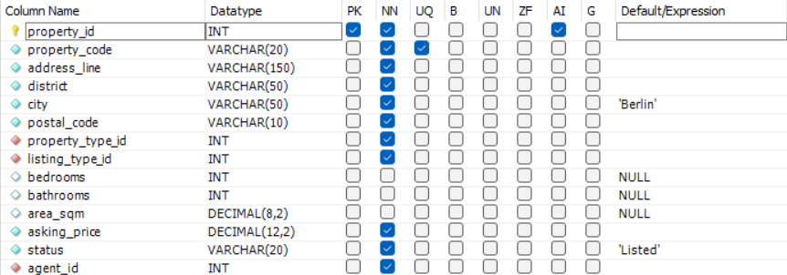
Figure 3: Main tables created for the Berealty database.

2.3 Data Population
In order to check the workability of the database, fictitious sample data was used. There are eight agents, twenty clients, twenty properties, twenty property views, and fifteen transactions in the sample data set.
Different property records are made for various districts of Berlin, such as Mitte, Prenzlauer Berg, Friedrichshain, Kreuzberg, Neukölln, Tiergarten, and Moabit. Property categories comprise apartments, houses, commercial, and offices. Listings include sale and rental.
Various statuses for the properties are used in the sample data set, such as Listed, Sold, Rented, and Reserved. It makes the queries show how the properties on different stages of the management can be distinguished.
The client data includes different client types, such as buyers, tenants, sellers, and landlords. The view records reflect relationships between the clients, agents, and properties. Transactions include completed, pending, and cancelled ones.
Use of the sample data allows testing the database and queries without risk of using the real customer data. The records are just illustrative and cannot be considered to be Berealty business transactions.
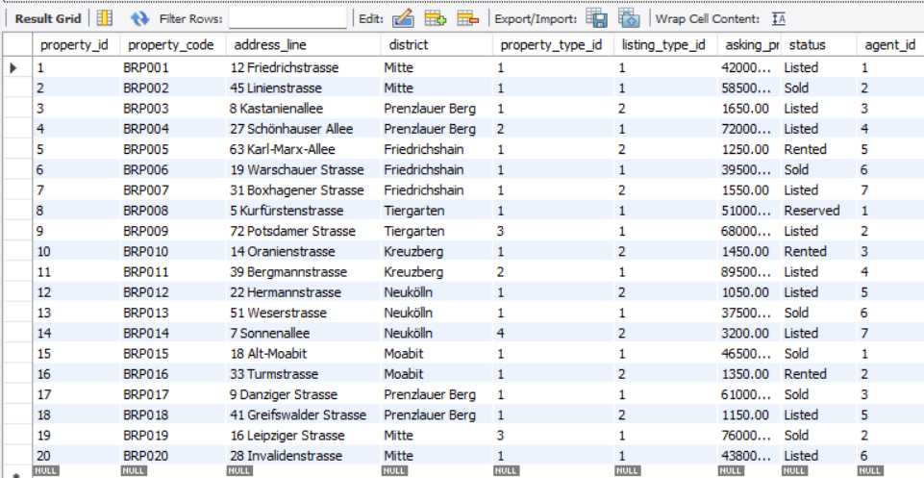
Figure 4: Sample property records stored in the database.

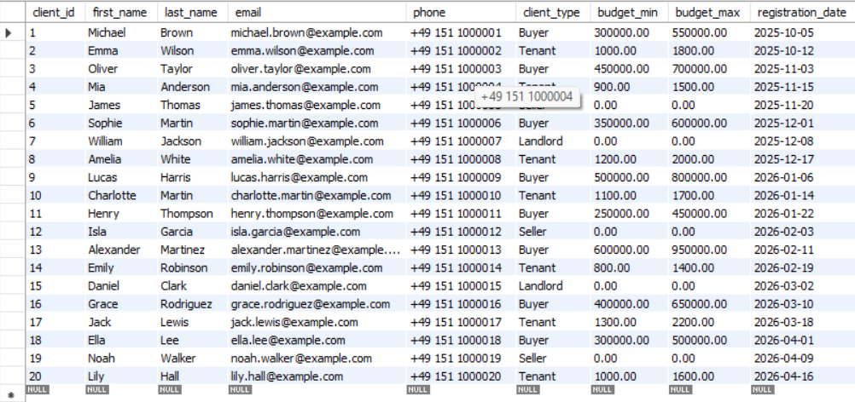
Figure 5: Sample client or agent records stored in the database.

2.4 SQL Queries and Data Analysis
SQL statements were used to extract data needed for property management and accounting purposes. SELECT statements extract data, whereas WHERE statements filter the extracted data according to specific criteria. ORDER BY command arranges records in an order selected by the user.
Property queries extract property code, address, district, asking price and status. Property query filtering properties on the basis of status helps us identify which are currently listed and reserved. It gives us a quick idea of the properties which have not been sold or rented.
Queries extracting properties for sale or rent join property table with listing type table. These queries help us understand how related data can be extracted even without storing same category in every record of the property table.
Agent Management Queries show all properties allocated to each agent. Client Management Queries show all client related data and transaction history. Viewing History Queries shows all the properties seen by the clients, agent related to the viewing and the date of the viewing.
Transaction Queries extract transaction date, transaction amount, transaction type, transaction status and property/client related information. 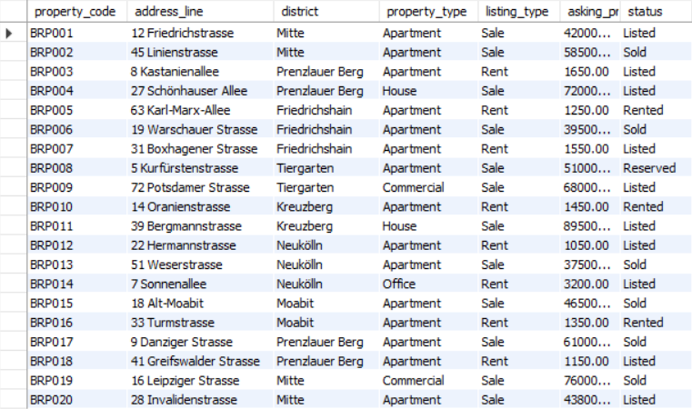
Figure 6: SQL query displaying property listing information.

Figure 7: Client transaction history showing properties and transaction details.
The results of the query for the client transaction history might include more than one row for each client because each client could have more than one transaction. This is evident from the sample data where there are two transactions in which client ID 17, Jack Lewis, appears.
Likewise, the query for the viewing history could also have multiple rows for the same property because the property may be viewed more than once and each viewing will have a viewing ID.

2.5 Joins and Subqueries
Joins are used to access data that is held within several related tables. Joins are especially important in this database due to the fact that property management operations include more than one entity.
INNER JOIN returns only records which match in the two compared tables. For instance, joining property and agent will return property records along with names of their agents.
LEFT JOIN will give all records from the left table even if there is no record at all in the right table. Thus, this kind of join may help identify the agents which do not have any property. In case of implementation of the data, there will be an agent without a property in the results with NULL values in property fields.
RIGHT JOIN will give all records from the right table regardless of the existence of the record in the left table.
CROSS JOIN results in all possible combinations between the records in two tables. Here, the combination of eight agents and two listing types results in sixteen combinations. This is an example of the Cartesian product which can come in handy when we need to generate combinations for analysis purposes even though it is rarely used to directly find property assignments.
Subqueries are used in case of comparison of the data to the calculated ones. One query finds those properties where the asking price exceeds the average asking price from the property table. Therefore, we can find out the relatively expensive properties without manually entering the average.
The query provided us with twelve properties. This is correct since the query itself is used to find the records that have the asking price above the average of the dataset.
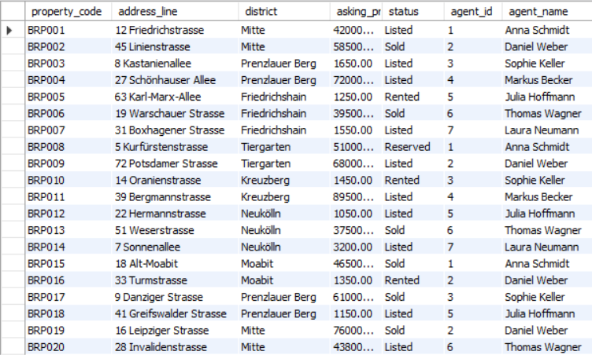
Figure 8: Example of a join combining property and agent information.

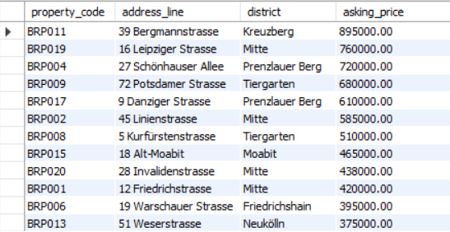
Figure 9: Properties with asking prices above the dataset average.

2.6 Reporting and Window Functions
The aggregate functions enable management reporting because they summarize several rows. For this project, the queries for counting properties depending on their status, summary of transactions depending on their types and transaction values based on agents have been performed.
The monthly, quarterly and yearly transaction reports group the transaction rows depending on date period. Such reports are helpful to show how the company can track its activity over time. The reports divide the completed transactions from pending and cancelled records so that the results show the selected transaction status.
The monthly completed transaction report can be used to analyze the number and total amount of the completed transactions in every month. Quarterly report is divided into three-month periods whereas yearly report shows the whole picture.
Window functions allow analyzing data by calculating values among the related rows without losing rows. In MySQL there are functions like ROW_NUMBER(), RANK() and aggregate functions with OVER clause (Oracle, n.d.).
Ranking functions are utilized in the project in order to rank properties based on their asking prices and agents based on their transaction amounts. Running Total is one of the queries that shows how amounts can be accumulated based on the order of records.
The example of using the ranking function ROW_NUMBER() shows how we can number records in a certain order. These ranking functions show how reporting capabilities in SQL can be more advanced than just filtering.
However, the practicality of any ranking or aggregation depends greatly on the chosen data and groupings.
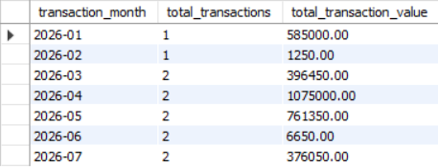
Figure 10: Transaction summary grouped by reporting period.

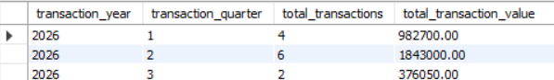
Figure 11: SQL window function used to rank or analyse records.

2.7 Trigger and Data Integrity
Trigger was used to automatically update the status of the property once the transaction status becomes completed. The trigger is set to work on the real_estate_transaction table and it works after an update.
Once the transaction status becomes Completed, the status of the property is updated based on the transaction type. Once the transaction becomes a sale, the property is sold. When it becomes rental, the property becomes rented and when it is reservation, it becomes reserved.
The trigger is supposed to run once the transaction status goes from incomplete to completed. This helps prevent updating the same record multiple times in case the transaction status is changed again but remains completed.
During testing, the transaction number 13 became completed and its corresponding property BRP013 became sold.
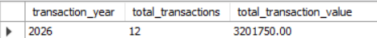
Figure 12: Trigger used to update property status after transaction completion.

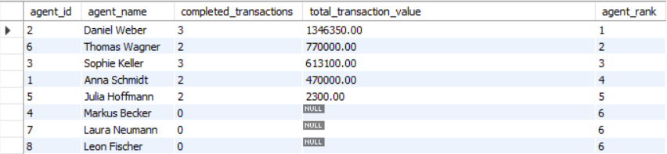
Figure 13: Property status after the trigger test

The trigger ensures consistency between the status of a transaction and the status of the property, although it is not designed to account for all situations in the real business environment. The trigger runs after an update rather than automatically when there is an insert of an already complete transaction.
The trigger also depends on the currently available transaction types. In case of any changes in lookup transaction types, the logic behind the trigger should be analyzed.

2.8 Testing and Validation
Testing the database was done through the execution of the SQL queries and checking their result grids in the MySQL Workbench. The testing verified if there was retrieval of the records through the supposed relationships, as well as updating of the property status by the trigger.
The sample record counts expected were eight agents, twenty clients, twenty properties, twenty viewings, and fifteen transactions. These numbers give a simple verification if the sample records have been added to the database.
The query for the property listing resulted in eleven records where ten records had Listing status while one record had Reserved status. The above results came after the trigger test where the status of BRP013 was changed from Listing to Sold.
Since the history of client transactions included multiple rows for each client having made several transactions, and the history of viewing included several rows of views of the same property, these results can be considered normal for a relational database.
According to the test results, the database meets the needs of primary retrieval and relationships in the example. However, the testing was carried out using only the small sample of data and didn’t take into account other factors such as performance and security.
Figure 14: Final validation of the sample record counts.

CHAPTER THREE: CAP Theorem and Database Availability

The CAP theorem comes into play when one is trying to envision how a database can work on several interconnected systems. The CAP theorem is about the compromise of consistency, availability, and partition tolerance within a distributed data system. It was introduced by Brewer (2000), and CAP is often associated with the design of distributed systems.
Consistency implies that all operations follow the same view of the data. Availability is when the request to functioning nodes gets responded to. Partition tolerance is the capability of a system to function despite communication failure between some parts of the distributed system.
It is said that, if there is a network partition in a distributed system, then the system cannot guarantee the availability and consistency for every request. One should make design choices when such network partitions happen.
In terms of Berealty, the consistency is a requirement since the transactions and properties are related. The system should not show inconsistent status of the same property to various users or nodes in the system. An agent or a client may base their decisions on wrong property status.
Availability is yet another aspect that should be considered as well. The agent might need to look up the information about a property, the client, or the viewing schedule while working normally. In case of database unavailability, these actions would be disturbed.
At the moment, the system uses a local instance of MySQL and does not represent any distributed architecture and, thus, does not show any trade-offs between CAP. Nevertheless, the CAP theorem is considered here as a potential design choice that might be made when creating the next version of the system.
In case Berealty started to operate using several offices with replicated databases, the network failure would influence the communication between database nodes. At that point, the system would have to decide on rejecting or delaying certain actions in order to keep the system consistent, or perform the action despite the temporary inconsistency of replicas.
For example, a reservation of the property is such a business transaction which can be performed inconsistently. Two disconnected nodes accepting reservations of the same property would make the system consist of inconsistent data records at that very moment.
This example highlights the necessity of associating CAP concerns with business needs instead of looking at it from an abstract point of view. Property status, completion of the transaction and reservations are sensitive to any inconsistent updates. Thus, the acceptable trade-off would rely on what the effects of denying requests for some time versus accepting requests which could lead to conflicts would be.
It is important to understand that according to CAP, not all databases will be forced to select two properties permanently. What matters most about CAP theorem is the behavior of distributed systems under partitions. This is not a problem that the local Berealty faces but the theorem is helpful when planning a future multi-site system.

CONCLUDING REMARKS

In this assignment, a relational database of the fictitious company Berealty, a real estate property management firm, was designed and implemented. It was necessary to structure and organize data about property, agents, clients, viewing and transactions.
The database was created according to the entity-relationship model and converted into relational tables. Relationships were established through the usage of primary keys, foreign keys, unique constraints and not nullable fields. Tables with lookup values were included for property, listing and transaction types and separate viewing and transaction tables were used to keep history of activities.
Implementation was made in MySQL Workbench. Fictitious sample data was entered in order to show main actions of the database. SQL queries were created to select property listing, agent assignments, transaction history of clients, viewing data and transaction details. Joins and subqueries were used to select related data and compare property prices with the average price of the dataset. Aggregate and window functions were used for reporting and ranking.
Trigger testing showed that a modification of the transaction to Completed would automatically alter the property status as well. This means that consistency can be provided for two inter-related entities in the database, although the trigger does not cover all possible business rules or transaction cycles.
CAP theorem discussion illustrated how consistency, availability, and partition tolerance might be considered important if Berealty decides to switch to a distributed database architecture in the future. Although there is no network partition shown in the current implementation, it shows what aspects can be considered in future development.
Generally speaking, the project illustrates an application of relational database modeling, SQL queries, and data manipulation as well as reporting in practice. In terms of its results, the database created serves as a basis for more complex application. Future development may include more complex validation rules, transaction conflict resolution, role-based access control, automatic backup, and performance testing using a bigger set of data.

BIBLIOGRAPHY

Brewer, E.A. (2000) ‘Towards robust distributed systems’. Proceedings of the Nineteenth Annual ACM Symposium on Principles of Distributed Computing, Portland, Oregon, pp. 7–10.

Connolly, T. and Begg, C. (2015) Database Systems: A Practical Approach to Design, Implementation, and Management. 6th ed. Harlow: Pearson.

Elmasri, R. and Navathe, S.B. (2016) Fundamentals of Database Systems. 7th ed. Harlow: Pearson.

Oracle (n.d.) MySQL 8.0 Reference Manual. Available at: (Accessed: 18 September 2026).

APPENDIX (if necessary)

Appendix A: SQL Source Code
This Appendix consists of the SQL scripts used in the creation and testing of the Berealty Real Estate Property Management Database. These scripts include database commands, example data, queries, reports, as well as the trigger for updating the property status upon completion of the transaction.
These SQL scripts have been provided as a record of this implementation process. This document is not a script for the reconstruction of the entire database.

Appendix B: Entity Relationship Diagram

Appendix C: Additional Query Outputs

Figure C1: Property records with assigned agents.

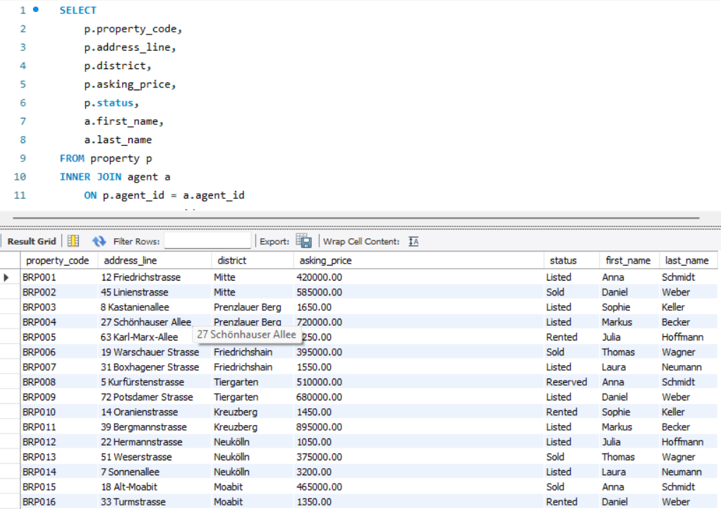

Figure C2: Client transaction history.
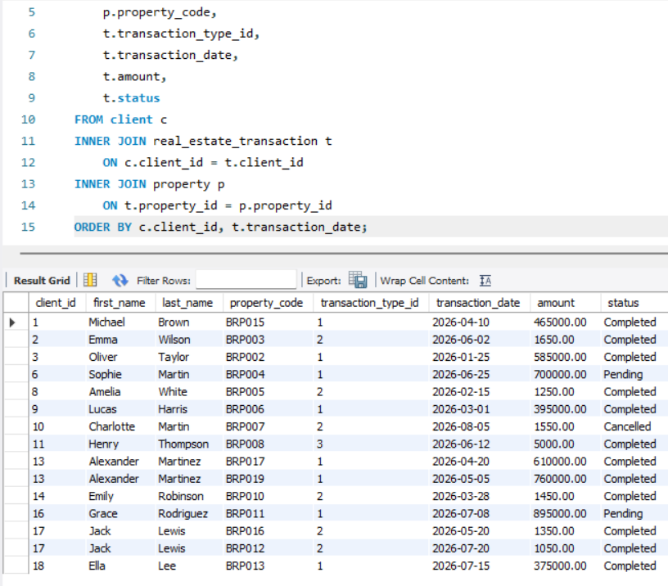

Figure C3: Monthly summary of completed transactions.
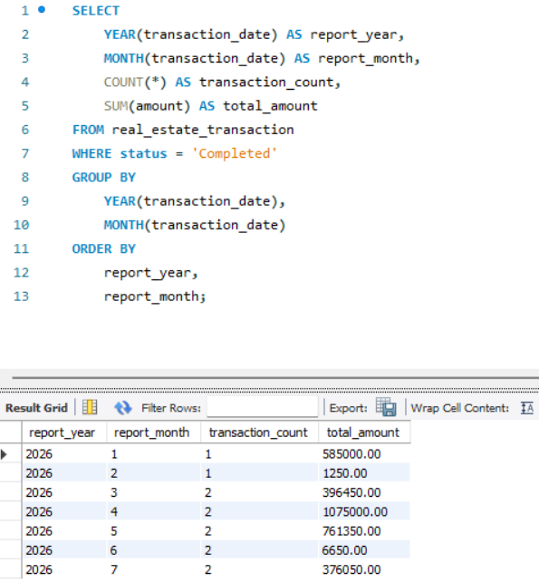

Figure C4: Agent ranking based on completed transactions.

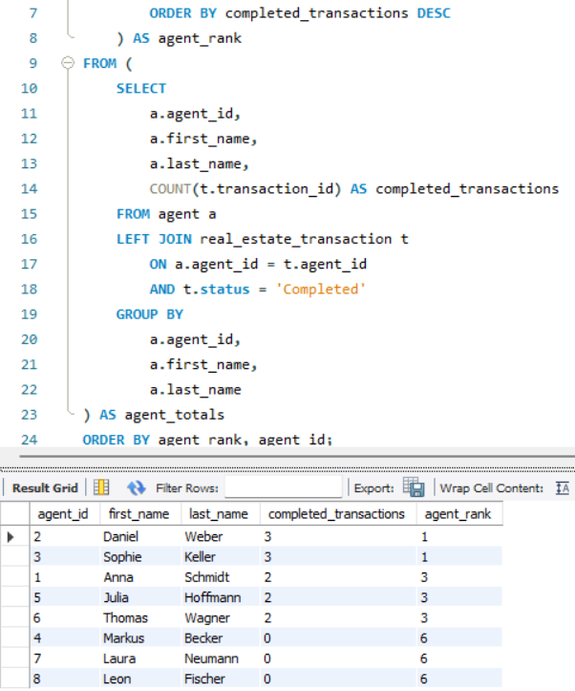

Figure C5: Transaction and property status verification.
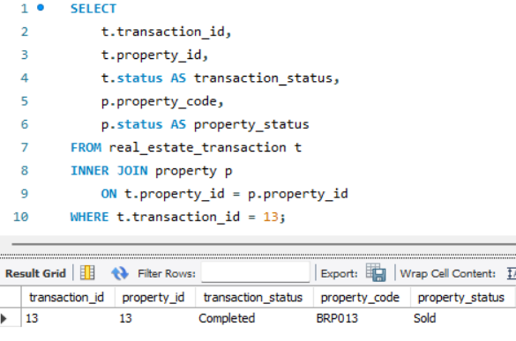

LIST OF FIGURES

Figure 1: Entity-relationship diagram for the Berealty property management database. 10
Figure 2: Berealty schema in MySQL Workbench. 13
Figure 3: Main tables created for the Berealty database. 15
Figure 4: Sample property records stored in the database. 16
Figure 5: Sample client or agent records stored in the database. 16
Figure 6: SQL query displaying property listing information. 18
Figure 7: Client transaction history showing properties and transaction details. 18
Figure 8: Example of a join combining property and agent information. 19
Figure 9: Properties with asking prices above the dataset average. 20
Figure 10: Transaction summary grouped by reporting period. 21
Figure 11: SQL window function used to rank or analyse records. 21
Figure 12: Trigger used to update property status after transaction completion. 22
Figure 13: Property status after the trigger test 22
Figure 14: Final validation of the sample record counts. 23

