Introduction

Lung cancer is a malignant tumor originating from the bronchial mucosa or glands of the lungs, and is one of the most life-threatening malignant tumors to human health and life. In the past 50 years, many countries have reported that the incidence rate and mortality of lung cancer have increased significantly. The tissue type of lung cancer is closely related to its etiology, biological characteristics, clinical manifestations, prognosis, and treatment response. It is important to determine the tissue type of lung cancer before formulating a treatment plan. Lung cancer can be divided into small cell lung cancer (SCLC) and non-small cell lung cancer (NSCLC), with over three-quarters of patients suffering from non-small cell lung cancer. The histological subtypes of non-small cell lung cancer can be further divided into adenocarcinoma (ADC) and squamous cell carcinoma (SqCC). There are different clinical treatment methods and prognostic effects for different subtypes. Accurate classification of lung cancer subtypes helps to develop better clinical treatment methods and strategies, and also provides patients with more suitable diagnosis and treatment plans.

The rapid advancements in deep learning have brought about significant enhancements in the processing of image data through the emergence of convolutional neural networks. These networks have revolutionized image classification and pattern recognition by providing efficient end-to-end systems. In this study, our focus is on constructing a simple yet highly accurate model. Therefore, we have selected ResNet-18 as the foundational model for our improvements. This dataset we used is sourced from Kaggle. The dataset is divided into three categories, namely Lung benign tissue (Lung_n), Lung adenocarcinoma (Lung_aca), Lung squamous cell carcinoma (Lung_scc). According to transfer learning, we use ResNet-18 and analyze the depth characteristics of the image using a small sample dataset, which is divided into training sets and independent test sets. The grayscale values of the regions of interest in the images are standardized. Initially, we train the source model using benign and malignant data of pulmonary nodules. Subsequently, we apply transfer learning to the data of pulmonary nodules by inputting SqCC and ADC images. These steps enable us to construct an end-to-end classification model. Finally, we validate the model using independent test sets. The result of experiment can achieve an accuracy rate of 88.03% on the testset. The F1 score can reach 0.8814.

The research shows that by using ResNet-18 during training, we can avoid issues like gradients vanishing or exploding. This helps the network converge faster and improves the accuracy and generalization of the model. Applying this network can be highly beneficial in assisting doctors with diagnosing lung cancer, ensuring that patients receive timely treatment.

RESNET-18

For traditional CNN models, as the depth of network increases continuously, the training error does not decrease but instead increases. This is mainly because in the training process of networks based on random gradient descent, the multi-layer back propagation of error signals can easily cause gradients to vanish or explode. In order to effectively solve this decline phenomenon in the network, the ResNet network structure was proposed. This structure is relatively easy to optimize, and its network performance far surpasses traditional network models.

The main feature of ResNet is the introduction of the concept of the residual block, as shown in Figure 1, which is used to solve the problems of gradient vanishing and gradient explosion in deep convolutional neural networks. In residual blocks, shortcut connections can directly connect inputs to outputs, allowing the network to learn residual information and perform better in feature extraction and processing.

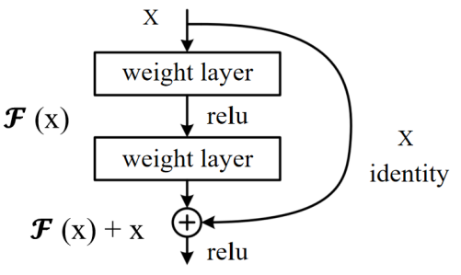

Fig. 1. The structure of the residual block

As shown in Figure 2, each module in this ResNet model has 4 convolutional layers. Adding the first 7x7 convolutional layer and the last fully connected layer, there are a total of 18 layers. Therefore, this model is commonly referred to as ResNet-18. ResNet-18 is a very classic and effective deep convolutional neural network model with excellent feature extraction and classification capabilities, which can be applied to computer vision tasks such as image classification and object detection.

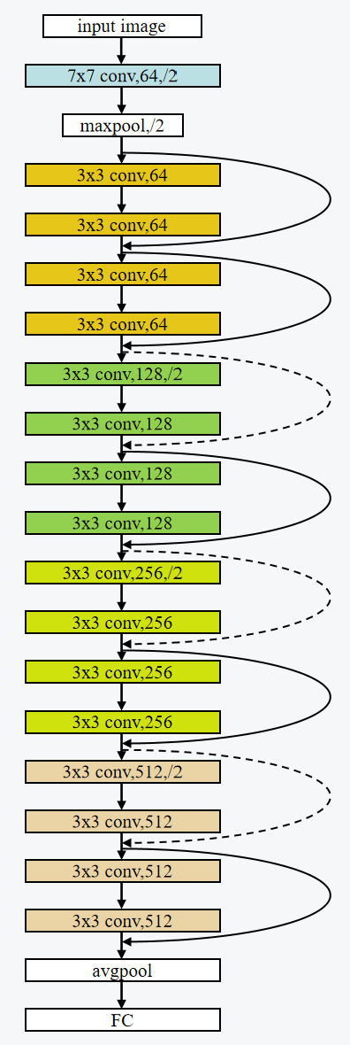

Fig. 2. The structure of ResNet-18