|  |
| --- |
| COMS 309 Spring 2024 – Group MK1_4 |
| Fiesta Fetch |
| Screen Sketches |

|  |
| --- |
| Lucas Schakel, Benjamin Steenhoek, Harsh Modi, Benjamin Bartels 2-15-2024 |

# Actors

## Admins: Have the privilege to:

* Create, modify, or delete user accounts for building staff and other administrators
* Reset passwords and manage account access
* Add new apartment or dorm buildings to the system
* Configure and customize notification settings, such as the content and timing of package arrival notifications.
* Manage security-related settings, such as passwords policies and account lockout thresholds

## Desk Employee / Staff: Have the privilege to:

* Scan packages into the database using the phone camera
* Mark a package as delivered
* Mark package as picked up
* Search for users in database
* Edit resident information
* Verify a user by their pickup code

## Residents: Have the privilege to:

* View packages ready to pick up
* View when the package was scanned in
* View pickup code to show at front desk
* View package history of previously picked up packages
* Add occupants to their household
* Change profile and app settings
* Get code to pick up packages
* Give feedback for the app

# Non-Functional Requirements

* Implementation of user authentication and authorization mechanisms to ensure that only authorized personnel can access sensitive information or perform certain actions.
* Residents should receive timely notifications when packages are received and when they are available for pickup.
* The scanning feature should have a high level of accuracy to correctly identify and log packages.
* The application should provide quick response times for actions like scanning packages, notifying residents, and updating package status.
* The system should be scalable to handle an increasing number of users, packages, and buildings.
* The application should have a user-friendly interface that is easy for both residents and building staff to use without extensive training.
* Implement comprehensive logging to track activities within the app, aiding in debugging, auditing, and compliance.

# Tables and Fields

## User Information

* Stores information about the user/manager/admin such as:
  + Name
  + ID -> Unique number used as key
  + Age
  + Address/Building Number
  + Email
  + Phone
  + Username/Password
  + Privilege level (either User, Manager, or Admin)

## Package Information

* Scanned (or manually entered) in by managers, tracks data about packages such as:
  + Package ID (some kind of unique ID, this is the key)
  + Tracking Number (tied with carrier)
  + Carrier (i.e. FedEx, UPS)
  + Age (stored as initial scan date)
  + Address/Name of Recipient
  + Foreign Key: User ID (links the package to the user)

## Building Information

* Configured by admins, tracks data about buildings such as:
  + Building Name
  + Address
  + ID -> Used as a key

# Screen Flow Diagram

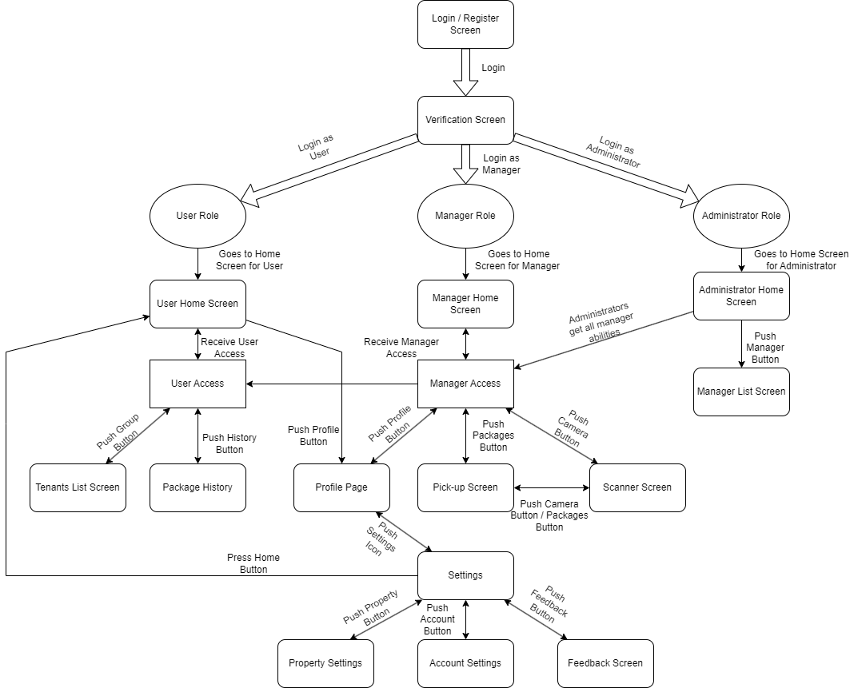

# Home Screen

Benjamin Steenhoek

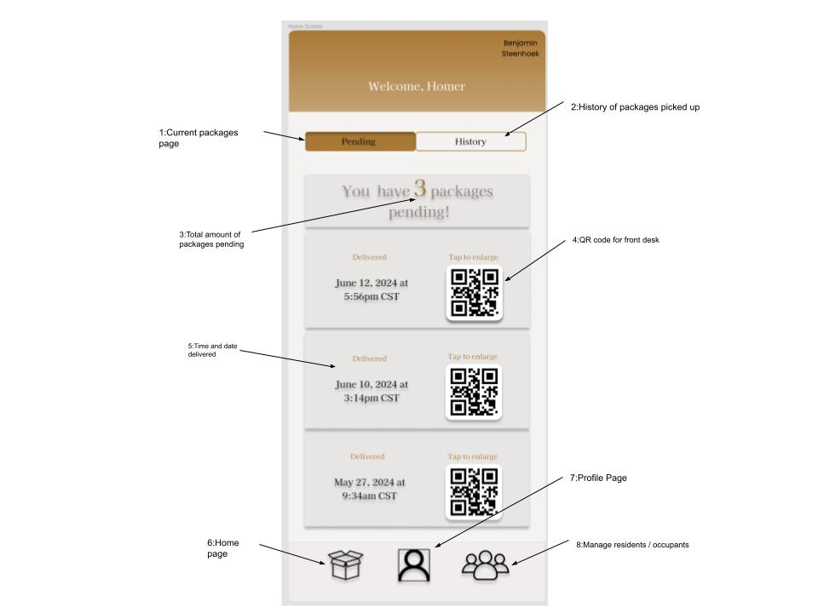

Figure 1: Home Screen

This screen allows the user to check if they have any packages that are ready for pickup. It will have several details about the packages that are ready for pickup. The page is structured to intuitively look from top to bottom with the first thing being a welcome message with your name. You can then choose to see pending packages or a history of packages that were picked up already. As you look down, the packages that are ready for pickup are listed by date with the newest notifications at the top.

This screen lets the user choose to see pending packages (1), or switch to package history (2), see total amount of packages ready to pickup (3), get a code to show the front desk to pickup their package (4), see time of delivery (5), and allow to switch between the other screens (6)(7)(8).

# Profile Screen

Benjamin Steenhoek

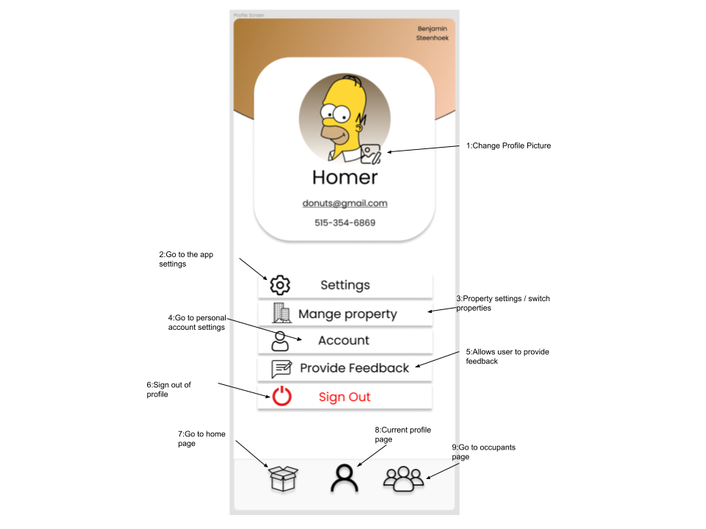

Figure 2: Profile Screen

This screen allows users to see their personal information and change account and app settings. The screen is structured so users will look from top to bottom, starting with their profile picture and personal information. As you look down, you will see some other options such as app, property, and account settings.

This screen allows the user to change their profile picture (1), open the app settings (2), change property settings (3), change account settings (4), provide feedback for the app (5), sign out of their profile (6), and navigate between the main screens (7)(8)(9).

# Package History Screen

Harsh Modi

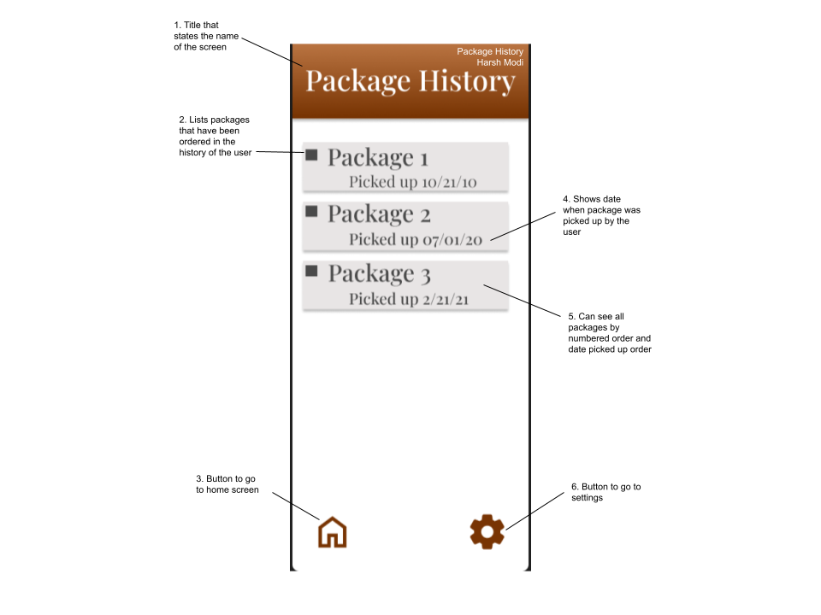

Figure 3: Package History Screen

The Package History Screen allows for users to see all of their packages that they have had delivered to their apartment complex in the time that they have been using the app. This screen is easily accessible when the user goes to click on the package history button on the home screen.

This screen shows that 1. you are on the package history screen, 2. each package ordered and delivered, 5. the order of time it was picked up, 3. the date of each package as it was picked up, and 3. the home and 6. buttons to go to each respectively.

# Tenants Page Screen

Benjamin Bartels

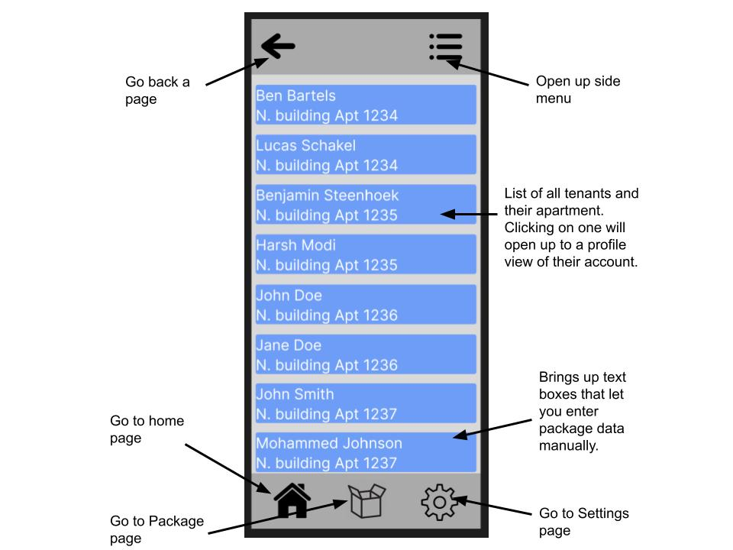Figure 4: Tenants Page Screen

The tenants page is something we’re still developing what we want it to be. The two current ideas are that its whoever is living in your household editable by the user, or it’s the list of people registered to the apartment only accessible from by the manager or admin(s). The first idea would lead us to create a super-user level for the head of household.

# Manager Screen

Lucas Schakel

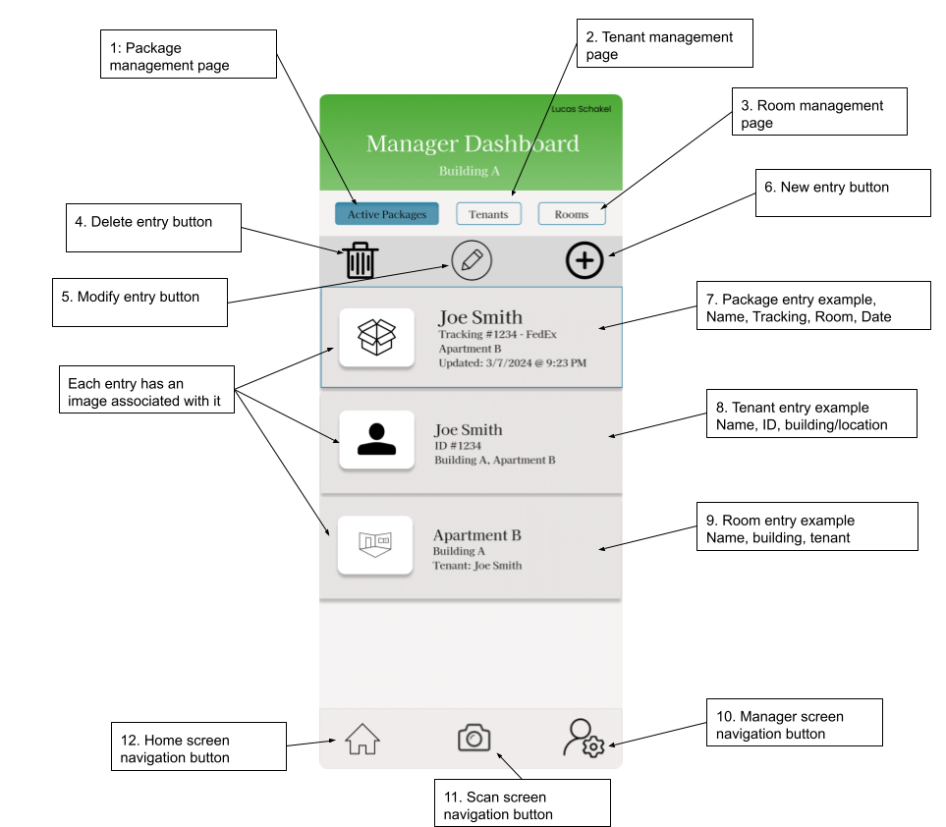

Figure 5: Manager Screen

The manager screen is the default dashboard upon login to a manager account. The manager dashboard includes options to manage the tenant database, manage packages that are ready to be picked up, and configure rooms within the building. The layout includes a top navigation that has buttons to filter which data the manager needs, by packages, tenants, or rooms. The layout also features a scrollable list of entries in the selected category, controlled by the filter buttons above. Each entry has its own image and data and is individually selectable. An additional button bar above the data view has options for manually editing, deleting and adding entries. At the bottom of the screen, the layout includes a “scan” button, which leads to the scanner screen, along with a home button, and a manager screen button (this button is kept in so the UI keeps a consistent look across all screens).

# Admin Screen

Lucas Schakel

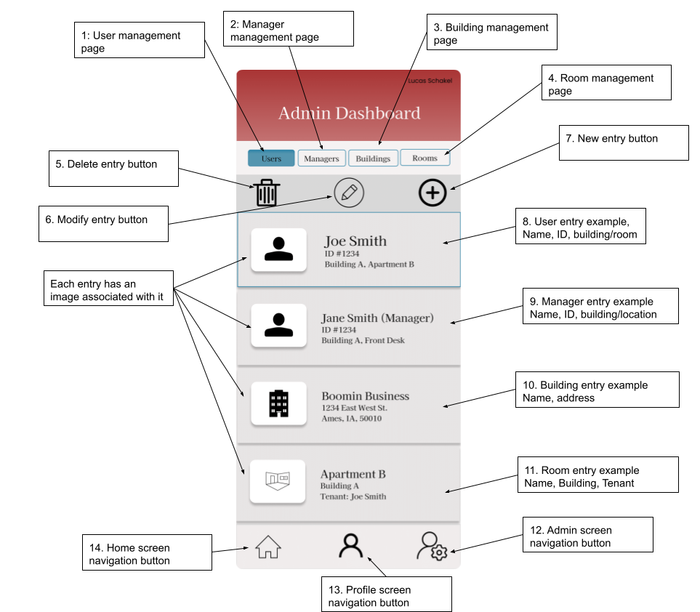

Figure 6: Admin Screen

The admin screen is visually similar to the manager screen, with more emphasis for editing data, rather than scanning and package management. The purpose of the admin screen is to provide an overlay for creating, editing, and deleting user, manager, building, and room data. The top navigation buttons (labelled 1 through 4 in the drawing) all control the data viewer, with each button allowing control over what the admin is seeing. So, if the admin wants to change something in the buildings table, they would select the “Buildings” button, and it should update the entries to contain buildings. Each entry in the list should be selectable, allowing the admin to edit one entry at a time. The bottom navigation is similar to the manager’s, with the addition of the profile screen instead of the scan screen.

# Pick-up Screen

Harsh Modi

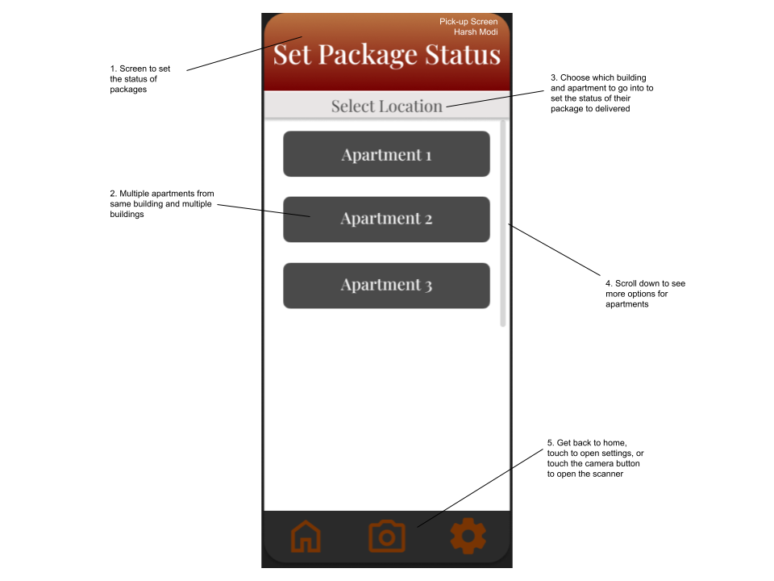

Figure 7: Pick-up Screen

The Pick-Up Screen is how a manager/administrator can mark a package ready for pick-up. The user of this screen selects the location in which the tenant resides so that the tenant can be notified that their package has arrived. Then, they can scroll down the list of tenants in the apartment until they find the name they are looking for. Lastly, they notify the resident that a package has arrived for them to pick up, thus completing the process.

This screen 1. signifies its function to set the status of a package. It does this by 2. selecting a location, 3. choosing from multiple apartments and 4. scrolling down to see more apartments as needed, and finally getting to choose the tenant from the apartment. It also has 5. navigation buttons to go back to home, to settings, or to open the scanner to scan the package.

# Scanner Screen

Benjamin Bartels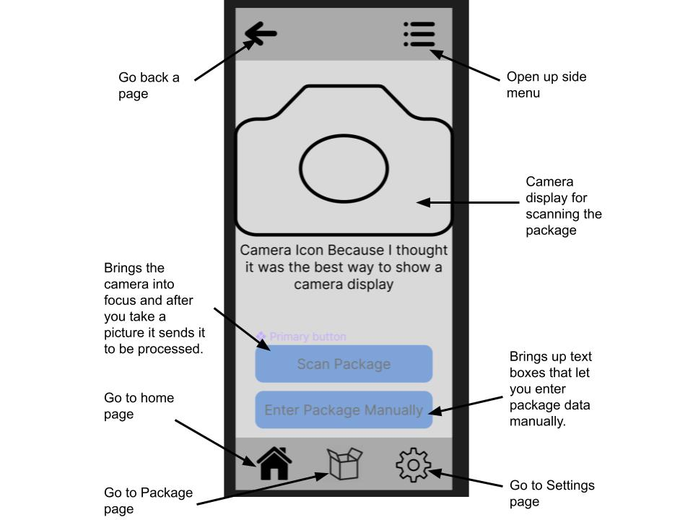

Figure 8: Scanner Screen

The Scanner screen was designed and intended only to be used by the manager and admin level users. It’s main feature of the scanner page is the camera, the camera takes a picture of the package label, and sends it to be processed. After it is processed it comes back to the person who scanned it, for confirmation, after confirmation it is sent to the data base. A secondary feature that we added for a “just in case” scenario was the “Enter Package Manually” feature. It is for if the label is damaged or smudged, but the human eye can still pick up on what it is on it, then the data can be entered manually.