**# liriBot**

**Concert this: (Enrique Iglesias)**

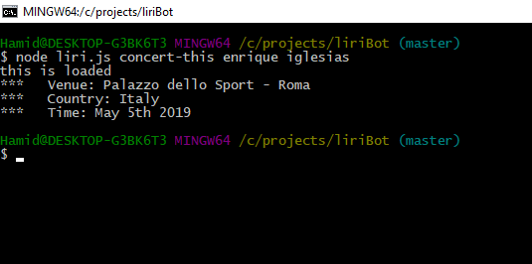

**Spotify this song: (I want it that way)**

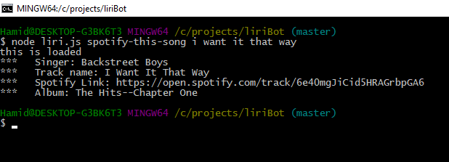

**Movie-this: (no country for old men)**

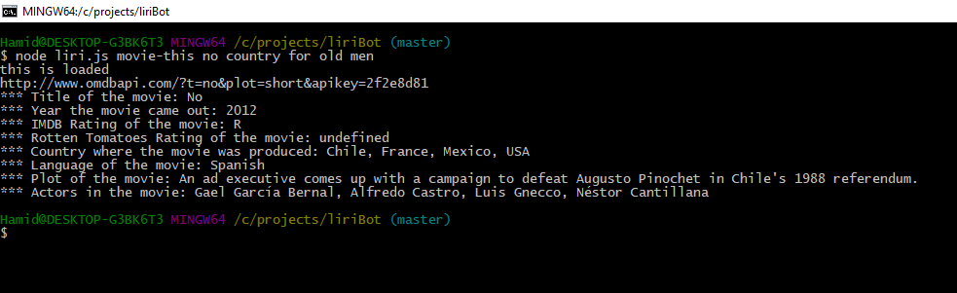

**Do what it says: (concert this, celine dion)**

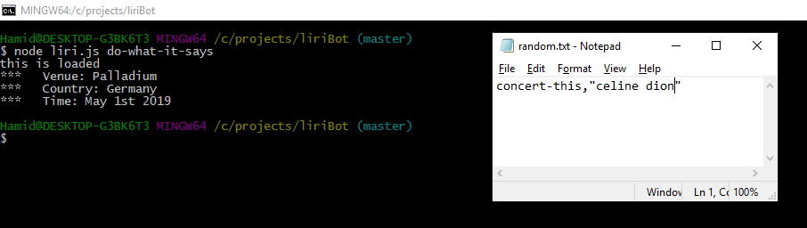

**Do what it says: (Spotify this song, I want it that way)**

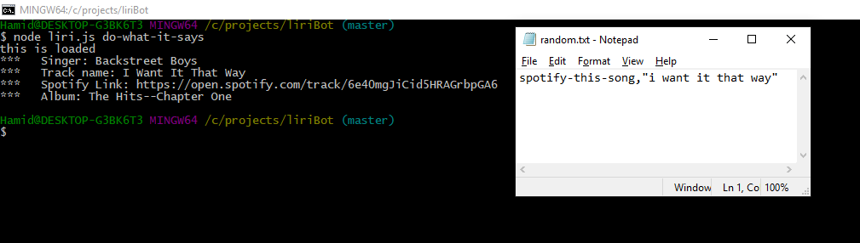

**Do what it says: (a star is born)**

