Report on Gun Murders

Rafael Irizarry

5/1/2020

## Introduction

This is a report on 2010 gun murder rates obtained from FBI reports. The original data was obtained from [this Wikipedia page](https://en.wikipedia.org/wiki/Murder_in_the_United_States_by_state).

We are going to use the following library:

library(tidyverse)

and load the data we already wrangled:

load("rda/murders.rda")

## Murder rate by state

We note the large state to state variability by generating a barplot showing the murder rate by state:

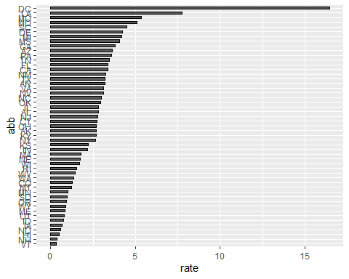

## Shrinking core model

$$x(t,R)=1−(1−\frac{t}{τ})^{3};t≤τ$$

Where $x(t,R)$ is the fraction reacted at elapsed time $t$ (particle of radius $R$), $t$ is time, $R$ particle radius, $τ$ is the time required for complete reaction:

$$τ=\frac{K*Au*R}{[CN^{−}]}$$

summary(murders)

## state abb region population   
## Alabama : 1 AK : 1 North Central:12 Min. : 563626   
## Alaska : 1 AL : 1 Northeast : 9 1st Qu.: 1696962   
## Arizona : 1 AR : 1 South :17 Median : 4339367   
## Arkansas : 1 AZ : 1 West :13 Mean : 6075769   
## California: 1 CA : 1 3rd Qu.: 6636084   
## Colorado : 1 CO : 1 Max. :37253956   
## (Other) :45 (Other):45   
## total rate   
## Min. : 2.0 Min. : 0.3196   
## 1st Qu.: 24.5 1st Qu.: 1.2526   
## Median : 97.0 Median : 2.6871   
## Mean : 184.4 Mean : 2.7791   
## 3rd Qu.: 268.0 3rd Qu.: 3.3861   
## Max. :1257.0 Max. :16.4528   
##