**Issue #1:**

**Content:** All contents

**Element:** PAGE CONTRIBUTOR

1. User should be able to delete previously added contributors.
2. If a contributor has been added at a (2nd +) position, it is not detected at review/saving, therefore “Page Contributor field is required” error message is displayed



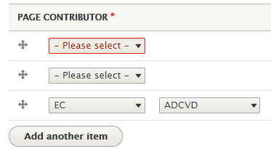

**Issue #2**

**Content:** All contents

**Element:** AddING MEDIA

1. Assorting the media Desc/Asc doesn’t work properly

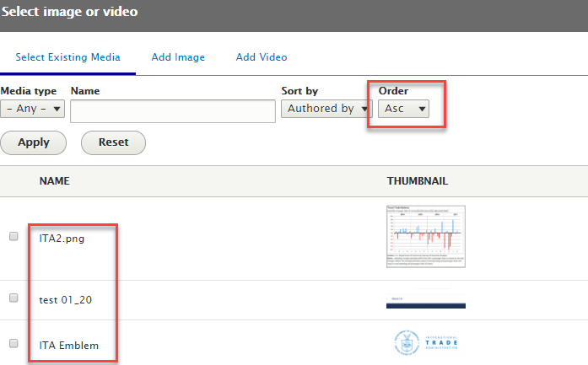

1. Clicking on Reset button is supposed to reset filter instead of taking to add image window.

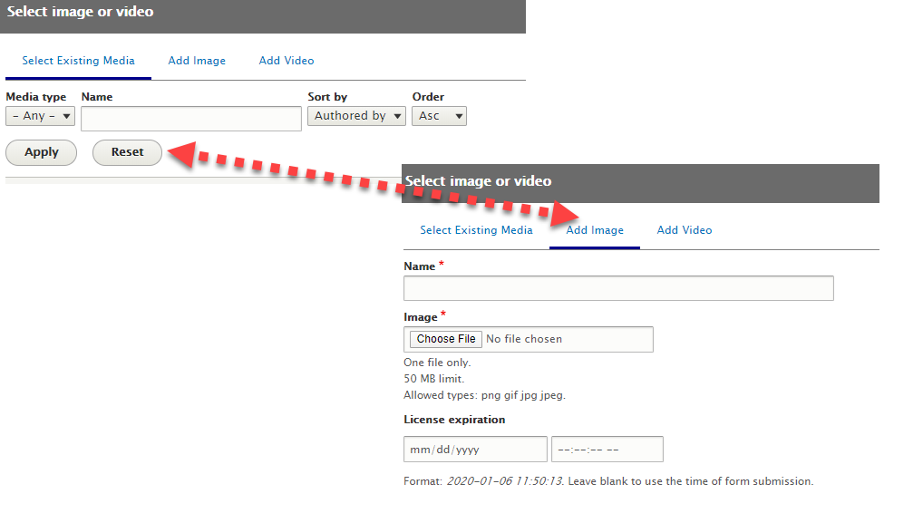

1. Selecting multiple medias at the same time.

In case only one item can be selected at the same time then it’s preferable to use radio-button rather than check-box.

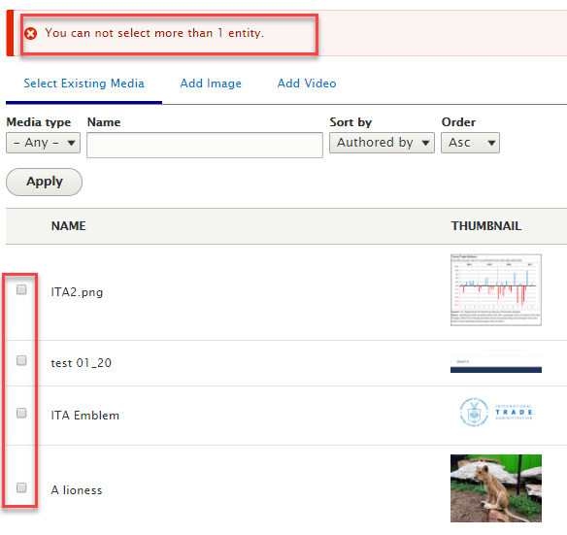

**Issue #3**

**Content:** All contents

**Element:** AddING VIDEO

1. Why “Youtube Video” field is mandatory if we could download an mp4 file from local desktop.

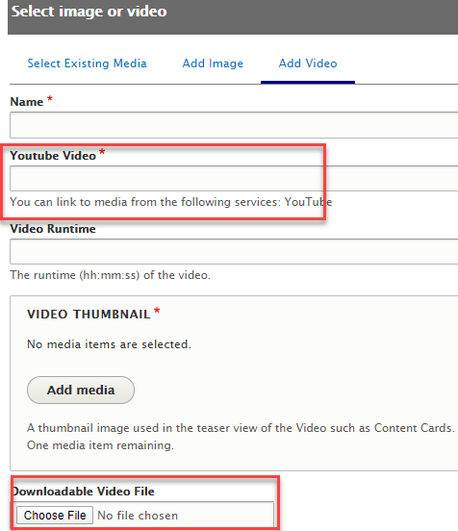

1. When we fill up all information to add video to library and hit “Save video” the download doesn’t work

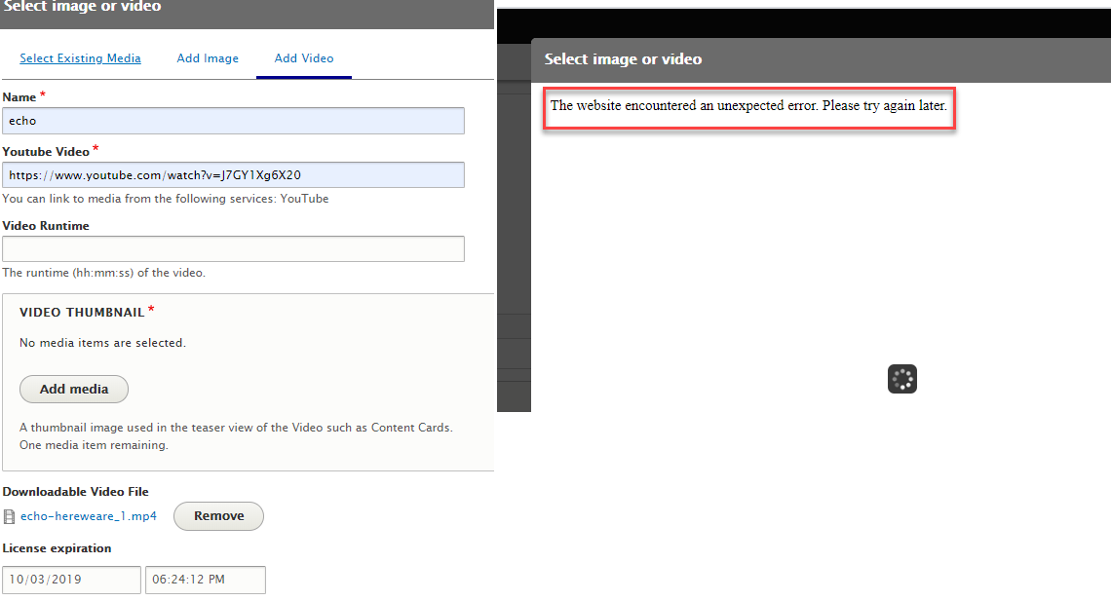

**Issue #4**

**Content:** All contents

**Element:** CONTENTStatus

Sometimes I am getting the below issues when switching from status to another

Here are some of them

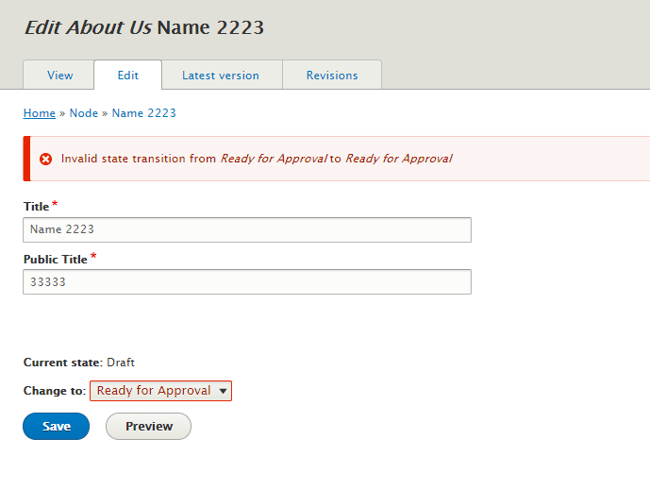

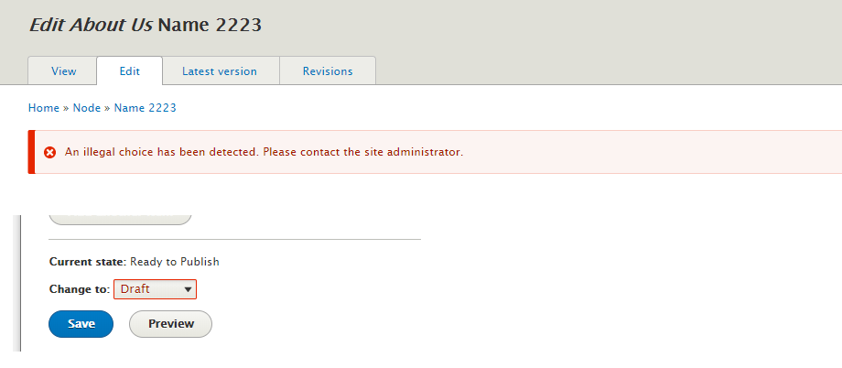

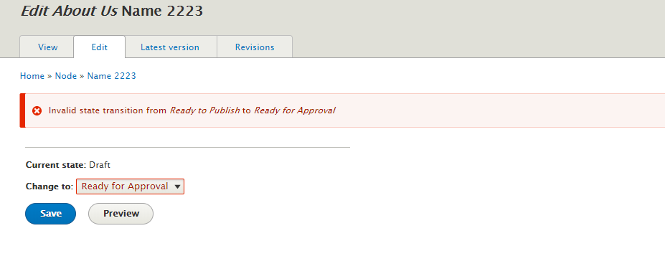

Questions:

What is the external portal link?