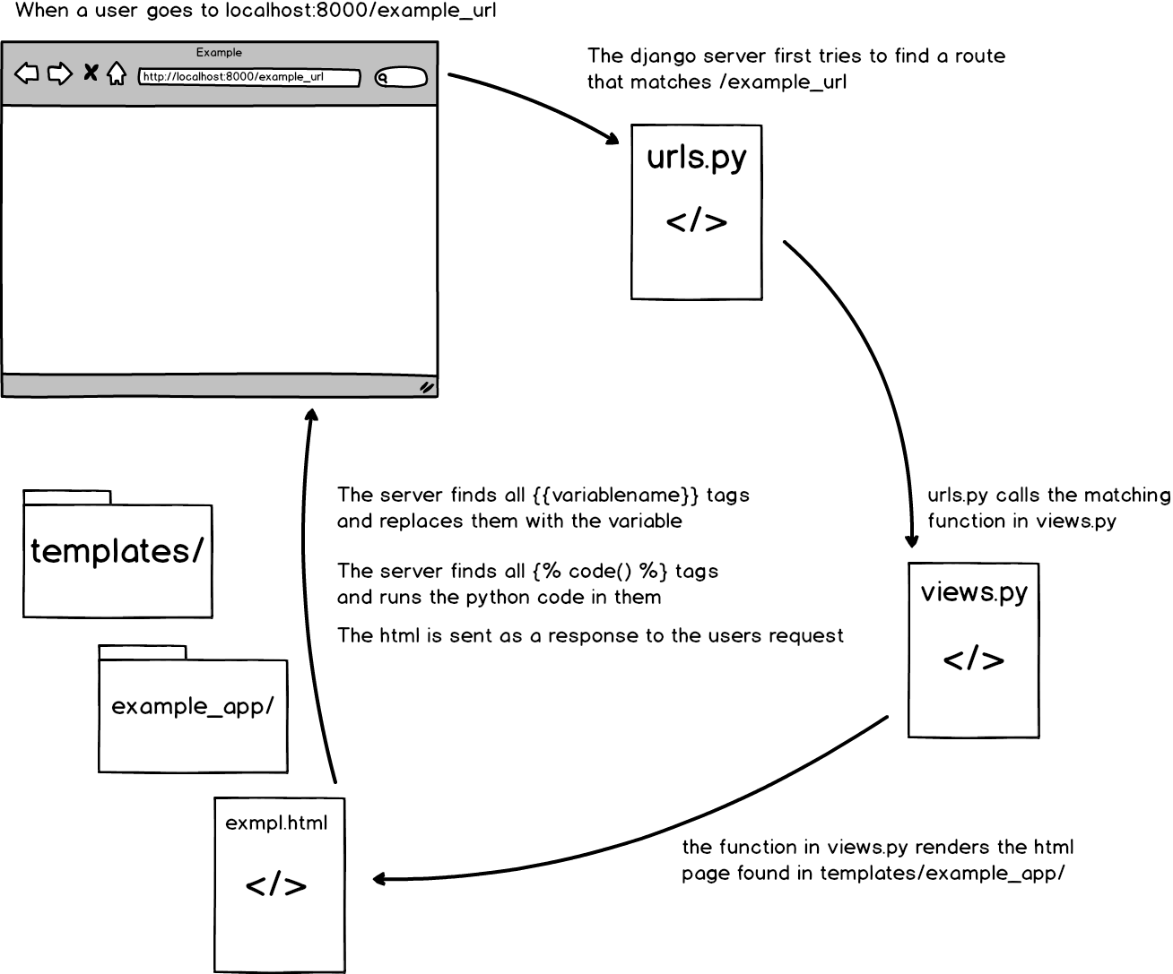

Starting a Django Project

1. activate your virtual environment

2. run the startproject command

django-admin startproject example

3. create the apps folder

cd example

mkdir apps

4. inside the apps folder create __init__.py

touch __init__.py

5. run the startapp command

python ../manage.py startapp example_app

6. inside the apps folder create urls.py and the templates folder

cd apps/example_app

touch urls.py

7. go to the settings.py file inside the example folder

add in the example_app to the list of installed apps

INSTALLED_APPS = [

'apps.example_app', # add example_app here

‘...’

]

8. go to the urls.py inside the example folder and include the urls.py from the example_app

from django.conf.urls import url, include

urlpatterns = [

url(r'^', include('apps.example_app.urls')),

]

9. add to the urls.py inside your example_app folder

from django.conf.urls import url

from . import views

urlpatterns = [

url(r'^$', views.index),

]

10. Add an index function to the views.py in the example_app folder

def index(request):

return render(request, “example_app/index.html”)

11. Setting up session

run the following commands to create the session table

also run these commands when you update the models.py

python manage.py makemigrations

python manage.py migrate