1. Requirement #1: Plot in Bar Chart the total number of issues closed every day for every Origination Phase

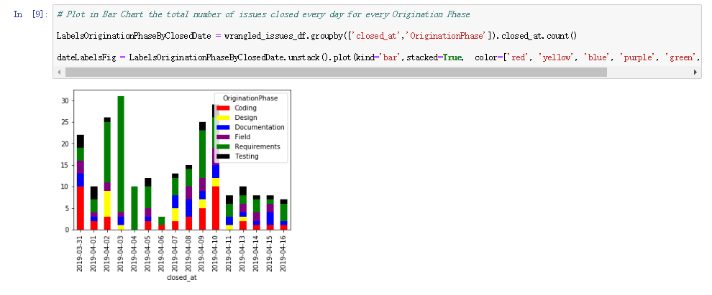

2. Requirement #2: Plot in Bar Chart the total number of issues created for every Phase based on their Status

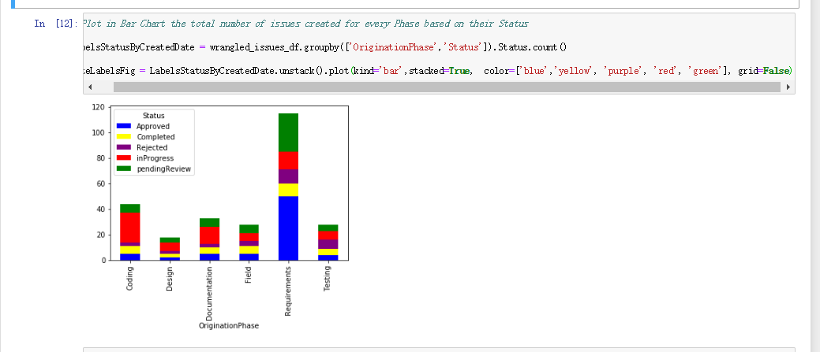

3. Requirement #3: Plot in Bar Chart the total number of issues for

1) DetectionPhase is Field AND Priority is Critical

2) DetectionPhase is Field AND Status is Completed

3) DetectionPhase is Field AND Priority is Critical AND Status is Approved

4) DetectionPhase is Field AND Priority is Critical or High AND Status is Approved or inProgress

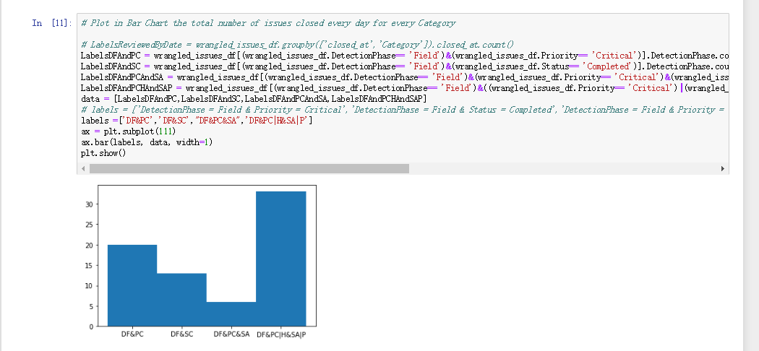

4.1

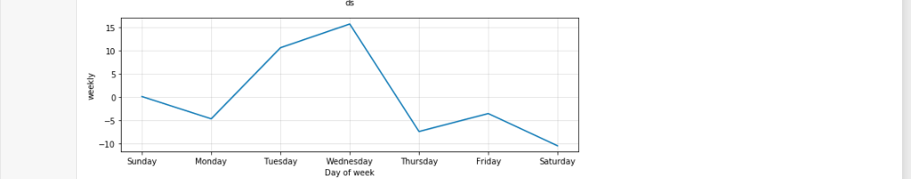

# 1. The day of the week maximum number of issues created is Wednesday

4.2

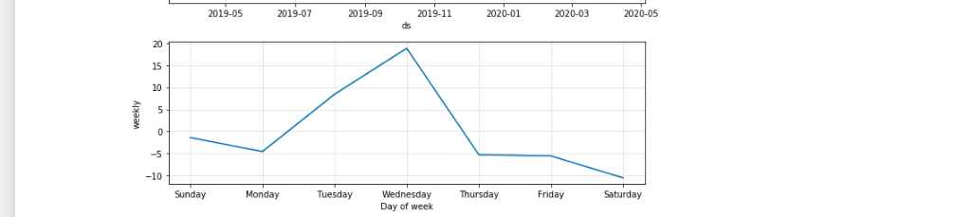

# 2. The day of the week maximum number of issues closed is Wednesday

4.3

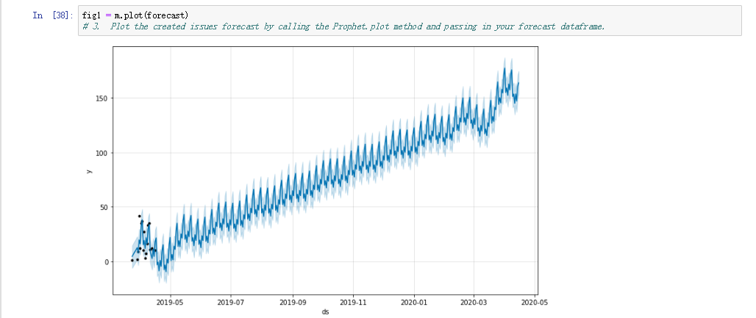

4.4

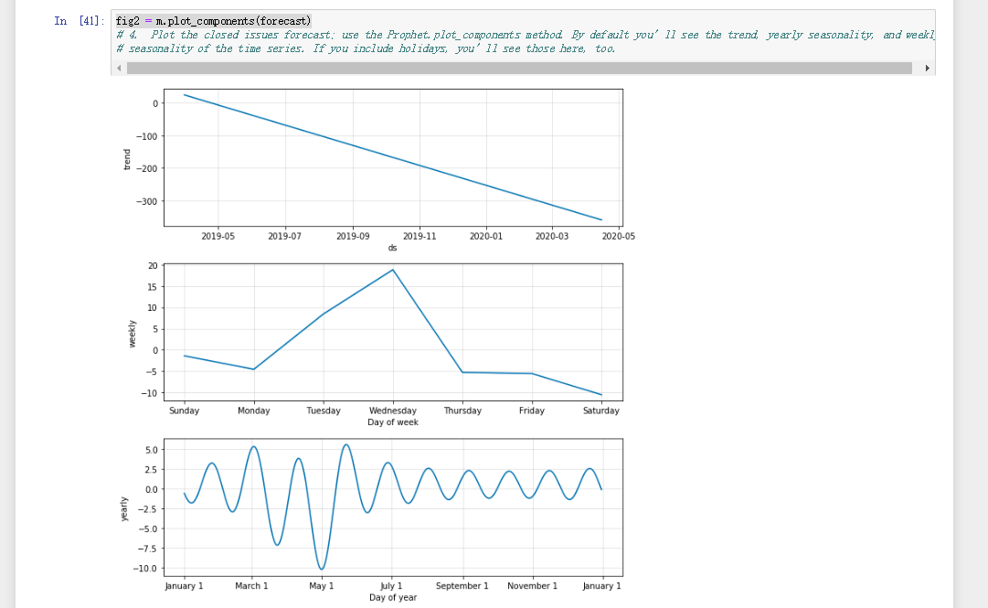

4.5

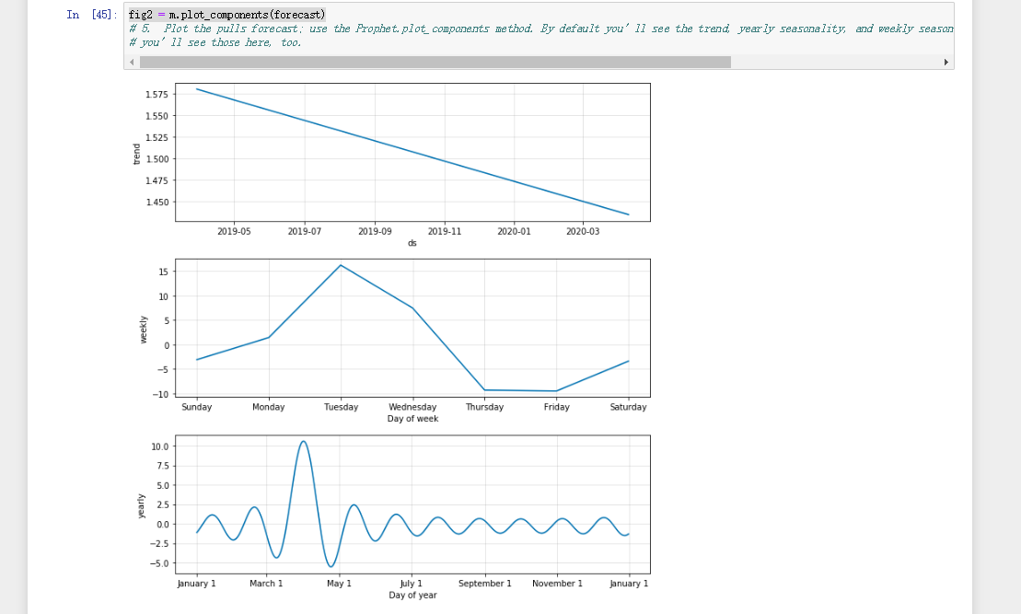

4.6

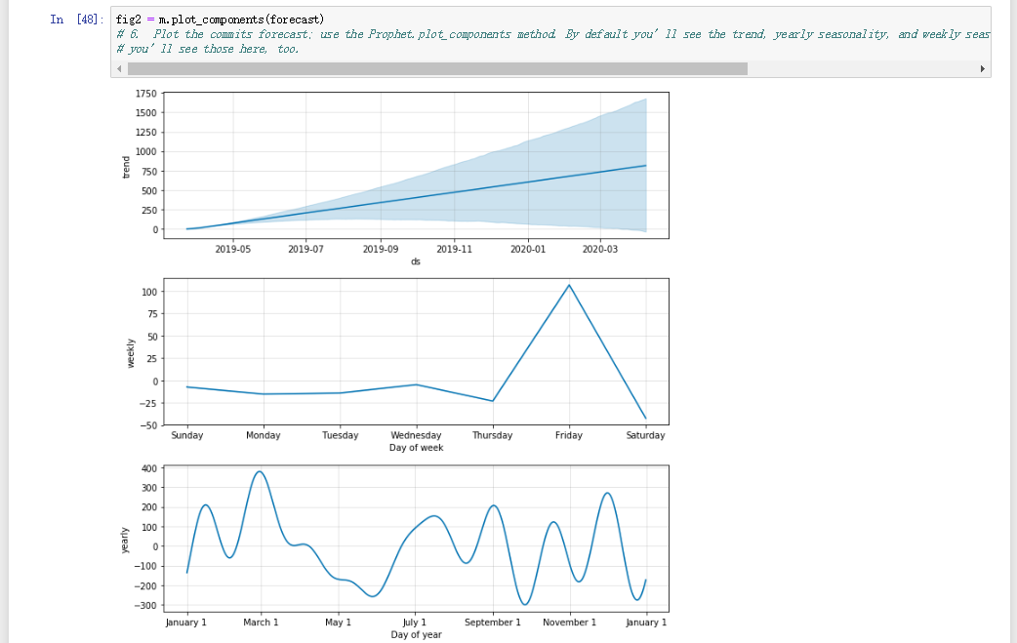

5.1 Wednesday

5.2 Wednesday

5.3

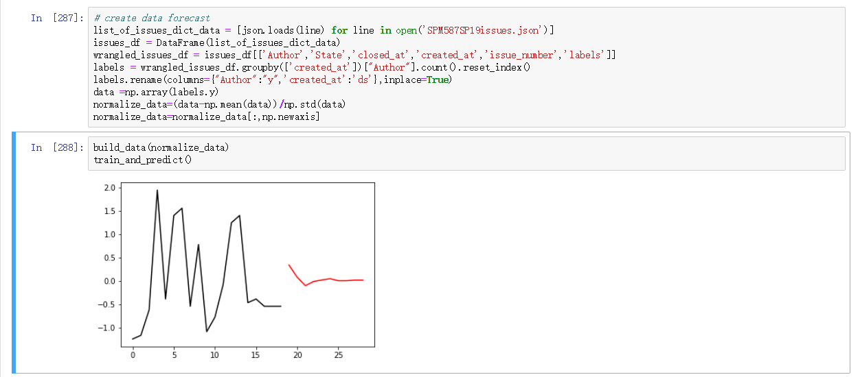

5.4

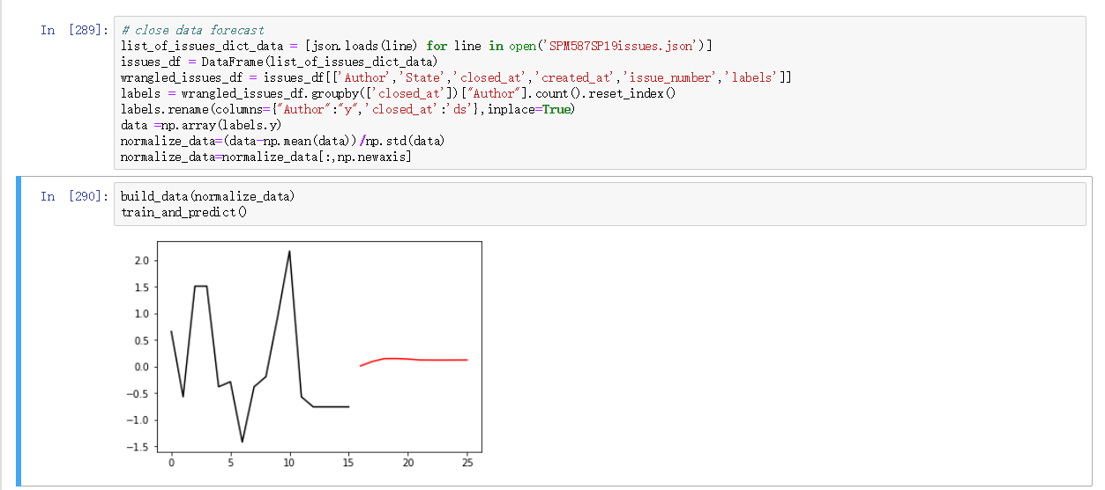

5.5

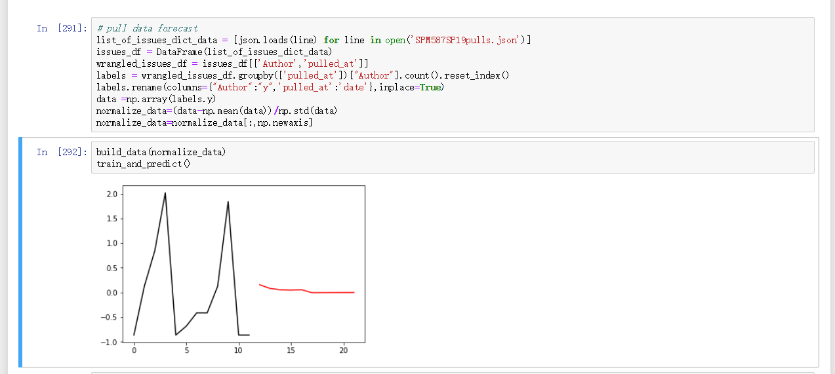

5.6

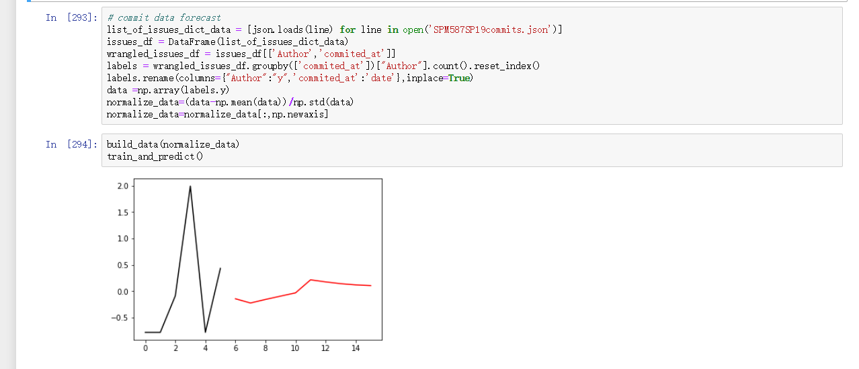

6.1 Wednesday

6.2 Wednesday

6.3

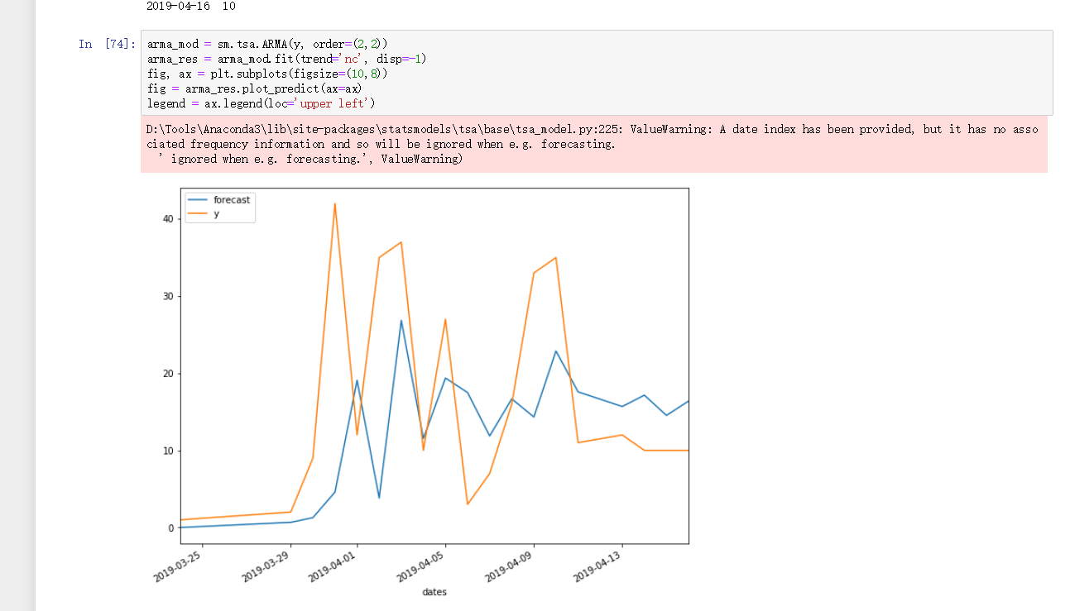

6.4

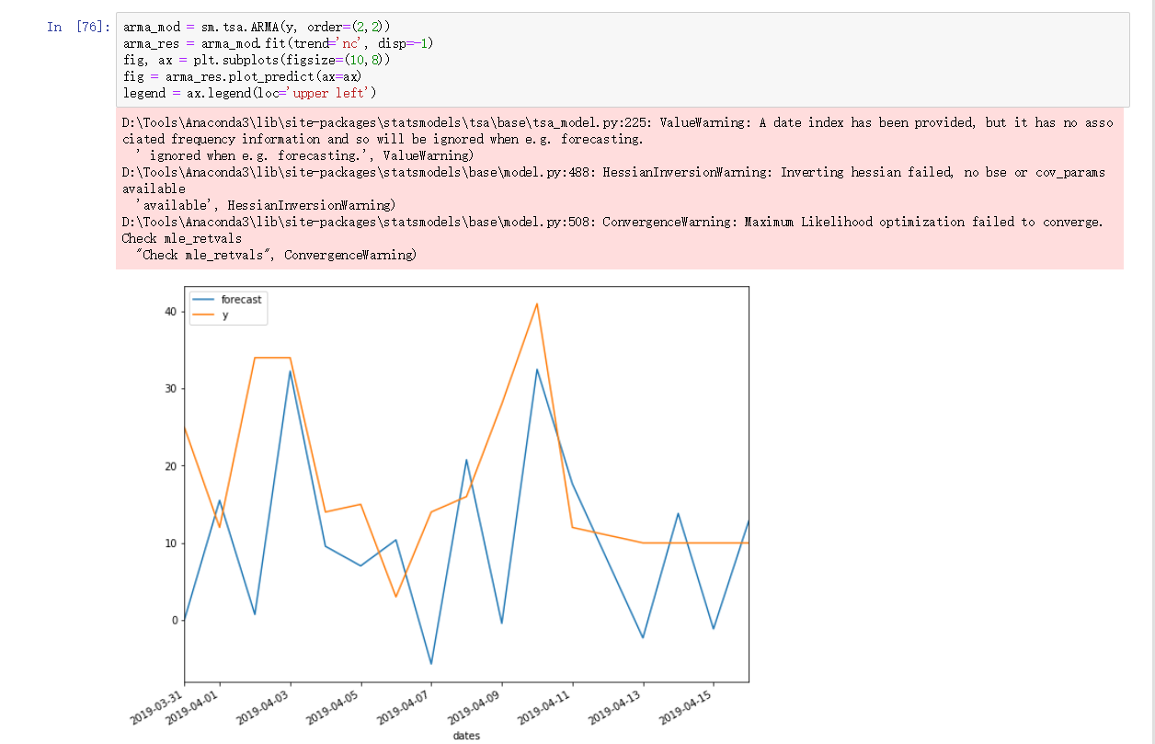

6.5

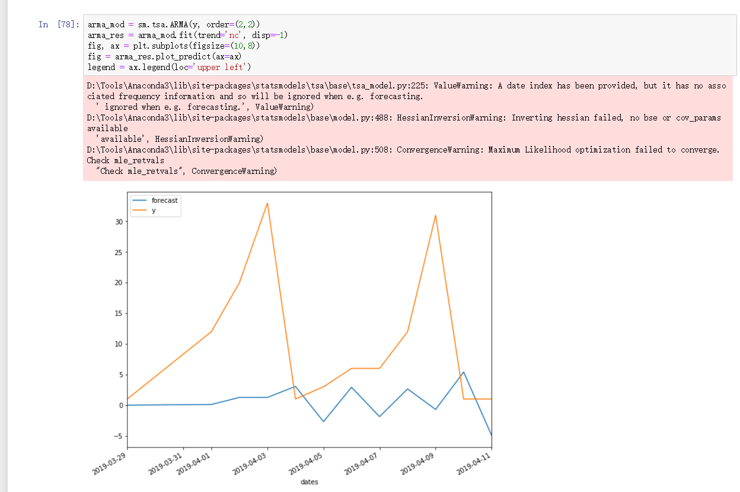

6.6 (commit data is not enough to build a model)

