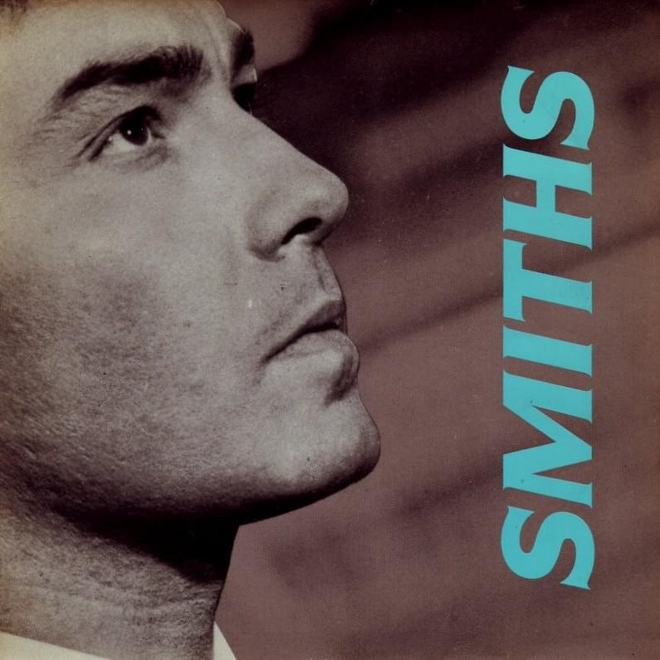

Panic on the streets of London  
Panic on the streets of Birmingham  
I wonder to myself  
"Could life ever be sane again?"  
The Leeds side streets that you slip down  
I wonder to myself

Hopes may rise on the Grasmere  
But honey pie, you're not safe here  
So you run down to the safety of the town  
But there's panic on the streets of Carlisle  
Dublin, Dundee, Humberside  
I wonder to myself

Burn down the disco  
Hang the blessed DJ  
Because the music that they constantly play  
It says nothing to me about my life  
Hang the blessed DJ  
Because the music they constantly play

On the Leeds side streets that you slip down  
Provincial towns you jog 'round

Hang the DJ, hang the DJ, hang the DJ  
Hang the DJ, hang the DJ, hang the DJ  
Hang the DJ, hang the DJ, hang the DJ  
Hang the DJ, hang the DJ

Hang the DJ, hang the DJ  
Hang the DJ, hang the DJ, hang the DJ  
Hang the DJ, hang the DJ  
Hang the DJ, hang the DJ

Hang the DJ, hang the DJ, hang the DJ  
Hang the DJ, hang the DJ  
Hang the DJ, hang the DJ  
Hang the DJ, hang the DJ, hang the DJ  
Hang the DJ, hang the DJ