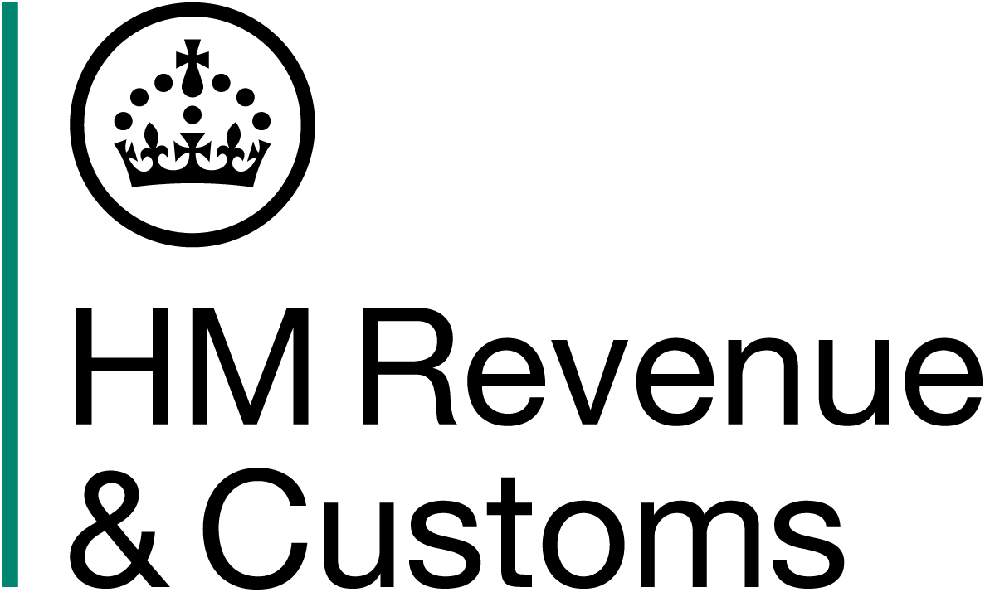

Customs Change

Readiness Checklist for NCTS6 Integration

This checklist confirms that the undersigned Software Developer (SWD) has aligned and tested their software product(s) to ensure compatibility and compliance with NCTS6 integration requirements.

SWD Name: ___________________________________________
Contact Email: ________________________________________
Declaration:
Please confirm the following by checking the boxes and signing electronically:

ᘒ 1) Our NCTS6 Software product is aligned with developer hub resources detailed below
- Technical Interface Specification and changelog
- API definitions
- Service Guide
- XML schemas
- Terms of use
☐ 2) Please tell us the sandbox name and ID you used when testing our CTC traders API
Sandbox Application Name: Click or tap here to enter text.
Sandbox Application ID: Click or tap here to enter text.

☐ 3) Please tell us your Production Application Name and ID.
Production Application Name: Click or tap here to enter text.
Production Application ID: Click or tap here to enter text.

☐ 4) We have carried out testing and integration of the product to meet our in-house standards.

☐ 5) Evidence of a completed Outbound Transit Movement (IE015 to IE029) we have submitted an IE015 declaration which has successfully progressed to ‘Movement Released’ and received an IE029 release notification in the Trader Test environment for NCTS 6.
MRN used: Click or tap here to enter text.
Date/Time: Click or tap here to enter text.

☐ 6) Our NCTS6 product is ready for the Go Live of NCTS6.

Electronic Signature: Click or tap here to enter text.
Date: Click or tap here to enter text.

