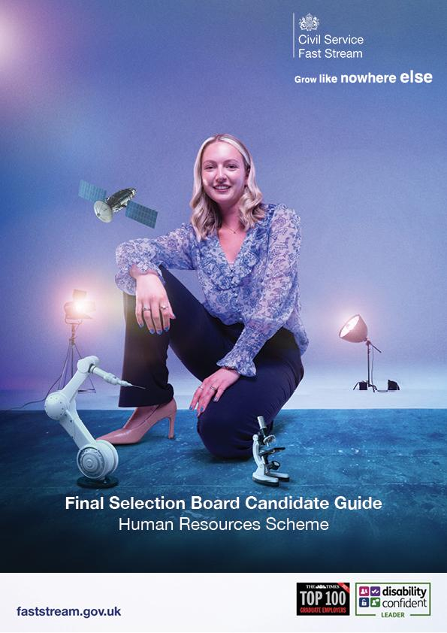

Congratulations on reaching the Final Selection Board (FSB) stage of the HR Fast
Stream process!

Please inform us if you have any reasonable adjustment requirements so that we can allocate you
additional time as needed by submitting a ticket, and a member of the team will get back to you

Welcome! This guide is designed to help you understand the format of your upcoming HR Final Selection Board (FSB) and prepare to do your best. We want to see you succeed.
If you require any reasonable adjustments please raise a ticket with FSET here and email us at gpgpeoplefunction@cabinetoffice.gov.uk
Candidates are required to demonstrate their own unique skills and judgment, and therefore, AI-generated content or drafting is not permitted for any part of the FSB process. Further information is available here: Artificial Intelligence and Recruitment

On the Day: Interview Format
Your interview will be a 45-minute virtual meeting conducted on Google Meet. A link will be sent to you in advance. The structure for the session is as follows:
- 2 Minutes: Welcome & Introductions
  - The panel member will introduce themself and outline the structure of the interview to help you feel comfortable.
- 40 Minutes: Your Interview
  - This is the main part of the session, where the panel will ask you four questions. You should aim to spend about 5-7 minutes on each question. The assessor may ask you follow up questions to get the most information from your answer.
- 3 Minutes: Your Questions & Wrap-up
  - You'll have an opportunity to ask the panel any questions you may have before the interview concludes.

The Questions: What to Expect
You will be asked four questions in total during your interview. The questions are designed to assess your motivations, skills, and values. The structure will be:
1. One Motivational Question This question explores your reasons for applying. The panel is looking for a genuine interest in public service, your motivation for a career in HR and an understanding of what makes HR in the Civil Service unique.

2. One Scenario-Based Question You will be given a hypothetical workplace situation and asked how you would handle it. The goal is to see your problem-solving skills and your commitment to core principles like fairness and compliance.
3. Two Discretionary Questions The panel will select two additional questions from a range of key competency areas. These topics may include:
- Diversity & Inclusion
- Communication and Stakeholder Engagement
- Ethics, Confidentiality and Safeguarding
- Learning & Development
- Data, Policy Awareness and Evidence
- Public Service Values

How You'll Be Assessed
Your answers will be scored on a 1-7 scale, where '1' is 'Not Demonstrated' and '7' is 'Outstanding Demonstration'.
What We're Looking For
Across all your answers, the assessors will be looking for evidence of specific skills and mindsets. Some examples of what we will be looking for include
- An understanding of HR: the types of jobs that exist within the profession and their role in supporting the business to succeed.
- Your engagement and motivation for pursuing a career in HR.
- A proactive and solution-focused mindset: Show that you are a flexible, strategic partner who looks for constructive resolutions rather than simply following a process rigidly or assigning blame.
- Integrity and courage: Provide evidence that you act on your values, can handle ethical dilemmas, and are willing to "speak truth to power" constructively when necessary. A commitment to fairness, transparency, and accountability is key.
- Empathy and emotional Intelligence: Demonstrate your ability to understand others' perspectives, manage sensitive situations with tact, and adjust your communication style to the audience, especially during change or conflict.
- Strategic and analytical thinking: Show that you can see the bigger picture, use data to inform your decisions, and connect HR activities to business objectives.
- A commitment to development: Highlight your proactive approach to your own professional growth and your ability to support and coach others.

Good luck with your preparation!

